Company name:

Brand

**Fater Electronic**

|  |  |  |  |  |  |  |  |  |  |  |  |  |  |  |  |
| --- | --- | --- | --- | --- | --- | --- | --- | --- | --- | --- | --- | --- | --- | --- | --- |
|  |  |  |  | **X6116 TC** | | | | Product photo: | | | |  |  |  |  |
|  | Product Specifications: | | |  |  |  |  |  |  |  |  |
| High Acturacy & Stability | | | |  |  |  |  |  |  |  |  |  |  |  |  |
| High Acturacy PID temp control with New microcontrolers | | | | | | | |  |  |  |  |  |  |  |  |
| & PC base full function unlimitted time programable Seed | | | | | | | |  |  |  |  |  |  |  |  |
| Germinators with independently 16 chambers control for | | | | | | | |  |  |  |  |  |  |  |  |
| LED Lights, ultrasonic Humidity and Temp full controls. | | | | | | | |  |  |  |  |  |  |  |  |
| and many functions. | | | |  |  |  |  |  |  |  |  |  |  |  |  |
|  | ultrasonic Humidifier | | |  |  |  |  |  |  |  |  |  |  |  |  |
|  | LED light | | |  |  |  |  |  |  |  |  |  |  |  |  |
|  | Touch Color Sharp LCD | | |  |  |  |  |  |  |  |  |  |  |  |  |
|  | independently Temp,humidity,Light control for each | | | | | | |  |  |  |  |  |  |  |  |
| Chamber. | | | |  |  |  |  |  |  |  |  |  |  |  |  |
|  | Data Logger and SD Card memory | | | | | | |  |  |  |  |  |  |  |  |
|  | single program and 10 program (optional) | | | | | | |  |  |  |  |  |  |  |  |
|  | High & Low Alarm with Flash Light & Soun | | | | | | |  |  |  |  |  |  |  |  |
|  |  |  |  |  |  |  |  |  |  |  |  |  |  |  |  |
|  | production capacity**:** | | |  |  |  |  |  |  |  |  |  |  |  |  |
|  | offer price in China ($): | | |  |  |  |  |  |  |  |  |  |  |  |  |
|  | **US$ 26,750** | | |  |  |  |  |  |  |  |  |  |  |  |  |
|  | Maximum order/Minimum delivery time (EX: one ton/one month or 1000/year or ….): | | | | | | | | | | |  |  |  |  |
|  | **1 pcs / 45 days** | | |  |  |  |  |  |  |  |  |  |  |  |  |
| MSDS OR Technical data sheet: | | | | | | | |  |  |  |  |  |  |  |  |
|  |  |  |  |  |  |  |  |  |  |  |  |  |  |  |  |
|  |  |  |  |  |  |  |  |  |  |  |  |  |  |  |  |
|  |  |  |  |  |  |  |  |  |  |  |  |  |  |  |  |
|  |  |  |  |  |  |  |  |  |  |  | ) | ( |  |  |  |
|  |  |  |  |  |  |  |  |  |  |  |  |  |  |  |  |
|  |  |  |  |  |  |  |  |  |  |  | ) | ( |  |  |  |
|  |  |  |  |  |  |  |  |  |  |  |  |  |  |  |  |
|  |  |  |  |  |  |  |  |  |  |  |  |  |  |  |  |
|  |  |  |  |  |  |  |  |  |  |  |  |  |  |  |  |
|  |  |  |  | ± | | |  |  |  |  |  |  |  |  |  |
|  |  |  |  |  | |  |  |  |  |  |  |  |  |  |  |
|  |  |  |  | ± | |  |  |  |  |  |  |  |  |  |  |
|  |  | | |  | |  | |  |  |  |  |  |  |  |  |
|  | contact person: Ali Arghavan | | | | | | | Company contact: | | | |  |  |  |  |
|  | Email: head@fater.ir | | |  |  |  |  | Website: www.fater.ir (www.fater-electronic.com) | | | | | | |  |
|  | Tell: +98- 9121272405 | | |  |  |  |  | Email: head@fater.ir | | | |  |  |  |  |
|  | Address**: Tehran-Iran** | | |  |  |  |  | Tell: +98 -21 88552340-42 | | | |  |  |  |  |
|  |  |  |  |  |  |  |  | Fax: +98 – 21 88552305 | | | |  |  |  |  |
|  |  |  |  |  |  |  |  | Address: No.14, 18th St., Vozara Ave., Tehran-Iran | | | | | | |  |

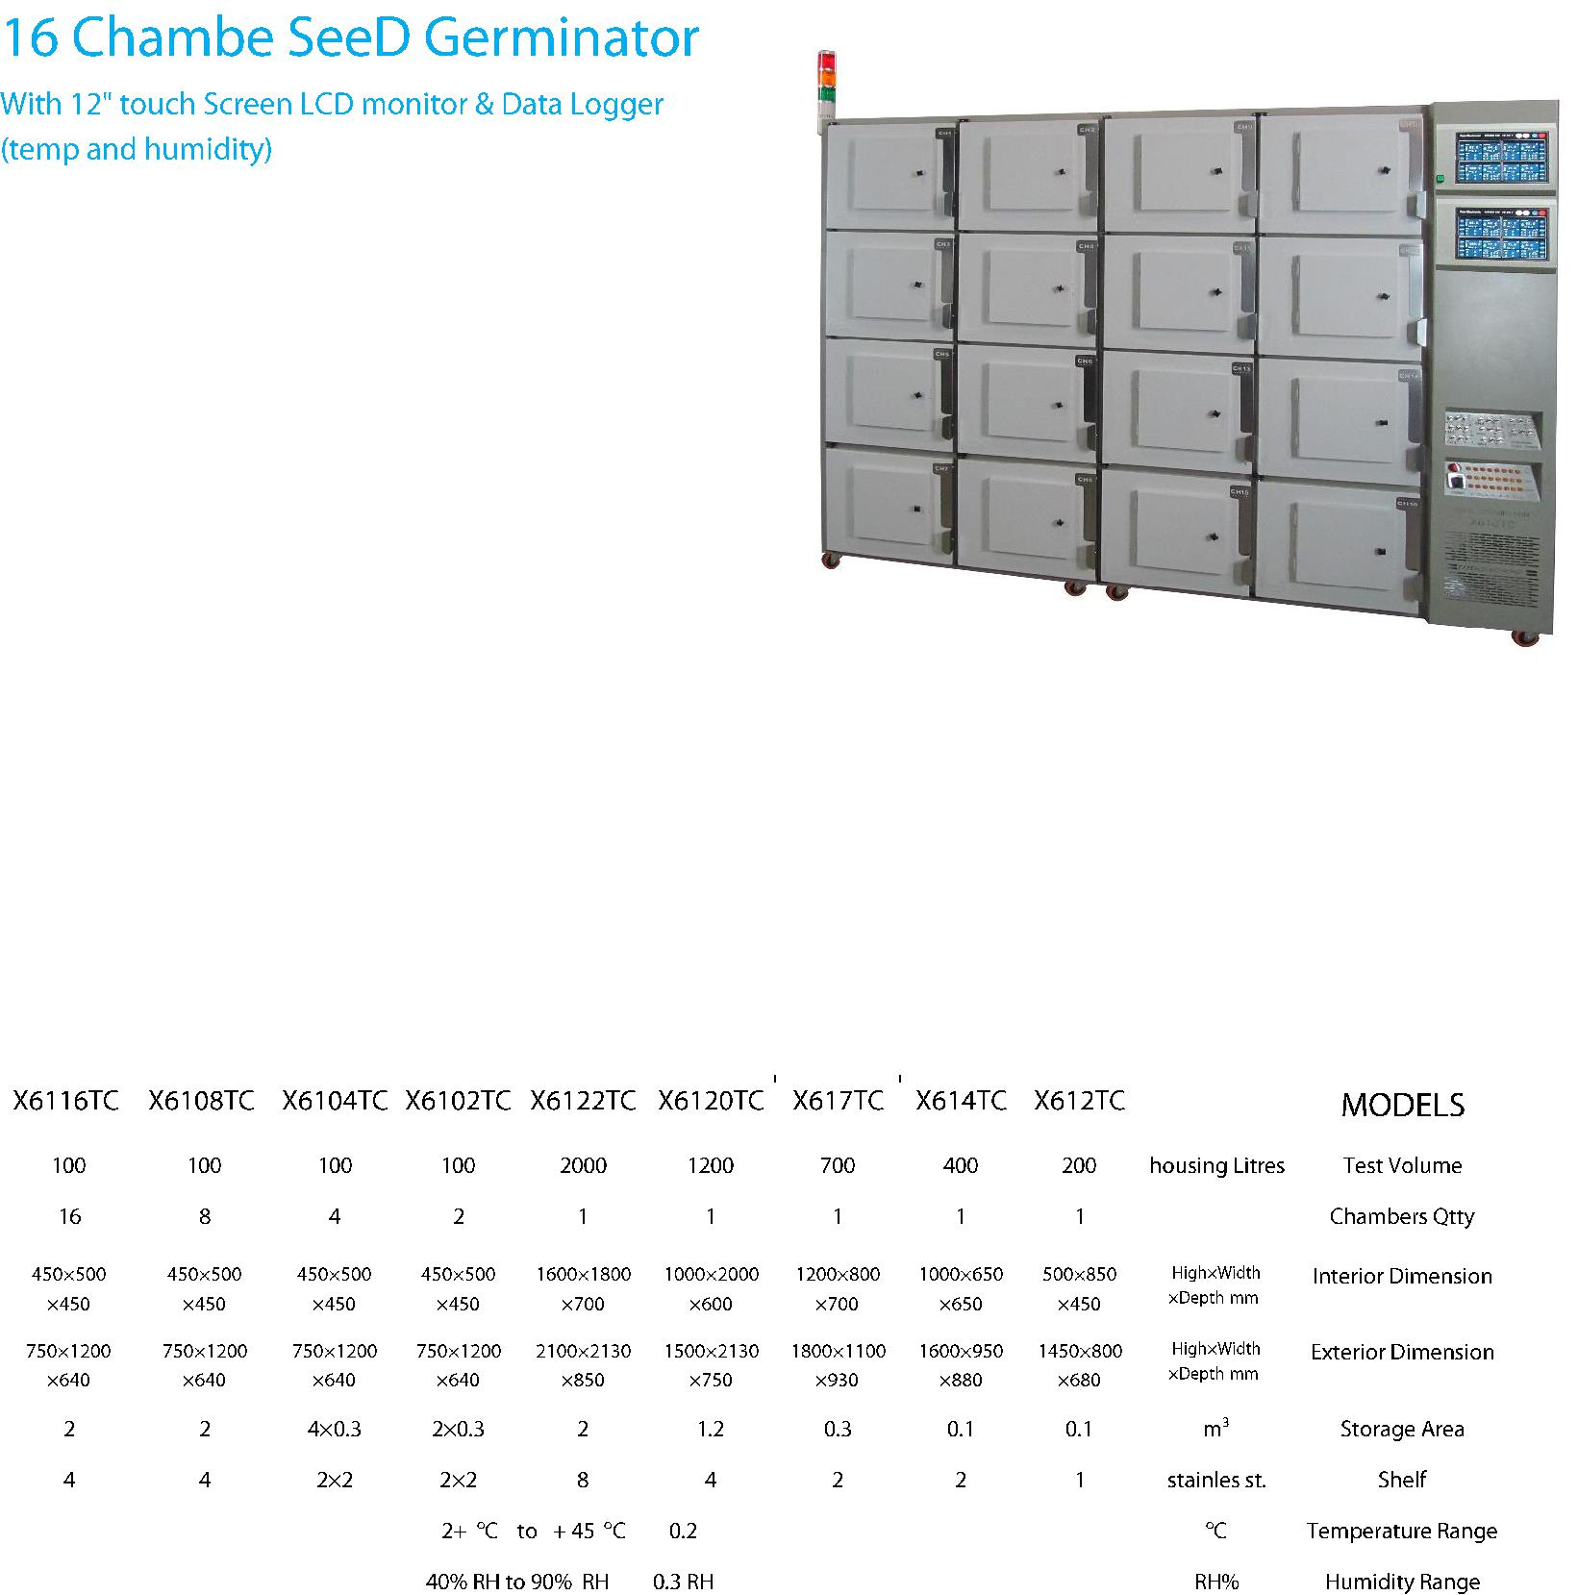

Company name:

Brand

**Fater Electronic**

|  |  |  |  |  |  |  |  |  |  |  |  |  |  |  |  |
| --- | --- | --- | --- | --- | --- | --- | --- | --- | --- | --- | --- | --- | --- | --- | --- |
|  |  |  |  | **X6108 TC** | | | | Product photo: | | | |  |  |  |  |
| Product Specifications: | | | |  |  |  |  |  |  |  |  |
| High Acturacy & Stability | | | |  |  |  |  |  |  |  |  |  |  |  |  |
| High Acturacy PID temp control with New microcontrolers | | | | | | | |  |  |  |  |  |  |  |  |
| & PC base full function unlimitted time programable Seed | | | | | | | |  |  |  |  |  |  |  |  |
| Germinators with independently 8 chambers control for | | | | | | | |  |  |  |  |  |  |  |  |
| LED Lights, ultrasonic Humidity and Temp full controls. | | | | | | | |  |  |  |  |  |  |  |  |
| and many functions. | | | |  |  |  |  |  |  |  |  |  |  |  |  |
|  | ultrasonic Humidifier | | |  |  |  |  |  |  |  |  |  |  |  |  |
|  | LED light | | |  |  |  |  |  |  |  |  |  |  |  |  |
|  | Touch Color Sharp LCD | | |  |  |  |  |  |  |  |  |  |  |  |  |
|  | independently Temp,humidity,Light control for each | | | | | | |  |  |  |  |  |  |  |  |
| Chamber. | | | |  |  |  |  |  |  |  |  |  |  |  |  |
|  | Data Logger and SD Card memory | | | | | | |  |  |  |  |  |  |  |  |
|  | single program and 10 program (optional) | | | | | | |  |  |  |  |  |  |  |  |
|  | High & Low Alarm with Flash Light & Soun | | | | | | |  |  |  |  |  |  |  |  |
|  |  |  |  |  |  |  |  |  |  |  |  |  |  |  |  |
| production capacity**:** | | | |  |  |  |  |  |  |  |  |  |  |  |  |
| offer price in China ($): | | | |  |  |  |  |  |  |  |  |  |  |  |  |
| **US$ 14,750** | | | |  |  |  |  |  |  |  |  |  |  |  |  |
| Maximum order/Minimum delivery time (EX: one ton/one month or 1000/year or ….): | | | | | | | | | | | |  |  |  |  |
| **1 pcs / 45 days** | | | |  |  |  |  |  |  |  |  |  |  |  |  |
| MSDS OR Technical data sheet: | | | | | | | |  |  |  |  |  |  |  |  |
|  |  |  |  |  |  |  |  |  |  |  |  |  |  |  |  |
|  |  |  |  |  |  |  |  |  |  |  |  |  |  |  |  |
|  |  |  |  |  |  |  |  |  |  |  |  |  |  |  |  |
|  |  |  |  |  |  |  |  |  |  |  | ) | ( |  |  |  |
|  |  |  |  |  |  |  |  |  |  |  |  |  |  |  |  |
|  |  |  |  |  |  |  |  |  |  |  | ) | ( |  |  |  |
|  |  |  |  |  |  |  |  |  |  |  |  |  |  |  |  |
|  |  |  |  |  |  |  |  |  |  |  |  |  |  |  |  |
|  |  |  |  |  |  |  |  |  |  |  |  |  |  |  |  |
|  |  |  |  | ± | | | |  |  |  |  |  |  |  |  |
|  |  |  |  |  | | |  |  |  |  |  |  |  |  |  |
|  |  |  |  | ± | | |  |  |  |  |  |  |  |  |  |
|  |  |  | | |  |  |  |  |  |  |  |  |  |  |  |
| contact person: Ali Arghavan | | | | | | | | Company contact: | | | |  |  |  |  |
| Email: head@fater.ir | | | |  |  |  |  | Website: www.fater.ir (www.fater-electronic.com) | | | | | | |  |
| Tell: +98- 9121272405 | | | |  |  |  |  | Email: head@fater.ir | | | |  |  |  |  |
| Address**: Tehran-Iran** | | | |  |  |  |  | Tell: +98 -21 88552340-42 | | | |  |  |  |  |
|  |  |  |  |  |  |  |  | Fax: +98 – 21 88552305 | | | |  |  |  |  |
|  |  |  |  |  |  |  |  | Address: No.14, 18th St., Vozara Ave., Tehran-Iran | | | | | | |  |

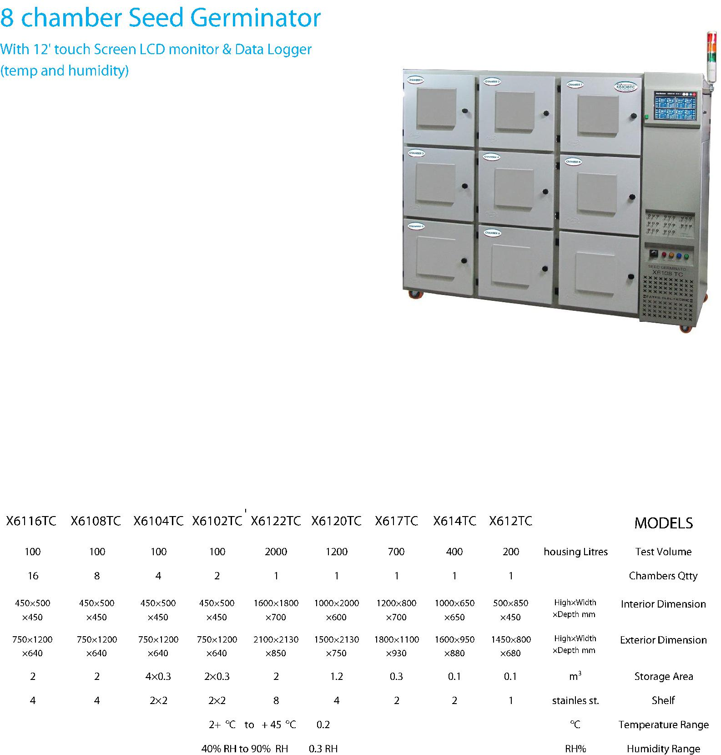

Company name:

Brand

**Fater Electronic**

|  |  |  |
| --- | --- | --- |
| Product Specifications:**X6104 TC** | Product photo: |  |
|  |  |

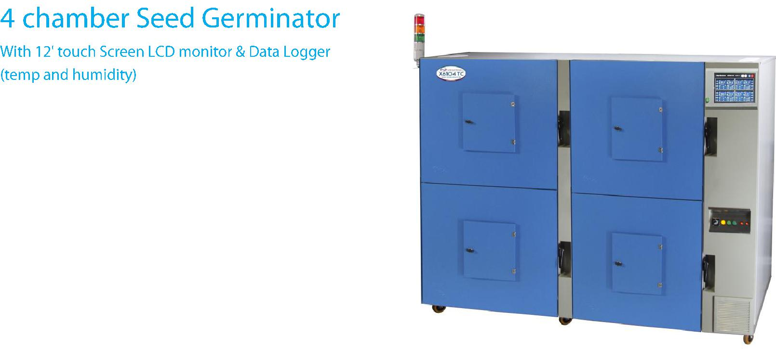

High Acturacy & Stability

High Acturacy PID temp control with New microcontrolers

* PC base full function unlimitted time programable Seed Germinators with independently 4 chambers control for LED Lights, ultrasonic Humidity and Temp full controls. and many functions.

ultrasonic Humidifier LED light

Touch Color Sharp LCD

independently Temp,humidity,Light control for each Chamber.

Data Logger and SD Card memory

single program and 10 program (optional) High & Low Alarm with Flash Light & Soun

production capacity**:**

offer price in China ($):

**US$ 12,350**

Maximum order/Minimum delivery time (EX: one ton/one month or 1000/year or ….):

**2 pcs /** **45 days**

MSDS OR Technical data sheet:

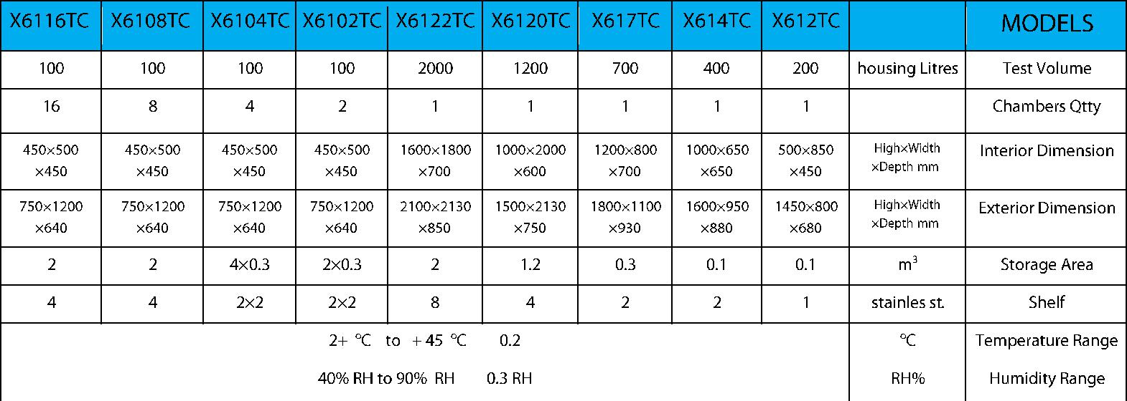

) (

) (

|  |  |  |  |  |
| --- | --- | --- | --- | --- |
|  |  | ± |  |  |
|  |  |  |  |  |
|  |  | ± |  |  |
|  | |  |  |  |
| contact person: Ali Arghavan | |  | Company contact: |  |
| Email: head@fater.ir | |  | Website: www.fater.ir (www.fater-electronic.com) |  |
| Tell: +98- 9121272405 | |  | Email: head@fater.ir |  |
| Address**: Tehran-Iran** | |  | Tell: +98 -21 88552340-42 |  |
|  |  |  | Fax: +98 – 21 88552305 |  |
|  |  |  | Address: No.14, 18th St., Vozara Ave., Tehran-Iran |  |

Company name:

Brand

**Fater Electronic**

|  |  |  |  |  |  |  |  |  |  |  |  |  |
| --- | --- | --- | --- | --- | --- | --- | --- | --- | --- | --- | --- | --- |
|  |  |  | **X620** | | | | Product photo: | |  |  |  |  |
|  | Product Specifications: | |  |  |  |  |  |  |
| FULL AUTOMATIC PROGRAMABLE AND VERY STABLE - 200 & | | | | | | |  |  |  |  |  |  |
| 500 Litre Chamber | | |  |  |  |  |  |  |  |  |  |  |
| LED light for day brightnes and ultrasonic humidity | | | | | | |  |  |  |  |  |  |
|  | & High acturacy PID temp control with new microcontrolers | | | | | |  |  |  |  |  |  |
| and many functions for temp and time control in two type | | | | | | |  |  |  |  |  |  |
| control System. | | |  |  |  |  |  |  |  |  |  |  |
|  | Digital micro controled System with full automatic control | | | | | |  |  |  |  |  |  |
|  | Programable from 1 up to 99 day and night | | | | | |  |  |  |  |  |  |
|  | LED light for day light | |  |  |  |  |  |  |  |  |  |  |
|  | temp control 2+ oC - | | + 45 oC | ± 0.1 |  |  |  |  |  |  |  |  |
|  | Humidity 40% RH to 90% RH ± 0.3 RH | | | | | |  |  |  |  |  |  |
|  | Stainless Steel 304 interior Chamber | | | | | |  |  |  |  |  |  |
|  | Stainles Steel body coated with electrostatic paint) | | | | | |  |  |  |  |  |  |
|  |  |  |  |  |  |  |  |  |  |  |  |  |
|  | production capacity**:** | |  |  |  |  |  |  |  |  |  |  |
|  | offer price in China ($): | |  |  |  |  |  |  |  |  |  |  |
|  | **US$ 3,190** | |  |  |  |  |  |  |  |  |  |  |
|  | Maximum order/Minimum delivery time (EX: one ton/one month or 1000/year or ….): | | | | | | | |  |  |  |  |
|  | **30 pcs / 45 days** | |  |  |  |  |  |  |  |  |  |  |
|  |  |  |  |  |  |  |  |  |  |  |  |  |
|  |  |  |  |  |  |  |  |  |  |  |  |  |
|  |  |  |  |  |  |  |  |  |  |  |  |  |
|  |  |  |  |  |  |  |  |  |  |  |  |  |
|  |  |  |  |  |  |  |  |  |  |  |  |  |
|  |  |  |  |  |  |  |  | ) | ( |  |  |  |
|  |  |  |  |  |  |  |  |  |  |  |  |  |
|  |  |  |  |  |  |  |  | ) | ( |  |  |  |
|  |  |  |  |  |  |  |  |  |  |  |  |  |
|  |  |  |  |  |  |  |  |  |  |  |  |  |
|  |  |  |  |  |  |  |  |  |  |  |  |  |
|  |  |  |  | ± | |  |  |  |  |  |  |  |
|  |  |  |  |  | |  |  |  |  |  |  |  |
|  |  |  |  | ± | |  |  |  |  |  |  |  |
|  |  |  | |  |  |  |  |  |  |  |  |  |
|  |  | | |  |  |  |  | |  |  |  |  |
|  | contact person: Ali Arghavan | | |  |  |  | Company contact: | |  |  |  |  |
|  | Email: head@fater.ir | |  |  |  |  | Website: www.fater.ir (www.fater-electronic.com) | | | | |  |
|  | Tell: +98- 9121272405 | |  |  |  |  | Email: head@fater.ir | |  |  |  |  |
|  | Address**: Tehran-Iran** | |  |  |  |  | Tell: +98 -21 88552340-42 | |  |  |  |  |
|  |  |  |  |  |  |  | Fax: +98 – 21 88552305 | |  |  |  |  |
|  |  |  |  |  |  |  | Address: No.14, 18th St., Vozara Ave., Tehran-Iran | | | | |  |

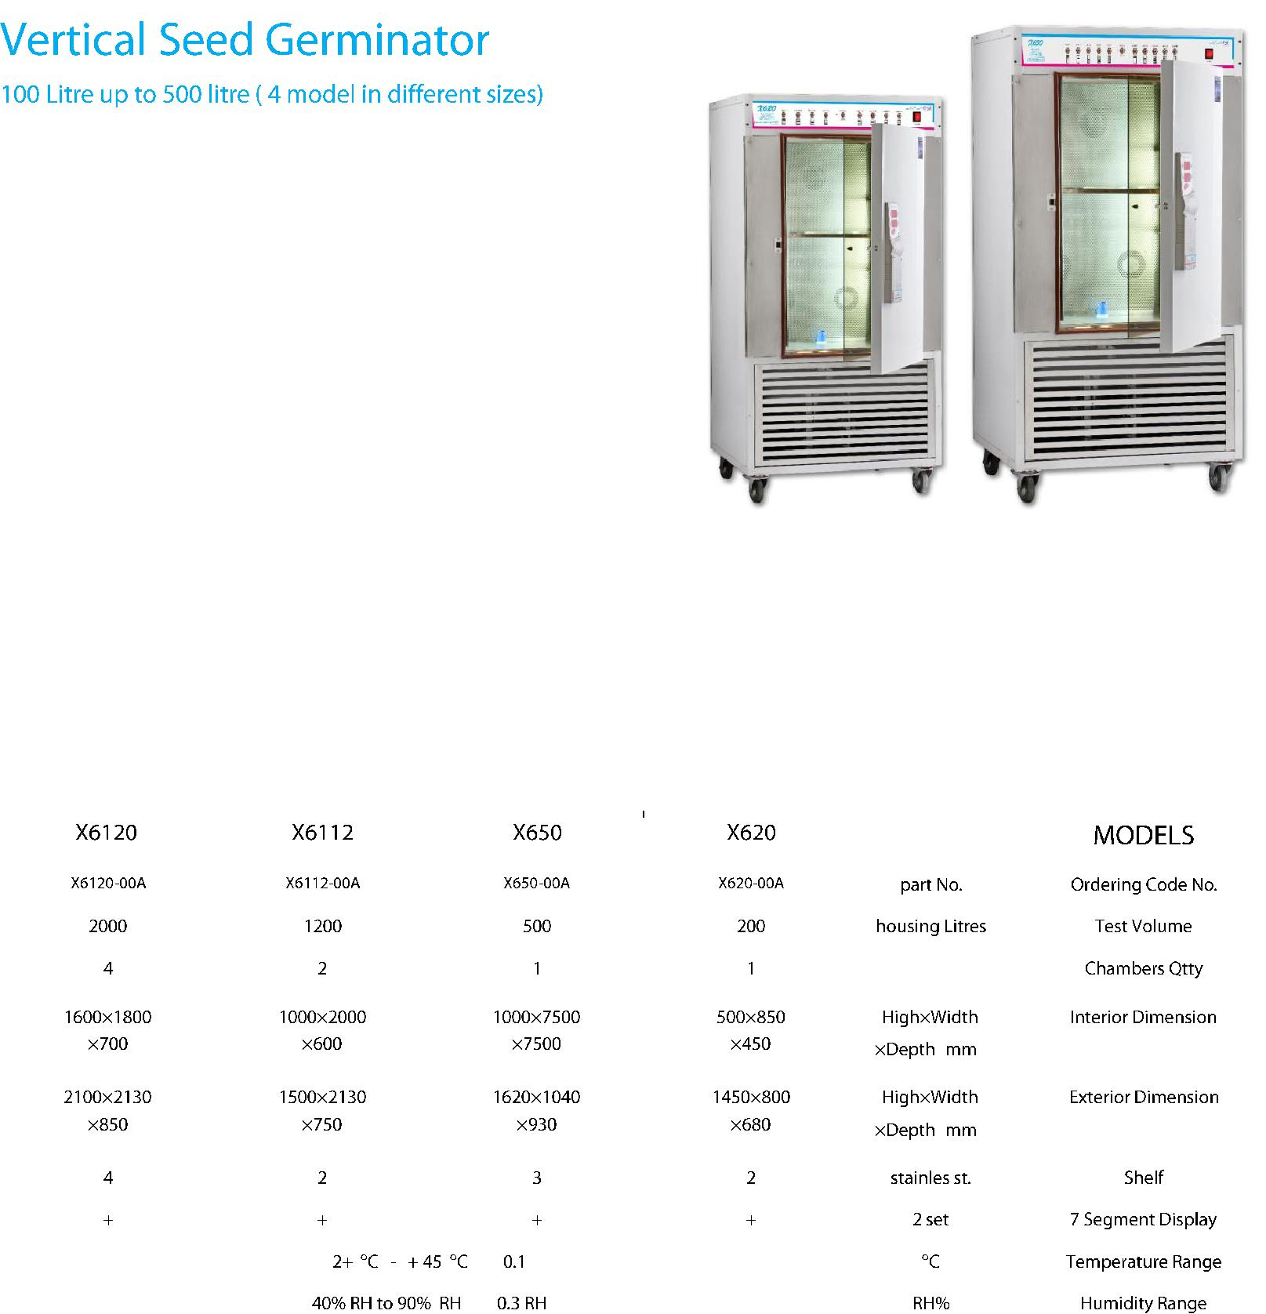

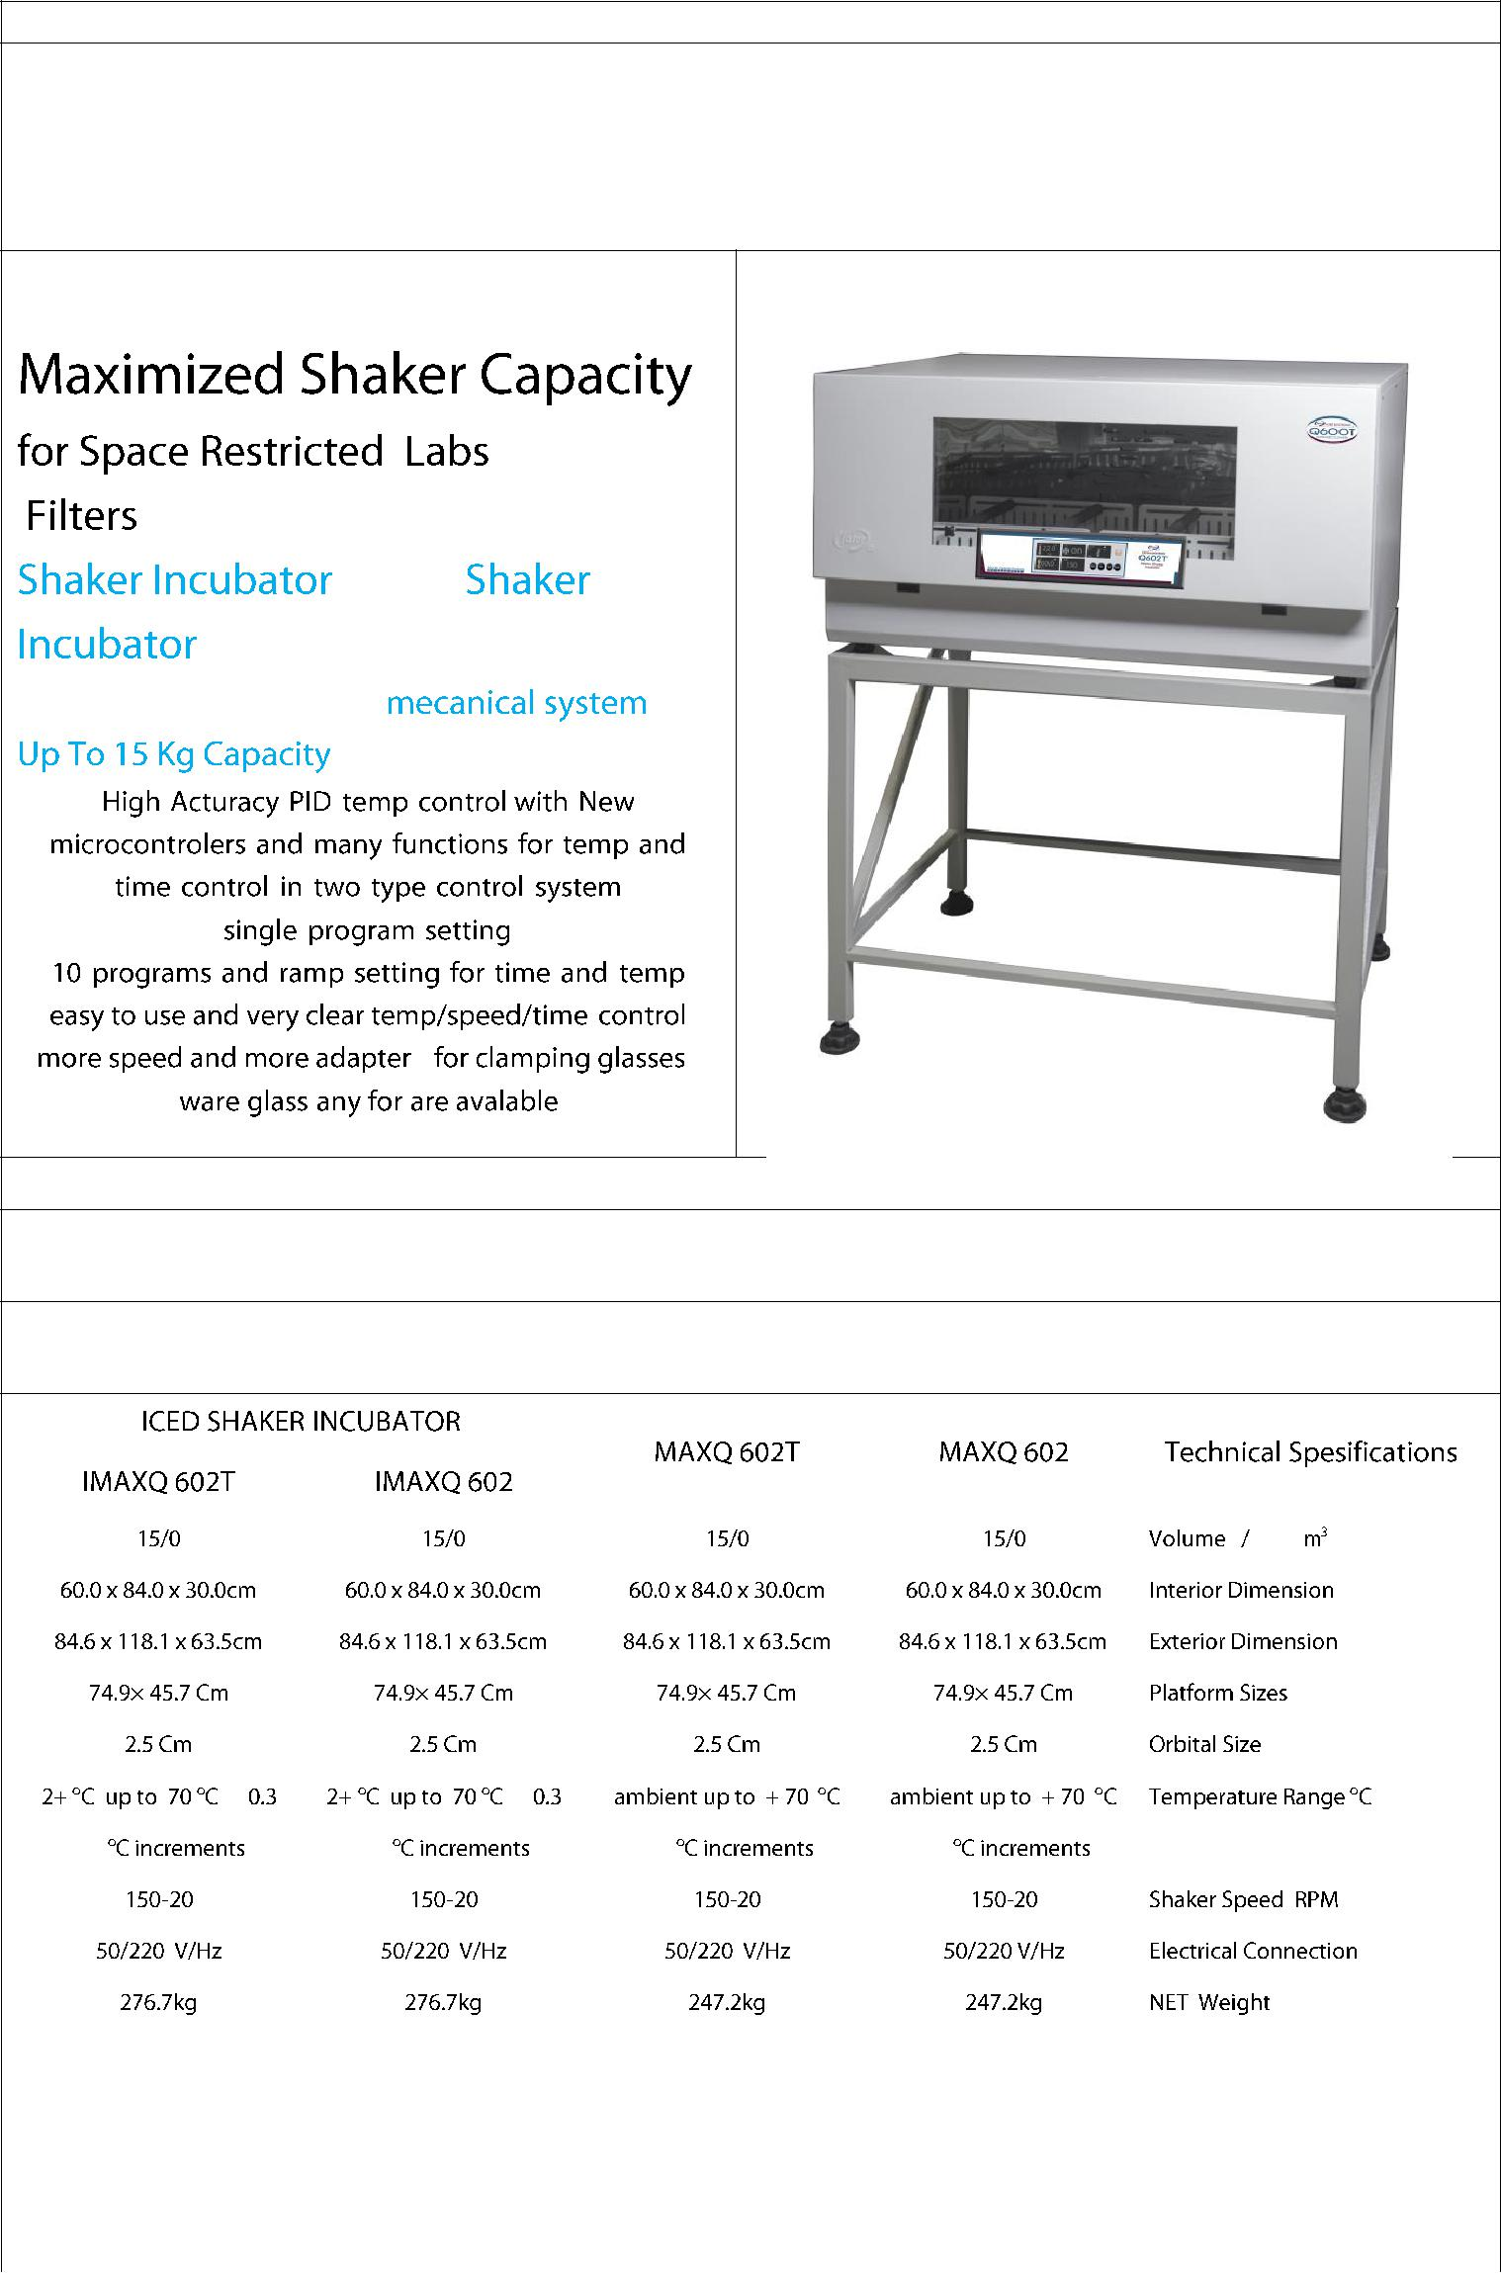Company name:

Brand

**Fater Electronic**

|  |  |  |
| --- | --- | --- |
| Product Specifications: **Q602A** | Product photo: |  |
|  |  |

+ 

& 

&

production capacity**:**

offer price in China($):

**US$ 3850**

Maximum order/Minimum delivery time (EX: one ton/one month or 1000/year or ….):

**20 pcs /** **45 days**

|  |  |  |  |  |  |
| --- | --- | --- | --- | --- | --- |
|  |  |  |  |  |  |
|  |  |  |  |  |  |
|  |  |  |  |  |  |
|  |  |  |  |  |  |
|  |  |  |  |  |  |
|  |  |  |  |  |  |
|  |  |  |  |  |  |
|  |  |  |  |  |  |
|  |  |  |  |  |  |
|  |  |  |  |  |  |
|  |  |  |  |  |  |
| ± |  | ± |  |  |  |
|  |  |  |  |  |  |
| 0.1 | 0.1 |  | 0.1 | 0.1 | Display Indicator |
|  |  |  |  |  |  |
|  |  |  |  |  |  |
|  |  |  |  |  |  |
|  |  |  |  |  |  |

|  |  |
| --- | --- |
| contact person: ali arghavan | Company contact: |
| Email: head@fater.ir | Website: www.fater.ir (www.fater-electronic.com) |
| Tell: +98- 9121272405 | Email: head@fater.ir |
| Address**: Tehran-Iran** | Tell: +98 -21 88552340-42 |
|  | Fax: +98 – 21 88552305 |
|  | Address: No.14, 18th St., Vozara Ave., Tehran-Iran |

Company name:

|  |  |  |  |  |  |  |  |  |  |  |
| --- | --- | --- | --- | --- | --- | --- | --- | --- | --- | --- |
|  |  |  |  |  | Brand | | |  |  |  |
|  | **Fater Electronic** | |  |  |  |  |  |  |  |  |
|  |  |  |  |  |  |  | |  |  |  |
|  | Product Specifications: **CB629 TC** | | |  | Product photo: | | |  |  |  |
|  | **55 liter cold incubator** | | |  |  |  |  |  |  |  |
|  | **10 STEP programmable setting** | | |  |  |  |  |  |  |  |
|  | **& single step includes data logger** | | |  |  |  |  |  |  |  |
|  | **(available sizes from 55L up to 200L)** | | |  |  |  |  |  |  |  |
|  |  |  |  |  |  |  |  |  |  |  |
|  | production capacity**:** | |  |  |  |  |  |  |  |  |
|  |  |  |  |  |  |  |  |  |  |  |
|  | offer price in China ($): | |  |  |  |  |  |  |  |  |
|  | **US$ 1450** |  |  |  |  |  |  |  |  |  |
|  |  |  |  | | |  | |  |  |  |
|  | Maximum order/Minimum delivery time (EX: one ton/one month or 1000/year or ….): | | | | | | | |  |  |
|  | **50 pcs / 45 days** | |  |  |  |  |  |  |  |  |
|  | MSDS OR Technical data sheet: | |  |  |  |  |  |  |  |  |
|  |  |  |  | |  |  |  |  |  |  |
|  |  | Technical | MODEL: CB | |  |  | MODEL: CB | MODEL: CB | MODEL: CB |  |
|  |  | Specifications | 629L TC | |  |  | 630L TC | 631L TC | 632L TC |  |
|  | Test Volume | Liters | 55 |  |  |  | 65 | 120 | 200 |  |
|  | Temperature | oC | -20 oC up to 60 | | |  | 20 oC up to 60 | 20 oC up to 60 | 20 oC up to 60 |  |
|  | Range |  | oC ± 0.3 | |  |  | oC ± 0.3 | oC ± 0.3 | oC ± 0.3 |  |
|  | Interior | mm | 330×420×400 | |  |  | 330×460×400 | 330×700×500 | 600×800×400 |  |
|  | Dimension |  |  |  |  |  |  |  |  |  |
|  | Exterior | mm | 500×750×500 | |  |  | 500×850×500 | 600×1050×500 | 700×1150×550 |  |
|  | Dimension |  |  |  |  |  |  |  |  |  |
|  | Storage Area | m3 | 0.045 |  |  |  | 0.065 | 0.120 | 0.200 |  |
|  | Shelf | Pcs | 1 |  |  |  | 1 | 2 | 3 |  |
|  | Touch Screen | ``5.7 | High resolution | | |  | High resolution | High resolution | High resolution |  |
|  | Display |  | Color LCD | |  |  | Color LCD | Color LCD | Color LCD |  |
|  | Pc control | m2 | + optional | |  |  | + optional | + optional | + optional |  |
|  | Thermal Printer | - | + optional | |  |  | + optional | + optional | + optional |  |
|  |  |  |  |  |  |  | |  |  |  |
|  | contact person: | Ali Arghavan |  |  | Company contact: | | |  |  |  |
|  | Email: head@fater.ir | |  |  | Website: www.fater.ir (www.fater-electronic.com) | | | | | |
|  | Tell: +98- 9121272405 | |  |  | Email: head@fater.ir | | |  |  |  |
|  | Address**: Tehran-Iran** | |  |  | Tell: +98 -21 88552340-42 | | | |  |  |
|  |  |  |  |  | Fax: | | +98 – 21 88552305 | |  |  |
|  |  |  |  |  | Address: No.14, 18th St., Vozara Ave., Tehran-Iran | | | | | |

