production capacity**:**

Koopa D06 is a state-of-the-art digital portable hardness tester designed to test the hardness of large metal parts. The D06 uses a unique indentation technique with auto-reload impact body feature. It provides one-hand test experience and constant indentation energy in all directions. D06 measures the hardness in Leeb scale and converts the results to the most popular hardness scales such as Rockwell, Brinell, Vickers, and Shore. The user can separately calibrate the hardness measurement for different materials in three hardness ranges, i.e.,

**.**low, medium, and high

offer price in China($): 800USD

Maximum order/Minimum delivery time (EX: one ton/one month or 1000/year or ….):

50 Set /one month

MSDS OR Technical data sheet:

**Technical Specifications**

|  |  |  |  |  |  |  |  |  |
| --- | --- | --- | --- | --- | --- | --- | --- | --- |
|  |  | Accuracy |  |  | ± 0.5 % (referred to Leeb 800) | |  |  |
|  |  |  |  |  |  |
|  |  |  |  |  |  |  |  |  |
|  | Repeatability accuracy | | |  | ± 4 HL | |  |  |
|  |  | |  |  |  |  |  |  |
|  |  | Measuring range |  |  | 200-960 HL | |  |  |
|  |  |  |  |  |  |  |  |  |
|  | Battery type | |  |  | 5 AA rechargeable NiCd | |  |  |
|  |  | |  |  |  |  |  |  |
|  |  | Operating temperature | |  | 32-122 ºF (0-50 ºC) | |  |  |
|  |  |  |  |  |  |  |  |  |
|  | Dimensions | |  |  | 7.5×39.5×20 in (190×100×40 mm) | |  |  |
|  |  | |  |  |  |  |  |  |
|  |  | Weight |  |  | 15.9 oz (450 g) | |  |  |
|  |  |  |  |  |  |  |  |  |
|  |  | |  |  |  |  |  |  |
|  | **Applicable materials** | | |  |  |  |  |  |
|  |  | |  | | |  |  |  |
|  | LS | | Low Alloy Steel | | |  |  |  |
|  |  | |  | | |  |  |  |
|  | HS | | High Alloy Steel | | |  |  |  |
|  |  | |  | | |  |  |  |
|  | GG | | Grey Cast Iron | | |  |  |  |
|  |  | |  | | |  |  |  |
|  | 3G | | Ductile Cast Iron | | |  |  |  |
|  |  | |  |  |  |  |  |  |
|  | AL | | Aluminum |  |  |  |  |  |
|  |  | |  |  |  |  |  |  |
|  | BS | | Brass |  |  |  |  |  |
|  |  | |  |  |  |  |  |  |
|  | BZ | | Bronze |  |  |  |  |  |
|  |  |  |  |  |  |  |  |  |

|  |  |  |  |  |  |  |  |  |
| --- | --- | --- | --- | --- | --- | --- | --- | --- |
|  | CU | | | Copper | | |  |  |
|  |  |  |  |  |  |  |  |  |
|  |  |  |  |  |  |  |  |  |
|  | **Methods** | | |  |  |  |  |  |
|  |  | |  |  |  |  |  |  |
|  |  | HRA |  |  | Rockwell A |  |  |  |
|  |  |  |  |  |  |  |  |  |
|  | HRB | | |  | Rockwell B | |  |  |
|  |  | | |  |  | |  |  |
|  |  | HRC |  |  | Rockwell C |  |  |  |
|  |  |  |  |  |  |  |  |  |
|  | HR15N | | |  | Superficial Rockwell | |  |  |
|  |  | | |  |  | |  |  |
|  |  | HV |  |  | Vickers |  |  |  |
|  |  |  |  |  |  |  |  |  |
|  | HB | | |  | Brinell | |  |  |
|  |  | | |  |  | |  |  |
|  |  | HSc |  |  | Shore Scleroscope |  |  |  |
|  |  |  |  |  |  |  |  |  |
|  | MPa | | |  | Tensile Strength | |  |  |
|  |  | | |  | | |  |  |
|  |  | | | | | |  |  |
|  | contact person: AHMAD MOOTAB | | | | | |  | Company contact: |
|  | Email: manager@koopaco.com | | | | | |  | Website: WWW.KOOPACO.COM |
|  | Tell: 09111531841 | | |  |  |  |  | Email:INFO@KOOPACO.COM |
|  | Address**:** Larimi Allay -Bendar kheil Road- | | | | | |  | Tell : 011-33366282 |
|  | West ringRoad-Sari | | | | | |  | Fax: 011-33366282 |
|  |  |  |  |  |  |  |  | Address:Larimi Allay -Bendar kheil Road- |
|  |  |  |  |  |  |  |  | West ringRoad-Sari |

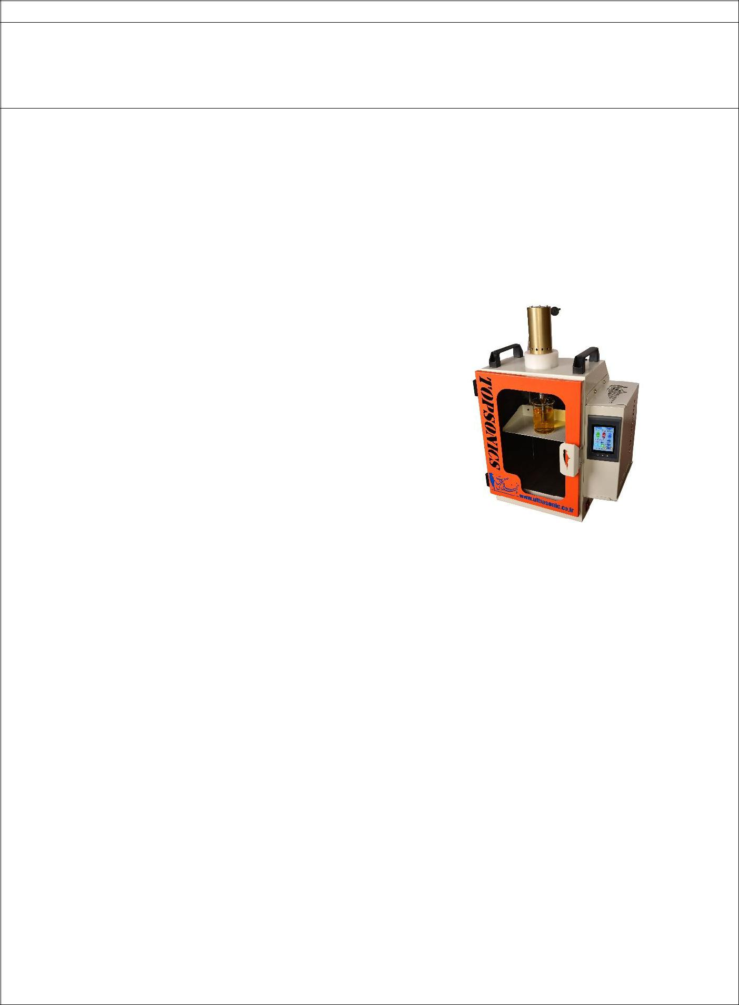

Company name: Ultrasonic Technology Development

Brand: TOPsonics

**About Company**

The scientific background of the Ultrasonic Technology Development Company dates back to 2003 with the design and manufacturing of an ultrasonic surgical knife. Now, after more than 10 years experience on many fields such as nano technology, sono-chemistry, sono-electrochemistry, ultrasonic assisted enhanced oil recovery, ultrasonic impact treatments, etc. we have established our new office in INCC office and offered robust and reliable ultrasonic instruments for research and industrial projects.

|  |  |
| --- | --- |
| Product Specifications: | Product photo: |
| Ultrasonic homogenizer fabricated by TopSonics |  |
| Company is a special and unique product which is |  |
| applicable for laboratorial works. |  |
| This device is suitable for developing new ideas |  |
| and performing scientific researches and studies |  |
| in laboratory. It has 20 kHz working frequency |  |
| with adjustable power range between 0-400 W. It |  |
| operates in pulse mode and total duration of |  |
| reaction is also adjustable. Moreover, this device |  |
| is equipped with thermometer which is for |  |
| regulating the reaction chamber temperature. |  |
| Ultrasonic Homogenizer applications are |  |
| including: |  |
| Synthesis and processing nano-materials; |  |
| Preparing stable emulsions; |  |
| Dispersing nano-materials in liquids; |  |
| Collapsing agglomerates; |  |
| Homogenizing; |  |
| Accelerating chemical reactions; |  |
| Cell-lysing; |  |
| Processing of proteins and DNA; |  |
| Facilitating solving reaction; |  |
| Improvement of vegetable extraction; |  |
| Cracking of heavy polymer molecules; |  |
|  |  |
| HS code of product: |  |
| 84798200 |  |
| Standards and legally certificates: |  |
|  |  |
| After sale services/ Guarantee: |  |
| 1 Year Guaranty , 5 Year after sales service |  |
| Product’s Application: |  |



Nano material (synthesis and processing)

Dispersion

Emulsification

Waste water refinement

Depolymerization & Polymerization

Oil refinement & Desulfurization

Nano-composite coating

Cell lysing

Tissue Homogenizing

And .....

Production capacity (per month)**: 60-80 set/month**

Sales’ Price (EXW):

Offer price in China($): 2500 USD

Maximum order/Minimum delivery time (EX: one ton/ month or 1000 device/year or ….): 1200

set/year

MSDS or Technical data sheet:

|  |  |
| --- | --- |
| contact person: Alireza Shahidi | Company contact: |
| Email:a.shahidi@gmail.com | Website: http://ultrasonic.co.ir/ |
| Tell:+989123830551 | Email: a.shahidi@gmail.com |
| Address**:** | Tell :00989123830551 |
|  | Fax:00982189771039 |
|  | Address: |
|  | Ultrasonic Technology Development Company. |
|  | Ehsani Rad St., Enqelab St., Parsa Sq., Ahmadabad |
|  | Mostoufi Rd., Azadegan Highway, P. O. Box 3353- |
|  | 5111, Tehran 3353136846, |

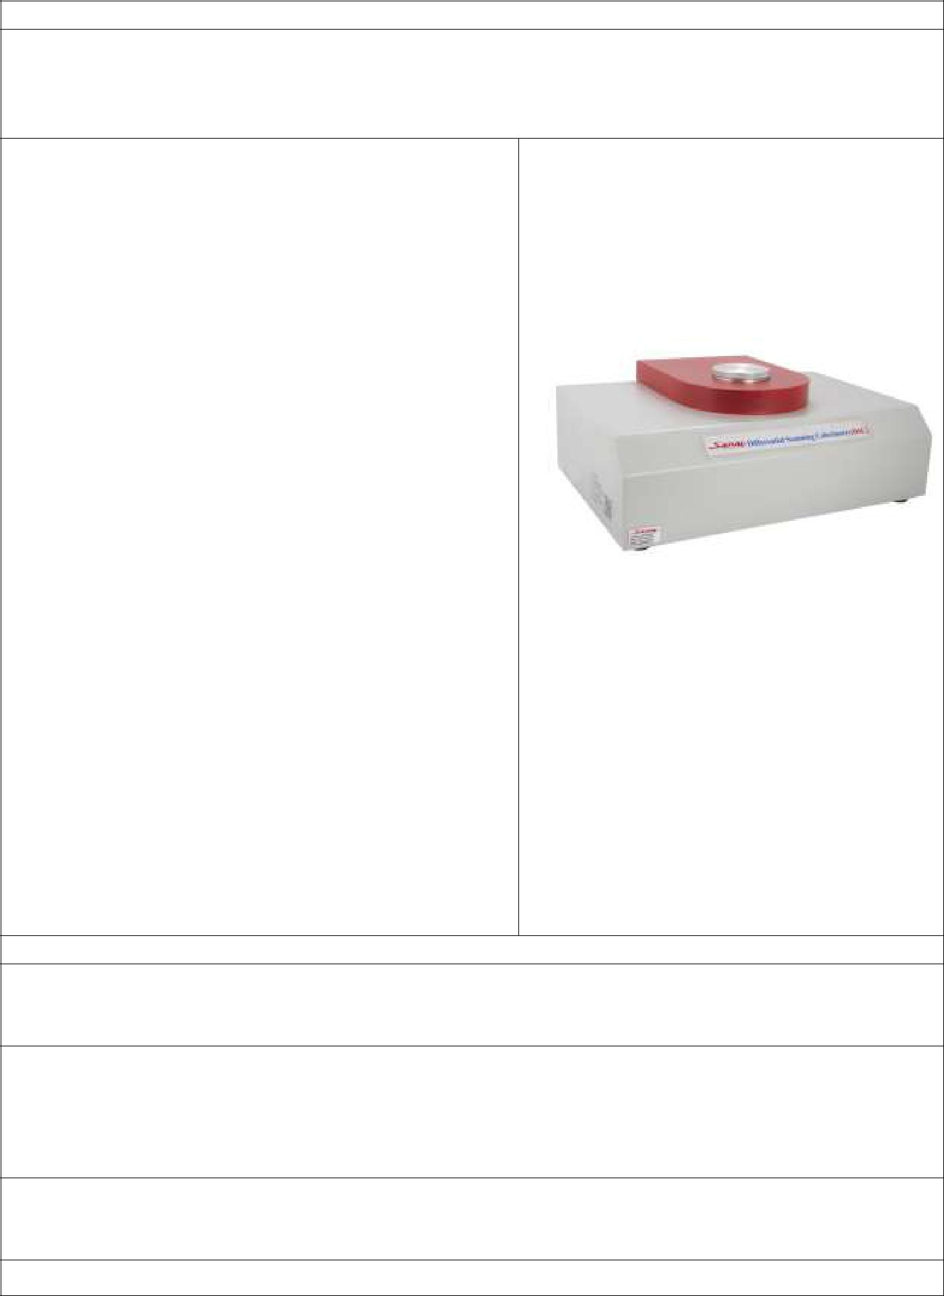

Company name: Sanaf electronic industires

Brand

SANAF

|  |  |
| --- | --- |
| Product Specifications: | Product photo: |

* **Heating Rate: 1 - 40 °C/min**
* **Display Gas Flow rate**
* **Gas Flow rate Alarm**
* **Calibration Software**
* **Diagram :Temperature & DSC (mW) versus Time**
* **Data Processing System :**
* **Data sampling, saving, printing result, opening exist files.**
* **Automatic switching between Nitrogen and Oxygen**
* **Capable of measuring OIT – DSC, melt enthalpy**

**Melt point, Glass transition temperature**

* + **crystallization temperature**
* **Enable to plot thermographs and gas flow in the software**
* **Enable to print full test report**
* **Separate High accuracy control valve**
* **Works according to EN 728, ISO 10837**
  + **ISO 11357-6**

**Accessories box:**

* **Pans(alumınum contaıner) (1000 pieces)**
* **Tin & Indium (For calibration)**
* **Forceps**

HS code of product: 902780

Standards and legally certificates:

CE. ISO 9001, ISO 14001

After sale services/ Guarantee:

**3 Years Warranty on equipment, service & spare parts include everything related/ associated with the equipment, consumables, labor and rectification without any additional cost**

Product’s Application:

Production capacity (per month)**: 30 units**



Sales’ Price (EXW): 10000 $

Offer price in China($): 11000 $ (CIF)

Maximum order/Minimum delivery time (EX: one ton/ month or 1000 device/year or ….):

**200 units/year**

MSDS or Technical data sheet:

-

|  |  |  |  |  |  |
| --- | --- | --- | --- | --- | --- |
| contact person: | | Omid Ghadrdan | | Company contact: Dr farzin fekravar |  |
| Email: [sales@sanaf.com](mailto:sales@sanaf.com) | | | | Website: www.sanaf.com |  |
|  |  |  |  |  |  |
| Tel:+98 21 66805056 | |  |  | Email: info@sanaf.com |  |
| Address**: no 1 vazin Fath highway** | | | | Tel :+98 21 66805056 |  |
| **Tehran Iran** | |  |  | Fax:+98 21 66805056 |  |
|  |  | Address: **no 1 vazin Fath highway** |  |
|  |  |  |  |  |
|  |  |  |  | **Tehran Iran** |  |

The English product catalog should be attached to this form