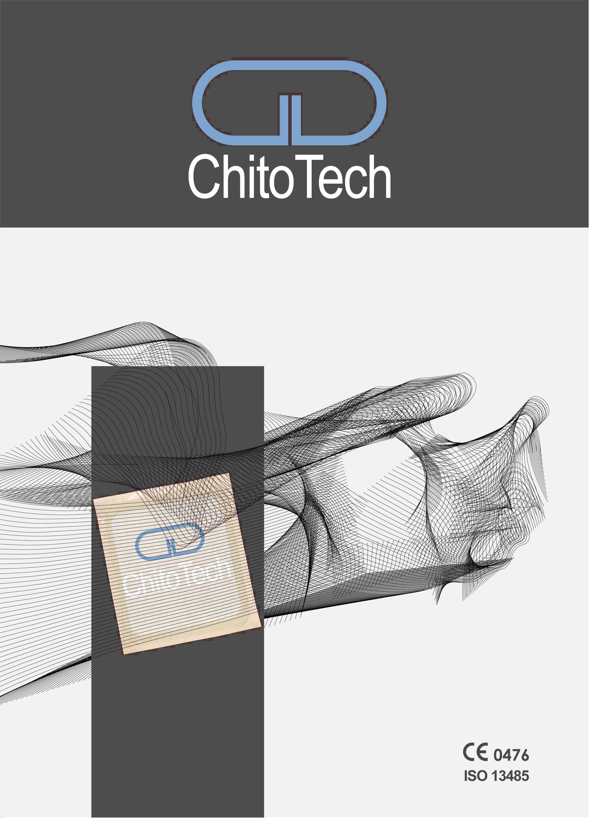ChitoTech

ChitoTech

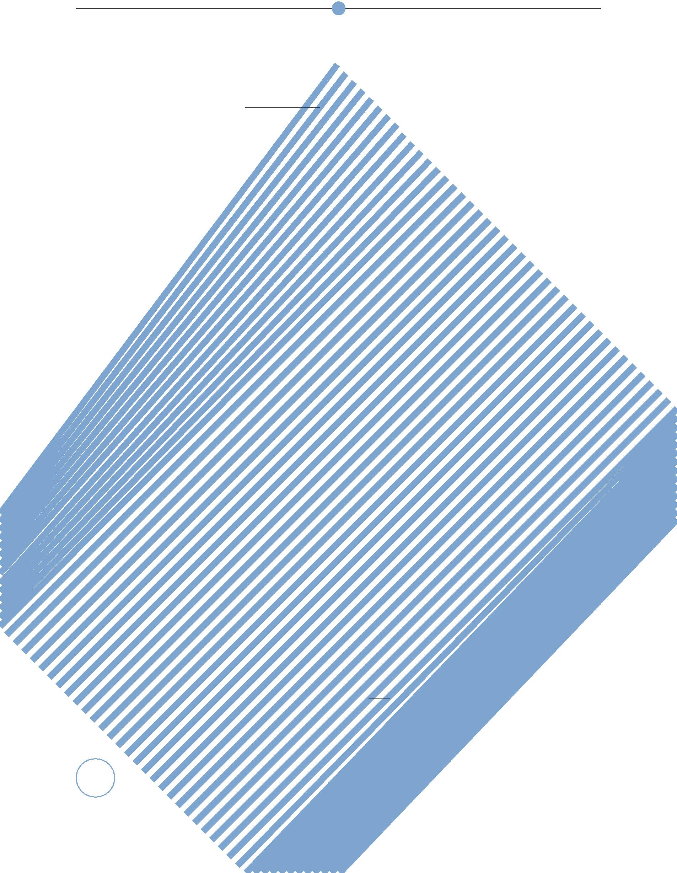

**C**ontent

|  |  |
| --- | --- |
| 3 | Introduction |
| 4 | Needle free injection |
| 6 | SilvoSepts Products |
| 6 | Antiseptic Products |
| 13 | Hemostatic Products |
| 14 | Wound Healing Products |
| 19 | Hygiene Products |
| 15 | SecoundryDressings |
| 25 | First Aid Boxes |

2

ChitoTech



**I**ntroduction

**P**roducts



* **Needle free injection**
* **Antiseptic products**
* **Hemostatic products**
* **Wound healing product**
* **Hygiene products**
* **Secondary dressings**
* **First aid boxes**

ChitoTech was developed from a research facility for studying marine biopolymers and their applications in medicine.

The manufacturing site of the company established in 2004. ChitoTech activities are based on cutting edge technologies, producing advanced wound care, hemostatic products and colloidal silver antiseptic. Products in ChitoTech have the approval of Iranian Ministry of Health as well as CE, ISO13485 certificates. Our technology is protected by 5 European and 22 National patents.

ChitoTech wound care products are suitable for a wide range of ulcers and burn wounds, he-mostatic products are in differ-ent forms and are suitable for stopping venous and arterial bleedings and SilvoSept antisep-tic solutions are a novel class of non-alcoholic antiseptics using colloidal silver technology. ChitoTech aims to offer consum-ers and healthcare systems safe, high quality and non-invasive.



3

ChitoTech

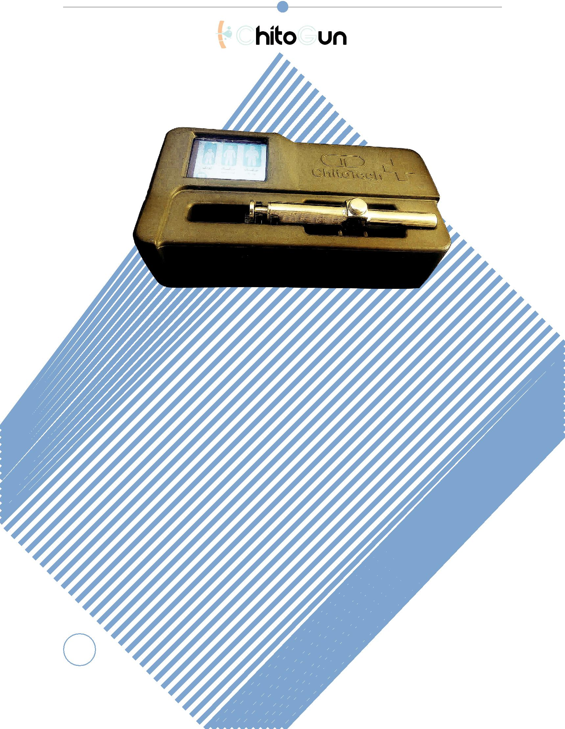

**ChitoGun**

**D**escription

A PLC based smart needle free

injector capable of automat-

ically adjusting the depth of

penetration for adult and or

children.

The injector is loaded electri-

cally according to the option

chosen by the user.

**F**eatures and **B**enefits

No more needle

No more phobia

User Friendly

4

ChitoTech

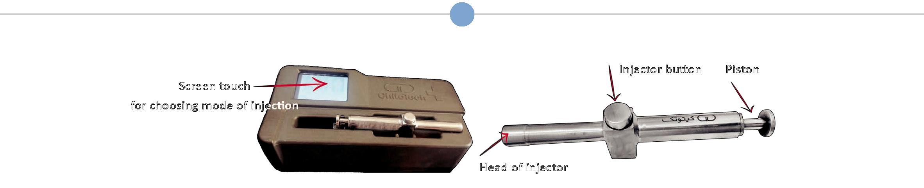

A) Prepare ChitoGun

1. Put ChitoGun on the desired site of the charger.
2. Turn on the charger by pressing ON/OFF power.
3. Wait until the image of the screen touch appeared.
4. Select required mode for children, adults or adults with overweight.
5. Piston would move, wait until ChitoGun get ready

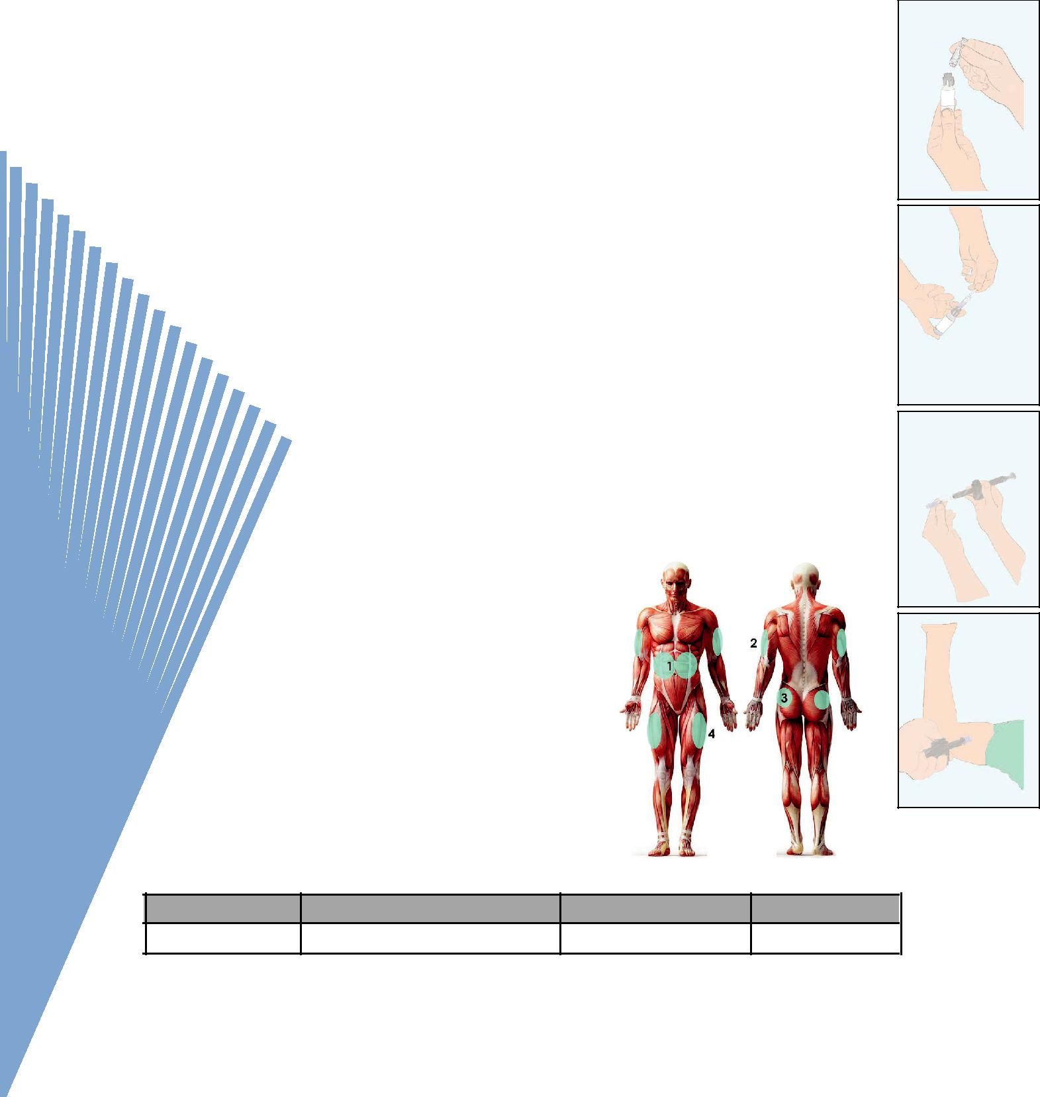

to inject.

B) Fill Cartridge

1. Remove adaptor from its packaging. Put it on the vial.
2. Insert the cartridge into the adaptor.
3. Invert the assembly. Pull down the piston to draw fluid into

the cartridge.

C) Load ChitoGun

1. Remove cartridge from the vial and adaptor. (Remove the bubbles accordingly.)
2. Twist the cartridge to assemble on the ChitoGun.

D) Do Injection

1. Apply ChitoGun perpendicular to the prepared injection site.
2. Press the injection bottom slightly.

Discard the cartridge after use.

**I**nstruction for use

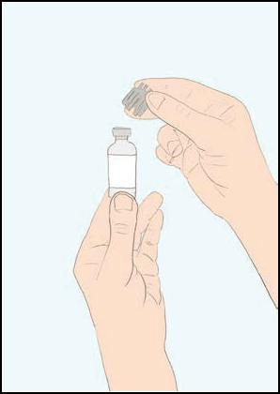

6

7

8

10

11



|  |  |  |  |  |  |
| --- | --- | --- | --- | --- | --- |
| **Code** | **Name** | **Size (mL)** | **No. in box** | 5 |  |
| 0613 | ChitoGun |  | 1 |  |
|  |  |  |

ChitoTech



**Anticeptic**

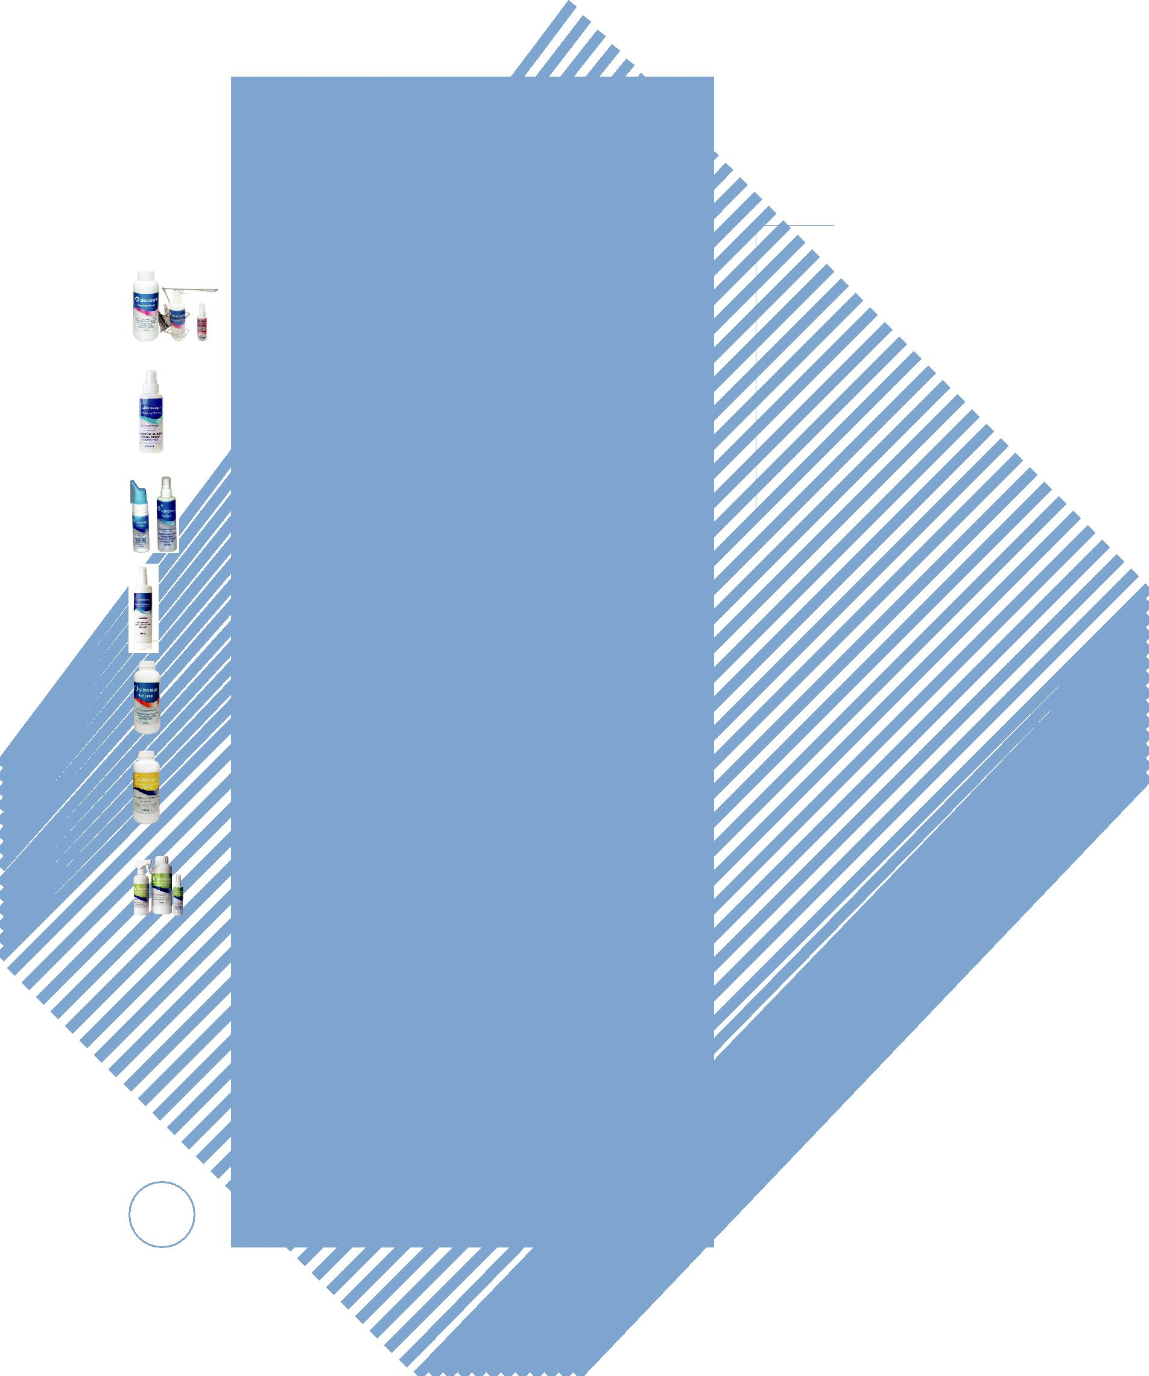

SilvoSept antiseptics are a novel class of non-alcoholic antiseptics using nanocol-loidal silver technology. They are effective against a wide range of pathogens includ-ing bacteria, viruses and fungus.

Silver is one of the oldest metals used extensively for its antimicrobial activities throughout history.

In recent years with the advent of nano-technology various applications of nano silver have emerged and developed. Silver nanoparticles have enormous scientific, technological, and commercial potential due to their unique size and shape depen-dent properties.

Mechanism of action

Several mechanisms have been proposed to explain the inhibitory effects of silver ion/silver metal on bacteria. It is gener-ally believed that destroys the host cell membrane and possibly interferes with DNA replication and prevents the bacterial proliferation.

HSCode = 38089490

*References*

*1.A novel wound rinsing solution based on nano colloidal silver, NanoMedicine Journal vol 1, no 5. 2014.*

*2.In Vitro Antiviral Effect of “Nanosilver” on Influenza Virus, Scientific Information Database vol 17, no 2., 2009.*

*3. Antimicrobial activity of Iranian “SilvoSept”*

*compared with povidone iodine for hand scrub before sur-gery and its utility as an*

*alternative solution from the perspective of*

|  |  |  |
| --- | --- | --- |
| 6 | *the surgical team, Koomesh, 2015.* |  |
|  |  |

|  |  |  |
| --- | --- | --- |
| P | |  |
| roducts | SilvoSept Hand |  |
|  |  |
|  | SilvoSept Wound |  |
|  | SilvoSept Burn |  |
|  | SilvoSept suitable |  |
|  | prior to injection |  |
|  | SilvoSept Prep |  |
|  | SilvoSept surface |  |
|  | and floor |  |
|  | SilvoSept Tools |  |
|  | and Instrument |  |