ChitoTech



**SilvoSept Hand**

**D**escription

Suitable for cleaning hand which can eliminate wide range of pathogenic viruses, bacteria and fungus SilvoSept Hand is a new product, suggested as an alternative solution instead of povidone iodine – which has either bad color or bad odor and can cause damage to the skin – for hand scrub before surgery.

In an experimental study, selected participants from surgical team members of Amir Hospital in Semnan were participated to scrub their hands with Sil-voSept Hand and povidone iodine, in two separate times. Dominant hand was sampled 3 times to get microbial cultures: before scrubbing, after drying, and after an hour. Participants were asked about each solution’s utilities. Analysis was performed by software spss-16 and p value less than 0.05 was considered significant.

The findings not only confirmed the antimicrobial effectiveness of the SilvoSept Hand, and its equality with povidone iodine on willingness of applying, but also showed its superiority to povidone iodine be-cause of its lower adverse effects on skin as well as its better color. SilvoSept Hand can be suggested as an effective, acceptable and affordable alternative.

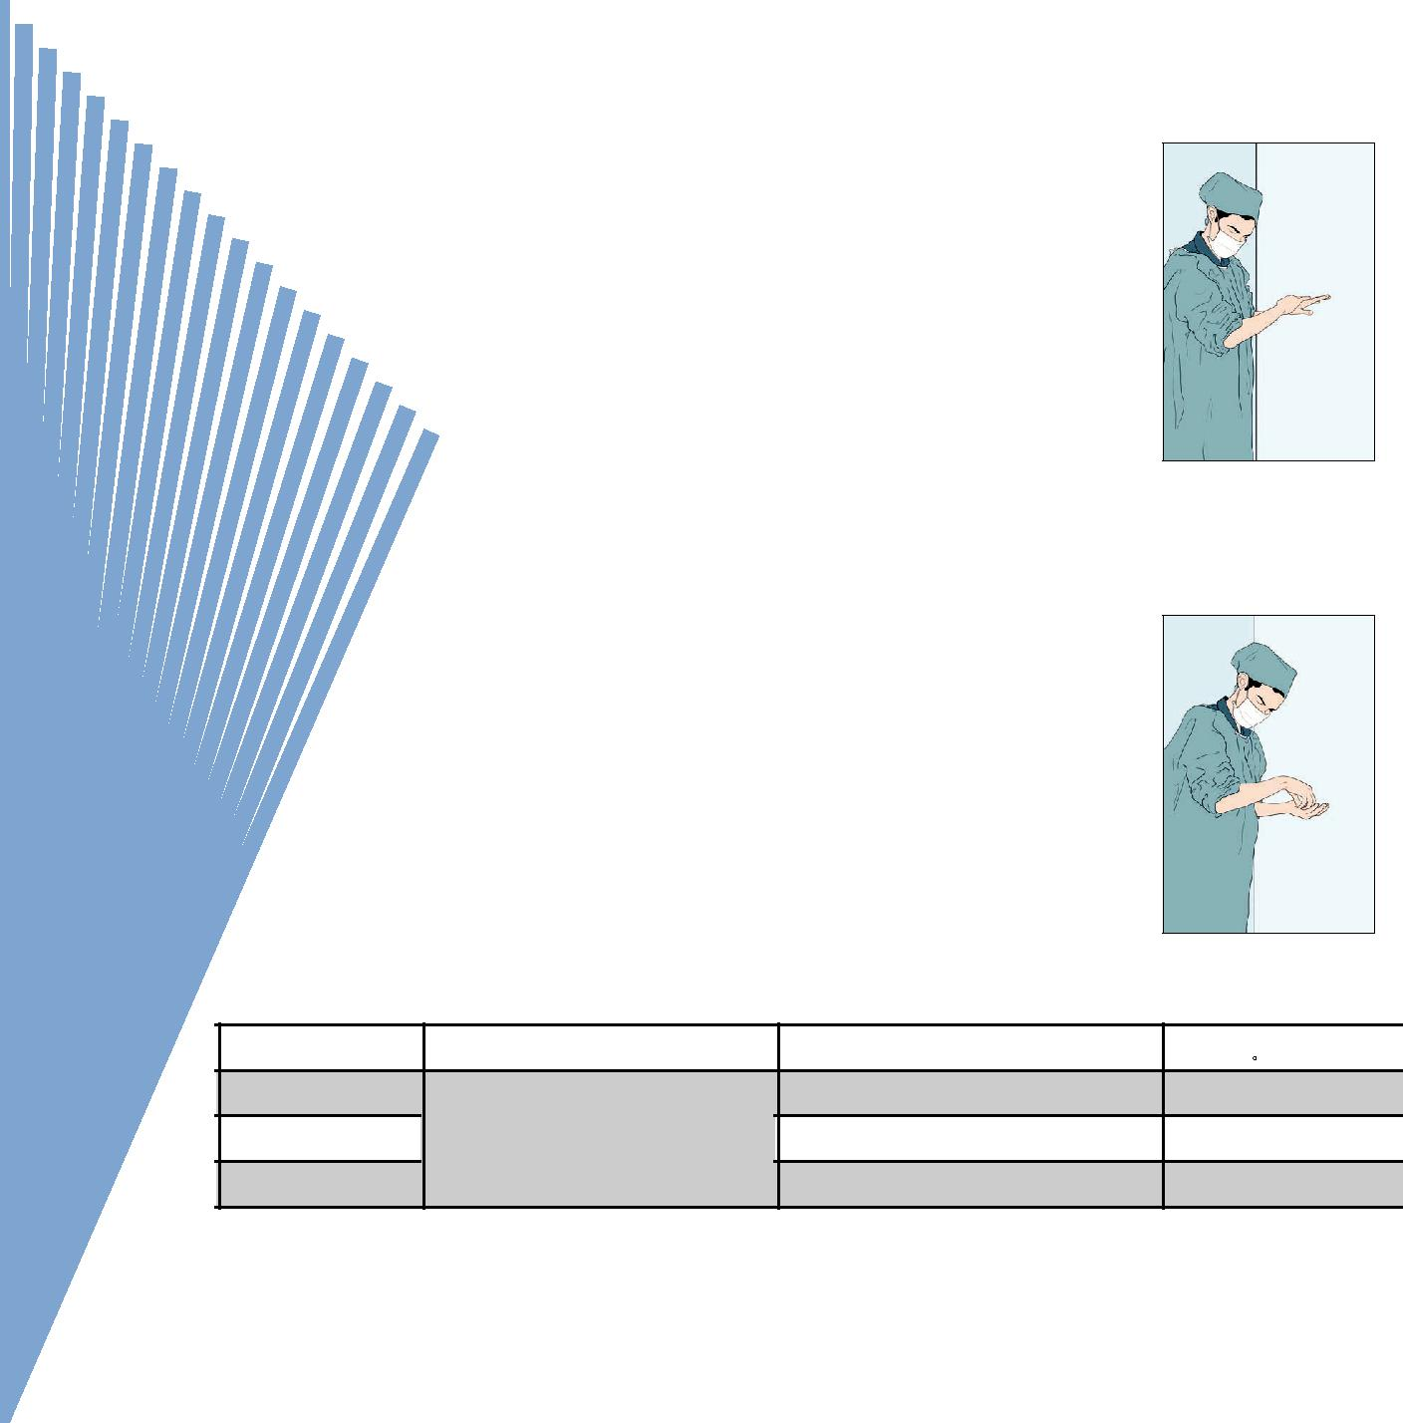

**M**ain component:Nano colloidal silver

**F**eatures & **B**enefits

* + Alcohol free, thus prevent hand dryness
* Odorless and colorless
* No irritation, no sensitivity- According to ISO 10993-10
* No toxicity- According to ISO 10993-5
* Effectiveness time: 5 minutes- According to EN1276

**A**pplication

* Hand antiseptic solution in hospitals and health centers
* Hand scrub before surgeries

**I**nstruction for use

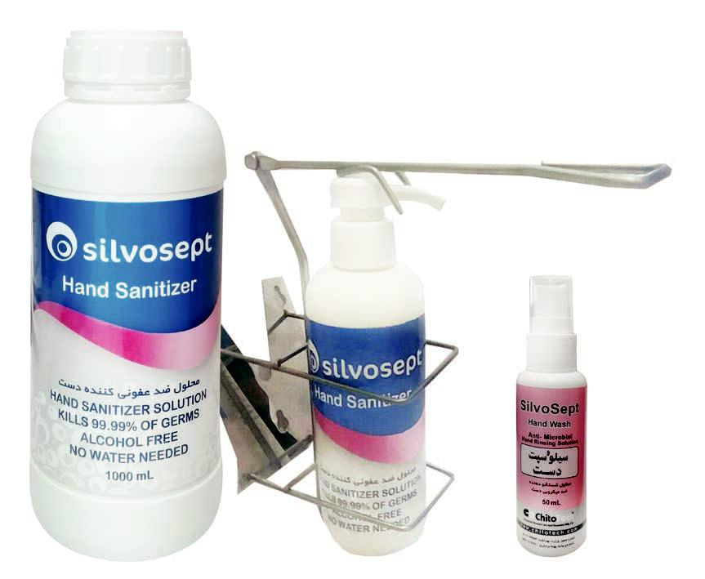

1,2-Press the lever dispenser with left elbow, pour 5 mL SilvoSept Hand in the palm of the right hand, and immerse left hand fingertips in to the solution to cleaning whole hand and nails. (Vice versa)



3, 4-Imbrue left forearm to SilvoSept Hand properly. Cleaning whole skin with rotary movements. (Vice versa)



|  |  |  |  |  |  |
| --- | --- | --- | --- | --- | --- |
| Code | Name | Size mL (spray) | No. in box |  |  |
| 31450 |  | 50 | 12 |  |  |
| 3144001 | SilvoSept Hand | with Dispenser 400 | 10 | 7 |  |
| 3141000 |  | 1000 | 6 |  |
|  |  |  |



ChitoTech

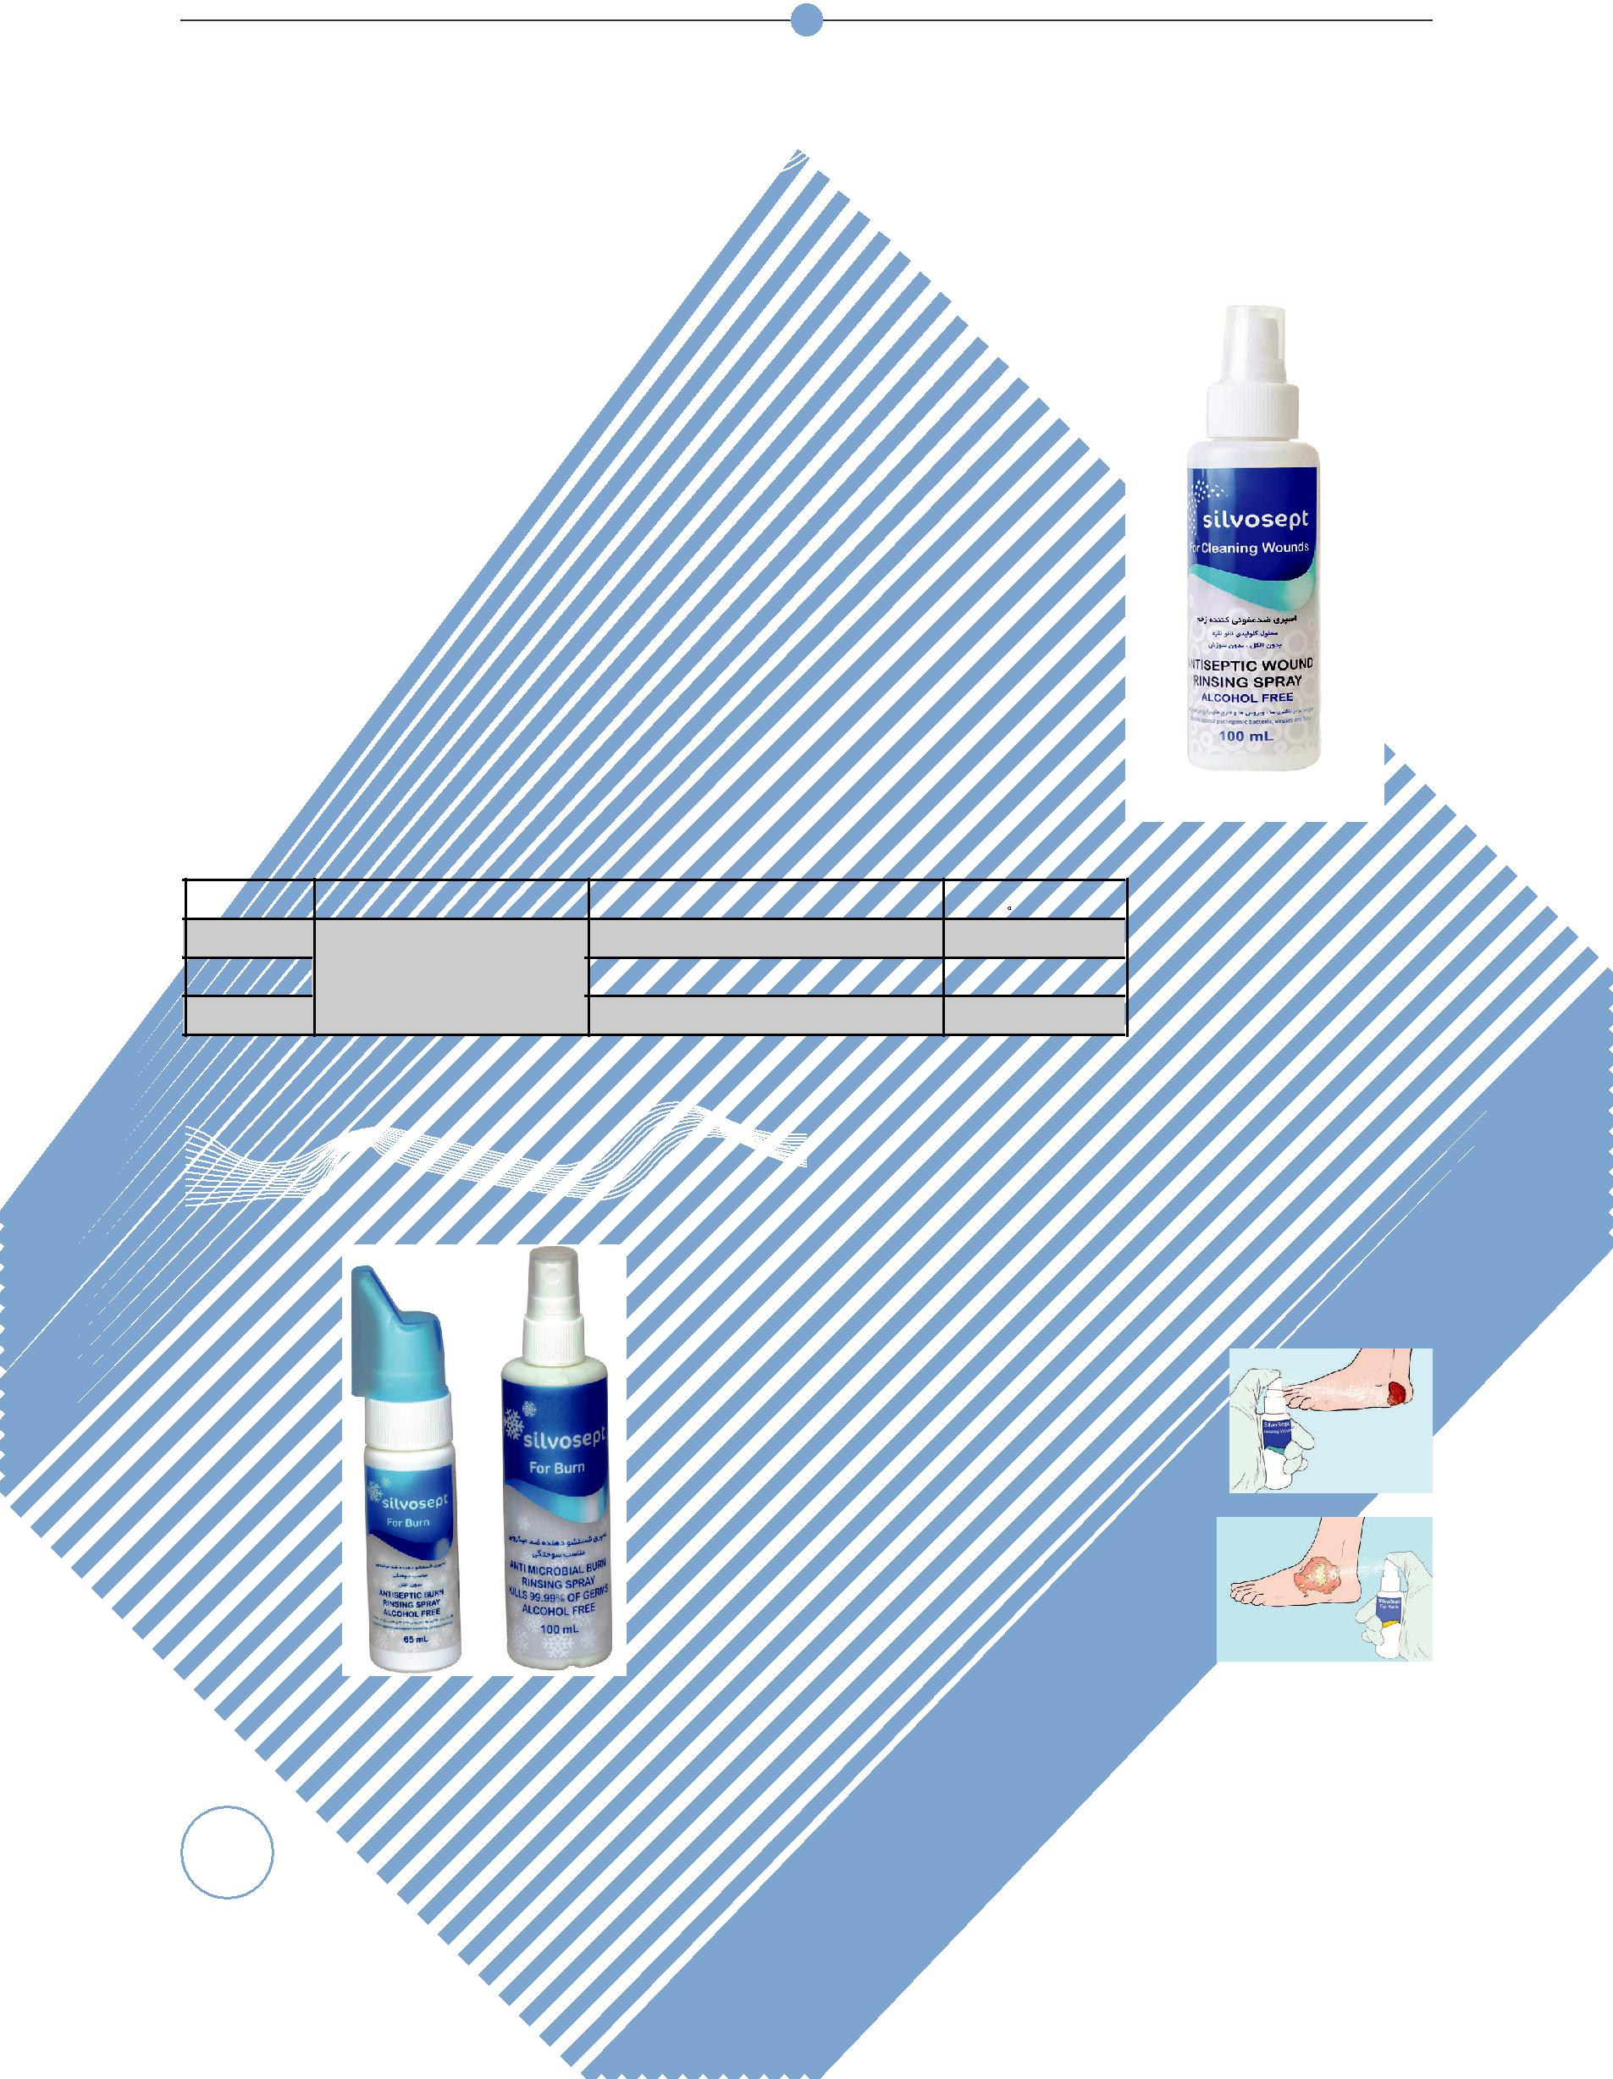

**SilvoSept Wound**

**D**escription

Antimicrobial wound spray special for cleaning wounds which can eliminate wide range of pathogenic viruses, bacteria and fungus.

SilvoSept wound rinsing solution containing nano silver particles is an ef-fective antiseptic solution against a wide spectrum of microorganism. This compound can be a suitable candidate for wound irrigation.

**M**ain component: Nano colloidal silver

**F**eatures & **B**enefits

* Alcohol free
* Odorless and colorless
* No irritation, no sensitivity- According to ISO 10993-10
* No toxicity- According to ISO 10993-5
* Without any genotoxicity
* Safe dose: 625 ug/mL
* Effectiveness time: 3 minutes- According to EN1276

|  |  |  |  |
| --- | --- | --- | --- |
| Code | Name | Size )mL( | No. in box |
| 31020 |  | 20 | 48 |
| 32850 | SilvoSept Wound | 50 in 360 degree spray | 12 |
| 310100 |  | 100 | 1 |

**A**pplication

|  |  |  |  |  |  |  |  |  |  |  |
| --- | --- | --- | --- | --- | --- | --- | --- | --- | --- | --- |
| **SilvoSept Burn** | | | | • | Cleaning all types of wounds (Diabetic and | | | | |  |
|  | bed sore wound) | | |  |  |  |
| • | Suitable wound irrigation solution before | | | | |  |
|  |  |  |  |  | wound debridement | | |  |  |  |
|  |  |  |  | **I**nstruction for use | | | |  |  |  |
|  |  |  |  |  | |  |  |  |  |  |
|  |  |  |  | 1-Shake well before use and | | |  |  |  |  |
|  |  |  |  | spray on the affected area. Re- | | |  |  |  |  |
|  |  |  |  | peat the action several times. | | |  |  |  |  |
|  |  |  |  | Do not dry after use. | | |  |  |  |  |
|  |  |  |  |  | |  |  |  |  |  |
|  |  |  |  |  | |  | |  |  |  |
|  |  |  |  | 1-Shake well before use and | |  | |  |  |  |
|  |  |  |  | spray on the affected area. Re- | |  | |  |  |  |
|  |  |  |  | peat the action several times. | |  | |  |  |  |
|  |  |  |  | Do not dry after use. | |  | |  |  |  |
|  |  |  |  |  |  |  |  |  | |  |
|  |  |  |  |  |  |  |  |  |  |  |
|  |  | Code | Name |  | Size(mL) | | | No. in box | |  |
|  |  | 31265 |  |  | )in 360 degree Spray( 65 | | | 12 |  |  |
| 8 |  | 312100 | SilvoSept Burn |  | )Spray( 100 | | | 24 |  |  |
|  | 312400 |  |  | )Spray( 400 | | | 10 |  |  |
|  |  |  |  |  |  |

ChitoTech



**SilvoSept suitable prior to injection**

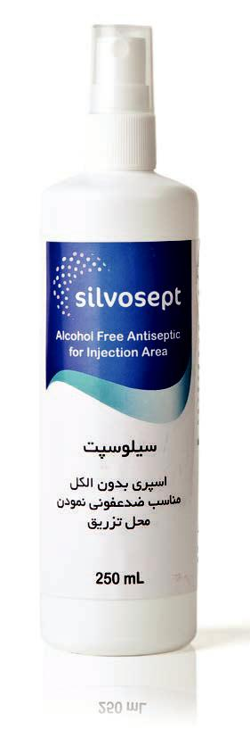

**D**escription

Suitable for preparing and cleaning area before injection.

**M**ain component:Nano colloidal silver

**A**pplication

• Cleaning area before injection instead of alcohol **F**eatures & **B**enefits

* No toxicity- According to ISO 10993-5
* No irritation and sensitivity- According to ISO 10993-10
* Odorless
* Alcohol free
* Effectiveness time: 5 minutes- According to EN1276

**I**nstruction for use SilvoSept suitable prior to injection

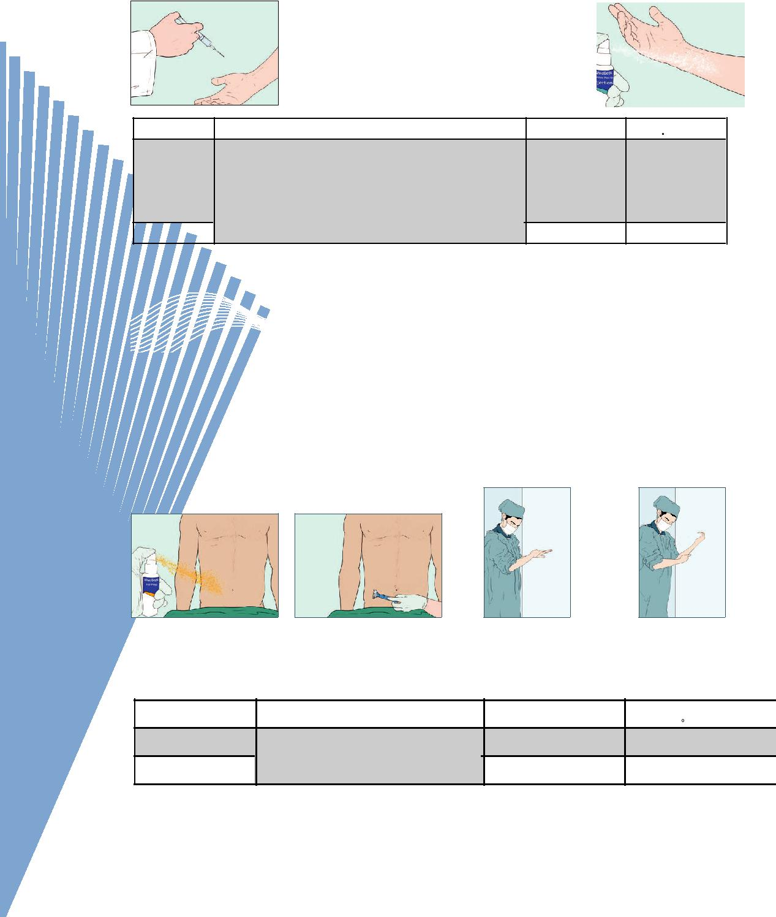

|  |  |  |  |
| --- | --- | --- | --- |
| 1. Spray SilvoSept Suitable |  |  |  |
| Prior to injection over the |  | 2. Do the injection. |  |
| area . |  |  |
|  |  |  |
|  |  |  |  |

|  |  |  |  |  |
| --- | --- | --- | --- | --- |
| Code | Name | Size(mL) | No. in box |  |
| 311100 | SilvoSept Suitable Prior to Injection | 100 | 24 |  |
|  |  |  |  |
| 311250 |  | 250 | 18 |  |

**SilvoSept Prep**

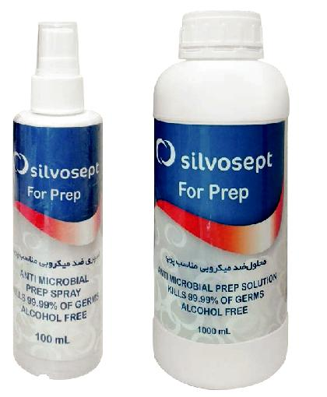

**A**pplication

* For operating areas

**I**nstruction for use SilvoSept Prep

1,2- Clean your hands with SilvoSept Hand.

3- Shave the surgical site.

4-Shake well and spray.

|  |  |  |  |  |  |
| --- | --- | --- | --- | --- | --- |
| Code | Name | Size(mL) | No. in box |  |  |
| 313100 | SilvoSept Prep | 100 | 24 | 9 |  |
| 3131000 | 1000 | 6 |  |
|  |  |  |



ChitoTech



**SilvoSept Hospital Surface and Floor**

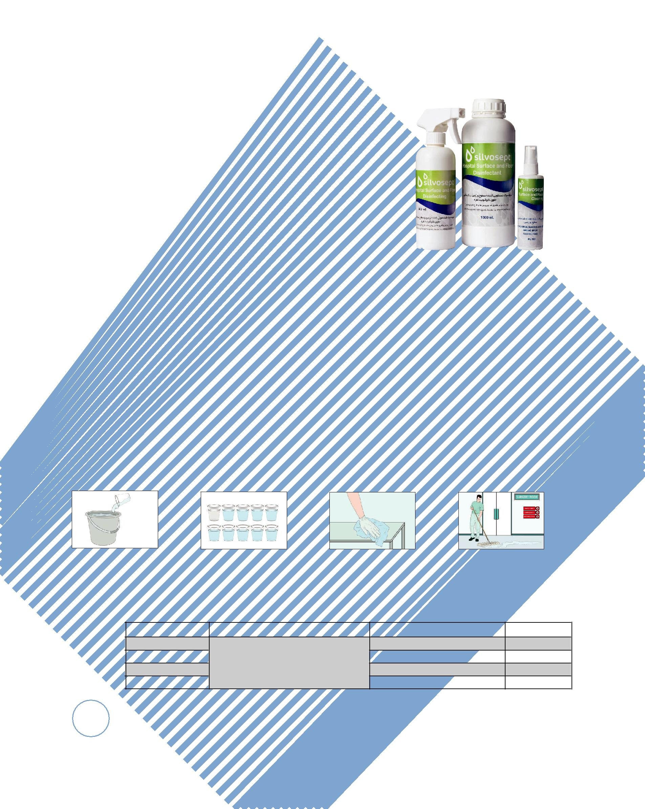

It is suitable for cleaning hospital, hygiene places, restaurants and general surfaces and floors. It can eliminate various range of microorganisms such as viruses, bacteria and fungus.

**M**ain component:Nano colloidal silver

**A**pplication

* Cleaning hospital surface and floor
* Suitable for household application.

**F**eatures & **B**enefits

* Odorless
* No acute inhalation toxicity
* Without causing any corrosion- according to ASTM G31-12a
* Without causing bacterial resistance
* Shelf-life time of diluted solution with distilled water: 1 year in polyethylene container away from light and moisture
* Effectiveness time: 5 minutes- According to EN1276

**I**nstruction for use

1,2-Dilute one part of SilvoSept Surface and Floor with 9 parts of distilled water in a proper container.

3,4- Use the prepared solution to disinfect the surfaces.

Code Name

0316100

316400 SilvoSept Surface and Floor

3161000

316100010

|  |  |
| --- | --- |
| Size(mL) | No. in box |
| 100 Spray | 24 |
| 400 Spray | 10 |
| 1000(ready for use) | 6 |
| 1000 (concentrated) | 6 |

10

ChitoTech



**SilvoSept Tools and Instrument**

This disinfectant is special for cleaning a variety of medical, surgical and dental tools and can eliminate wide range of viruses, bacteria and fungus.

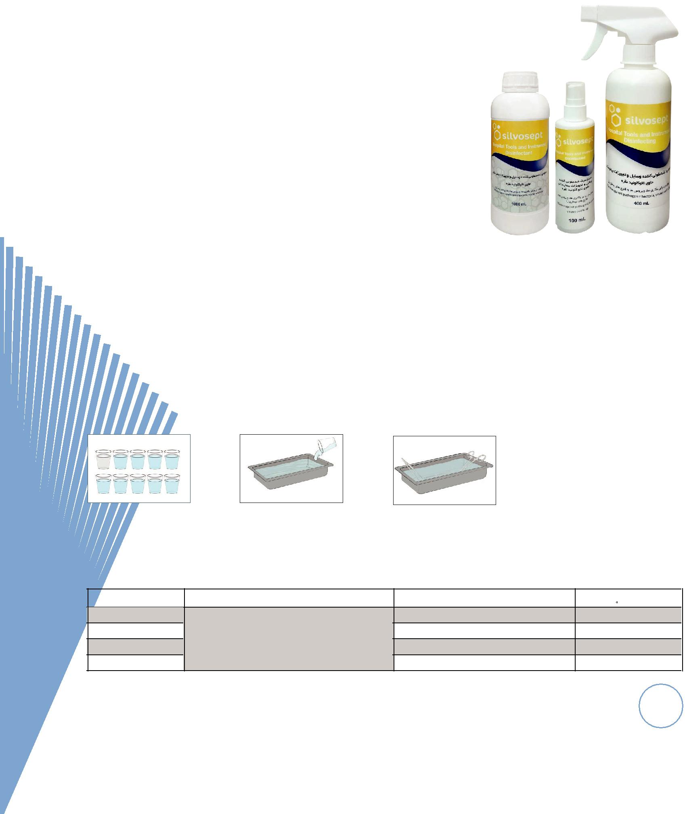

**M**ain component:Nano colloidal silver

**A**pplication

* Cleaning hospital surface and floor
* Suitable for household application.

**F**eatures & **B**enefits

* Alcohol free
* Odor and colorless
* No acute inhalation toxicity
* Without causing any corrosion- ASTM G31-12a
* Shelf-life time of diluted solution with distilled water: 1 year in polyethylene container away from light and moisture
* Effectiveness time: 5 minutes- According to EN1276
* Suitable for all tools and instruments in hospital (Flexible endosco pies, Anesthetic devices and dental tools)

**I**nstruction for use

1,2- Dilute one part of SilvoSept Tools and Instrument with 9 parts of distilled water in a proper container.

3- Immerse the device and equipment in the prepared solution for at least 5 minutes.

|  |  |  |  |  |
| --- | --- | --- | --- | --- |
| Code | Name | Size | No. in box |  |
| 317100 |  | 100mL(Spray) | 24 |  |
| 317400 | SilvoSept Tools and Instrument | 400mL(spray) | 10 |  |
| 3171000 | 1000 mL(ready for use) | 6 |  |
|  |  |
| 317100010 |  | 1000 mL (concentrated) | 6 |  |

11

ChitoTech

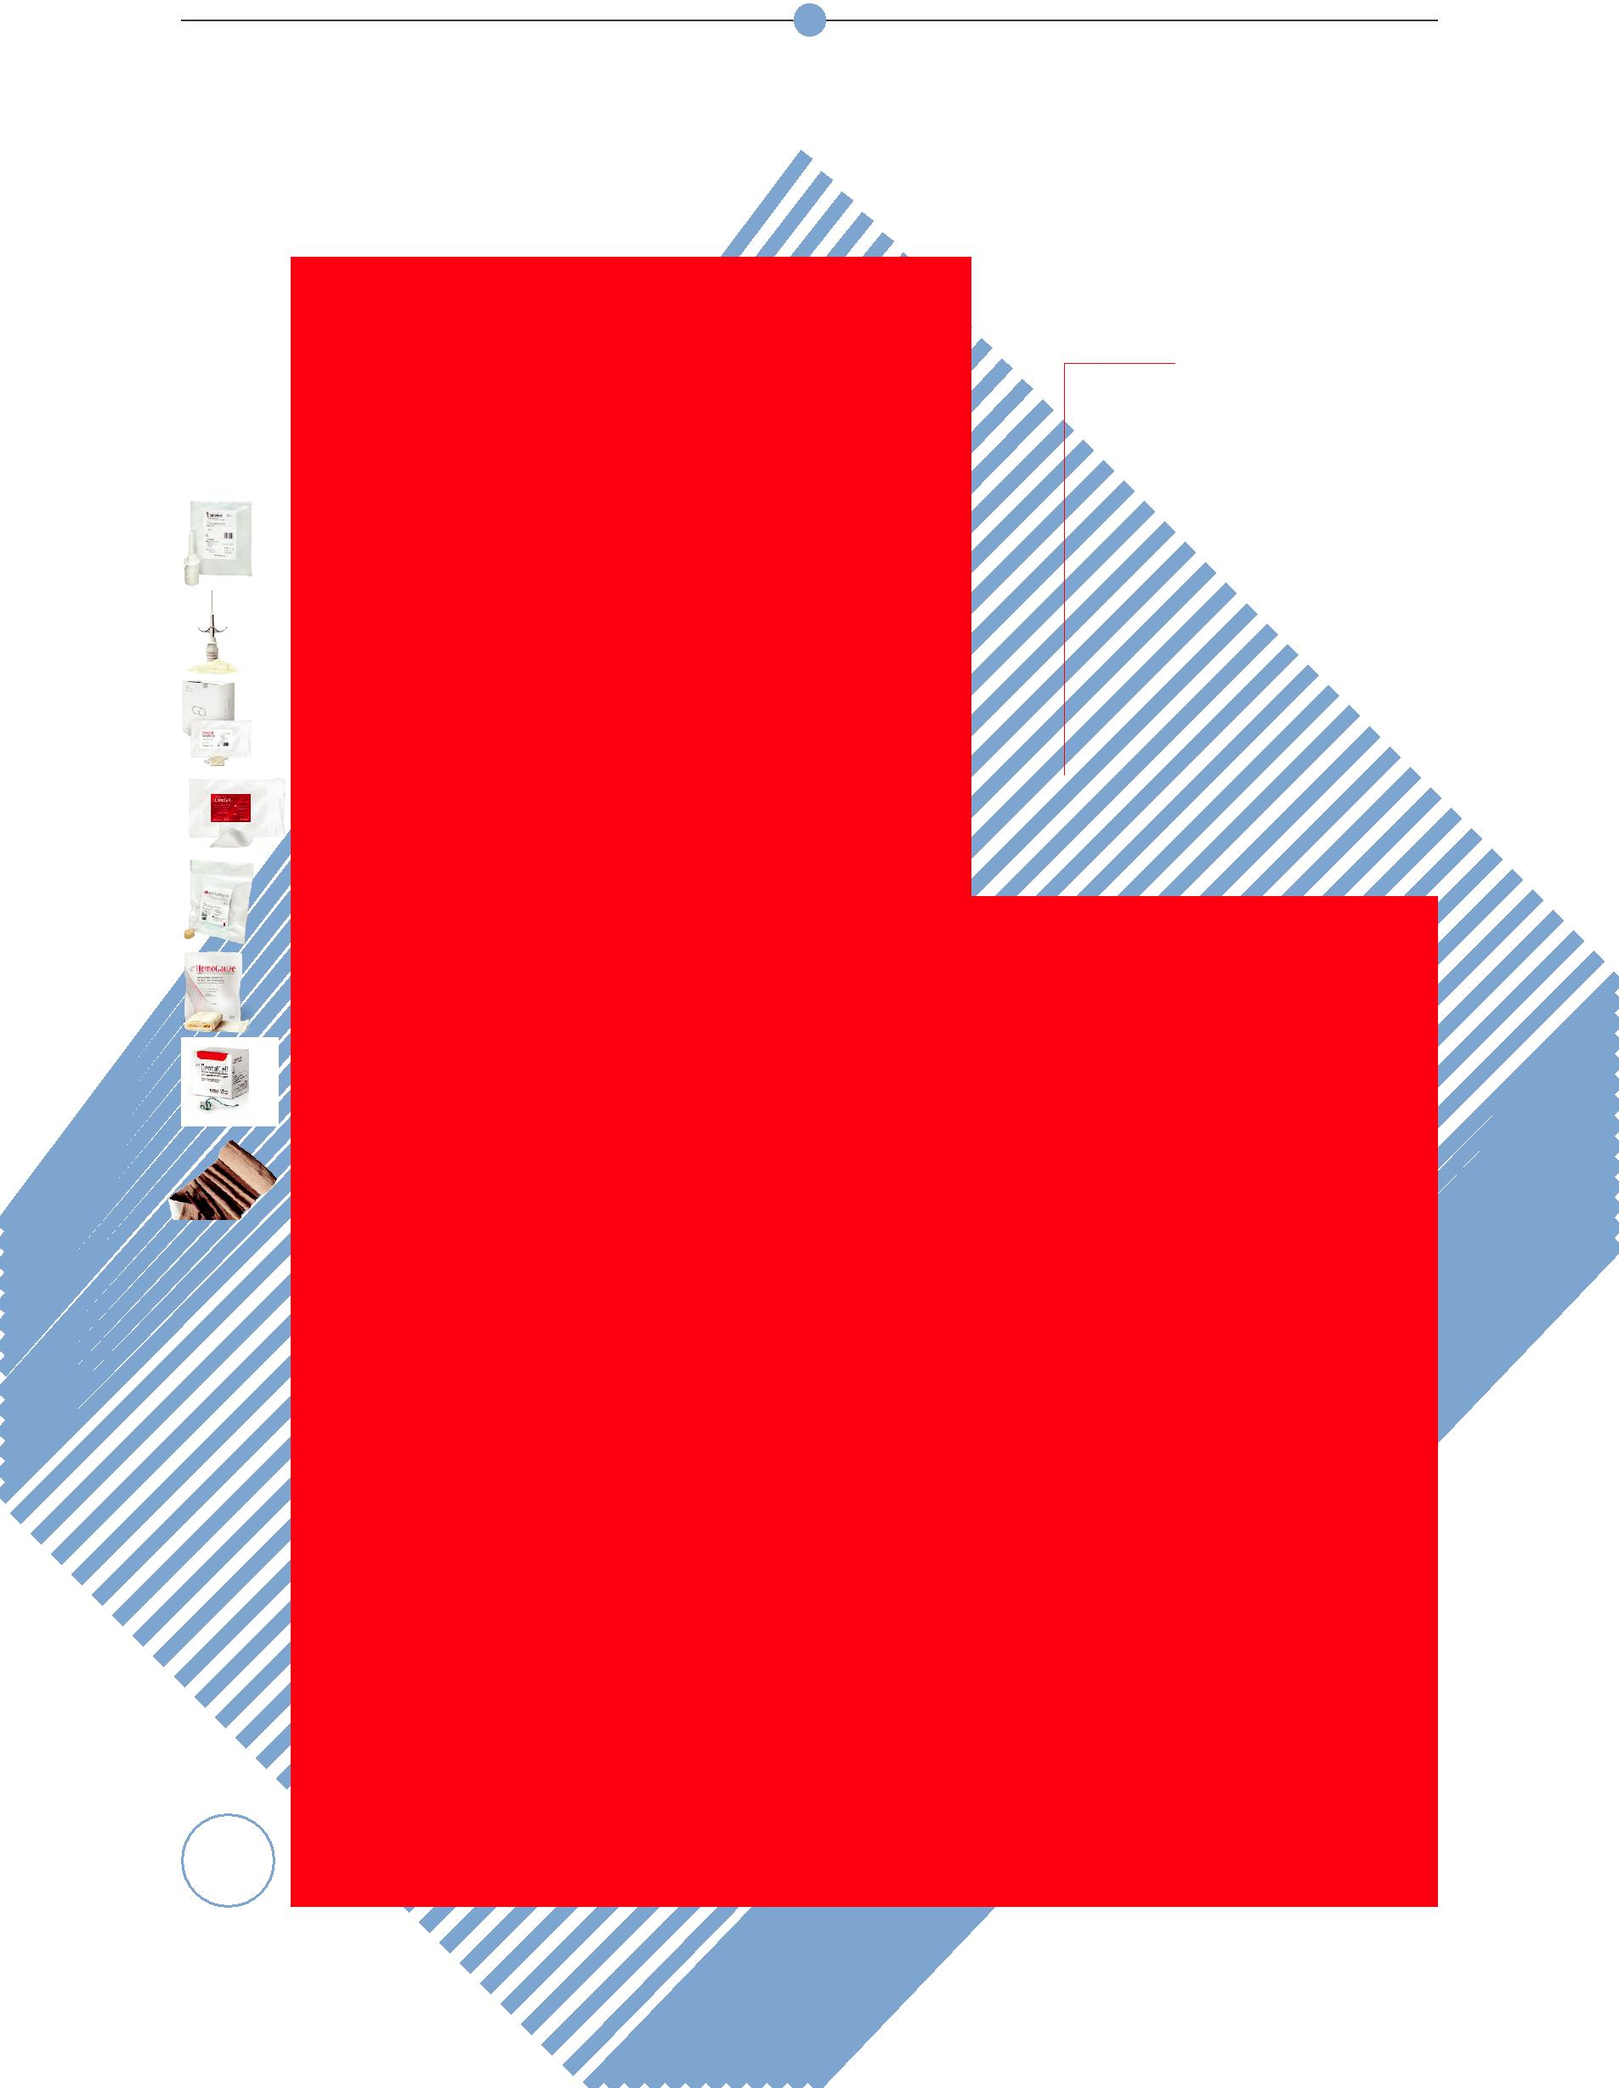

**Hemostatic**

ChitoTech Hemostatic Products are made of natural cellulosic biopolymers. They cause rapid hemostasis in arterial, venous and capillary bleedings, useful in trau-ma, surgery1-3, angiography catheters4, dentistry, nasal and mouth bleeding5-6, genital mutilation, traumatic skin incisions, hemodialysis and vascular problems. They save patients’ life, decrease costs and hospital length of stay, blood transfusions and transmission of infection. They can be effective in conversion of hospitalization to outpatient treatment.

Also, these products have been in-creasingly used in the field of inherited bleeding disorders including hemophilia, Glanzmann and Von Willebrand disease. ChitoTech Hemostatic Products are safe and effective for diabetic patients.

Mechanism of Action:

|  |  |  |
| --- | --- | --- |
|  | ChitoTech hemostatic products act with |  |
|  | the following mechanisms: |  |
|  | Absorbs blood plasma, therefore increases |  |
|  | the concentration of clotting factors and |  |
|  | platelets aggregation in the affected area. |  |
|  | It then provides a matrix for platelet ad- |  |
|  | hesion, accelerating the formation of the |  |
|  | platelet plug. |  |
|  | According to investigated biocompatibility |  |
|  | tests, ChitoTech hemostatic products are |  |
|  | biocompatible, with no evidence of cyto- |  |
|  | toxicity, inflammation, skin irritation, acute |  |
|  | or chronic toxicity, genotoxicity or other |  |
|  | complications related to incompatibility. |  |
| 12 | HSCode = 30061090 |  |
|  |  |

|  |  |
| --- | --- |
| roductsP | HemoFoam |
|  | ChitoHem |
|  | ChitoCell |
|  | ChitoCell UT |
|  | HemoGauze |
|  | EpiCell |
|  | DenTamp & |
|  | DentalCell |
|  | Combat Bandage |

*References:*

1. *S. Honardar, S.S. Kordestani, M. Daliri, F. NayebHabib, “The effect of chi-tosan-based gel on second degree burn wounds.” Journal of wound care 25, no.8 (2016): 489-494.*
2. *Bahman Ebrahimi-Hosseinzadeh*,*

*Mirsepehr Pedram , Ashrafalsadat Hat-amian-Zarmi, Soheila Salahshour-Kord-estani , Mahtab Rasti, Zahra Beagom Mokhtari-Hosseini , and Mohammad Mir-Derikvand. “In vivo Evaluation of Gelatin/Hyaluronic Acid Nanofiber as Burn-wound Healing and Its Comparison with ChitoHeal Gel.” Journal of Fibers and Polymers 17, No.6 (2016): 820-826.*

1. *Soheila S.kordestani, Farzaneh NayebHabib, Mitra S.Abyaneh, “The role of advanced bioactive wound dressing in treating diabetic foot ulcers.” Journal of JSM foot Ankle 1, No.1 (2016): 1-9.*
2. *Soheila S. Kordestani, “Natural Bio-polymers: Wound Care Applications”. Encyclopedia of Biomedical Polymers and Polymeric Biomaterials, (2014):1-14.*
3. *Kordestani, Soheila S., Shahrezaee. M, Tahmasbi.M.N., Hajimahmodi.H, Hahi Ghasemali.D., Abyaneh.M.S.” A random-ized controlled trial on the effectiveness of an advanced wound dressing used in Iran.” Journal of wound care 17, no.7*

*(2008):323-327.*