ChitoTech



**ChitoHem**

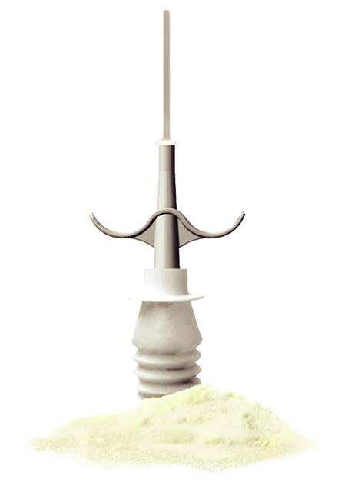

**D**escription

Sterile hemostatic and absorbable powder, containing particles of oxidized regenerated cellulose which is suitable for all types of bleedings, arterial venous and capillary.

The most important outcome after coronary angiography via femoral artery is to achieve fast and effective hemostasis. Due to the superabsorbent nature of this powder, when ap-plied to the puncture site, following the removal of the catheter the serum of the jetting blood is absorbed by the powder. As a result the rate of blood flow from the puncture site is reduced which in return accelerates the initiation of clot formation. The application of ChitoHem hemostatic powder on the patients has reduced the time to hemostasis significantly compared to the conventional manual compression1.

**M**ain component:Oxidized Regenerated Cellulose

|  |  |  |  |  |  |  |  |  |  |  |  |  |  |  |  |  |  |
| --- | --- | --- | --- | --- | --- | --- | --- | --- | --- | --- | --- | --- | --- | --- | --- | --- | --- |
| **A**pplication | | | | |  |  |  |  | **F**eatures & **B**enefits | | | | |  |  |  |  |
| • | | | Cardiovascular, orthopedic, graft, ENT surgeries | | | | | | • | Absorbable and readily dissolves in body fluids | | | | | | |  |
|  |  |  | and Laparoscopy | | | | | | • | Biocompatible | | | |  |  |  |  |
| • | | | Soft tissue surgery | | | | | | • | No genotoxicity | | | |  |  |  |  |
| • | | | Angiography | | | | | | • | No cell toxicity- According to ISO 10993-5 | | | | | | |  |
| • | | | Emergency | |  |  |  |  | • | Complies with the requirement of ISO 10993-6 for | | | | | | |  |
| • | | | Inherited bleeding disorders | | | | | |  | local effect after implantation | | | | | | |  |
| • | | | Stop bleeding in diabetic patients | | | | | | • | No skin irritation, no sensitivity- According to ISO | | | | | | |  |
| • | | | Suitable for all patients with coagulopathy | | | | | |  | 10993-10 | |  |  |  |  |  |  |
|  |  |  | disorder and diabetes | | | | | | • | No systemic toxicity (Acute and sub chronic toxici | | | | | | |  |
| • | | | Capillary, venous and arterial bleeding | | | | | |  | ty) - According to ISO | | | | | 10993-11 | |  |
|  |  |  |  |  |  |  |  |  |  |  |  |  |  | • | ChitoHem is a power | |  |
|  |  |  | Code |  |  |  | Name | | Size | No. in box | |  |  |  |
|  |  |  |  |  |  |  |  |  | ful hemostatic powder | |  |
|  |  |  | 5111 |  |  |  |  |  | g 1 | **5** |  |  |  |  | due to its micropo | |  |
|  |  |  | 5113 |  | ChitoHem in mini hemovag | | | | g 3 | **5** |  |  |  |  | rous polysaccharide | |  |
|  |  |  |  |  |  |  |  |  |  |  |  |  |  |  | structures | |  |
|  |  |  | 5115 |  |  |  |  |  | g 5 | **5** |  |  |  |  |  |
|  |  |  |  |  |  |  |  |  |  |  | • | Complete Hemostasis | |  |
|  |  |  | 52205 |  |  |  |  |  | g 0.5 | **20** |  |  |  |  |
|  |  |  |  |  | ChitoHem in Dropper | | |  |  |  |  | Is achieved in a minutes | |  |
|  |  |  | 5221 |  |  | g 1 | **20** |  |  |  | • | pH= 3-4 | |  |
|  |  |  |  |  |  |  |  |  |  |  |  |
|  |  |  | 5331 |  |  | ChitoHem in Sachet | | | g 1 | **20** |  |  |  | • | Clot formation: less | |  |
|  |  |  |  |  |  |  |  |  | than one minutes | |  |
|  |  |  |  |  |  |  |  |  |  |  |  |  |  |  |  |
|  |  |  |  |  |  |  |  |  |  |  |  |  |  |  |  |  |  |
|  |  |  |  |  |  |  |  |  |  |  |  |  |  |  |  |  |  |

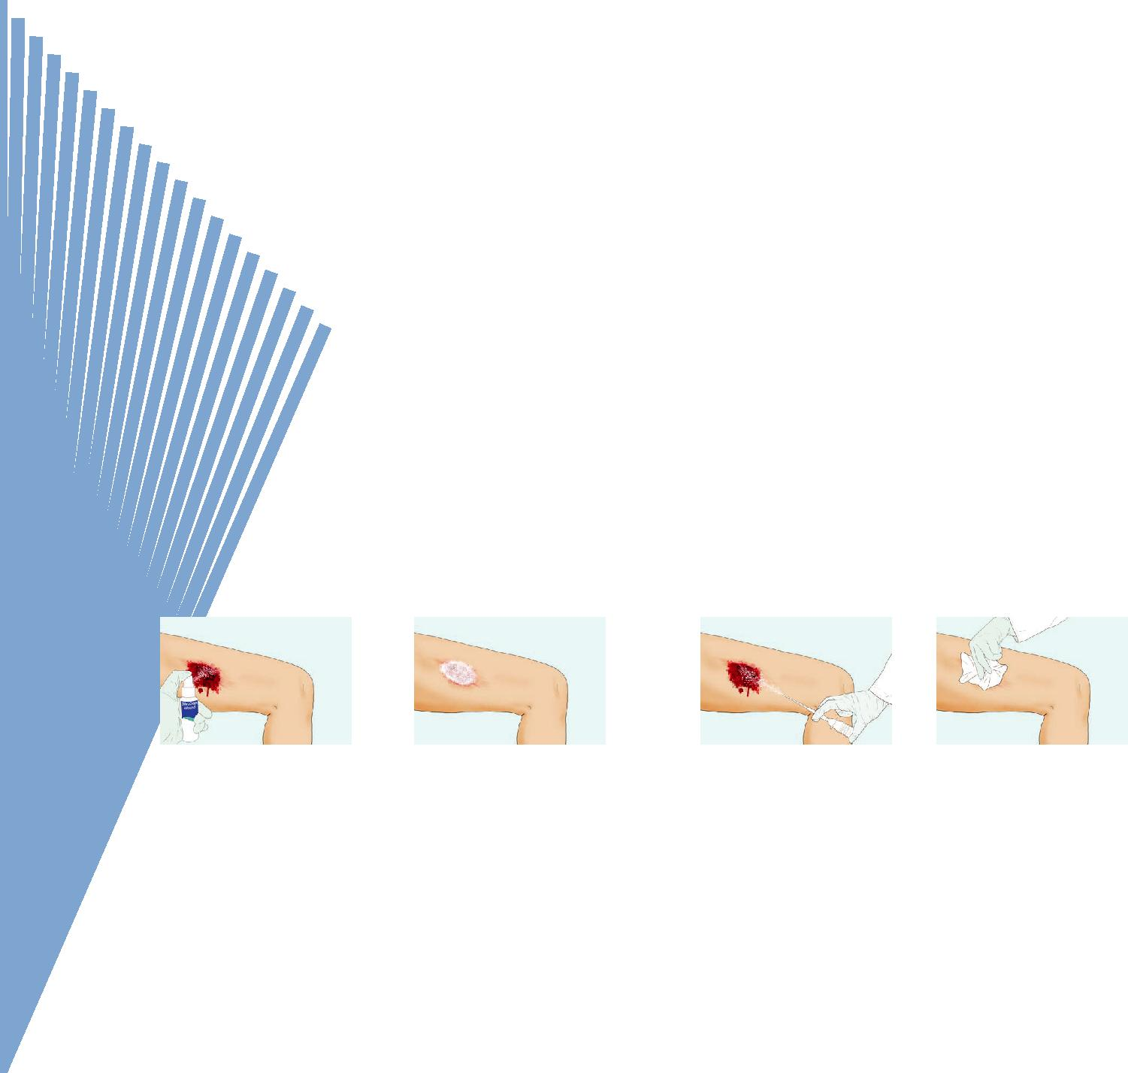

1- Clean the bleeding area with SilvoSept spray.

**I**nstruction for use

2- Using your thumb to press 3-If needed, install

the mini hemovag and pump the on the mini

the desired amount of Chito- hemovag and pump

Hem powder. the desired amount

of ChitoHem powder.

4-Less than 1 minute bleeding is stopped if needed, repeat the section 2.Compress the source of bleeding for 2-3 minutes 13 using a dry compress.



ChitoTech

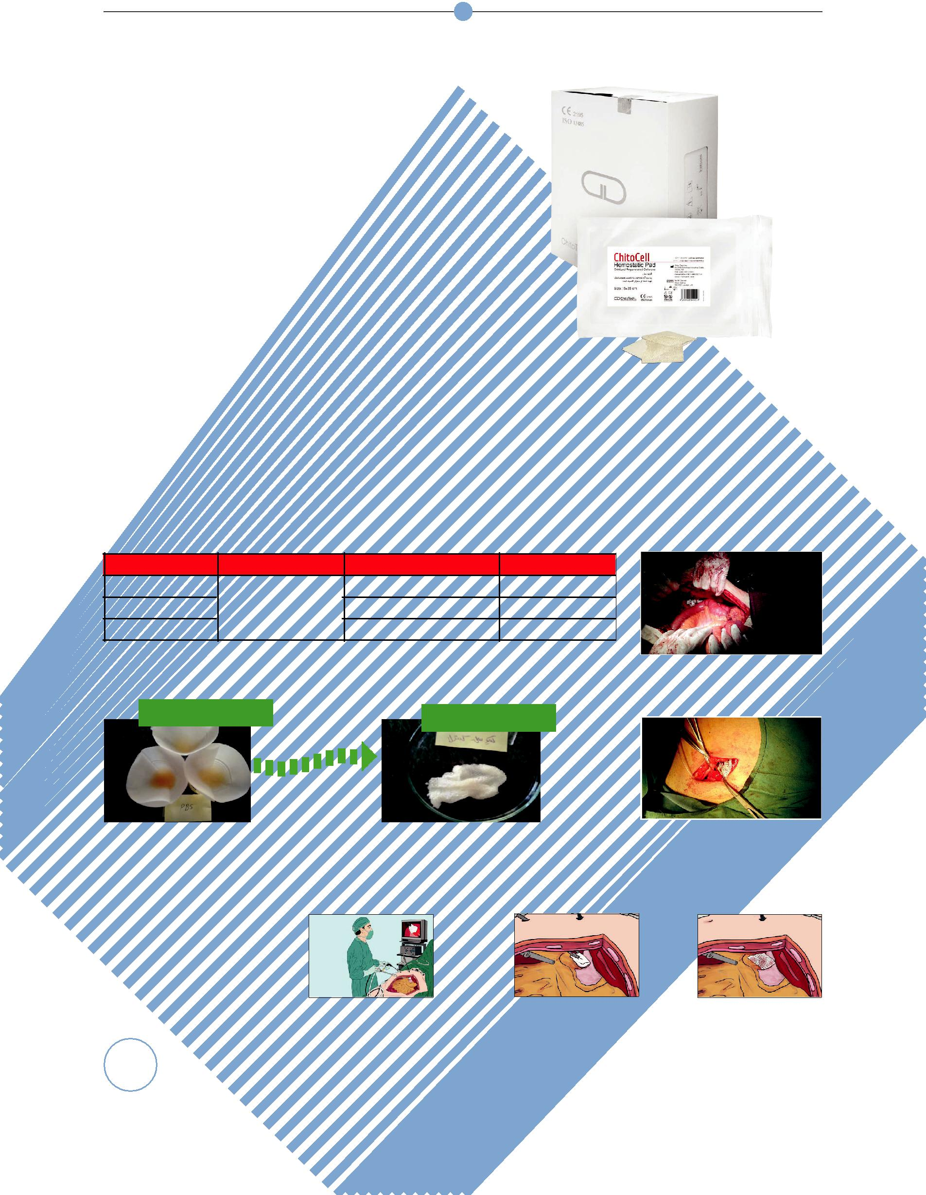

**ChitoCell**

**D**escription

ChitoCell is an oxidized regenerated cellulosic pad which accelerates hemostasis. This product is suitable for venous bleedings.

ChitoCell is used on the surgical bed for con-trolling capillary, venous, or suture line bleeding postoperatively. As it absorbs blood and gets saturated, it gently swells into a brownish black gelatinous mass which aids in the formation of clot. The mechanism of action of ChitoCell to stop bleeding is basically absorbing blood fluid, swell-ing and exerting pressure on the surrounding tissue contributing to hemostasis.

**M**ain component:Oxidized Regenerated Cellulose **A**pplication

* All surgeries, anastomosis, tumor beds, neuro-surgeries and plastic surgeries.
* Suitable for patients with coagulation disorders

|  |  |  |  |  |
| --- | --- | --- | --- | --- |
| Code | Name | Size | No. in box |  |
| 5105080 | ChitoCell | cm 8×5 | **12** |  |
| 51050350 | cm 35×5 | **12** |  |
| 510100200 |  | cm 20×10 | **12** |  |

First day After 28 days

**I**nstruction for use

Clinical Study of ChitoCell

Hernia Inguinal

Volvulus Surgery

Clean the damaged organ by removing blood and other fluids properly. Cover the bleeding site with ChitoCell.

14

ChitoTech



**Ultra-Thin ChitoCell**

ChitoCell UT is an ultra-thin hemostatic pad part of the ChitoTech family of hemostatic products. It is a non-woven oxidized regenerated cellulosic pad which accelerates hemostasis. This product is suitable for spinal and neurosurgery. The mech-anism of action of ChitoCell UT to stop bleeding is basically absorbing blood fluid, swelling and exerting pressure on the surrounding tissue con-tributing to hemostasis.

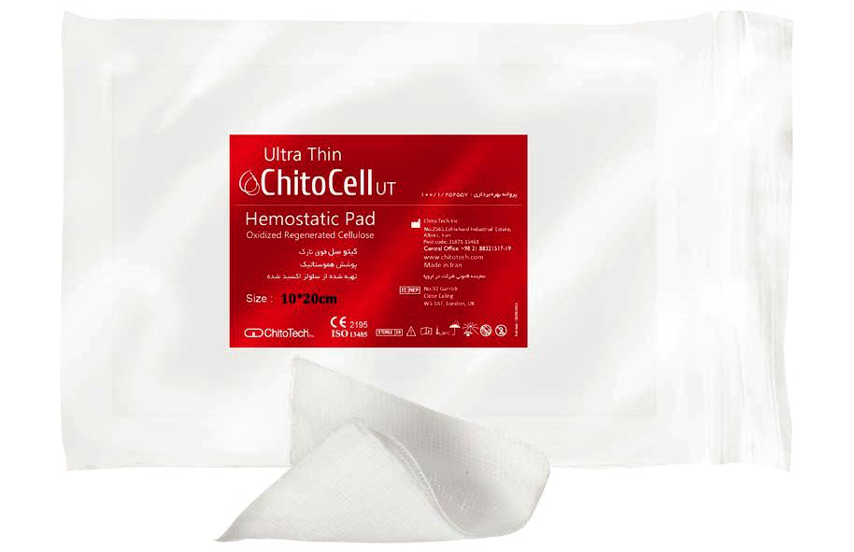

**M**ain component:Oxidized Regenerated Cellulose



**F**eatures & **B**enefits

* Sterile and biocompatible
* No genotoxicity
* No cell toxicity (ISO 10993-5)
* Complies with the requirement of

ISO 10993-6 for local effect after implantation

* No irritation, no sensitivity (ISO

10993-10)

* No systemic toxicity- Acute and sub chronic toxicity-( ISO 10993-11)
* absorbable in the body

**I**nstruction for use

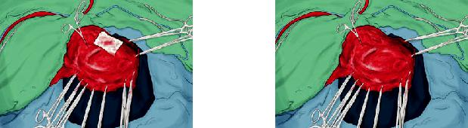

2. Apply Ultra-Thin 1. Clean the damaged

ChitoCell on bleed- organ by removing the

ing site. blood and exudates.

|  |  |  |  |  |  |  |  |  |
| --- | --- | --- | --- | --- | --- | --- | --- | --- |
|  | Code | | Name | Size(cm) | No. in box |  |  |  |
|  | 5215080 |  |  | 5×8 | 12 |  |  |  |
|  | 521100200 |  |  | 10×20 | 12 |  |  |  |
|  | 52150350 |  | ChitoCell UT | 5×35 | 12 |  |  |  |
|  | 5212550 |  | 2.5×5 | 12 |  |  |  |
|  |  |  |  |  |  |
|  | 52150100 |  |  | 5×10 | 12 |  | 15 |  |
|  | 521100100 |  |  | 10×10 | 12 |  |  |
|  |  |  |  |  |  |



ChitoTech



**HemoFoam**

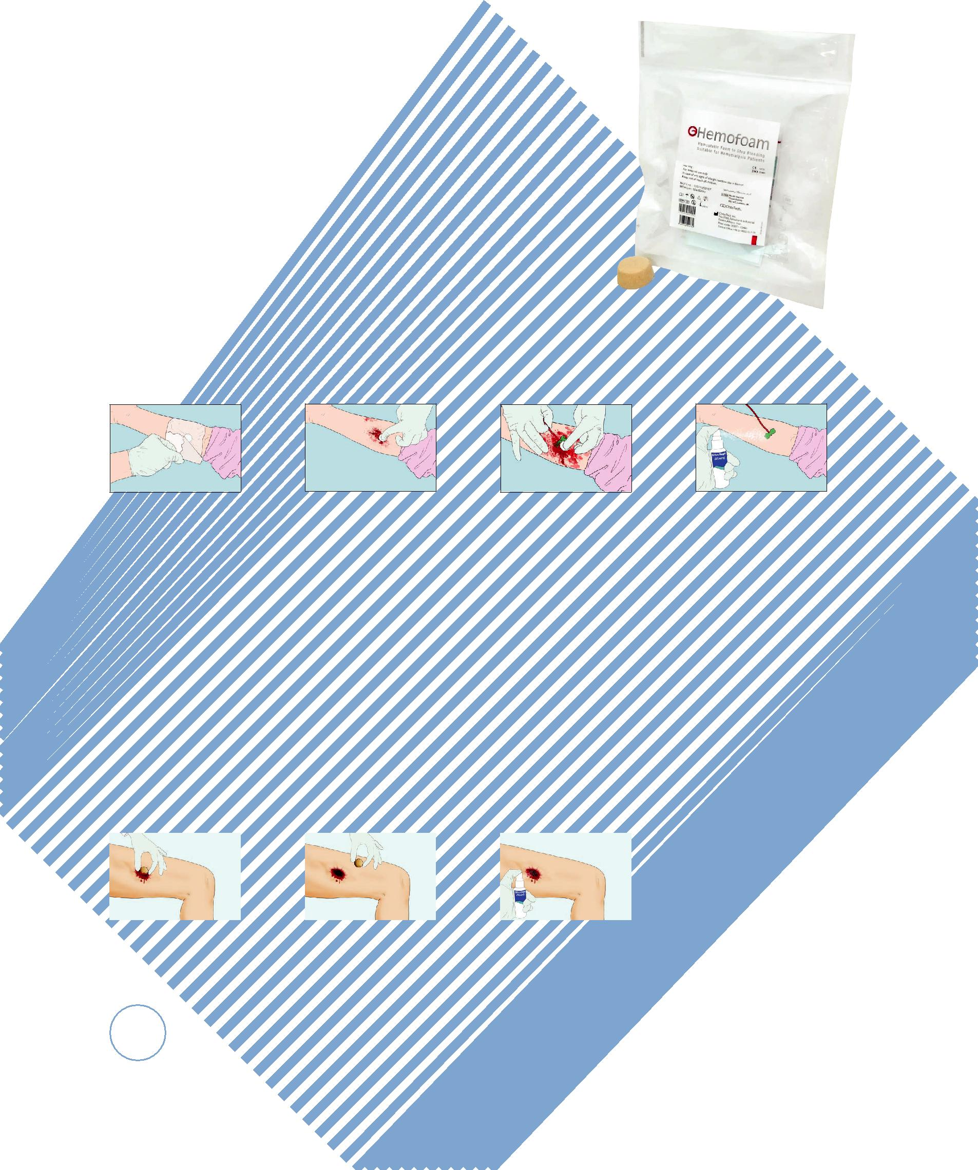

**D**escription

HemoFoam is soft, foam like hemostatic dressing, made of natu-ral biopolymers.

This hemostatic foam can be used control of bleeding in patients following hemodialysis. Bleeding would be chronic in such pa-tients and hospital should take care of them with special health-care. Since HemoFoam provide an ideal hemostatic tool, nurses could use it with confidence and patients would rest at hospital in a shorter time.

Nurses in hospital would consume about 1.200.000 hours a year for hemostasis of hemodialysis patients. Using HemoFoam would reduce this time up to 1-4 minutes.

**M**ain component:Oxidized Regenerated Cellulose

**I**nstruction for use HemoFoam

1. Clean the 2. Place HemoFoam 3. Press it for 3 to 5

bleeding site with over bleeding site min.

silvoSept spray. then remove the

sheath.

1. Fix HemoFoam with

ChitoTrans when bleeding has stopped.

|  |  |  |  |  |  |  |  |  |  |  |  |  |  |  |  |  |
| --- | --- | --- | --- | --- | --- | --- | --- | --- | --- | --- | --- | --- | --- | --- | --- | --- |
|  |  | **Code** |  | **Name** |  |  | **Size** | | **No. in box** | | |  |  |  |  |  |
|  |  | 51525 |  | HemoFoam |  | cm Diameter 2.5 | | |  | 16 | |  |  |  |  |  |
| **Spherical HemoFoam** | | | | | | | | |  | •Flexible & | | | | | |  |
|  |  |  |  |  |  |  |  |  | **F**eatures & **B**enefits | | | | | | |  |
| **D**escription | |  |  |  |  |  |  |  |  |  | non-Allergic | | | | |  |
|  |  |  |  |  |  |  |  | •Biocompatible | | | | | |  |
| Spherical hemostatic HemoFoam suitable for cavity | | | | | |  |  |  |  | •No genotoxicity | | | | | |  |
|  |  |  |  | •No cell toxicity- Ac- | | | | | |  |
| wounds and all types of arterial bleeding. | | | | | |  |  |  |  |  |
|  |  |  |  | cording to ISO 10993-5 | | | | | |  |
| **I**nstruction for use Spherical HemoFoam | | | | | |  |  |  |  |  |
|  |  |  |  | •No skin irritation, no | | | | | |  |
|  |  |  |  |  |  |  |  |  |  | sensitivity- According | | | | | |  |
|  |  |  |  |  |  |  |  |  |  | to ISO 10993-10 | | | | | |  |
|  |  |  |  |  |  |  |  |  |  | •No systemic toxicity | | | | | |  |
|  |  |  |  |  |  |  |  |  |  | (Acute and sub chronic | | | | | |  |
| 1. Remove excess | | 2. Place spherical HemoFoam | | | | 3. When bleeding has | | |  | toxicity) - According to | | | | | |  |
|  | ISO 10993-11 | | | | | |  |
| bleeding in the injured | | in the cavity of the injured area | | | | stopped, cover it with Chi- | | |  |  |
|  | •Easy to use | | | | | |  |
| area and disinfect with | | and apply compression for 3-5 | | | | toAbsorbent (or sterile gauze) | | | |  |
|  |  |  |  |  |  |  |
| SilvoSept. | | minutes using sterile gauze. | | | | then fix it with ChitoTrans. | | |  |  |  |  |  |  |  |  |
|  |  |  |  |  | |  |  |  |  |  |  | | |  |  |  |
| 16 |  | **Code** |  | **Name** | |  |  | **Size** |  |  | **No. in box** | | |  |  |  |
|  |  | 51530 |  | Spherical HemoFoam | | |  | 3 cm Diameter | |  | 5 | | |  |  |  |

ChitoTech



**Combat Bandage**

**D**escription

Combat Bandage is an advanced hemostatic dressing for front line medical professionals. 5 unique features are gathered as one in combat bandage. This product consists of hemostatic dressing supported by superabsorbent pad, A clip device, pressure bar on the dressing that applies compression on the site of bleeding and a hooking ends which secure the bandage tightly, therefore there is no further need for adhesive.

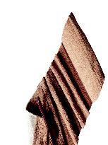

**M**ain component:

Oxidized Regenerated Cellulose + Superabsorbent Pad



**F**eatures & **B**enefits

* Stops sever bleedings
* Soft and comfortable therefore suitable for all parts of external bleedings
* Sterile
* Quick and easy self-application
* Biocompatible
* No cell toxicity- According to ISO 10993-5
* No skin irritation, no sensitivity- According to ISO 10993-10

**I**nstruction for use

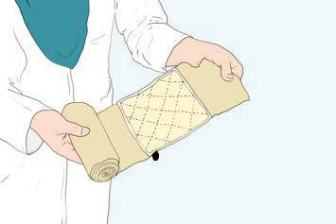

1-Place super absor-

bent hemostatic pad

on wound.

2-Wrap the elastic bandage around bleeding site, then insert it into pres-sure bar.

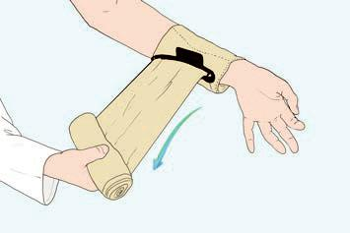

**A**pplication

* First aid in the following case:
* Emergency
* Road accidents
* Military forces
* Life-threatening bleeding

3-Turn the bandage in the opposite direction while it is in the hook and com-pletely fasten it around the location.

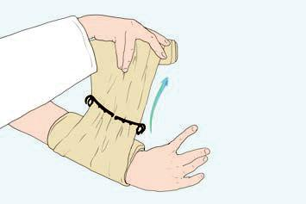

4- Wrap elastic bandage tightly over-pressure bar. Secure hooking ends into elastic bandage.

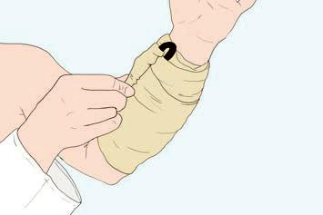

|  |  |  |  |  |  |
| --- | --- | --- | --- | --- | --- |
|  | **Code** | **Name** | **Size (cm)** | **No. in box** |  |
|  | 5181502000 | Combat Bandage | 200×15 | 40 |  |

17

ChitoTech



**HemoGauze**

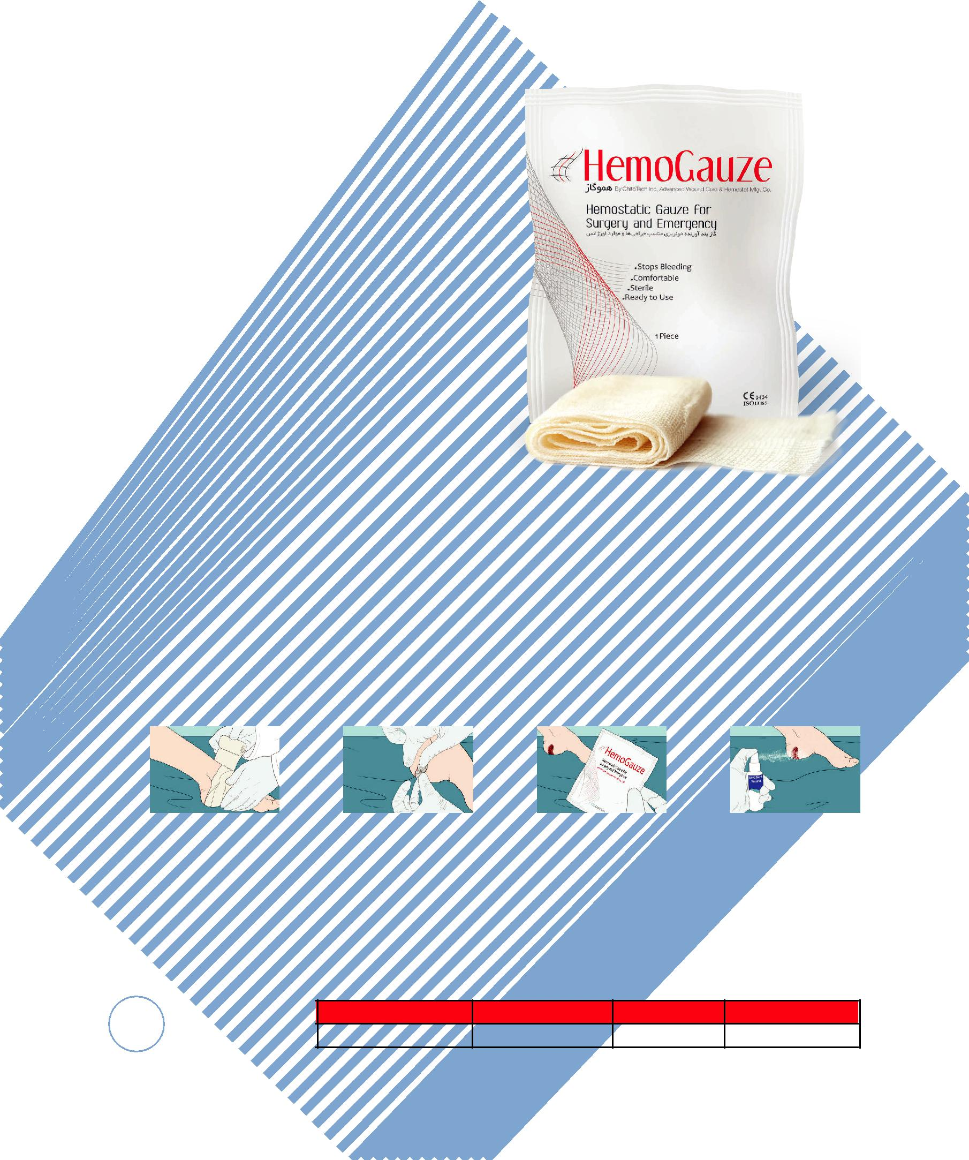

**D**escription

HemoGauze is soft and pliable oxidised gauze suitable for capillary and small veins bleeding.

**M**ain component:Oxidized Cellulose

**F**eatures & **B**enefits

* Rapid hemostasis of capillary and small veins bleeding
* Soft and flexible
* Biocompatible
* No cell toxicity ( ISO 10993-5)
* No skin irritation, no sensitivity ( ISO

10993-10)

**A**pplication

* Capillary bleeding (Domestic wounds, abrasions and cuts)

**I**nstruction for use

1. Clean the bleeding 2. Place HemoGauze 3. Press it for 60 sec- 4. Fix HemoGauze

site with SilvoSept spray. over bleeding site. onds to stop bleeding. with appropriate

bandage.

|  |  |  |  |  |  |
| --- | --- | --- | --- | --- | --- |
| 18 | **Code** | **Name** | **Size** | **No. in box** |  |
| 514100400 | HemoGauze | cm 40×10 | 40 |  |
|  |  |