ChitoTech



**EpiCell**

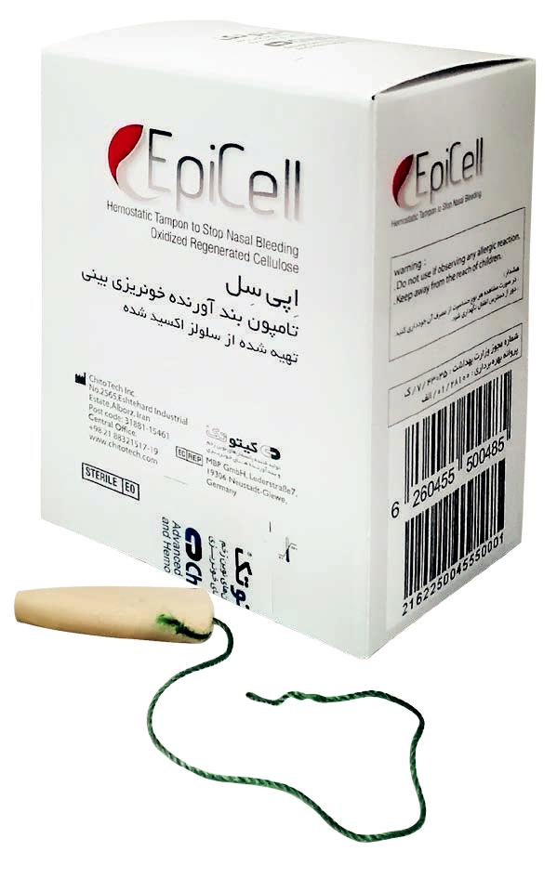

**D**escription

EpiCell is ChitoTech hemostatic nasal tampon suitable for Patients self-application in controlling epistaxis. EpiCell is a cylindrical tampon made of chitosan and ORC and it come in two sizes for adults and children.

The tampon comprises a safety thread which makes it very easy to remove. This tampon as well as hemostatic properties, promotes healing and is anti bacterial. When the tampon is placed within the nasal cavity, blood from a nose bleed expands the tampon, holding it in place. When the nose bleed has stopped the tampon can be removed by pulling the thread.

**M**ain component: Chitosan and Oxidized Regenerated Cellulose



**F**eatures & **B**enefits

* Rapid Hemostasis
* Biocompatible
* No cell toxicity- According to ISO 10993-5
* No skin irritation, no sensitivity- According to ISO 10993-10
* Soft and flexible
* Safe thraed to ease removal of tampon ,

Without any harm to nos

**A**pplication

* Nasal bleedings (Epistaxis)
* Suitable for patients with coagulation disorders

**I**nstruction for use

1-Place EpiCell into the na-sal cavity and push upwards

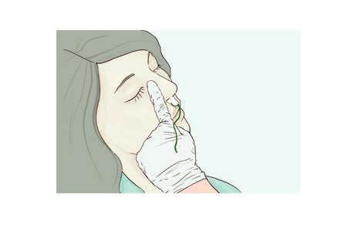

2- Press the septum of the nose from outside for 1-2

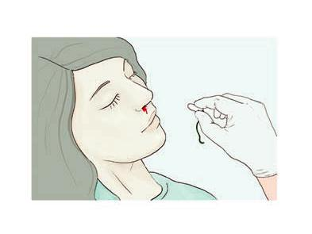

|  |  |  |  |  |  |  |
| --- | --- | --- | --- | --- | --- | --- |
| **Code** | **Name** | **Size** | **No. in box** |  |  |  |
| 513530 | Epicell (Children) | Children | 10 |  | 19 |  |
| 513835 | Epicell (Adult) | Adult | 10 |  |  |
|  |  |  |



ChitoTech



**DentalCell & DenTamp**

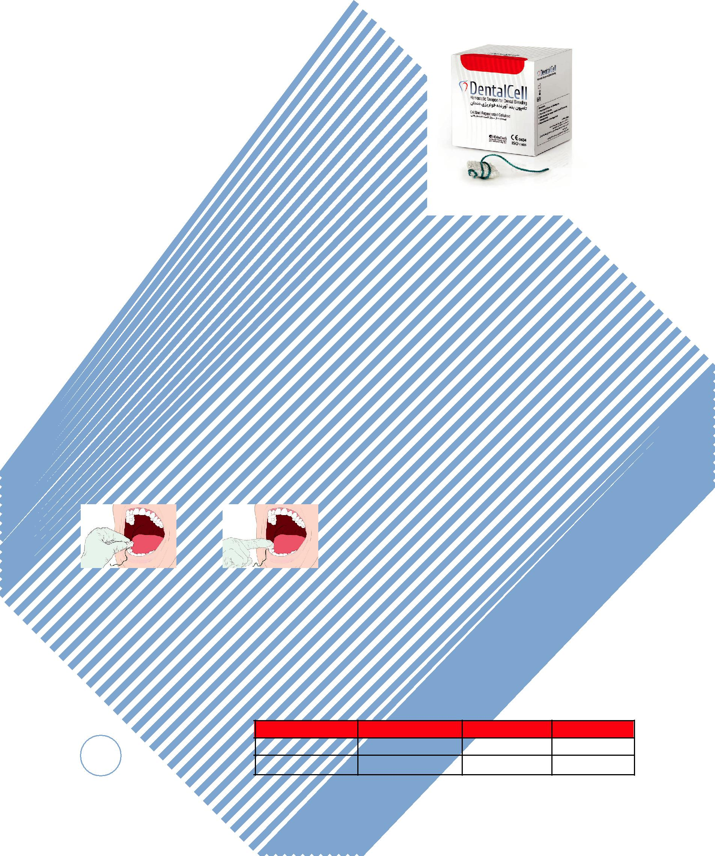

**D**escription

Dental Cell is a biocompatible oxidized cellulose hemostatic tampon.

It is equipped with a safety thread which can be removed from the bleeding site after hemostasis has occurred. It can be used in the extraction sucked accelerating the formation of blood clot. DentalCell & DenTamp are hemostatic with rein-forced hemostatic properties for dental extracting and related surgeries.

**M**ain component:Oxidized Regenerated Cellulose

**F**eatures & **B**enefits

* Rapid Hemostasis
* Biocompatible
* No cell toxicity ( ISO 10993-5)
* No skin irritation, no sensitivity ( ISO

10993-10)

* Soft and flexible
* Easy and safe to use

**A**pplication

* Suitable for extraction site and oral surgeries
* Suitable for patients with coagula tion disorders such as (Von Wille brand disease, Glanzmann disease and Hemophilia)

**I**nstruction for use

1. Place DentalCell/ 2. Then apply slight pressure

DenTamp over the bleeding on the DentalCell/DenTamp.

site. When the bleeding is stopped

wash off your mouth.

|  |  |  |  |  |  |
| --- | --- | --- | --- | --- | --- |
|  | **Code** | **Name** | **Size** | **No. in box** |  |
| 20 | 517150150 | DentalCell | mm 15×15 | 16 |  |
| 517101010 | DenTamp | cm 13 | 16 |  |

ChitoTech



21

ChitoTech



**ChitoTech Wound Algorithm**

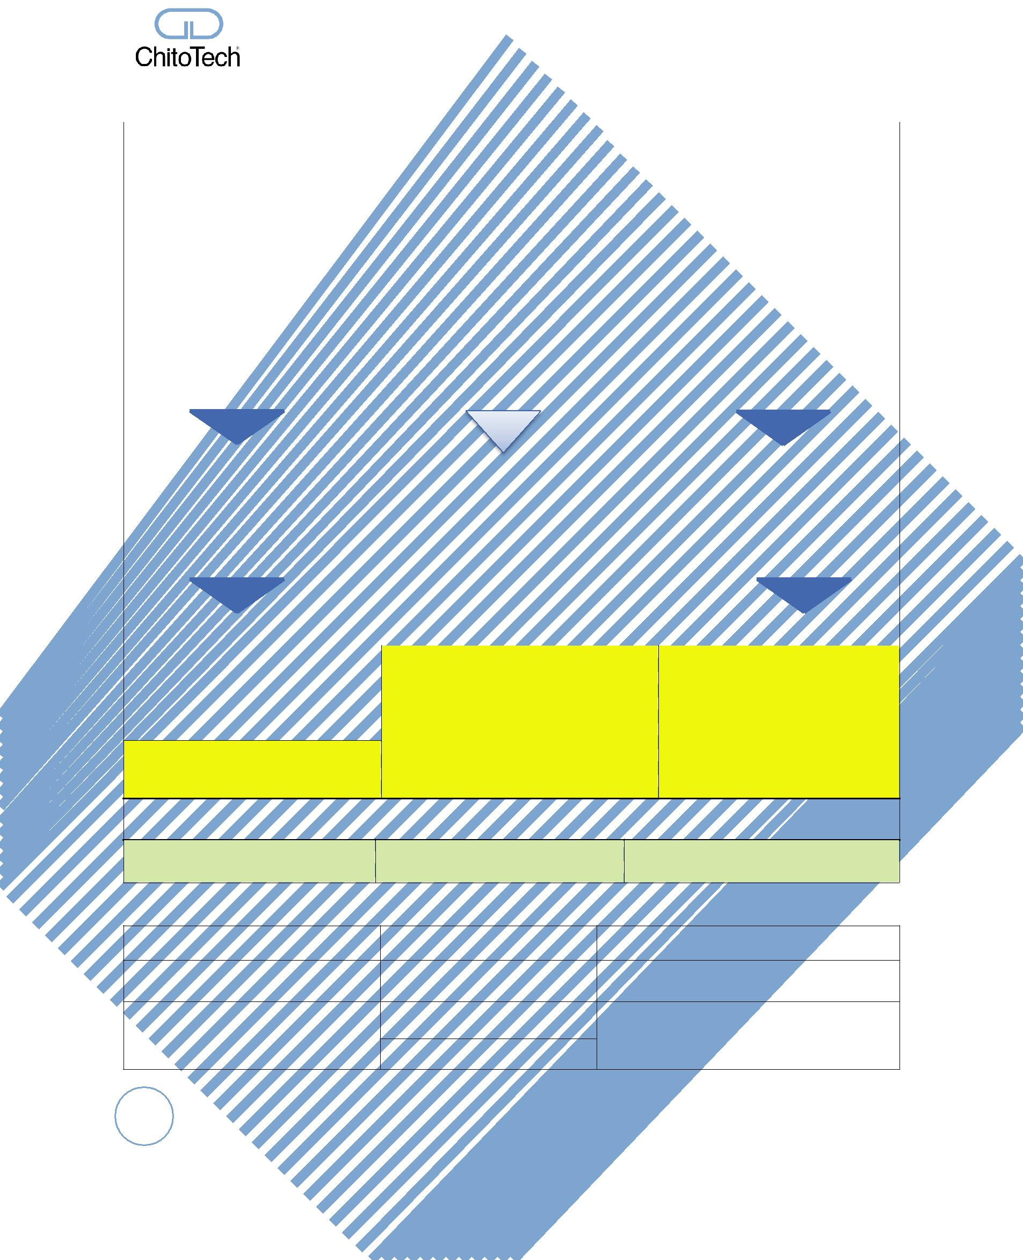

|  |  |  |  |  |  |  |  |  |  |  |  |  |  |  |  |  |  |
| --- | --- | --- | --- | --- | --- | --- | --- | --- | --- | --- | --- | --- | --- | --- | --- | --- | --- |
|  |  |  |  |  |  |  |  |  | **for Chronic Wound** | | | |  |  |  |  |  |
|  |  |  |  |  |  |  |  |  |  | **D I P1,2,3** | | |  |  |  |  |  |
|  |  |  |  |  |  |  |  | **Wound measurement** | | | | |  |  |  |  |  |
|  |  |  |  | **Length** |  |  |  |  |  | **width** | |  |  |  | **Depth** |  |  |
|  |  |  |  |  |  |  |  |  |  |  |  |  |  |  |  |  |  |
|  |  |  |  |  |  |  |  |  |  | |  | |  |  |  |  |  |
|  |  |  |  |  |  |  |  |  | **Wound assessment** | | | |  |  |  |  |  |
|  |  |  |  |  |  |  |  |  |  | |  | |  |  |  |  |  |
|  |  |  |  |  |  |  |  |  | ***What to assess?*** | | | |  |  |  |  |  |
|  |  |  |  | **D** |  |  |  |  |  | **I** | |  |  |  | **P** |  |  |
|  |  |  |  | **Debridement** |  |  |  |  |  | **Inflammation** | |  |  |  | **Proliferation** |  |  |
|  |  | • | **Devitalised tissues** | |  |  | • |  | **Activate tissue macrophages** | | |  | • | **Granulation statues** | |  |  |
|  |  |  |  |  |  |  |
|  |  | • **Depth of the wound** | | |  |  |  |  | • | **Angiogenesis status** | |  |  |
|  |  |  |  | • |  | **Activate growth factors** | | |  |  |  |
|  |  | • | **Infection status** | |  |  |  |  |  |  |  |  |  |
|  |  |  |  |  |  |  |  |  |  |  |  |  |  |  |
|  |  |  |  |  |  |  |  |  |  |  |  |  |  |  |  |  |  |
|  |  |  |  |  |  |  |  |  |  | **jfdjdkkdkWhat*Whatto*treat?to** |  |  |  |  |  |  |  |
|  |  |  | • | **Necrotic tissue** |  |  |  |  | • | **Cavity** | |  |  | • | **Generating granulation** |  |  |
|  |  |  | • **White & yellow slough** | |  |  |  |  | • | **Fistula** | |  |  |  | **tissue and achieving** |  |  |
|  |  |  | • | **Microbes & cell debris** |  |  |  |  | • | **Tunelling** | |  |  |  | **red tissue** |  |  |
|  |  |  |  | **accumulation** |  |  |  |  | • | **Others** | |  |  | • | **Contraction from edges** |  |  |
|  |  |  | • | **Stop hypoxia** |  |  |  |  |  |  |  |  |  | • | **Accelerating blood** |  |  |
|  |  |  |  |  |  |  |  |  |  |  |  |  |  |  | **perfusion** |  |  |
|  |  |  |  |  |  |  |  |  |  |  |  |  |  |  |  |  |  |
|  |  |  |  |  |  |  |  |  |  | ***What to use?*** | | |  |  |  |  |  |
|  |  |  | **Clean the wound before dressing application using SilvoSept antiseptic** | | | | | | | | | | | | |  |  |
|  |  |  |  |  |  |  |  |  |  |  |  |  |  |  |  |  |  |
|  |  |  | • | **Debrid gel** |  |  | • |  | **ChitoCavity** | |  |  |  | • | **ChitoHeal gel** |  |  |
|  |  |  | • | **Debrid pad** |  |  | • |  | **Calcium Alginate** | |  | |  | • | **ChitoHeal Foam** |  |  |
|  |  |  | • | **Chitohem** |  |  | • |  | **ChitoPowder** | | | |  |  |  |  |  |
|  |  |  |  |  |  |  |  |  |  |  |  |  |  |  |  |  |  |

* **ChitoSorb Ag+**

**Time to change each dressing**

|  |  |  |  |
| --- | --- | --- | --- |
| **24 hours** | **24 – 48 hours** | **24 hours** |  |
|  | Remodelling |  |  |
| Collagen formation to build up | Layer of epidermis forms | The colour of the wound turning |  |
| tissue strength | pink |  |
|  |  |
|  | ***What to use ?*** |  |  |
|  | **ChitoScar** |  |  |

22

ChitoTech



**ChitoTech Wound Algorithm**

|  |  |  |  |  |  |  |  |  |  |  |  |  |  |  |  |
| --- | --- | --- | --- | --- | --- | --- | --- | --- | --- | --- | --- | --- | --- | --- | --- |
|  |  |  |  |  |  |  |  |  | **For Acute Wound** |  |  |  |  |  |  |
|  |  |  |  |  |  |  |  |  | **C I P1,2,3** |  |  |  |  |  |  |
|  |  |  |  |  |  |  |  |  | **Wound measurement** |  |  |  |  |  |  |
|  |  |  |  | **Length** |  |  |  |  | **width** |  |  |  | **Depth** |  |  |
|  |  |  |  |  |  |  |  |  |  |  |  |  |  |  |  |
|  |  |  |  |  |  |  |  |  | |  |  |  |  |  |  |
|  |  |  |  |  |  |  |  | **Wound assessment** | |  |  |  |  |  |  |
|  |  |  |  |  |  |  |  |  | |  |  |  |  |  |  |
|  |  |  |  |  |  |  |  | ***What to assess?*** | |  |  |  |  |  |  |
|  |  |  |  | **C** |  |  |  |  | **I** |  |  |  | **P** |  |  |
|  |  |  |  | **Clearing infection** |  |  |  |  | **Inflammation** |  |  |  | **Proliferation** |  |  |
|  |  | • | **Infection status** | |  |  | • | **Activate tissue macrophages** | |  | • | **Granulation status** | |  |  |
|  |  |  |  |  | • | **Angiogenesis status** | |  |  |
|  |  | • | **Preparing for inflammatory** | |  |  | • | **Activate growth factors** | |  |  |  |
|  |  |  |  |  |  |  |  |  |  |
|  |  |  | **phase** | |  |  |  |  |  |  |  |  |  |  |  |
|  |  |  |  |  |  |  |  |  |  |  |  |  |  |  |  |
|  |  |  |  |  |  |  |  |  | ***What To Treat?*** |  |  |  |  |  |  |
|  |  |  | • | **Accumulation of microbes** |  |  |  | • | **Cavity** |  |  | • | **Filling thewound** |  |  |
|  |  |  |  |  |  |  |  | • | **Generating granulation** |  |  |
|  |  |  |  | **& cell debris** |  |  |  | • | **Fistula** |  |  |  | **and achieving red** |  |  |
|  |  |  |  |  |  |  |  | • | **Tunelling** |  |  |  | **tissue** |  |  |
|  |  |  |  |  |  |  |  | • | **Others** |  |  | • | **Contraction from edges** |  |  |
|  |  |  |  |  |  |  |  |  |  |  |  | • | **Accelerating blood** |  |  |
|  |  |  |  |  |  |  |  |  |  |  |  |  | **perfusion** |  |  |
|  |  |  |  |  |  |  |  | | |  |  |  |  |  |  |
|  |  |  |  |  |  | ***What Products to use?*** | | | |  |  |  |  |  |  |
|  |  |  |  | **Clean the wound before dressing using SilvoSept** | | | | | | | | | |  |  |
|  |  |  |  |  |  |  |  |  |  |  |  |  |  |  |  |
|  |  |  | • | **SlivoSept** |  |  | • | **ChitoCavity** | |  |  | • | **ChitoHeal gel** |  |  |
|  |  |  | • | **ChitoSorb Ag+** |  |  | • | **Calcium Alginate** | |  |  | • | **ChitoHeal Foam** |  |  |
|  |  |  |  |  |  |  | • | **ChitoPowder** | |  |  |  |  |  |  |
|  |  |  |  |  |  |  |  |  |  |  |  |  |  |  |  |

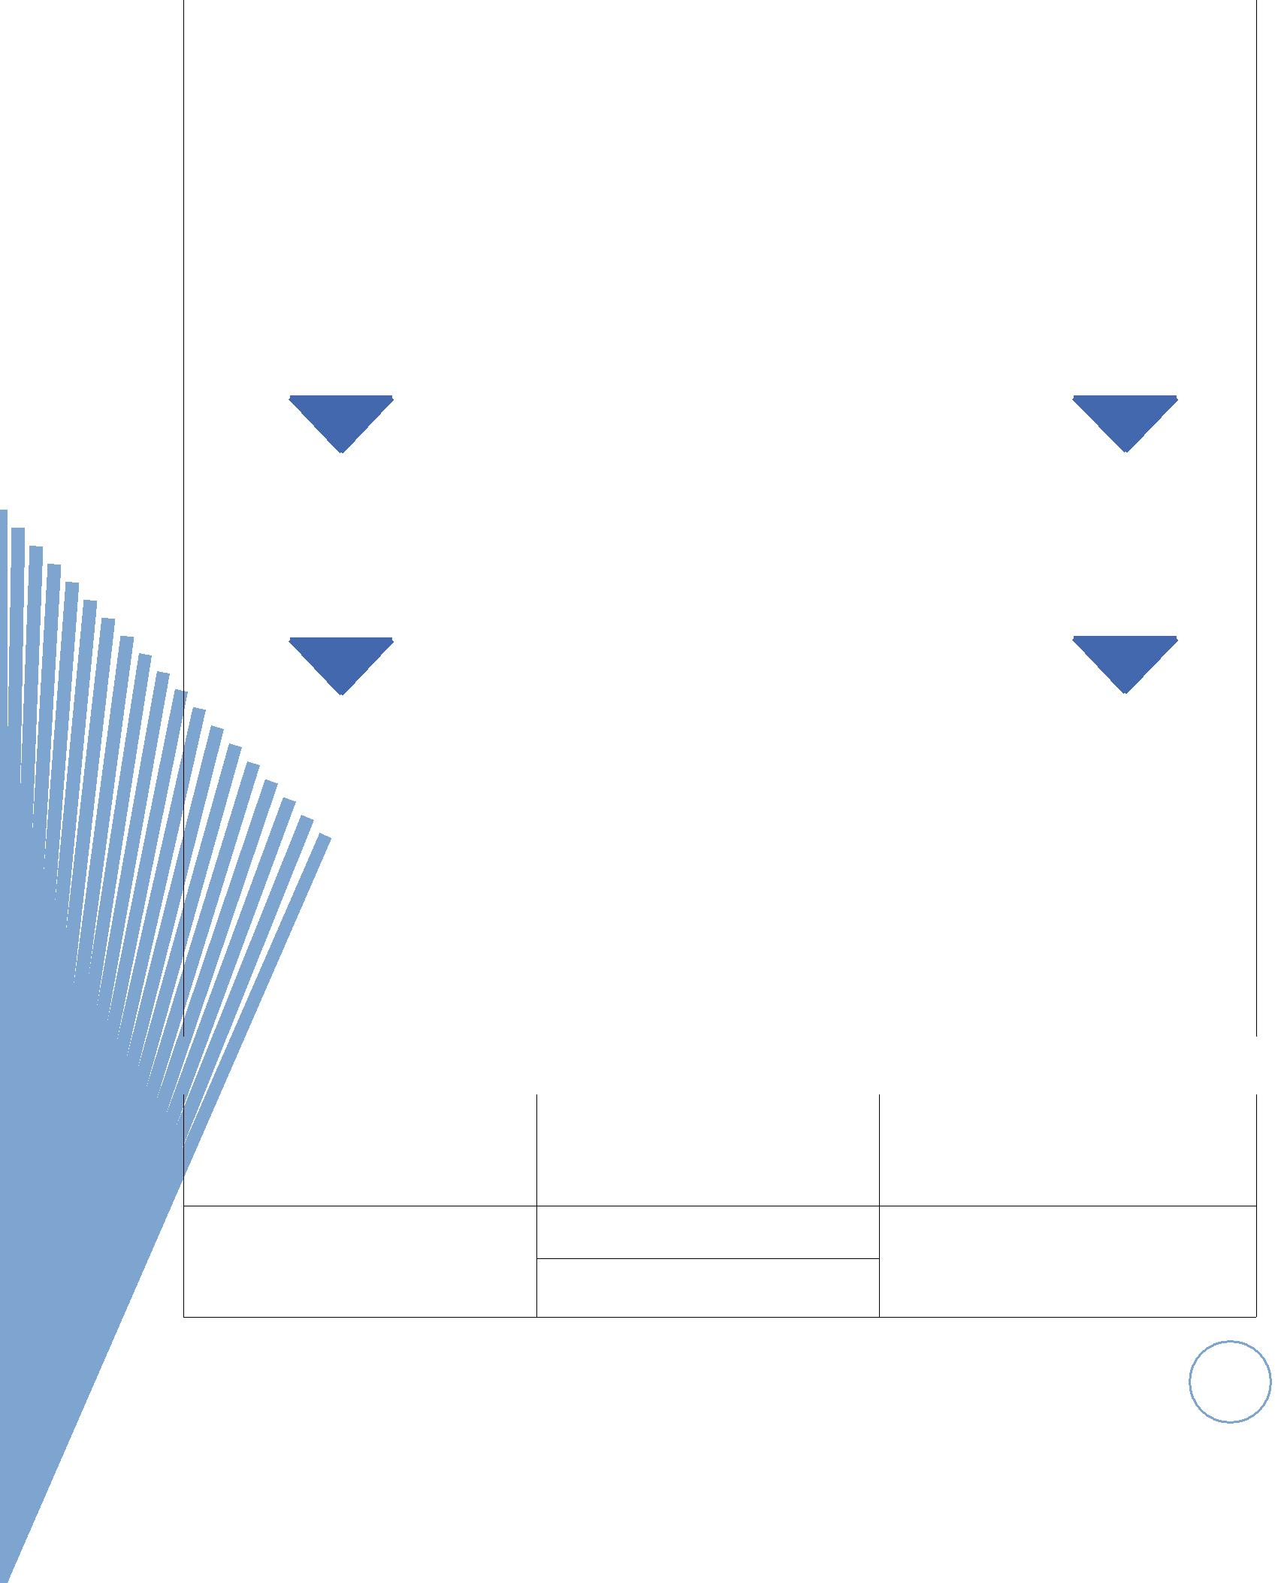

**Time to change each dressing**

|  |  |  |  |  |  |  |  |
| --- | --- | --- | --- | --- | --- | --- | --- |
|  |  | **24 hours** |  | **24 – 48 hours** |  | **24 hours** |  |
|  |  |  |  |  |  |  |  |
|  |  |  |  |  |  |  |  |
|  |  |  |  | Remodelling |  |  |  |
|  |  |  |  |  |  |  |  |
|  |  | Collagen formation to build up |  | Layer of epidermis forms |  | The colour of the wound turning |  |
|  |  | tissue strength |  |  | pink |  |
|  |  |  |  |  |  |

***What to use?***

**ChitoScar**

23

ChitoTech

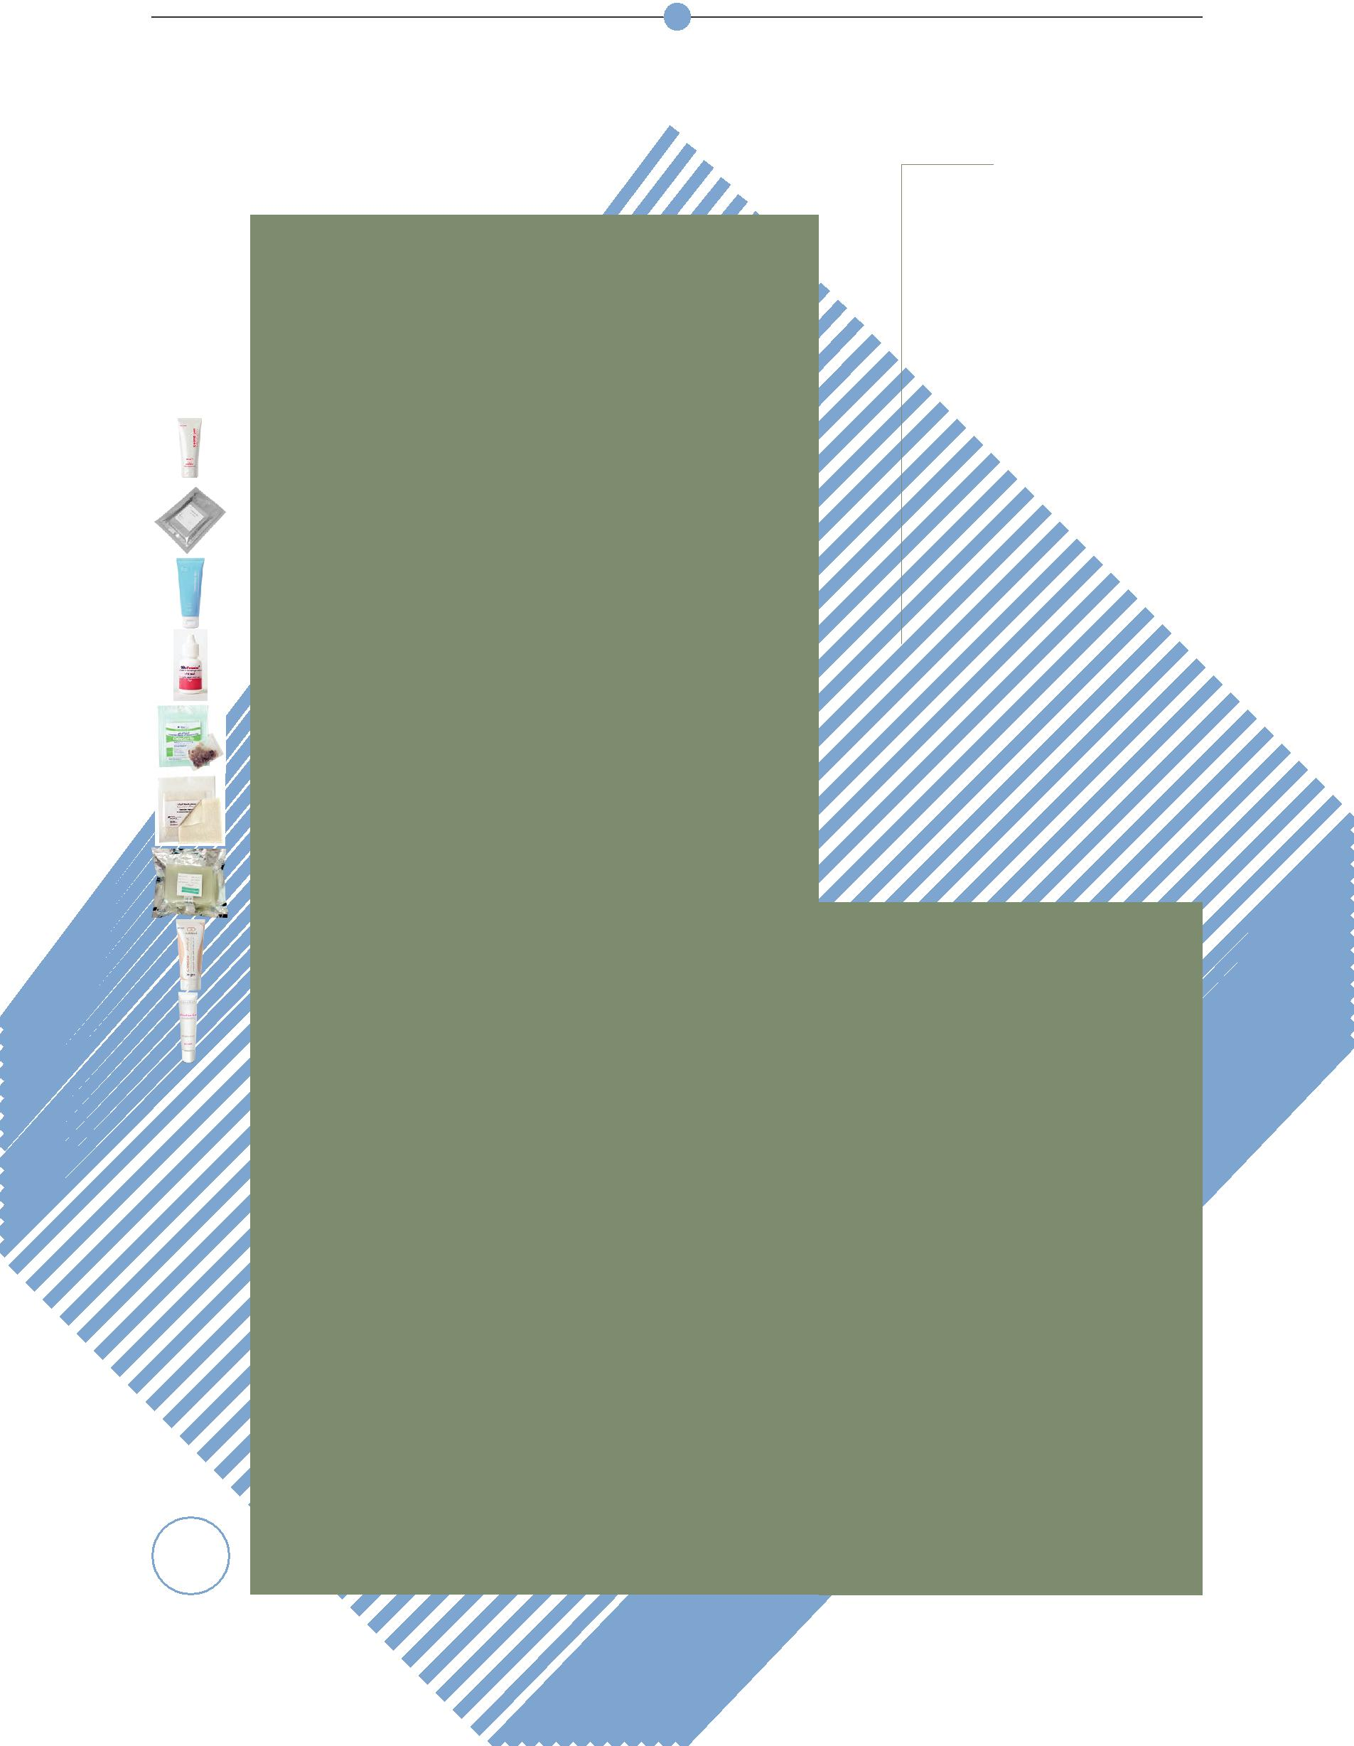

**Wound Healing**

Wound healing dressing as the first prod-ucts of the company are based on the latest medical science achievements and practical principles of moist wound healing methods. The dressings are biocompatible and made from N-acetyl – D- Glucosamine which leads to activate effective factors particularly macrophages in wound heal-ing. They are capable of absorbing wound exudates1-5.

Wound healing is a multifactorial, compli-cated, physiological process. Cellular and biochemical components as well as enzy-matic pathways play pivotal roles during the repair and recovery of a wound tissue. Some natural polymers have excellent structural and physicochemical properties, making them suitable agents for differ-ent applications in medical care of which wound management aids are one of the most important and encouraging modali-ty4.

Mechanism of Action:

They accelerate wound healing process up to 70%, by increasing population of mac-rophages, immune system essential bio-molecules and maintaining optimal moist wound condition.

HSCode = 30059090

References:

1. S. Honardar, S.S. Kordestani, M. Daliri, F. NayebHabib, “The effect of chitosan-based gel on second degree burn wounds.” Journal of wound care 25, no.8 (2016): 489-494.
2. Bahman Ebrahimi-Hosseinzadeh*, Mirsepehr Pedram , Ashrafalsadat Hatamian-Zarmi, Soheila Salahshour-Kord-

24 estani , Mahtab Rasti, Zahra Beagom Mokhtari-Hosseini

|  |  |  |
| --- | --- | --- |
| roductsP | Debrid Gel |  |
| ChitoDebrid Pad |  |
| ChitoHeal Gel |  |
| ChitoHeal Foam |  |
|  |  |
|  | Dressing |  |
|  | ChitoPowder |  |
|  | ChitoCavity |  |
|  | ChitoSorb |  |
|  | Calcium Alginate |  |
|  | Petrolatum |  |
|  | Gauze |  |
|  | ChitoScar |  |
|  | ChitoHeal Gel |  |
|  | Acne Remedy |  |

* and Mohammad Mir-Derikvand. “In vivo Evaluation of Gelatin/Hyaluronic Acid Nanofiber as Burn-wound Healing and Its Comparison with ChitoHeal Gel.” Journal of Fibers and Polymers 17, No.6 (2016): 820-826.

3. Soheila S.kordestani, Farzaneh NayebHabib, Mitra S.Abyaneh, “The role of advanced bioactive wound dressing in treating diabetic foot ulcers.” Journal of JSM foot Ankle 1, No.1 (2016): 1-9.

4. Soheila S. Kordestani, “Natural Bio-polymers: Wound Care Applications”.

Encyclopedia of Biomedical Polymers and Polymeric Biomaterials, (2014):1-14.

5. Kordestani, Soheila S., Shahrezaee. M, Tahmasbi.M.N., Hajimahmodi.H, Hahi Ghasemali.D., Abyaneh.M.S.” A random-ized controlled trial on the effectiveness of an advanced wound dressing used in Iran.” Journal of wound care 17, no.7

(2008):323-327.