Technical Feasibility Test for Open Mobile Network Testbed
------------------
Topology Gui Environment

Table of Contents
A – Glossary 2
I – Introduction 3
II – System overview 3
III – System functionality 3
IV – Development aspects 4
1 – GUI design overview 4
2 – Development tool/framework 5
3 – Application architecture 5
3.1 Design pattern: 5

A – Glossary
HTML5:
RESTful API:
JSON:
IDE:
Eclipse:
GWT:
Chrome:
MVC:

I – Introduction
Topology GUI environment (TGE) is a web application that helps illustrate the Open Mobile Network Testbed (OMNT) topology. Users can perform various interactions with the GUI to examine the whole network topology.
To make it portable and working across different platforms, topology GUI environment is developed to give output as HTML5 (the new web standard markup language).

II – System overview
Figure 1 describes the abstract level of how the TGE fits into the whole OMNT. User have a set of user interface (UI) components such as buttons, menus in the TGE to interact with. Base on that, the TGE will use the OMNT cloud Application Programming Interface (API) to get various topology information. The API is implemented as RESTful web API, thus the API will return JavaScript Object Notation (JSON) as its result.

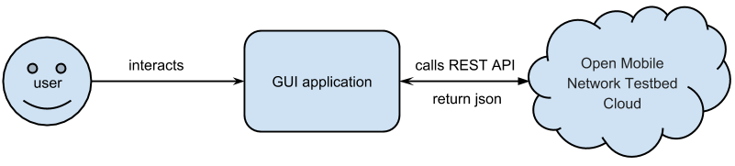
Figure 1: System overview

III – System functionality
The table below describes the set of functionality that user can interact with the TGE

Function | Action
1 – See all OMNT topology information | User clicks on button “get topology”
2 – Zoom into a cluster, get its information | User clicks on “zoom” button, then clicks on a cluster
3 – View a path-flow connection from one end-host/switch (node) to another node in the topology | User clicks on “make path” button, then clicks on two nodes
Table 1: System functionality

IV – Development aspects

1 – GUI design overview
Figure 2 shows the general design of the TGE application. Although it is a web application, the layout is designed to be similar with a normal desktop application including menu bar and task bar, which provides various options to user. For displaying topology information, a left and right panel are used. Both of them can display information in different tabs, where as left panel will display visualized information including image, drawing of shapes, etc, and the right panel will show detail information about the topology such as node IP address, its connection, etc.

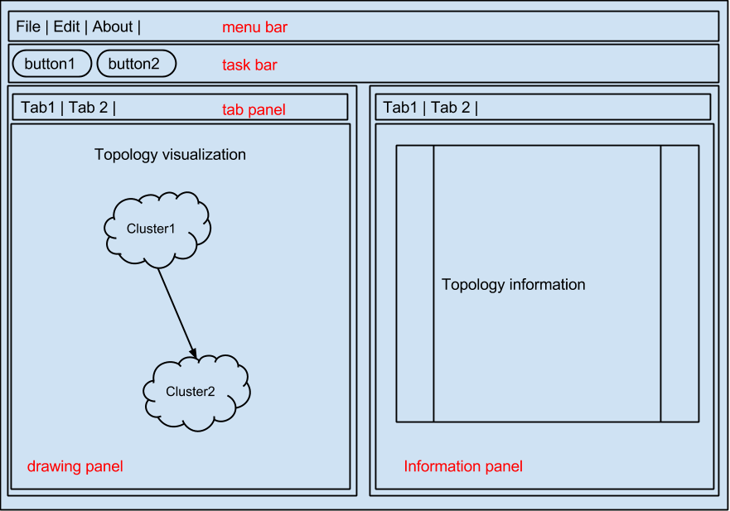
Figure 2: GUI design overview

2 – Development tool/framework
The author uses Google Web Toolkit (GWT) as the framework for development because of the author's proficiency in Java programming language. The chosen Integrated Development Environment (IDE) is Eclipse, an open-source, versatile IDE to help speed up the development process. Other reasons for choosing GWT are the rich set of provided widgets (an UI component) and its strong open-source community. When compiling the source code, GWT will convert Java into JavaScript code to run in the browser. And the main target browser in the development is Google Chrome.

3 – Application architecture

3.1 MVC Design pattern:
The GUI application has medium complexity in user interaction. It can evolve to a complex GUI application later on, to address this issue, the author applied a modified Model-View-Controller pattern when implementing the application. Figure 3 shows how the modified MVC works in TGE. Each view will have its own controller. When a user interacts with the view, the events will be sent to a separate component called the EventBus. The EventBus will perform some reasoning to deliver the event to appropriate controllers. This model focus on centralize event processing to one entity, to help organize and avoid messy event handling.
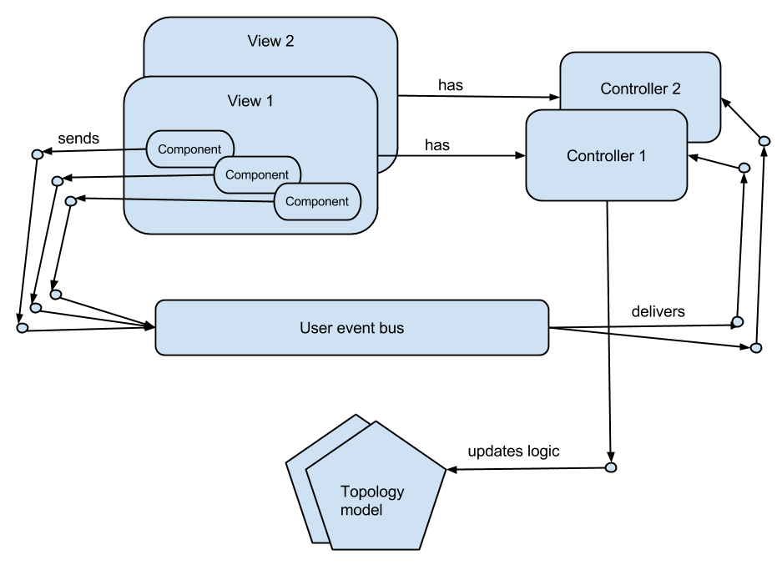
Figure 3: Modified MVC architecture

