Developing with the WIKITUDE API

Content

Introduction 1

Wikitude API Step-by-Step Tutorial 1

Wikitude API Custom Menubutton 5

Contact Information 5

# Introduction

The WIKITUDE API enables any iPhone developer to seamlessly integrate the award winning WIKITUDE Augmented Reality (AR) camera view within any custom iPhone application. The following documentation contains some basic information about the WIKITUDE API including a Step-by-Step-Tutorial.

Every developer who wants to use the WIKITUDE API in full functionality needs to register with Mobilizy GmbH to obtain an API key. After the registration progress the developer receives an E-Mail to the address provided containing all necessary data and the API key which can be used to unlock the camera view and remove the watermarking.

The WIKITUDE API can be used without registration as well. However, in this case the screen will be watermarked, and the developer is not allowed to publish the application in the iPhone market.

# Wikitude API Step-by-Step Tutorial

Add the WikitudeAPI-Folder containing the Static Library, Public Headers and Resources to your iPhone-Project in Xcode.

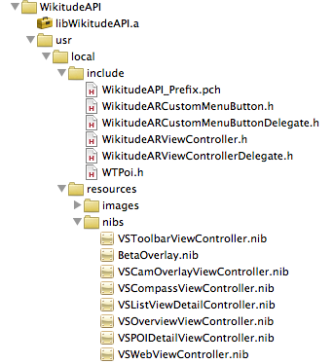

Add the following Frameworks to your iPhone-Project in Xcode:

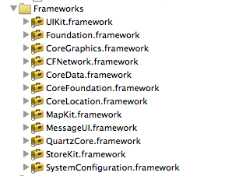

Add the following Linker Flags to your Project's and Target's Build Settings:

**-all_load**

**-ObjC**

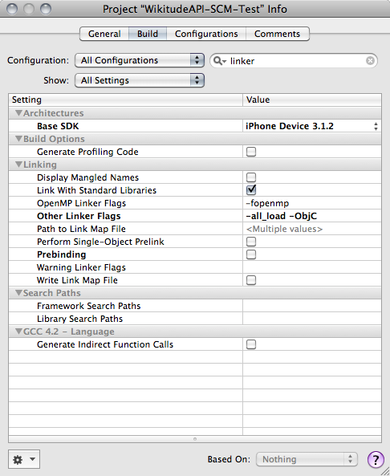

Within your custom application, create a new WikitudeARViewController:

WikitudeARViewController* wikitudeAR = [[WikitudeARViewController alloc]

initWithDelegate :wikitudeARDelegate

applicationPackage :APPPACKAGE

applicationKey :APPKEY

applicationName :APPNAME

developerName :DEVNAME];

Parameters:

- The wikitudeARDelegate has to implement the WikitudeARViewControllerDelegate protocol:

(void) verificationDidSucceed

This method is called when the wikitudeAR Instance has been properly instantiated.

(void) verificationDidFail

This method is called when the WikitudeARViewController could not be instantiated.

(void) APIFinishedLoading

This method is called after the camera view has been loaded correctly. This method can be used i.e. to add a Custom Menu to the camera view via the addMenuItem: WikitudeARCustomMenuButton* menuButton (...) method or to add POIs to the camera view via the addPOIs:NSMutableArray* POIs method.

(void) didUpdateToLocation: (CLLocation*) newLocation

fromLocation: (CLLocation*) oldLocation

This method is called everytime the location has been updated.

(void) actionFired:(WTPoi*)aPOI

This method is called when a user clicks the action button within the bubble of aPOI in the AR camera view the info view of a POI.

- String APPPACKAGE

- String APPNAME

- String APPKEY is the key provided by Mobilizy for every registered application, which makes usage of the Wikitude API. Use nil if you want to use the watermarked version of the API.

- String DEVNAME is the developer name submitted during the registration process of the application. If no APPKEY is submitted, DEVNAME will not be checked.

The start method on the wikitudeAR object (preferably called within the verificationDidSucceed method) returns an instance of UIView - the camera view.

The hide method dismisses the camera view. This needs to be called when the another view in the application wants to be displayed.

If the camera view should be displayed again, call the show method.

The reloadPOIs method can be used to update the POIs in the camera view.

Add up to 3 custom menu buttons (preferably within the APIFinishedLoading method) by calling

[wikitudeAR addMenuItem:(WikitudeARCustomMenuButton*)menuItem

atPosition: (int) position]

Create WTPoi-Objects, each representing one Point of Interest (POI) to be displayed on the Augmented Reality (AR) camera view. The fields which can be set are:

**float** latitude (required, the latitude of the POI)

**float** longitude (required, the longitude of the POI)

**float** altitude (in meters, the altitude of the POI, defaults to 0)

**NSString\*** name (defaults to “Name unknown”)

**NSString\*** shortDescription (defaults to “”; the text which is displayed in the bubble when the POI is selected)

**NSString\*** url (an arbitrary URL called in a WebView when the user clicks on the WWW-button in the bubble of the POI in the AR camera view)

**NSString\*** icon (the URL of the icon representing the POI in the AR view)

**NSString\*** thumbnail (the URL of the thumbnail which should be displayed in the bubble view of a in the AR view)

The number of POIs displayed in the AR view is arbitrary. However, a maximum number of 50 POIs is suggested for performance reasons.

Add the generated POIs to the camera view (preferably within the APIFinishedLoading method) for example with

[wikitudeAR addPOIs: POIs]

If necessary, set the flag for not drawing the POI-title-teaser beneath the marker (default setting is to draw the teaser):

wikitudeAR.setPrintMarkerSubText(**false**);

**Remark:**

After starting the wikitudeAR, the system checks if the application was approved to use the API (e.g. a valid combination of application key, application name and developer name was provided). This check requests the Wikitude server and is executed on a weekly basis.

# Wikitude API Custom Menubutton

A developer can define up to 3 customized menu-buttons and actions to control the program flow. When the user presses the “menu”-button, the customized buttons will show up.

For each WikitudeARCustomMenuButton a delegate, which implements the WikitudeARCustomMenuButtonDelegate protocol has to be defined. When the user clicks on a menu button the customMenuButtonPressed:(WTPoi*)currentSelectedPoi method of the delegate is called.

# Contact Information



*The World IS the Platform!*

Mobilizy GmbH

Jakob-Haringer Str 5/IV

5020 Salzburg

Austria

Phone: +43 662 45 45 55 – 425

Fax: +43 662 45 45 55 - 410

Web: [www.mobilizy.com](http://www.mobilizy.com)

[developers@wikitude.me](mailto:developers@wikitude.me)

Follow us on twitter: <http://twitter.com/wikitude>

and on facebook (search for Wikitude).