

BestSolution.at EDV Systemhaus GmbH

heroku Eclipse plugin 0.1.0
Development Setup

Project: heroku Eclipse plugin
Author: Tom Schindl
Version: 2012-08-01

Copyright (c) by BestSolution.at EDV Systemhaus GmbH
All Rights Reserved.

BestSolution.at MAKES NO REPRESENTATIONS OR WARRANTIES ABOUT THE SUITABILITY OF THIS SPECIFICATION, EITHER EXPRESS OR IMPLIED, INCLUDING BUT NOT LIMITED TO THE IMPLIED WARRANTIES OF MERCHANTABILITY, FITNESS FOR A PARTICULAR PURPOSE, OR NON-INFRINGEMENT OR ANY WARRANTY OTHERWISE ARISING OUT OF ANY PROPOSAL, SPECIFICATION OR SAMPLE.

No license, express or implied, by estoppel or otherwise, to any intellectual property rights is granted herein.

This Specification as well as the software described in it is furnished under license and may only be used or copied in accordance with the terms of the license. The information in this document is furnished for informational use only, is subject to change without notice, and should not be construed as a commitment by BestSolution.at. BestSolution.at assumes no responsibility or liability for any errors or inaccuracies that may appear in this document or any software that may be provided in association with this document.

This specification must not be used, redistributed, stored, transmitted or based upon in any other than the designated way without express written consent of BestSolution.at.

Abstract
heroku Eclipse plugin is an extension to the well known Eclipse Java IDE, allowing developers to work with their existing heroku applications or create new ones using predefined templates. It also allows users to manage their existing applications in terms of performance, monitoring, user management and more.

This document describes how to set up the environment to develop the plugin itself.
Table of Contents
Downloading essential pieces 5
Preparing the „target platform“ 5
Create a local folder structure on your filesystem 5
Download Eclipse SDK 3.7.0 for your Platform 5
Configure workspace to compile for a specific target 6
Launching the plugin from within the IDE 8
Running JUnit-Tests 8
Preparation for the tests 8
Heroku test users 8
SSH key used by local Eclipse 9
Linux secure keystore pecularity 9
Launch core JUnit-Tests 9
Launch UI JUnit-Tests 9
Development Requirements 11
Status of this Document 12

Downloading essential pieces
- Download Eclipse J2EE >= 3.7.2 from http://www.eclipse.org
- Install the eGit plugin from http://download.eclipse.org/egit/updates
- Install the SWTBot plugin from http://download.eclipse.org/technology/swtbot/helios/dev-build/update-site

Preparing the „target platform“
The „target platform“ is a collection of software „pieces“ required to develop the plugin. Those pieces are typically other Eclipse bundles and plugins. As such, the required pieces must be downloaded and stored in a static location.

Create a local folder structure on your filesystem
Proposed base location:
- win32: C:\dev\heroku_plugin\target
- mac: /Users/$USER/dev/heroku_plugin/target
replace $USER with your real user name
- linux: /opt/heroku_plugin/target
Create three folders inside the „target“ folder from above:
- target
- delta-pack-37
- jdt-37
- platform-37

Download Eclipse SDK 3.7.0 for your Platform
Download from http://archive.eclipse.org/eclipse/downloads/drops/R-3.7-201106131736/
- Platform SDK – Platform Source Repo
- DeltaPack - All
- JDT SDK – JDT Source Repo

Unzip the downloaded zip-Files and move the content to the respective target folders so that the folder structure now looks like this
- target
  - delta-pack-37
    - features
    - ...
  - jdt-37
    - artifacts.jar
    - ...
  - platform-37
    - artifacts.jar
    - …

Configure workspace to compile for a specific target
- Open the Eclipse Preferences and navigate to „Run/Debug > String Substitution“
- Create a new substitution using the „New …“ Button on the right
Name: heroku_target
Value: Location of your target folder e.g. „/Users/$USER/dev/heroku_plugin/target“
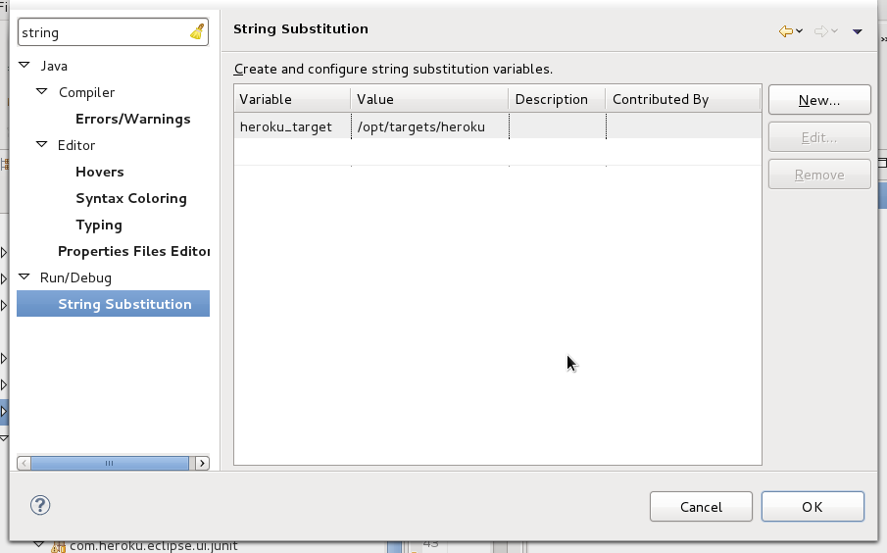Illustration 1: set up the "heroku_target" Eclipse variable

- Clone the heroku-git repo from github.com and import the following plugins:
Plugin name | Description
com.heroku.api | OSGi wrapper for the heroku-api.jar
com.heroku.eclipse.core.serivces | Service interface definitions
com.heroku.eclipse.core.services.junit | Service unit tests
com.heroku.eclipse.core.services.rest | REST service implementation
com.heroku.eclipse.feature | Eclipse feature definition for the plugin
com.heroku.eclipse.ui | UI code
com.heroku.eclipse.ui.junit | UI unit tests
com.heroku.eclipse.updatesite | Bundle defining how the plugin's update site is created
heroku-eclipse-useragent | UserAgentValueProvider implementation identifying the Eclipse plugin
releng | Release engeneering stuff, defining ie. the target platform used for automated building

- Open the Eclipse Preferences and navigate to „Plug-in Development > Target Platform“ and set the checkbox on the „heroku“ entry in the list, that will appear once the git cloning from step 3 has been completed:
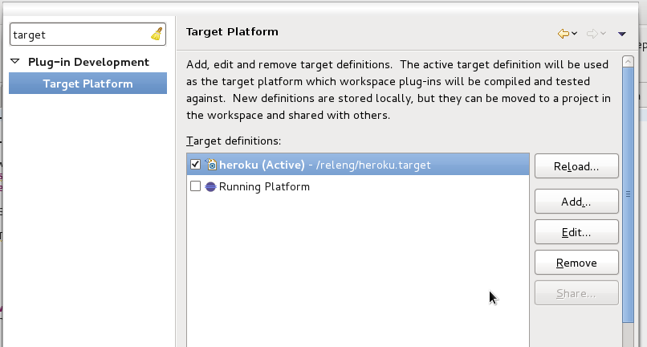Illustration 2: activate the "heroku" target platform

Launching the plugin from within the IDE
To launch an internal Eclipse session of the plugin, open the context menu on the „Package Explorer“ and select „Run As > Eclipse Application“.
An additonal Eclipse instance should come up now, integrating the plugin from the development instance.

Running JUnit-Tests

Preparation for the tests

Heroku test users
In order to run the tests, two seperate test accounts have to be set up with Heroku. You need to tell Eclipse about the login details (username, password and API key) of those users:
Open the Eclipse preferences, navigate to „Run/Debug > String Substitution“ and create the following new substitutions using the „New ...“ button on the right :
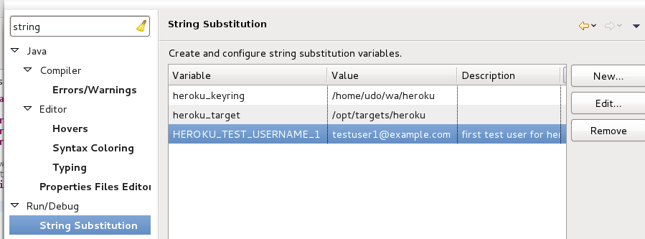Illustration 3: adding variables required for testing
- Name: HEROKU_TEST_USERNAME_1, Value: $USER1
- Name: HEROKU_TEST_PWD_1, Value: $PWD1
- Name: HEROKU_TEST_APIKEY_1, Value: $API_KEY1
- Name: HEROKU_TEST_USERNAME_2, Value: $USER2
- Name: HEROKU_TEST_PWD_2, Value: $PWD2
- Name: HEROKU_TEST_APIKEY_2, Value: $API_KEY2
$USER1, $PWD1 and $API_KEY1 have to be replaced by valid heroku user account data used for testing. The same goes for $USER2, $PWD2 and $API_KEY2.

SSH key used by local Eclipse
In order to run the tests, the local user must have setup valid and passwordless SSH keys in the development Eclipse.

Linux secure keystore pecularity
Contrary to Windows and OS/X, Linux key managment is not well integrated with Eclipse's secure store.
So at the time of writing, when developing under Linux, you will first have to unzip the seperatly available „keyring.zip“ file into your „target“ directory from step Preparing the „target platform“ on page 5.

Launch core JUnit-Tests
The „core“ JUnit tests cover the entire „service“ side of the plugin and do not use any GUI code, residing in the com.heroku.eclipse.ui bundle. The UI is tested seperately, see Launch UI JUnit-Tests on page 9.
Open the context menu on „...core.services.junit/All Tests.launch“ and select „Run As > All Tests“:
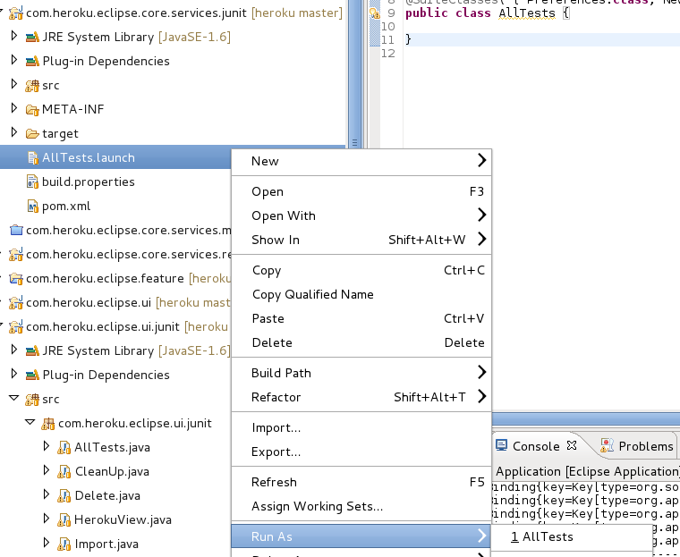Illustration 4: run all core tests

Launch UI JUnit-Tests
The UI JUnit tests are based upon SWTBot. SWTBot allows to run an application and behave like an immaginary user clicking on buttons, filling in text and so on.
Furthermore, in order to run the tests, the local user must have setup valid and passwordless SSH keys password in the development Eclipse.
Once the plugin has been installed, run the UI tests by right clicking the launcher config found in „...core.services.ui.junit/launchConfigurations/SWTBot AllTests.launch“.
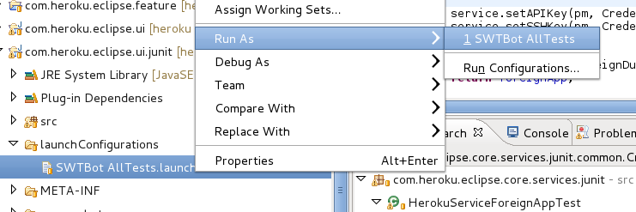Illustration 5: run all UI JUnit tests

Development Requirements
The plugin was developed using Eclipse 3.7.2, running on Java 6 on standard Fedora® Core 17 and OS/X® Lion workstations.
It has been tested to run under Windows® XP SP3 and Windows® 7 SP1, running the latest Java 6 version.

Status of this Document
2012-07-26: initial creation, tom.schindl@bestsolution.at
2012-07-27: UI unit tests setup, short description of the plugins, minor text corrections,
installation requirements, udo.rader@bestsolution.at
2012-08-01: detailled required preparations for the unit tests, added Eclipse J2EE
requirement, udo.rader@bestsolution.at

