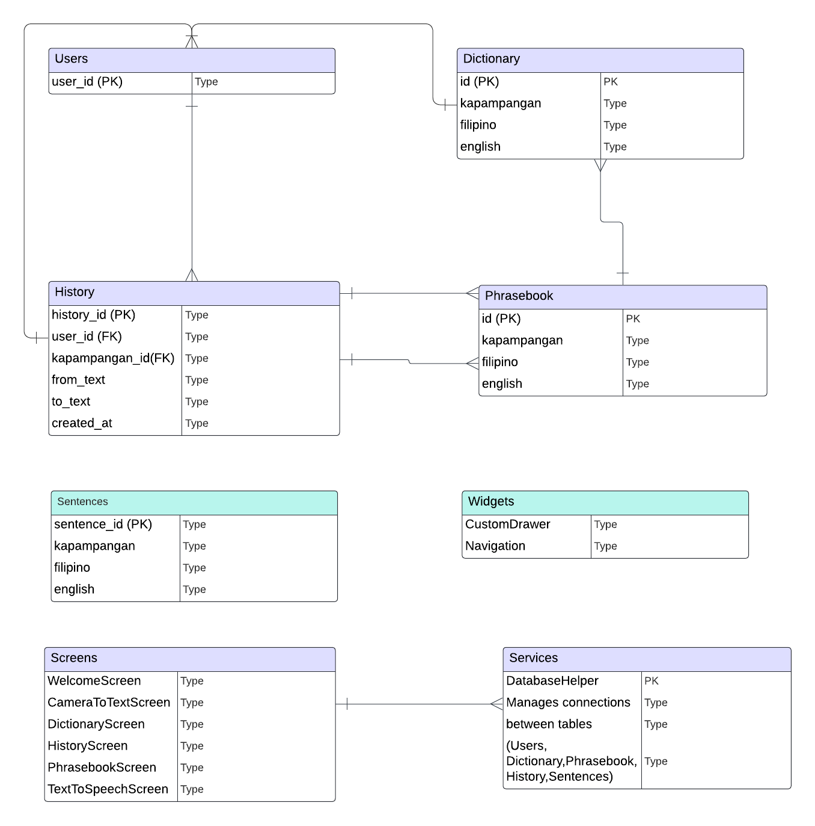

The figure above represents the relationship between the key entities in the system. **Users** store the details of system users, including their user_id, username, and email. The user_id (PK) is referenced in the **History** table as user_id (FK) to track which user performed a translation.

**Dictionary** contains individual Kapampangan words and their translations. Each word has an id (PK), which is referenced by the **History** table via kapampangan_id (FK) to track which word is translated. Similarly, **Phrasebook** stores common phrases in Kapampangan, Filipino, and English, with its id (PK) also referenced in the **History** table.

The **History** table logs each translation, linking the user_id (FK) to **Users** and kapampangan_id (FK) to either **Dictionary** or **Phrasebook**. It also records the original text (from_text), translated text (to_text), and the time of the translation (created_at).

**Sentences** table stores longer sentences in Kapampangan, along with their translations into Filipino and English. It is used to store complete phrases or paragraphs instead of individual words.

The system’s **Screens** provide the user interface, allowing users to interact with the data. Screens like **DictionaryScreen**, **PhrasebookScreen**, and **HistoryScreen** communicate with the database via **Services**. **DatabaseHelper** manages data storage and retrieval, ensuring that the data from tables like **Users**, **Dictionary**, **Phrasebook**, **History**, and **Sentences** is correctly handled.

**Widgets**, like the **CustomDrawer**, allow navigation between the screens. This provides a smooth user experience, enabling easy access to different features of the system.