multi_state_quarto

HERON-UK-02-002-CVDValveReplacement

Incidence

Age-standardised incidence by socioeconomic status
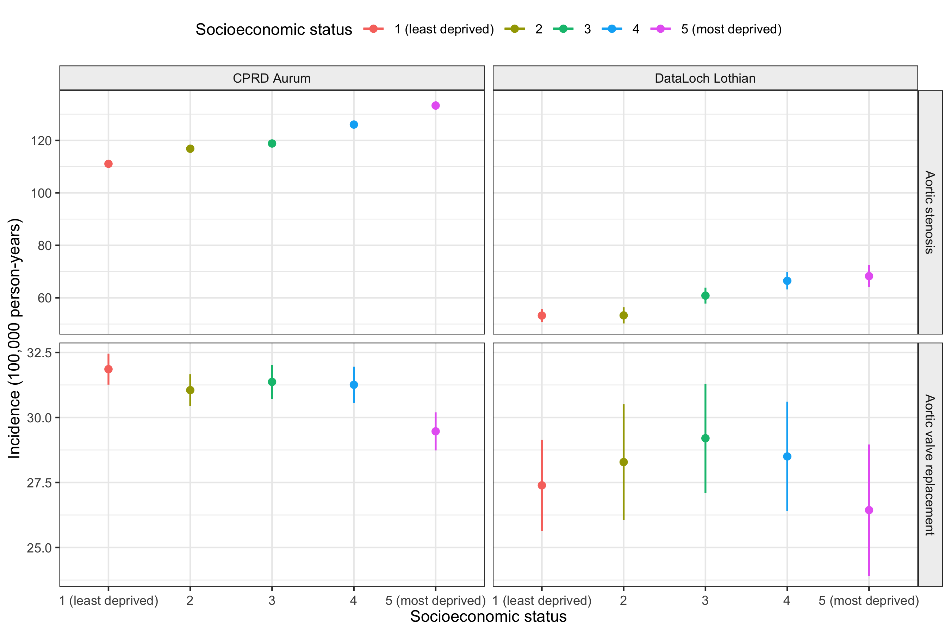

Incidence by age and socioeconomic status
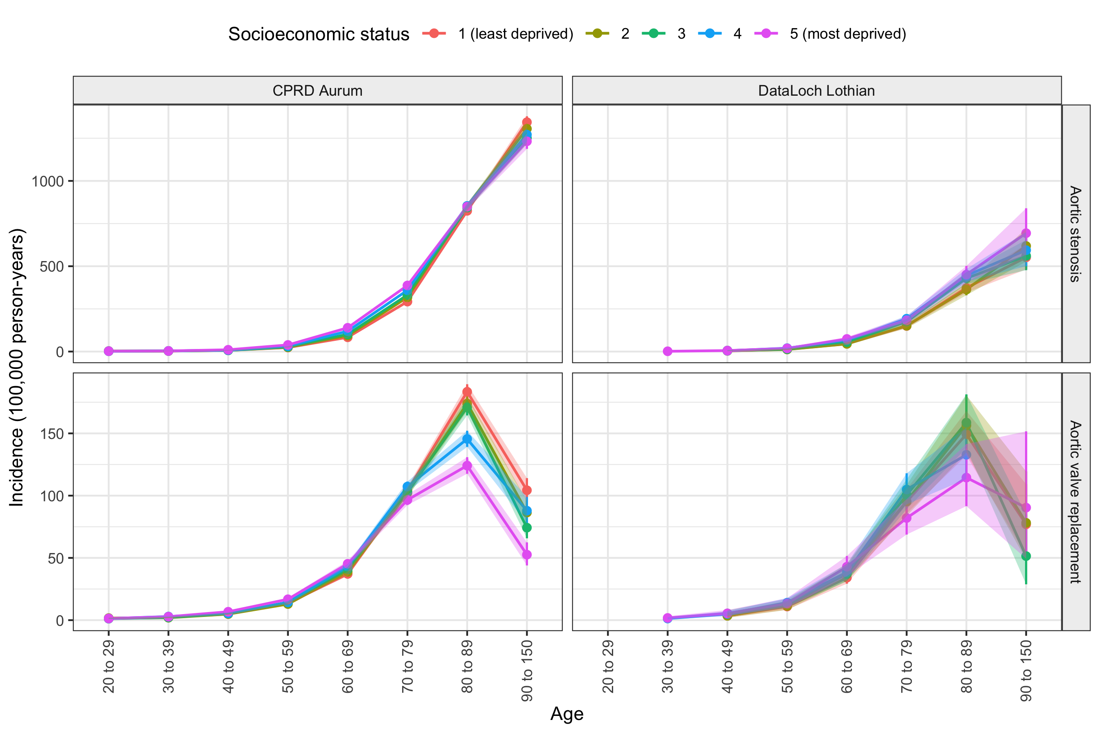

Incidence by year and socioeconomic status
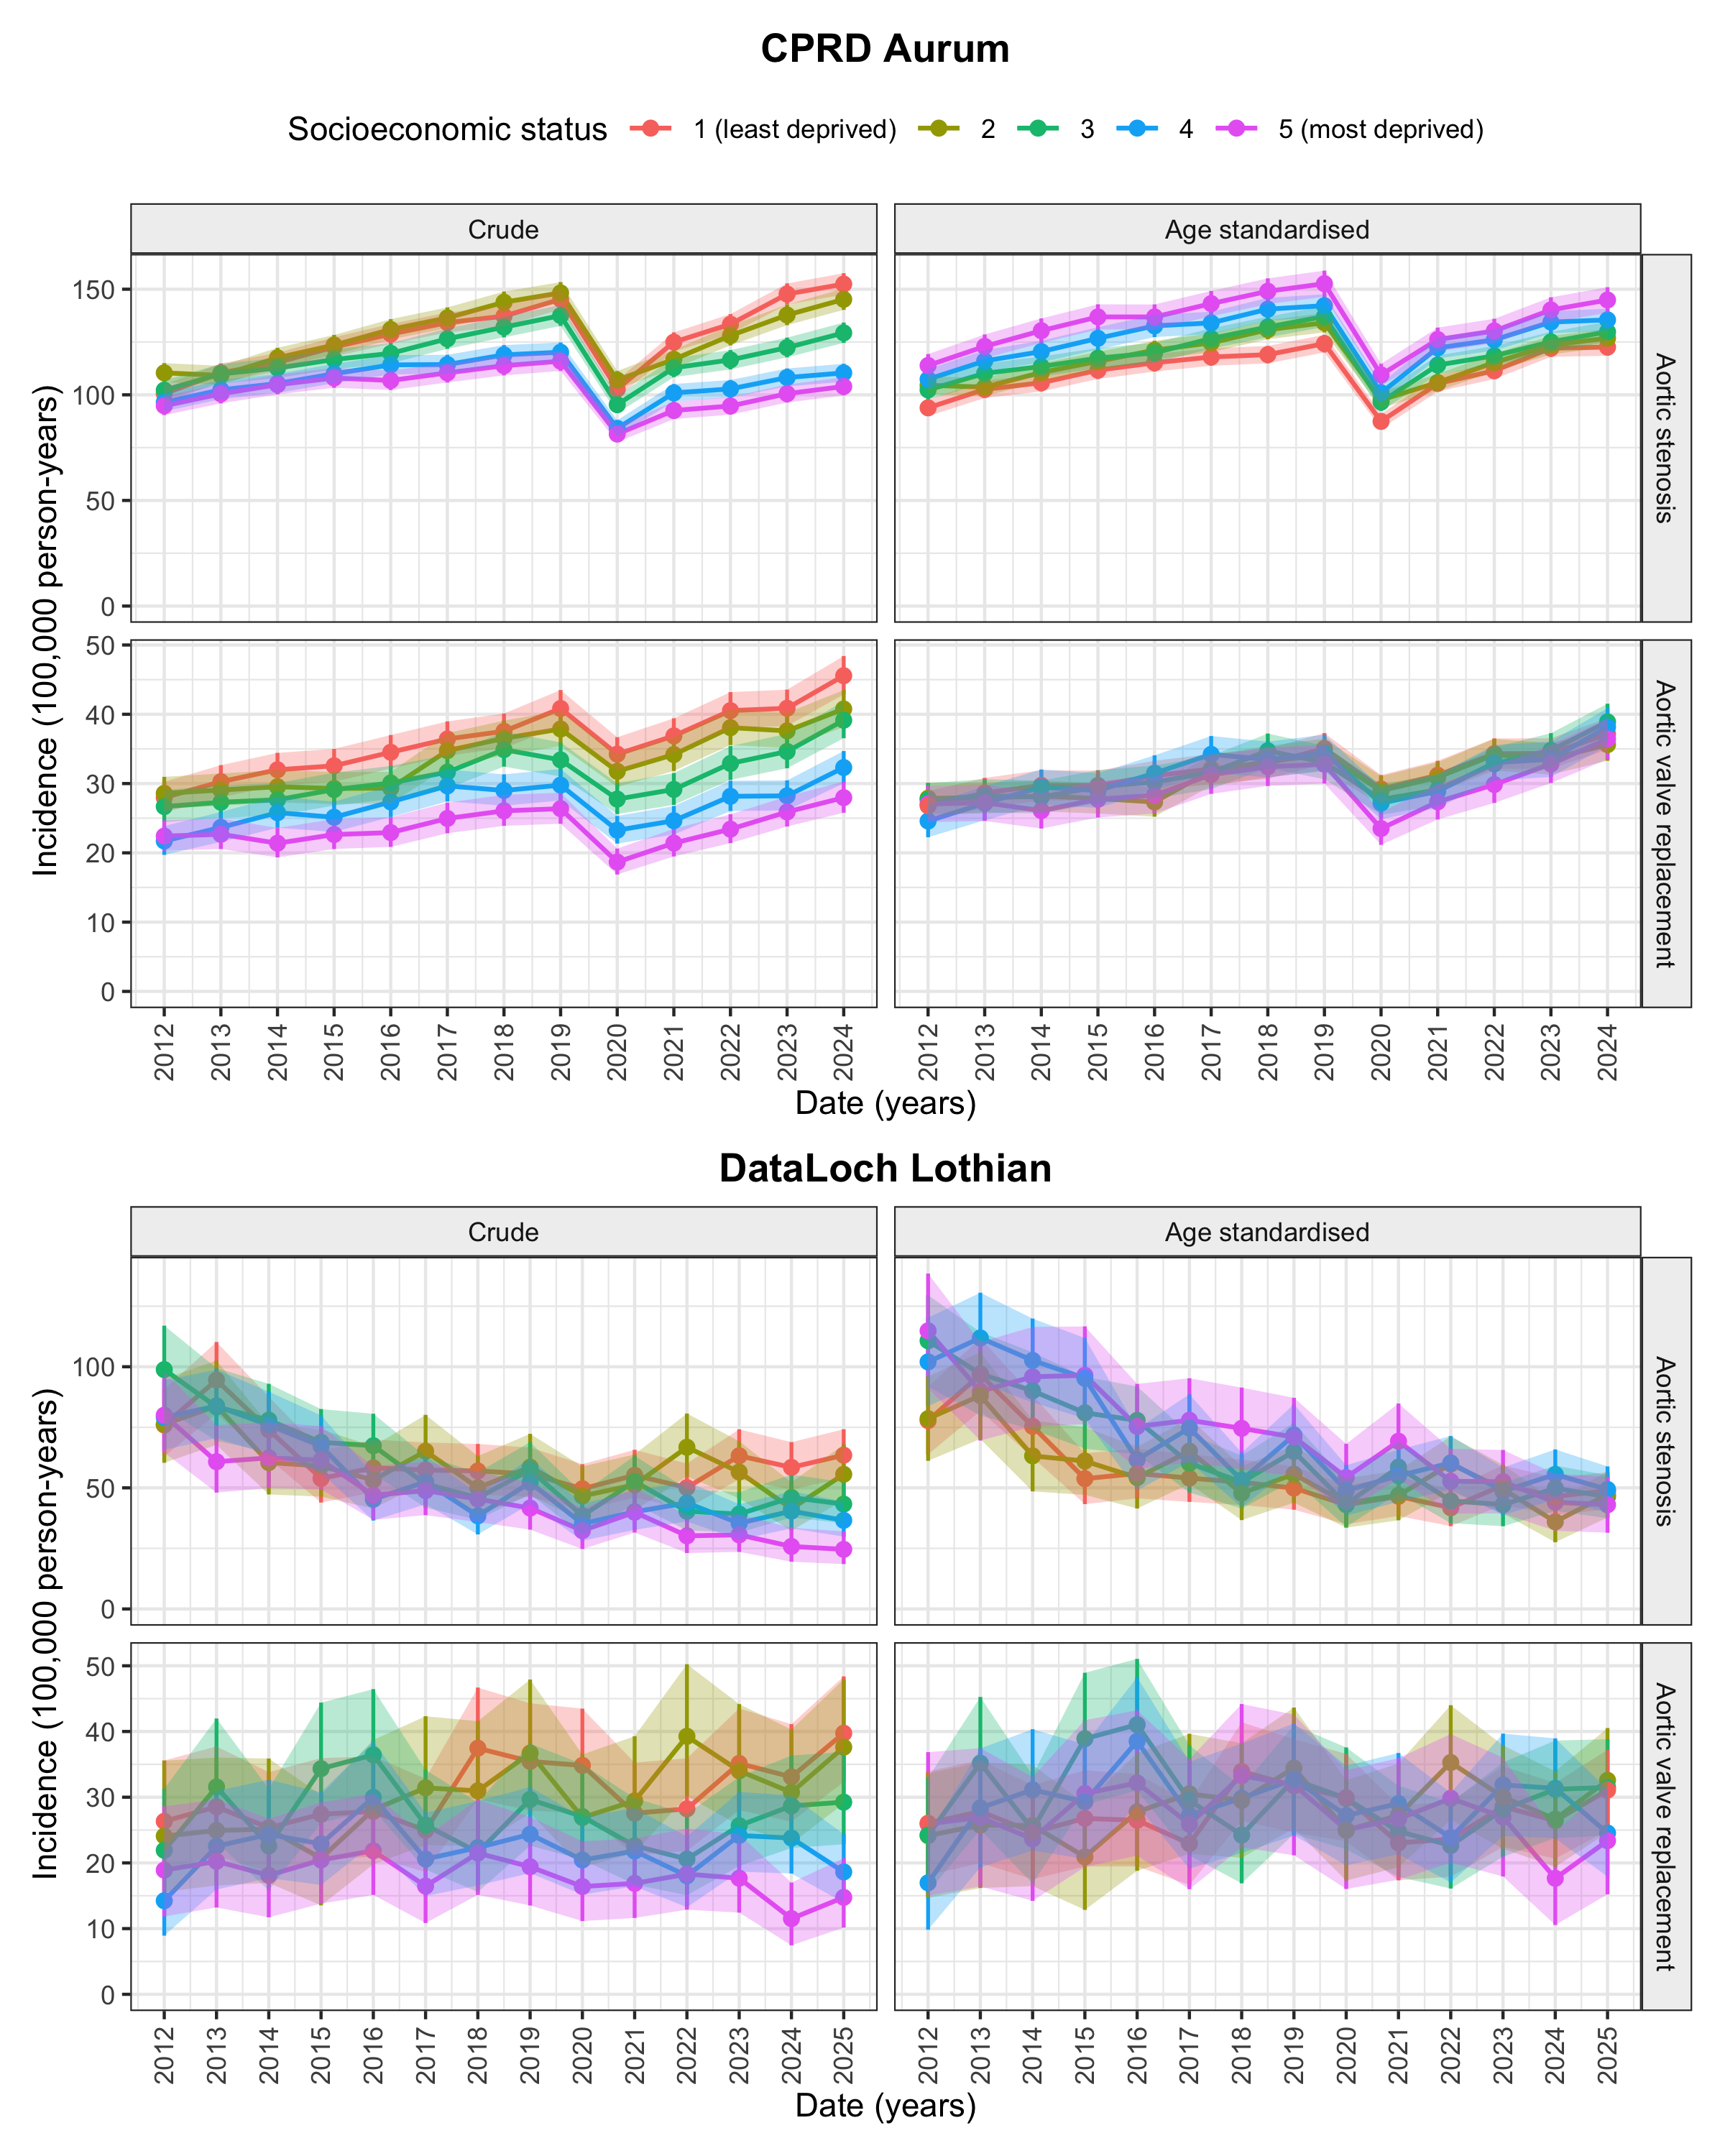
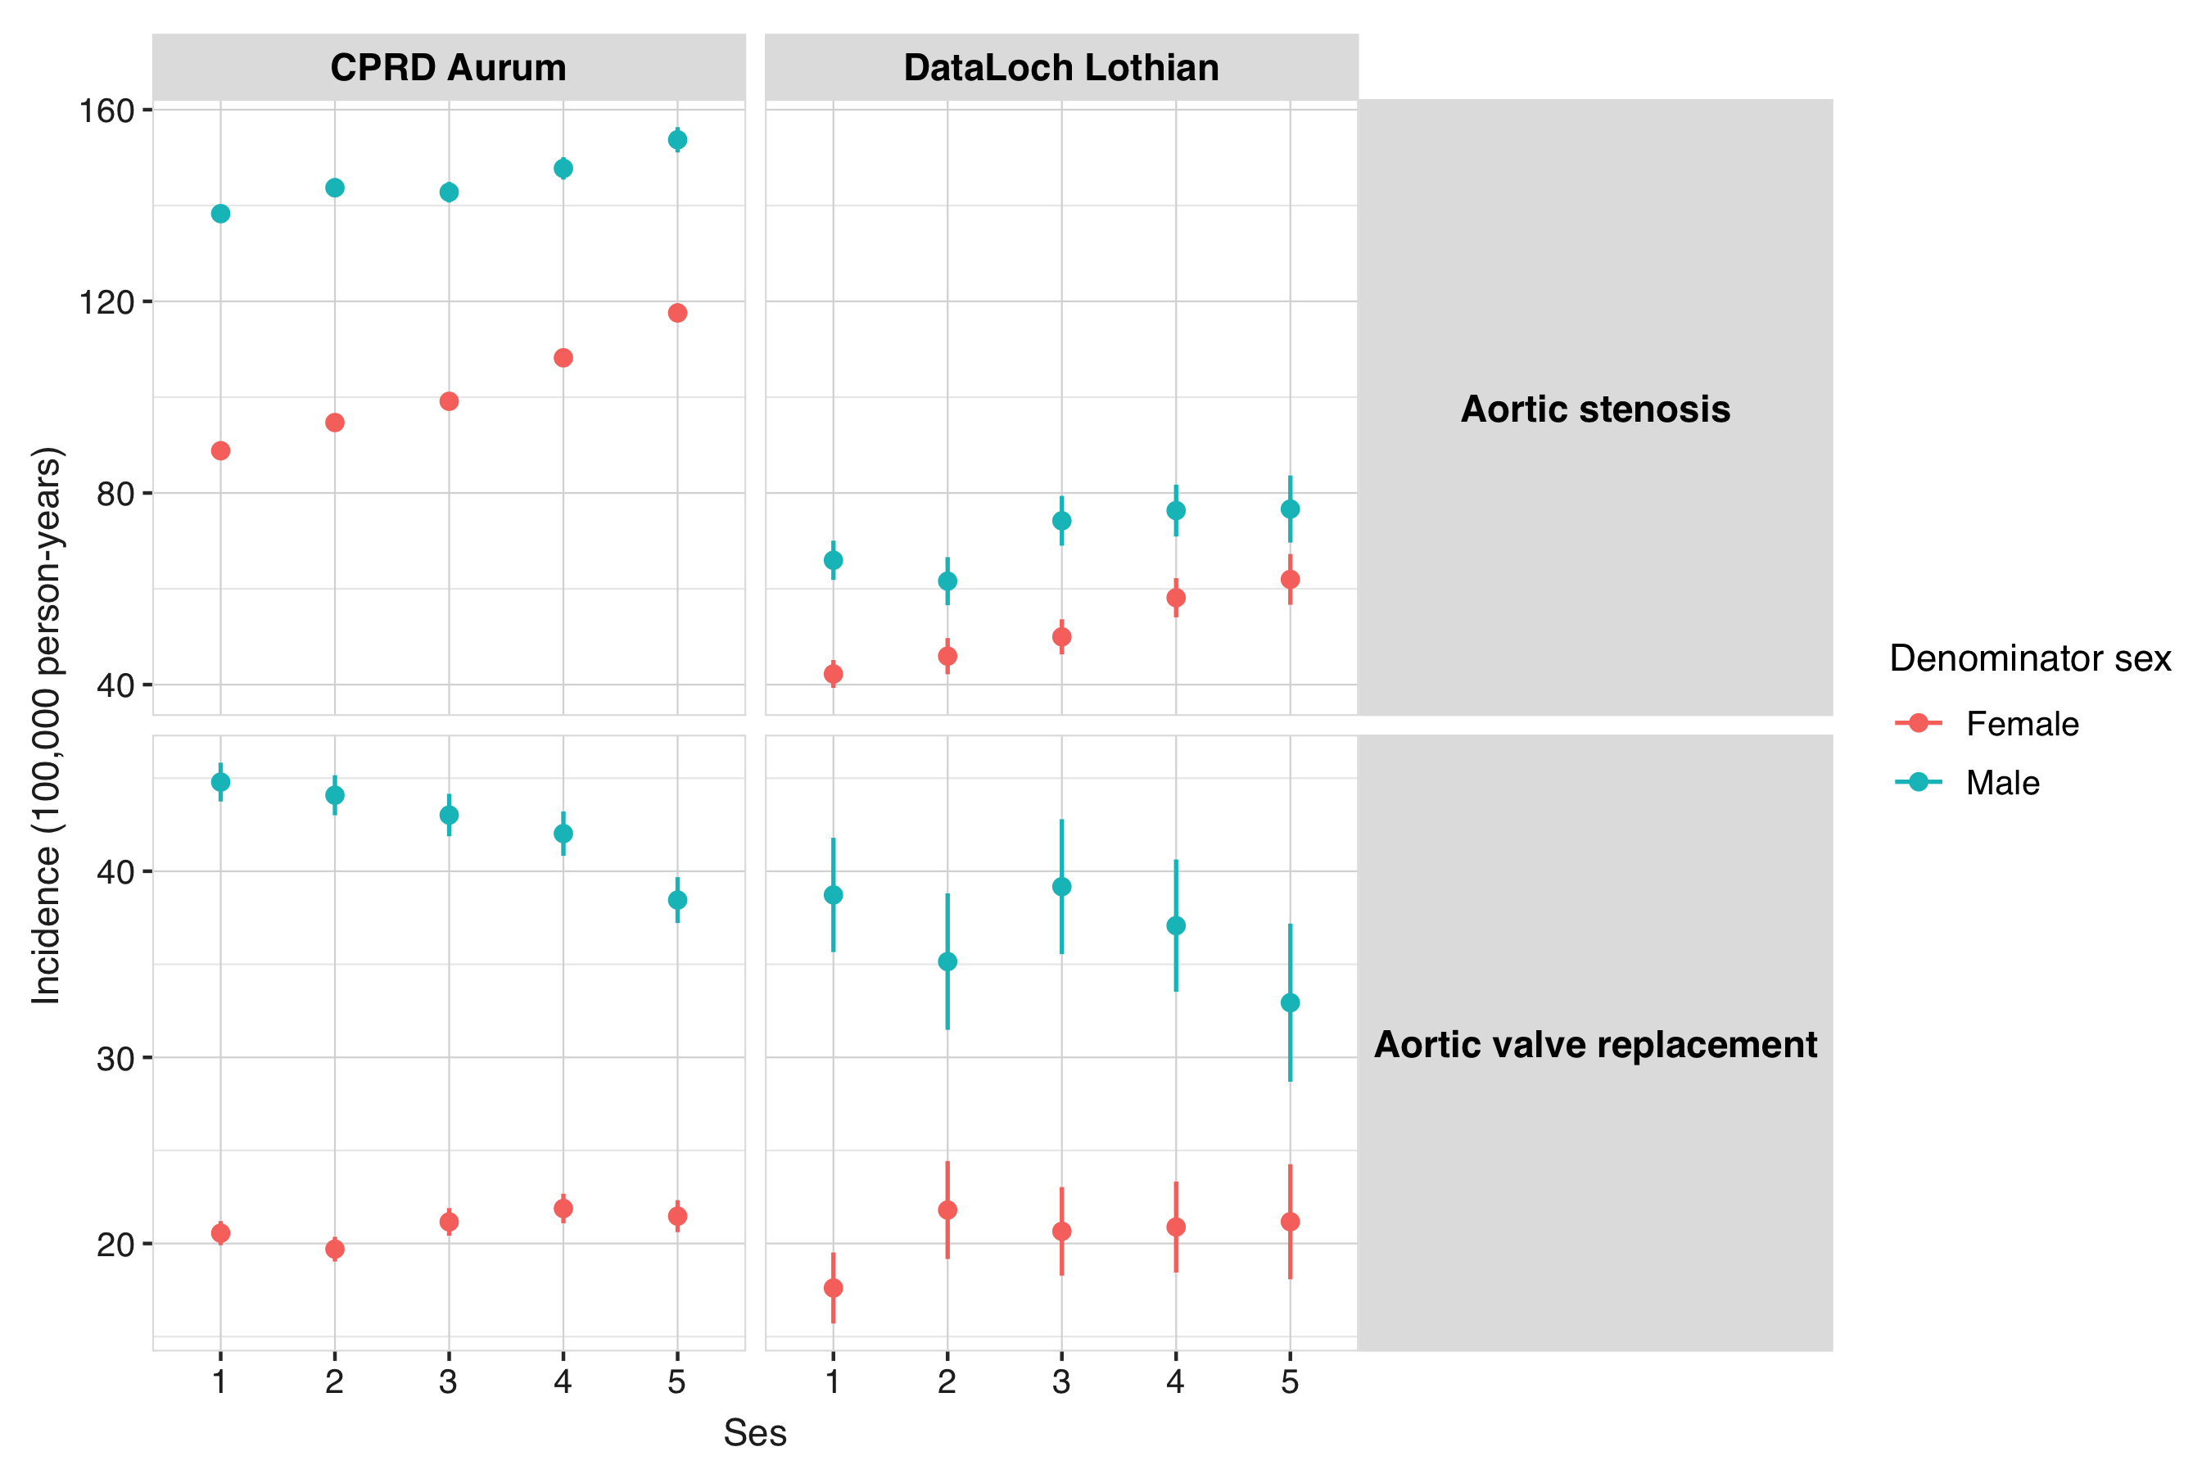

Characteristics
Data source | Ses | Healthy | Healthy to as | Estimate value
CPRD Aurum | 1 | 4476073 | 38559 | 0.861447076488699
 | 2 | 4552529 | 37019 | 0.813152425827491
 | 3 | 4562136 | 32484 | 0.712034888920453
 | 4 | 5002170 | 30659 | 0.612913995326029
 | 5 | 4432642 | 26959 | 0.608192585821278
DataLoch Lothian | 1 | 287658 | 1823 | 0.63373867578861
 | 2 | 200096 | 1163 | 0.581221013913322
 | 3 | 280287 | 1526 | 0.544441947004321
 | 4 | 327516 | 1574 | 0.480587207953199
 | 5 | 259752 | 1036 | 0.39884197234285
cdm_name | ses | count | percentage
CPRD Aurum | overall | 23058763 | 100.0000000
CPRD Aurum | 1 | 4476073 | 19.4115920
CPRD Aurum | 2 | 4552529 | 19.7431623
CPRD Aurum | 3 | 4562136 | 19.7848254
CPRD Aurum | 4 | 5002170 | 21.6931411
CPRD Aurum | 5 | 4432642 | 19.2232428
CPRD Aurum | Missing | 33213 | 0.1440363
DataLoch Lothian | overall | 1509057 | 100.0000000
DataLoch Lothian | 1 | 287658 | 19.0621030
DataLoch Lothian | 2 | 200096 | 13.2596714
DataLoch Lothian | 3 | 280287 | 18.5736523
DataLoch Lothian | 4 | 327516 | 21.7033551
DataLoch Lothian | 5 | 259752 | 17.2128687
DataLoch Lothian | Missing | 153748 | 10.1883494

Multi state model

only age model
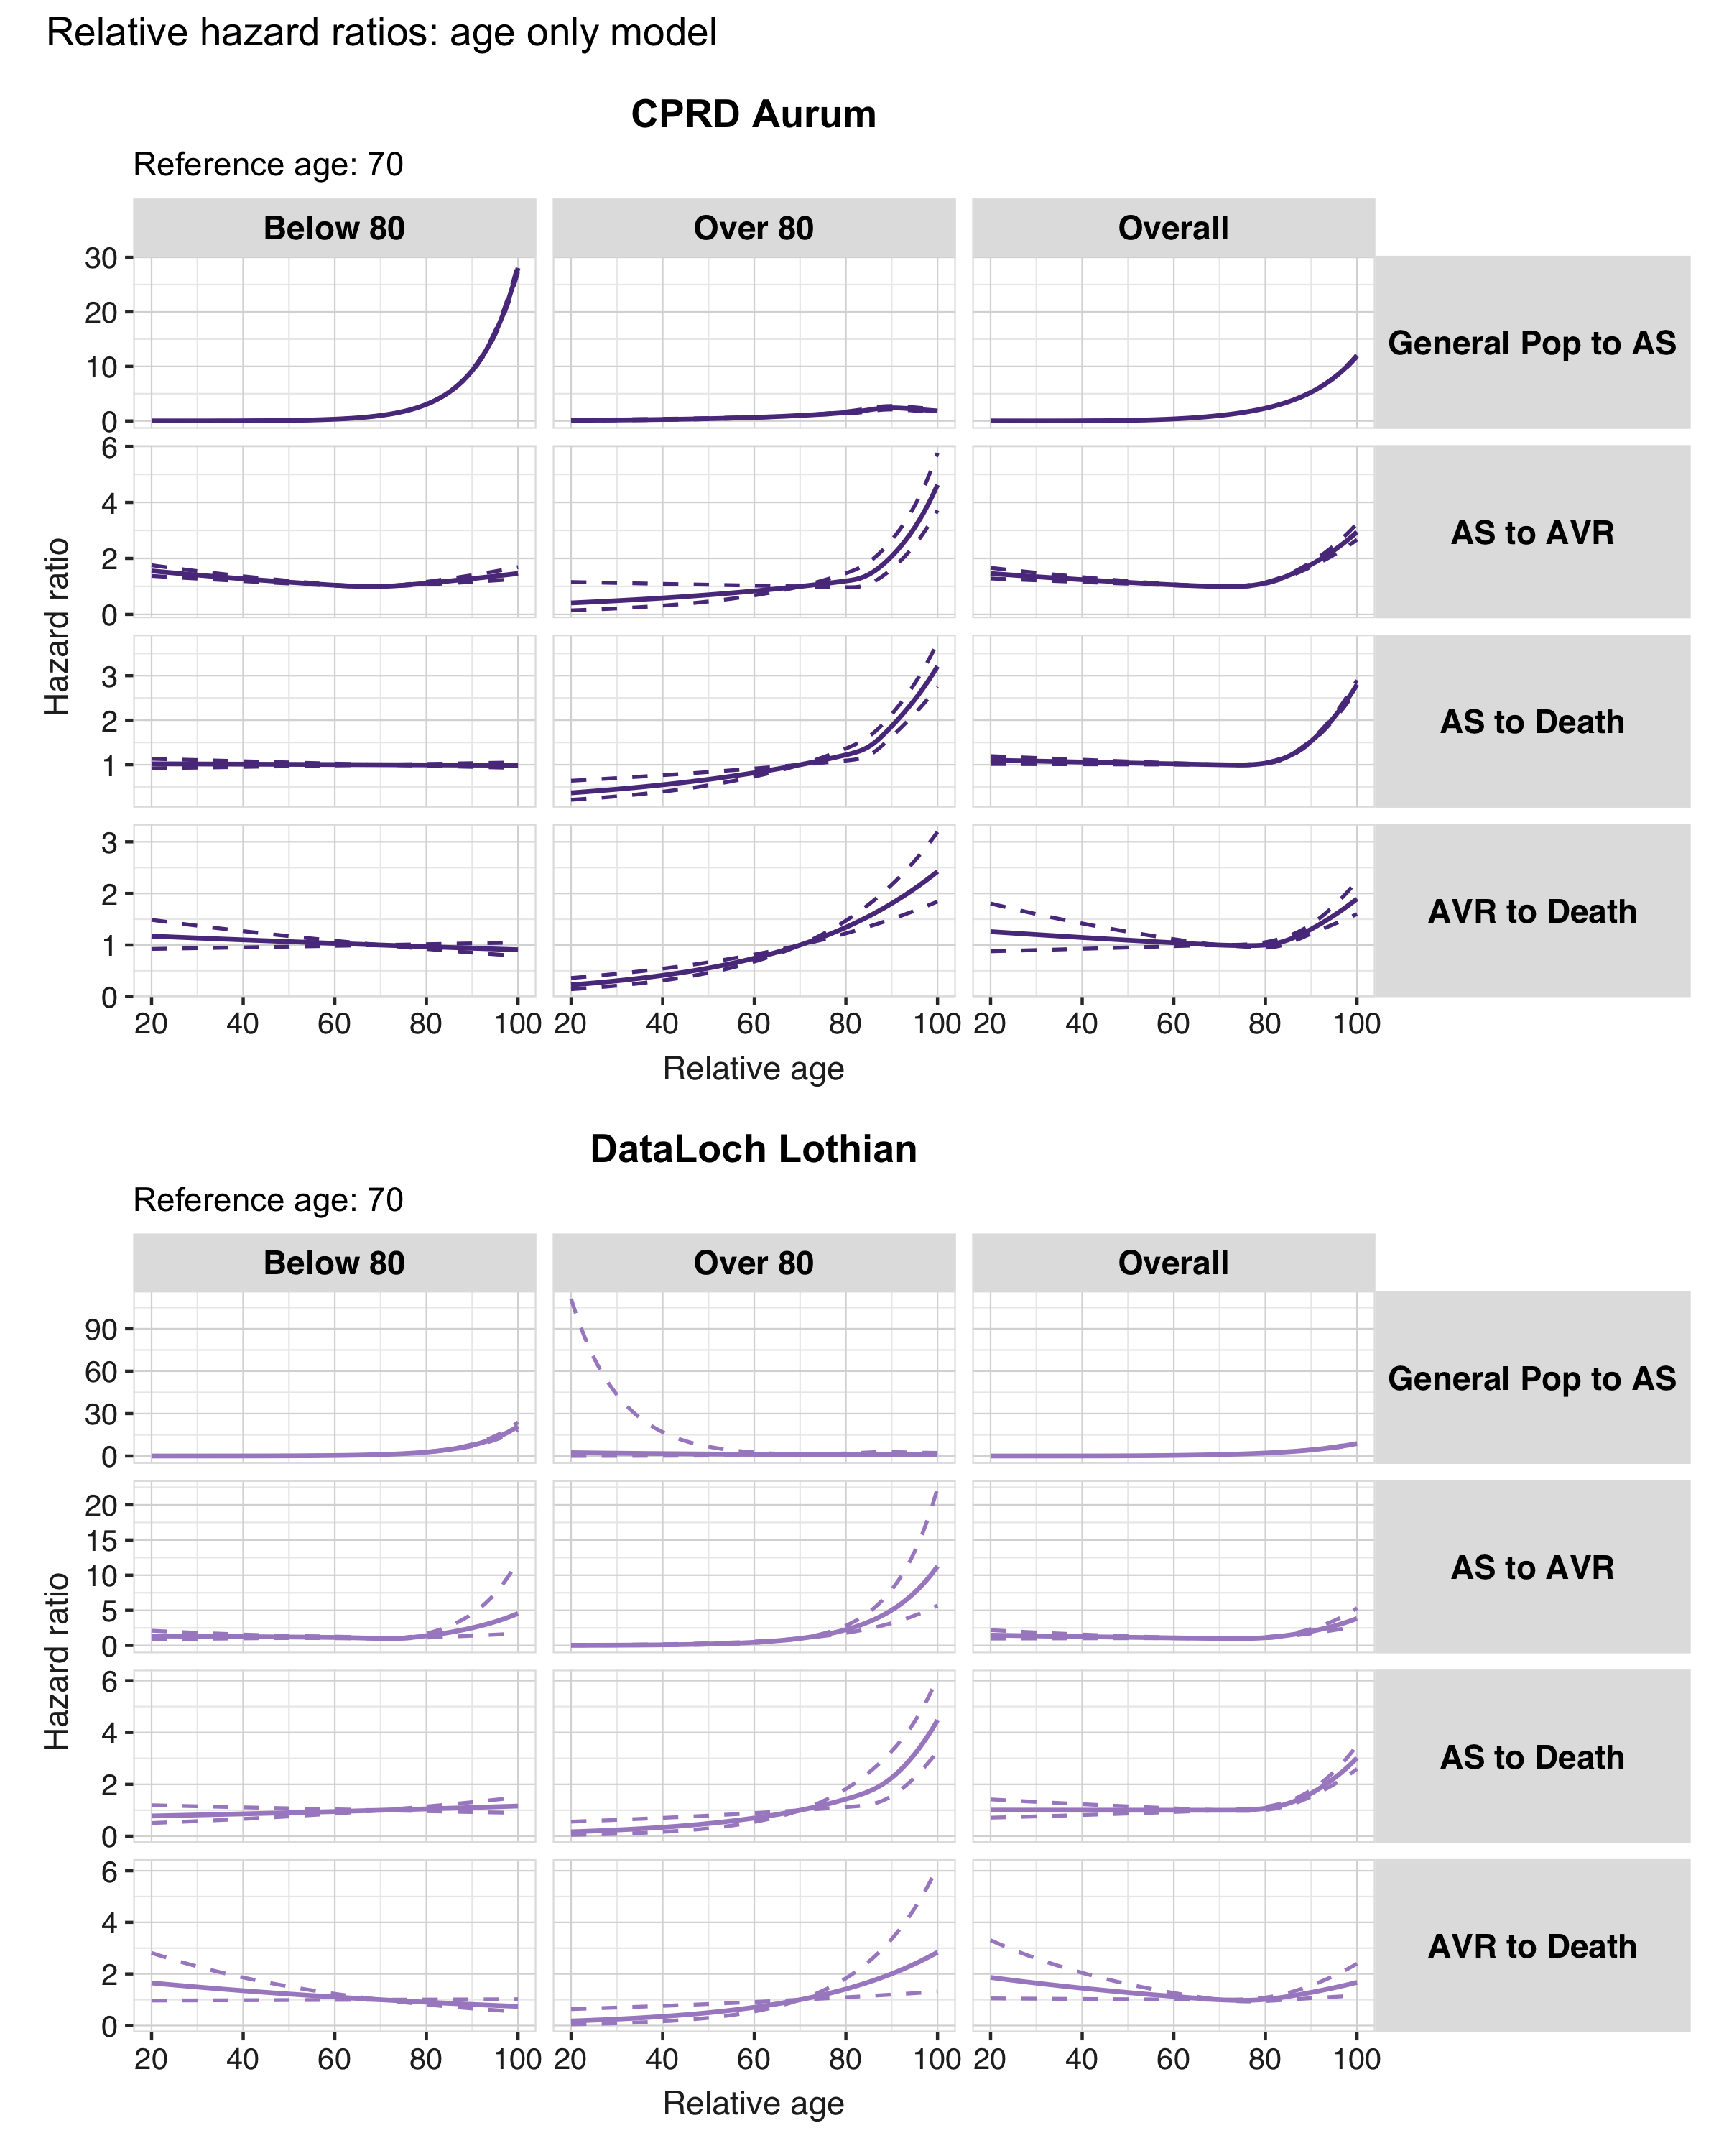
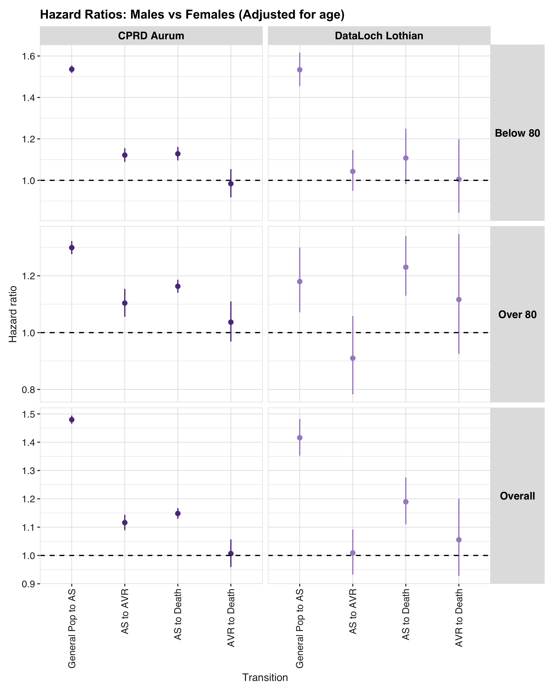
Transition | Estimate name | Age limit
 |  | Below 80 | Over 80 | Overall
CPRD Aurum
General Pop to AS | HR [95% CI] | 1.54 [1.52, 1.55] | 1.30 [1.28, 1.32] | 1.48 [1.47, 1.49]
AS to AVR | HR [95% CI] | 1.12 [1.09, 1.16] | 1.10 [1.06, 1.15] | 1.12 [1.09, 1.14]
AS to Death | HR [95% CI] | 1.13 [1.10, 1.16] | 1.16 [1.14, 1.19] | 1.15 [1.13, 1.17]
AVR to Death | HR [95% CI] | 0.98 [0.92, 1.05] | 1.04 [0.97, 1.11] | 1.01 [0.96, 1.06]
DataLoch Lothian
General Pop to AS | HR [95% CI] | 1.53 [1.45, 1.62] | 1.18 [1.07, 1.30] | 1.42 [1.35, 1.48]
AS to AVR | HR [95% CI] | 1.04 [0.95, 1.15] | 0.91 [0.78, 1.06] | 1.01 [0.93, 1.09]
AS to Death | HR [95% CI] | 1.11 [0.98, 1.25] | 1.23 [1.13, 1.34] | 1.19 [1.11, 1.28]
AVR to Death | HR [95% CI] | 1.01 [0.84, 1.20] | 1.12 [0.93, 1.35] | 1.06 [0.93, 1.20]

ses models
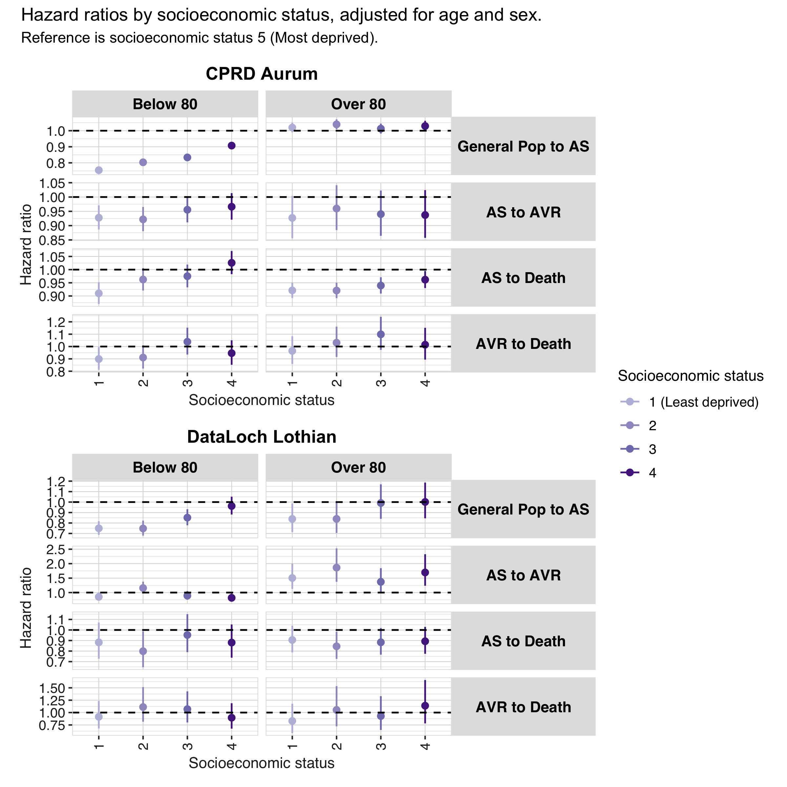

Variable | Estimate name | General Pop to AS |  |  | AS to AVR |  |  | AS to Death |  |  | AVR to Death
 |  | Below 80 | Over 80 | Overall | Below 80 | Over 80 | Overall | Below 80 | Over 80 | Overall | Below 80 | Over 80 | Overall
CPRD Aurum
Ses: 1 | HR [95% CI] | 0.754 [0.741, 0.768] | 1.020 [0.990, 1.050] | 0.824 [0.811, 0.837] | 0.928 [0.886, 0.971] | 0.927 [0.856, 1.004] | 0.925 [0.889, 0.962] | 0.910 [0.869, 0.952] | 0.921 [0.892, 0.951] | 0.923 [0.899, 0.947] | 0.899 [0.811, 0.996] | 0.965 [0.859, 1.083] | 0.926 [0.858, 0.999]
Ses: 2 | HR [95% CI] | 0.803 [0.788, 0.818] | 1.039 [1.009, 1.071] | 0.864 [0.851, 0.878] | 0.922 [0.880, 0.965] | 0.960 [0.884, 1.041] | 0.933 [0.896, 0.971] | 0.963 [0.921, 1.006] | 0.921 [0.892, 0.951] | 0.936 [0.913, 0.961] | 0.911 [0.822, 1.010] | 1.031 [0.915, 1.161] | 0.964 [0.893, 1.042]
Ses: 3 | HR [95% CI] | 0.834 [0.818, 0.850] | 1.013 [0.982, 1.044] | 0.878 [0.864, 0.893] | 0.956 [0.911, 1.002] | 0.940 [0.864, 1.023] | 0.951 [0.913, 0.991] | 0.975 [0.933, 1.019] | 0.940 [0.909, 0.971] | 0.953 [0.928, 0.978] | 1.038 [0.935, 1.153] | 1.099 [0.973, 1.241] | 1.060 [0.980, 1.147]
Ses: 4 | HR [95% CI] | 0.907 [0.890, 0.925] | 1.029 [0.997, 1.062] | 0.937 [0.922, 0.953] | 0.966 [0.921, 1.014] | 0.937 [0.857, 1.024] | 0.958 [0.919, 0.999] | 1.026 [0.983, 1.071] | 0.962 [0.930, 0.995] | 0.987 [0.961, 1.013] | 0.946 [0.852, 1.050] | 1.015 [0.894, 1.152] | 0.971 [0.896, 1.052]
Ses: Missing | HR [95% CI] | 0.868 [0.715, 1.055] | 0.807 [0.617, 1.055] | 0.755 [0.645, 0.884] | 0.892 [0.561, 1.417] | 1.067 [0.553, 2.060] | 0.943 [0.646, 1.378] | 2.488 [1.448, 4.274] | 1.150 [0.829, 1.596] | 1.334 [1.005, 1.772] | 1.194 [0.297, 4.789] | 0.912 [0.293, 2.842] | 0.977 [0.405, 2.353]
DataLoch Lothian
Ses: 1 | HR [95% CI] | 0.749 [0.687, 0.817] | 0.839 [0.713, 0.987] | 0.769 [0.713, 0.830] | 0.852 [0.725, 1.001] | 1.504 [1.128, 2.005] | 1.000 [0.870, 1.149] | 0.883 [0.727, 1.071] | 0.905 [0.788, 1.040] | 0.896 [0.801, 1.002] | 0.915 [0.678, 1.234] | 0.831 [0.586, 1.177] | 0.871 [0.695, 1.091]
Ses: 2 | HR [95% CI] | 0.748 [0.679, 0.823] | 0.839 [0.705, 0.999] | 0.769 [0.708, 0.837] | 1.157 [0.972, 1.377] | 1.863 [1.372, 2.528] | 1.298 [1.118, 1.507] | 0.799 [0.647, 0.987] | 0.845 [0.726, 0.983] | 0.832 [0.736, 0.941] | 1.112 [0.816, 1.515] | 1.052 [0.722, 1.534] | 1.083 [0.855, 1.373]
Ses: 3 | HR [95% CI] | 0.851 [0.778, 0.931] | 0.991 [0.840, 1.169] | 0.883 [0.816, 0.956] | 0.893 [0.756, 1.053] | 1.371 [1.019, 1.844] | 0.990 [0.857, 1.142] | 0.953 [0.790, 1.150] | 0.883 [0.766, 1.019] | 0.907 [0.810, 1.015] | 1.069 [0.800, 1.428] | 0.930 [0.649, 1.332] | 1.000 [0.799, 1.251]
Ses: 4 | HR [95% CI] | 0.962 [0.881, 1.051] | 1.001 [0.845, 1.186] | 0.969 [0.896, 1.048] | 0.818 [0.694, 0.965] | 1.695 [1.236, 2.326] | 1.007 [0.871, 1.164] | 0.881 [0.737, 1.052] | 0.893 [0.774, 1.029] | 0.889 [0.795, 0.993] | 0.896 [0.676, 1.189] | 1.138 [0.782, 1.658] | 0.975 [0.779, 1.221]
Ses: Missing | HR [95% CI] | 0.630 [0.542, 0.733] | 0.515 [0.380, 0.698] | 0.510 [0.445, 0.585] | 0.764 [0.591, 0.989] | 2.126 [1.342, 3.369] | 0.978 [0.783, 1.221] | 0.780 [0.534, 1.139] | 0.599 [0.458, 0.783] | 0.645 [0.519, 0.802] | 1.011 [0.547, 1.869] | 0.646 [0.357, 1.171] | 0.775 [0.507, 1.185]

Comorbidities in CPRD Aurum
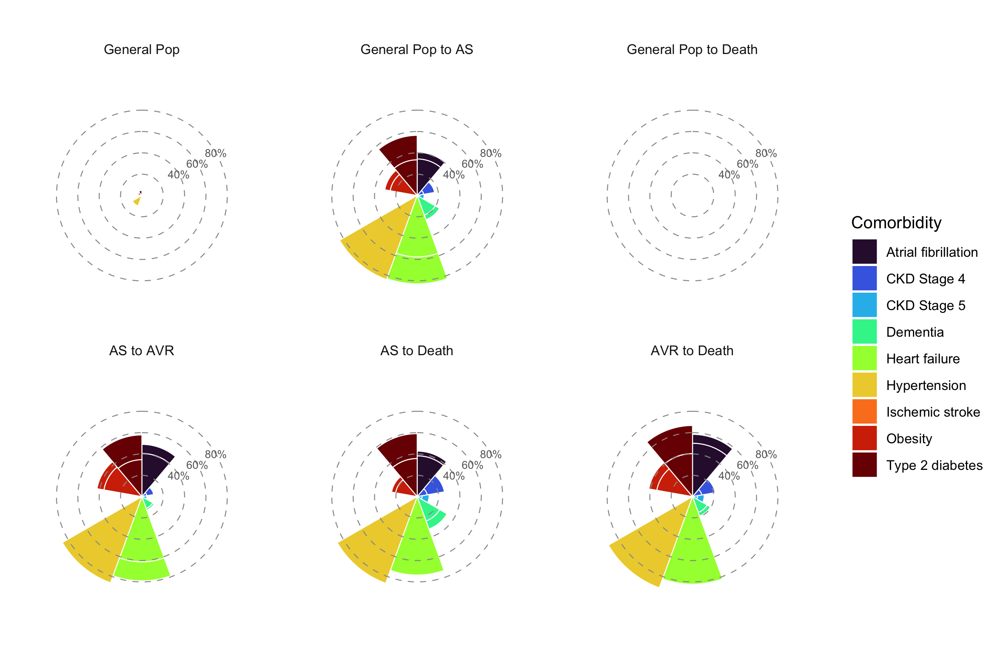

Incidence rates aortic stenosis
Year | Ses | Incidence 100,000 person-years [95% CI]
 |  | Crude | Age-standardised
DataLoch Lothian
2012 | 1 | 75.95 (63.02 -  90.75) | 77.76 (63.80 -  91.73)
 | 2 | 76.22 (60.35 -  95.00) | 78.58 (61.16 -  95.99)
 | 3 | 98.82 (82.85 -  116.96) | 110.74 (91.90 -  129.57)
 | 4 | 79.09 (65.68 -  94.44) | 102.02 (83.78 -  120.25)
 | 5 | 80.00 (64.57 -  98.01) | 114.83 (91.18 -  138.48)
2024 | 1 | 58.46 (49.27 -  68.87) | 46.48 (38.83 -  54.13)
 | 2 | 41.41 (32.28 -  52.32) | 36.00 (27.53 -  44.47)
 | 3 | 46.01 (37.78 -  55.50) | 49.85 (40.49 -  59.22)
 | 4 | 40.39 (33.26 -  48.60) | 55.53 (45.21 -  65.85)
 | 5 | 25.81 (19.50 -  33.52) | 44.06 (32.31 -  55.81)
CPRD Aurum
2012 | 1 | 100.59 (96.44 -  104.87) | 93.84 (89.91 -  97.78)
 | 2 | 110.42 (105.96 -  115.01) | 104.53 (100.25 -  108.81)
 | 3 | 102.22 (97.78 -  106.81) | 102.32 (97.79 -  106.84)
 | 4 | 96.49 (92.20 -  100.93) | 107.38 (102.51 -  112.24)
 | 5 | 94.82 (90.41 -  99.38) | 113.89 (108.50 -  119.29)
2024 | 1 | 152.43 (147.42 -  157.57) | 122.60 (118.51 -  126.69)
 | 2 | 145.20 (140.24 -  150.29) | 126.88 (122.49 -  131.27)
 | 3 | 129.33 (124.58 -  134.22) | 129.84 (125.02 -  134.67)
 | 4 | 110.38 (106.17 -  114.72) | 135.48 (130.25 -  140.72)
 | 5 | 103.96 (99.70 -  108.34) | 144.90 (138.85 -  150.96)

Incidence rates AVR
Year | Ses | Incidence 100,000 person-years [95% CI]
 |  | Crude | Age-standardised
DataLoch Lothian
2012 | 1 | 26.33 (18.98 -  35.59) | 26.04 (18.13 -  33.95)
 | 2 | 24.09 (15.59 -  35.56) | 24.15 (14.65 -  33.65)
 | 3 | 21.92 (14.79 -  31.30) | 24.23 (15.53 -  32.93)
 | 4 | 14.24 (8.93 -  21.56) | 16.97 (9.82 -  24.12)
 | 5 | 18.90 (11.85 -  28.62) | 25.93 (15.01 -  36.86)
2024 | 1 | 33.08 (26.27 -  41.12) | 26.41 (20.64 -  32.19)
 | 2 | 30.74 (22.95 -  40.31) | 26.67 (19.40 -  33.93)
 | 3 | 28.68 (22.27 -  36.35) | 31.20 (23.78 -  38.63)
 | 4 | 23.78 (18.39 -  30.25) | 31.35 (23.75 -  38.95)
 | 5 | 11.52 (7.45 -  17.00) | 17.65 (10.55 -  24.76)
CPRD Aurum
2012 | 1 | 27.97 (25.81 -  30.27) | 26.79 (24.66 -  28.91)
 | 2 | 28.59 (26.35 -  30.97) | 27.88 (25.64 -  30.12)
 | 3 | 26.68 (24.44 -  29.07) | 27.68 (25.29 -  30.07)
 | 4 | 21.71 (19.71 -  23.87) | 24.59 (22.25 -  26.93)
 | 5 | 22.41 (20.30 -  24.69) | 27.06 (24.42 -  29.69)
2024 | 1 | 45.57 (42.85 -  48.41) | 37.15 (34.89 -  39.42)
 | 2 | 40.76 (38.16 -  43.50) | 35.62 (33.30 -  37.94)
 | 3 | 39.14 (36.55 -  41.87) | 38.90 (36.28 -  41.53)
 | 4 | 32.31 (30.06 -  34.69) | 38.17 (35.45 -  40.90)
 | 5 | 27.97 (25.79 -  30.28) | 36.44 (33.51 -  39.37)
