Temporal Trends in the Real-World Use of SAVR and TAVI in the UK Clinical Practice: A Population-Base Cohort Study from 2012 to 2025
Marta Alcalde Herraiz
This version: 3pmrc6, 2026

1 @ -0,0 +1,32 @@
title: “Temporal Trends in the Real-World Use of SAVR and TAVI in the UK Clinical Practice: A Population-Base Cohort Study from 2012 to 2025” author: - name: Marta Alcalde Herraiz format: docx: number-sections: true colorlinks: true keeptex: true
date: ‘last-modified’ date-format: ‘[This version:] March, 2026’ csl: american-sociological-association.csl tbl-cap-location: top number-sections: true execute: echo: false warning: false message: false cache: false editor: mode: source filters: - docx-landscape.lua —

Concept ID | Concept name | Domain | Vocabulary
Aortic stenosis
4108595 | Aortic stenosis with doming | Condition | SNOMED
4111098 | Aortic stenosis, non-rheumatic | Condition | SNOMED
4189343 | Aortic valve stenosis | Condition | SNOMED
4111099 | Aortic valve stenosis with insufficiency | Condition | SNOMED
4119463 | Calcific aortic stenosis - bicuspid valve | Condition | SNOMED
4314258 | Calcific stenosis | Observation | SNOMED
4244966 | Congenital hypertrophy of aortic valve | Condition | SNOMED
314457 | Congenital stenosis of aortic valve | Condition | SNOMED
4144901 | Critical stenosis of aortic valve | Condition | SNOMED
4230774 | Heart valve regurgitation | Condition | SNOMED
4195003 | Heart valve stenosis | Condition | SNOMED
4081037 | Isolated aortic stenosis | Condition | SNOMED
3654574 | Mild aortic valve stenosis | Condition | SNOMED
317890 | Mitral and aortic stenosis | Condition | SNOMED
320115 | Mitral insufficiency and aortic stenosis | Condition | SNOMED
3654575 | Moderate aortic valve stenosis | Condition | SNOMED
4058384 | Nodular calcific aortic valve stenosis | Condition | SNOMED
45766136 | Non-rheumatic aortic valve stenosis with regurgitation | Condition | SNOMED
45766125 | Postprocedural aortic valve stenosis | Condition | SNOMED
45766081 | Prosthetic aortic valve stenosis | Condition | SNOMED
45766186 | Prosthetic aortic valve stenosis and regurgitation | Condition | SNOMED
313221 | Rheumatic aortic stenosis | Condition | SNOMED
320429 | Rheumatic aortic stenosis with regurgitation | Condition | SNOMED
607641 | Rheumatic aortic valve obstruction | Condition | SNOMED
4181949 | Rheumatic aortic valve sclerosis | Condition | SNOMED
4156119 | Rheumatic mitral AND aortic valve obstruction | Condition | SNOMED
4259295 | Rheumatic mitral valve and aortic valve stenosis | Condition | SNOMED
4304541 | Rheumatic mitral valve insufficiency and aortic valve stenosis | Condition | SNOMED
4119956 | Senile aortic stenosis | Condition | SNOMED
3654576 | Severe aortic valve stenosis | Condition | SNOMED
43020959 | Stenosis of fetal aortic valve | Condition | SNOMED
Aortic insufficiency
4108596 | Aortic cusp regurgitation | Condition | SNOMED
4111409 | Aortic incompetence, non-rheumatic | Condition | SNOMED
4119589 | Aortic regurgitation due to cystic medial necrosis of aorta | Condition | SNOMED
315564 | Aortic valve regurgitation | Condition | SNOMED
45771326 | Aortic valve regurgitation due to aortic dilation | Condition | SNOMED
45766211 | Aortic valve regurgitation due to dissection | Condition | SNOMED
45766210 | Aortic valve regurgitation due to trauma | Condition | SNOMED
321107 | Congenital insufficiency of aortic valve | Condition | SNOMED
4230774 | Heart valve regurgitation | Condition | SNOMED
3654798 | Mild aortic valve regurgitation | Condition | SNOMED
4108659 | Mitral and aortic incompetence | Condition | SNOMED
321041 | Mitral stenosis and aortic insufficiency | Condition | SNOMED
3654799 | Moderate aortic valve regurgitation | Condition | SNOMED
45766136 | Non-rheumatic aortic valve stenosis with regurgitation | Condition | SNOMED
43021945 | Regurgitation of fetal aortic valve | Condition | SNOMED
439834 | Rheumatic aortic regurgitation | Condition | SNOMED
4244437 | Rheumatic mitral AND aortic valve regurgitation | Condition | SNOMED
4215619 | Rheumatic mitral valve stenosis AND aortic valve insufficiency | Condition | SNOMED
3654800 | Severe aortic valve regurgitation | Condition | SNOMED
4189522 | Syphilitic aortic incompetence | Condition | SNOMED
Aortic endocarditis
42539157 | Endocarditis of neoaortic valve | Condition | SNOMED
45766095 | Endocarditis of prosthetic aortic valve | Condition | SNOMED
43020882 | Infective endocarditis of aortic valve | Condition | SNOMED
318689 | Syphilitic endocarditis of aortic valve | Condition | SNOMED
4232337 | Valvular endocarditis | Condition | SNOMED

Concept ID | Concept name | Domain | Vocabulary
Aortic valve replacement
4339824 | Aortic valve replacement and replacement of ascending aorta | Procedure | SNOMED
4170281 | Ball valve aortic valve replacement | Procedure | SNOMED
4166457 | Bi-leaflet aortic valve replacement | Procedure | SNOMED
4018560 | Homograft aortic valve replacement | Procedure | SNOMED
4018561 | Mechanical prosthetic aortic valve replacement | Procedure | SNOMED
4095407 | Replacement of aortic valve | Procedure | SNOMED
4020077 | Xenograft aortic valve replacement | Procedure | SNOMED
Aortic valve replacement (potential TAVI)
4170281 | Ball valve aortic valve replacement | Procedure | SNOMED
4166457 | Bi-leaflet aortic valve replacement | Procedure | SNOMED
4095407 | Replacement of aortic valve | Procedure | SNOMED
4020077 | Xenograft aortic valve replacement | Procedure | SNOMED
TAVI
37157401 | Bioprosthetic transcatheter aortic valve implantation | Procedure | SNOMED
36676805 | Transcatheter aortic valve implantation | Procedure | SNOMED
TAVI (used in combination with an aortic valve replacement -potential TAVI- code)
44517104 | Other specified approach to organ through artery | Observation | OPCS4
4129306 | Transaortic approach | Observation | SNOMED
44793263 | Transapical approach to heart | Observation | SNOMED
4011473 | Transarterial approach | Observation | SNOMED
4044372 | Transaxillary approach | Observation | SNOMED
4125581 | Via femoral artery | Observation | SNOMED
4129781 | Via subclavian artery | Observation | SNOMED

Indications by age group (0 to 64)
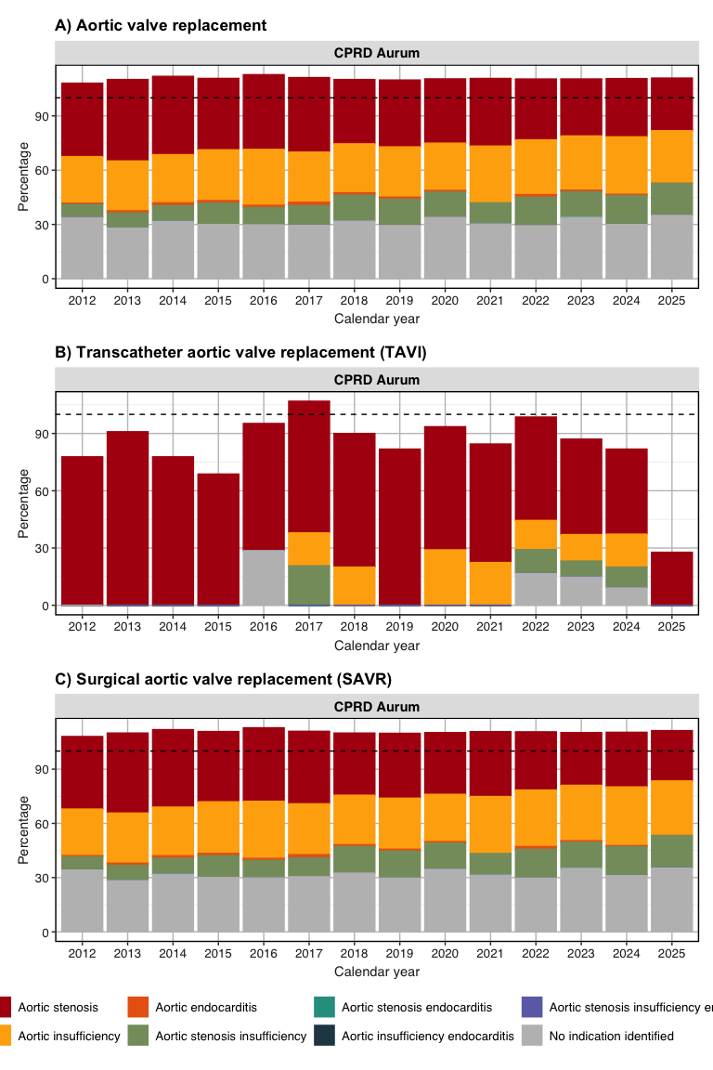

Indications by age group (65 to 150)
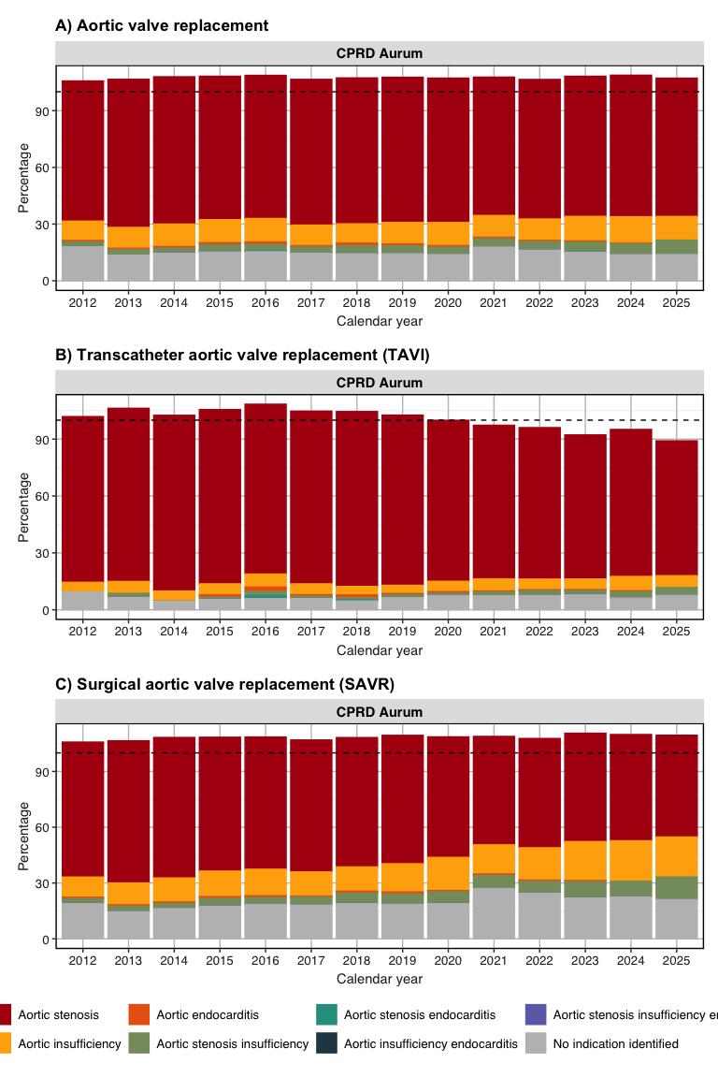

Indications by sex (Females)
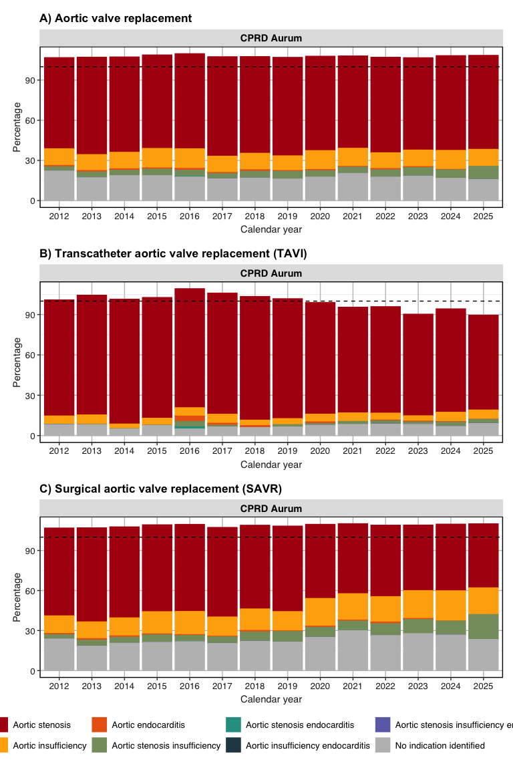

Indications by sex (Males)
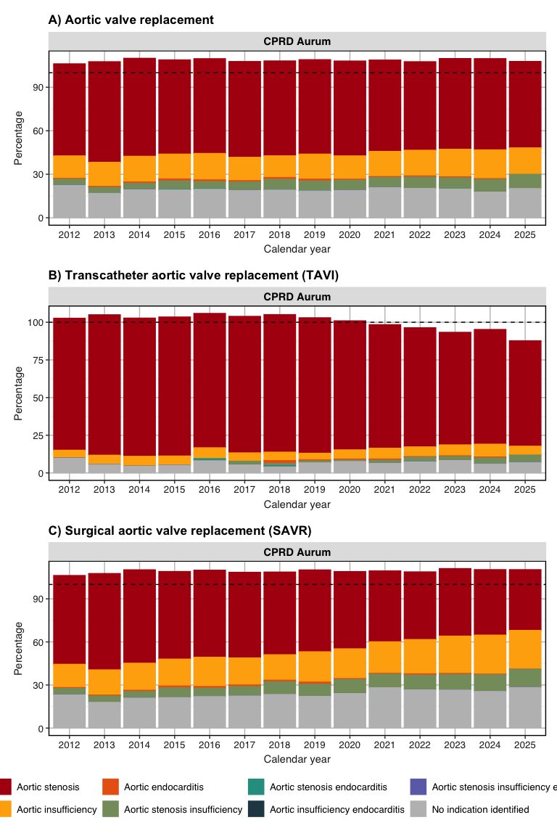

Incidence stratified by sex (Female)

Incidence stratified by sex (Male)

Table incidence (Aortic valve replacement) - Overall
Incidence start date | Incidence end date | Database name
 |  | CPRD Aurum
 |  | Estimate name
 |  | Denominator (N) | Person-years | Outcome (N) | Incidence 100,000 person-years [95% CI]
0 to 150; Both
2012-01-01 | 2012-12-31 | 13,735,000 | 12,730,303.14 | 2,570 | 20.19 (19.41 -  20.98)
2013-01-01 | 2013-12-31 | 13,978,227 | 12,846,090.75 | 2,702 | 21.03 (20.25 -  21.84)
2014-01-01 | 2014-12-31 | 14,111,995 | 13,012,068.77 | 2,810 | 21.59 (20.80 -  22.41)
2015-01-01 | 2015-12-31 | 14,429,455 | 13,300,793.01 | 2,906 | 21.85 (21.06 -  22.66)
2016-01-01 | 2016-12-31 | 14,734,996 | 13,663,159.36 | 3,097 | 22.67 (21.88 -  23.48)
2017-01-01 | 2017-12-31 | 15,063,758 | 13,942,722.70 | 3,442 | 24.69 (23.87 -  25.52)
2018-01-01 | 2018-12-31 | 15,394,936 | 14,229,446.88 | 3,643 | 25.60 (24.78 -  26.45)
2019-01-01 | 2019-12-31 | 15,590,818 | 14,293,399.51 | 3,755 | 26.27 (25.44 -  27.12)
2020-01-01 | 2020-12-31 | 15,655,497 | 14,525,372.62 | 3,074 | 21.16 (20.42 -  21.92)
2021-01-01 | 2021-12-31 | 15,705,551 | 14,514,767.96 | 3,297 | 22.72 (21.95 -  23.50)
2022-01-01 | 2022-12-31 | 15,986,963 | 14,434,505.43 | 3,660 | 25.36 (24.54 -  26.19)
2023-01-01 | 2023-12-31 | 15,723,952 | 14,560,979.57 | 3,793 | 26.05 (25.23 -  26.89)
2024-01-01 | 2024-12-31 | 15,673,692 | 14,439,982.36 | 4,173 | 28.90 (28.03 -  29.79)

Table incidence (TAVI) - Overall
Incidence start date | Incidence end date | Database name
 |  | CPRD Aurum
 |  | Estimate name
 |  | Denominator (N) | Person-years | Outcome (N) | Incidence 100,000 person-years [95% CI]
0 to 150; Both
2012-01-01 | 2012-12-31 | 13,753,422 | 12,749,009.35 | 262 | 2.06 (1.81 -  2.32)
2013-01-01 | 2013-12-31 | 13,997,489 | 12,865,467.97 | 325 | 2.53 (2.26 -  2.82)
2014-01-01 | 2014-12-31 | 14,132,016 | 13,032,284.27 | 373 | 2.86 (2.58 -  3.17)
2015-01-01 | 2015-12-31 | 14,450,330 | 13,321,721.88 | 535 | 4.02 (3.68 -  4.37)
2016-01-01 | 2016-12-31 | 14,756,510 | 13,684,796.29 | 719 | 5.25 (4.88 -  5.65)
2017-01-01 | 2017-12-31 | 15,085,943 | 13,964,960.22 | 969 | 6.94 (6.51 -  7.39)
2018-01-01 | 2018-12-31 | 15,417,746 | 14,252,171.58 | 1,134 | 7.96 (7.50 -  8.43)
2019-01-01 | 2019-12-31 | 15,613,976 | 14,316,343.40 | 1,241 | 8.67 (8.19 -  9.16)
2020-01-01 | 2020-12-31 | 15,678,626 | 14,548,168.52 | 1,293 | 8.89 (8.41 -  9.39)
2021-01-01 | 2021-12-31 | 15,728,198 | 14,536,931.74 | 1,556 | 10.70 (10.18 -  11.25)
2022-01-01 | 2022-12-31 | 16,009,135 | 14,455,933.37 | 1,809 | 12.51 (11.94 -  13.10)
2023-01-01 | 2023-12-31 | 15,745,360 | 14,582,002.08 | 2,062 | 14.14 (13.54 -  14.77)
2024-01-01 | 2024-12-31 | 15,694,700 | 14,460,585.69 | 2,360 | 16.32 (15.67 -  16.99)

Table incidence (SAVR) - Overall
Incidence start date | Incidence end date | Database name
 |  | CPRD Aurum
 |  | Estimate name
 |  | Denominator (N) | Person-years | Outcome (N) | Incidence 100,000 person-years [95% CI]
0 to 150; Both
2012-01-01 | 2012-12-31 | 13,735,150 | 12,730,517.79 | 2,401 | 18.86 (18.11 -  19.63)
2013-01-01 | 2013-12-31 | 13,978,506 | 12,846,432.75 | 2,475 | 19.27 (18.51 -  20.04)
2014-01-01 | 2014-12-31 | 14,112,418 | 13,012,565.60 | 2,575 | 19.79 (19.03 -  20.57)
2015-01-01 | 2015-12-31 | 14,430,034 | 13,301,493.69 | 2,548 | 19.16 (18.42 -  19.91)
2016-01-01 | 2016-12-31 | 14,735,850 | 13,664,165.88 | 2,597 | 19.01 (18.28 -  19.75)
2017-01-01 | 2017-12-31 | 15,064,937 | 13,944,089.00 | 2,792 | 20.02 (19.29 -  20.78)
2018-01-01 | 2018-12-31 | 15,396,544 | 14,231,259.77 | 2,873 | 20.19 (19.46 -  20.94)
2019-01-01 | 2019-12-31 | 15,592,882 | 14,295,599.37 | 2,933 | 20.52 (19.78 -  21.27)
2020-01-01 | 2020-12-31 | 15,657,910 | 14,527,946.27 | 2,127 | 14.64 (14.03 -  15.28)
2021-01-01 | 2021-12-31 | 15,708,414 | 14,517,922.85 | 2,041 | 14.06 (13.46 -  14.68)
2022-01-01 | 2022-12-31 | 15,990,530 | 14,438,319.62 | 2,193 | 15.19 (14.56 -  15.84)
2023-01-01 | 2023-12-31 | 15,728,216 | 14,565,629.38 | 2,127 | 14.60 (13.99 -  15.24)
2024-01-01 | 2024-12-31 | 15,678,832 | 14,445,610.94 | 2,189 | 15.15 (14.53 -  15.80)

Table incidence (Aortic valve replacement) - By age
Incidence start date | Incidence end date | Database name
 |  | CPRD Aurum
 |  | Estimate name
 |  | Denominator (N) | Person-years | Outcome (N) | Incidence 100,000 person-years [95% CI]
0 to 39; Both
2012-01-01 | 2012-12-31 | 6,601,244 | 5,909,744.02 | 73 | 1.24 (0.97 -  1.55)
2013-01-01 | 2013-12-31 | 6,744,122 | 5,994,029.00 | 58 | 0.97 (0.74 -  1.25)
2014-01-01 | 2014-12-31 | 6,842,103 | 6,102,974.28 | 84 | 1.38 (1.10 -  1.70)
2015-01-01 | 2015-12-31 | 7,020,476 | 6,273,949.60 | 84 | 1.34 (1.07 -  1.66)
2016-01-01 | 2016-12-31 | 7,209,670 | 6,484,968.68 | 78 | 1.20 (0.95 -  1.50)
2017-01-01 | 2017-12-31 | 7,416,852 | 6,671,863.92 | 86 | 1.29 (1.03 -  1.59)
2018-01-01 | 2018-12-31 | 7,617,602 | 6,849,971.30 | 95 | 1.39 (1.12 -  1.70)
2019-01-01 | 2019-12-31 | 7,725,033 | 6,891,204.86 | 93 | 1.35 (1.09 -  1.65)
2020-01-01 | 2020-12-31 | 7,790,282 | 7,043,847.72 | 69 | 0.98 (0.76 -  1.24)
2021-01-01 | 2021-12-31 | 7,810,618 | 7,039,937.19 | 74 | 1.05 (0.82 -  1.32)
2022-01-01 | 2022-12-31 | 7,981,474 | 7,008,677.44 | 92 | 1.31 (1.06 -  1.61)
2023-01-01 | 2023-12-31 | 7,832,487 | 7,086,103.58 | 88 | 1.24 (1.00 -  1.53)
2024-01-01 | 2024-12-31 | 7,772,332 | 6,982,489.82 | 83 | 1.19 (0.95 -  1.47)
40 to 64; Both
2012-01-01 | 2012-12-31 | 4,616,252 | 4,425,140.65 | 556 | 12.56 (11.54 -  13.65)
2013-01-01 | 2013-12-31 | 4,661,117 | 4,430,770.24 | 517 | 11.67 (10.68 -  12.72)
2014-01-01 | 2014-12-31 | 4,676,987 | 4,454,374.69 | 579 | 13.00 (11.96 -  14.10)
2015-01-01 | 2015-12-31 | 4,754,996 | 4,521,990.82 | 589 | 13.03 (11.99 -  14.12)
2016-01-01 | 2016-12-31 | 4,823,949 | 4,613,576.84 | 610 | 13.22 (12.19 -  14.31)
2017-01-01 | 2017-12-31 | 4,895,918 | 4,668,477.61 | 631 | 13.52 (12.48 -  14.61)
2018-01-01 | 2018-12-31 | 4,975,213 | 4,735,314.18 | 654 | 13.81 (12.77 -  14.91)
2019-01-01 | 2019-12-31 | 5,031,043 | 4,747,601.75 | 673 | 14.18 (13.12 -  15.29)
2020-01-01 | 2020-12-31 | 5,043,355 | 4,815,273.05 | 576 | 11.96 (11.01 -  12.98)
2021-01-01 | 2021-12-31 | 5,064,328 | 4,807,588.22 | 617 | 12.83 (11.84 -  13.89)
2022-01-01 | 2022-12-31 | 5,136,225 | 4,777,039.78 | 692 | 14.49 (13.43 -  15.61)
2023-01-01 | 2023-12-31 | 5,052,469 | 4,800,136.89 | 685 | 14.27 (13.22 -  15.38)
2024-01-01 | 2024-12-31 | 5,039,932 | 4,768,503.30 | 740 | 15.52 (14.42 -  16.68)
65 to 69; Both
2012-01-01 | 2012-12-31 | 740,246 | 716,645.81 | 313 | 43.68 (38.97 -  48.79)
2013-01-01 | 2013-12-31 | 765,572 | 736,587.87 | 349 | 47.38 (42.54 -  52.62)
2014-01-01 | 2014-12-31 | 769,228 | 740,307.45 | 366 | 49.44 (44.50 -  54.77)
2015-01-01 | 2015-12-31 | 790,592 | 759,149.80 | 380 | 50.06 (45.15 -  55.35)
2016-01-01 | 2016-12-31 | 777,829 | 750,354.07 | 388 | 51.71 (46.69 -  57.12)
2017-01-01 | 2017-12-31 | 750,882 | 722,096.56 | 350 | 48.47 (43.52 -  53.82)
2018-01-01 | 2018-12-31 | 745,226 | 714,963.31 | 392 | 54.83 (49.53 -  60.53)
2019-01-01 | 2019-12-31 | 742,267 | 705,403.22 | 375 | 53.16 (47.92 -  58.82)
2020-01-01 | 2020-12-31 | 732,585 | 704,558.79 | 303 | 43.01 (38.30 -  48.13)
2021-01-01 | 2021-12-31 | 740,789 | 708,271.88 | 336 | 47.44 (42.50 -  52.79)
2022-01-01 | 2022-12-31 | 758,150 | 709,349.03 | 376 | 53.01 (47.78 -  58.64)
2023-01-01 | 2023-12-31 | 757,662 | 724,244.58 | 405 | 55.92 (50.61 -  61.64)
2024-01-01 | 2024-12-31 | 770,196 | 734,008.47 | 412 | 56.13 (50.84 -  61.82)
70 to 74; Both
2012-01-01 | 2012-12-31 | 549,520 | 531,629.67 | 425 | 79.94 (72.52 -  87.92)
2013-01-01 | 2013-12-31 | 563,429 | 541,582.04 | 496 | 91.58 (83.70 -  100.01)
2014-01-01 | 2014-12-31 | 586,235 | 564,308.83 | 434 | 76.91 (69.84 -  84.50)
2015-01-01 | 2015-12-31 | 607,528 | 583,277.61 | 489 | 83.84 (76.57 -  91.61)
2016-01-01 | 2016-12-31 | 656,279 | 633,384.46 | 491 | 77.52 (70.81 -  84.69)
2017-01-01 | 2017-12-31 | 706,170 | 679,801.44 | 616 | 90.61 (83.60 -  98.06)
2018-01-01 | 2018-12-31 | 733,298 | 703,846.34 | 603 | 85.67 (78.97 -  92.79)
2019-01-01 | 2019-12-31 | 737,079 | 701,204.08 | 617 | 87.99 (81.18 -  95.22)
2020-01-01 | 2020-12-31 | 736,344 | 708,487.69 | 511 | 72.12 (66.01 -  78.66)
2021-01-01 | 2021-12-31 | 712,841 | 682,980.84 | 494 | 72.33 (66.09 -  79.00)
2022-01-01 | 2022-12-31 | 682,673 | 639,807.48 | 513 | 80.18 (73.39 -  87.43)
2023-01-01 | 2023-12-31 | 655,640 | 627,306.16 | 552 | 88.00 (80.81 -  95.65)
2024-01-01 | 2024-12-31 | 647,616 | 617,283.10 | 588 | 95.26 (87.71 -  103.28)
75 to 79; Both
2012-01-01 | 2012-12-31 | 462,589 | 444,903.87 | 537 | 120.70 (110.71 -  131.35)
2013-01-01 | 2013-12-31 | 474,232 | 452,429.42 | 525 | 116.04 (106.33 -  126.40)
2014-01-01 | 2014-12-31 | 479,070 | 458,652.71 | 560 | 122.10 (112.19 -  132.64)
2015-01-01 | 2015-12-31 | 484,963 | 462,987.56 | 545 | 117.71 (108.04 -  128.02)
2016-01-01 | 2016-12-31 | 485,026 | 465,251.45 | 592 | 127.24 (117.20 -  137.92)
2017-01-01 | 2017-12-31 | 497,913 | 476,033.22 | 602 | 126.46 (116.56 -  136.98)
2018-01-01 | 2018-12-31 | 512,573 | 489,100.02 | 672 | 137.40 (127.20 -  148.19)
2019-01-01 | 2019-12-31 | 534,785 | 505,990.14 | 725 | 143.28 (133.04 -  154.10)
2020-01-01 | 2020-12-31 | 539,211 | 515,313.77 | 568 | 110.22 (101.34 -  119.67)
2021-01-01 | 2021-12-31 | 573,290 | 546,623.16 | 668 | 122.20 (113.11 -  131.83)
2022-01-01 | 2022-12-31 | 613,066 | 572,016.02 | 692 | 120.98 (112.13 -  130.34)
2023-01-01 | 2023-12-31 | 614,915 | 585,988.54 | 793 | 135.33 (126.07 -  145.08)
2024-01-01 | 2024-12-31 | 613,460 | 582,268.63 | 851 | 146.15 (136.50 -  156.31)
80 to 84; Both
2012-01-01 | 2012-12-31 | 364,208 | 343,969.34 | 416 | 120.94 (109.60 -  133.14)
2013-01-01 | 2013-12-31 | 364,097 | 340,517.83 | 473 | 138.91 (126.67 -  152.01)
2014-01-01 | 2014-12-31 | 364,160 | 342,529.47 | 491 | 143.34 (130.94 -  156.60)
2015-01-01 | 2015-12-31 | 368,136 | 345,478.23 | 494 | 142.99 (130.66 -  156.17)
2016-01-01 | 2016-12-31 | 374,932 | 353,979.41 | 529 | 149.44 (136.98 -  162.74)
2017-01-01 | 2017-12-31 | 382,303 | 359,845.08 | 643 | 178.69 (165.14 -  193.05)
2018-01-01 | 2018-12-31 | 394,574 | 370,445.89 | 676 | 182.48 (168.98 -  196.77)
2019-01-01 | 2019-12-31 | 400,643 | 373,255.42 | 705 | 188.88 (175.19 -  203.35)
2020-01-01 | 2020-12-31 | 395,117 | 370,773.22 | 549 | 148.07 (135.94 -  160.99)
2021-01-01 | 2021-12-31 | 387,358 | 363,121.85 | 570 | 156.97 (144.35 -  170.40)
2022-01-01 | 2022-12-31 | 393,691 | 361,960.66 | 668 | 184.55 (170.82 -  199.09)
2023-01-01 | 2023-12-31 | 393,085 | 368,762.49 | 651 | 176.54 (163.23 -  190.63)
2024-01-01 | 2024-12-31 | 408,220 | 382,293.63 | 744 | 194.62 (180.88 -  209.12)
85 to 150; Both
2012-01-01 | 2012-12-31 | 400,941 | 358,269.78 | 250 | 69.78 (61.40 -  78.99)
2013-01-01 | 2013-12-31 | 405,658 | 350,174.33 | 284 | 81.10 (71.94 -  91.11)
2014-01-01 | 2014-12-31 | 394,212 | 348,921.34 | 296 | 84.83 (75.44 -  95.07)
2015-01-01 | 2015-12-31 | 402,764 | 353,959.39 | 325 | 91.82 (82.11 -  102.36)
2016-01-01 | 2016-12-31 | 407,311 | 361,644.44 | 409 | 113.10 (102.40 -  124.60)
2017-01-01 | 2017-12-31 | 413,720 | 364,604.87 | 514 | 140.98 (129.05 -  153.71)
2018-01-01 | 2018-12-31 | 416,450 | 365,805.85 | 551 | 150.63 (138.31 -  163.74)
2019-01-01 | 2019-12-31 | 419,968 | 368,740.02 | 567 | 153.77 (141.37 -  166.96)
2020-01-01 | 2020-12-31 | 418,603 | 367,118.38 | 498 | 135.65 (124.00 -  148.10)
2021-01-01 | 2021-12-31 | 416,327 | 366,244.82 | 538 | 146.90 (134.74 -  159.85)
2022-01-01 | 2022-12-31 | 421,684 | 365,655.02 | 627 | 171.47 (158.31 -  185.44)
2023-01-01 | 2023-12-31 | 417,694 | 368,437.32 | 619 | 168.01 (155.03 -  181.78)
2024-01-01 | 2024-12-31 | 421,936 | 373,135.41 | 755 | 202.34 (188.16 -  217.30)

Table incidence (Tavi) - By age
Incidence start date | Incidence end date | Database name
 |  | CPRD Aurum
 |  | Estimate name
 |  | Denominator (N) | Person-years | Outcome (N) | Incidence 100,000 person-years [95% CI]
0 to 39; Both
2012-01-01 | 2012-12-31 | 6,601,761 | 5,910,262.58 | 0 | 0.00 (0.00 -  0.06)
2013-01-01 | 2013-12-31 | 6,744,651 | 5,994,546.78 | 0 | 0.00 (0.00 -  0.06)
2014-01-01 | 2014-12-31 | 6,842,628 | 6,103,506.15 | <5 | -
2015-01-01 | 2015-12-31 | 7,021,029 | 6,274,512.75 | 0 | 0.00 (0.00 -  0.06)
2016-01-01 | 2016-12-31 | 7,210,258 | 6,485,555.80 | <5 | -
2017-01-01 | 2017-12-31 | 7,417,451 | 6,672,466.78 | 0 | 0.00 (0.00 -  0.06)
2018-01-01 | 2018-12-31 | 7,618,232 | 6,850,597.63 | <5 | -
2019-01-01 | 2019-12-31 | 7,725,681 | 6,891,844.71 | 0 | 0.00 (0.00 -  0.05)
2020-01-01 | 2020-12-31 | 7,790,920 | 7,044,483.90 | <5 | -
2021-01-01 | 2021-12-31 | 7,811,252 | 7,040,555.90 | 5 | 0.07 (0.02 -  0.17)
2022-01-01 | 2022-12-31 | 7,982,092 | 7,009,291.12 | <5 | -
2023-01-01 | 2023-12-31 | 7,833,106 | 7,086,718.02 | 9 | 0.13 (0.06 -  0.24)
2024-01-01 | 2024-12-31 | 7,772,927 | 6,983,078.80 | 5 | 0.07 (0.02 -  0.17)
40 to 64; Both
2012-01-01 | 2012-12-31 | 4,619,571 | 4,428,624.65 | 10 | 0.23 (0.11 -  0.42)
2013-01-01 | 2013-12-31 | 4,664,572 | 4,434,317.17 | 12 | 0.27 (0.14 -  0.47)
2014-01-01 | 2014-12-31 | 4,680,492 | 4,458,026.77 | 12 | 0.27 (0.14 -  0.47)
2015-01-01 | 2015-12-31 | 4,758,621 | 4,525,739.59 | 14 | 0.31 (0.17 -  0.52)
2016-01-01 | 2016-12-31 | 4,827,726 | 4,617,502.49 | 17 | 0.37 (0.21 -  0.59)
2017-01-01 | 2017-12-31 | 4,899,832 | 4,672,536.16 | 32 | 0.69 (0.47 -  0.97)
2018-01-01 | 2018-12-31 | 4,979,265 | 4,739,489.14 | 27 | 0.57 (0.38 -  0.83)
2019-01-01 | 2019-12-31 | 5,035,149 | 4,751,843.03 | 27 | 0.57 (0.37 -  0.83)
2020-01-01 | 2020-12-31 | 5,047,551 | 4,819,595.10 | 27 | 0.56 (0.37 -  0.81)
2021-01-01 | 2021-12-31 | 5,068,545 | 4,811,883.53 | 39 | 0.81 (0.58 -  1.11)
2022-01-01 | 2022-12-31 | 5,140,445 | 4,781,321.62 | 53 | 1.11 (0.83 -  1.45)
2023-01-01 | 2023-12-31 | 5,056,662 | 4,804,442.28 | 80 | 1.67 (1.32 -  2.07)
2024-01-01 | 2024-12-31 | 5,044,156 | 4,772,839.76 | 83 | 1.74 (1.39 -  2.16)
65 to 69; Both
2012-01-01 | 2012-12-31 | 742,448 | 718,914.38 | 18 | 2.50 (1.48 -  3.96)
2013-01-01 | 2013-12-31 | 767,800 | 738,896.85 | 14 | 1.90 (1.04 -  3.18)
2014-01-01 | 2014-12-31 | 771,432 | 742,607.55 | 13 | 1.75 (0.93 -  2.99)
2015-01-01 | 2015-12-31 | 792,898 | 761,523.79 | 30 | 3.94 (2.66 -  5.62)
2016-01-01 | 2016-12-31 | 780,014 | 752,643.26 | 27 | 3.59 (2.36 -  5.22)
2017-01-01 | 2017-12-31 | 753,058 | 724,372.82 | 30 | 4.14 (2.79 -  5.91)
2018-01-01 | 2018-12-31 | 747,389 | 717,217.37 | 48 | 6.69 (4.93 -  8.87)
2019-01-01 | 2019-12-31 | 744,505 | 707,714.18 | 29 | 4.10 (2.74 -  5.88)
2020-01-01 | 2020-12-31 | 734,785 | 706,800.25 | 52 | 7.36 (5.50 -  9.65)
2021-01-01 | 2021-12-31 | 742,963 | 710,490.68 | 54 | 7.60 (5.71 -  9.92)
2022-01-01 | 2022-12-31 | 760,333 | 711,562.62 | 67 | 9.42 (7.30 -  11.96)
2023-01-01 | 2023-12-31 | 759,863 | 726,512.31 | 84 | 11.56 (9.22 -  14.31)
2024-01-01 | 2024-12-31 | 772,433 | 736,297.44 | 83 | 11.27 (8.98 -  13.97)
70 to 74; Both
2012-01-01 | 2012-12-31 | 552,348 | 534,577.34 | 20 | 3.74 (2.29 -  5.78)
2013-01-01 | 2013-12-31 | 566,270 | 544,510.91 | 41 | 7.53 (5.40 -  10.21)
2014-01-01 | 2014-12-31 | 589,214 | 567,376.10 | 32 | 5.64 (3.86 -  7.96)
2015-01-01 | 2015-12-31 | 610,615 | 586,471.88 | 51 | 8.70 (6.47 -  11.43)
2016-01-01 | 2016-12-31 | 659,589 | 636,795.20 | 56 | 8.79 (6.64 -  11.42)
2017-01-01 | 2017-12-31 | 709,612 | 683,373.22 | 84 | 12.29 (9.80 -  15.22)
2018-01-01 | 2018-12-31 | 736,898 | 707,542.10 | 105 | 14.84 (12.14 -  17.96)
2019-01-01 | 2019-12-31 | 740,619 | 704,813.60 | 115 | 16.32 (13.47 -  19.59)
2020-01-01 | 2020-12-31 | 739,920 | 712,131.98 | 129 | 18.11 (15.12 -  21.52)
2021-01-01 | 2021-12-31 | 716,156 | 686,333.95 | 154 | 22.44 (19.03 -  26.27)
2022-01-01 | 2022-12-31 | 685,759 | 642,872.46 | 160 | 24.89 (21.18 -  29.06)
2023-01-01 | 2023-12-31 | 658,586 | 630,304.10 | 194 | 30.78 (26.60 -  35.43)
2024-01-01 | 2024-12-31 | 650,549 | 620,272.51 | 194 | 31.28 (27.03 -  36.00)
75 to 79; Both
2012-01-01 | 2012-12-31 | 466,042 | 448,461.31 | 46 | 10.26 (7.51 -  13.68)
2013-01-01 | 2013-12-31 | 477,898 | 456,161.35 | 52 | 11.40 (8.51 -  14.95)
2014-01-01 | 2014-12-31 | 482,818 | 462,480.87 | 75 | 16.22 (12.76 -  20.33)
2015-01-01 | 2015-12-31 | 488,788 | 466,874.51 | 84 | 17.99 (14.35 -  22.27)
2016-01-01 | 2016-12-31 | 488,911 | 469,214.23 | 121 | 25.79 (21.40 -  30.81)
2017-01-01 | 2017-12-31 | 501,891 | 480,065.01 | 139 | 28.95 (24.34 -  34.19)
2018-01-01 | 2018-12-31 | 516,610 | 493,208.33 | 160 | 32.44 (27.61 -  37.88)
2019-01-01 | 2019-12-31 | 538,990 | 510,246.95 | 195 | 38.22 (33.04 -  43.97)
2020-01-01 | 2020-12-31 | 543,467 | 519,533.59 | 242 | 46.58 (40.90 -  52.83)
2021-01-01 | 2021-12-31 | 577,630 | 550,914.25 | 346 | 62.80 (56.36 -  69.78)
2022-01-01 | 2022-12-31 | 617,409 | 576,255.48 | 361 | 62.65 (56.35 -  69.45)
2023-01-01 | 2023-12-31 | 619,090 | 590,147.99 | 472 | 79.98 (72.93 -  87.53)
2024-01-01 | 2024-12-31 | 617,489 | 586,253.41 | 530 | 90.40 (82.87 -  98.44)
80 to 84; Both
2012-01-01 | 2012-12-31 | 367,602 | 347,334.29 | 74 | 21.30 (16.73 -  26.75)
2013-01-01 | 2013-12-31 | 367,643 | 344,053.47 | 96 | 27.90 (22.60 -  34.07)
2014-01-01 | 2014-12-31 | 367,923 | 346,288.05 | 89 | 25.70 (20.64 -  31.63)
2015-01-01 | 2015-12-31 | 372,004 | 349,303.63 | 156 | 44.66 (37.93 -  52.24)
2016-01-01 | 2016-12-31 | 378,889 | 357,927.67 | 187 | 52.24 (45.02 -  60.29)
2017-01-01 | 2017-12-31 | 386,437 | 363,912.84 | 280 | 76.94 (68.19 -  86.50)
2018-01-01 | 2018-12-31 | 398,854 | 374,626.69 | 341 | 91.02 (81.62 -  101.22)
2019-01-01 | 2019-12-31 | 404,895 | 377,380.62 | 382 | 101.22 (91.33 -  111.90)
2020-01-01 | 2020-12-31 | 399,227 | 374,755.48 | 382 | 101.93 (91.97 -  112.69)
2021-01-01 | 2021-12-31 | 391,312 | 366,893.26 | 452 | 123.20 (112.10 -  135.10)
2022-01-01 | 2022-12-31 | 397,450 | 365,505.57 | 548 | 149.93 (137.64 -  163.02)
2023-01-01 | 2023-12-31 | 396,648 | 372,160.57 | 577 | 155.04 (142.65 -  168.22)
2024-01-01 | 2024-12-31 | 411,712 | 385,616.50 | 679 | 176.08 (163.08 -  189.84)
85 to 150; Both
2012-01-01 | 2012-12-31 | 403,650 | 360,834.79 | 94 | 26.05 (21.05 -  31.88)
2013-01-01 | 2013-12-31 | 408,655 | 352,981.44 | 110 | 31.16 (25.61 -  37.56)
2014-01-01 | 2014-12-31 | 397,509 | 351,998.77 | 151 | 42.90 (36.33 -  50.31)
2015-01-01 | 2015-12-31 | 406,375 | 357,295.73 | 200 | 55.98 (48.49 -  64.30)
2016-01-01 | 2016-12-31 | 411,123 | 365,157.63 | 309 | 84.62 (75.45 -  94.60)
2017-01-01 | 2017-12-31 | 417,662 | 368,233.39 | 404 | 109.71 (99.27 -  120.95)
2018-01-01 | 2018-12-31 | 420,498 | 369,490.31 | 451 | 122.06 (111.05 -  133.86)
2019-01-01 | 2019-12-31 | 424,137 | 372,500.30 | 493 | 132.35 (120.92 -  144.56)
2020-01-01 | 2020-12-31 | 422,756 | 370,868.22 | 460 | 124.03 (112.96 -  135.90)
2021-01-01 | 2021-12-31 | 420,340 | 369,860.18 | 506 | 136.81 (125.15 -  149.26)
2022-01-01 | 2022-12-31 | 425,647 | 369,124.51 | 616 | 166.88 (153.96 -  180.60)
2023-01-01 | 2023-12-31 | 421,405 | 371,716.83 | 646 | 173.79 (160.64 -  187.72)
2024-01-01 | 2024-12-31 | 425,434 | 376,227.28 | 786 | 208.92 (194.56 -  224.05)

Table incidence (savr) - By age
Incidence start date | Incidence end date | Database name
 |  | CPRD Aurum
 |  | Estimate name
 |  | Denominator (N) | Person-years | Outcome (N) | Incidence 100,000 person-years [95% CI]
0 to 39; Both
2012-01-01 | 2012-12-31 | 6,601,244 | 5,909,744.02 | 73 | 1.24 (0.97 -  1.55)
2013-01-01 | 2013-12-31 | 6,744,122 | 5,994,029.00 | 58 | 0.97 (0.74 -  1.25)
2014-01-01 | 2014-12-31 | 6,842,103 | 6,102,974.28 | 84 | 1.38 (1.10 -  1.70)
2015-01-01 | 2015-12-31 | 7,020,476 | 6,273,949.60 | 84 | 1.34 (1.07 -  1.66)
2016-01-01 | 2016-12-31 | 7,209,671 | 6,484,968.99 | 77 | 1.19 (0.94 -  1.48)
2017-01-01 | 2017-12-31 | 7,416,854 | 6,671,865.60 | 86 | 1.29 (1.03 -  1.59)
2018-01-01 | 2018-12-31 | 7,617,604 | 6,849,974.15 | 94 | 1.37 (1.11 -  1.68)
2019-01-01 | 2019-12-31 | 7,725,036 | 6,891,207.86 | 93 | 1.35 (1.09 -  1.65)
2020-01-01 | 2020-12-31 | 7,790,285 | 7,043,851.07 | 68 | 0.96 (0.75 -  1.22)
2021-01-01 | 2021-12-31 | 7,810,622 | 7,039,941.44 | 73 | 1.04 (0.81 -  1.30)
2022-01-01 | 2022-12-31 | 7,981,479 | 7,008,682.88 | 90 | 1.28 (1.03 -  1.58)
2023-01-01 | 2023-12-31 | 7,832,494 | 7,086,111.61 | 85 | 1.20 (0.96 -  1.48)
2024-01-01 | 2024-12-31 | 7,772,341 | 6,982,498.84 | 83 | 1.19 (0.95 -  1.47)
40 to 64; Both
2012-01-01 | 2012-12-31 | 4,616,259 | 4,425,151.86 | 550 | 12.43 (11.41 -  13.51)
2013-01-01 | 2013-12-31 | 4,661,126 | 4,430,780.59 | 512 | 11.56 (10.58 -  12.60)
2014-01-01 | 2014-12-31 | 4,676,997 | 4,454,386.90 | 573 | 12.86 (11.83 -  13.96)
2015-01-01 | 2015-12-31 | 4,755,006 | 4,522,005.79 | 579 | 12.80 (11.78 -  13.89)
2016-01-01 | 2016-12-31 | 4,823,966 | 4,613,598.14 | 599 | 12.98 (11.96 -  14.07)
2017-01-01 | 2017-12-31 | 4,895,942 | 4,668,506.20 | 614 | 13.15 (12.13 -  14.23)
2018-01-01 | 2018-12-31 | 4,975,247 | 4,735,351.54 | 633 | 13.37 (12.35 -  14.45)
2019-01-01 | 2019-12-31 | 5,031,086 | 4,747,649.47 | 658 | 13.86 (12.82 -  14.96)
2020-01-01 | 2020-12-31 | 5,043,400 | 4,815,321.90 | 563 | 11.69 (10.75 -  12.70)
2021-01-01 | 2021-12-31 | 5,064,373 | 4,807,643.57 | 590 | 12.27 (11.30 -  13.30)
2022-01-01 | 2022-12-31 | 5,136,280 | 4,777,106.58 | 655 | 13.71 (12.68 -  14.80)
2023-01-01 | 2023-12-31 | 5,052,538 | 4,800,217.52 | 635 | 13.23 (12.22 -  14.30)
2024-01-01 | 2024-12-31 | 5,040,014 | 4,768,602.04 | 694 | 14.55 (13.49 -  15.68)
65 to 69; Both
2012-01-01 | 2012-12-31 | 740,257 | 716,658.52 | 306 | 42.70 (38.05 -  47.76)
2013-01-01 | 2013-12-31 | 765,590 | 736,605.71 | 340 | 46.16 (41.38 -  51.33)
2014-01-01 | 2014-12-31 | 769,244 | 740,324.46 | 359 | 48.49 (43.60 -  53.78)
2015-01-01 | 2015-12-31 | 790,607 | 759,173.59 | 364 | 47.95 (43.15 -  53.13)
2016-01-01 | 2016-12-31 | 777,857 | 750,390.09 | 366 | 48.77 (43.91 -  54.04)
2017-01-01 | 2017-12-31 | 750,913 | 722,135.48 | 327 | 45.28 (40.51 -  50.47)
2018-01-01 | 2018-12-31 | 745,265 | 715,014.48 | 361 | 50.49 (45.41 -  55.98)
2019-01-01 | 2019-12-31 | 742,326 | 705,468.24 | 355 | 50.32 (45.22 -  55.84)
2020-01-01 | 2020-12-31 | 732,648 | 704,631.76 | 266 | 37.75 (33.35 -  42.57)
2021-01-01 | 2021-12-31 | 740,854 | 708,345.44 | 298 | 42.07 (37.43 -  47.13)
2022-01-01 | 2022-12-31 | 758,233 | 709,451.10 | 329 | 46.37 (41.50 -  51.67)
2023-01-01 | 2023-12-31 | 757,772 | 724,377.41 | 352 | 48.59 (43.65 -  53.94)
2024-01-01 | 2024-12-31 | 770,321 | 734,149.92 | 352 | 47.95 (43.07 -  53.23)
70 to 74; Both
2012-01-01 | 2012-12-31 | 549,530 | 531,645.66 | 411 | 77.31 (70.01 -  85.16)
2013-01-01 | 2013-12-31 | 563,447 | 541,615.94 | 460 | 84.93 (77.35 -  93.06)
2014-01-01 | 2014-12-31 | 586,281 | 564,361.96 | 412 | 73.00 (66.12 -  80.40)
2015-01-01 | 2015-12-31 | 607,584 | 583,343.09 | 454 | 77.83 (70.83 -  85.33)
2016-01-01 | 2016-12-31 | 656,344 | 633,460.14 | 452 | 71.35 (64.93 -  78.25)
2017-01-01 | 2017-12-31 | 706,248 | 679,900.22 | 564 | 82.95 (76.25 -  90.09)
2018-01-01 | 2018-12-31 | 733,396 | 703,970.70 | 537 | 76.28 (69.97 -  83.02)
2019-01-01 | 2019-12-31 | 737,186 | 701,334.71 | 541 | 77.14 (70.78 -  83.92)
2020-01-01 | 2020-12-31 | 736,484 | 708,651.68 | 427 | 60.26 (54.67 -  66.25)
2021-01-01 | 2021-12-31 | 713,022 | 683,199.35 | 377 | 55.18 (49.75 -  61.04)
2022-01-01 | 2022-12-31 | 682,884 | 640,046.81 | 395 | 61.71 (55.78 -  68.11)
2023-01-01 | 2023-12-31 | 655,854 | 627,573.93 | 408 | 65.01 (58.86 -  71.64)
2024-01-01 | 2024-12-31 | 647,895 | 617,605.78 | 431 | 69.79 (63.35 -  76.69)
75 to 79; Both
2012-01-01 | 2012-12-31 | 462,610 | 444,935.90 | 504 | 113.28 (103.60 -  123.61)
2013-01-01 | 2013-12-31 | 474,274 | 452,481.38 | 497 | 109.84 (100.39 -  119.93)
2014-01-01 | 2014-12-31 | 479,125 | 458,725.22 | 516 | 112.49 (102.99 -  122.62)
2015-01-01 | 2015-12-31 | 485,046 | 463,086.55 | 493 | 106.46 (97.27 -  116.28)
2016-01-01 | 2016-12-31 | 485,142 | 465,401.30 | 506 | 108.72 (99.46 -  118.62)
2017-01-01 | 2017-12-31 | 498,076 | 476,225.85 | 511 | 107.30 (98.20 -  117.02)
2018-01-01 | 2018-12-31 | 512,784 | 489,339.26 | 565 | 115.46 (106.14 -  125.39)
2019-01-01 | 2019-12-31 | 535,044 | 506,277.57 | 592 | 116.93 (107.70 -  126.74)
2020-01-01 | 2020-12-31 | 539,508 | 515,658.86 | 382 | 74.08 (66.84 -  81.89)
2021-01-01 | 2021-12-31 | 573,679 | 547,098.93 | 398 | 72.75 (65.78 -  80.26)
2022-01-01 | 2022-12-31 | 613,574 | 572,591.18 | 401 | 70.03 (63.34 -  77.23)
2023-01-01 | 2023-12-31 | 615,513 | 586,721.00 | 411 | 70.05 (63.44 -  77.16)
2024-01-01 | 2024-12-31 | 614,198 | 583,174.02 | 410 | 70.31 (63.66 -  77.45)
80 to 84; Both
2012-01-01 | 2012-12-31 | 364,247 | 344,023.79 | 372 | 108.13 (97.42 -  119.70)
2013-01-01 | 2013-12-31 | 364,167 | 340,604.97 | 406 | 119.20 (107.89 -  131.38)
2014-01-01 | 2014-12-31 | 364,259 | 342,647.93 | 438 | 127.83 (116.14 -  140.38)
2015-01-01 | 2015-12-31 | 368,259 | 345,648.42 | 381 | 110.23 (99.44 -  121.87)
2016-01-01 | 2016-12-31 | 375,135 | 354,228.92 | 399 | 112.64 (101.86 -  124.25)
2017-01-01 | 2017-12-31 | 382,576 | 360,184.45 | 454 | 126.05 (114.72 -  138.19)
2018-01-01 | 2018-12-31 | 394,939 | 370,879.13 | 447 | 120.52 (109.61 -  132.23)
2019-01-01 | 2019-12-31 | 401,119 | 373,795.72 | 451 | 120.65 (109.77 -  132.32)
2020-01-01 | 2020-12-31 | 395,683 | 371,411.69 | 268 | 72.16 (63.78 -  81.33)
2021-01-01 | 2021-12-31 | 388,027 | 363,910.17 | 191 | 52.48 (45.31 -  60.48)
2022-01-01 | 2022-12-31 | 394,576 | 362,966.31 | 218 | 60.06 (52.35 -  68.58)
2023-01-01 | 2023-12-31 | 394,171 | 369,993.56 | 174 | 47.03 (40.30 -  54.56)
2024-01-01 | 2024-12-31 | 409,547 | 383,797.38 | 152 | 39.60 (33.56 -  46.42)
85 to 150; Both
2012-01-01 | 2012-12-31 | 401,003 | 358,358.04 | 185 | 51.62 (44.45 -  59.62)
2013-01-01 | 2013-12-31 | 405,780 | 350,315.17 | 202 | 57.66 (49.98 -  66.19)
2014-01-01 | 2014-12-31 | 394,409 | 349,144.85 | 193 | 55.28 (47.75 -  63.65)
2015-01-01 | 2015-12-31 | 403,056 | 354,286.64 | 193 | 54.48 (47.06 -  62.73)
2016-01-01 | 2016-12-31 | 407,735 | 362,118.30 | 198 | 54.68 (47.33 -  62.85)
2017-01-01 | 2017-12-31 | 414,328 | 365,271.20 | 236 | 64.61 (56.63 -  73.40)
2018-01-01 | 2018-12-31 | 417,309 | 366,730.51 | 236 | 64.35 (56.40 -  73.11)
2019-01-01 | 2019-12-31 | 421,085 | 369,865.81 | 243 | 65.70 (57.70 -  74.50)
2020-01-01 | 2020-12-31 | 419,902 | 368,419.30 | 153 | 41.53 (35.21 -  48.66)
2021-01-01 | 2021-12-31 | 417,837 | 367,783.95 | 114 | 31.00 (25.57 -  37.24)
2022-01-01 | 2022-12-31 | 423,504 | 367,474.75 | 105 | 28.57 (23.37 -  34.59)
2023-01-01 | 2023-12-31 | 419,874 | 370,634.34 | 62 | 16.73 (12.82 -  21.44)
2024-01-01 | 2024-12-31 | 424,516 | 375,782.96 | 67 | 17.83 (13.82 -  22.64)

Table incidence (aortic valve replacement) - By sex
Incidence start date | Incidence end date | Database name
 |  | CPRD Aurum
 |  | Estimate name
 |  | Denominator (N) | Person-years | Outcome (N) | Incidence 100,000 person-years [95% CI]
0 to 150; Female
2012-01-01 | 2012-12-31 | 6,866,144 | 6,350,026.67 | 955 | 15.04 (14.10 -  16.02)
2013-01-01 | 2013-12-31 | 6,986,059 | 6,410,279.83 | 1,002 | 15.63 (14.68 -  16.63)
2014-01-01 | 2014-12-31 | 7,055,111 | 6,482,530.49 | 1,039 | 16.03 (15.07 -  17.03)
2015-01-01 | 2015-12-31 | 7,208,042 | 6,624,626.02 | 1,074 | 16.21 (15.26 -  17.21)
2016-01-01 | 2016-12-31 | 7,358,715 | 6,803,969.13 | 1,150 | 16.90 (15.94 -  17.91)
2017-01-01 | 2017-12-31 | 7,520,677 | 6,939,655.26 | 1,265 | 18.23 (17.24 -  19.26)
2018-01-01 | 2018-12-31 | 7,681,781 | 7,078,395.76 | 1,349 | 19.06 (18.05 -  20.10)
2019-01-01 | 2019-12-31 | 7,778,306 | 7,106,909.56 | 1,323 | 18.62 (17.63 -  19.65)
2020-01-01 | 2020-12-31 | 7,809,704 | 7,224,248.10 | 1,116 | 15.45 (14.55 -  16.38)
2021-01-01 | 2021-12-31 | 7,834,618 | 7,226,807.50 | 1,195 | 16.54 (15.61 -  17.50)
2022-01-01 | 2022-12-31 | 7,961,999 | 7,170,503.04 | 1,287 | 17.95 (16.98 -  18.96)
2023-01-01 | 2023-12-31 | 7,826,431 | 7,222,767.53 | 1,314 | 18.19 (17.22 -  19.20)
2024-01-01 | 2024-12-31 | 7,806,902 | 7,171,396.08 | 1,504 | 20.97 (19.93 -  22.06)
0 to 150; Male
2012-01-01 | 2012-12-31 | 6,868,856 | 6,380,276.47 | 1,615 | 25.31 (24.09 -  26.58)
2013-01-01 | 2013-12-31 | 6,992,168 | 6,435,810.92 | 1,700 | 26.41 (25.17 -  27.70)
2014-01-01 | 2014-12-31 | 7,056,884 | 6,529,538.28 | 1,771 | 27.12 (25.87 -  28.42)
2015-01-01 | 2015-12-31 | 7,221,413 | 6,676,166.99 | 1,832 | 27.44 (26.20 -  28.73)
2016-01-01 | 2016-12-31 | 7,376,281 | 6,859,190.23 | 1,947 | 28.39 (27.14 -  29.68)
2017-01-01 | 2017-12-31 | 7,543,081 | 7,003,067.44 | 2,177 | 31.09 (29.79 -  32.42)
2018-01-01 | 2018-12-31 | 7,713,155 | 7,151,051.12 | 2,294 | 32.08 (30.78 -  33.42)
2019-01-01 | 2019-12-31 | 7,812,512 | 7,186,489.95 | 2,432 | 33.84 (32.51 -  35.21)
2020-01-01 | 2020-12-31 | 7,845,793 | 7,301,124.51 | 1,958 | 26.82 (25.64 -  28.03)
2021-01-01 | 2021-12-31 | 7,870,933 | 7,287,960.46 | 2,102 | 28.84 (27.62 -  30.10)
2022-01-01 | 2022-12-31 | 8,024,964 | 7,264,002.39 | 2,373 | 32.67 (31.37 -  34.01)
2023-01-01 | 2023-12-31 | 7,897,521 | 7,338,212.04 | 2,479 | 33.78 (32.47 -  35.14)
2024-01-01 | 2024-12-31 | 7,866,790 | 7,268,586.28 | 2,669 | 36.72 (35.34 -  38.14)

Table incidence (tavi) - By sex
Incidence start date | Incidence end date | Database name
 |  | CPRD Aurum
 |  | Estimate name
 |  | Denominator (N) | Person-years | Outcome (N) | Incidence 100,000 person-years [95% CI]
0 to 150; Female
2012-01-01 | 2012-12-31 | 6,872,826 | 6,356,820.82 | 127 | 2.00 (1.67 -  2.38)
2013-01-01 | 2013-12-31 | 6,993,012 | 6,417,261.37 | 154 | 2.40 (2.04 -  2.81)
2014-01-01 | 2014-12-31 | 7,062,306 | 6,489,799.07 | 164 | 2.53 (2.15 -  2.94)
2015-01-01 | 2015-12-31 | 7,215,508 | 6,632,108.63 | 237 | 3.57 (3.13 -  4.06)
2016-01-01 | 2016-12-31 | 7,366,357 | 6,811,607.47 | 333 | 4.89 (4.38 -  5.44)
2017-01-01 | 2017-12-31 | 7,528,472 | 6,947,426.63 | 430 | 6.19 (5.62 -  6.80)
2018-01-01 | 2018-12-31 | 7,689,690 | 7,086,262.76 | 500 | 7.06 (6.45 -  7.70)
2019-01-01 | 2019-12-31 | 7,786,257 | 7,114,710.54 | 557 | 7.83 (7.19 -  8.51)
2020-01-01 | 2020-12-31 | 7,817,477 | 7,231,862.16 | 568 | 7.85 (7.22 -  8.53)
2021-01-01 | 2021-12-31 | 7,842,127 | 7,234,099.21 | 695 | 9.61 (8.91 -  10.35)
2022-01-01 | 2022-12-31 | 7,969,216 | 7,177,415.35 | 788 | 10.98 (10.23 -  11.77)
2023-01-01 | 2023-12-31 | 7,833,231 | 7,229,405.83 | 815 | 11.27 (10.51 -  12.07)
2024-01-01 | 2024-12-31 | 7,813,496 | 7,177,807.27 | 988 | 13.77 (12.92 -  14.65)
0 to 150; Male
2012-01-01 | 2012-12-31 | 6,880,596 | 6,392,188.53 | 135 | 2.11 (1.77 -  2.50)
2013-01-01 | 2013-12-31 | 7,004,477 | 6,448,206.61 | 171 | 2.65 (2.27 -  3.08)
2014-01-01 | 2014-12-31 | 7,069,710 | 6,542,485.20 | 209 | 3.19 (2.78 -  3.66)
2015-01-01 | 2015-12-31 | 7,234,822 | 6,689,613.25 | 298 | 4.46 (3.96 -  4.99)
2016-01-01 | 2016-12-31 | 7,390,153 | 6,873,188.81 | 386 | 5.62 (5.07 -  6.20)
2017-01-01 | 2017-12-31 | 7,557,471 | 7,017,533.59 | 539 | 7.68 (7.05 -  8.36)
2018-01-01 | 2018-12-31 | 7,728,056 | 7,165,908.82 | 634 | 8.85 (8.17 -  9.56)
2019-01-01 | 2019-12-31 | 7,827,719 | 7,201,632.86 | 684 | 9.50 (8.80 -  10.24)
2020-01-01 | 2020-12-31 | 7,861,149 | 7,316,306.36 | 725 | 9.91 (9.20 -  10.66)
2021-01-01 | 2021-12-31 | 7,886,071 | 7,302,832.53 | 861 | 11.79 (11.02 -  12.60)
2022-01-01 | 2022-12-31 | 8,039,919 | 7,278,518.03 | 1,021 | 14.03 (13.18 -  14.91)
2023-01-01 | 2023-12-31 | 7,912,129 | 7,352,596.25 | 1,247 | 16.96 (16.03 -  17.93)
2024-01-01 | 2024-12-31 | 7,881,204 | 7,282,778.42 | 1,372 | 18.84 (17.86 -  19.86)

Table incidence (savi) - By sex
Incidence start date | Incidence end date | Database name
 |  | CPRD Aurum
 |  | Estimate name
 |  | Denominator (N) | Person-years | Outcome (N) | Incidence 100,000 person-years [95% CI]
0 to 150; Female
2012-01-01 | 2012-12-31 | 6,866,216 | 6,350,134.42 | 870 | 13.70 (12.80 -  14.64)
2013-01-01 | 2013-12-31 | 6,986,203 | 6,410,452.00 | 903 | 14.09 (13.18 -  15.04)
2014-01-01 | 2014-12-31 | 7,055,323 | 6,482,775.39 | 930 | 14.35 (13.44 -  15.30)
2015-01-01 | 2015-12-31 | 7,208,324 | 6,624,968.81 | 904 | 13.64 (12.77 -  14.56)
2016-01-01 | 2016-12-31 | 7,359,124 | 6,804,454.15 | 919 | 13.51 (12.65 -  14.41)
2017-01-01 | 2017-12-31 | 7,521,247 | 6,940,305.24 | 978 | 14.09 (13.22 -  15.00)
2018-01-01 | 2018-12-31 | 7,682,539 | 7,079,254.16 | 1,011 | 14.28 (13.41 -  15.19)
2019-01-01 | 2019-12-31 | 7,779,289 | 7,107,956.99 | 953 | 13.41 (12.57 -  14.29)
2020-01-01 | 2020-12-31 | 7,810,847 | 7,225,452.24 | 684 | 9.47 (8.77 -  10.20)
2021-01-01 | 2021-12-31 | 7,835,956 | 7,228,281.23 | 634 | 8.77 (8.10 -  9.48)
2022-01-01 | 2022-12-31 | 7,963,660 | 7,172,264.71 | 641 | 8.94 (8.26 -  9.66)
2023-01-01 | 2023-12-31 | 7,828,381 | 7,224,857.04 | 633 | 8.76 (8.09 -  9.47)
2024-01-01 | 2024-12-31 | 7,809,181 | 7,173,901.84 | 664 | 9.26 (8.56 -  9.99)
0 to 150; Male
2012-01-01 | 2012-12-31 | 6,868,934 | 6,380,383.37 | 1,531 | 24.00 (22.81 -  25.23)
2013-01-01 | 2013-12-31 | 6,992,303 | 6,435,980.75 | 1,572 | 24.42 (23.23 -  25.66)
2014-01-01 | 2014-12-31 | 7,057,095 | 6,529,790.20 | 1,645 | 25.19 (23.99 -  26.44)
2015-01-01 | 2015-12-31 | 7,221,710 | 6,676,524.88 | 1,644 | 24.62 (23.45 -  25.84)
2016-01-01 | 2016-12-31 | 7,376,726 | 6,859,711.73 | 1,678 | 24.46 (23.30 -  25.66)
2017-01-01 | 2017-12-31 | 7,543,690 | 7,003,783.76 | 1,814 | 25.90 (24.72 -  27.12)
2018-01-01 | 2018-12-31 | 7,714,005 | 7,152,005.61 | 1,862 | 26.04 (24.86 -  27.25)
2019-01-01 | 2019-12-31 | 7,813,593 | 7,187,642.38 | 1,980 | 27.55 (26.35 -  28.79)
2020-01-01 | 2020-12-31 | 7,847,063 | 7,302,494.03 | 1,443 | 19.76 (18.75 -  20.81)
2021-01-01 | 2021-12-31 | 7,872,458 | 7,289,641.62 | 1,407 | 19.30 (18.31 -  20.34)
2022-01-01 | 2022-12-31 | 8,026,870 | 7,266,054.91 | 1,552 | 21.36 (20.31 -  22.45)
2023-01-01 | 2023-12-31 | 7,899,835 | 7,340,772.34 | 1,494 | 20.35 (19.33 -  21.41)
2024-01-01 | 2024-12-31 | 7,869,651 | 7,271,709.09 | 1,525 | 20.97 (19.93 -  22.05)

Table incidence (aortic valve replacement) - By age and sex

Table incidence (tavi) - By age and sex

Table incidence (savr) - By age and sex

