multi_state_quarto

HERON-UK-02-002-CVDValveReplacement

Import Results

Incidence

Age-standardised incidence by socioeconomic status
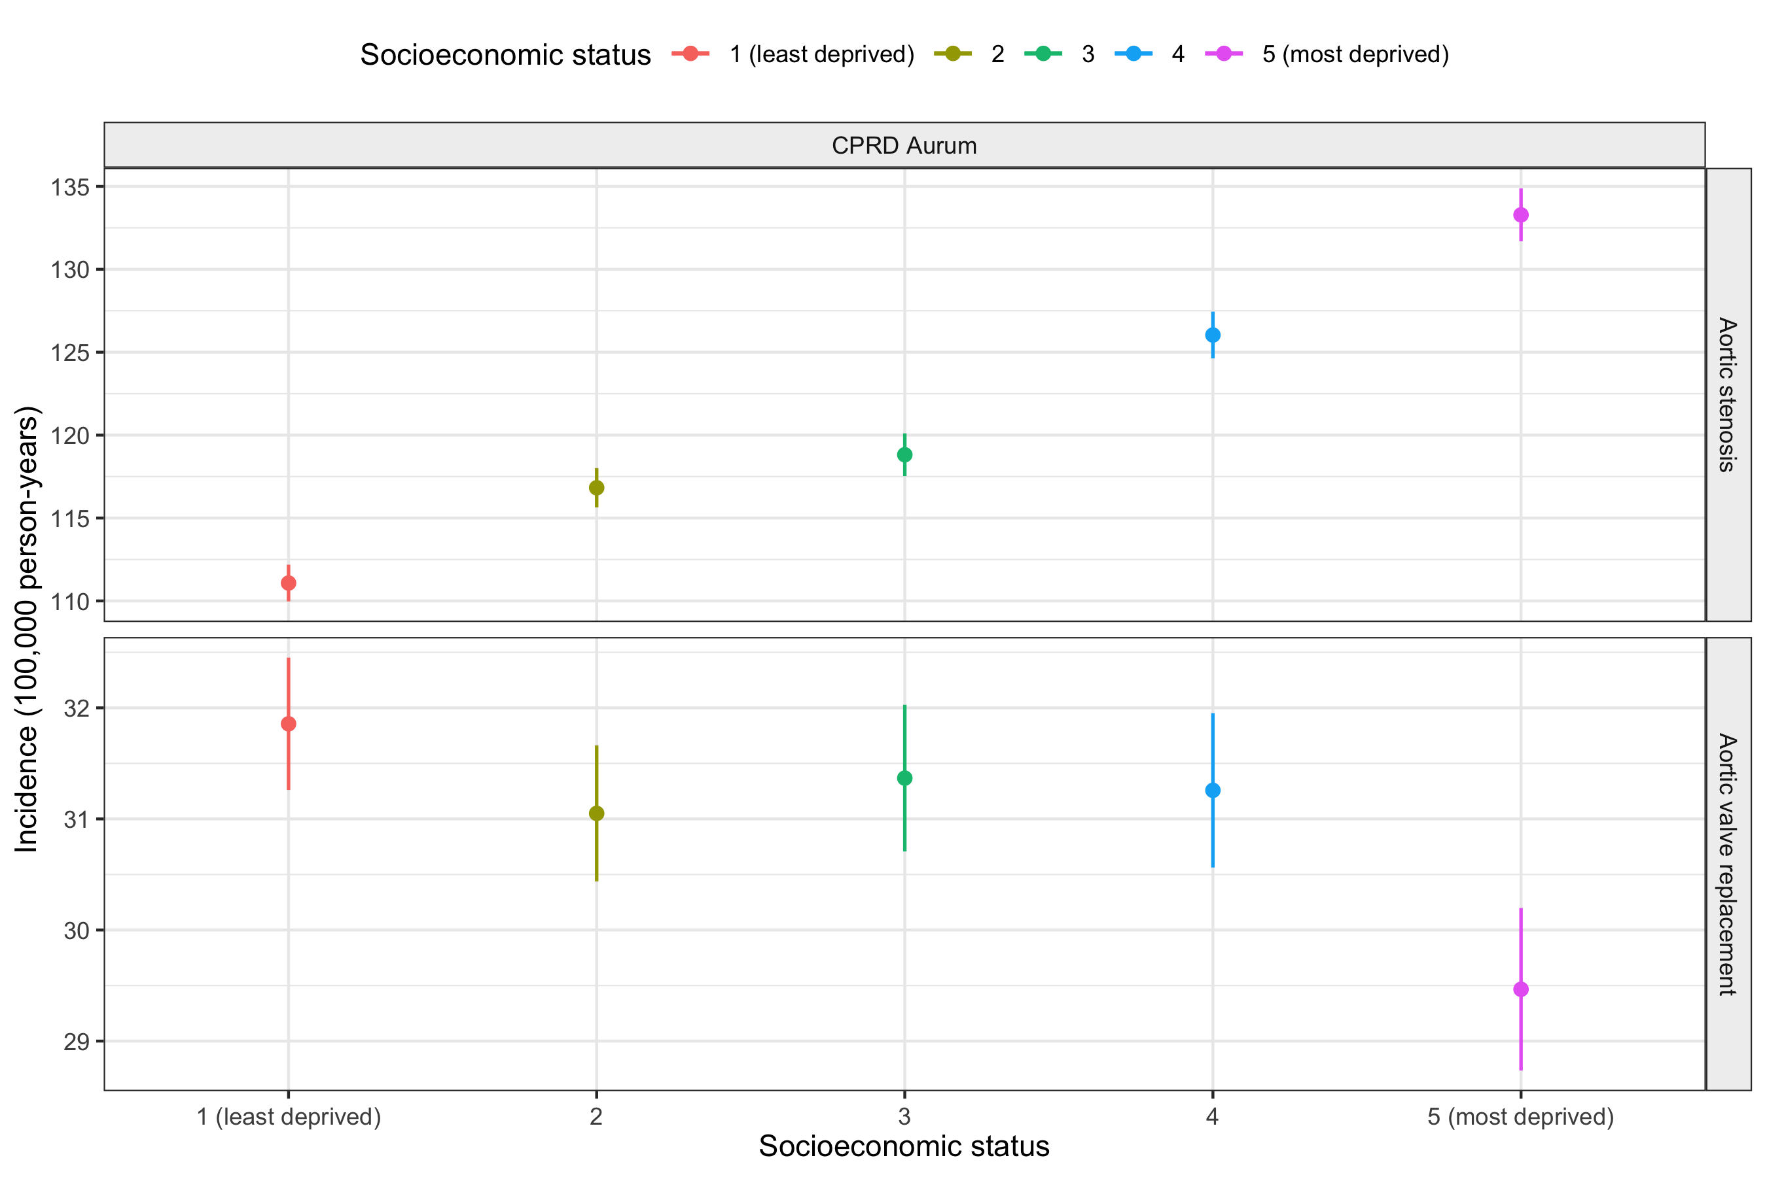

Incidence by age and socioeconomic status
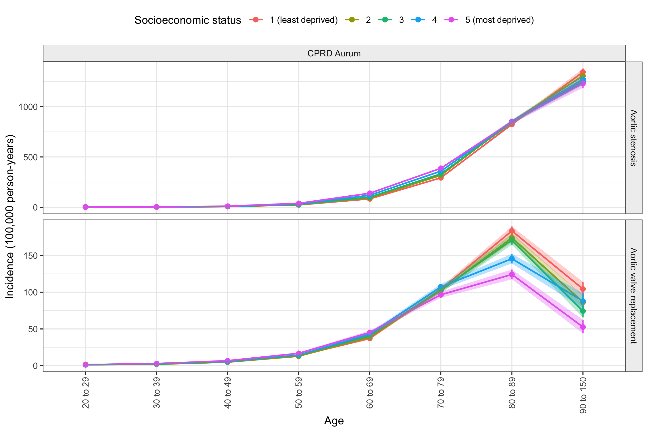

Incidence by year and socioeconomic status
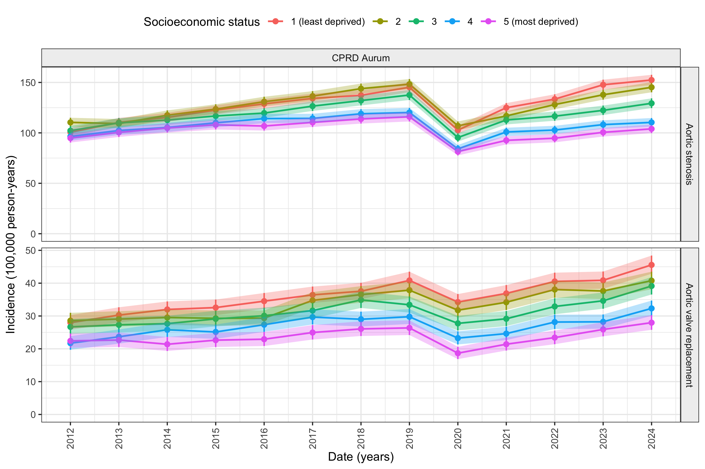
Age-standardised incidence by socioeconomic status and sex
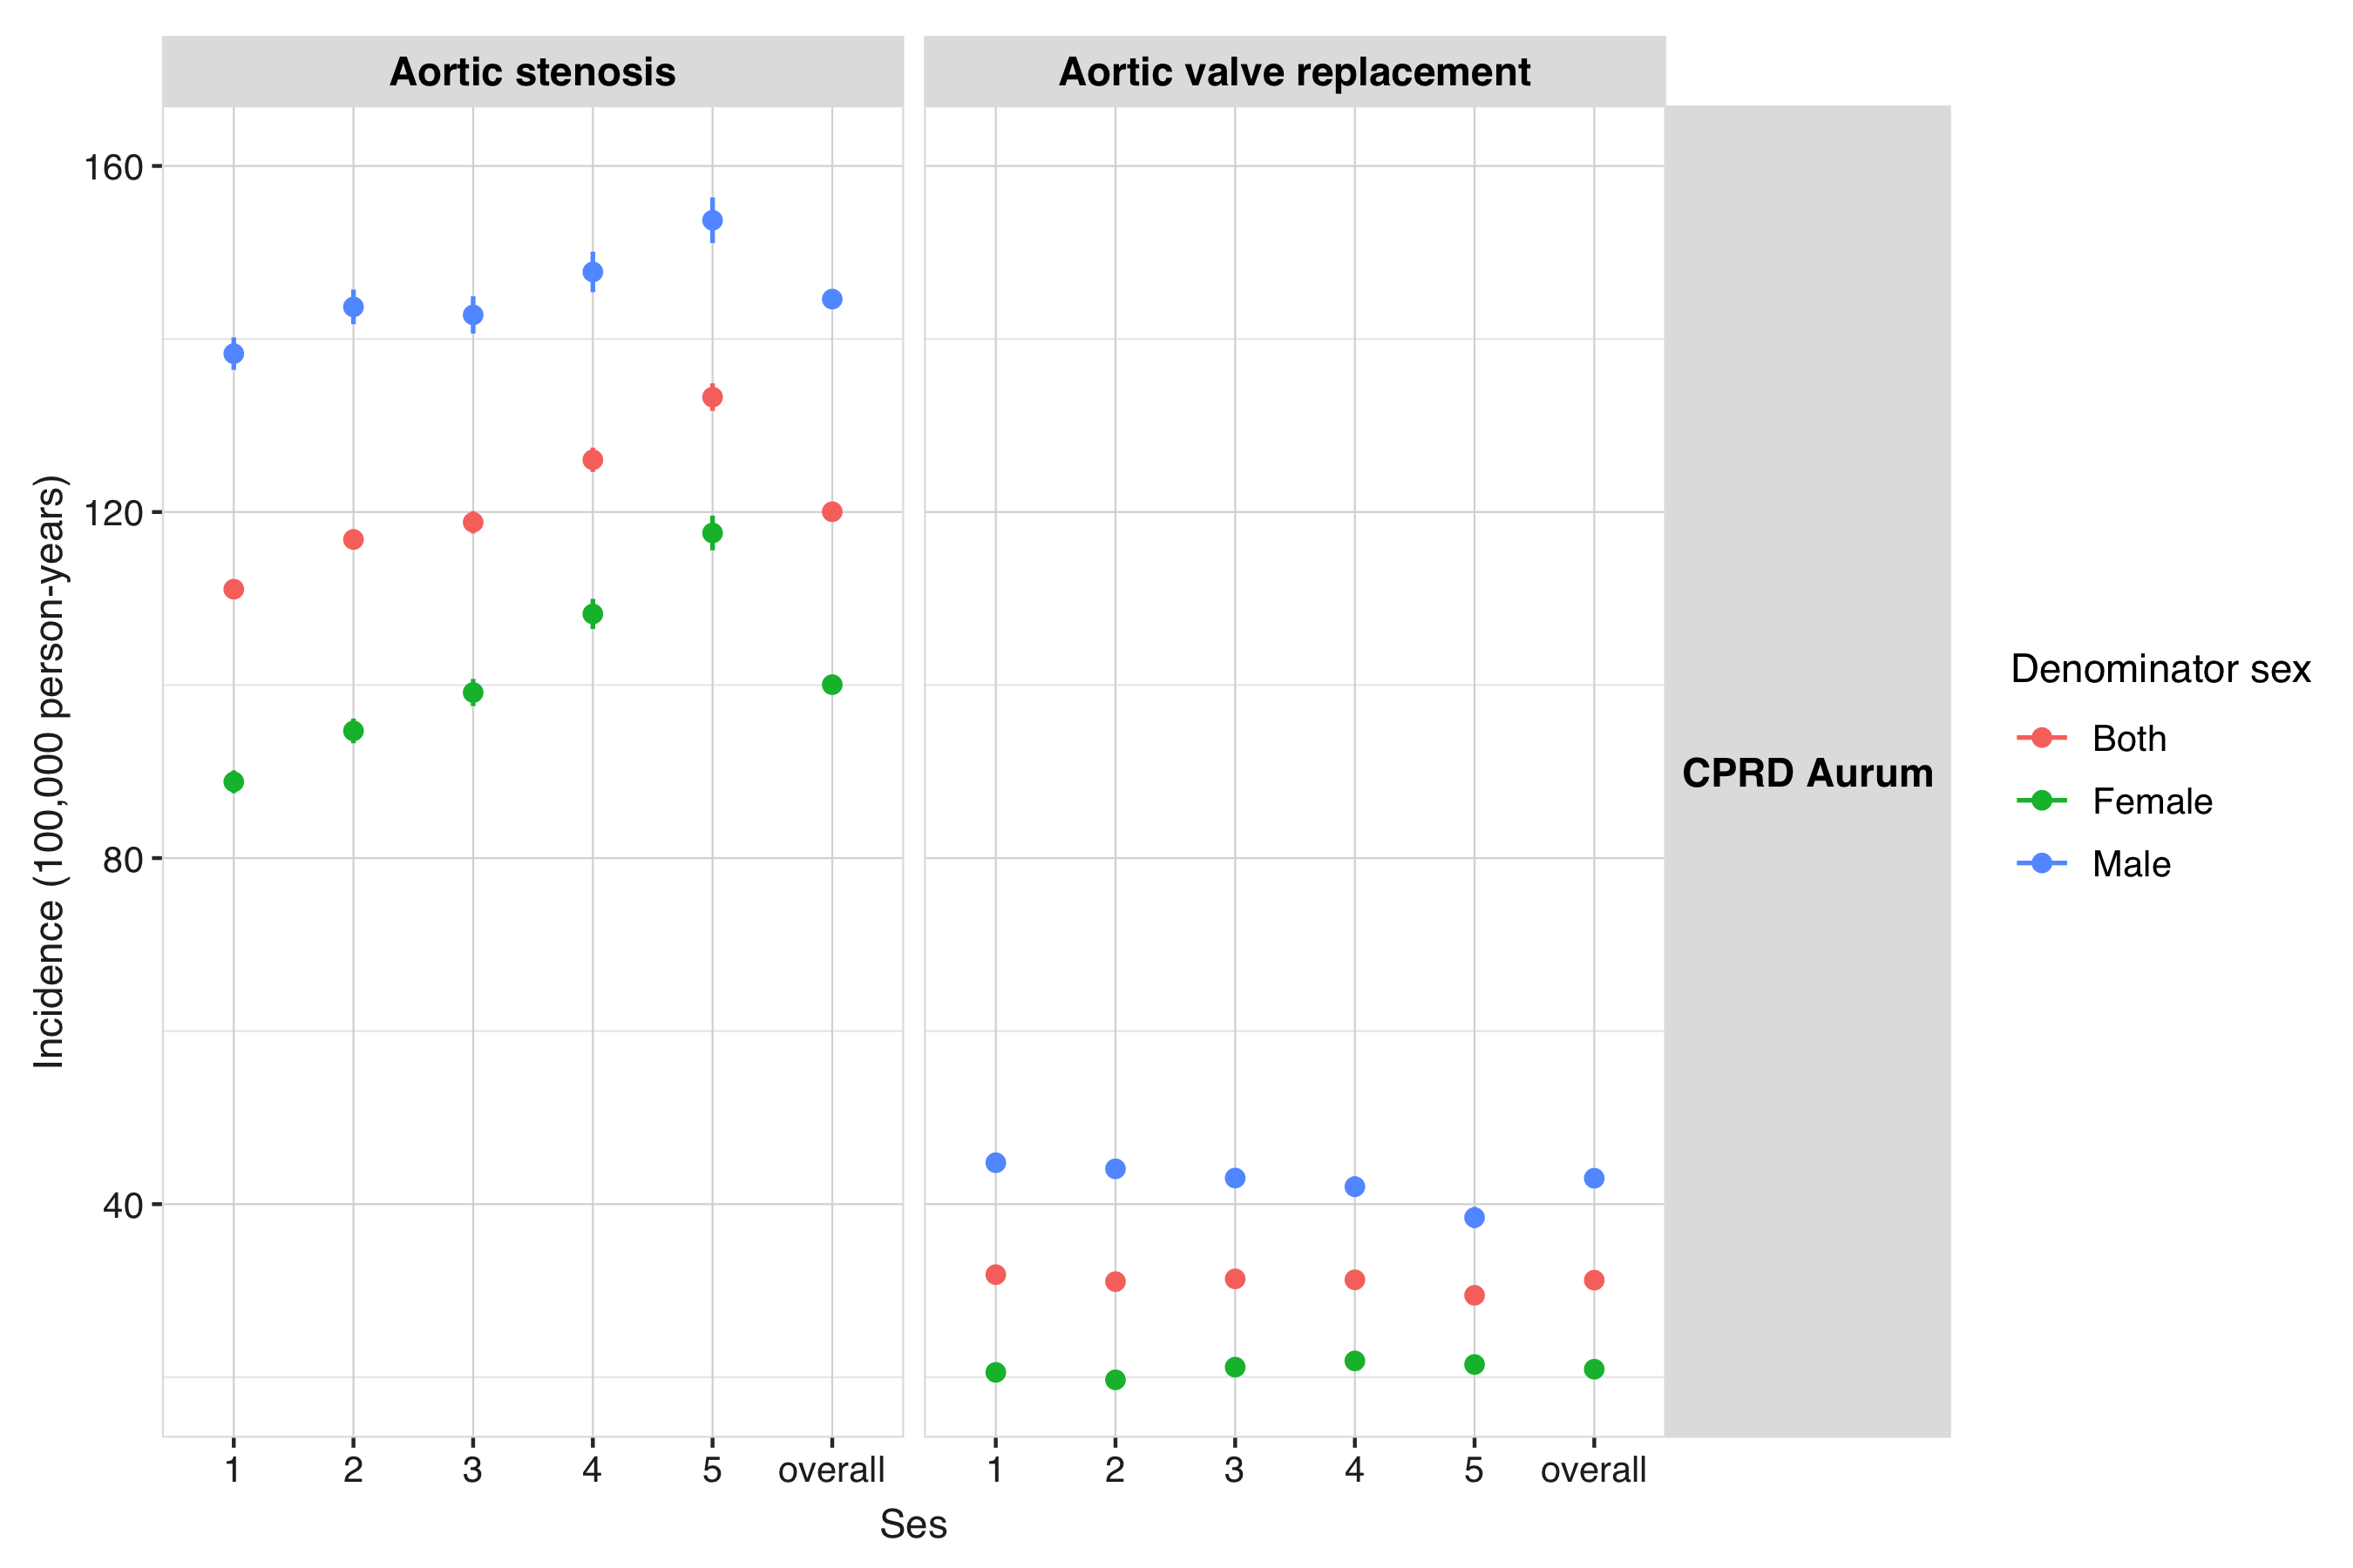
Incidence of Aortic Stenosis by age group and socioeconomic status

Incidence of Aortic Valve Replacement by age group and socioeconomic status


Characteristics

Characteristics of healthy population
 |  |  | CDM name
 |  |  | CPRD Aurum
 |  |  | Cohort name
Variable name | Variable level | Estimate name | healthy
Number subjects | – | N | 23,058,763
Cohort start date | – | Median [Q25 - Q75] | 2013-10-10 [2012-01-01 - 2019-08-28]
 |  | Range | 2012-01-01 to 2025-03-30
Cohort end date | – | Median [Q25 - Q75] | 2024-12-09 [2019-02-28 - 2025-03-31]
 |  | Range | 2012-01-02 to 2025-03-31
Ses | 1 | N (%) | 4,476,073 (19.41%)
 | 2 | N (%) | 4,552,529 (19.74%)
 | 3 | N (%) | 4,562,136 (19.78%)
 | 4 | N (%) | 5,002,170 (21.69%)
 | 5 | N (%) | 4,432,642 (19.22%)
 | Missing | N (%) | 33,213 (0.14%)
Ethnicity group | Asian | N (%) | 2,307,265 (10.01%)
 | Black | N (%) | 1,042,555 (4.52%)
 | Mix | N (%) | 405,266 (1.76%)
 | Other | N (%) | 207,708 (0.90%)
 | Unknown | N (%) | 1,323,924 (5.74%)
 | White | N (%) | 17,772,045 (77.07%)
Ethnicity | Asian: bangladeshi | N (%) | 170,672 (0.74%)
 | Asian: chinese | N (%) | 304,220 (1.32%)
 | Asian: indian | N (%) | 762,604 (3.31%)
 | Asian: other asian | N (%) | 638,139 (2.77%)
 | Asian: pakistani | N (%) | 431,630 (1.87%)
 | Black: african | N (%) | 591,078 (2.56%)
 | Black: caribbean | N (%) | 221,124 (0.96%)
 | Black: other black | N (%) | 230,353 (1.00%)
 | Mixed/multiple: other mixed/multiple | N (%) | 191,191 (0.83%)
 | Mixed/multiple: white/asian | N (%) | 75,812 (0.33%)
 | Mixed/multiple: white/black african | N (%) | 65,323 (0.28%)
 | Mixed/multiple: white/black caribbean | N (%) | 72,940 (0.32%)
 | Other: arab | N (%) | 46,430 (0.20%)
 | Other: other ethnicity | N (%) | 161,278 (0.70%)
 | Unknown | N (%) | 1,323,924 (5.74%)
 | White: british/n. Irish | N (%) | 13,179,310 (57.16%)
 | White: gypsy/irish traveller | N (%) | 1,767 (0.01%)
 | White: irish | N (%) | 162,118 (0.70%)
 | White: other white | N (%) | 4,420,414 (19.17%)
 | White: roma | N (%) | 8,436 (0.04%)
Age | – | Median [Q25 - Q75] | 39 [27 - 56]
 |  | Mean (SD) | 42.78 (18.85)
 |  | Range | 20 to 121
Age group | 20 to 29 | N (%) | 7,152,963 (31.02%)
 | 30 to 39 | N (%) | 4,728,228 (20.51%)
 | 40 to 49 | N (%) | 3,592,446 (15.58%)
 | 50 to 59 | N (%) | 2,807,122 (12.17%)
 | 60 to 69 | N (%) | 2,216,997 (9.61%)
 | 70 to 79 | N (%) | 1,435,678 (6.23%)
 | 80 to 89 | N (%) | 854,116 (3.70%)
 | 90 to 150 | N (%) | 271,213 (1.18%)
Sex | Female | N (%) | 11,781,564 (51.09%)
 | Male | N (%) | 11,277,199 (48.91%)
Prior observation | – | Median [Q25 - Q75] | 465 [365 - 5,073]
 |  | Mean (SD) | 2,177.79 (2,252.14)
 |  | Range | 365 to 7,305
Future observation | – | Median [Q25 - Q75] | 1,858 [685 - 4,043]
 |  | Mean (SD) | 2,273.13 (1,730.20)
 |  | Range | 1 to 4,838
Days in cohort | – | Median [Q25 - Q75] | 1,859 [686 - 4,044]
 |  | Mean (SD) | 2,274.13 (1,730.20)
 |  | Range | 2 to 4,839
Comorbidities | Atrial fibrillation | N (%) | 290,531 (1.26%)
 | Heart failure | N (%) | 594,884 (2.58%)
 | Hypertension | N (%) | 2,414,211 (10.47%)
 | Type 2 diabetes | N (%) | 1,111,313 (4.82%)

Characteristics of aortic stenosis patients
 |  |  | CDM name
 |  |  | CPRD Aurum
 |  |  | Cohort name
Variable name | Variable level | Estimate name | healthy_to_as
Number subjects | – | N | 165,836
Cohort start date | – | Median [Q25 - Q75] | 2023-08-10 [2019-08-30 - 2025-03-31]
 |  | Range | 2012-01-09 to 2025-03-31
Time to event | – | Median [Q25 - Q75] | 2,003.00 [900.00 - 3,266.00]
 |  | Mean (SD) | 2,126.50 (1,394.35)
 |  | Range | 1.00 to 4,838.00
Ses | 1 | N (%) | 38,559 (23.25%)
 | 2 | N (%) | 37,019 (22.32%)
 | 3 | N (%) | 32,484 (19.59%)
 | 4 | N (%) | 30,659 (18.49%)
 | 5 | N (%) | 26,959 (16.26%)
 | Missing | N (%) | 156 (0.09%)
Ethnicity group | Asian | N (%) | 5,329 (3.21%)
 | Black | N (%) | 2,063 (1.24%)
 | Mix | N (%) | 542 (0.33%)
 | Other | N (%) | 122 (0.07%)
 | Unknown | N (%) | 5,533 (3.34%)
 | White | N (%) | 152,247 (91.81%)
Ethnicity | Asian: bangladeshi | N (%) | 430 (0.26%)
 | Asian: chinese | N (%) | 231 (0.14%)
 | Asian: indian | N (%) | 2,333 (1.41%)
 | Asian: other asian | N (%) | 1,245 (0.75%)
 | Asian: pakistani | N (%) | 1,090 (0.66%)
 | Black: african | N (%) | 621 (0.37%)
 | Black: caribbean | N (%) | 1,113 (0.67%)
 | Black: other black | N (%) | 329 (0.20%)
 | Mixed/multiple: other mixed/multiple | N (%) | 203 (0.12%)
 | Mixed/multiple: white/asian | N (%) | 126 (0.08%)
 | Mixed/multiple: white/black african | N (%) | 98 (0.06%)
 | Mixed/multiple: white/black caribbean | N (%) | 115 (0.07%)
 | Other: arab | N (%) | 35 (0.02%)
 | Other: other ethnicity | N (%) | 87 (0.05%)
 | Unknown | N (%) | 5,533 (3.34%)
 | White: british/n. Irish | N (%) | 135,390 (81.64%)
 | White: gypsy/irish traveller | N (%) | <5
 | White: irish | N (%) | 1,805 (1.09%)
 | White: other white | N (%) | 15,045 (9.07%)
 | White: roma | N (%) | 6 (0.00%)
Age | – | Median [Q25 - Q75] | 83 [76 - 89]
 |  | Mean (SD) | 81.56 (10.77)
 |  | Range | 20 to 111
Age group | 20 to 29 | N (%) | 274 (0.17%)
 | 30 to 39 | N (%) | 651 (0.39%)
 | 40 to 49 | N (%) | 1,198 (0.72%)
 | 50 to 59 | N (%) | 4,288 (2.59%)
 | 60 to 69 | N (%) | 14,143 (8.53%)
 | 70 to 79 | N (%) | 38,270 (23.08%)
 | 80 to 89 | N (%) | 68,597 (41.36%)
 | 90 to 150 | N (%) | 38,415 (23.16%)
Sex | Female | N (%) | 78,481 (47.32%)
 | Male | N (%) | 87,355 (52.68%)
Prior observation | – | Median [Q25 - Q75] | 7,771 [4,828 - 9,768]
 |  | Mean (SD) | 7,025.16 (2,957.87)
 |  | Range | 373 to 10,226
Comorbidities | Atrial fibrillation | N (%) | 56,838 (34.27%)
 | Heart failure | N (%) | 95,597 (57.65%)
 | Hypertension | N (%) | 139,226 (83.95%)
 | Type 2 diabetes | N (%) | 55,510 (33.47%)

Characteristics of patients dying after AVR
 |  |  | CDM name
 |  |  | CPRD Aurum
 |  |  | Cohort name
Variable name | Variable level | Estimate name | healthy_to_death
Number subjects | – | N | 1,480,907
Cohort start date | – | Median [Q25 - Q75] | 2018-07-31 [2015-04-01 - 2021-10-27]
 |  | Range | 2012-01-02 to 2025-03-31
Time to event | – | Median [Q25 - Q75] | 1,677.00 [683.00 - 3,030.00]
 |  | Mean (SD) | 1,916.26 (1,384.08)
 |  | Range | 1.00 to 4,838.00
Ses | 1 | N (%) | 291,325 (19.67%)
 | 2 | N (%) | 302,560 (20.43%)
 | 3 | N (%) | 288,398 (19.47%)
 | 4 | N (%) | 290,837 (19.64%)
 | 5 | N (%) | 306,226 (20.68%)
 | Missing | N (%) | 1,561 (0.11%)
Ethnicity group | Asian | N (%) | 45,969 (3.10%)
 | Black | N (%) | 27,970 (1.89%)
 | Mix | N (%) | 5,519 (0.37%)
 | Other | N (%) | 1,535 (0.10%)
 | Unknown | N (%) | 95,683 (6.46%)
 | White | N (%) | 1,304,231 (88.07%)
Ethnicity | Asian: bangladeshi | N (%) | 3,358 (0.23%)
 | Asian: chinese | N (%) | 2,815 (0.19%)
 | Asian: indian | N (%) | 19,867 (1.34%)
 | Asian: other asian | N (%) | 9,513 (0.64%)
 | Asian: pakistani | N (%) | 10,416 (0.70%)
 | Black: african | N (%) | 8,405 (0.57%)
 | Black: caribbean | N (%) | 14,950 (1.01%)
 | Black: other black | N (%) | 4,615 (0.31%)
 | Mixed/multiple: other mixed/multiple | N (%) | 2,362 (0.16%)
 | Mixed/multiple: white/asian | N (%) | 922 (0.06%)
 | Mixed/multiple: white/black african | N (%) | 728 (0.05%)
 | Mixed/multiple: white/black caribbean | N (%) | 1,507 (0.10%)
 | Other: arab | N (%) | 198 (0.01%)
 | Other: other ethnicity | N (%) | 1,337 (0.09%)
 | Unknown | N (%) | 95,683 (6.46%)
 | White: british/n. Irish | N (%) | 1,027,062 (69.35%)
 | White: gypsy/irish traveller | N (%) | 24 (0.00%)
 | White: irish | N (%) | 13,330 (0.90%)
 | White: other white | N (%) | 263,785 (17.81%)
 | White: roma | N (%) | 30 (0.00%)
Age | – | Median [Q25 - Q75] | 81 [71 - 89]
 |  | Mean (SD) | 78.25 (14.23)
 |  | Range | 20 to 122
Age group | 20 to 29 | N (%) | 8,802 (0.59%)
 | 30 to 39 | N (%) | 17,164 (1.16%)
 | 40 to 49 | N (%) | 40,630 (2.74%)
 | 50 to 59 | N (%) | 94,193 (6.36%)
 | 60 to 69 | N (%) | 180,526 (12.19%)
 | 70 to 79 | N (%) | 329,117 (22.22%)
 | 80 to 89 | N (%) | 484,402 (32.71%)
 | 90 to 150 | N (%) | 326,073 (22.02%)
Sex | Female | N (%) | 744,047 (50.24%)
 | Male | N (%) | 736,860 (49.76%)
Prior observation | – | Median [Q25 - Q75] | 5,931 [2,458 - 7,715]
 |  | Mean (SD) | 5,346.66 (2,946.77)
 |  | Range | 366 to 10,226
Comorbidities | Atrial fibrillation | N (%) | 280,623 (18.95%)
 | Heart failure | N (%) | 581,054 (39.24%)
 | Hypertension | N (%) | 934,233 (63.09%)
 | Type 2 diabetes | N (%) | 374,291 (25.27%)

Characteristics of patients receiving AVR after AS diagnosis
 |  |  | CDM name
 |  |  | CPRD Aurum
 |  |  | Cohort name
Variable name | Variable level | Estimate name | as_to_avr
Number subjects | – | N | 27,980
Cohort start date | – | Median [Q25 - Q75] | 2025-03-31 [2022-03-19 - 2025-03-31]
 |  | Range | 2012-03-16 to 2025-03-31
Time to event | – | Median [Q25 - Q75] | 286.00 [94.00 - 968.00]
 |  | Mean (SD) | 662.64 (822.74)
 |  | Range | 1.00 to 4,768.00
Ses | 1 | N (%) | 7,163 (25.60%)
 | 2 | N (%) | 6,440 (23.02%)
 | 3 | N (%) | 5,564 (19.89%)
 | 4 | N (%) | 4,879 (17.44%)
 | 5 | N (%) | 3,907 (13.96%)
 | Missing | N (%) | 27 (0.10%)
Ethnicity group | Asian | N (%) | 779 (2.78%)
 | Black | N (%) | 222 (0.79%)
 | Mix | N (%) | 92 (0.33%)
 | Other | N (%) | 24 (0.09%)
 | Unknown | N (%) | 726 (2.59%)
 | White | N (%) | 26,137 (93.41%)
Ethnicity | Asian: bangladeshi | N (%) | 47 (0.17%)
 | Asian: chinese | N (%) | 28 (0.10%)
 | Asian: indian | N (%) | 342 (1.22%)
 | Asian: other asian | N (%) | 223 (0.80%)
 | Asian: pakistani | N (%) | 139 (0.50%)
 | Black: african | N (%) | 72 (0.26%)
 | Black: caribbean | N (%) | 110 (0.39%)
 | Black: other black | N (%) | 40 (0.14%)
 | Mixed/multiple: other mixed/multiple | N (%) | 39 (0.14%)
 | Mixed/multiple: white/asian | N (%) | 23 (0.08%)
 | Mixed/multiple: white/black african | N (%) | 10 (0.04%)
 | Mixed/multiple: white/black caribbean | N (%) | 20 (0.07%)
 | Other: arab | N (%) | 5 (0.02%)
 | Other: other ethnicity | N (%) | 19 (0.07%)
 | Unknown | N (%) | 726 (2.59%)
 | White: british/n. Irish | N (%) | 24,090 (86.10%)
 | White: gypsy/irish traveller | N (%) | <5
 | White: irish | N (%) | 302 (1.08%)
 | White: other white | N (%) | 1,743 (6.23%)
 | White: roma | N (%) | <5
Age | – | Median [Q25 - Q75] | 80 [73 - 86]
 |  | Mean (SD) | 78.63 (10.34)
 |  | Range | 20 to 103
Age group | 20 to 29 | N (%) | 18 (0.06%)
 | 30 to 39 | N (%) | 81 (0.29%)
 | 40 to 49 | N (%) | 260 (0.93%)
 | 50 to 59 | N (%) | 1,033 (3.69%)
 | 60 to 69 | N (%) | 3,473 (12.41%)
 | 70 to 79 | N (%) | 8,360 (29.88%)
 | 80 to 89 | N (%) | 11,339 (40.53%)
 | 90 to 150 | N (%) | 3,416 (12.21%)
Sex | Female | N (%) | 10,344 (36.97%)
 | Male | N (%) | 17,636 (63.03%)
Prior observation | – | Median [Q25 - Q75] | 8,711 [5,866 - 10,226]
 |  | Mean (SD) | 7,745.76 (2,707.11)
 |  | Range | 440 to 10,226
Comorbidities | Atrial fibrillation | N (%) | 11,326 (40.48%)
 | Heart failure | N (%) | 17,119 (61.18%)
 | Hypertension | N (%) | 24,087 (86.09%)
 | Type 2 diabetes | N (%) | 9,695 (34.65%)

Characteristics of patients dying after AS diagnosis without receiving AVR
 |  |  | CDM name
 |  |  | CPRD Aurum
 |  |  | Cohort name
Variable name | Variable level | Estimate name | as_to_death
Number subjects | – | N | 59,933
Cohort start date | – | Median [Q25 - Q75] | 2020-03-06 [2017-04-10 - 2022-09-20]
 |  | Range | 2012-01-09 to 2025-03-31
Time to event | – | Median [Q25 - Q75] | 518.00 [121.00 - 1,237.00]
 |  | Mean (SD) | 807.66 (853.47)
 |  | Range | 0.00 to 4,802.00
Ses | 1 | N (%) | 12,919 (21.56%)
 | 2 | N (%) | 12,990 (21.67%)
 | 3 | N (%) | 11,713 (19.54%)
 | 4 | N (%) | 11,511 (19.21%)
 | 5 | N (%) | 10,752 (17.94%)
 | Missing | N (%) | 48 (0.08%)
Ethnicity group | Asian | N (%) | 1,682 (2.81%)
 | Black | N (%) | 701 (1.17%)
 | Mix | N (%) | 137 (0.23%)
 | Other | N (%) | 29 (0.05%)
 | Unknown | N (%) | 2,829 (4.72%)
 | White | N (%) | 54,555 (91.03%)
Ethnicity | Asian: bangladeshi | N (%) | 154 (0.26%)
 | Asian: chinese | N (%) | 74 (0.12%)
 | Asian: indian | N (%) | 759 (1.27%)
 | Asian: other asian | N (%) | 342 (0.57%)
 | Asian: pakistani | N (%) | 353 (0.59%)
 | Black: african | N (%) | 170 (0.28%)
 | Black: caribbean | N (%) | 436 (0.73%)
 | Black: other black | N (%) | 95 (0.16%)
 | Mixed/multiple: other mixed/multiple | N (%) | 55 (0.09%)
 | Mixed/multiple: white/asian | N (%) | 25 (0.04%)
 | Mixed/multiple: white/black african | N (%) | 23 (0.04%)
 | Mixed/multiple: white/black caribbean | N (%) | 34 (0.06%)
 | Other: arab | N (%) | 5 (0.01%)
 | Other: other ethnicity | N (%) | 24 (0.04%)
 | Unknown | N (%) | 2,829 (4.72%)
 | White: british/n. Irish | N (%) | 46,975 (78.38%)
 | White: irish | N (%) | 639 (1.07%)
 | White: other white | N (%) | 6,941 (11.58%)
Age | – | Median [Q25 - Q75] | 86 [80 - 91]
 |  | Mean (SD) | 84.70 (8.91)
 |  | Range | 23 to 109
Age group | 20 to 29 | N (%) | 8 (0.01%)
 | 30 to 39 | N (%) | 23 (0.04%)
 | 40 to 49 | N (%) | 130 (0.22%)
 | 50 to 59 | N (%) | 639 (1.07%)
 | 60 to 69 | N (%) | 2,888 (4.82%)
 | 70 to 79 | N (%) | 10,631 (17.74%)
 | 80 to 89 | N (%) | 26,329 (43.93%)
 | 90 to 150 | N (%) | 19,285 (32.18%)
Sex | Female | N (%) | 28,977 (48.35%)
 | Male | N (%) | 30,956 (51.65%)
Prior observation | – | Median [Q25 - Q75] | 7,178 [4,666 - 8,630]
 |  | Mean (SD) | 6,463.48 (2,742.94)
 |  | Range | 373 to 10,226
Comorbidities | Atrial fibrillation | N (%) | 22,948 (38.29%)
 | Heart failure | N (%) | 44,092 (73.57%)
 | Hypertension | N (%) | 51,856 (86.52%)
 | Type 2 diabetes | N (%) | 21,422 (35.74%)

Characteristics of patients dying after AVR
 |  |  | CDM name
 |  |  | CPRD Aurum
 |  |  | Cohort name
Variable name | Variable level | Estimate name | avr_to_death
Number subjects | – | N | 7,225
Cohort start date | – | Median [Q25 - Q75] | 2021-09-07 [2019-04-01 - 2023-07-24]
 |  | Range | 2012-03-16 to 2025-03-31
Time to event | – | Median [Q25 - Q75] | 948.00 [291.00 - 1,810.00]
 |  | Mean (SD) | 1,157.23 (999.43)
 |  | Range | 0.50 to 4,682.00
Ses | 1 | N (%) | 1,768 (24.47%)
 | 2 | N (%) | 1,595 (22.08%)
 | 3 | N (%) | 1,440 (19.93%)
 | 4 | N (%) | 1,300 (17.99%)
 | 5 | N (%) | 1,117 (15.46%)
 | Missing | N (%) | 5 (0.07%)
Ethnicity group | Asian | N (%) | 167 (2.31%)
 | Black | N (%) | 54 (0.75%)
 | Mix | N (%) | 21 (0.29%)
 | Other | N (%) | <5
 | Unknown | N (%) | 300 (4.15%)
 | White | N (%) | 6,679 (92.44%)
Ethnicity | Asian: bangladeshi | N (%) | 10 (0.14%)
 | Asian: chinese | N (%) | 9 (0.12%)
 | Asian: indian | N (%) | 73 (1.01%)
 | Asian: other asian | N (%) | 46 (0.64%)
 | Asian: pakistani | N (%) | 29 (0.40%)
 | Black: african | N (%) | 15 (0.21%)
 | Black: caribbean | N (%) | 31 (0.43%)
 | Black: other black | N (%) | 8 (0.11%)
 | Mixed/multiple: other mixed/multiple | N (%) | 6 (0.08%)
 | Mixed/multiple: white/asian | N (%) | 8 (0.11%)
 | Mixed/multiple: white/black african | N (%) | <5
 | Mixed/multiple: white/black caribbean | N (%) | 5 (0.07%)
 | Other: arab | N (%) | <5
 | Other: other ethnicity | N (%) | <5
 | Unknown | N (%) | 300 (4.15%)
 | White: british/n. Irish | N (%) | 6,110 (84.57%)
 | White: irish | N (%) | 94 (1.30%)
 | White: other white | N (%) | 475 (6.57%)
Age | – | Median [Q25 - Q75] | 83 [76 - 88]
 |  | Mean (SD) | 81.28 (8.91)
 |  | Range | 20 to 103
Age group | 20 to 29 | N (%) | <5
 | 30 to 39 | N (%) | 0 (0.00%)
 | 40 to 49 | N (%) | 26 (0.36%)
 | 50 to 59 | N (%) | 129 (1.79%)
 | 60 to 69 | N (%) | 561 (7.76%)
 | 70 to 79 | N (%) | 1,945 (26.92%)
 | 80 to 89 | N (%) | 3,362 (46.53%)
 | 90 to 150 | N (%) | 1,199 (16.60%)
Sex | Female | N (%) | 2,595 (35.92%)
 | Male | N (%) | 4,630 (64.08%)
Prior observation | – | Median [Q25 - Q75] | 8,028 [5,987 - 9,177]
 |  | Mean (SD) | 7,310.40 (2,389.32)
 |  | Range | 455 to 10,226
Comorbidities | Atrial fibrillation | N (%) | 3,616 (50.05%)
 | Heart failure | N (%) | 5,933 (82.12%)
 | Hypertension | N (%) | 6,579 (91.06%)
 | Type 2 diabetes | N (%) | 2,915 (40.35%)

age and sex distribution
# A tibble: 60 × 5
cdm_name cohort_name variable_name variable_level count
<chr> <chr> <chr> <chr> <int>
1 CPRD Aurum healthy Age group 20 to 29 7152963
2 CPRD Aurum healthy Age group 30 to 39 4728228
3 CPRD Aurum healthy Age group 40 to 49 3592446
4 CPRD Aurum healthy Age group 50 to 59 2807122
5 CPRD Aurum healthy Age group 60 to 69 2216997
6 CPRD Aurum healthy Age group 70 to 79 1435678
7 CPRD Aurum healthy Age group 80 to 89 854116
8 CPRD Aurum healthy Age group 90 to 150 271213
9 CPRD Aurum healthy Sex Female 11781564
10 CPRD Aurum healthy Sex Male 11277199
# ℹ 50 more rows

Multi state model

only age model
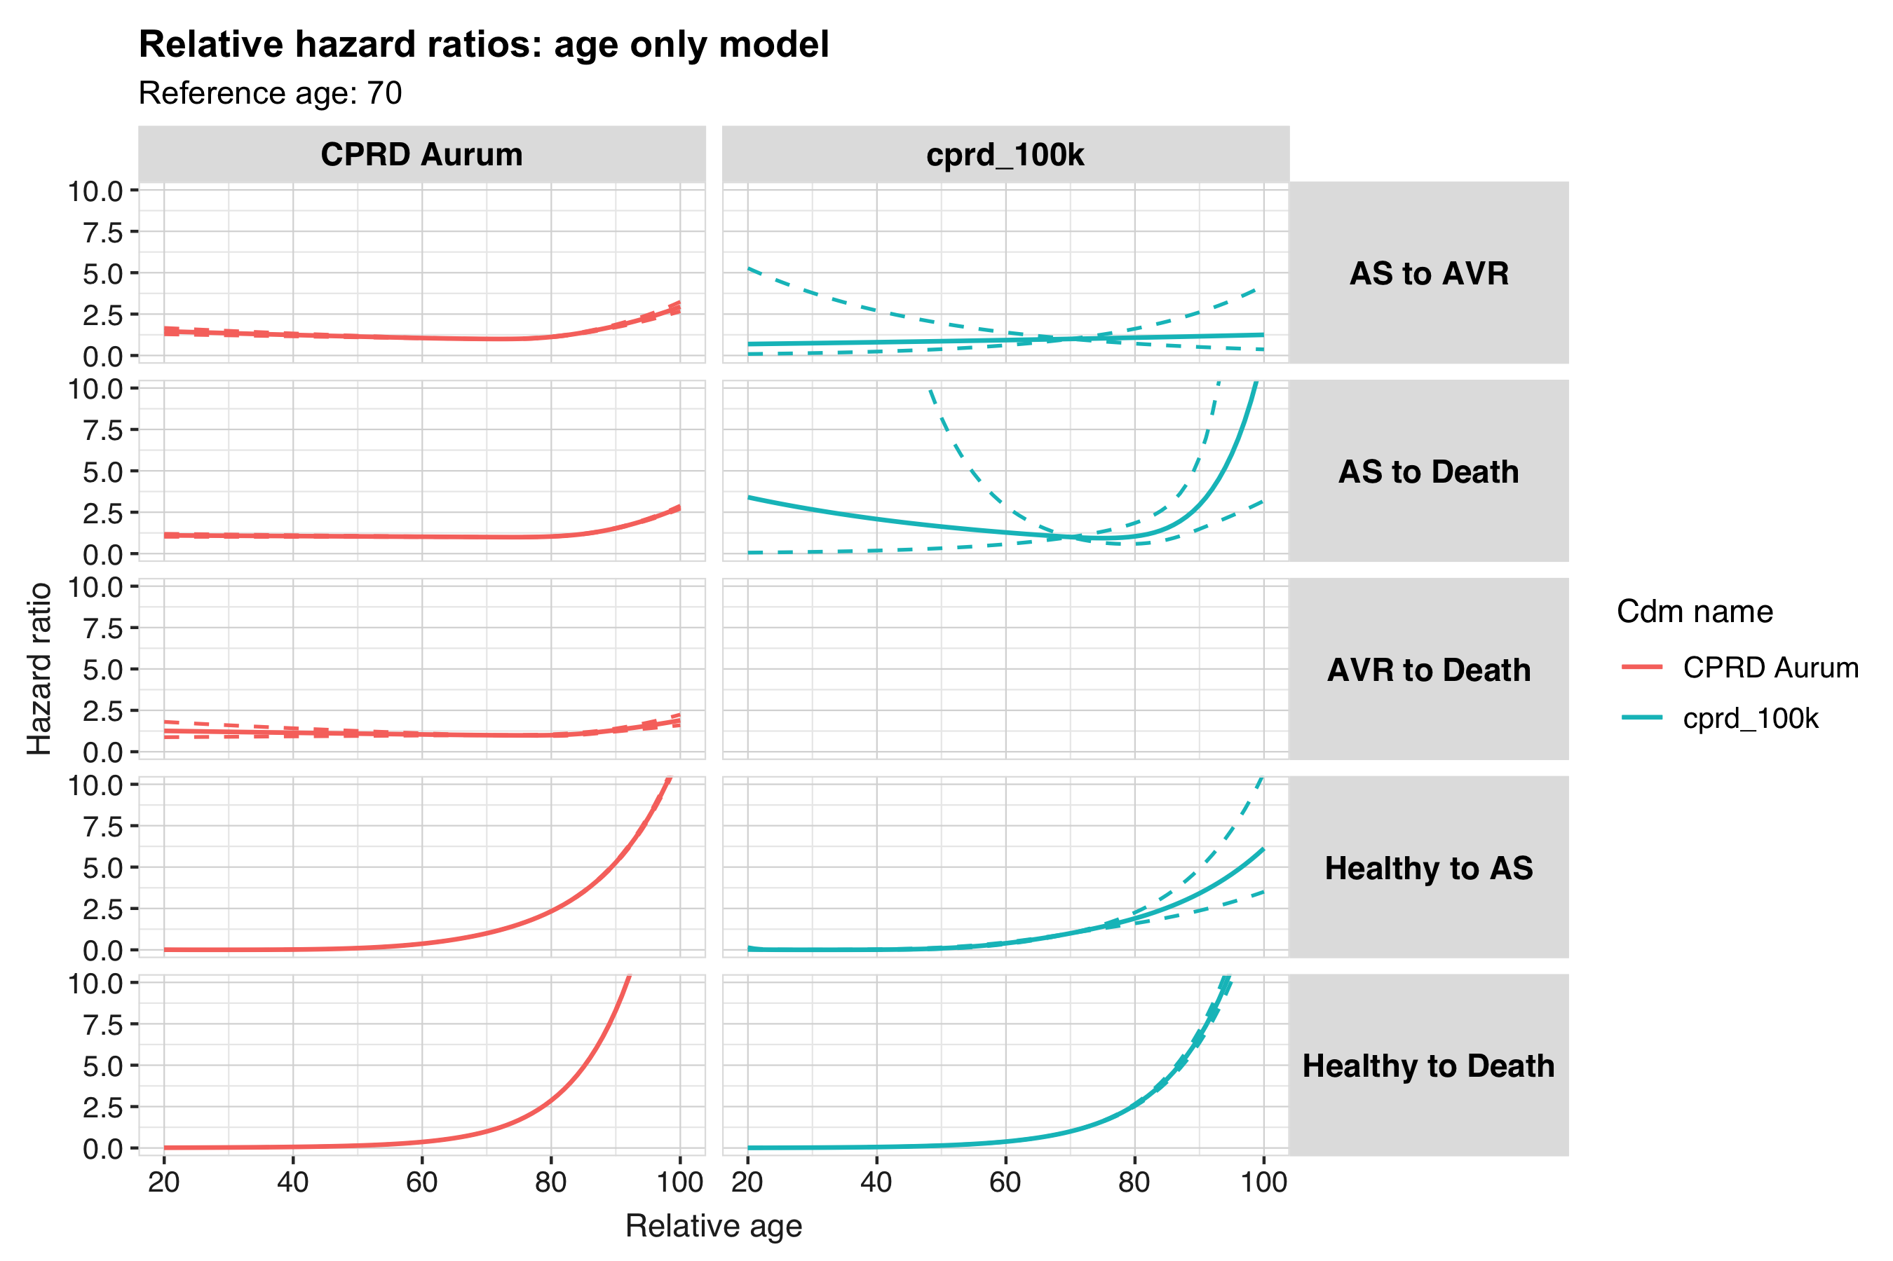

Other models
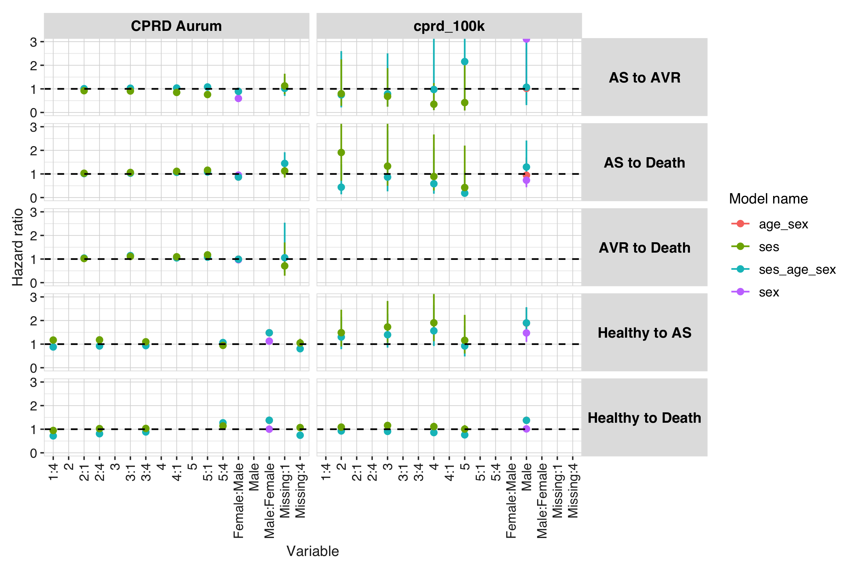
 |  |  |  | CDM name
Model name | Variable name | Variable level | Estimate name | CPRD Aurum | cprd_100k
healthy_to_as
age_sex | sex | Male:Female | Hazard Ratio [95% CI] | 1.480 [1.465, 1.494] | –
 |  |  | P Value | 0.000 | –
 |  |  | Standard Error | 0.005 | –
sex | sex | Male:Female | Hazard Ratio [95% CI] | 1.126 [1.116, 1.137] | –
 |  |  | P Value | 0.000 | –
 |  |  | Standard Error | 0.005 | –
ses_age_sex | sex | Male:Female | Hazard Ratio [95% CI] | 1.482 [1.467, 1.496] | –
 |  |  | P Value | 0.000 | –
 |  |  | Standard Error | 0.005 | –
 | ses | 1:4 | Hazard Ratio [95% CI] | 0.879 [0.866, 0.892] | –
 |  |  | P Value | 0.000 | –
 |  |  | Standard Error | 0.008 | –
 |  | 2:4 | Hazard Ratio [95% CI] | 0.922 [0.908, 0.936] | –
 |  |  | P Value | 0.000 | –
 |  |  | Standard Error | 0.008 | –
 |  | 3:4 | Hazard Ratio [95% CI] | 0.937 [0.923, 0.952] | –
 |  |  | P Value | 0.000 | –
 |  |  | Standard Error | 0.008 | –
 |  | 5:4 | Hazard Ratio [95% CI] | 1.067 [1.050, 1.085] | –
 |  |  | P Value | 0.000 | –
 |  |  | Standard Error | 0.008 | –
 |  | Missing:4 | Hazard Ratio [95% CI] | 0.806 [0.689, 0.943] | –
 |  |  | P Value | 0.000 | –
 |  |  | Standard Error | 0.080 | –
ses | ses | 1:4 | Hazard Ratio [95% CI] | 1.172 [1.154, 1.190] | –
 |  |  | P Value | 0.000 | –
 |  |  | Standard Error | 0.008 | –
 |  | 2:4 | Hazard Ratio [95% CI] | 1.179 [1.162, 1.197] | –
 |  |  | P Value | 0.000 | –
 |  |  | Standard Error | 0.008 | –
 |  | 3:4 | Hazard Ratio [95% CI] | 1.099 [1.082, 1.116] | –
 |  |  | P Value | 0.000 | –
 |  |  | Standard Error | 0.008 | –
 |  | 5:4 | Hazard Ratio [95% CI] | 0.947 [0.932, 0.963] | –
 |  |  | P Value | 0.000 | –
 |  |  | Standard Error | 0.008 | –
 |  | Missing:4 | Hazard Ratio [95% CI] | 1.047 [0.895, 1.226] | –
 |  |  | P Value | 0.000 | –
 |  |  | Standard Error | 0.080 | –
age_sex | sex | Male | Hazard Ratio [95% CI] | – | 1.892 [1.401, 2.555]
 |  |  | P Value | – | 0.000
 |  |  | Standard Error | – | 0.153
sex | sex | Male | Hazard Ratio [95% CI] | – | 1.473 [1.094, 1.984]
 |  |  | P Value | – | 0.011
 |  |  | Standard Error | – | 0.152
ses_age_sex | sex | Male | Hazard Ratio [95% CI] | – | 1.899 [1.406, 2.565]
 |  |  | P Value | – | 0.000
 |  |  | Standard Error | – | 0.153
 | ses | 2 | Hazard Ratio [95% CI] | – | 1.301 [0.787, 2.152]
 |  |  | P Value | – | 0.304
 |  |  | Standard Error | – | 0.257
 |  | 3 | Hazard Ratio [95% CI] | – | 1.397 [0.853, 2.288]
 |  |  | P Value | – | 0.304
 |  |  | Standard Error | – | 0.252
 |  | 4 | Hazard Ratio [95% CI] | – | 1.564 [0.922, 2.653]
 |  |  | P Value | – | 0.304
 |  |  | Standard Error | – | 0.270
 |  | 5 | Hazard Ratio [95% CI] | – | 0.922 [0.478, 1.778]
 |  |  | P Value | – | 0.304
 |  |  | Standard Error | – | 0.335
ses | ses | 2 | Hazard Ratio [95% CI] | – | 1.486 [0.899, 2.458]
 |  |  | P Value | – | 0.101
 |  |  | Standard Error | – | 0.257
 |  | 3 | Hazard Ratio [95% CI] | – | 1.727 [1.055, 2.828]
 |  |  | P Value | – | 0.101
 |  |  | Standard Error | – | 0.252
 |  | 4 | Hazard Ratio [95% CI] | – | 1.903 [1.123, 3.226]
 |  |  | P Value | – | 0.101
 |  |  | Standard Error | – | 0.269
 |  | 5 | Hazard Ratio [95% CI] | – | 1.162 [0.603, 2.240]
 |  |  | P Value | – | 0.101
 |  |  | Standard Error | – | 0.335
as_to_avr
age_sex | sex | Female:Male | Hazard Ratio [95% CI] | 0.896 [0.874, 0.918] | –
 |  |  | P Value | 0.000 | –
 |  |  | Standard Error | 0.012 | –
sex | sex | Female:Male | Hazard Ratio [95% CI] | 0.595 [0.581, 0.610] | –
 |  |  | P Value | 0.000 | –
 |  |  | Standard Error | 0.012 | –
ses_age_sex | sex | Female:Male | Hazard Ratio [95% CI] | 0.894 [0.872, 0.916] | –
 |  |  | P Value | 0.000 | –
 |  |  | Standard Error | 0.013 | –
 | ses | 2:1 | Hazard Ratio [95% CI] | 1.009 [0.975, 1.043] | –
 |  |  | P Value | 0.004 | –
 |  |  | Standard Error | 0.017 | –
 |  | 3:1 | Hazard Ratio [95% CI] | 1.028 [0.993, 1.065] | –
 |  |  | P Value | 0.004 | –
 |  |  | Standard Error | 0.018 | –
 |  | 4:1 | Hazard Ratio [95% CI] | 1.036 [0.999, 1.074] | –
 |  |  | P Value | 0.004 | –
 |  |  | Standard Error | 0.019 | –
 |  | 5:1 | Hazard Ratio [95% CI] | 1.081 [1.039, 1.125] | –
 |  |  | P Value | 0.004 | –
 |  |  | Standard Error | 0.020 | –
 |  | Missing:1 | Hazard Ratio [95% CI] | 1.020 [0.699, 1.488] | –
 |  |  | P Value | 0.004 | –
 |  |  | Standard Error | 0.193 | –
ses | ses | 2:1 | Hazard Ratio [95% CI] | 0.922 [0.892, 0.954] | –
 |  |  | P Value | 0.000 | –
 |  |  | Standard Error | 0.017 | –
 |  | 3:1 | Hazard Ratio [95% CI] | 0.910 [0.879, 0.942] | –
 |  |  | P Value | 0.000 | –
 |  |  | Standard Error | 0.018 | –
 |  | 4:1 | Hazard Ratio [95% CI] | 0.850 [0.819, 0.881] | –
 |  |  | P Value | 0.000 | –
 |  |  | Standard Error | 0.019 | –
 |  | 5:1 | Hazard Ratio [95% CI] | 0.760 [0.731, 0.790] | –
 |  |  | P Value | 0.000 | –
 |  |  | Standard Error | 0.020 | –
 |  | Missing:1 | Hazard Ratio [95% CI] | 1.125 [0.771, 1.642] | –
 |  |  | P Value | 0.000 | –
 |  |  | Standard Error | 0.193 | –
age_sex | sex | Male | Hazard Ratio [95% CI] | – | 1.021 [0.382, 2.734]
 |  |  | P Value | – | 0.966
 |  |  | Standard Error | – | 0.502
sex | sex | Male | Hazard Ratio [95% CI] | – | 3.111 [1.278, 7.571]
 |  |  | P Value | – | 0.012
 |  |  | Standard Error | – | 0.454
ses_age_sex | sex | Male | Hazard Ratio [95% CI] | – | 1.071 [0.311, 3.684]
 |  |  | P Value | – | 0.914
 |  |  | Standard Error | – | 0.631
 | ses | 2 | Hazard Ratio [95% CI] | – | 0.747 [0.215, 2.600]
 |  |  | P Value | – | 0.844
 |  |  | Standard Error | – | 0.636
 |  | 3 | Hazard Ratio [95% CI] | – | 0.787 [0.247, 2.503]
 |  |  | P Value | – | 0.844
 |  |  | Standard Error | – | 0.590
 |  | 4 | Hazard Ratio [95% CI] | – | 0.973 [0.118, 8.056]
 |  |  | P Value | – | 0.844
 |  |  | Standard Error | – | 1.078
 |  | 5 | Hazard Ratio [95% CI] | – | 2.156 [0.348, 13.366]
 |  |  | P Value | – | 0.844
 |  |  | Standard Error | – | 0.931
ses | ses | 2 | Hazard Ratio [95% CI] | – | 0.796 [0.282, 2.249]
 |  |  | P Value | – | 0.506
 |  |  | Standard Error | – | 0.530
 |  | 3 | Hazard Ratio [95% CI] | – | 0.681 [0.247, 1.878]
 |  |  | P Value | – | 0.506
 |  |  | Standard Error | – | 0.517
 |  | 4 | Hazard Ratio [95% CI] | – | 0.348 [0.097, 1.244]
 |  |  | P Value | – | 0.506
 |  |  | Standard Error | – | 0.650
 |  | 5 | Hazard Ratio [95% CI] | – | 0.418 [0.083, 2.110]
 |  |  | P Value | – | 0.506
 |  |  | Standard Error | – | 0.825
healthy_to_death
age_sex | sex | Male:Female | Hazard Ratio [95% CI] | 1.374 [1.370, 1.379] | –
 |  |  | P Value | 0.000 | –
 |  |  | Standard Error | 0.002 | –
sex | sex | Male:Female | Hazard Ratio [95% CI] | 1.002 [0.999, 1.005] | –
 |  |  | P Value | 0.203 | –
 |  |  | Standard Error | 0.002 | –
ses_age_sex | sex | Male:Female | Hazard Ratio [95% CI] | 1.380 [1.375, 1.384] | –
 |  |  | P Value | 0.000 | –
 |  |  | Standard Error | 0.002 | –
 | ses | 1:4 | Hazard Ratio [95% CI] | 0.717 [0.713, 0.720] | –
 |  |  | P Value | 0.000 | –
 |  |  | Standard Error | 0.003 | –
 |  | 2:4 | Hazard Ratio [95% CI] | 0.809 [0.805, 0.814] | –
 |  |  | P Value | 0.000 | –
 |  |  | Standard Error | 0.003 | –
 |  | 3:4 | Hazard Ratio [95% CI] | 0.884 [0.880, 0.889] | –
 |  |  | P Value | 0.000 | –
 |  |  | Standard Error | 0.003 | –
 |  | 5:4 | Hazard Ratio [95% CI] | 1.272 [1.265, 1.278] | –
 |  |  | P Value | 0.000 | –
 |  |  | Standard Error | 0.003 | –
 |  | Missing:4 | Hazard Ratio [95% CI] | 0.745 [0.709, 0.783] | –
 |  |  | P Value | 0.000 | –
 |  |  | Standard Error | 0.025 | –
ses | ses | 1:4 | Hazard Ratio [95% CI] | 0.947 [0.942, 0.952] | –
 |  |  | P Value | 0.000 | –
 |  |  | Standard Error | 0.003 | –
 |  | 2:4 | Hazard Ratio [95% CI] | 1.026 [1.020, 1.031] | –
 |  |  | P Value | 0.000 | –
 |  |  | Standard Error | 0.003 | –
 |  | 3:4 | Hazard Ratio [95% CI] | 1.033 [1.028, 1.038] | –
 |  |  | P Value | 0.000 | –
 |  |  | Standard Error | 0.003 | –
 |  | 5:4 | Hazard Ratio [95% CI] | 1.139 [1.133, 1.144] | –
 |  |  | P Value | 0.000 | –
 |  |  | Standard Error | 0.003 | –
 |  | Missing:4 | Hazard Ratio [95% CI] | 1.070 [1.018, 1.124] | –
 |  |  | P Value | 0.000 | –
 |  |  | Standard Error | 0.025 | –
age_sex | sex | Male | Hazard Ratio [95% CI] | – | 1.377 [1.272, 1.490]
 |  |  | P Value | – | 0.000
 |  |  | Standard Error | – | 0.040
sex | sex | Male | Hazard Ratio [95% CI] | – | 1.014 [0.938, 1.096]
 |  |  | P Value | – | 0.734
 |  |  | Standard Error | – | 0.040
ses_age_sex | sex | Male | Hazard Ratio [95% CI] | – | 1.376 [1.272, 1.489]
 |  |  | P Value | – | 0.000
 |  |  | Standard Error | – | 0.040
 | ses | 2 | Hazard Ratio [95% CI] | – | 0.927 [0.822, 1.046]
 |  |  | P Value | – | 0.009
 |  |  | Standard Error | – | 0.061
 |  | 3 | Hazard Ratio [95% CI] | – | 0.908 [0.806, 1.024]
 |  |  | P Value | – | 0.009
 |  |  | Standard Error | – | 0.061
 |  | 4 | Hazard Ratio [95% CI] | – | 0.858 [0.750, 0.981]
 |  |  | P Value | – | 0.009
 |  |  | Standard Error | – | 0.069
 |  | 5 | Hazard Ratio [95% CI] | – | 0.761 [0.651, 0.889]
 |  |  | P Value | – | 0.009
 |  |  | Standard Error | – | 0.080
ses | ses | 2 | Hazard Ratio [95% CI] | – | 1.089 [0.966, 1.228]
 |  |  | P Value | – | 0.101
 |  |  | Standard Error | – | 0.061
 |  | 3 | Hazard Ratio [95% CI] | – | 1.160 [1.029, 1.306]
 |  |  | P Value | – | 0.101
 |  |  | Standard Error | – | 0.061
 |  | 4 | Hazard Ratio [95% CI] | – | 1.113 [0.973, 1.272]
 |  |  | P Value | – | 0.101
 |  |  | Standard Error | – | 0.069
 |  | 5 | Hazard Ratio [95% CI] | – | 1.006 [0.860, 1.175]
 |  |  | P Value | – | 0.101
 |  |  | Standard Error | – | 0.080
as_to_death
age_sex | sex | Female:Male | Hazard Ratio [95% CI] | 0.871 [0.857, 0.885] | –
 |  |  | P Value | 0.000 | –
 |  |  | Standard Error | 0.008 | –
sex | sex | Female:Male | Hazard Ratio [95% CI] | 0.950 [0.935, 0.965] | –
 |  |  | P Value | 0.000 | –
 |  |  | Standard Error | 0.008 | –
ses_age_sex | sex | Female:Male | Hazard Ratio [95% CI] | 0.869 [0.855, 0.883] | –
 |  |  | P Value | 0.000 | –
 |  |  | Standard Error | 0.008 | –
 | ses | 2:1 | Hazard Ratio [95% CI] | 1.015 [0.990, 1.040] | –
 |  |  | P Value | 0.000 | –
 |  |  | Standard Error | 0.012 | –
 |  | 3:1 | Hazard Ratio [95% CI] | 1.032 [1.007, 1.059] | –
 |  |  | P Value | 0.000 | –
 |  |  | Standard Error | 0.013 | –
 |  | 4:1 | Hazard Ratio [95% CI] | 1.070 [1.043, 1.097] | –
 |  |  | P Value | 0.000 | –
 |  |  | Standard Error | 0.013 | –
 |  | 5:1 | Hazard Ratio [95% CI] | 1.084 [1.056, 1.112] | –
 |  |  | P Value | 0.000 | –
 |  |  | Standard Error | 0.013 | –
 |  | Missing:1 | Hazard Ratio [95% CI] | 1.446 [1.089, 1.920] | –
 |  |  | P Value | 0.000 | –
 |  |  | Standard Error | 0.145 | –
ses | ses | 2:1 | Hazard Ratio [95% CI] | 1.030 [1.006, 1.056] | –
 |  |  | P Value | 0.000 | –
 |  |  | Standard Error | 0.012 | –
 |  | 3:1 | Hazard Ratio [95% CI] | 1.063 [1.037, 1.090] | –
 |  |  | P Value | 0.000 | –
 |  |  | Standard Error | 0.013 | –
 |  | 4:1 | Hazard Ratio [95% CI] | 1.112 [1.084, 1.140] | –
 |  |  | P Value | 0.000 | –
 |  |  | Standard Error | 0.013 | –
 |  | 5:1 | Hazard Ratio [95% CI] | 1.159 [1.130, 1.189] | –
 |  |  | P Value | 0.000 | –
 |  |  | Standard Error | 0.013 | –
 |  | Missing:1 | Hazard Ratio [95% CI] | 1.126 [0.848, 1.495] | –
 |  |  | P Value | 0.000 | –
 |  |  | Standard Error | 0.145 | –
age_sex | sex | Male | Hazard Ratio [95% CI] | – | 0.946 [0.526, 1.702]
 |  |  | P Value | – | 0.853
 |  |  | Standard Error | – | 0.300
sex | sex | Male | Hazard Ratio [95% CI] | – | 0.734 [0.436, 1.236]
 |  |  | P Value | – | 0.245
 |  |  | Standard Error | – | 0.266
ses_age_sex | sex | Male | Hazard Ratio [95% CI] | – | 1.294 [0.693, 2.416]
 |  |  | P Value | – | 0.418
 |  |  | Standard Error | – | 0.319
 | ses | 2 | Hazard Ratio [95% CI] | – | 0.439 [0.137, 1.406]
 |  |  | P Value | – | 0.146
 |  |  | Standard Error | – | 0.594
 |  | 3 | Hazard Ratio [95% CI] | – | 0.866 [0.264, 2.841]
 |  |  | P Value | – | 0.146
 |  |  | Standard Error | – | 0.606
 |  | 4 | Hazard Ratio [95% CI] | – | 0.586 [0.162, 2.115]
 |  |  | P Value | – | 0.146
 |  |  | Standard Error | – | 0.655
 |  | 5 | Hazard Ratio [95% CI] | – | 0.185 [0.030, 1.128]
 |  |  | P Value | – | 0.146
 |  |  | Standard Error | – | 0.921
ses | ses | 2 | Hazard Ratio [95% CI] | – | 1.910 [0.715, 5.101]
 |  |  | P Value | – | 0.135
 |  |  | Standard Error | – | 0.501
 |  | 3 | Hazard Ratio [95% CI] | – | 1.330 [0.499, 3.544]
 |  |  | P Value | – | 0.135
 |  |  | Standard Error | – | 0.500
 |  | 4 | Hazard Ratio [95% CI] | – | 0.892 [0.298, 2.673]
 |  |  | P Value | – | 0.135
 |  |  | Standard Error | – | 0.560
 |  | 5 | Hazard Ratio [95% CI] | – | 0.425 [0.082, 2.202]
 |  |  | P Value | – | 0.135
 |  |  | Standard Error | – | 0.839
avr_to_death
age_sex | sex | Female:Male | Hazard Ratio [95% CI] | 0.993 [0.946, 1.043] | –
 |  |  | P Value | 0.787 | –
 |  |  | Standard Error | 0.025 | –
sex | sex | Female:Male | Hazard Ratio [95% CI] | 0.970 [0.924, 1.017] | –
 |  |  | P Value | 0.210 | –
 |  |  | Standard Error | 0.025 | –
ses_age_sex | sex | Female:Male | Hazard Ratio [95% CI] | 0.992 [0.945, 1.041] | –
 |  |  | P Value | 0.741 | –
 |  |  | Standard Error | 0.025 | –
 | ses | 2:1 | Hazard Ratio [95% CI] | 1.042 [0.974, 1.115] | –
 |  |  | P Value | 0.008 | –
 |  |  | Standard Error | 0.035 | –
 |  | 3:1 | Hazard Ratio [95% CI] | 1.145 [1.068, 1.228] | –
 |  |  | P Value | 0.008 | –
 |  |  | Standard Error | 0.036 | –
 |  | 4:1 | Hazard Ratio [95% CI] | 1.049 [0.976, 1.127] | –
 |  |  | P Value | 0.008 | –
 |  |  | Standard Error | 0.037 | –
 |  | 5:1 | Hazard Ratio [95% CI] | 1.080 [1.001, 1.166] | –
 |  |  | P Value | 0.008 | –
 |  |  | Standard Error | 0.039 | –
 |  | Missing:1 | Hazard Ratio [95% CI] | 1.055 [0.438, 2.540] | –
 |  |  | P Value | 0.008 | –
 |  |  | Standard Error | 0.448 | –
ses | ses | 2:1 | Hazard Ratio [95% CI] | 1.021 [0.954, 1.093] | –
 |  |  | P Value | 0.000 | –
 |  |  | Standard Error | 0.035 | –
 |  | 3:1 | Hazard Ratio [95% CI] | 1.110 [1.035, 1.190] | –
 |  |  | P Value | 0.000 | –
 |  |  | Standard Error | 0.036 | –
 |  | 4:1 | Hazard Ratio [95% CI] | 1.096 [1.020, 1.177] | –
 |  |  | P Value | 0.000 | –
 |  |  | Standard Error | 0.037 | –
 |  | 5:1 | Hazard Ratio [95% CI] | 1.176 [1.091, 1.268] | –
 |  |  | P Value | 0.000 | –
 |  |  | Standard Error | 0.038 | –
 |  | Missing:1 | Hazard Ratio [95% CI] | 0.709 [0.295, 1.704] | –
 |  |  | P Value | 0.000 | –
 |  |  | Standard Error | 0.447 | –

