The Final Exam of Network Programming
January 16th, 2014
(Total: 110 points)
- (5%) Explain the key idea of effective user IDs in UNIX.
- (5%) For the following program segments, describe how the function execle works (including program loading and linking). In addition, what is the console output result after calling the following function?
...
execle("prog0", "prog1", "prog2", "prog3", 0, envp);
...
// in the program file "prog0.c", compiled to "prog0".
main(int argc, char *argv[], char *envp[]) {
int i;
for (i=0; i<argc; i++) {
printf("%s\n",argv[i]);
}
}
- (18%) Write a simple and short program (named wrapper) for the following:
(a) create three child processes p1, p2 and error_handler,
(b) forward stdin (or 0) messages of wrapper to stdin (or 0) of p1,
(c) forward stdout (or 1) of p1 to stdin (or 0) of p2,
(d) forward stdout (or 1) of p2 back to wrapper’s stdout (or 1),
(e) forward stderr (or 2) of both p1 and p2 to error_handler’s stdin (or 0), and
(f) forward stdout (or 1) of error_handler back to wrapper’s stdout (or 1).
(g) forward stderr (or 2) of error_handler back to wrapper’s stderr (or 2).
- (14%) In WSAAsyncSelect, there are five events, FD_READ, FD_WRITE, FD_CONNECT, FD_ACCEPT, and FD_CLOSE. Explain how to use each event by illustrating the following simple example: establishing a connection between a client and a server.
- (6%) Apache servers are based on the pre-allocation model. What is pre-allocation? Describe how it works in UNIX and its advantage.
- (6%) In the expiration model of HTTP, describe the method of calculating the age of an object and the principle behind it.
- (8%) Briefly describe fastcgi and its merits. In addition, explain the issue of memory leaks and how you suggest reducing the problem.
- (12%) For each of the next four firewall architectures, indicate whether it is safe and explain the reason.
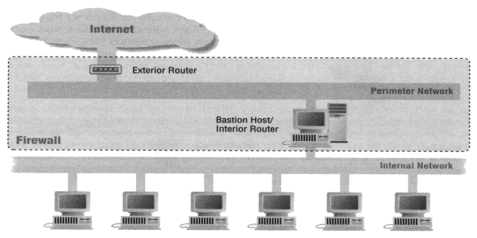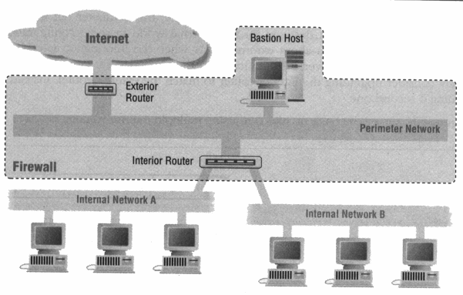
(a) (b)
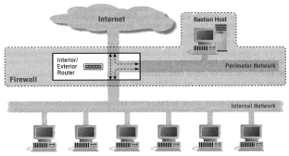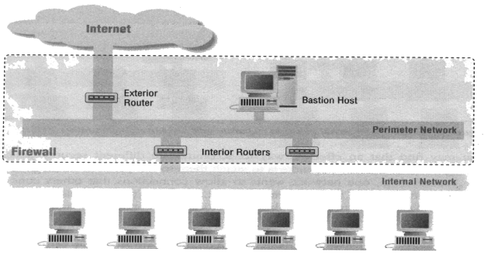
(c) (d)

- (12%) If we want to allow outbound HTTP connections to port 80 of Internet servers only, design your firewall and describe your policy setting table for the interior routers.
- (9%) Now, a programmer wants to design a game service in which one server serves as a web server (providing web pages) and another (different IP or domain name) serves as a game server. The web pages on the web server allows users to play games using JavaScript or HTML5 (in the pages) in a connection-oriented way through the interior router given in the above question (question 9). What kind of technology should he/she use? Explain how it works, why it can pass through the router, and why malicious game services cannot break into intranets.
- (10%) For SUN RPC, let the server netprog.csie.nctu.edu.tw have a RPC process including:
registerrpc(MYSERVER=5, MYVERSION=2, PROCEDURE=1, funcA, …);
svc_run();
the client on student1.csie.nctu.edu.tw have the following actions:
callrpc(“netprog.csie.nctu.edu.tw”, MYSERVER=5, MYVERSION=2,PROCEDURE=1, ….);
Please explain how the above functions works with Portmapper. Please use a flow chart to illustrate the work of each function.
- (5%) If a mail system supports “piping” in the fields of “To” and “From” without any protection, design a simple way to attack the system and explain the reason.

