1. LED Light

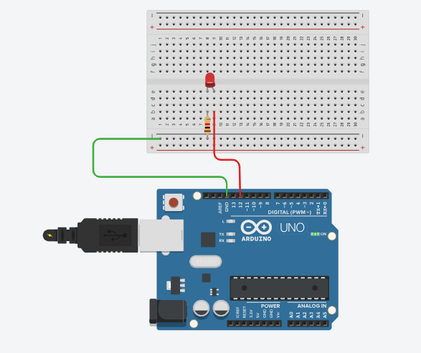

Code:-

int led = 12;

void setup(){

pinMode(led,OUTPUT);

}

void loop(){

digitalWrite(led, HIGH);

delay(200);

digitalWrite(led, LOW);

delay(200);

}

1. Photo resistor

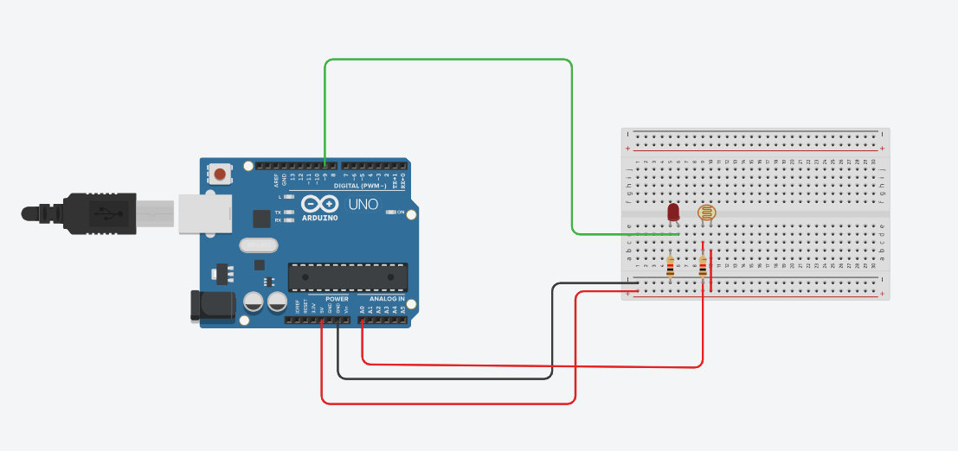

Code:-

const int sensorPin = A0;

const int ledPin = 9;

int sensorValue = 0;

int sensorMin = 1023;

int sensorMax = 0;

void setup() {

pinMode(LED_BUILTIN, OUTPUT);

digitalWrite(LED_BUILTIN, HIGH);

// Calibrate the sensor for 5 seconds

while (millis() < 5000) {

sensorValue = analogRead(sensorPin);

if (sensorValue > sensorMax) {

sensorMax = sensorValue;

}

if (sensorValue < sensorMin) {

sensorMin = sensorValue;

}

delay(50);

}

digitalWrite(LED_BUILTIN, LOW);

}

void loop() {

sensorValue = analogRead(sensorPin);

sensorValue = map(sensorValue, sensorMin, sensorMax, 0, 255);

sensorValue = constrain(sensorValue, 0, 255);

analogWrite(ledPin, sensorValue);

delay(50);

}

1. Temperature

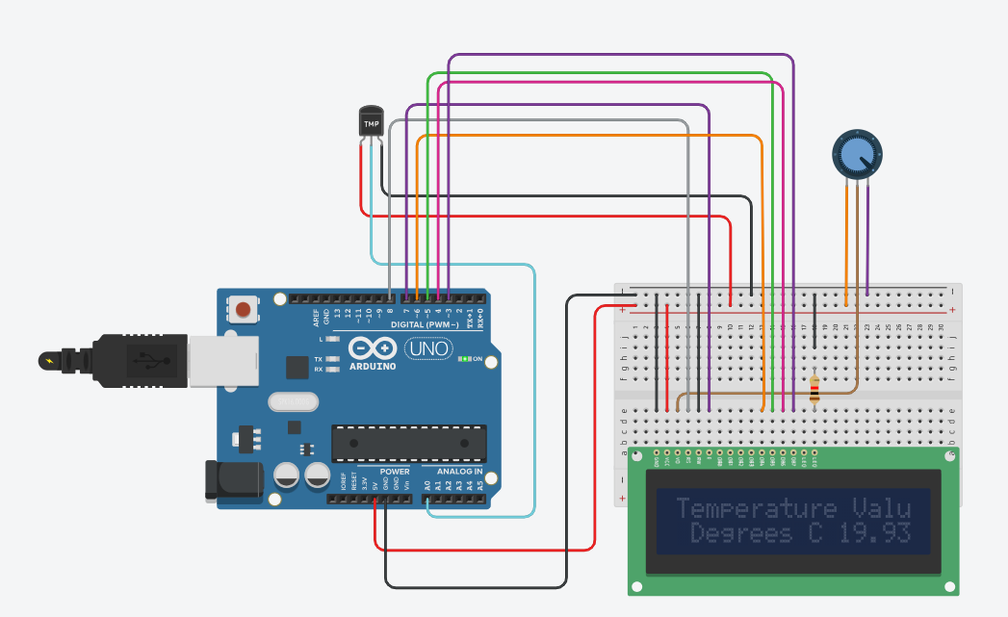

Code:-

#include "LiquidCrystal.h"

LiquidCrystal lcd(8,7,6,5,4,3);

int sensorPin = 0;

void setup() {

Serial.begin(9600);

lcd.begin(16,2);

}

void loop() {

int reading = analogRead(sensorPin);

float voltage = reading * 4.68;

voltage /= 1024.0;

float temperatureC = (voltage - 0.5) * 100;

Serial.print(temperatureC);

Serial.println(" Degrees C");

lcd.setCursor(0,0);

lcd.print("Temperature Value");

lcd.setCursor(0,1);

lcd.print(" Degrees C");

lcd.setCursor(11,1);

lcd.print(temperatureC);

delay(100);

}

1. Servo motor

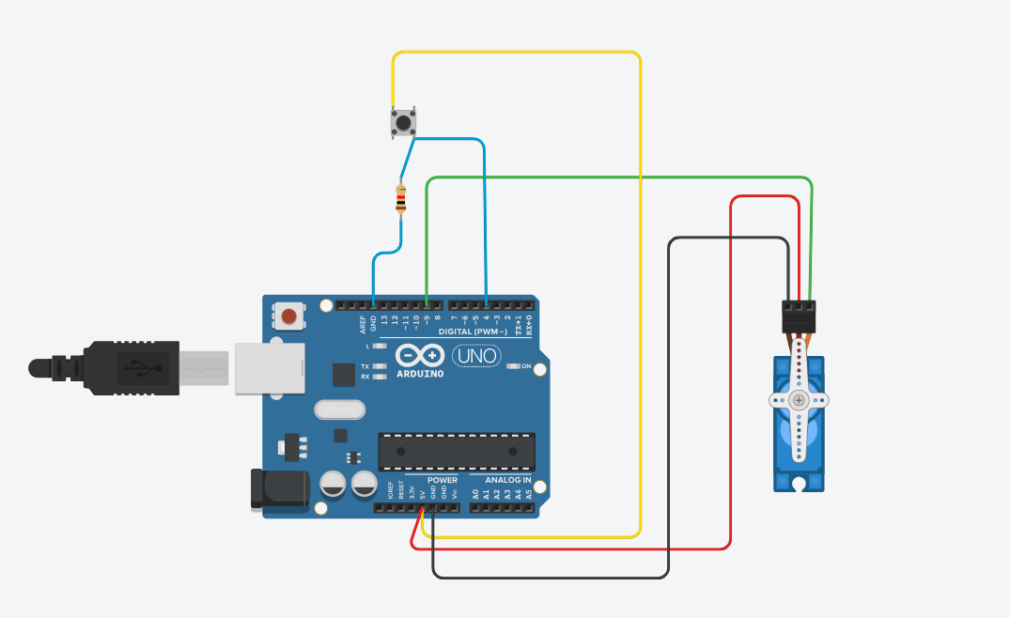

Code:-

#include <Servo.h>

int push = 0;

Servo servo_9;

void setup()

{

pinMode(4, INPUT);

Serial.begin(9600);

servo_9.attach(9, 500, 2500);

}

void loop()

{

push = digitalRead(4);

Serial.println(push);

if (push == 1)

{

servo_9.write(90);

}

else

{

servo_9.write(0);

}

delay(10);

}

6)Traffic

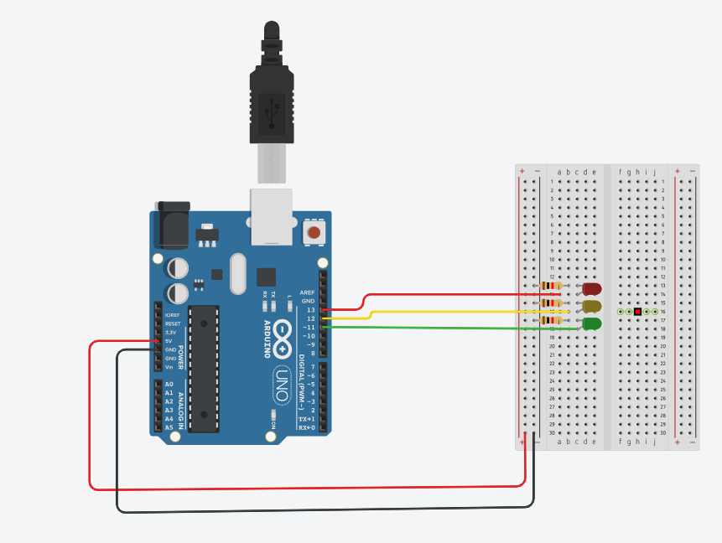

Code:-

int animationSpeed=0;

void setup(){

pinMode(13, OUTPUT);

pinMode(12, OUTPUT);

pinMode(11, OUTPUT);

}

void loop(){

animationSpeed=400;

digitalWrite(13,HIGH);

delay(animationSpeed);

digitalWrite(13,LOW);

delay(animationSpeed);

digitalWrite(12,HIGH);

delay(animationSpeed);

digitalWrite(12,LOW);

delay(animationSpeed);

digitalWrite(11,HIGH);

delay(animationSpeed);

digitalWrite(11,LOW);

delay(animationSpeed);

}

7)Calculator