Frankle Revisited
(Finite Familys with finite Members)

A^{s}, B^{s}, C^{s}, … Z^{s}:= Set of Set’s.
A, B, C, ….. Z:= Set. ex. D is member of A^{s} .
a, b, c, ……. z:= Building Block. ex. e is member of A.

A Family, M^{s} is Set such that:

Each Family has a „Basis“ (I don’t mean that in a Vector sense, this just a Name for it). Meaning there are Members of a Family that can not be „created“ by others. This members „created“ all other Elements by uniting with each other and/or uniting with other Set’s of the Family(Elements of that Family). The Basis of a Family M^{s} we call B^{s} = β(M^{s} ). To create a Family u don’t need to start with a „exact“ Basis. The Basis is just the Smallest Set of Sets u need to create a given Family. φ(B^{s})=F^{s} . Where
F^{s} is the Family which emerges from a Set of Sets B^{s} . φ is a Function that makes any Set of Sets a Family.

For an building Block to be abundant it means it is in half or more of the Sets in F^{s} . It does not need to be in half or more of the Sets of the Basis of that Family. But if that’s the case inevitably that Building Block is abundant in that Family. In the Extrem there is only the Basis. Meaning there are no other Elements in that Familie.

In this case it means:

M^{s} :={A₁ , A₂ , A₃ , ….., A_{n} }

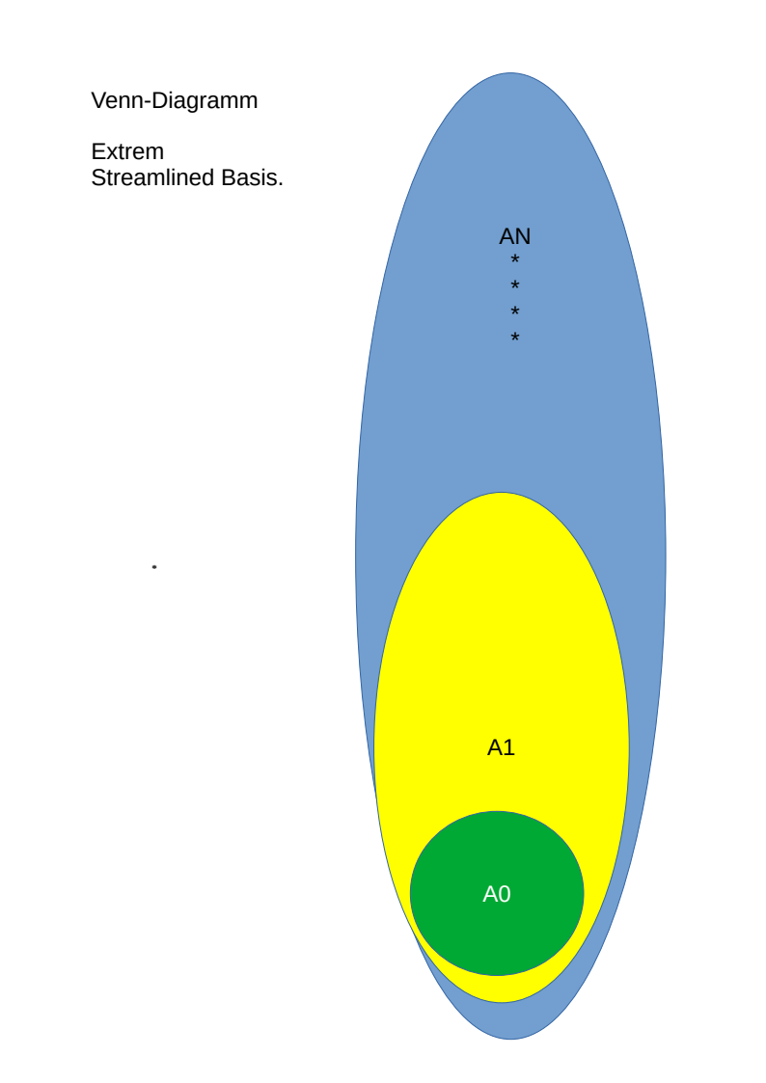
If |M^{s}| = n then there are exactly n(n-2)/2 subset relations and i call that case a maximal absorbing base.

If we define r>s => A_{r} is a superset of A_{s} .

Than in that extrem case only the member of the A_{k}‘s are abundant. Where k is smaller or equal to: (n/2)+1 (rounding down).

The other Extrem case is when the Basis β(F^{s})=B^{s} has only paarwise completly distinct members.

Such that:

That case is the case of a extrem parallel Basis. The resulting Familie is of Size:

Every Building Block is abundant in that Family.

It is the case the more subset relations a Basis has, among it’ members, the smaller the resulting Family. Also the lesser the number of Sets that have abundant elements.
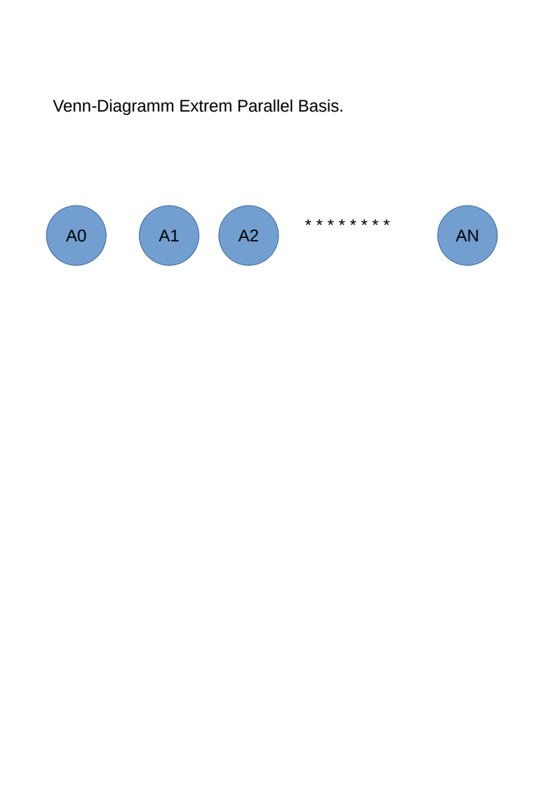

Induction

Given a Set Z, and a Family ₁F^{s} . Z is defined not to be a Member of ₁F^{s} . If one extends ₁F^{s} with Z. You get another Set of Sets K^{s} . K^{s} is not nessesarily a Family. But if we define:

₂F^{s} is a Family. To proof the conjecture we show that regardless how u choose Z the abundance state of Elements of ₁F^{s} is preserved to ₂F^{s} or new abundance is created. The reason is u can create any Family step by step by expanding the Basis. Given that ₁F^{s} has some abundant Building Blocks. If i am correct that means Frankles Conjecture is right.

Here we go:

1.) Every thinkable Family is constructable from the Familys-Basis. If you now the Basis of the Family you can construct the whole thing. Thats what φ does.

2.)Every member of a Family contains at least one abundant element. And they might not be all the same.

Solution Case by Case. Depending on what the Relation of Z is to the Family(₁F^{s}):

A.) Z is a Superset of some Elements in ₁F^{s} . That means Z contains a Element that is abundant. Tho this element is in every Set which is not in ₁F^{s} but in ₂F^{s} . This the „difference“, the „new“ ones. And all of them contain every part of Z. Especially the ones which where abundant in ₁F^{s} tho these elments also abundant in ₂F^{s} .

B.) Z is parallel to ₁F^{s} . Meaning Z is not a Superset of any Element in ₁F^{s}. Additional Z and any Element of ₁F^{s} share nothing. That means every Union of Set of ₁F^{s} with Z is unique. The „difference“, the „new“ ones in ₂F^{s} are in numbers the same as in ₁F^{s} . One can map bijectivly map them to the „old“ ones in ₁F^{s} . And that means abundance is preserved.

C.)Z is not a Superset of any Element of any Element in ₁F^{s} , but is subset of at least one. If Z contains an abundant Element than, as previously shown, all Elements in the „difference“ contain that abundant Element. So Abundance is preserved. If Z does not contain a Abundant Element of ₁F^{s} . Let’s call the Number of Elements , in ₁F^{s} , of which Z is a subset of, s. And the Corresponding Set, in which all the Supersets are collected S. The value of s must be smaller than (1/2)| ₁F^{s} | because other wise the Content of Z is in a half or more Sets in ₁F^{s} . And this means the content is abundant in ₁F^{s} and Z contains abundant Elements. Like before if Z contains abundant Elements than those Elements are abundant in ₂F^{s} . Last subcase left is when the Sets of which Z is not a Superset and no Subset of more than (1/2)| ₁F^{s} |. In this case Z is parallel to more than the half of ₁F^{s}. Let’s collect them and call that Set R^{s}. Since Z is parallel to all Sets in R^{s} also: φ( R^{s}∪{Z})= ₂L^{s} is double the Size of φ(R^{s})= ₁L^{s} . The Members of which Z is a subset of we call T^{s}. It can be shown that all the „new“ ones, meaning the ones in ₂F^{s} but not in ₁F^{s} . In the case that Z is mostly parallel to ₁F^{s} are in ₂L^{s} . Which means Abundance of Members of Members of R^{s} are preserved.

