Frankle Revisited
(Finite Familys with finite Members)

A^{s}, B^{s}, C^{s}, … Z^{s}:= Set of Set’s.
A, B, C, ….. Z:= Set. ex. D is member of A^{s} .
a, b, c, ……. z:= Building Block. ex. e is member of A.

A Family, M^{s} is Set such that:

Each Family has a „Basis“ (I don’t mean that in a Vector sense, this just a Name for it). Meaning there are Members of a Family that can not be „created“ by others. This members „created“ all other Elements by uniting with each other and/or uniting with other Set’s of the Family(Elements of that Family). The Basis of a Family M^{s} we call B^{s} = β(M^{s} ). To create a Family u don’t need to start with a „exact“ Basis. The Basis is just the Smallest Set of Sets u need to create a given Family. φ(B^{s})=F^{s} . Where
F^{s} is the Family which emerges from a Set of Sets B^{s} . φ is a Function that makes any Set of Sets a Family.

For an building Block to be abundant it means it is in half or more of the Sets in F^{s} . It does not need to be in half or more of the Sets of the Basis of that Family. But if that’s the case inevitably that Building Block is abundant in that Family. In the Extrem there is only the Basis. Meaning there are no other Elements in that Familie.

In this case it means:

M^{s} :={A₁ , A₂ , A₃ , ….., A_{n} }

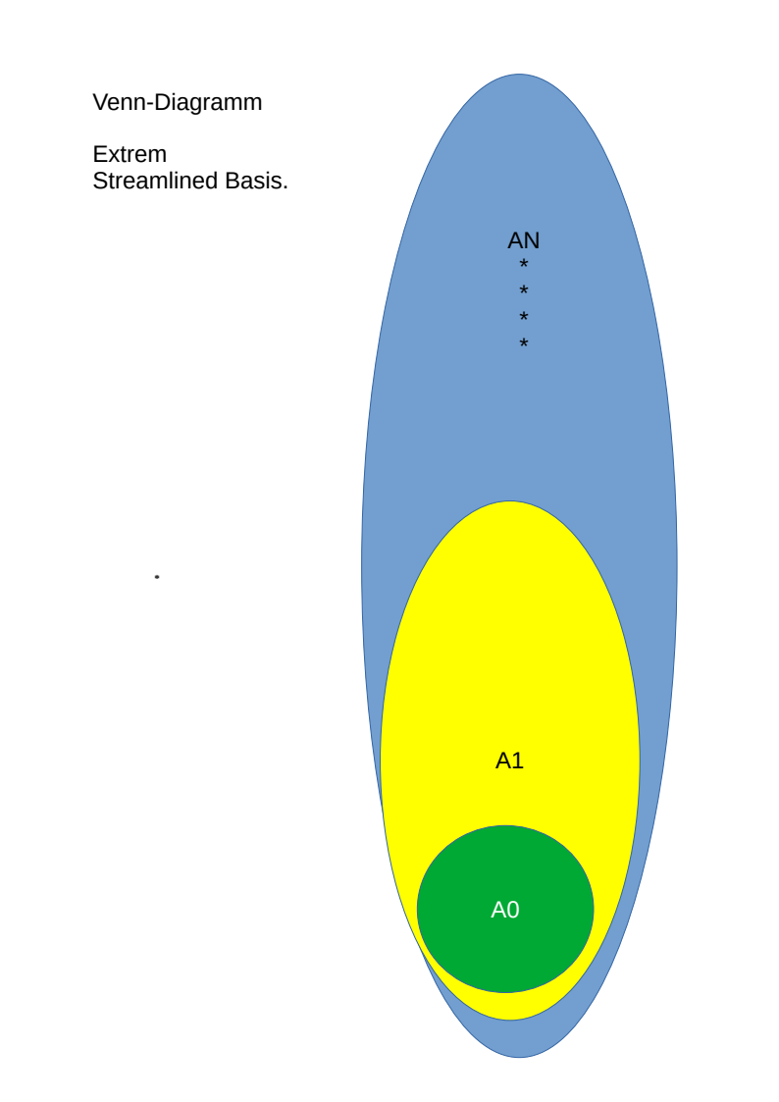
If |M^{s}| = n then there are exactly n(n-2)/2 subset relations and i call that case a maximal absorbing base.

If we define r>s => A_{r} is a superset of A_{s} .

Than in that extrem case only the member of the A_{k}‘s are abundant. Where k is smaller or equal to: (n/2)+1 (rounding down).

The other Extrem case is when the Basis β(F^{s})=B^{s} has only paarwise completly distinct members.

Such that:

That case is the case of a extrem parallel Basis. The resulting Familie is of Size:

Every Building Block is abundant in that Family.

It is the case the more subset relations a Basis has, among it’ members, the smaller the resulting Family. Also the lesser the number of Sets that have abundant elements.
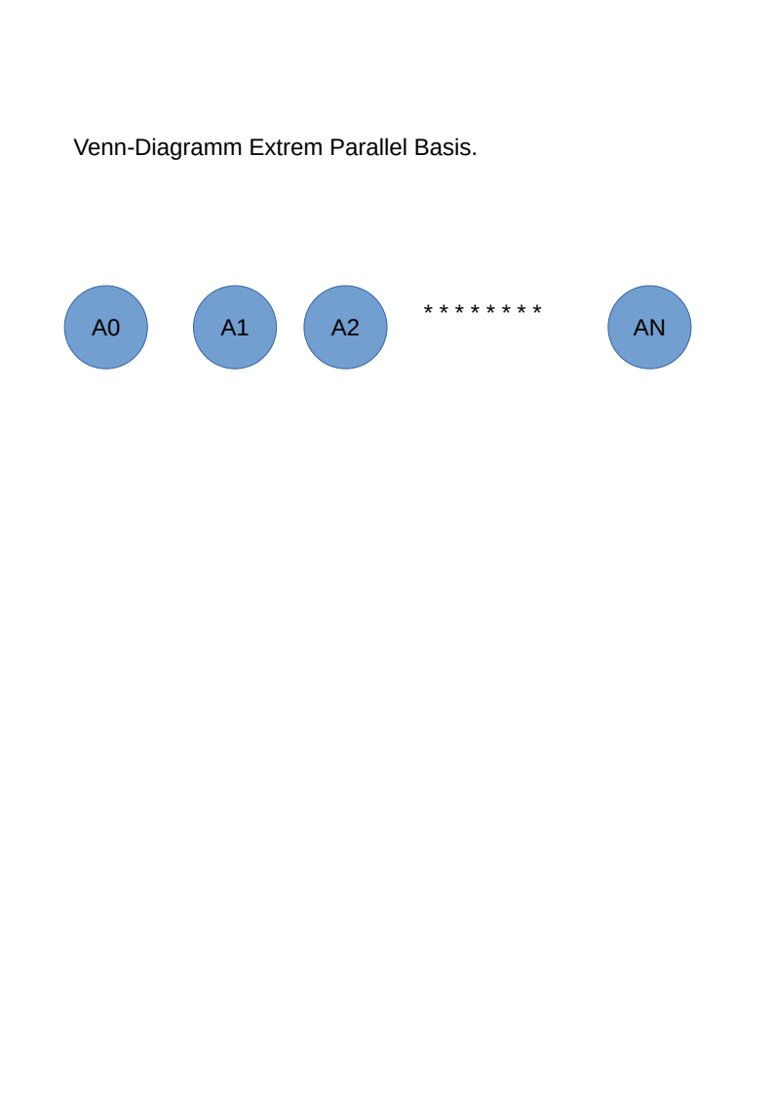

Induction

Given a Set Z, and a Family ₁F^{s} . Z is defined not to be a Member of ₁F^{s} . If one extends ₁F^{s} with Z. You get another Set of Sets K^{s} . K^{s} is not nessesarily a Family. But if we define:

₂F^{s} is a Family. To proof the conjecture we show that regardless how u choose Z the abundance state of Elements of ₁F^{s} is preserved to ₂F^{s} or new abundance is created. The reason is u can create any Family step by step by expanding the Basis. Given that ₁F^{s} has some abundant Building Blocks. If i am correct that means Frankles Conjecture is right.

Here we go:

1.) Every thinkable Family is constructable from the Familys-Basis. If you now the Basis of the Family you can construct the whole thing. Thats what φ does.

2.)Every member of a Family contains at least one abundant element. And they might not be all the same.

Solution Case by Case. Depending on what the Relation of Z is to the Family(₁F^{s}):

A.) Z is a Superset of some Elements in ₁F^{s} and elsewhere there might be other „Relations“. That means Z contains a Element that is abundant. Tho this element is in every Set which is not in ₁F^{s} but in ₂F^{s} . This the „difference“, the „new“ ones. And all of them contain every part of Z. Especially the ones which where abundant in ₁F^{s} tho these elments also abundant in ₂F^{s} .

B.) Z is parallel to ₁F^{s} . Meaning Z is not a Superset of any Element in ₁F^{s}. Additional Z and any Element of ₁F^{s} share nothing. That means every Union of Set of ₁F^{s} with Z is unique. The „difference“, the „new“ ones in ₂F^{s} are in numbers the same as in ₁F^{s} . One can map bijectivly map them to the „old“ ones in ₁F^{s} to the „new“ ones in ₂F^{s}. And that means abundance is preserved.

C.)Z is not a Superset of any Element of any Element in ₁F^{s} , but is subset of at least one. If Z contains an abundant Element than, as previously shown, all Elements in the „difference“ contain that abundant Element. So Abundance is preserved.

If Z does not contain a Abundant Element of ₁F^{s} . Let’s call the Number of Elements , in ₁F^{s} , of which Z is a subset of, θ. And the Corresponding Set, in which all the Supersets are collected T^{s} . The value of |T^{s}|=θ, must be smaller than (1/2)| ₁F^{s} | to be interresting. Because other wise the Content of Z is in a half or more Sets in ₁F^{s} . And this means the content is abundant in ₁F^{s} and Z contains abundant Elements. Like before if Z contains abundant Elements than those Elements are abundant in ₂F^{s} .

Last subcase left is when the Sets of which Z is not a Subset (or Superset) of more than (1/2)| ₁F^{s} |. Let’s collect them and call that Set R^{s}. Since Z is no Super- or Subset to all Sets in R^{s} also: φ( R^{s}∪{Z})= ₂L^{s} is bigger in Size then φ(R^{s})= ₁L^{s} . It can be shown that all the „new“ ones, meaning the ones in ₂F^{s} but not in ₁F^{s} are all in ₂L^{s}.

There are to extremes that can happen. It can also happen to be some mixture of those extremes.

Extreme A. Is when ₂L^{s} is equal or minimal bigger than ₁L^{s}. Minimum „growth“. That can be achieved by making Z a Superset of each Set in ₁L^{s}. Than of course Abundance is preserved of each Element in each Set in ₂L^{s}. Like shown before. Another way to achiev that is to maximize „Collisions“ meaning many if not all Sets in ₁L^{s} are, when united with Z, result in the same Set K. When K is not the same as Z or any Set in ₁L^{s}. To make Extrem lets assume that that is the case for all Sets in ₁L^{s}. So the only „new“ ones are: ₂L^{s}\ ₁L^{s} = N^{s}. N^{s}= {Z, K}. Meaning the only „new“ ones are Z and K. It is the case that all Sets in ₁L^{s} need to have somthing in common to make this happen. That is all Elements of the Set we want to call D. Defined: K\Z = D. The rest of the content of the Sets in ₁L^{s} are parts of Z, which will be differnt for each Set of ₁L^{s}. These shared elements are also in K. So half of the „new“ ones have them and half of the „old“ ones have them. Which means abundance is preserved. But what if the Set of „Collision“-results (meaning {K}) is larger than just one. Lets call that Set C^{s}. C^{s} ={K₁, K₂, K₃, …… K_{n}}. This means some Sets of ₁L^{s} united with Z have the result K₁, some have the Result K₂ and so on up to K_{n}. If n = |₁L^{s}| than we have in fact no „Collision“.

Extrem case B is when |N^{s}| = |₁L^{s}|+1. Maximum „growth“ because |C^{s}| = |₁L^{s}|. In that case the content of Z is in all „new“ ones (N^{s}) and in every Set of T^{s}. Which means abundance of every element of Z. Abundance is created.

What left is to prove that abundant Elements apear for any n = |C^{s}|.

_{i}O^{s} = {∀A ∈ ₁L^{s} | A ∪Z = K_{i} }.
n = |C^{s}| .
Q = { ∀ _{i}O^{s} | ∀i∈[1, n]∧i∈ ℕ }

What would take to avoid every Element of Z to be abundant while no abundance of Elements in ₁F^{s} is preserved. If that is possible the conjecture would be wrong.

But what if we reorder the way ₂F^{s} is constructed? We Start with
₀F^{s} = φ((₁F^{s}∪{Z})\ T^{s*} ). Where T^{s*} is all Sets in T^{s} and all Sets a Set in T^{s} „needs“ (if any) to make ₁F^{s} a Family.

₂B^{s} = {B₁, B₂, B₃ ….B_{j}} are all of the members in T^{s*} which are part of β( ₁F^{s} ). It is clear that Z cant have an empty intersection with any Members of ₂B^{s} . Also clear ₀F^{s} is a Family. And if we do this: φ(₀F^{s} ∪{B₁}) = _{α1}F^{s} we get a Family. The idea is do this recursivly

φ(_{αn}F^{s} ∪{B_{α(n+1)}}) = _{α(n+1)}F^{s}

we get ₂F^{s} back. Each time adding some B_{k} to the Basis and make it via φ a Family. And each B_{k} has a „relation“ with Z. If B_{k} is Superset of a Member(Z) of an existing Family Abundance is preserved. B_{k} can only be a superset of Z and of no other Set in ₀F^{s}. B_{k} can’t be a subset of Z. If B_{k} just intersects Z

