From https://famousclowns.org/history-of-clowns/different-types-of-clowns/

There are three basic types of clowns:
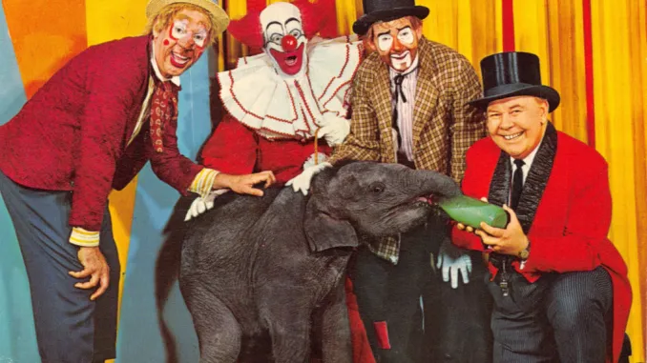

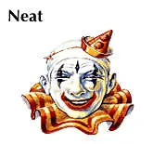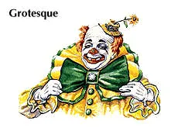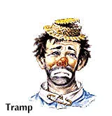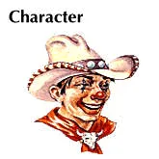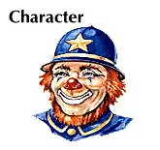

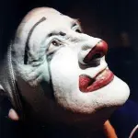

Whiteface Clown: Ringleader, smartest clown, oldest type. Perhaps scariest clown
Types: Neat, Grotesque

Auguste:
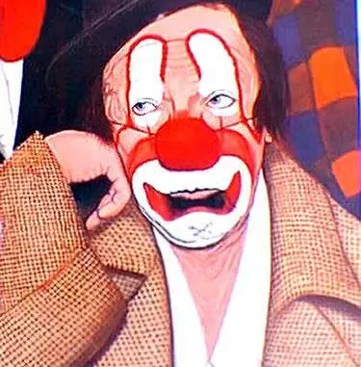
The auguste clown is the least intelligent. Earth tones, exagerated makeup.

Character Clown:
{$SCRImageLink[w:680;h:995]=$PROJECT://3CF8EBC4-8808-4C73-A17F-B8507769217C.jpg}

