HUMAN COLLABRATIVE UNIVERSAL ROBOTS(UR3e)- (23016)
FINAL MILESTONE

MOVEIT2 config working level with human movement acting on F/T sensor collaboration has done due to rviz2 version change TCP Controllers effect creation delayed on controllers and now its working

$ ros2 launch ur_sim spawn_ur3e_gripper_moveit2.launch.py
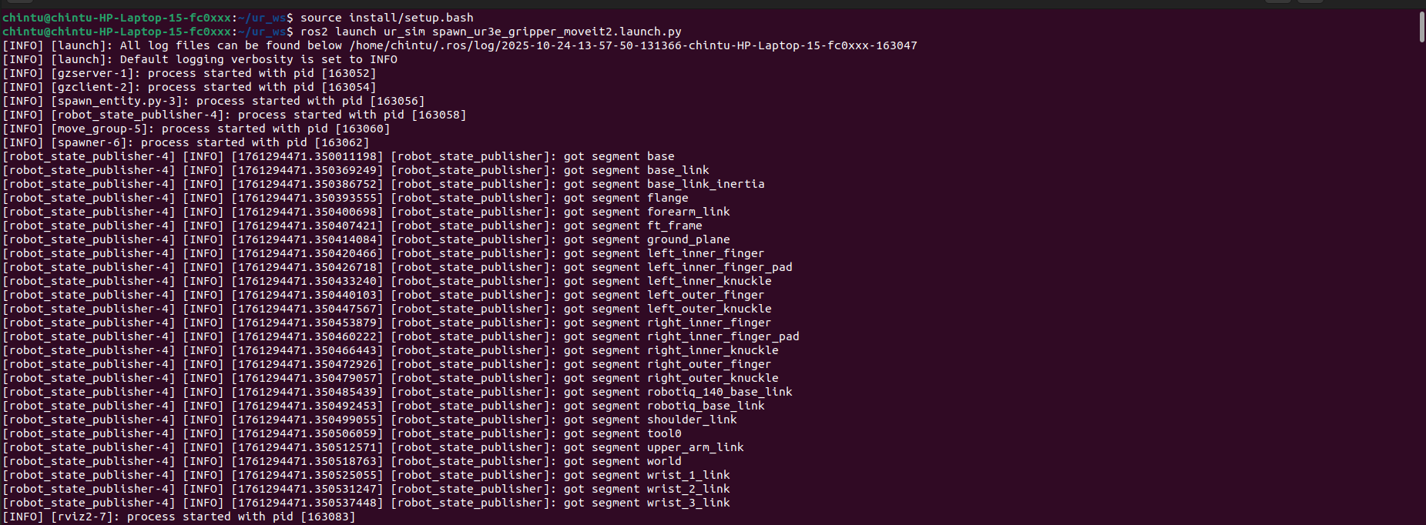

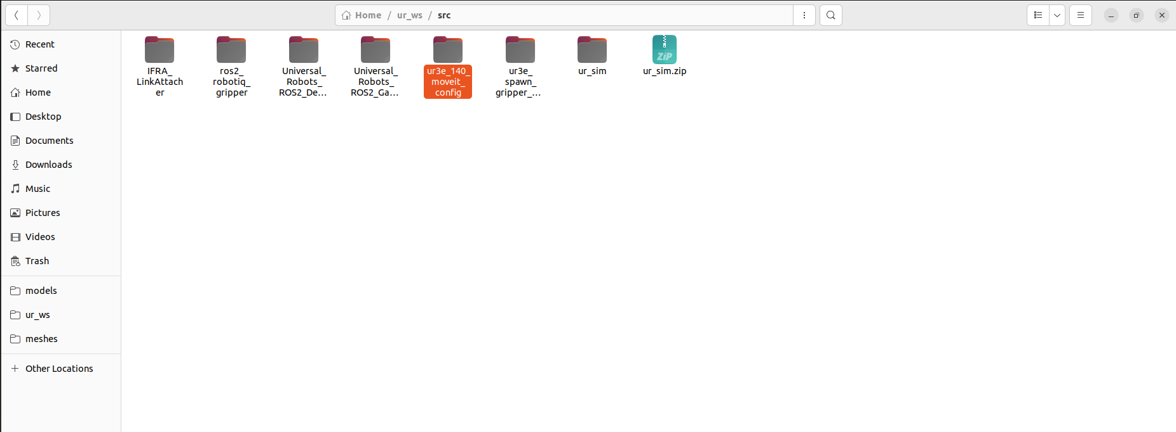

During our recent development and testing, we observed that the upgraded version of RViz was unstable and frequently crashing, which was affecting our workflow and the reliability of our simulations. After analyzing the issue, we determined that certain compatibility problems and changes in the newer RViz release were the root cause of these crashes. To address this, we decided to downgrade RViz to a stable version known for consistent performance. In order to manage this version safely without affecting the system-wide ROS environment, we created a dedicated workspace specifically for the downgraded RViz. This workspace is sourced properly in our environment, ensuring that all dependencies are correctly loaded and RViz runs smoothly without conflicts. This setup has stabilized RViz, allowing us to continue development and testing without interruptions or unexpected crashes let me tell about this in meeting.

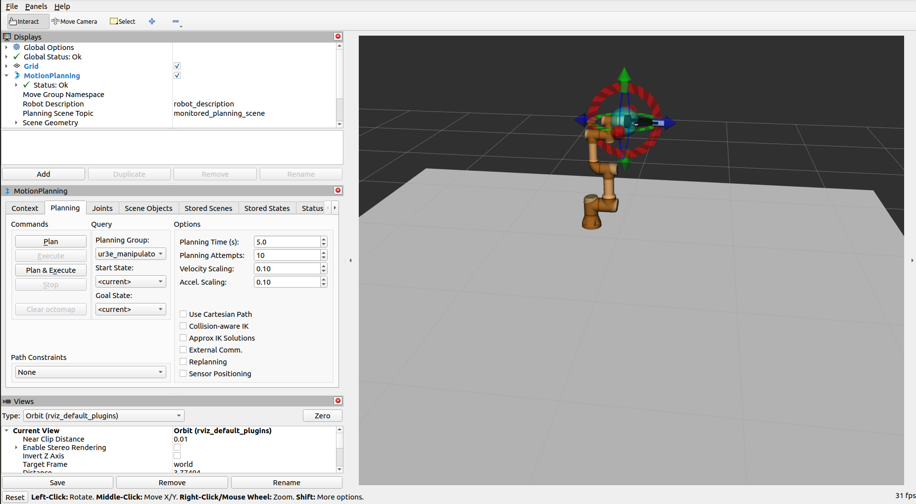

The full setup with TCP controllers and moveit config as added and rviz node directly after solving errors using tcp the ball like structure to move the arm using the cursor of our system to check the force and torque control simultaneously in the terminals.

You can test this with the force and torqur control measurements while moving the tcp tool using cursor with our hand

