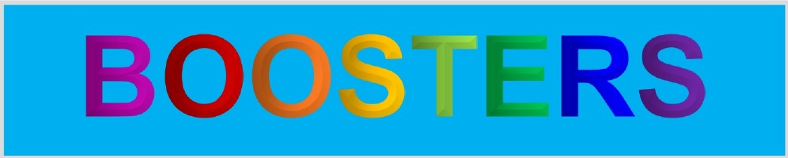**Herron Island Member & Services Directory**

The Herron Island Boosters print a directory for use by island members only. Every effort is made to keep your personal information private, which is why an electronic version of the member information section of the directory is never made available to members or advertisers. Paid advertising helps cover the costs associated with the publication and helps members locate local businesses that value your business, but they are not given access to your personal information.

If you would like to be included in the next publication or need to make changes to your listing, please complete this form and submit your information via the BOOSTERS drop box located by the HMC Community Center side door, or contact Robin Kelly at 253-884-1883 or [herronislandboosters@gmail.com](mailto:herronislandboosters@gmail.com) You may include as much or as little information as you choose.

|  |  |
| --- | --- |
| NAME(S) (Last, First): | |
| ISLAND ADDRESS: | PHONE #(S): |
| MAILING ADDRESS: | EMAIL(S): |
| **OPTIONAL**  I would like to receive BOOSTERS electronic notifications using the following email address: __________________________________________________  _________________________________ ____________________  Signature Date  Members may discontinue receiving notifications and/or change the member information provided at any time. | |