INDIA’S FODDER EXPORTS AND THE GLOBAL FODDER MARKET
An analysis of Ministry of Commerce trade data (EIDB / DGCI&S), FY2017-18 to FY2025-26
Prepared 23 July 2026 · Data updated by DGCI&S on 19 May 2026 · Values in US$ million

Executive summary
- India exports almost no “fodder” in the conventional sense — the commodities the world calls fodder (hay, alfalfa, forage, HS 1214) are a rounding error for India: $0.01M in FY25-26. India’s real fodder-complex export basket is oilseed meals, fishmeal and compound feed.
- The fodder complex earned $2.24bn in FY2025-26, essentially flat on FY24-25 ($2.22bn) and well below the FY23-24 peak of $2.78bn.
- Beneath the flat total is a sharp composition shift: commodity meals (soybean meal −32%, bran −58%) are being replaced by fishmeal (+88%), feed preparations (+18%) and DDGS (+58%) — higher-value, faster-growing lines.
- Policy is the biggest variable on both sides: the de-oiled rice bran export ban caps HS 2302, ethanol-blending policy feeds DDGS exports, and China’s restrictions on Canadian canola single-handedly revived Indian rapeseed meal.
- The global hay/alfalfa trade is a separate arena, dominated by the US, Australia, Canada and Spain selling to Japan, China, Korea and Saudi Arabia — a market India realistically will not enter given its own domestic green-fodder deficit.

1. The export series
Commodity-wise export values pulled from tradestat.commerce.gov.in (EIDB, 4-digit HS level). Financial years run April–March; FY26 = FY2025-26.
HS | Line | FY18 | FY19 | FY20 | FY21 | FY22 | FY23 | FY24 | FY25 | FY26
2304 | Soybean meal | 796 | 1,109 | 473 | 1,135 | 552 | 853 | 1,037 | 852 | 581
2301 | Fishmeal / meat meal | 83 | 106 | 76 | 86 | 94 | 336 | 453 | 269 | 508
2309 | Feed preparations | 273 | 291 | 256 | 283 | 339 | 332 | 348 | 419 | 495
2306 | Other oilcakes (rapeseed etc.) | 294 | 395 | 353 | 437 | 477 | 737 | 667 | 487 | 454
2303 | DDGS, brewing dregs | 5 | 8 | 3 | 15 | 8 | 26 | 83 | 105 | 166
2302 | Bran (rice/wheat) | 6 | 2 | 4 | 52 | 106 | 206 | 184 | 74 | 31
2305 | Groundnut cake | 3 | 5 | 2 | 14 | 3 | 12 | 10 | 9 | 5
1213 | Cereal straw | 0.3 | 1.1 | 1.7 | 1.3 | 3.5 | 0.2 | 0.2 | 0.8 | 2.0
1214 | Hay, lucerne, forage | 0.03 | 0.05 | 0.3 | 0.06 | 0.01 | 0.09 | 0.1 | 0.08 | 0.01
2308 | Veg. waste for feed | 0.2 | 0.3 | 0.3 | 0.2 | 4.2 | 0.8 | 0.8 | 0.6 | 0.1
 | Fodder complex total | 1,460 | 1,916 | 1,170 | 2,022 | 1,587 | 2,503 | 2,783 | 2,216 | 2,243

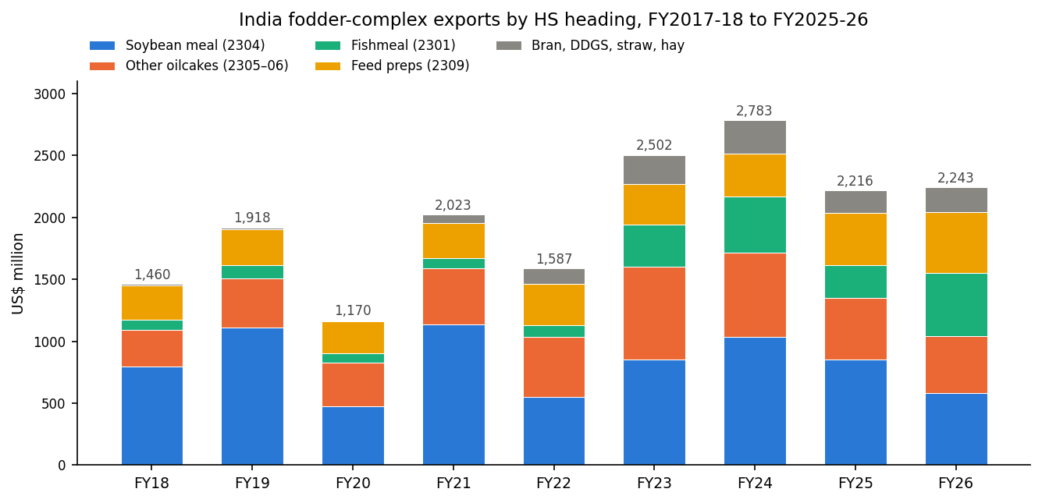

2. What is driving each line

2.1 Soybean meal (HS 2304) — structurally uncompetitive
India’s largest fodder export line fell 32% to $581M in FY25-26. Indian FOB prices ran near $605/t against roughly $430/t CIF Rotterdam for South American meal. The Solvent Extractors’ Association reports total oilmeal volumes fell 13% in FY25-26 (37.68 lakh t vs 43.42 lakh t), with Red Sea rerouting adding freight cost. The destination detail confirms a broad retreat: Germany $129M→$91M, France $84M→$50M, Belgium −82%. What remains is India’s non-GMO premium niche (Germany, France, Japan, Korea) plus captive neighbours (Nepal, Bangladesh).

2.2 Rapeseed and other oilcakes (HS 2306) — rescued by China
Six-digit data shows the swing: exports to China jumped from $16M to $195M in one year, making it the top destination, after Beijing restricted Canadian canola. Meanwhile Bangladesh ($158M→$59M) and Korea ($122M→$51M) collapsed. The line now moves on China–Canada trade politics rather than Indian fundamentals — a concentration risk.

2.3 Fishmeal (HS 2301) — the boom story
At $508M, fishmeal exports are roughly six times their FY18 level and nearly doubled year-on-year. Growth is driven by aquaculture feed demand — China ($174M), Vietnam ($126M, tripled), Turkey ($56M) — and helped by India lifting long-standing restrictions on new fishmeal and fish-oil plant capacity. China, Vietnam and the US take around 62% of shipments.

2.4 Feed preparations (HS 2309) — the quiet compounder
The only line that grew in every year of the series (from $256M in FY20 to $495M in FY26). Destinations are well diversified — Bangladesh, Germany, Vietnam, US, Norway and Chile (salmon-feed inputs) — and pet food (HS 230910) is now $81M of it. This is the highest value-add, least volatile line in the basket.

2.5 Bran and DDGS (HS 2302 / 2303) — two sides of one policy
The de-oiled rice bran export ban (July 2023, since extended) took HS 2302 from $206M to $31M. Meanwhile the ethanol blending programme created a DDGS surplus that has become a $166M export line — and DDGS is also displacing soymeal in domestic feed rations, worsening the soymeal export surplus.

3. Top destinations, FY2025-26
US$ million; prior year (FY24-25) in parentheses.
Soybean meal (2304) | Rapeseed & other (2306) | Fishmeal (2301) | Feed preps (2309)
Germany — 91 (129) | China — 195 (16) | China — 174 (113) | Bangladesh — 90 (75)
Nepal — 69 (89) | Bangladesh — 59 (158) | Vietnam — 126 (40) | Germany — 33 (20)
Bangladesh — 51 (60) | Korea — 51 (122) | Turkey — 56 (9) | Nepal — 33 (33)
France — 50 (84) | Thailand — 48 (87) | Taiwan — 36 (34) | Vietnam — 31 (24)
Kenya — 45 (50) | Vietnam — 40 (48) | Japan — 25 (19) | USA — 29 (31)
UAE — 34 (43) | Indonesia — 11 (9) | Denmark — 23 (0) | Madagascar — 20 (17)

4. Global market context
- Hay and alfalfa. The global forage trade is dominated by the United States ($1.14bn hay exports in 2024, 3.2M t), Australia, Canada and Spain, selling to Japan (~$357M of US hay), China (~$330M), Korea and Saudi Arabia. The alfalfa hay market is estimated at roughly $101bn (2025) growing at ~6.6% CAGR. Hay is water-intensive, and India runs an 11–35% domestic green-fodder deficit — India is structurally absent from this market and likely to remain so.
- Soybean meal. Brazil (>30% of world exports) and Argentina set the global price. Argentina’s export-tax cuts and a record Brazilian crop keep 2025/26 fundamentals bearish; Indian meal clears only where non-GMO status or freight differentials work in its favour.
- Fishmeal and aquafeed. A market projected at ~$22bn by 2035, with China forecast to take over half of world imports by 2034. This is the one global fodder segment where India is gaining structural share.

5. Takeaways
- India’s fodder story is a composition shift, not growth: the FY26 total merely matched FY25, but commodity meals are being replaced by fishmeal, feed preps and DDGS.
- Three momentum lines worth monthly tracking (MEIDB): HS 2301, 2309 and 2303. Two headline-risk lines: HS 2304 (South American pricing) and HS 2306 (China policy).
- Watch policy calendars: the rice-bran export ban, ethanol blending targets, and China–Canada canola relations each move individual lines by $100M+ per year.

Sources
- Ministry of Commerce & Industry, tradestat.commerce.gov.in — EIDB commodity-wise and commodity-by-country export tables (all India trade figures; pulled 23 Jul 2026).
- Solvent Extractors’ Association of India (via Rural Voice, Kedia Advisory, Business Standard) — FY2025-26 oilmeal volumes and price competitiveness.
- Globoil India Intelligence — “The Meal Reversal”, FY26 oilmeal export analysis.
- USDA FAS — forage and hay export data; grains and oilseeds outlook 2025/26.
- Mordor Intelligence, Precedence Research, Tridge, Volza, AgNavigator — global alfalfa hay, fishmeal and marine-ingredients market estimates.

