**To run the application locally:**

1. **Install android studio**
2. **Click on get from VCS near the Search bar**

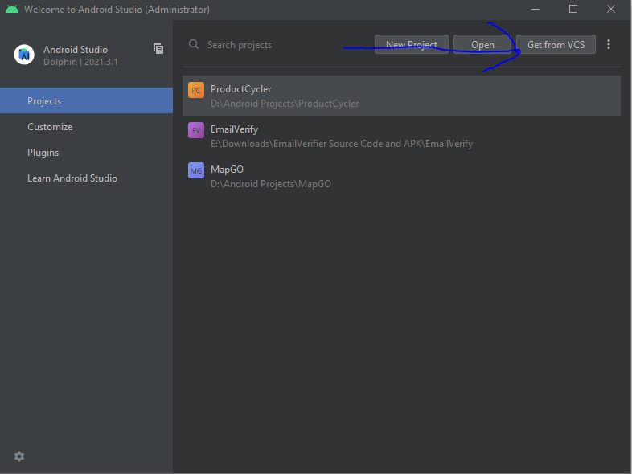

1. **Enter** [**https://github.com/herrsh12/ProductCycler**](https://github.com/herrsh12/ProductCycler) **in URL**

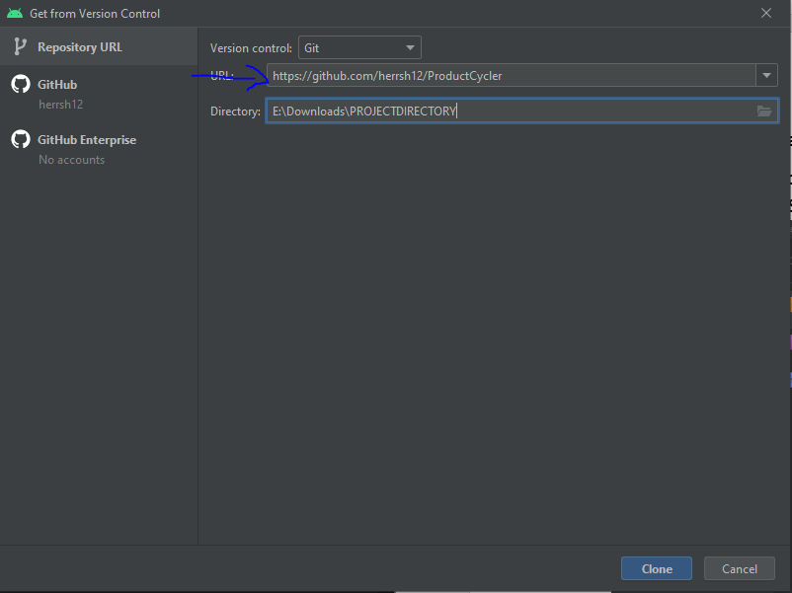

1. **Click on clone 🡪 Trust Project**
2. **Connect your android device**
3. [**Enable USB Debugging Mode**](https://developer.android.com/studio/debug/dev-options#:~:text=Enable%20USB%20debugging%20on%20your%20device,-Before%20you%20can&text=Enable%20USB%20debugging%20in%20the,Advanced%20%3E%20Developer%20Options%20%3E%20USB%20debugging) **setting (Can be found under Developer options)**
4. **Tap on Allow Debugging on your android device once connected via usb**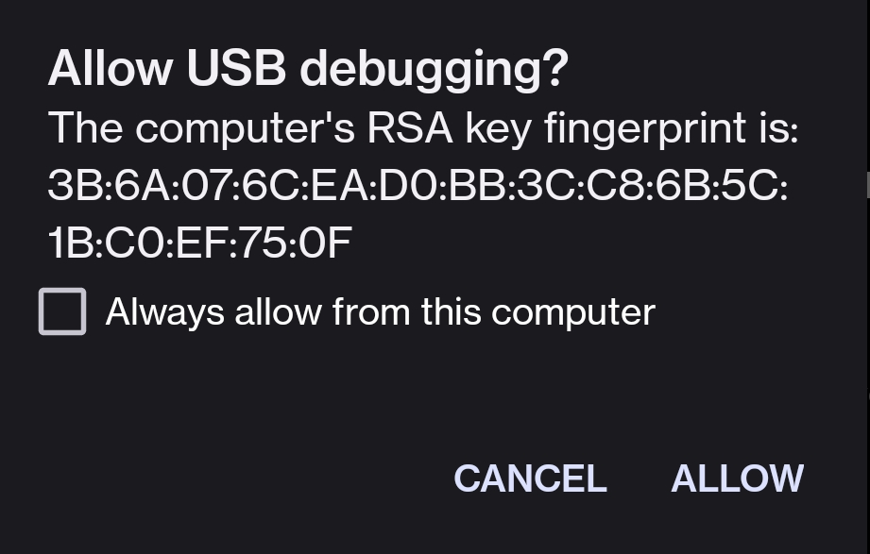
5. **Click on run**

