**Unix Processes**

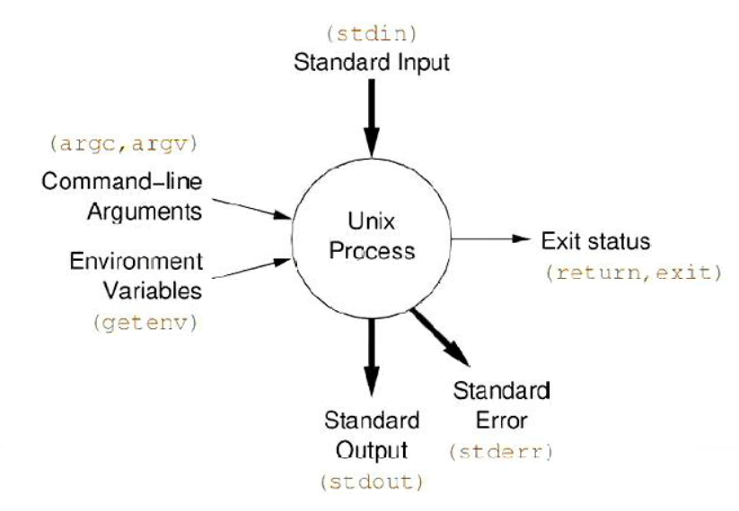Unix process executes in this environment

* C Programmer’s View:
  + char *argv[]
  + int argc
  + char *env[] 🡪 name=value pairs from parent process
  + FILE *stdin 🡪 input byte-stream
  + Etc
* Output a file: