Acculturation in Practice: Integrating Western Classical Vocal Technique into the Performance of Shandong Folk Songs
Yang Wei
Faculty of Music and Performing Arts, Universiti Pendidikan Sultan Idris, Malaysia
Abstract
Shandong folk song and Western classical singing have each been studied extensively, yet almost never through the body of a single performer who commands both. This article reports a practice-based study in which the author, trained in Shandong folk song from the age of eight and in Western classical technique from the age of fifteen, performed fourteen programmed Shandong folk songs across two recitals, singing each item first in the traditional manner and then with acculturated classical technique. Three sources of evidence were combined: semi-structured interviews with three senior experts who work in both traditions, a comparative analysis of seven paired renditions coded for breathing, vocal placement and resonance, and an intuitive strand documented through a reflective journal and two improvisatory ad-libs. The experts converged on the technical contrast between the two systems and on a staging principle of selective borrowing, but divided on whether integration succeeds: one expert reported a failed attempt in which technique eclipsed emotional content. The comparative analysis found that placement and resonance shifted consistently between renditions, whereas breathing was governed more by the genre of the song than by the technique applied. The study proposes a balanced acculturation model in which breath support, placement and resonance are adjustable levers while dialect phonology, tonal contour and direct emotional address are held constant. It also argues that the common framing of classical technique as "scientific" and folk technique as "limited" is itself an acculturation ideology that the evidence does not support.
Keywords: acculturation; Shandong folk song; bel canto; vocal placement; resonance; practice-based research; Chinese national vocal music

1. Introduction
The claim that Western classical vocal technique can "improve" Chinese folk singing has circulated in Chinese conservatories for seventy years, and it has rarely been tested where it matters: in the throat of one singer, on one stage, with the same song sung both ways. The debate over native and foreign singing methods, the tu-yang zhi zheng of the 1950s, was settled institutionally rather than empirically, producing a national vocal style (minzu changfa) that borrowed selectively from bel canto while asserting Chinese identity (Lau, 2008; Mittler, 1997). The regional folk repertoires on which that national style was supposedly built, however, were rarely examined on their own technical terms. Shandong folk song is a case in point. It has been catalogued by region and genre (Li, 2000; Liu, 2023), analysed for dialect and melodic structure (Huang, 2022; Wang, 2023; Yao, 2021) and lamented for its shrinking base of transmitters (Ma, 2020; Qi, 2014). What has not been done is a performance-based comparison of how a Shandong folk song behaves when the body producing it switches between folk and classical technical settings.
This gap is practical as well as empirical. Vocal training in China still separates folk singing from classical voice study at the level of curriculum and studio, so a singer who wishes to combine them does so without a method and without a vocabulary for describing what changes (Zhang, 2020). The consequences are visible on stage. Integrations that over-apply classical resonance produce a rounded, covered sound that flattens the dialect and erases the regional identity of the tune, while integrations that refuse technique leave coloratura passages and sustained notes under-supported. Both outcomes are heard regularly in competition and television performance, and both are the result of guesswork rather than analysis.
The present study addresses the problem from the inside. As a performer with two decades of parallel training in Shandong folk song and Western classical singing, I designed a practice-based inquiry around three research questions: (1) how can the vocal techniques of Shandong folk song and Western classical singing be analysed and distinguished; (2) how can Western classical technique be integrated into the performance of selected Shandong folk songs; and (3) how can the acculturated result be showcased on stage without loss of folk identity. The questions were answered through three complementary strands of evidence: expert interviews, a paired-rendition comparative analysis across three technical dimensions, and an intuitive strand documented through a reflective journal.
The article makes three contributions. First, it provides the first systematic, performer-generated comparison of breathing, placement and resonance across paired folk and classical renditions of the same Shandong repertoire. Second, it reframes the integration problem through acculturation theory rather than through the language of improvement, which allows the asymmetry between the two systems to be named and examined instead of assumed. Third, it proposes a balanced acculturation model that separates the technical parameters that may legitimately move from the cultural parameters that must stay fixed. The remainder of the article presents the theoretical framework, the method, the findings, a discussion that interprets the findings against the framework and the wider literature, and a conclusion.

2. Theoretical Framework

2.1 Acculturation as a theory of contact, not of improvement
The classic anthropological definition describes acculturation as the phenomena that result when groups with different cultures come into continuous first-hand contact, with subsequent changes in the original cultural patterns of either or both groups (Redfield, Linton, & Herskovits, 1936). Two features of this definition are often lost in musical applications. The first is reciprocity: change may occur in either or both groups. The second is neutrality: the definition does not rank the cultures in contact. Berry (1997) later distinguished four acculturation strategies according to whether a group maintains its heritage identity and whether it adopts the contact culture: integration (both), assimilation (adopt without maintaining), separation (maintain without adopting) and marginalisation (neither). Transposed to vocal performance, these strategies describe four possible outcomes for a Shandong folk song sung by a classically trained singer, and only one of them, integration, is what practitioners mean when they speak of fusion.
Ethnomusicology refined these ideas for music specifically. Nettl (1978) separated Westernization, in which a non-Western music adopts central features of Western music in order to become part of the Western system, from modernization, in which it adopts non-central Western features in order to remain itself under new conditions. Kartomi (1981) rejected biological metaphors of hybridity and insisted that musical culture contact be analysed as a process with identifiable results, which may include the creation of a genuinely new music, the pluralistic coexistence of two musics, or the loss of one. Lomax (1968) had earlier argued, from a very different direction, that vocal style is itself a cultural signature, so that timbre, phonation and articulation carry meaning before any melody is heard. Together these positions supply the critical test applied in this study: does the acculturated rendition retain the features that make a Shandong folk song recognisably itself, or does it convert the song into a Western-system object that happens to use a Shandong tune?

2.2 Shandong folk song as a technical system
Shandong folk song is geographically and generically diverse. Liu (2023) divides the province into eastern (Jiaodong), northwestern, southwestern, central and southern regions, each with characteristic forms: maritime work songs and yangge in Jiaodong, minor tunes (xiaodiao) in the northwest, the Chengwu flower-drum tradition in the southwest, the Zibo flower-drum in the centre, and the five great tunes of the south, which carry the flavour of northern Jiangsu. Across these regions the genre set includes labour chants, mountain songs, minor tunes, children's songs, custom songs and suites (Li, 2000). The repertoire has been transmitted orally and in dialect, and the dialect geography of the province, which splits broadly into Jilu, Zhongyuan and Jiaoliao Mandarin zones, is audible in the songs' phonology, tonal contour and rhythmic shape (Huang, 2022; Yao, 2021).
The vocal technique of the tradition is usually described negatively, as an absence of fixed norms, but the descriptive literature in fact identifies a coherent set of practices. Singers favour baisang, an unembellished natural voice, or zhensheng, a chest-dominant true voice; the timbre is bright and penetrating; ornamentation includes trills, vibrato and vibrato rolls; and the range exploited can be wide, with frequent register leaps (Lu, 2020; Wang, 2023; Zheng, 2022). Emotional expression is direct and speech-like, and phrasing follows the text. The transmission base, however, is narrow. Fewer than half of the artists able to sing Yimeng songs are under sixty, young audiences encounter the repertoire mainly through modern arrangements, and the dialect requirement limits geographic spread (Ma, 2020; Qi, 2014). The pressure to adapt is therefore real, which is exactly why the terms of adaptation need to be examined rather than assumed.

2.3 Western classical technique: what is actually being borrowed
Bel canto pedagogy, as codified from the Italian schools of the eighteenth and nineteenth centuries and systematised in the twentieth, rests on three coordinated controls: appoggio breath management, in which the inspiratory posture is maintained during phonation; a stable, relatively low laryngeal position with a widened pharynx; and a resonance strategy that balances bright and dark components, the chiaroscuro ideal (Miller, 1986; Stark, 1999). Voice science has clarified what these sensations correspond to acoustically. The characteristic ring of the trained classical voice is a clustering of upper formants, the singer's formant, produced largely by the configuration of the lower pharynx and larynx tube rather than by any cavity in the head (Sundberg, 1974, 1987; Titze, 2000). "Placement" and "resonance" in pedagogical speech are therefore proprioceptive metaphors for laryngeal and pharyngeal adjustments. This distinction matters for the present study, because the comparative analysis reported below relies on exactly this metaphoric vocabulary, and its findings must be read as reports of sensation rather than as acoustic measurements.
In China the reception of bel canto has been inseparable from the project of national vocal music. Early advocates argued for a "Chinese bel canto school" that would apply Italian principles to Chinese texts (Li, 1982; Shang, 1982), and later pedagogy, notably in the lineage associated with Jin Tielin at the China Conservatory, produced a standardised national style that borrowed breath support and high placement from the West while retaining Chinese diction (Lau, 2008; Melvin & Cai, 2004). Recent Chinese scholarship continues to promote head resonance and the mask technique as scientific tools for the refinement of national singing (Chen, 2023; Li, 2018; Liu, 2024; Ren, 2022). The critical point, developed in the discussion, is that this literature consistently describes the direction of borrowing as one-way and the Western contribution as "scientific", a framing that Nettl would recognise as Westernization presented in the language of modernization.

2.4 Analytical frame: three dimensions
Three technical dimensions were selected as the coding frame for the entire study: breathing, vocal placement and resonance. They were chosen because they are central to both traditions, because they are the dimensions along which the pedagogical literature claims the two systems differ most, and because they are the dimensions a performer can consciously vary while holding melody, text and dialect constant. The conceptual framework is summarised in Figure 1. Inspiration, literature and problem feed a practice-based research design with a critical process (interviews and comparative analysis) and an intuitive process (reflective journal and ad-lib). All practice data are coded on the three dimensions, and the two recitals constitute the practice component from which a performance model is derived.
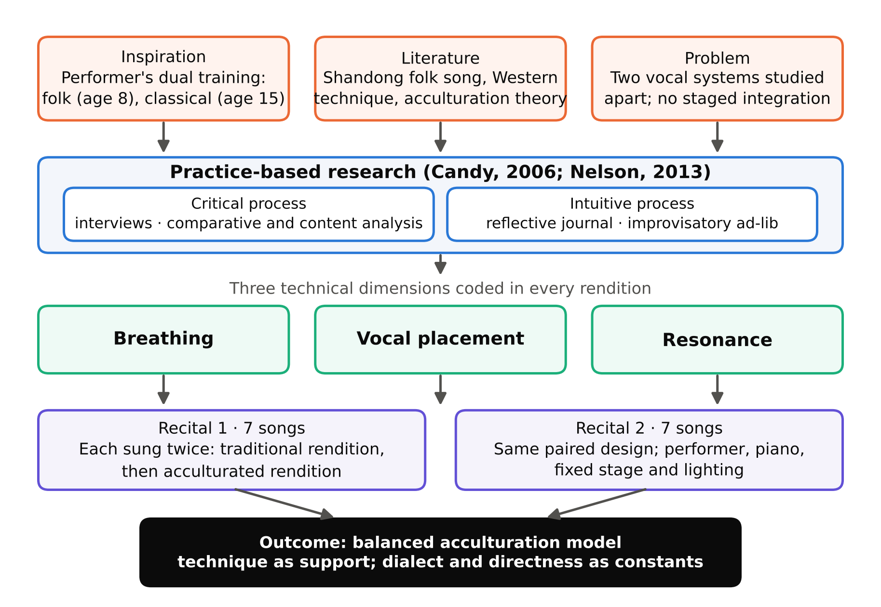
Figure 1. Conceptual framework of the study.

3. Method

3.1 Research approach and epistemological position
The study is practice-based research (PBR) in the sense defined by Candy (2006): an original investigation undertaken in order to gain new knowledge partly by means of practice and the outcomes of that practice, where the creative artefact is the basis of the contribution and the written component contextualises it. Candy and Edmonds (2018) and Nelson (2013) both stress that in PBR the practitioner's embodied knowing is a legitimate source of evidence provided it is made explicit, reflexive and open to critique. The epistemological commitment is therefore interpretivist and embodied: the data are produced by a trained body responding in real time to sonic and physical feedback, and the performer's sensations are treated as data rather than as noise. This position follows Schön's (1983) account of reflection in action, in which professional knowledge is revealed by doing and then interrogated, and it is justified here by the research object itself. The difference between a folk and a classical rendition of the same song is not available to an external observer in the first instance; it is available first to the singer, as a change in breath, placement and resonance sensation, and only secondarily to listeners and instruments.
Two processes structure the design (Figure 1). The critical process is deliberate and analytic: expert interviews, comparative coding of paired renditions and content analysis of performance video. The intuitive process is pre-reflective and improvisatory, in the sense of Høffding and Schiavio (2021), who describe expert music-making as an exploratory mode in which performers "feel their way" through sound and movement rather than planning each action. Intuitive events were captured in a reflective journal and are reported as a separate strand because they revealed adjustments that the critical process had not predicted.

3.2 The performer-researcher
The author began Shandong folk song at the age of eight and Western classical training at fifteen, and has performed both repertoires in recitals, competitions and academic settings for roughly twenty years. This dual competence is the enabling condition of the study and also its principal source of bias. The design addresses the bias in three ways: by triangulating the performer's self-report against three independent expert accounts; by committing in advance to a fixed coding frame so that the comparison could not drift toward a preferred outcome; and by reporting the intuitive strand, including an ad-lib that moved placement in the direction opposite to the one the researcher had been cultivating.

3.3 Repertoire
Fourteen programmed items were performed across two solo recitals with piano accompaniment, a fixed centre-stage position and a single top light, so that staging was held constant between renditions. Thirteen distinct songs were involved, two of which were reprised in the second recital. The repertoire was selected to span the regional and generic diversity of the province: work songs (Yun He Hao Zi), flower-drum tunes (Bao Leng Diao), yangge-derived songs (Chang Yang Ge), minor tunes (Yi Meng Shan Xiao Diao, Da Ta Qing), narrative and humorous songs (Da Shi Hua, Lao Han Chang Ge Si Ji, Hei Ni Zuo Xi Fu) and mid-twentieth-century songs in folk idiom (Shui Bu Shuo An Jia Xiang Hao, Ge Chang Da Sheng Chan). Table 1 lists the programmes.
Table 1. Recital repertoire by regional attribution and duration.
No. | Song (pinyin) | Regional attribution | Duration
R1-1 | Bao Leng Diao | Heze, Chengwu | 3′00″
R1-2 | Da Shi Hua | Liaocheng, Linqing | 3′20″
R1-3 | Chang Yang Ge | Wucheng | 2′18″
R1-4 | Da Ta Qing | Cangshan | 3′10″
R1-5 | Gan Niu Shan | Zibo | 4′40″
R1-6 | Yi Meng Shan Xiao Diao | Mengyin (Yimeng) | 5′00″
R1-7 | Shui Bu Shuo An Jia Xiang Hao | Shandong (Yimeng idiom) | 4′30″
R2-1 | Shui Bu Shuo An Jia Xiang Hao (reprise) | Shandong (Yimeng idiom) | 4′30″
R2-2 | Ge Chang Da Sheng Chan | Cangshan | 2′14″
R2-3 | Shuan Wa Wa | Binzhou | 4′50″
R2-4 | Yun He Hao Zi | Wucheng | 3′23″
R2-5 | Lao Han Chang Ge Si Ji | Jinan | 3′13″
R2-6 | Hei Ni Zuo Xi Fu | Pingdu | 3′56″
R2-7 | Da Ta Qing (reprise) | Cangshan | 4′12″
R2-8 | Fang Mian Hua | Cangshan | 3′50″
Note. R1 = Recital 1 (total 51′36″); R2 = Recital 2 (total 62′16″). Each item was sung twice in performance: first in the traditional Shandong manner, then with acculturated classical technique.

3.4 Data sources and procedures
Three data sources were aligned with the three research questions (Table 2).
Expert interviews (RQ1 to RQ3). Three experts were recruited against four criteria: age over forty, proficiency in classical vocal technique, familiarity with traditional Shandong folk song, and stage performance experience (Table 3). The interviews were semi-structured and open-ended, lasted between thirty and sixty minutes, were conducted face to face in each expert's city, and were audio-recorded and transcribed. The initial design called for four experts; three were ultimately interviewed, and the shortfall is noted as a limitation. The experts are reported as Expert A, B and C.
Practice-based experimentation (RQ2). Each programmed song was rehearsed and performed twice, first using traditional Shandong technique and then using acculturated classical technique, with seven songs per session. Audio recordings of the paired renditions were segmented into the phrases or performance units that most clearly exposed differences, and each segment was coded on the three dimensions. Rehearsal took place daily for two hours, with one round of folk practice and one round of acculturated practice per song.
Performance analysis (RQ3). Video of the two recitals was transcribed into three streams corresponding to the coding frame and analysed by content analysis, comparing the two renditions of each song and the treatment of each dimension across songs.
Table 2. Alignment of research questions, data sources, analysis and outputs.
Research question | Data source | Analysis | Output
RQ1 Analyse the vocal techniques of the two traditions | Semi-structured interviews with three experts | Descriptive analysis of transcripts; themes by dimension | Technical vocabulary and baseline contrast
RQ2 Integrate classical technique into selected songs | Paired renditions of fourteen programmed items; audio | Comparative analysis: segmentation, coding on breathing, placement, resonance | Song-by-song matrix of technical shifts
RQ3 Showcase the acculturated performance | Recital video; reflective journal; expert commentary | Content analysis of performance streams; open coding of journal | Staging principle and performance model

Table 3. Expert selection criteria.
No. | Criterion | Rationale
1 | Age above forty years | Sufficient career length to have witnessed earlier integration attempts
2 | Proficiency in classical vocal technique | Can describe the classical side from practice, not report
3 | Familiarity with traditional Shandong folk song | Can judge loss or retention of regional identity
4 | Stage performance experience | Can speak to staging and audience response, not only pedagogy

3.5 Analytical procedures
Interview transcripts were analysed descriptively, question by question, to extract each expert's position and the technical reasons given for it, and then compared across experts to identify convergence and dissent. The comparative analysis of paired renditions used a fixed coding scheme with three codes, vocal placement, breathing and resonance, applied to each segment of each rendition, and the coded descriptions were tabulated side by side. The reflective journal was coded openly, following the general logic of thematic analysis (Braun & Clarke, 2006), and entries that recorded unplanned adjustments were separated as ad-libs. Trustworthiness was pursued through triangulation across the three sources, a stable coding frame declared before data collection, and a transparent reporting of the performer's position. Informed consent was obtained from the experts, who are anonymised; the folk repertoire performed is in the public domain or performed under standard educational use.

3.6 Limitations of the design
Four limitations constrain interpretation. The study involves one performer, so the technical shifts reported are those of one trained body. Placement and resonance were coded from the performer's proprioceptive report and from listening, not from acoustic measurement. Three rather than four experts were interviewed. Audience reception, although named in the original design, was not formally collected and is therefore excluded from the findings. These limitations are returned to in the discussion.

4. Findings

4.1 Expert accounts

RQ1: How do the two techniques differ?
All three experts agreed that Shandong folk song and Western classical singing differ fundamentally in vocal production and resonance, but each located the core of the difference in a different place. Expert A located it in systematisation and articulation:
Western classical singing is characterised by a systematic and structured vocal technique, with clear and rigorous standards regarding breath intake, breathing methods, mouth shape, chest resonance, and the use of facial muscles such as the zygomatic muscles. Shandong folk songs are freer and more spontaneous, placing less emphasis on fixed vocal production. Although both traditions share general principles regarding breath support, the most fundamental difference lies in articulation. (Expert A)
Expert B located it in resonance strategy, contrasting the coordinated use of chest, head and nasal cavities in classical singing with the baisang and zhensheng production of the folk tradition, whose sound is "bright and clear, rich in regional character", and whose performance "places greater emphasis on emotional expression rather than a standardised vocal placement". Expert C located it in language, and issued the first warning of the study:
Relying solely on Western classical vocal concepts and resonance techniques may diminish the expressive power of the dialect, potentially stripping the folk songs of their regional authenticity. It is essential to draw upon the technical strengths of Western vocalism while preserving the subtle expressiveness of the dialect, avoiding excessive pursuit of resonance at the expense of the folk song's original essence. (Expert C)

RQ2: Does integration work?
Here the experts divided. Experts A and B held that integration enhances both technique and expressiveness, and both gave concrete cases. Expert A pointed to the coloratura passages of Gan Niu Shan and Da Ta Qing, where traditional singing "relies primarily on natural vocal ability with insufficient breath support, resulting in uneven breath flow", and reported that classical breathing makes these passages "smoother and more effortless", while also permitting longer sustained notes and chromatic embellishment. Expert A cited the career of a Shandong-born soprano who, after training in regional methods and then under Jin Tielin, won a national award with an integrated style. Expert B cited newly composed songs in the Yimeng idiom which retain the flowing folk melody while adding harmony, instrumentation and high placement, and gave a phonetic example: the word ren in a Linyi-dialect line must be produced with the tongue against the hard palate, close to yin, and this dialect feature is what carries the song's "heartfelt and earthy" tone even inside a modernised arrangement.
Expert C reported a failure:
I once performed a choral piece composed by Professor Jin Xi. The outcome was less than ideal. The core issue lay in the fact that earlier approaches to integration placed excessive emphasis on the technical aspects of Western vocalism while overlooking the emotional expression and cultural connotations embedded in folk music. Bel canto emphasises vocal uniformity and resonance, yet these very qualities may compromise the spontaneity and dialectal characteristics that are essential to the folk tradition. With changing times, the expectations surrounding folk song performance have also evolved, now leaning more toward a return to authentic, unembellished vocal styles. (Expert C)

RQ3: How should the result be staged?
On staging the three converged on a principle of selective, folk-anchored borrowing. Expert A stressed that classical singing is bound to notation while folk song is transmitted orally and individualised, so a "direct transplantation of the Western system risks diluting the original flavour"; breath support, mask placement, coloratura and forward articulation may be borrowed, but "flexibly, according to the singer's individual vocal qualities". Expert B proposed that the folk song be the foundation and that the alignment of dialect tone contour with melodic direction be treated as a design constraint, adjusting articulation placement in high passages to keep the sound "resonant and transparent" without losing the dialect. Expert C argued that singers must "break through fixed perceptions", understand the stylistic differences, and find specific entry points for integration rather than learning bel canto first and applying it wholesale. Figure 2 maps the positions; Table 4 summarises them.
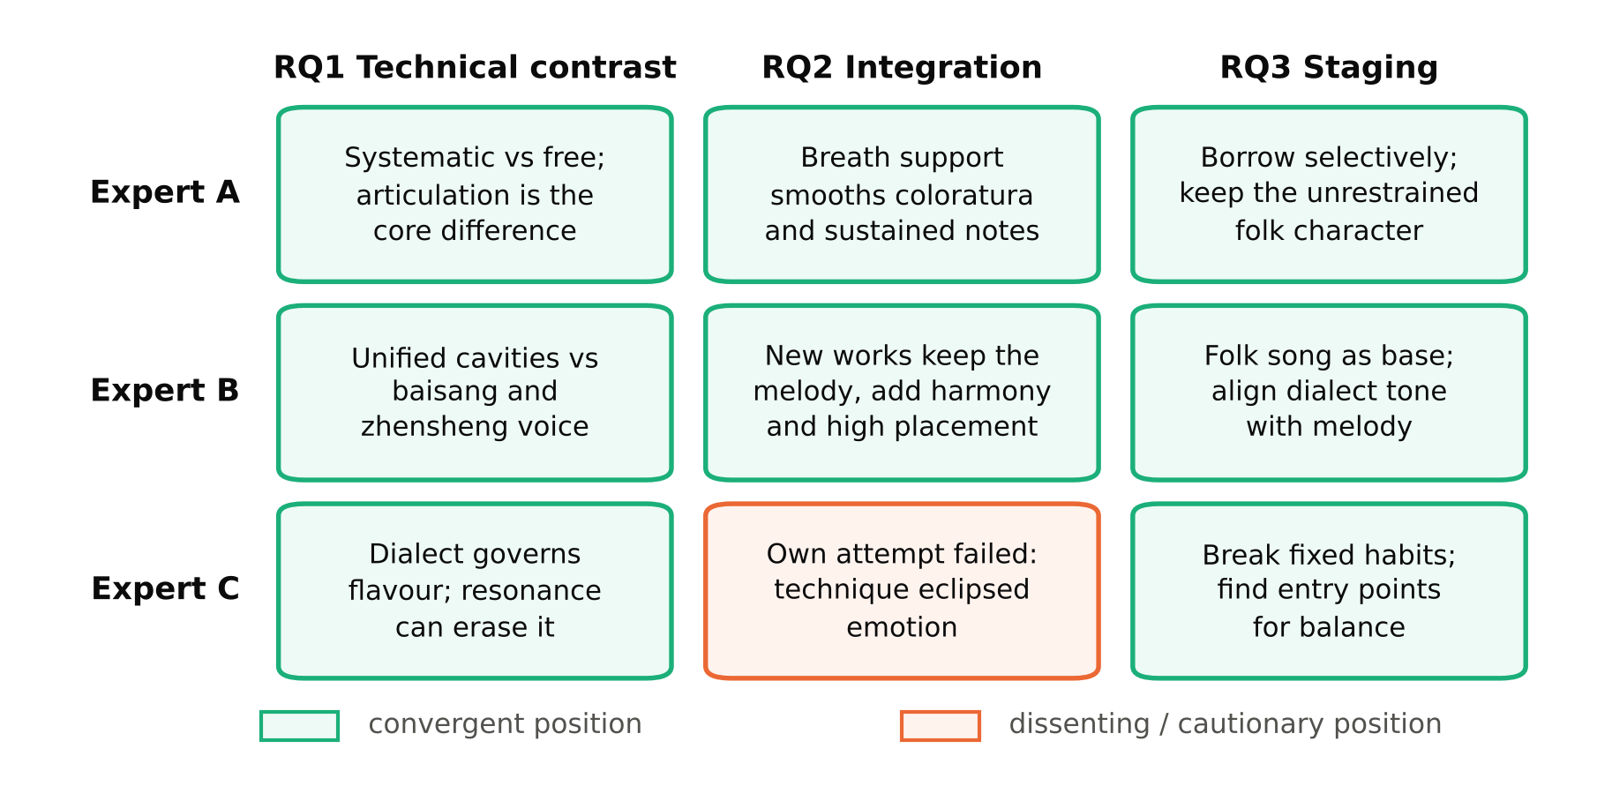
Figure 2. Expert positions by research question. Green cells mark convergence across experts; the orange cell marks the single dissenting position.
Table 4. Summary of expert positions.
 | RQ1 Core difference | RQ2 Integration | RQ3 Staging principle
Expert A | Systematisation; articulation is the decisive contrast | Positive: breath support transforms coloratura and sustained tones | Selective borrowing adapted to the singer; keep the unrestrained folk character
Expert B | Resonance strategy: unified cavities versus baisang/zhensheng | Positive: new works retain melody, add harmony and high placement | Folk song as foundation; align dialect tone contour with melody
Expert C | Dialect governs flavour; resonance can erase it | Cautionary: own attempt failed because technique eclipsed emotion | Break fixed habits; identify specific entry points; balance technique and emotional depth

4.2 Comparative analysis of paired renditions
The seven songs of Recital 1 were coded in both renditions on the three dimensions. Table 5 presents the matrix. Two dimensions behaved uniformly. In vocal placement, every traditional rendition was experienced as sitting near the upper part of the chest cavity, forward and high in the body, whereas every acculturated rendition moved the placement back toward the rear wall of the oral-pharyngeal cavity. In resonance, every traditional rendition was experienced as resonating close to the head cavity, bright and penetrating, whereas the acculturated renditions shifted resonance toward the chest cavity, producing the fuller, darker sound associated with classical covering.
Table 5. Comparative analysis of seven paired renditions on three technical dimensions.
Song | Dimension | Traditional rendition | Acculturated rendition
Bao Leng Diao | Placement | Upper chest, forward | Rear wall of oral-pharyngeal cavity
 | Breathing | Fast, shallow inhalation | Fast, shallow inhalation
 | Resonance | Head cavity | Chest cavity
Da Shi Hua | Placement | Upper chest, forward | Rear wall of oral-pharyngeal cavity
 | Breathing | Even, moderate inhalation | Even, moderate inhalation
 | Resonance | Head cavity | Chest cavity
Da Ta Qing | Placement | Upper chest, forward | Rear wall of oral-pharyngeal cavity
 | Breathing | Slow, deep inhalation | Slow, deep inhalation
 | Resonance | Head cavity | Chest cavity
Chang Yang Ge | Placement | Upper chest, forward | Rear wall of oral-pharyngeal cavity
 | Breathing | Slow, deep inhalation | Slow, deep inhalation
 | Resonance | Head cavity | Chest cavity
Gan Niu Shan | Placement | Upper chest, forward | Rear wall of oral-pharyngeal cavity
 | Breathing | Slow, deep inhalation | Even, moderate inhalation
 | Resonance | Head cavity | Chest cavity
Yi Meng Shan Xiao Diao | Placement | Upper chest, forward | Rear wall of oral-pharyngeal cavity
 | Breathing | Slow, deep inhalation | Even, moderate inhalation
 | Resonance | Head cavity | Chest cavity
Shui Bu Shuo An Jia Xiang Hao | Placement | Upper chest, forward | Rear wall of oral-pharyngeal cavity
 | Breathing | Slow, deep inhalation | Even, moderate inhalation
 | Resonance | Head cavity | Chest cavity
Note. Placement and resonance descriptors are the performer's proprioceptive reports confirmed by listening; they are not acoustic measurements.
Breathing behaved differently, and this is the most instructive result of the comparative strand (Figure 3). In four of the seven songs the breathing strategy did not change between renditions at all: Bao Leng Diao was sung with fast, shallow breaths in both versions, Da Shi Hua with even, moderate breaths in both, and Da Ta Qing and Chang Yang Ge with slow, deep breaths in both. Only in the three lyrical, long-phrased songs, Gan Niu Shan, Yi Meng Shan Xiao Diao and Shui Bu Shuo An Jia Xiang Hao, did the acculturated rendition change the breath strategy, and it changed it toward a more even, moderate pattern rather than toward deeper inhalation. The breathing strategy, in other words, was predicted by the song's genre and phrase architecture more than by the technique applied. A flower-drum tune with short, percussive phrases demanded quick shallow breaths whichever technique was used; a slow minor tune demanded deep breaths whichever technique was used; and the contribution of classical training, where it appeared, was regulation of breath flow across the phrase rather than a change in the volume inhaled.
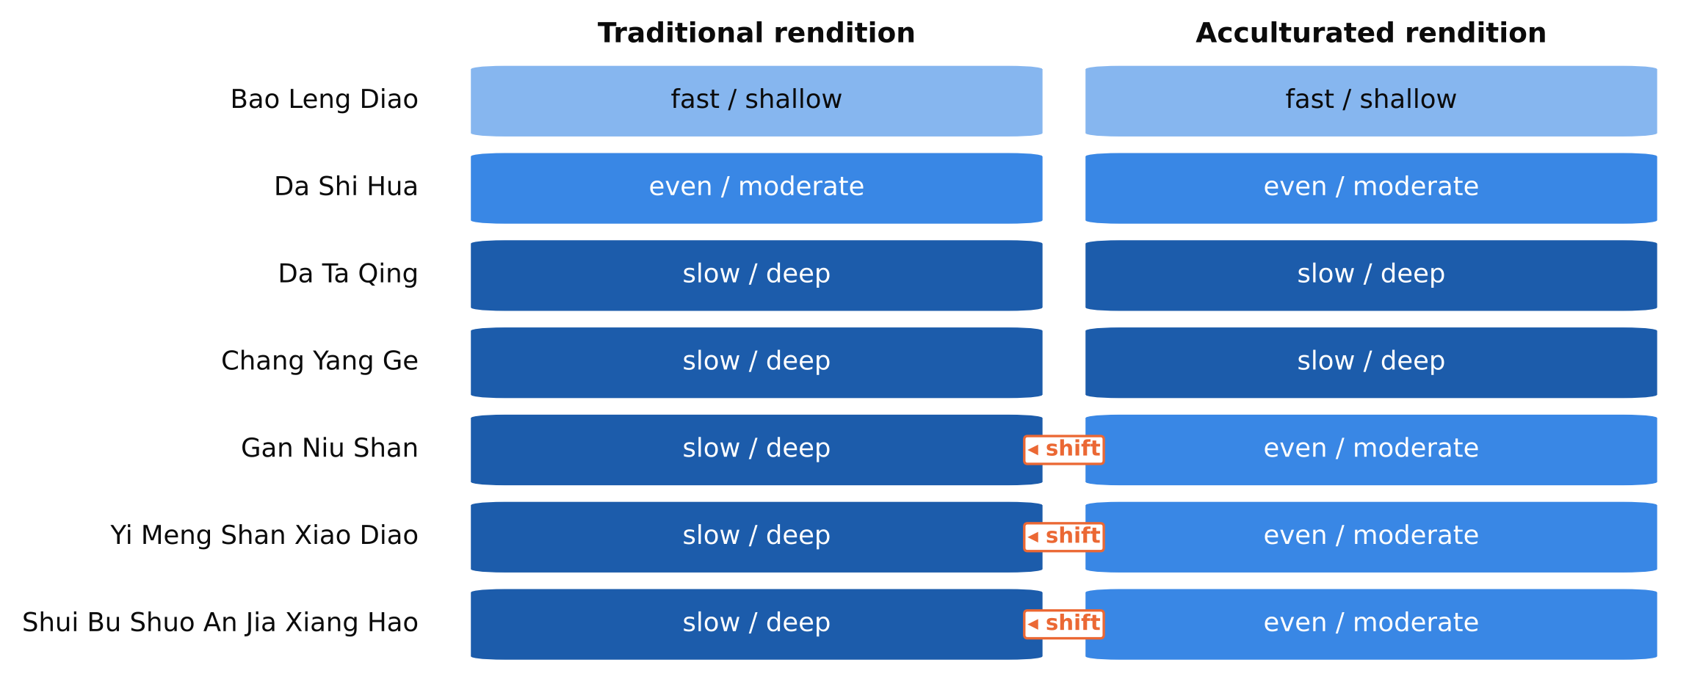
Figure 3. Breathing strategy by song and rendition. Shading steps from fast and shallow (light) to slow and deep (dark). Orange markers indicate the three songs in which the acculturated rendition changed the breathing strategy.

4.3 The intuitive strand: journal and ad-libs
The reflective journal covered daily practice between 11 and 17 April 2025 and yielded two general insights and two ad-libs (Table 6). The first general insight concerned physiology and timing: the voice was cleaner but under-resonant in the morning and fuller and more resonant in the afternoon and evening, so practice and performance schedules should follow the singer's physiological curve. The second concerned the acoustic environment: enclosed and open venues demanded different approaches, so the singing method must be adjusted to the room, a point that bears directly on how much classical resonance an acculturated rendition can afford in a given hall.
The two ad-libs are more revealing because they were unplanned. On 23 April 2025, during Shui Bu Shuo An Jia Xiang Hao, the syllable yi shifted spontaneously from its usual second tone to a fourth tone. The shift gave the voice noticeably greater penetration and power, and the researcher chose to retain it and to apply the falling tone to the first word of each line, which gave the whole performance a stronger and more resonant profile. On 9 April 2025, during Yi Meng Shan Xiao Diao, the placement of the words ren ren moved slightly back from its habitual forward, sharper position. The resulting sound was fuller and more robust and was judged better suited to the stage. Both events were pre-reflective in Høffding and Schiavio's (2021) sense: they emerged from the body's exploration of the sound before the analytic mind had decided anything, and both were then evaluated and adopted through the critical process.
Table 6. Intuitive strand: journal insights and ad-libs.
Date (2025) | Song / context | Event | Consequence for practice
11 to 17 April | Daily two-hour practice, seven songs | Morning voice clean but under-resonant; afternoon and evening fuller | Schedule performance and resonance-demanding practice later in the day
11 to 17 April | Enclosed versus open venues | Acoustics changed the singing approach required | Calibrate the amount of classical resonance to the room
9 April | Yi Meng Shan Xiao Diao, words ren ren | Placement moved spontaneously backward from forward, sharp position | Fuller, more robust tone retained for stage use
23 April | Shui Bu Shuo An Jia Xiang Hao, syllable yi | Tone shifted from second to fourth | Greater penetration; falling tone applied to first word of each line

5. Discussion

5.1 What the paired renditions show about acculturation
Read through Berry's (1997) typology, the comparative matrix describes two renditions that occupy different acculturation strategies. The traditional rendition is separation: heritage technique maintained, contact technique not adopted. The acculturated rendition, as coded, moved placement and resonance wholesale toward the classical setting while leaving breathing largely untouched. That is closer to assimilation on two dimensions and separation on the third than to integration on all three. The finding is uncomfortable for the project's premise, and it should be stated plainly: simply "applying" classical technique to a folk song does not produce integration. It produces a classical rendition of a folk tune, which is precisely the outcome Expert C described as a failure and Expert A warned against as "direct transplantation". Integration, in Berry's sense, requires that something of the heritage setting be retained in each dimension, and the ad-lib on ren ren shows what that might look like: a placement shift that is partial, word-specific and governed by the sound of the dialect rather than by a general rule.
The breathing result refines the picture in a way the pedagogical literature does not anticipate. The Chinese literature on bel canto in national singing treats breath support as the primary gift of the West to Chinese folk performance (Li, 2018; Liu, 2024). The present data show that inhalation pattern is a property of the song, not of the technique. Short-phrased flower-drum and narrative tunes demanded fast or moderate breaths in both renditions; long-phrased minor tunes demanded deep breaths in both. The genuine classical contribution, visible only in the three lyrical songs, was the regulation of expiratory flow across the phrase, which the folk tradition manages by phrase-end releases and the classical tradition manages by appoggio (Miller, 1986). This is consistent with Expert A's observation that classical breathing smooths coloratura and sustained notes: the benefit is in the management of air already taken, not in taking more of it. Pedagogically, the implication is that teachers should stop instructing folk singers to "breathe deeper" and should instead address flow control within the phrase lengths the repertoire actually contains.

5.2 Placement and resonance: sensation, acoustics and the direction of change
The resonance finding appears, at first sight, to contradict the pedagogical literature. Chinese and Western texts alike describe classical singing as the technique of head resonance and mask placement (Chen, 2023; Ren, 2022; Stark, 1999), yet the performer experienced the traditional rendition as head-resonant and the classical rendition as chest-resonant and pharyngeally placed. The contradiction dissolves once the vocabulary is understood as proprioceptive rather than acoustic. Sundberg (1974, 1987) and Titze (2000) established that the ring of the classical voice is produced by lowering the larynx and widening the lower pharynx, which clusters the upper formants into the singer's formant; the sensation of that adjustment is one of depth, space and backward placement, exactly as the performer reported. The bright, forward, speech-like phonation of the folk rendition, by contrast, keeps the larynx higher and the vocal tract shorter, which boosts energy in the region singers describe as "head" or "mask". The study's matrix therefore records a real and consistent difference in vocal tract configuration, correctly reported in the metaphoric language singers actually use. The critical lesson is methodological: studies of vocal acculturation must either measure the acoustics or state clearly, as this one does, that they are reporting sensation.
The direction of change also deserves comment. Across all seven songs, placement and resonance moved in only one direction, from the folk setting toward the classical one. Nothing moved the other way. The acculturation observed in the recital was unilateral, and Redfield, Linton and Herskovits (1936) were explicit that acculturation may change either or both groups. A reciprocal acculturation would show classical technique being altered by contact with the folk repertoire, for example a classically trained singer adopting a higher laryngeal position and brighter timbre for dialect syllables. The ad-lib on yi, where a tonal shift rather than a resonance adjustment produced the gain in penetration, hints at what such a reversal might be: power sought through the resources of the tonal language rather than through classical resonance. The point is not to romanticise the folk tradition but to insist, with Kartomi (1981), that the result of contact be examined in both directions before it is called fusion.

5.3 Dialect as the invariant
The three experts disagreed about whether integration works, but they agreed about what must not be sacrificed: the dialect. Expert B's phonetic example of ren in the Linyi dialect, Expert C's warning that resonance can "strip the folk songs of their regional authenticity", and Expert A's identification of articulation as the fundamental difference all point to the same conclusion, which the literature on Shandong song supports: the regional identity of the repertoire is carried primarily by phonology and tonal contour, not by melody alone (Huang, 2022; Yao, 2021). Lomax (1968) made the general version of this argument fifty years ago: vocal style is a cultural signature, and the signature can be erased while every pitch is sung correctly.
This gives a criterion for distinguishing integration from assimilation that is more precise than taste. An acculturated rendition remains a Shandong folk song as long as dialect phonology, tone contour and direct, unembellished emotional address are preserved; placement, resonance and breath flow may then move as far as the singer's body and the room allow. The ad-lib of 23 April tests the criterion at its edge. Changing yi from second to fourth tone increased power, but in a tonal language a tone change is also potentially a change of meaning, and the gain was purchased by altering a dialect feature rather than a resonance setting. Whether listeners from the region hear the altered tone as expressive emphasis or as an error is an empirical question this study cannot answer, and it is exactly the kind of question the constants in the model are designed to raise.

5.4 A balanced acculturation model
Figure 4 draws the findings together. The horizontal axis is a continuum from a folk-only rendition, at the preservation pole, to a classical-dominant rendition, at the assimilation pole. The three technical dimensions are the adjustable levers that move a performance along this continuum, and the comparative analysis specifies how each moves: breath flow regulation (not inhalation depth) in long-phrased songs, placement from forward upper chest toward the posterior pharynx, and resonance from bright and head-oriented toward covered and chest-oriented. Below the levers sit the constants, dialect phonology and tone contour, direct emotional address and the regional identity of the tune, which must not move if the result is to count as integration rather than assimilation. The balanced zone in the middle of the continuum is not a fixed point; the journal shows that its location depends on the venue and on the time of day, and Expert A's insistence on the singer's individual vocal qualities shows that it also depends on the body.
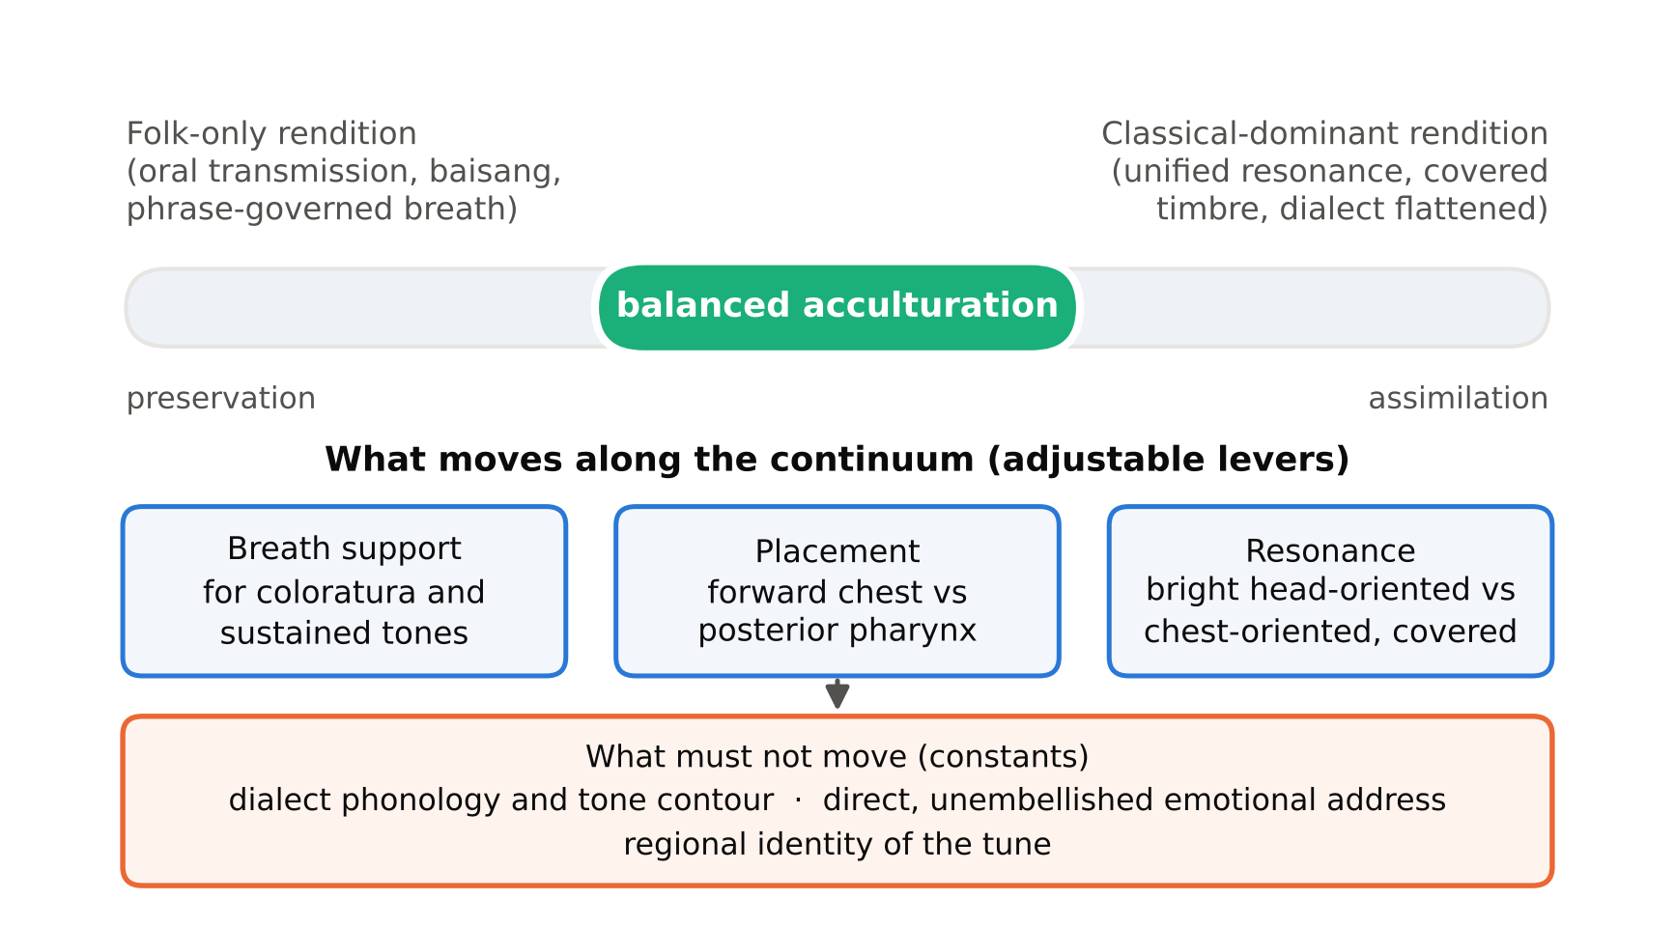
Figure 4. Balanced acculturation model: adjustable technical levers and cultural constants.
The model answers the three research questions in operational terms. The two techniques are analysed by coding the same song in both settings on three dimensions (RQ1). Classical technique is integrated by moving the levers only as far as the constants permit, song by song and word by word (RQ2). The result is showcased on stage by holding staging constant and letting the paired rendition itself make the comparison audible to the audience (RQ3), a format the recitals adopted and which is, in effect, a public version of the analytic method.

5.5 The ideology of the "scientific" voice
The study began, as its own early framing shows, from the assumption that Shandong folk song has "limitations in singing technique" while Western classical vocal music is "systematic and scientific". The evidence does not support this asymmetry, and it is worth saying why. The comparative matrix shows a folk technique with a consistent placement setting, a consistent resonance setting and a breath strategy sensitively matched to phrase length. That is a technical system, not the absence of one. What the folk tradition lacks is codification in writing and a pedagogy of named controls, and the Chinese literature has repeatedly mistaken this lack of codification for a lack of technique (Li, 1982; Shang, 1982; Liu, 2024). Nettl's (1978) distinction clarifies what is at stake. When Chinese writers describe bel canto as scientific and propose it as the means by which folk singing can "develop", they are describing Westernization in the vocabulary of modernization. Expert C's testimony that the current taste is swinging back toward "authentic, unembellished vocal styles" suggests that audiences are beginning to notice the difference. The performer-researcher's own trajectory in this study, from an improvement framing to a balance framing, is itself a small instance of the reflexive correction that practice-based research is supposed to produce (Nelson, 2013; Schön, 1983).

5.6 Implications for pedagogy and performance
Three implications follow for vocal pedagogy. First, curricula that separate folk and classical study should add a paired-rendition exercise in which students sing the same regional song in both settings and code the difference; the exercise is cheap, and it produces exactly the technical vocabulary the experts said singers lack. Second, breath instruction for folk repertoire should target flow regulation across the phrase rather than inhalation depth, since the data show depth is already governed by the genre. Third, dialect coaching should be treated as a technical subject on a par with resonance, with tone contour and placement-sensitive syllables such as ren identified in the score before resonance work begins. For performers, the staging lesson of the recitals is that the comparison itself is a viable concert format, and that the acculturated rendition should be calibrated to the room and the hour rather than fixed in rehearsal.

5.7 Limitations and future research
The single-performer design means that the technical shifts reported may not generalise to other voice types or training histories; a multi-performer replication, including singers trained first in classical technique, would test whether the direction of change is the same. The reliance on proprioceptive report leaves the acoustic basis of the placement and resonance findings inferred rather than measured; long-term average spectra and formant analysis of the paired renditions, which the recordings already permit, would settle whether the reported shifts correspond to changes in singer's formant energy and laryngeal height. The three-expert sample is small and was selected for dual competence, which may bias it toward favourable views of integration; the fact that one of three nonetheless reported failure suggests the bias is not overwhelming. Finally, the absence of audience data is the most consequential gap, because the constants in the model are defined by what regional listeners recognise. A reception study presenting paired renditions to Shandong and non-Shandong listeners, with attention to the altered tone on yi, is the most urgent next step.

6. Conclusion
This article set out to test, in the body of one performer, the long-standing claim that Western classical vocal technique can be integrated into Shandong folk song. The evidence from three experts, seven coded pairs of renditions and a reflective journal supports a qualified and more precise conclusion than the claim allows. Classical technique changes placement and resonance consistently and in one direction, it changes breathing only at the level of flow regulation and only in long-phrased songs, and it does nothing by itself to preserve the dialect features on which the regional identity of the repertoire depends. Integration, as opposed to assimilation, therefore requires a deliberate separation of what may move from what must not. The balanced acculturation model proposed here makes that separation explicit: breath flow, placement and resonance are levers; dialect phonology, tone contour and direct emotional address are constants.
The study also reaches a conclusion about the terms in which the question is usually asked. Shandong folk song is not a technique-poor tradition awaiting scientific rescue; it is a coherent technical system whose controls have not been written down. Framing classical technique as its improvement is an acculturation ideology, and the experts' divided testimony shows that practitioners already sense this. The more productive question is not whether the West can improve the folk voice but how two technical systems can be made to coexist inside one singer and one song. Answering it requires acoustic measurement, more performers and, above all, the ears of the people whose dialect the songs carry. The paired-rendition recital developed here offers a method for all three.

References
Berry, J. W. (1997). Immigration, acculturation, and adaptation. Applied Psychology, 46(1), 5–34.
Braun, V., & Clarke, V. (2006). Using thematic analysis in psychology. Qualitative Research in Psychology, 3(2), 77–101.
Candy, L. (2006). Practice based research: A guide (CCS Report 2006-V1.0). Creativity and Cognition Studios, University of Technology Sydney.
Candy, L., & Edmonds, E. (2018). Practice-based research in the creative arts: Foundations and futures from the front line. Leonardo, 51(1), 63–69.
Chen, A. (2023). Application of the Italian "mask technique" in Chinese songs [Master's thesis, Sichuan Conservatory of Music]. CNKI.
Høffding, S., & Schiavio, A. (2021). Exploratory expertise and the dual intentionality of music-making. Phenomenology and the Cognitive Sciences, 20(5), 811–829.
Huang, X. (2022). A brief discussion on the singing style of Shandong folk songs [Master's thesis, China Conservatory of Music]. CNKI.
Kartomi, M. J. (1981). The processes and results of musical culture contact: A discussion of terminology and concepts. Ethnomusicology, 25(2), 227–249.
Lau, F. (2008). Music in China: Experiencing music, expressing culture. Oxford University Press.
Li, H. O. (2000). Inheritance and innovation of Shandong folk song singing: My experience in singing Shandong folk songs [Master's thesis, Shandong Normal University]. CNKI.
Li, J. (1982). Striving to create the Chinese bel canto school: An interview with soprano Ye Peiying. Music and Dance Communication, (2), 41–43.
Li, Y. (2018). A practical study on singing Chinese poetry and folk songs using bel canto technique [Master's thesis, Hubei Normal University]. CNKI.
Liu, J. Q. (2023). The transmission of Shandong folk songs in other art forms [Master's thesis, Shandong Academy of Arts]. CNKI.
Liu, T. (2024). The value of bel canto technique for the development of ethnic vocal music. Art Observation, (4), 52–54.
Lomax, A. (1968). Folk song style and culture. American Association for the Advancement of Science.
Lu, S. (2020). Research on the artistic characteristics and singing techniques of Shandong Chengwu folk song "Baoleng Tune" [Master's thesis, Qilu University of Technology]. CNKI.
Ma, C. (2020). Research on the social function of Shandong folk songs. Modern and Ancient Culture, (29), 78–79.
Melvin, S., & Cai, J. (2004). Rhapsody in red: How Western classical music became Chinese. Algora.
Miller, R. (1986). The structure of singing: System and art in vocal technique. Schirmer Books.
Mittler, B. (1997). Dangerous tunes: The politics of Chinese music in Hong Kong, Taiwan, and the People's Republic of China since 1949. Harrassowitz.
Nelson, R. (2013). Practice as research in the arts: Principles, protocols, pedagogies, resistances. Palgrave Macmillan.
Nettl, B. (1978). Some aspects of the history of world music in the twentieth century: Questions, problems, and concepts. Ethnomusicology, 22(1), 123–136.
Qi, J. (2014). The current status and countermeasures of the inheritance of Shandong folk songs in the Shandong region. Northern Music, (8), 34.
Redfield, R., Linton, R., & Herskovits, M. J. (1936). Memorandum for the study of acculturation. American Anthropologist, 38(1), 149–152.
Ren, C. (2022). A brief discussion on head resonance. The Voice of the Yellow River, (4), 129–131.
Schön, D. A. (1983). The reflective practitioner: How professionals think in action. Basic Books.
Shang, J. (1982). An overview of the bel canto school (part 1). People's Music, (8), 55–58.
Stark, J. (1999). Bel canto: A history of vocal pedagogy. University of Toronto Press.
Sundberg, J. (1974). Articulatory interpretation of the "singing formant." Journal of the Acoustical Society of America, 55(4), 838–844.
Sundberg, J. (1987). The science of the singing voice. Northern Illinois University Press.
Titze, I. R. (2000). Principles of voice production (2nd printing). National Center for Voice and Speech.
Wang, B. H. (2023). Analysis of the singing style and characteristics of Shandong folk songs [Master's thesis, Shanghai Conservatory of Music]. CNKI.
Yao, X. T. (2021). Application of dialect use and singing style in Shandong folk songs. Art Observation, (3), 29–30.
Zhang, S. Y. (2020). An analysis of the construction of a nationalized course system for vocal performance majors. Sichuan Drama, (4), 177–179, 184.
Zheng, D. K. (2022). Musical characteristics of the traditional folk song "Yimeng Mountain Tune." Contemporary Music, (9), 76–78.
Declarations
Funding: none declared. Conflicts of interest: none. Ethics: expert participants gave informed consent and are anonymised. Data availability: recital recordings and interview transcripts are held by the author and available on reasonable request, subject to participant consent.

