

Lesson 3: Projects, Dashboard, and Status in AMP
Course: AMP Fundamentals | Version 1.0 | 2026
Preceding: Lesson 2 — User Roles | Following: Lesson 4 — The Project Information Form (PIF)

What You Should Understand After This Lesson
- How applications are organized as projects in AMP and what each project contains
- How the dashboard works and what each user type sees
- Every project status — what it means, what color it displays, and who needs to act
- How to read the dashboard correctly to determine the true state of any project
- What the Shot Clock is and why it matters for every review decision

Overview
Once a user logs into AMP, the first thing they see is the Dashboard. This is the control center for the entire application process — the place where every active project is visible, every status is tracked, and every required action is identified.

Understanding the dashboard is not optional. It is the primary tool used by Agents to monitor their submissions, by Analysts to manage their review workload, and by Jurisdictions to track applications and meet federal deadlines.

Projects in AMP

What Is a Project?
In AMP, every wireless facility application is organized as a project. A project represents a single request — from initial application submission all the way through final inspection and approval.

Every project contains:
- All submitted information entered by the Agent
- Required forms and components (PIF, NWF, TWF, NCM)
- Supporting documents uploaded during the application process
- Review history — every action taken, every comment made, every decision recorded
- Communication between Agent, Analyst, and Jurisdiction

What a Project Tracks
A project actively tracks the lifecycle of an application through defined stages:
- Creation — Agent initiates the project and begins the PIF
- Submission — Agent submits the completed PIF for review
- Review — Analyst and/or Jurisdiction reviews the application
- Revision — If corrections are needed, the project is returned; Agent revises and resubmits
- Approval — Jurisdiction approves; components unlock and the process continues
- Construction — Permit issued; construction begins and is tracked
- Final Inspection — On-site verification the project was built as approved
- Completion — Project is closed; all records stored in the Official Record

The Dashboard

What the Dashboard Is
The Dashboard is AMP's primary status page — the first screen a user sees after logging in. It provides a real-time view of every project the user has access to, showing current status, required actions, and timeline information at a glance.

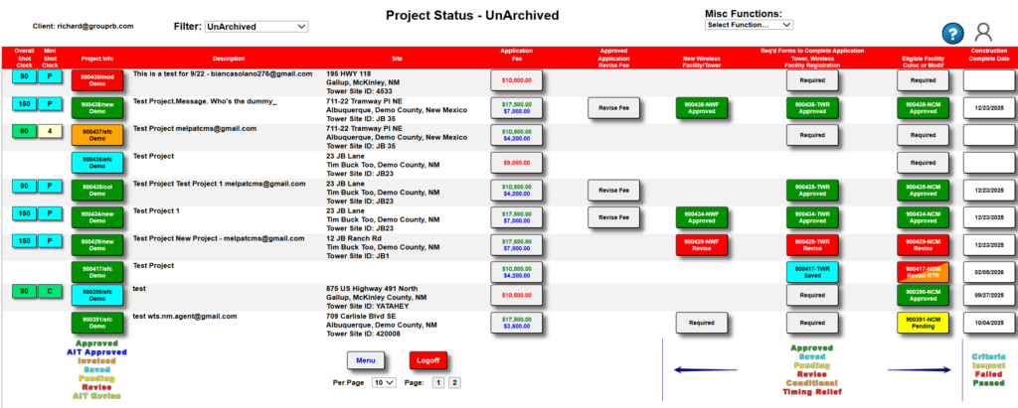

What Each User Type Sees
User Role | What They See on the Dashboard
Agent | Only the projects they personally created and submitted
Analyst | All projects within the jurisdiction(s) they are assigned to
Client (Jurisdiction) | All projects within their jurisdiction, based on the Filter setting at the top of the screen
Admin | System-level view; configurable

How to Read a Dashboard Row
Each row on the dashboard represents one project. Key information displayed per row:
- Project ID — the WTS-assigned unique identifier
- Project Type — what kind of application this is
- Jurisdiction — which local government is reviewing it
- Agent — who submitted it
- Component status columns — current status of each component shown in color
- Shot Clock — federal deadline countdown showing days remaining for Jurisdiction review
- Last Activity — when the most recent action occurred

Project Status — Complete Reference
Each project and each component within a project is assigned a status that communicates three things: where the project stands, what action is required, and who needs to take that action.

Complete Status Table
Status | Color | Meaning | Who Acts | Action Required
Draft | None | Being created, not yet submitted | Agent | Complete and submit the project
Saved | Teal / Cyan | Created or updated but NOT submitted for review | Agent | Must submit to continue the workflow
Submitted / In Review | Blue | Submitted and under active review | Analyst / Jurisdiction | Monitor for response
Pending | Yellow | In progress, awaiting the next step | Monitor | Determine if action is needed
Invoiced | Orange | Fees generated and issued | Agent | Payment required before submission unlocks
Revise | Red | Reviewed — requires corrections | Agent | Revise and resubmit before project can proceed
AIT Revise | Red | Requires revisions under the AIT track | Agent | Corrections required before continuing
Awaiting Revision | Red | Additional information or corrections required | Agent | Update and resubmit
Approved | Green | Met all requirements for this stage | None | No further action for this step
AIT Approved | Dark Blue | Approved under the Alternative Inspection Track | Analyst | Proceed to qualified Analyst sign-off
Completed | Green | Final steps verified and closed | None | Project is complete

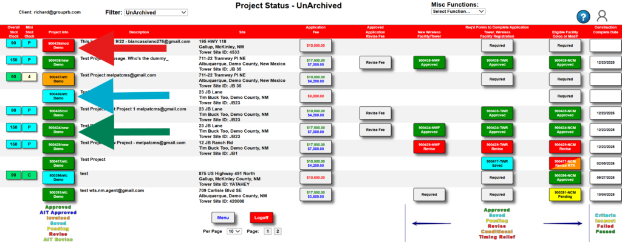
must act now. Green means this step is done. Always confirm by reading the full row.]

Understanding Status Colors
Color is your first signal — it tells you the urgency and general state of a project at a glance. But color alone is never enough. Always read the full row.

Red — Action Required
Red is the most urgent status. It means the project cannot move forward until someone takes action. Red statuses (Revise, AIT Revise, Awaiting Revision) are always assigned to the Agent — the Jurisdiction has reviewed the submission and found something that must be corrected before review can continue.

Teal / Cyan — Incomplete, Not Yet Submitted
Teal means the project or component has been saved but not yet submitted for review. The work has been started and saved, but it has not entered the review queue. A teal status requires the responsible user to go back in and click Submit.

Orange — Invoiced, Payment Required
Orange means the invoice has been issued and payment is required before the project can proceed to submission. After the May 2026 platform update, Agents can now fill out and save all components while payment processes — but no component can be submitted for Jurisdiction review until payment is confirmed.

Yellow — Pending, Monitor for Next Step
Yellow means the project is moving through a step and awaiting the next workflow action. Yellow projects are not stuck — they are in progress. Monitor them to ensure they advance on schedule and that the Shot Clock does not expire.

Green — Approved or Complete
Green means this step is done. An Approved status means the Jurisdiction has reviewed and accepted this stage. A Completed status means the entire project is verified and closed. No further action is required for green items.

Dark Blue — AIT Approved
Dark Blue indicates the project was approved under the Alternative Inspection Track (AIT), routing the approval through a qualified Analyst before finalization. This is the specialized workflow for Analysts in Training.

The Shot Clock

What It Is
The Shot Clock is a federal regulatory countdown timer. Based on requirements established by federal telecommunications law, local governments have a defined amount of time to review and respond to wireless facility applications before those applications are automatically deemed approved.

The Shot Clock column on the dashboard shows how many days remain for the Jurisdiction to take action on each project.

Why It Matters
The Shot Clock is not a suggestion — it is a federal legal requirement. If the Jurisdiction does not act before the Shot Clock expires:
- The application may be legally deemed approved by operation of federal law
- The carrier gains the right to proceed with construction
- The Jurisdiction loses its ability to review, condition, or deny the application

Shot Clock Behavior
- The Shot Clock STARTS when the Agent submits a complete application
- The Shot Clock PAUSES when the Jurisdiction sends the project back for revision
- The Shot Clock RESTARTS when the Agent resubmits after revisions
- The length varies by project type — SWF projects have different deadlines than Traditional Tower projects

The Dashboard Reading Rule

Each column represents a different component or stage. A project can have one green column and one red column at the same time — meaning one part is approved while another requires immediate action. Reading only the green column would give you a completely false picture.

How to Read a Row Correctly
When reviewing a project row, work through these questions in order:
- What is the overall project status? — Check the leftmost status indicator
- What is the status of each component? — Scan each component column left to right
- Are any components red? — If yes, action is required immediately
- Are any components teal? — If yes, something has been saved but not submitted
- What is the Shot Clock showing? — Is there time pressure on this project?
- Who is responsible for the next step? — Agent, Analyst, or Jurisdiction?

Common Dashboard Mistakes

Mistake 1 — Reading only one column
A project can look approved in one column and be stuck in another. Always read the full row.

Mistake 2 — Assuming teal means submitted
Teal/Cyan means saved but NOT submitted. A teal project is waiting for the user to go back in and click Submit.

Mistake 3 — Ignoring yellow projects
Yellow (Pending) projects are easy to overlook because they do not signal an immediate problem. But an unmonitored pending project can miss a Shot Clock deadline or stall without anyone noticing.

Mistake 4 — Assuming green means everything is done
A green indicator on one component means that component is approved — not that the entire project is complete. Check every column.

Mistake 5 — Not checking the Shot Clock
The Shot Clock is easy to ignore until it expires. Build a habit of checking Shot Clock values as part of every dashboard review.

Key Takeaways
- Every wireless facility application in AMP is organized as a project — the central unit of work in the system
- The Dashboard is the first screen after login — it shows a real-time view of all projects the user has access to
- Agents see only their own projects; Analysts and Clients see all projects within their jurisdiction
- There are 11 project statuses — each with a specific color, meaning, and required action
- Red = act now. Teal = not yet submitted. Orange = awaiting payment. Yellow = monitor. Green = approved/complete.
- The Shot Clock is a federal countdown — if it expires, the application may be legally deemed approved
- Never read status from a single column — always scan the entire row left to right

Checkpoint Question

Scenario: A Jurisdiction reviewer logs into AMP and sees a project row. The PIF column shows Green (Approved). The NCM column shows Red (Awaiting Revision). The Shot Clock shows 4 days remaining. The reviewer says: "The PIF is approved so this project is mostly fine. I'll come back to it next week."

What is wrong with this assessment — and what should the reviewer do?

- A) Nothing is wrong. The PIF is the most important component, so green on the PIF means the project is in good shape.
- B) The reviewer is correct to wait — 4 days on the Shot Clock is plenty of time to address the NCM next week.
- C) The assessment is incorrect on two counts: the NCM is red meaning action is required immediately, and with only 4 days on the Shot Clock there is no time to wait. The reviewer must address the NCM revision now to avoid a potential Shot Clock violation.
- D) The reviewer should contact the Agent and ask them to resubmit the whole project to reset the Shot Clock.

CORRECT ANSWER: C — Reading only the green PIF column and ignoring the red NCM is exactly the single-column mistake the Dashboard Reading Rule prevents. The NCM is red — action is required now. With only 4 days on the Shot Clock, waiting until next week risks a federal Shot Clock violation. This project needs immediate attention.

End of Lesson 3 | Next: Lesson 4 — The Project Information Form (PIF)

