LAWN ACE
Lawnie & the Team Dashboard
A simple guide for the Lawn Ace team
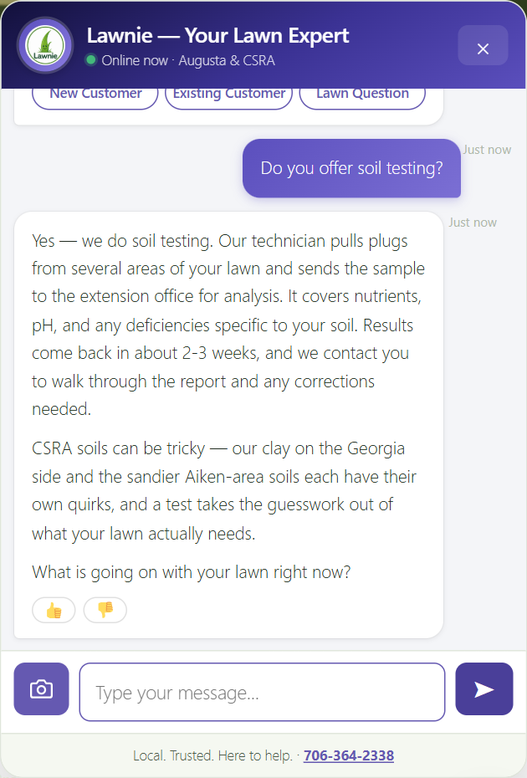

September 2026 · Plugin v3.85
Prepared by Start Performance · Richard Brashear

What's in this guide
1. Meet Lawnie | What the chatbot is, what it knows, and what it does with a customer.
2. The lead email | What lands in your inbox when Lawnie captures a customer.
3. The Team Dashboard | How to sign in and what the four tabs are for.
4. Tasks tab | Your daily to-do list: call, assign, note, tick.
5. Sales tab | Leads, the pipeline, CSV export, and what people are asking for.
6. Service tab | Complaints, no-shows, and anything that could cost a customer.
7. Insights tab | The AI summary, customer mood, competitors, and trends.
8. The Morning Brief | The 8:00 AM email that starts your day.
9. On your phone | Using the dashboard on the go.
10. Quick answers | Common questions and who to call.

1. Meet Lawnie
Lawnie is the chat helper on the Lawn Ace website. Lawnie answers customer questions 24 hours a day, 7 days a week, in the same friendly, local voice your team uses on the phone.
Customers see a small Lawnie button in the bottom-right corner of every page. When they click it, a chat window opens.
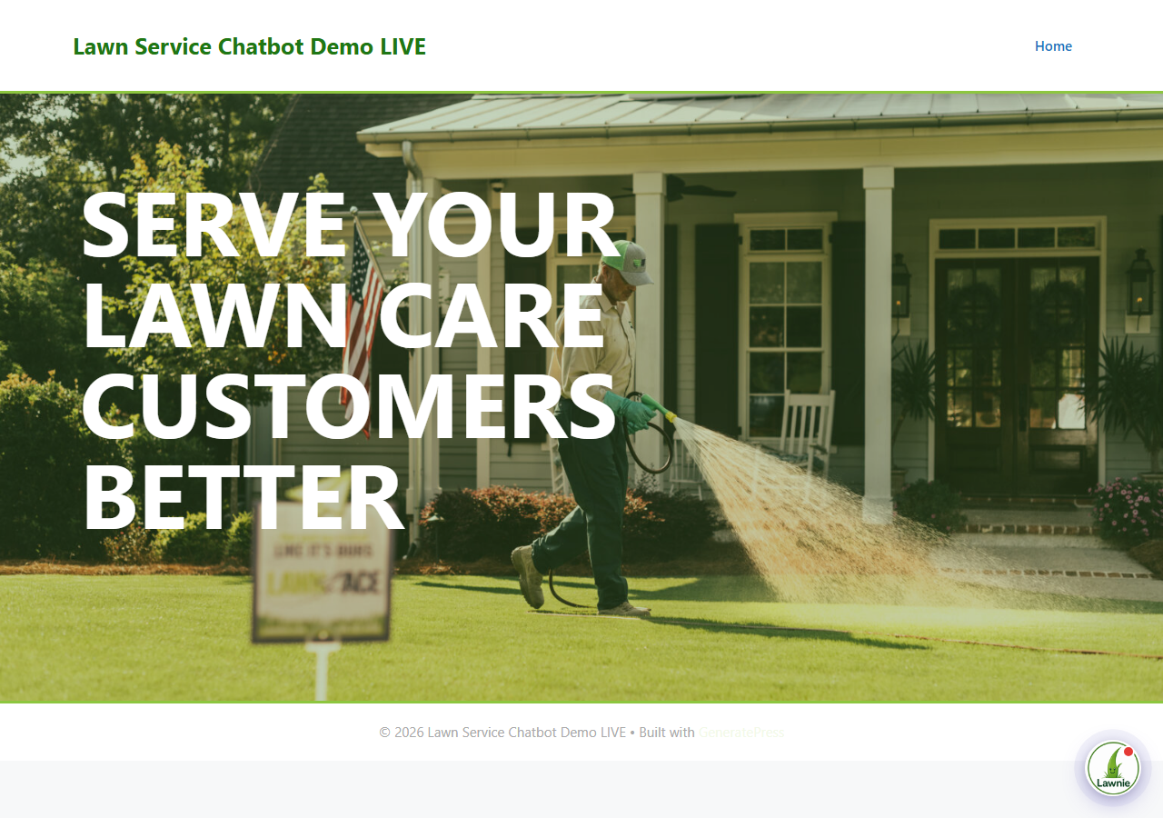
The Lawnie button sits in the bottom-right corner of the website.

What Lawnie knows
- Your services and plans. Essential, Grow, and Pro plans, plus add-ons like mosquito control, tree and shrub care, aeration, grub control, and soil testing.
- Local lawn knowledge. CSRA clay and sandy soils, Bermuda, Zoysia, Centipede, and St. Augustine, seasonal problems like armyworms, fall webworms, and fire ants.
- Your office hours. When the office is open, Lawnie invites people to call. When it is closed, Lawnie collects their info so you can call them back.
- What you do NOT do. No mowing, landscaping design, or irrigation. Lawnie says so honestly and steers the customer to what you do offer.

What Lawnie does with a customer
- Answers the question in plain language, then asks a follow-up to keep the conversation going.
- Recommends a plan (usually the Grow Plan) when the customer asks about pricing or what they need.
- Collects contact info: name, email, phone number, and street address, so you can pull up the property and quote it without a visit.
- Sends the lead to the office by email the moment the info is captured, and adds it to the dashboard.
- Flags problems. Complaints, no-shows, cancellation talk, and safety questions are all marked for your attention.
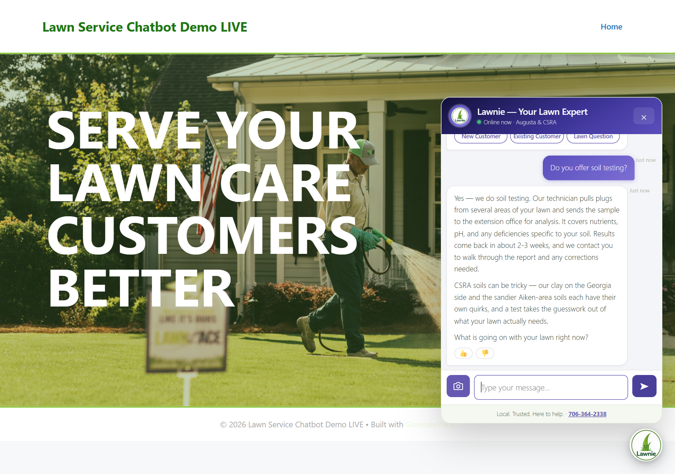
A customer asking Lawnie about soil testing.
Good to know
Lawnie never makes up prices. Exact numbers always come from your office.
If Lawnie cannot answer something, it tells the customer to call the office. Those conversations show up on the Service tab under "Referred to Office".
Lawnie can look at a photo of a lawn if the customer attaches one.

2. The lead email
Every time Lawnie captures a customer's contact info, the office gets an email right away. It has everything you need to call them back:
- Name, phone, email, and address. Tap the phone number to call. Tap the address to open it in Google Maps.
- A "Call" button so you can reach them in one tap from your phone.
- The full conversation, so you know exactly what they asked before you call.
- A note if something is missing. If the customer skipped their phone or address, the email says so.
If a customer gives their phone or address later in the same chat, you get a second email titled "Updated Lead Info" rather than a duplicate lead.
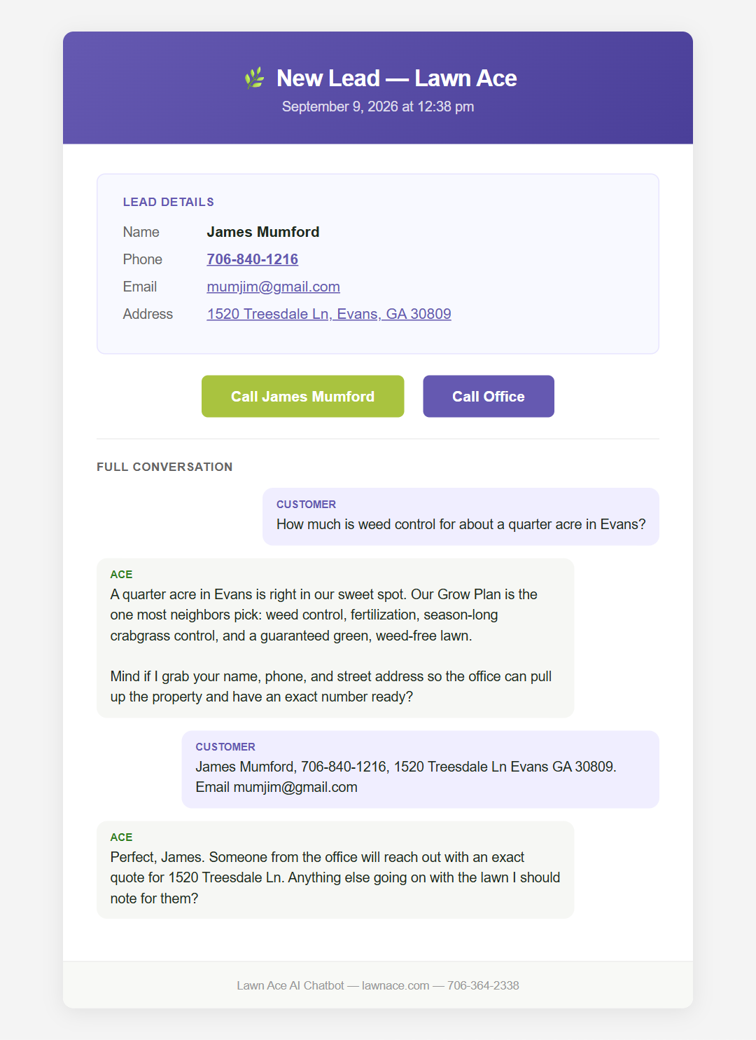
A lead email. Sample customer shown.

3. The Team Dashboard
The dashboard is where your team sees every conversation, every lead, and every problem Lawnie has spotted. It works on a computer, a tablet, or a phone.

Signing in
- Go to https://lawnace.com/la-team/
- Enter the team password. Kyle has it.
- You stay signed in for 8 hours. Bookmark the page on your phone for quick access.
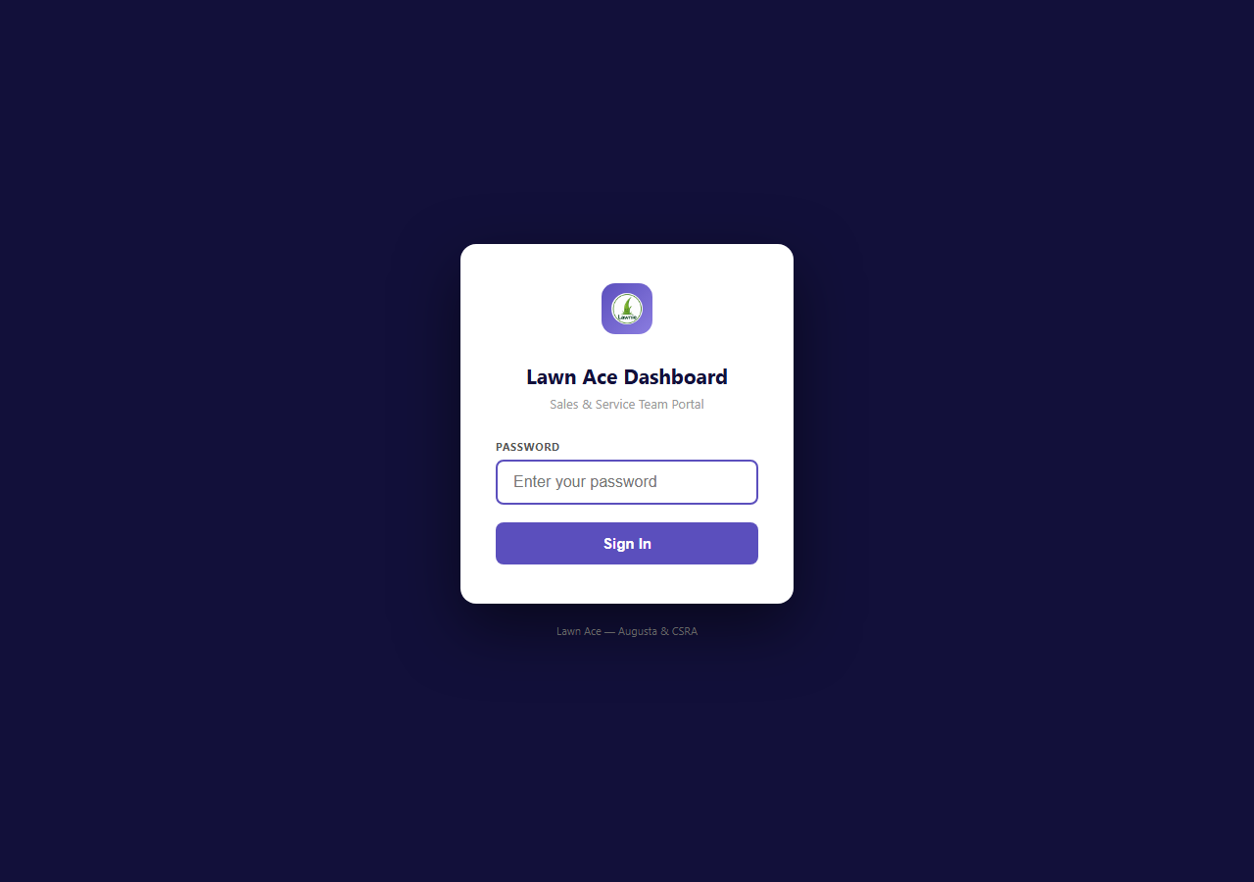
The sign-in screen.
The Range buttons (Last 7 Days, Last 30 Days, All Time) change what every tab shows. Most days, Last 30 Days is the right choice.

The four tabs
Tasks | Your daily to-do list. Leads to call, pricing questions to follow up, complaints to handle.
Sales | Leads, the lead pipeline, what services people are asking about, and where they live.
Service | Complaints, no-shows, cancellations, safety questions, and anyone Lawnie sent to the office.
Insights | A plain-English AI summary of the month, customer mood, competitors mentioned, and trends.

4. Tasks tab: your daily list
Start here every morning. Each row is one customer who needs a call or a follow-up. Tasks are grouped by type:
- New Lead — Follow Up. Lawnie captured their info. Call them and quote the lawn.
- Pricing Question — Follow Up. They asked about cost but did not leave their info. Open the chat to see what they asked.
- Complaint / Service Issue. Something went wrong. Call them personally.
- Drop-off — Re-engage. They left after one or two messages. Worth a look, low priority.

What you can do on each task
Checkbox | Tick it when the task is done. It stays on the list, greyed out, so nobody calls twice.
Status | For leads: New, Contacted, Quoted, Won, or Lost. Picking Won or Lost also ticks the box for you.
Assigned to | Pick Kyle, Tammi, or Tim so everyone knows who owns the call.
Add note | Type what happened: who called, what was quoted, next step. It saves when you click away.
View Chat | Opens the full conversation so you can read exactly what the customer said.

A simple morning routine
1. Open the Tasks tab.
2. Assign each new task to a person.
3. Call the New Leads first. Tap the phone number right from the task.
4. After each call, set the Status and add a quick note.
5. Tick the box when the task is finished.
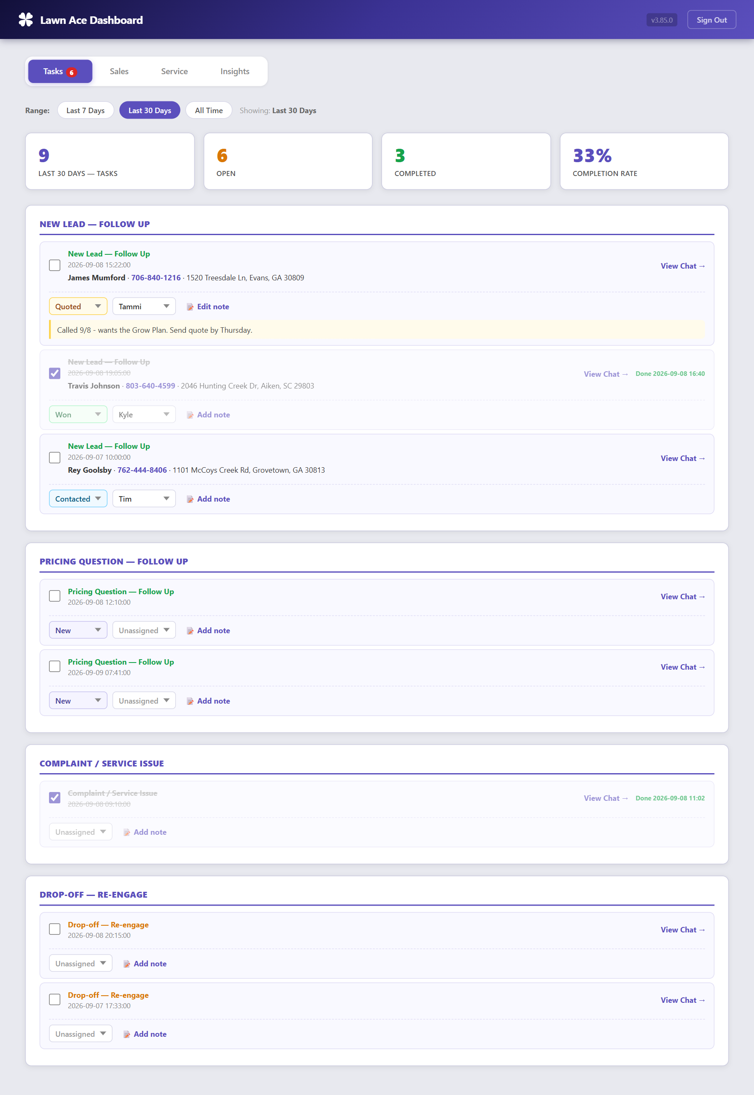
The Tasks tab. Sample customers shown.

5. Sales tab: leads and demand
This tab shows how Lawnie is doing as a salesperson and where the business is coming from.

The numbers at the top
Leads Captured | How many people left their contact info in the selected range.
Total Conversations | How many people chatted with Lawnie.
Conversion Rate | Leads divided by conversations. Higher is better.
Pricing Questions | How many people asked about cost.

Lead Pipeline
A count of your leads at each stage: New, Contacted, Quoted, Won, Lost. The Close Rate is the share of decided leads that you won. Keep statuses up to date and this becomes your real scoreboard for the chatbot.

Recent Leads
Every lead in the range with name, phone, email, and address. Phone numbers are tap-to-call and addresses open in Google Maps. You can set the Status and Assigned person right in the table.
Export CSV downloads the list as a spreadsheet, including status, who it is assigned to, and notes. Handy for a monthly review.
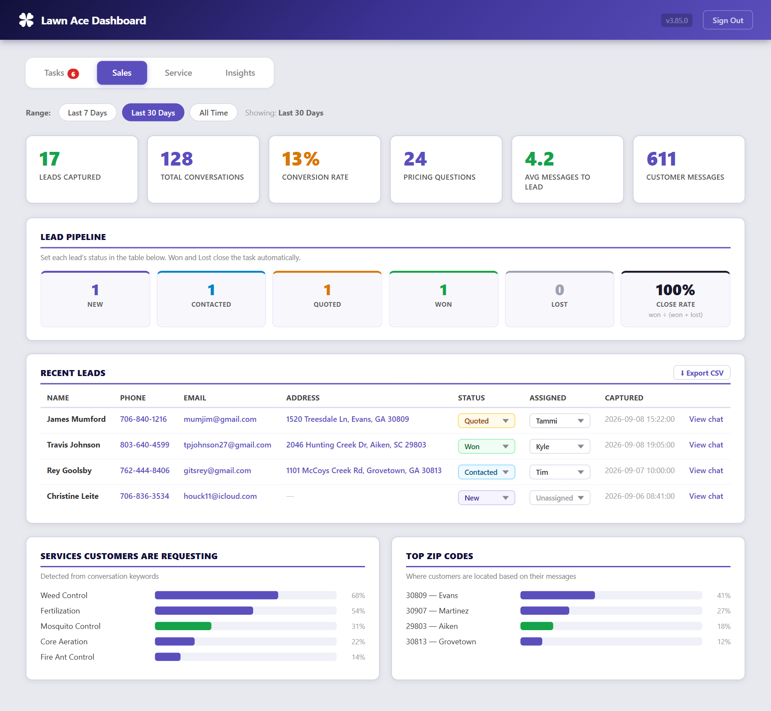
The Sales tab. Sample customers shown.

Lower down the page
- Services Customers Are Requesting: what people ask about most. Good for planning promotions.
- Top ZIP Codes: where your inquiries come from.
- Service Area Inquiries: people checking whether you cover their area, sorted by ZIP. Repeated ZIPs outside your map are expansion signals.
- Upsell Opportunities and Seasonal Treatment Demand: customers asking about add-ons and what is in season right now.

6. Service tab: problems to handle
This is the early-warning tab. Anything that could cost you a customer shows up here.
Needs Attention | No-show reports and cancellation talk. Call these people today.
Flagged Complaints | Customers who mentioned rude service or being unhappy.
Referred to Office | Questions Lawnie could not answer. If the same question keeps appearing, tell Richard so Lawnie can learn it.
Pet & Child Safety | People asking if treatments are safe. A personal call goes a long way here.
Billing, Weather Holds, Account Changes | Payment questions, rain reschedules, and pause or upgrade requests.
Customer Approval | The thumbs-up percentage customers gave Lawnie's answers.
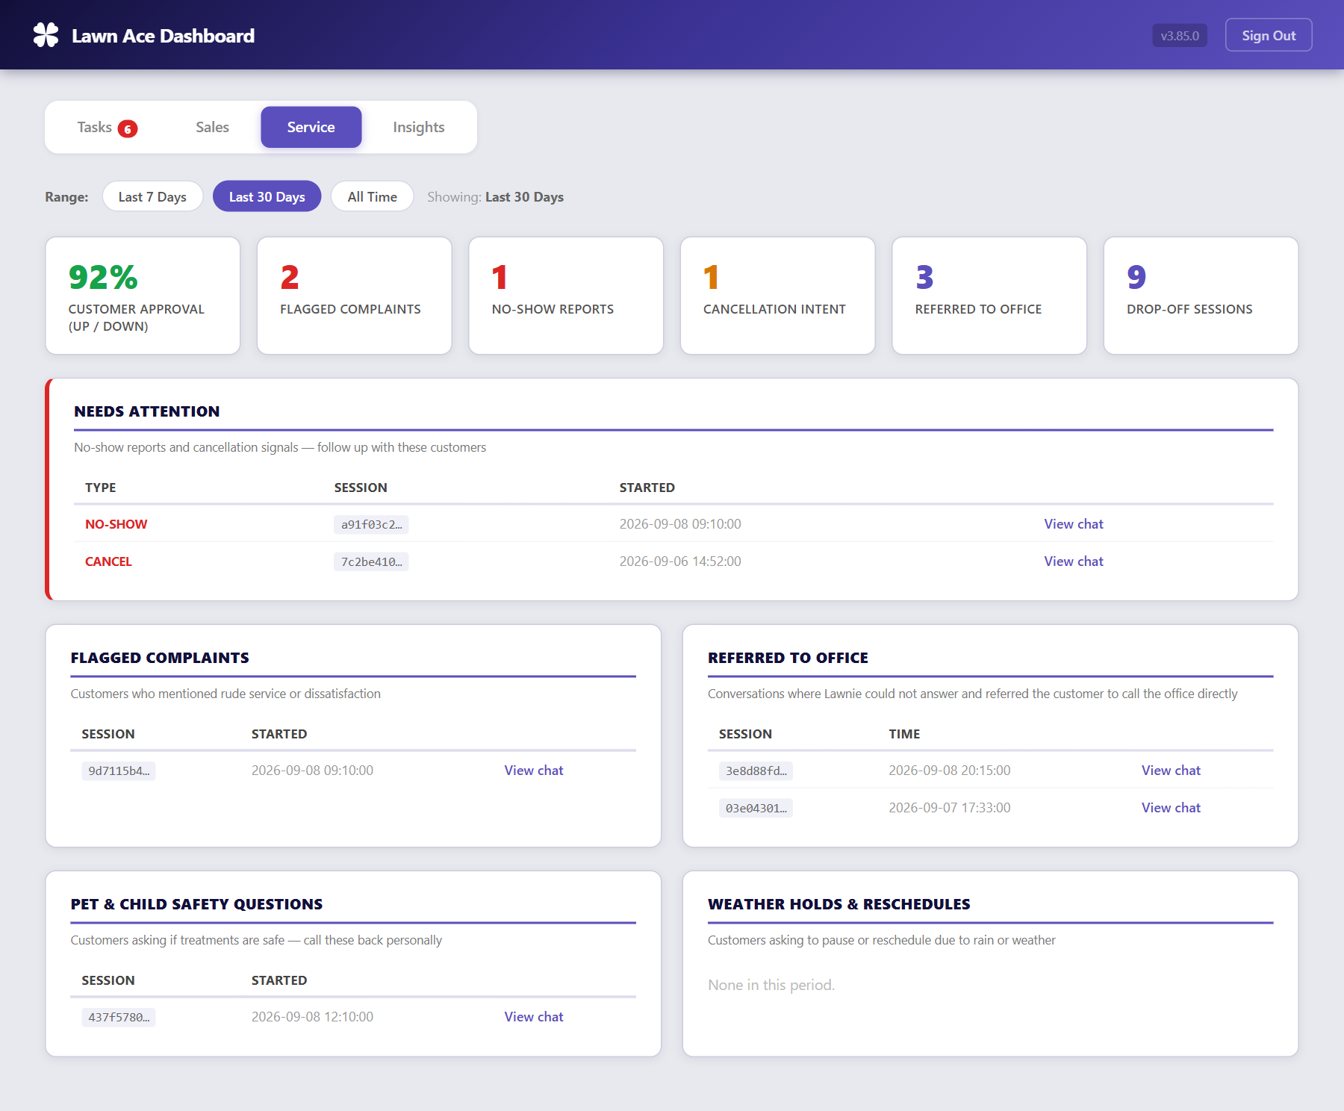
The Service tab. Sample data shown.

7. Insights tab: the big picture
AI Summary. Click "Generate Summary" and Lawnie writes a short plain-English brief for the selected range: how busy it was, the top topics, where customers are, and anything flagged. Takes about ten seconds.
Customer Sentiment. How many conversations sounded positive, neutral, or frustrated.
Competitors Mentioned. Which other companies customers bring up. TruGreen is the usual one.
Topic Trends. This period compared with the one before it. Green arrows are up, red arrows are down.
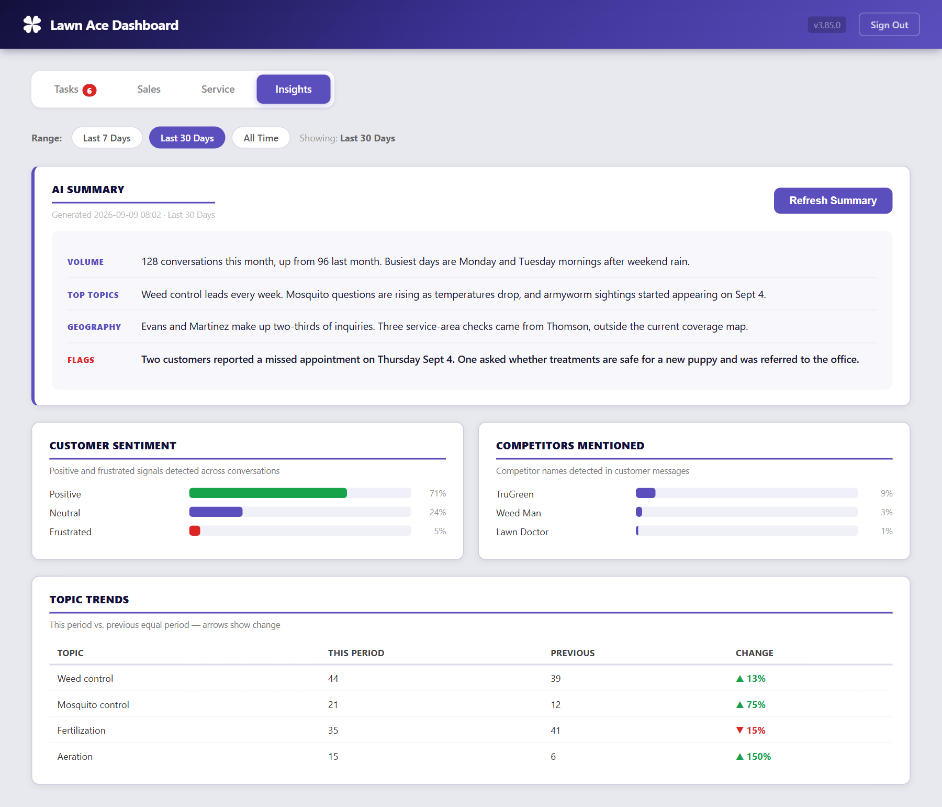
The Insights tab. Sample data shown.

8. The Morning Brief email
Every morning at 8:00 AM, Lawnie emails the team a short brief covering the last 24 hours, so you do not have to remember to open the dashboard:
- New Leads to call today, with phone, email, and address ready to tap.
- Pricing questions where no contact info was captured.
- Service issues from the last day.
- Open task count and a button that opens the dashboard.
Who receives it is set in the plugin settings. Ask Richard to add or remove people.
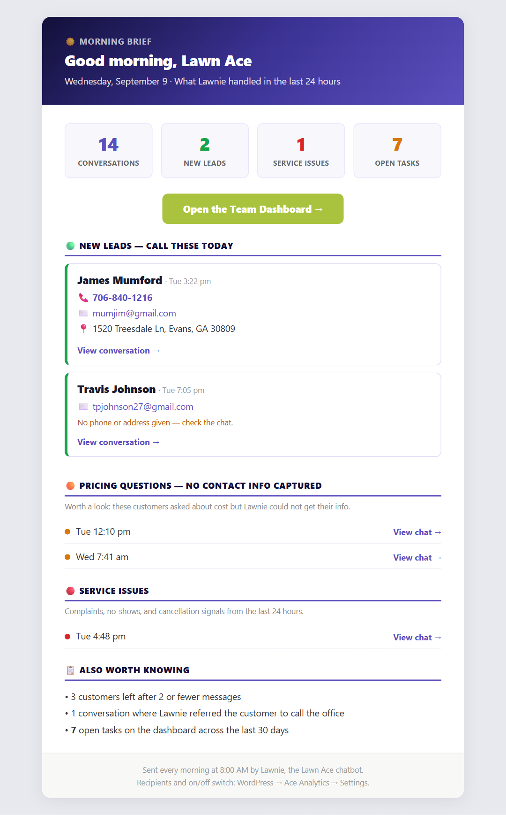
The Morning Brief. Sample customers shown.

9. On your phone
The dashboard is built for phones. Everything stacks into one column, phone numbers are tap-to-call, and tables scroll sideways inside their box. Bookmark the dashboard address on your home screen and it works like an app.
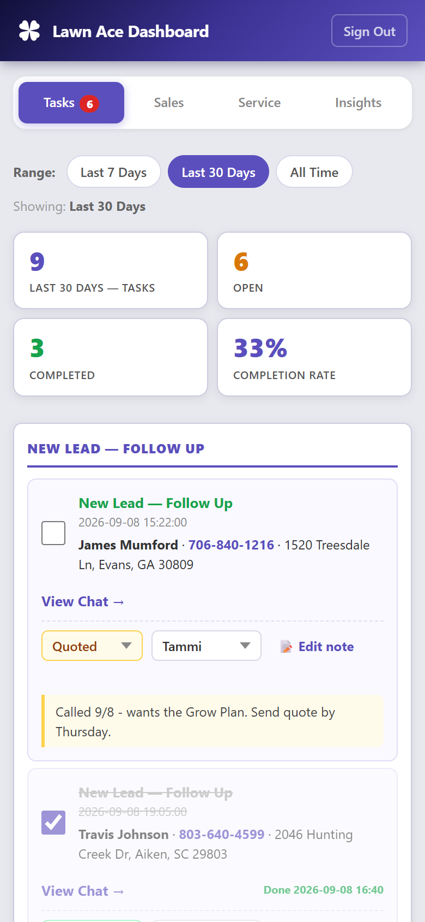
The Tasks tab on a phone.

10. Quick answers
Lawnie said something wrong | Email Richard the question and the answer you wanted. Lawnie can be corrected the same day.
A lead has no phone or address | The customer did not give it. Open View Chat to see what they did say, then email them.
Two of us called the same person | Use the Assigned to dropdown on every task. Assign first, then call.
I ticked a task by mistake | Untick it. Nothing is deleted.
I need the leads in a spreadsheet | Sales tab, then Export CSV. Pick the range first.
The Morning Brief did not arrive | Check spam first. Then tell Richard.
I forgot the password | Kyle has it. Richard can reset it.
Something looks broken | Email RBStart@StartPerformance.com or call 803-415-5062.

Contact
Richard Brashear · Start Performance
RBStart@StartPerformance.com · 803-415-5062

