CS518 - LAB 1:
Colour image segmentation
-Hersh Dhillon
2017csb1079

How to run the file

- Execute the answer_file.py file as
  - python answer_file.py in windows or
  - python3 answer_file.py file in Linux
- The EM_CI_seg_Lab1.py file contains the given boilerplate code and has not been edited.
- The images get stored in different sub-directories in the output directory as instructed in the boilerplate code.

EM Algorithm and Colour Image Segmentation

- The EM algorithm is an unsupervised classification algorithm that works in the following way:-
  - Parameter Initialization:- Involves initializing the values of the parameters for each cluster i.e. mu, pi and the weights in the given case.
  - Soft assignment of the pixels to the clusters (E-step) :- Assign each of the pixel to a particular cluster, expressed as the weight of the pixel for the cluster
  - Parameter Recomputation (M-step) :- The pi and mu matrices are recalculated from the updated values of the weights. This process is repeated till the change in the parameters is less than a given threshold.
- Colour image segmentation is a process which simplifies the task of object detection in Computer Vision by assuming that an objects are coloured distinctly and ignores other intricate information like changes in colour or brightness by only considering gross differences in colour. As a result of this assumption the required image can be processed very rapidly, as we also see in this example.

Observations

- There is no dtype attribute for a pillow image object and the dimensions are stored in reverse order to the image when opened via matplotlib.
- Np.where returns an array, using that for calculating max might be a problem in some cases where there are 2 elements with the max value.
- The same task if done with a matplotlib image object led to unsatisfactory results. I think this is the reason as the guesses for the mu and pi values would be off due as the range is in 0-1 rather than 0-255 which amplifies the difference between the pixel values.

Some steps taken

- Used matmul and sum to calculate the value of mu in the M-step, to avoid using a loop for the same.
- Ran a few tests with slightly different values for the initializing case. The code in the final submission might be slightly different than the boilerplate code which was given.

Results

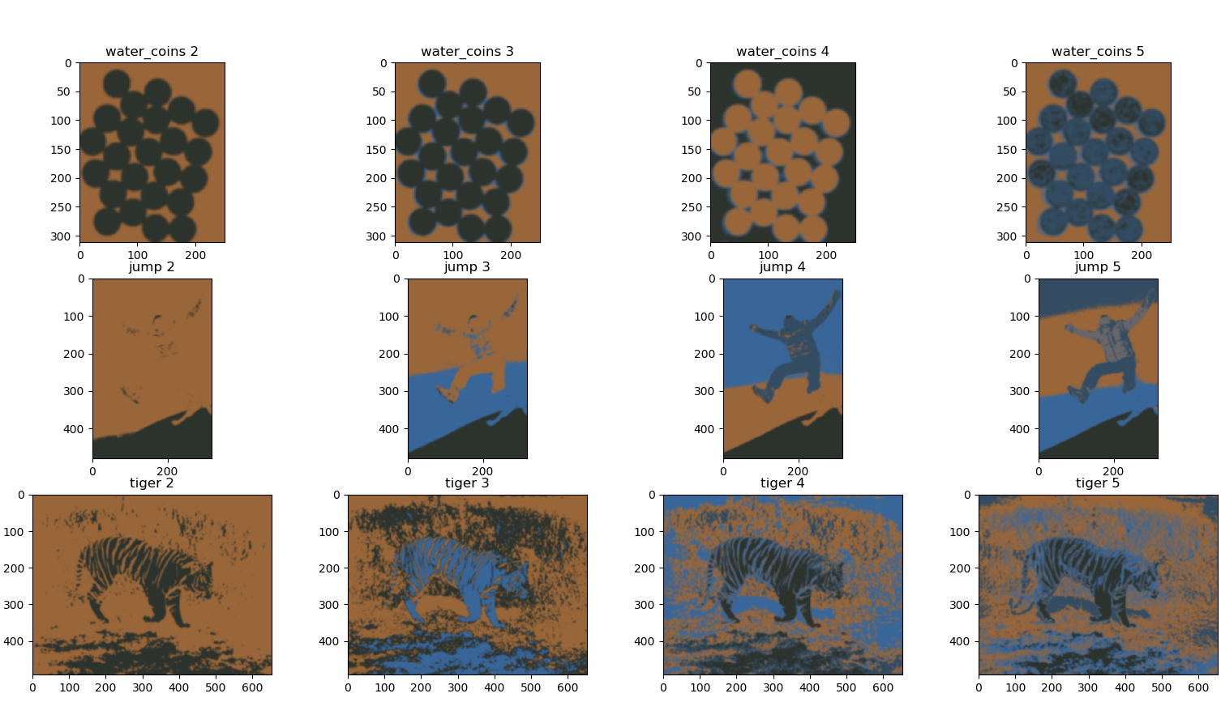

- The gradient of the sky in the picture jump gets expressed clearer as we increase the segments, which is expected.
- The water body in the tiger picture gets a different segment in itself in the 5 segment case.
- For the coins picture two different segments are the coins and the background as shown. Further the shadows get highlighted as the segments increase. Ultimately the minting on the coins starts to emerge as we reach 5 segments.

