Satellite-Derived PM2.5 Exposure and Pediatric Asthma Prevalence Across Philippine Regions, 2013–2022: Why a Strong Pooled Correlation Reverses Under Fixed Effects
Hertzan D. Alquizola II
Independent Researcher, Lee County High School, Leesburg, GA, USA
Abstract
Introduction. Fine particulate matter (PM2.5) is among the most harmful environmental exposures children face. The Philippines is one of Southeast Asia's most polluted countries, yet it has rarely been studied at the subnational level. This study examines whether satellite-derived PM2.5 predicts pediatric asthma prevalence across 17 Philippine regions (2013–2022) and separately validates the satellite exposure measure against ground monitoring. Methods. Annual PM2.5 estimates (ACAG V6.GL.02.04) were merged with GBD 2023 pediatric asthma prevalence (ages 5–14) for 170 region-year observations. We computed pooled correlations, a within/between variance decomposition and a two-way fixed-effects panel regression (region and year effects, region-clustered standard errors) as the primary analysis specification. Results. Regional PM2.5 averaged 14.72 ± 3.52 µg/m³ (Table I). Every region-year exceeded WHO's annual guideline, and 34.1% exceeded its stricter Interim Target-3. The pooled correlation was strongly positive (r = +0.887, p < 0.0001), but variance decomposition showed that 98.5% of asthma-prevalence variation was between-region; only 1.5% was within-region. Once fixed effects removed that structure, the association reversed and weakened (β = −2.554, p = 0.0024, within-R² = 0.080). Nine robustness checks (Methods; Table IV) confirmed this result with varying precision. The check that most changes how confidently this result should be read was letting each region follow its own time trend: the coefficient shrank 63% (β = −0.937, p = 0.038), leaving the finding directionally stable but only narrowly robust. A second, independent contribution comes from validating the satellite exposure measure itself. Comparing two ACAG product releases at identical Davao City locations and years revealed a systematic 2.87 µg/m³ version-drift artifact (mean absolute error 1.48 vs. 3.65 µg/m³), large enough to manufacture or mask a trend. This is a caution for any multi-year satellite PM2.5 panel that spans a product-version boundary. Conclusion. Between-region confounding, chiefly urbanization and diagnostic capacity, best explains the Philippines' strong pooled PM2.5-asthma correlation; a direct temporal pollution effect does not. Detecting a real effect, if one exists, likely requires higher-frequency outcome data than modeled prevalence estimates provide. The version-drift finding is a standalone methodological caution for satellite-based exposure panels generally.
Keywords: Particulate Matter; Air Pollution; Asthma; Child; Philippines
Introduction
A correlation can be strong and still point to the wrong cause. Across 17 Philippine regions from 2013 to 2022, satellite-derived PM2.5 and pediatric asthma prevalence move together almost perfectly when regions and years are pooled (Pearson r = +0.887), the kind of result that would ordinarily read as strong confirmation that pollution drives childhood asthma. Once fixed-effects methods isolate how each region changes relative to itself over time, holding constant stable regional differences and shared national trends, that same relationship reverses sign and nearly disappears (β = −2.554, within-region R² = 0.080). This paper explains why, and reports a second, independent finding: switching between two releases of the same satellite PM2.5 product shifts estimates by an amount comparable to a large share of this panel's entire measured variation, with consequences for any study built on data like it.
Air pollution is nonetheless one of the most serious environmental health problems in the world today, responsible for approximately 6.7 million premature deaths each year according to the World Health Organization (WHO). Fine particulate matter (PM2.5, particles ≤ 2.5 micrometers in diameter) is especially dangerous because it penetrates deep into the lungs and can enter the bloodstream, and children are especially vulnerable: they breathe more air relative to body weight, spend more time outdoors and have immune and respiratory systems still in development. PM2.5 exposure is linked to worsening asthma symptoms, increased respiratory hospitalization and higher rates of lower respiratory infection, and several large studies in Asia have tied short-term PM2.5 spikes to increased emergency-department visits among children with asthma.^{1,2}
The biological pathway connecting PM2.5 to pediatric asthma is well characterized: particles small enough to reach the distal airways trigger oxidative stress and airway inflammation, impair mucociliary clearance and, with repeated exposure, are thought to contribute to airway remodeling and heightened bronchial hyperresponsiveness.³ This mechanism operates on two time scales that matter for how it is measured here. An acute exposure spike can plausibly trigger a wheezing episode or emergency visit within days. Prevalence, the count of children currently living with a diagnosed condition (a “stock,” as opposed to a “flow”), moves only as fast as diagnosis, remission and mortality allow, which for a chronic condition like asthma can take years. A panel built to detect a same-year PM2.5 effect on prevalence implicitly assumes prevalence moves fast enough to track annual pollution changes. Whether that assumption holds here is a directly testable and consequential empirical question (see Results, Variance Decomposition; Discussion, “Why Asthma Prevalence Is the Wrong Outcome Variable”).
The Philippines faces a significant air quality challenge. As one of the most rapidly urbanizing countries in Southeast Asia, the country is experiencing growing pollution from motor vehicles, industrial emissions, open burning and other sources. This raises legitimate questions about the air quality that hundreds of thousands of Filipino school-age children breathe every day.
Globally, asthma is one of the most common chronic diseases of childhood. In the Philippines, a 2023 study by Legaspi et al. found that pediatric asthma carries a significant and growing burden⁴; a separate Philippine analysis linked PM2.5 exposure to child respiratory illness and mortality⁵; and Yang et al. project that asthma trends across the Western Pacific region will continue to rise through 2045⁶. Yet despite this recognized burden, the relationship between ambient PM2.5 and pediatric asthma within the Philippines has not been studied at the subnational, regional level using panel methods that properly account for structural differences between regions and shared national trends over time.
Most existing Philippine air quality and respiratory health research suffers from one or more of the following limitations: it uses national-level data with no subnational breakdown, it focuses on PM10 instead of the more health-relevant PM2.5, it does not use panel or fixed-effects methods, or it does not isolate the pediatric age group. This study addresses those gaps directly. The gap is not unique to the Philippines: across low- and middle-income countries generally, subnational research on air pollution and child health relies overwhelmingly on cross-sectional regression or health-impact-assessment designs. Panel designs that separate within-unit change from between-unit structure remain uncommon. Recent examples include a cross-sectional analysis of prenatal and postnatal air pollution and child growth across five East African countries⁷ and a health-impact assessment of PM2.5 exposure from Indonesian peatland fires.⁸ Two-way fixed-effects methods of this kind are increasingly standard in air-pollution epidemiology in higher-income settings, including recent work formalizing how sensitive such models are to their own specification choices⁹, but they remain comparatively rare in subnational LMIC applications. This study brings that design to a Southeast Asian pediatric-asthma setting where it does not appear to have been applied before.
Using satellite-derived annual PM2.5 estimates from the Atmospheric Composition Analysis Group (ACAG) and pediatric asthma prevalence data from the Global Burden of Disease (GBD) 2023 study¹⁰, we constructed a subnational ecological panel covering 17 Philippine administrative regions over 2013–2022 (170 region-year observations). We applied two-way fixed-effects panel regression, isolating the within-region, year-to-year relationship between changes in PM2.5 and asthma prevalence while controlling for stable regional differences and shared national time trends. We also conducted a variance decomposition, a diagnostic step that turns out to explain the rest of this paper's results. A second, independent line of inquiry, reported later in this manuscript, validates the satellite PM2.5 measure against ground monitoring in Davao City and identifies a systematic bias between two ACAG product releases. This is a methodological finding relevant to any multi-year satellite-based exposure panel, independent of this study's asthma question.
Three causal structures are consistent with a positive association between regional PM2.5 and diagnosed pediatric asthma prevalence, and this study's design exists to tell them apart. PM2.5 could act directly on children's airways, producing a same-year rise in diagnosed prevalence: a genuine biological effect. Regional PM2.5 and regional diagnostic capacity could instead move together only because both are consequences of urbanization, so that a comparison of pollution and diagnosed prevalence is really a comparison of pollution and how likely a child is to be formally diagnosed at all: a confounded path. Or urbanization could drive both directly, with PM2.5 and diagnostic capacity correlated only because they share this common cause and not because either affects the other. Region and year fixed effects, described next, are the tool used here to separate the first explanation from the second and third.
This manuscript is organized in two parts. Part I (Methods through Implications for Philippine Environmental Health Policy) develops and stress-tests the main regional panel finding above. Part II (Davao City Case Study onward) is a self-contained validation study of the satellite exposure measure itself; it does not feed into or change Part I's results, and its own conclusion is folded into the shared Conclusion at the end of this manuscript.
This manuscript makes three distinct contributions:
- A substantive finding: across 17 Philippine regions, a strong pooled correlation between PM2.5 and pediatric asthma prevalence (r = +0.887) reverses and nearly vanishes under two-way fixed effects (β = −2.554, within-R² = 0.080), driven by between-region confounding and asthma prevalence's own slow-moving dynamics. This is not a data artifact (Part I).
- A methodological finding: switching between two releases of the same satellite PM2.5 product shifts exposure estimates by 2.87 µg/m³ at identical locations and years, about 81% of this panel's entire ten-year standard deviation: a caution for any multi-year satellite-based exposure panel (Part II).
- A design contribution: to our knowledge, this is the first application of two-way fixed-effects panel methods, with a full robustness and specification-curve battery, to a subnational pediatric-asthma question in Southeast Asia.
Part I: Regional Panel Analysis
Methods
Study Design
This is an ecological subnational panel study. The unit of analysis is the region-year: each of the 17 administrative regions of the Philippines, observed annually from 2013 to 2022, producing a panel of 170 region-year observations. This design allows examination of both how regions differ from each other (cross-sectional variation) and how each region changes over time (temporal variation). This study followed the STROBE reporting guidelines for observational ecological studies.¹¹
Exposure Data: Satellite-Derived PM2.5
Annual mean PM2.5 concentrations (µg/m³) were obtained from the Atmospheric Composition Analysis Group (ACAG) V6.GL.02.04 dataset, developed at Washington University in St. Louis. This dataset provides annual global estimates of ambient PM2.5 derived from satellite observations of aerosol optical depth, combined with a chemical transport model (GEOS-Chem) and calibrated against more than 40,000 ground-level monitoring stations worldwide.¹²
We downloaded NetCDF (.nc) files for each year from 2013 to 2022 and, using Python's xarray library, extracted PM2.5 values within the Philippines' bounding box and computed the area-weighted mean PM2.5 for each of the 17 administrative regions using GADM level-1 shapefiles (gadm.org), so each pixel's contribution to the regional average is proportional to the land area it covers. This produced a panel of 170 region-year PM2.5 values in µg/m³.
Outcome Data: Pediatric Asthma Prevalence
Age-standardized asthma prevalence rates (per 100,000 population) were obtained from the Global Burden of Disease 2023 (GBD 2023) Results Tool for children ages 5–14 years at the subnational province level. Province-level estimates were aggregated to the 17 Philippine administrative regions using a province-to-region mapping, with the regional value computed as the simple mean of the constituent provincial rates. National-level observations were excluded before all analyses.
Statistical Analysis
All analyses were conducted in Python using the pandas, scipy, statsmodels and linearmodels libraries. First, we computed descriptive statistics and identified all region-year observations where annual mean PM2.5 exceeded WHO's Interim Target-3 (15 µg/m³). Second, we calculated pooled Pearson and Spearman correlations between PM2.5 and asthma prevalence across all 170 observations. Third, we conducted a variance decomposition partitioning total variance into within-region (year-to-year) and between-region (structural) components. Fourth, the primary analytical method was a two-way fixed-effects panel regression:
Asthmait = β¹·PM2.5it + αi + γt + εit
where αᵢ is a region fixed effect (absorbing all time-invariant regional differences) and γₜ is a year fixed effect (absorbing shared national-level trends).¹³ Standard errors were clustered by region. We estimated both levels (Model A) and log-log (Model B) specifications. We then assessed the primary coefficient's stability and precision with label- and block-permutation tests (5,000 iterations each), a wild cluster bootstrap, a leave-one-region-out jackknife, re-estimation excluding the 2020–2021 COVID-19 years, a Hausman test of fixed effects against random effects¹⁴, a Moran's I test for residual spatial autocorrelation^{15,16}, and a placebo/negative-control test using an outcome with no plausible PM2.5 pathway (see Results for all eight). Two further analyses fall outside the robustness-check battery and are treated as exploratory: lagged/cumulative PM2.5 exposure specifications and a minimum-detectable-effect calculation. The same-year model was designated the primary specification before this robustness battery was run. This was an internal designation; no external pre-analysis plan was registered. These checks test the stability of that designation instead of searching across alternatives, so they are not treated as a multiple-comparisons family requiring correction. The five-outcome comparison and four exposure-timing specifications below are labeled post hoc as exploratory, with Holm-Bonferroni-corrected p-values¹⁷ reported separately within each family (see Synthesis of Sensitivity Analyses in the Discussion).
Identification Strategy and Its Limits
This design identifies β from within-region, year-to-year covariation between PM2.5 and asthma prevalence, after removing all time-invariant regional differences (region fixed effects) and shared national-level shocks (year fixed effects). The core identifying assumption is that, conditional on these effects, no remaining time-varying confounder is correlated with both PM2.5 and asthma prevalence within a region. This assumption is most plausibly threatened by differential regional trajectories in healthcare access or diagnostic capacity (e.g., the staggered rollout of the Universal Health Care Act and PhilHealth expansion). Differences in regional levels are a smaller concern, since region fixed effects already remove them. Of the robustness checks below, four (permutation tests, wild cluster bootstrap, leave-one-region-out jackknife, Moran's I) evaluate whether the standard error on β is trustworthy given the small number of clusters (17 regions). They do not evaluate whether β itself could be confounded by a differential regional trajectory. The region-specific linear time trends check tests that directly, by allowing each region its own secular trend as well as its own level. Like the jackknife and COVID-exclusion checks, it tests the stability of the specification designated primary before the robustness battery instead of searching across specifications, so it is reported at its raw significance level and not folded into either Holm-Bonferroni-corrected family.
Results
Descriptive Statistics
Across all 170 region-year observations, mean annual PM2.5 was 14.72 ± 3.52 µg/m³, ranging from 9.65 to 31.59 µg/m³. Mean pediatric asthma prevalence was 7,477.67 ± 366.89 per 100,000, ranging from 7,014 to 8,908 per 100,000. Because the observed minimum (9.65 µg/m³) already exceeds WHO's 2021 annual PM2.5 guideline of 5 µg/m³, all 170 region-year observations (100%) exceeded that guideline. Using WHO's Interim Target-3 (15 µg/m³), an intermediate benchmark on the pathway toward the guideline and not a safe threshold, 58 of 170 region-year observations (34.1%) exceeded this stricter comparison point (Table I).
Table I. Descriptive statistics for PM2.5 and pediatric asthma prevalence across all 170 region-year observations, Philippines, 2013–2022.
Variable | Mean | SD | Min | Max
PM2.5 (µg/m³) | 14.72 | 3.52 | 9.65 | 31.59
Asthma prevalence (per 100,000) | 7,477.67 | 366.89 | 7,014 | 8,908
WHO Interim Target-3 exceedances (region-years) | 58/170 (34.1%) | N/A | N/A | N/A
Regional Patterns and WHO Interim Target-3 Exceedances
The National Capital Region (NCR, Metro Manila) had the highest mean PM2.5 at 26.74 µg/m³ (1.78 times WHO's Interim Target-3) and exceeded Interim Target-3 in all 10 study years, with a mean pediatric asthma prevalence of 8,866 per 100,000. Region VIII (Eastern Visayas) had the lowest mean PM2.5 at 12.06 µg/m³, never exceeded Interim Target-3 and had a mean asthma prevalence of 7,151 per 100,000. Figure 3 shows mean PM2.5 by region, and Figure 4 presents asthma prevalence as a heatmap across all regions and years.
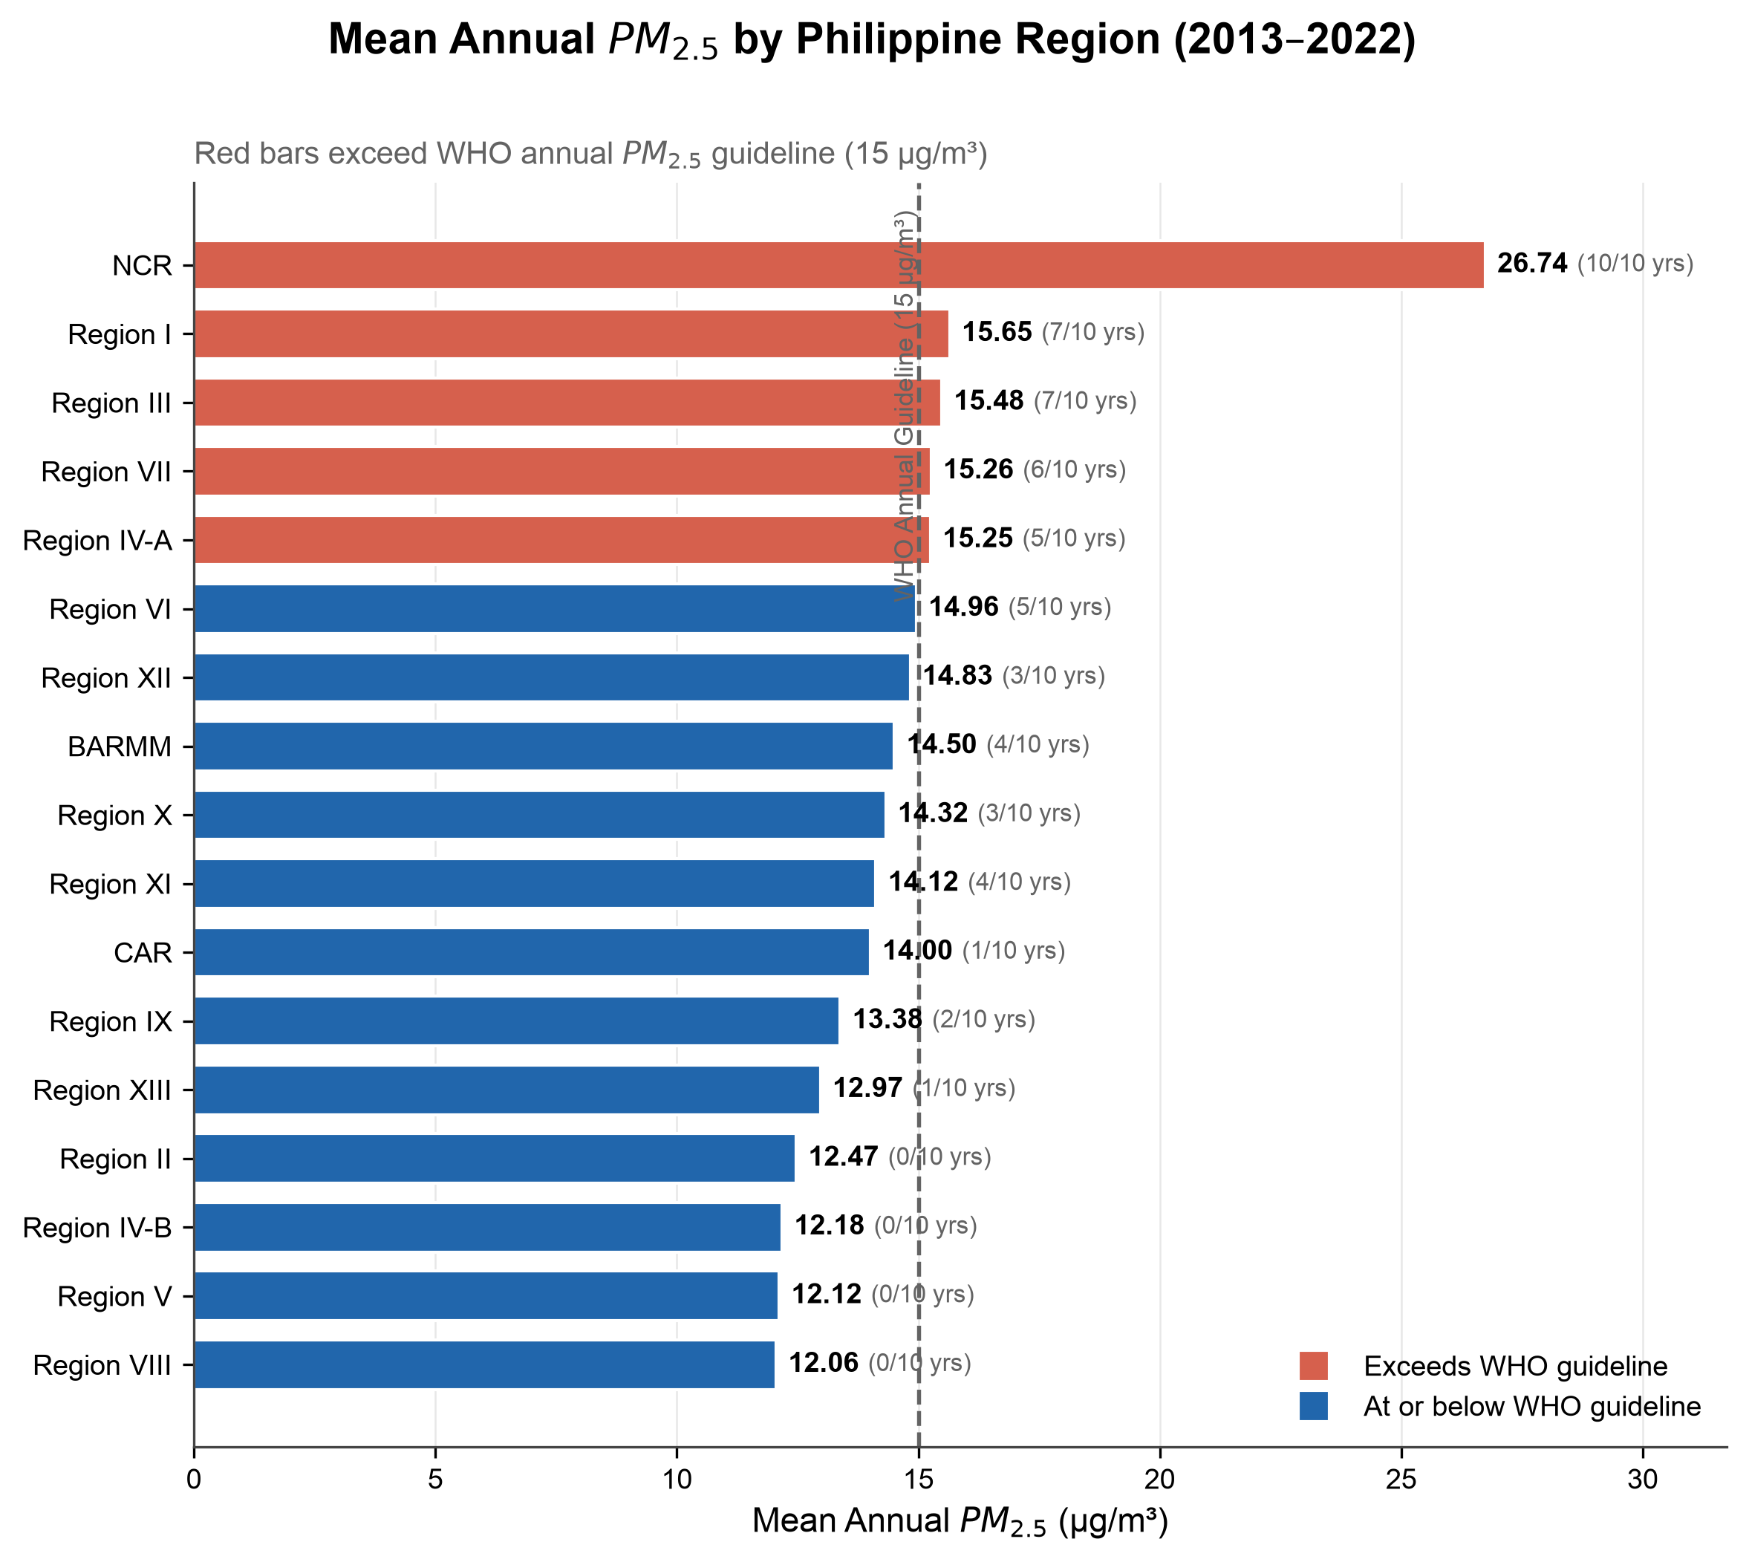
Figure 3. Mean annual PM2.5 concentration (µg/m³) by Philippine administrative region, 2013–2022. Red bars indicate regions where mean PM2.5 exceeded WHO's Interim Target-3 (15 µg/m³) (dashed line). NCR had the highest mean at 26.74 µg/m³, exceeding it all 10 years.
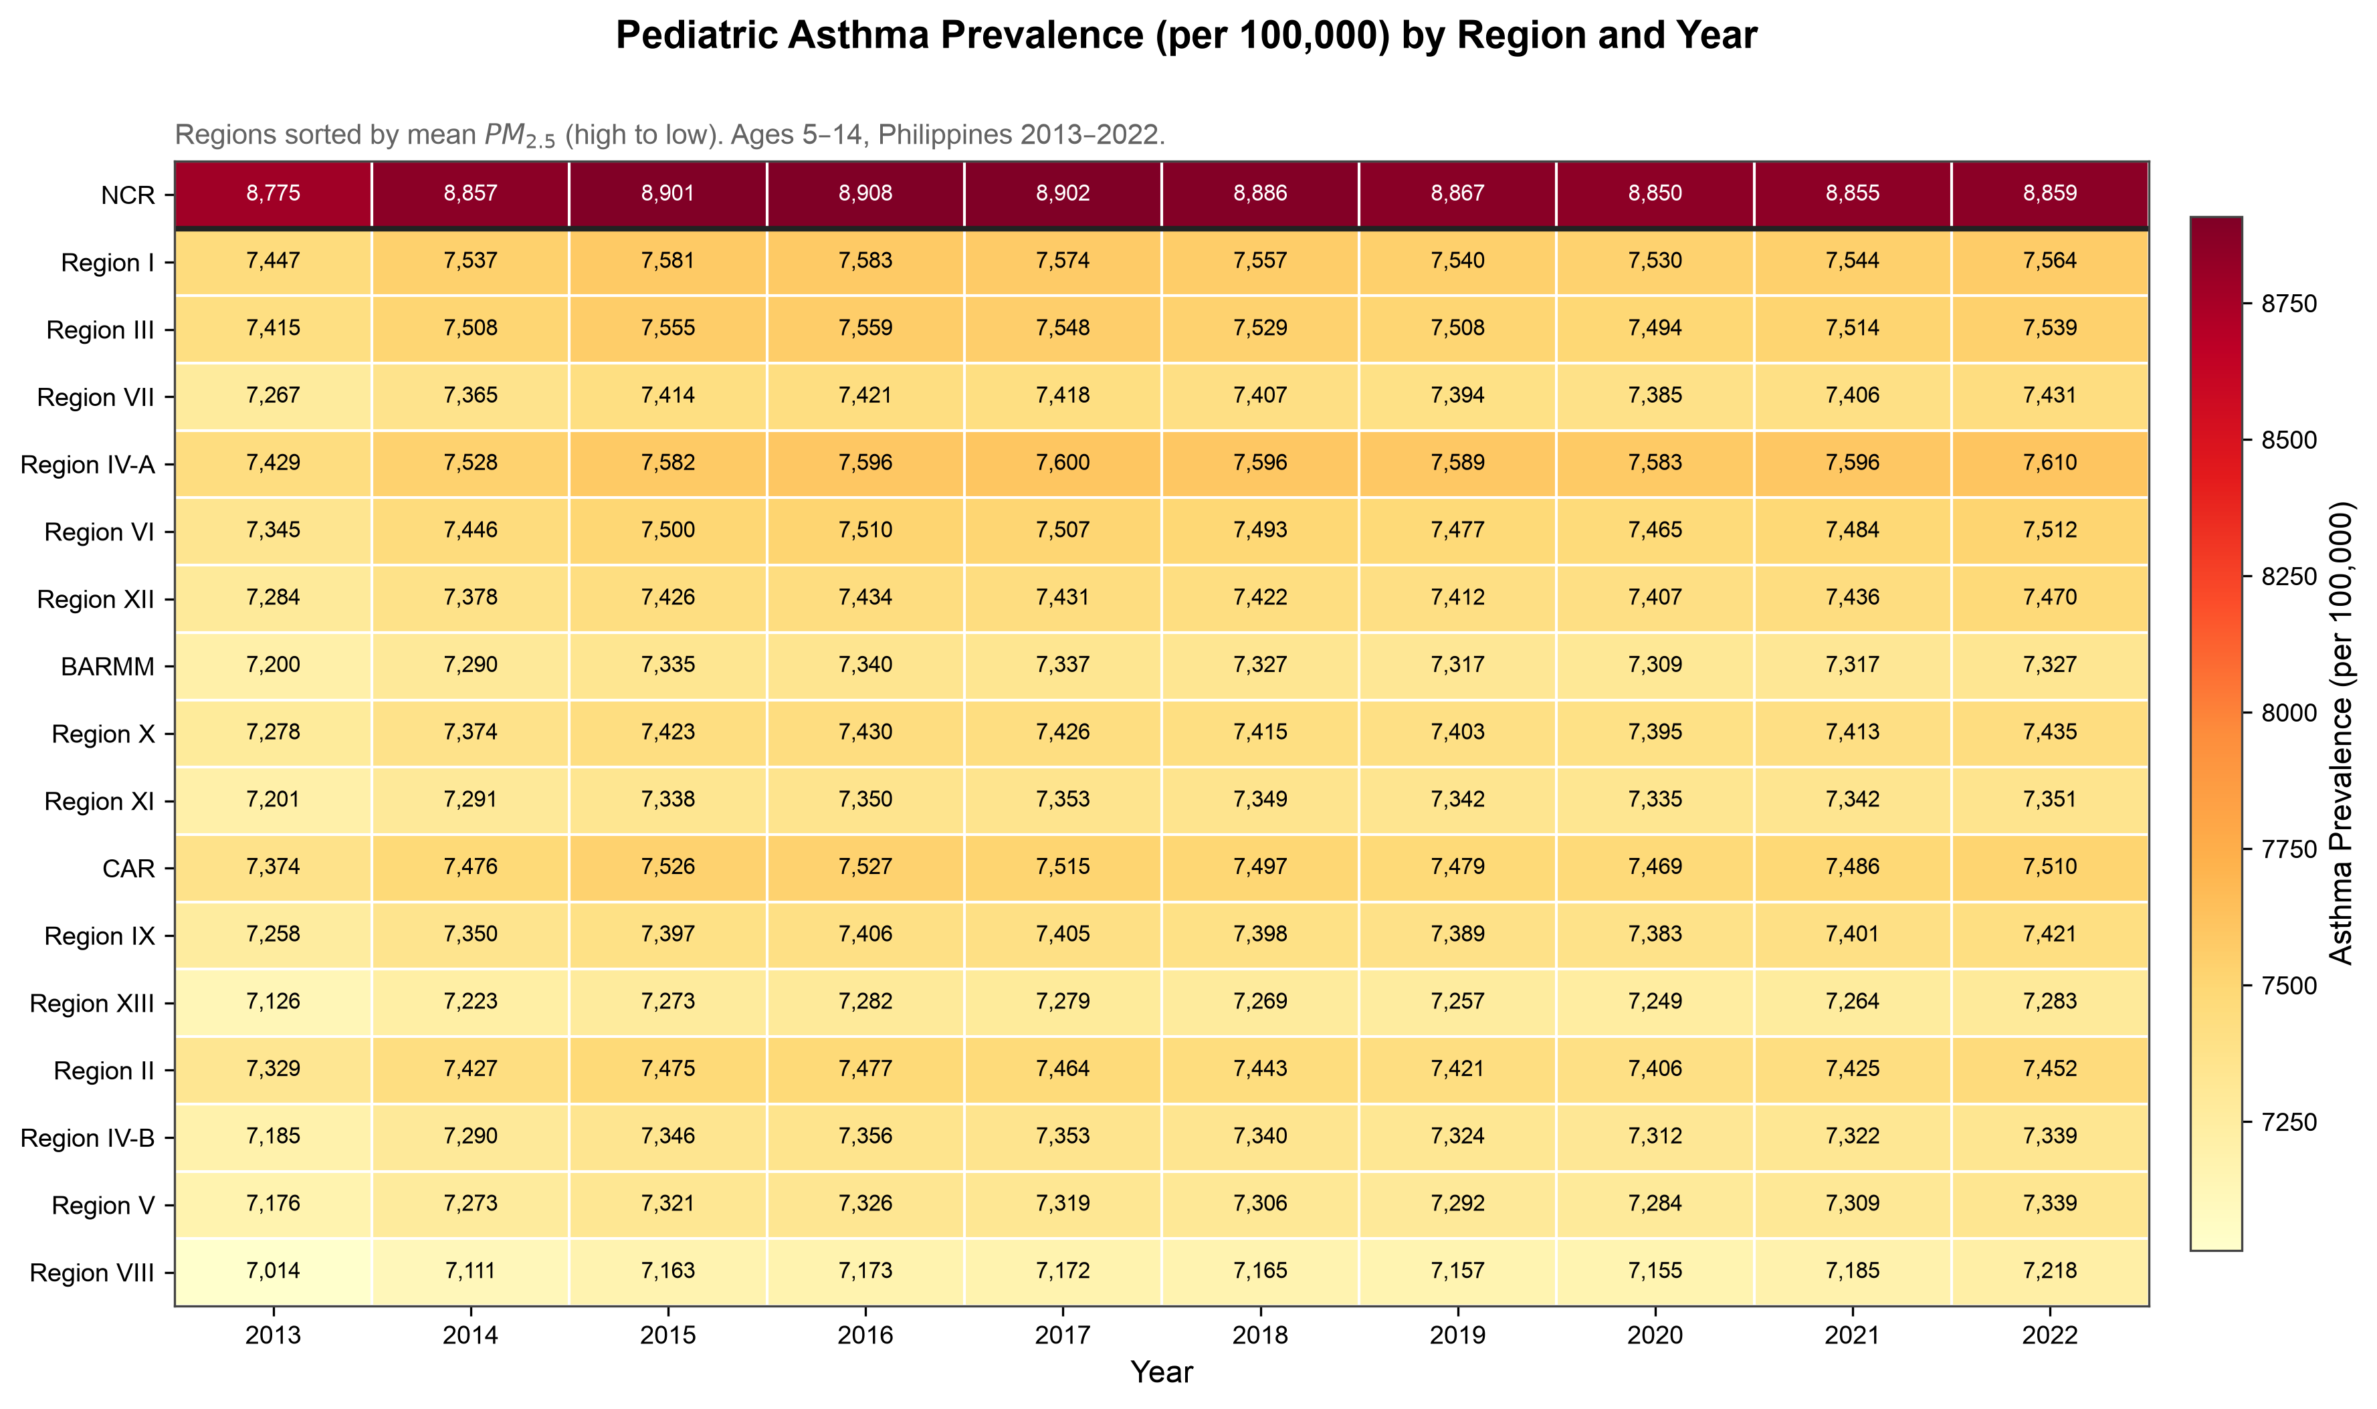
Figure 4. Heatmap of pediatric asthma prevalence (per 100,000, ages 5–14) by Philippine region and year, 2013–2022. Regions sorted by mean PM2.5 (high to low). NCR is shown separately at top. The near-uniform color within each row reflects the 1.5% within-region variance in asthma prevalence. Rates barely changed within any region over the decade.
Pooled Correlations
The pooled Pearson correlation between PM2.5 and pediatric asthma prevalence across all 170 region-year observations was r = +0.887 (p < 0.0001). The pooled Spearman rank correlation was ρ = +0.583 (p < 0.0001). Both suggest a strong positive association when all regions and years are viewed together. Figure 1 shows the scatter plot of all region-year observations. NCR observations fall as clear outliers in the upper-right quadrant. Figure 2 shows the national average annual trends in both variables as a dual-axis line chart.
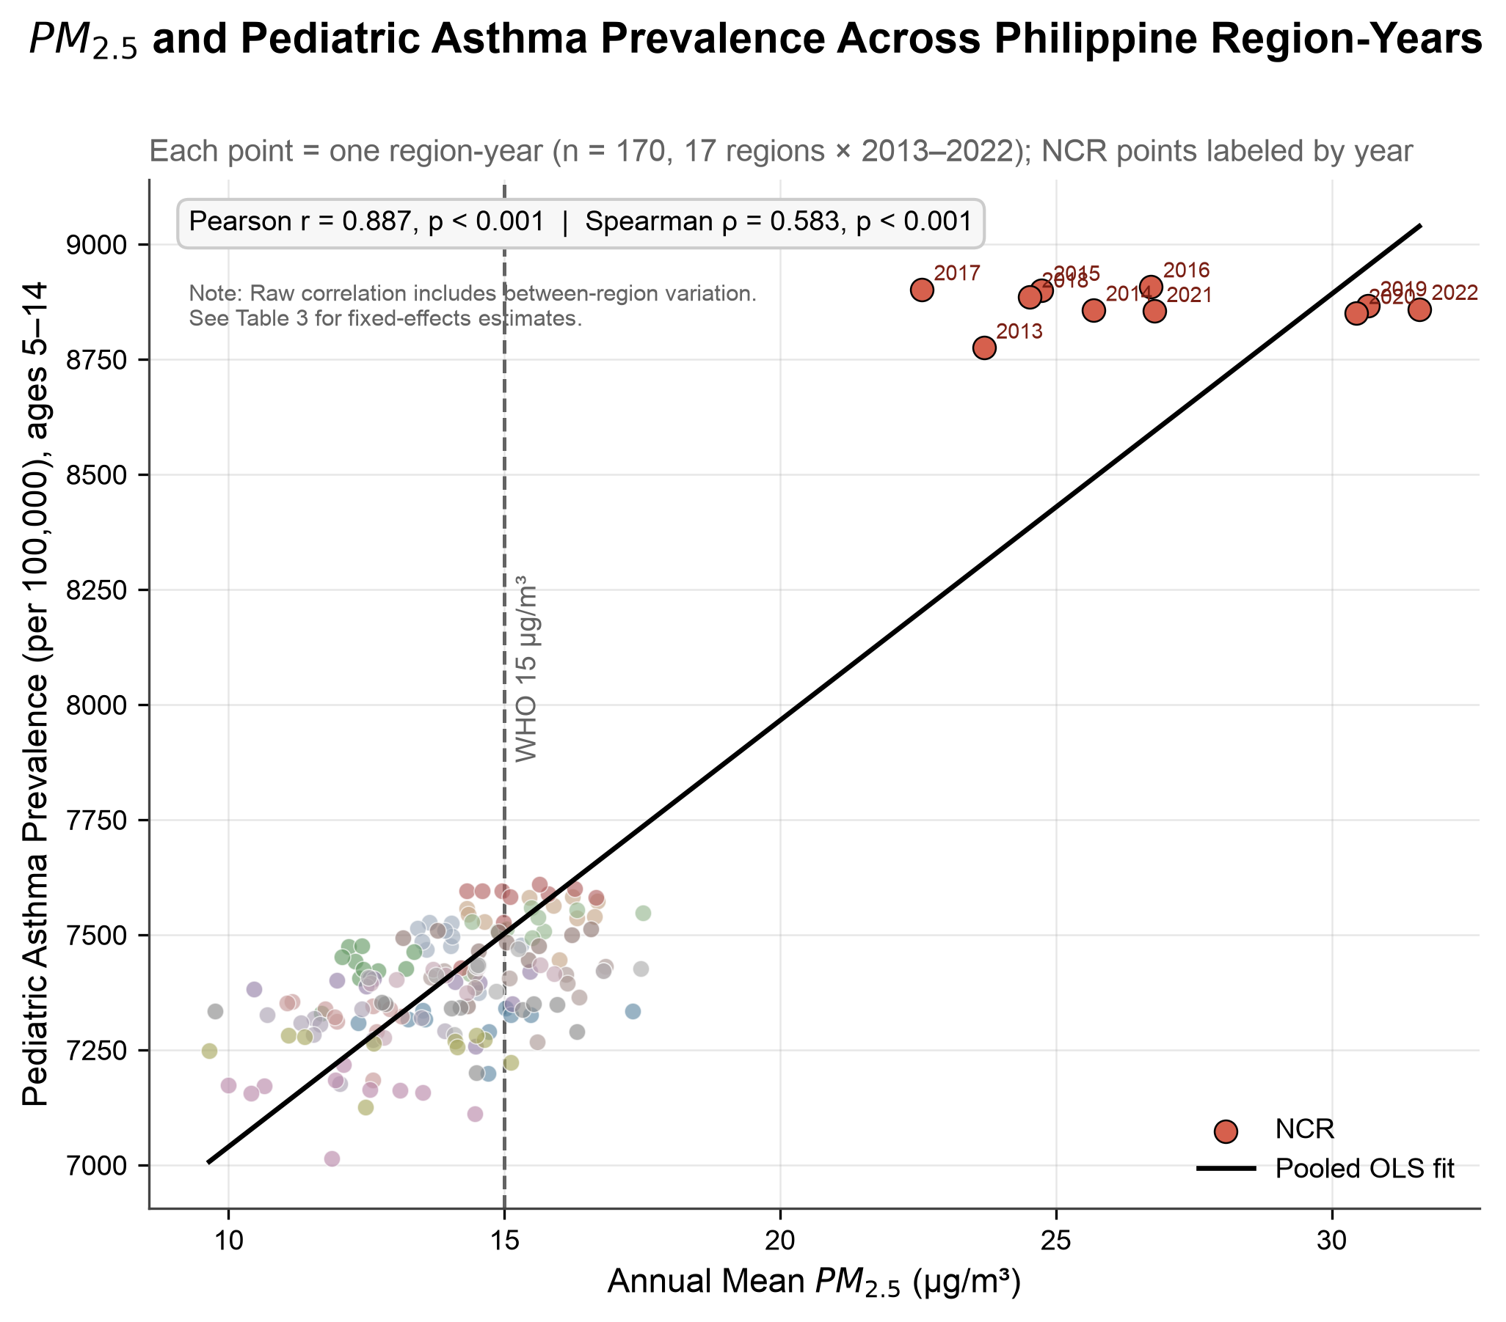
Figure 1. Scatter plot of satellite-derived PM2.5 (µg/m³) vs. pediatric asthma prevalence (per 100,000, ages 5–14) across all 170 Philippine region-year observations, 2013–2022. NCR observations are labeled by year. The solid line is the OLS best-fit line; the dashed vertical line marks WHO's Interim Target-3 (15 µg/m³). Pearson r = +0.887, p < 0.001. Note: this pooled correlation includes between-region structural variation; see Table III for fixed-effects estimates.
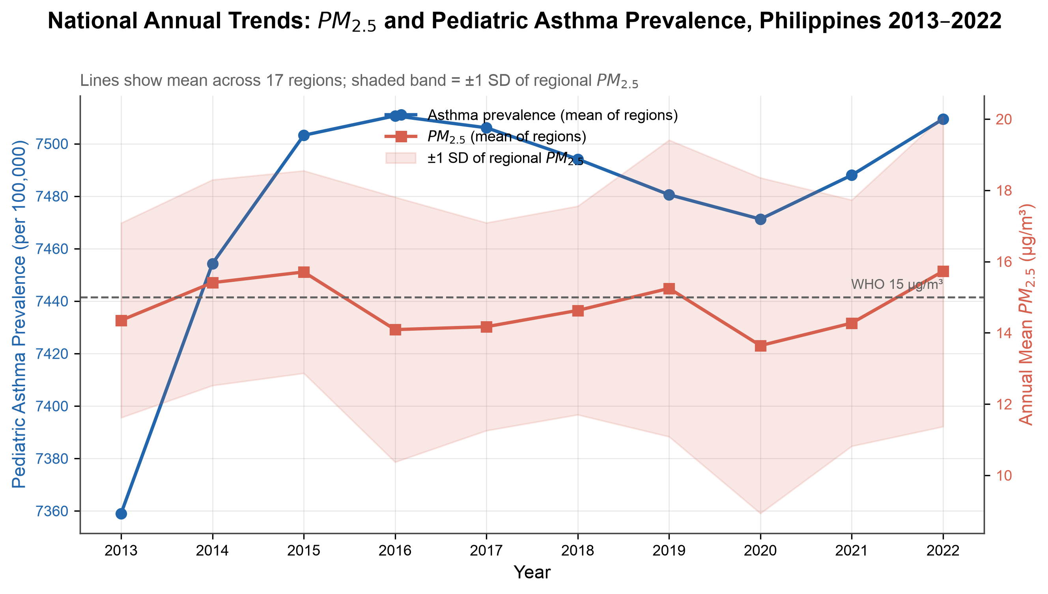
Figure 2. National annual trends in mean satellite-derived PM2.5 (µg/m³, red, right axis) and mean pediatric asthma prevalence (per 100,000, blue, left axis) across 17 Philippine regions, 2013–2022. The shaded band represents ±1 SD of regional PM2.5 for each year. The dashed horizontal line marks WHO's Interim Target-3 (15 µg/m³).
Variance Decomposition
Variance decomposition showed a stark asymmetry between the two variables: asthma prevalence exhibited only 1.5% within-region variance over the 10-year period, meaning 98.5% of all variation in asthma prevalence reflected stable structural differences between regions. PM2.5 showed more within-region variation (14.9% within-region), but still predominantly reflected between-region structural differences. Results are presented in Table II.
Table II. Variance decomposition of PM2.5 and pediatric asthma prevalence into within-region (temporal) and between-region (structural) components, Philippines, 2013–2022.
Variable | Within-Region Variance | Between-Region Variance
Asthma prevalence (per 100,000) | 1.5% | 98.5%
PM2.5 concentration (µg/m³) | 14.9% | 85.1%
Two-Way Fixed-Effects Panel Regression
In Model A (levels), the coefficient on PM2.5 was β = −2.554 (SE = 0.825, p = 0.0024, within-R² = 0.080). In Model B (log-log), β = −0.005 (SE = 0.002, p = 0.0078, within-R² = 0.052). Both models included 17 region fixed effects and 10 year fixed effects (Table III). Model B is reported once here for completeness and is not carried through the robustness battery below: the log transformation is undefined at zero and compresses PM2.5's scale nonlinearly, which complicates comparability across checks that add controls, restrict the sample or alter exposure timing. Model A is used throughout because it is estimated in PM2.5's natural units and is the coefficient every subsequent check in this manuscript stress-tests.
The sign reversal between the pooled Pearson correlation (+0.887) and the fixed-effects coefficient (−2.554) is striking. The very low within-R² values (0.080) indicate that PM2.5 explains almost none of the year-to-year variation in asthma prevalence remaining after fixed effects. The negative coefficient should NOT be interpreted as evidence that PM2.5 reduces asthma; it reflects the absence of a meaningful positive signal in a dataset where asthma prevalence is nearly constant within regions over time.
Table III. Two-way fixed-effects panel regression results. Dependent variable: pediatric asthma prevalence rate (per 100,000, ages 5–14). Both models include 17 region and 10 year fixed effects; standard errors clustered by region. Philippines, 2013–2022, n = 170 region-years.
Model | β (PM2.5) | SE | p-value | Within-R²
Model A (Levels) | −2.554 | 0.825 | 0.0024 | 0.080
Model B (Log-log) | −0.005 | 0.002 | 0.0078 | 0.052
Robustness Check: Region-Specific Linear Time Trends
The checks that follow this one test whether the standard error on the primary coefficient is trustworthy given a modest number of clusters (see Identification Strategy and Its Limits, Methods). This region-specific trends check instead asks whether the coefficient itself survives allowing each region its own secular trend, consistent with each region's own PM2.5 trend.¹⁸
Adding region-specific trends shrank the coefficient from β = −2.554 (p = 0.0024) to β = −0.937 (SE = 0.446, p = 0.038, n = 170), a 63% reduction that narrowly survives conventional significance. This is a demanding specification (18 parameters from 170 observations; within-R² rises mechanically from 0.080 to 0.791, since the region-specific trends absorb most of the panel's variance), so it is better read as a lower bound on how much of the primary coefficient could reflect differential regional trajectories than a precise re-estimate in its own right. Taken at face value, it shows the primary result is not fully robust to letting each region follow its own trend. This is a more fragile picture than the standard-error-focused checks below suggest on their own, and it supports this manuscript's existing caution against over-reading the primary coefficient as a confirmed effect.
SE-Reliability Checks: Small-Cluster Inference and Spatial Autocorrelation
The primary model clusters standard errors by region, but with only 17 clusters that correction can itself be unreliable.^{19,20,21} Six checks address this; Table IV summarizes them instead of presenting six separate subsections. None change the point estimate itself, only the precision of its standard error.
Table IV. SE-reliability checks, summarized (primary estimate: β = −2.554, n = 170 throughout):
Check | What it tests | Key result | Verdict
Permutation tests  (label & block, 5,000 iter. each) | Randomization-inference p-value under H0: β = 0 | Label p = 0.0048; block p = 0.0008 | Confirms significance
Wild cluster bootstrap  (WCR, 5,000 reps) | Small-G (17-cluster) sign-flip bootstrap p-value | p = 0.036 (t = −3.10) | Confirms significance, narrower margin
Leave-one-region-out jackknife  (17 refits, Figure 5) | Stability of β across single-region exclusions | Range β = −1.416 to −2.812, all p < 0.05; weakest excluding NCR (p = 0.045) | Confirms significance; NCR-sensitive
Moran's I  (k = 4 nearest-neighbor weights) | Spatial autocorrelation of residuals (SE validity) | I = −0.0017 (expected −0.063 under H0), p = 0.994 | No evidence of spatial autocorrelation
Hausman test (FE vs. RE)  (Swamy-Arora RE estimator²²) | Whether FE is preferred over the more efficient RE estimator | Classical statistic not computable (finite-sample degeneracy: the classical variance formula does not resolve in this sample, θ = 0.978); RE point estimate (β = −2.126) diverges from FE by 17%, moving toward the confounded pooled r = +0.887 | Not formally testable; divergence supports retaining FE
Minimum detectable effect  (MDE²³) | Statistical power of the design at conventional thresholds | MDE = 2.33 at 80% power (91% of observed |β| = 2.554); MDE = 2.69 at 90% power (exceeds observed |β|) | Adequately but not comfortably powered
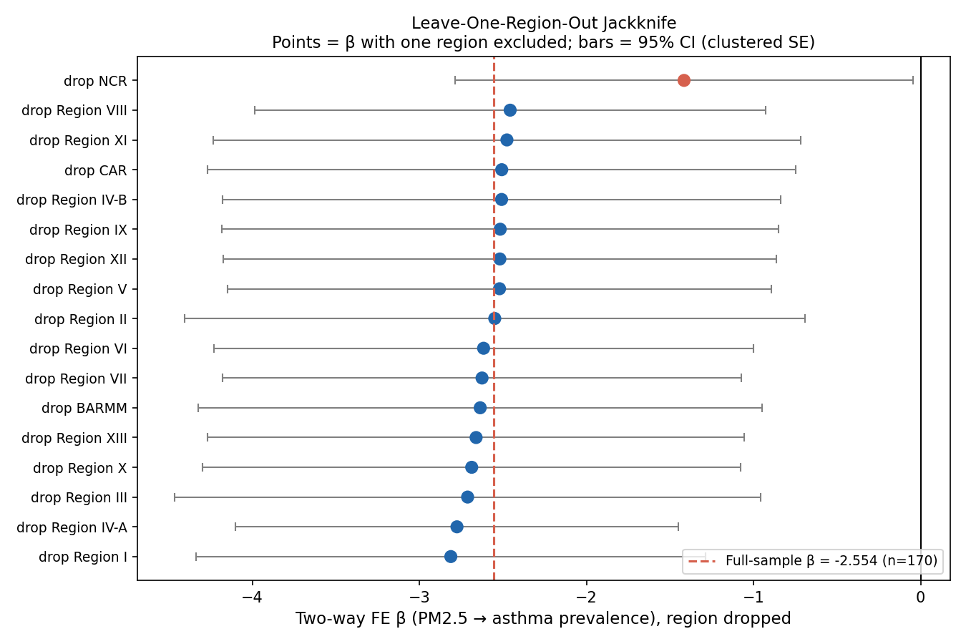
Figure 5. Leave-one-region-out jackknife: two-way fixed-effects β (PM2.5 → asthma prevalence) re-estimated 17 times, each time excluding one region, n = 160 per refit. Points show β with the labeled region excluded; horizontal bars show 95% confidence intervals (clustered SE). The dashed vertical line marks the full-sample β = −2.554 (n = 170). Excluding NCR (red point) produces the smallest-magnitude, least precise estimate of the 17.
Robustness Check: Excluding the COVID-19 Pandemic Years
The study period includes the COVID-19 pandemic years (2020–2021), which disrupted healthcare utilization and likely affected diagnosis rates (see Limitations). We re-estimated the primary model on a 17-region × 8-year panel excluding 2020–2021 (2013–2019, 2022; n = 136): the coefficient attenuated from β = −2.554 (p = 0.0024, n = 170) to β = −2.113 (SE = 1.225, p = 0.088, n = 136), a 17% reduction and a loss of significance at 0.05 (though not 0.10). Removing two of ten years reduces power (within-R² fell from 0.080 to 0.056), so this is consistent with reduced precision alone, though it cannot rule out that pandemic-era diagnostic disruption contributed to the estimate. This remains a genuine, unresolved sensitivity.
Robustness Check: Lag Structure and Cumulative Exposure
As introduced above, asthma prevalence is a slowly changing stock measure that may understate a same-year PM2.5 effect, and cumulative exposure is more biologically plausible than one year's concentration. We re-estimated the model with PM2.5 lagged 1 to 3 years and with a 3-year rolling-mean exposure on the correspondingly smaller balanced panels. These four exploratory specifications report raw and Holm-Bonferroni-adjusted p-values¹⁷ across the 4 tests. The 1- and 2-year lags stayed negative and similar in size (β = −2.156, raw p = 0.004, Holm p = 0.012, n = 153; β = −2.168, raw p = 0.054, Holm p = 0.107, n = 136). The 3-year lag attenuated further and lost significance before correction (β = −1.627, raw p = 0.151, n = 119). The 3-year rolling mean gave the strongest result in the manuscript, larger and more precise than the same-year model (β = −6.040, SE = 1.110, raw p < 0.0001, Holm p < 0.0001, within-R² = 0.204, n = 136), and the only specification not remotely in question after correction (Figure 6). As throughout this manuscript, this is not evidence of a protective effect (see Two-Way Fixed-Effects Panel Regression, above). The 1-year and 3-year rolling-mean specifications survive correction, while only the weaker 2- and 3-year lags do not; this pattern shows the result is not an artifact of timing or lag-picking.
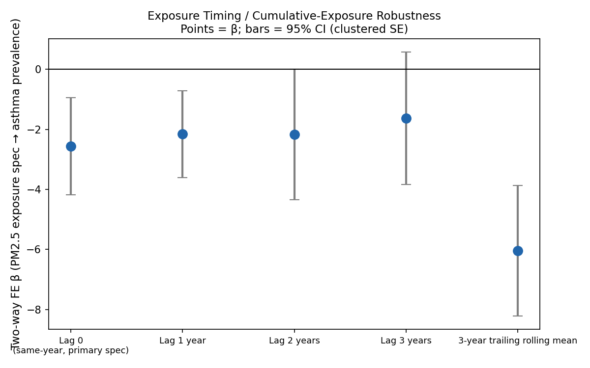
Figure 6. Two-way fixed-effects β under alternative PM2.5 exposure timing: same-year (primary spec), 1/2/3-year lags and a 3-year trailing rolling mean. Points show β; horizontal bars show 95% confidence intervals (clustered SE). All specifications remain negative; the 3-year rolling mean produces the largest-magnitude, most precisely estimated coefficient of any specification in this manuscript (β = −6.040, raw p < 0.0001, Holm-adjusted p < 0.0001 across the 4-specification exploratory family; see text).
Robustness Check: Placebo Outcome
The multi-outcome analysis below (Table VI) tests generalizability across four additional respiratory outcomes, but all five outcomes examined so far (asthma plus the four in Table VI) share at least a plausible PM2.5 pathway. A stronger test of whether the primary null reflects a real absence of a same-year effect, as opposed to an artifact of how GBD subnational estimates are constructed or of the two-way fixed-effects estimator itself, is a true negative control: an outcome with no plausible PM2.5 pathway at all.²⁴ We obtained GBD 2023 prevalence data for low back pain (ages 5–14, same province-level filters as the other outcomes) and confirmed non-degenerate variance across all 82 provinces and years before proceeding (mean 773.0 ± 14.7 per 100,000; within-province SD 3.3–14.5). Applying the identical two-way fixed-effects specification used throughout this manuscript, PM2.5 showed no significant association with low back pain prevalence (β = −0.180, SE = 0.414, p = 0.664, within-R² = 0.003, n = 170). This null result on a genuinely implausible outcome supports interpreting the primary asthma null as a real absence of a detectable PM2.5 effect. It argues against reading the null as an artifact of the GBD pipeline or the fixed-effects estimator itself.
Discussion
This study found a striking discrepancy between two analytical approaches applied to the same dataset. The pooled Pearson correlation between satellite-derived PM2.5 and GBD-modeled pediatric asthma prevalence was very strong at r = +0.887, suggesting what appears to be a near-perfect positive relationship. Yet once the two-way fixed-effects model removed the influence of stable structural differences between regions and shared national time trends, the estimated association became negative and tiny, with very low within-R². Understanding why this happened is the core contribution of this paper.
Diagnostic Capacity and Between-Region Confounding: An Unconfirmed Hypothesis
The explanation developed in this section is a hypothesis consistent with the data. This design does not confirm it. The covariate-adjustment test later in this section that most directly supports it loses significance when a single region (NCR) is excluded. We state that limitation here, up front, and discuss it fully in the caveat paragraph below.
The discrepancy between the pooled correlation (r = +0.887) and the two-way fixed-effects estimate (β = −2.554) is best read as a textbook instance of aggregation bias, closely related to Simpson's paradox and the ecological fallacy²⁵, in the specific form fixed-effects estimation is designed to correct. A between-unit association driven by a stable confounder can persist, or even strengthen, when units are pooled, yet weaken or reverse once that confounder is held constant. Here the confounder is structural: regions with higher ambient PM2.5 in this panel are also more urbanized, wealthier and more densely served by healthcare infrastructure, so a cross-sectional comparison of pollution and diagnosed prevalence is simultaneously a comparison of pollution and diagnostic capacity. The pooled correlation cannot separate these two forces; region fixed effects are designed to.
NCR (Metro Manila) illustrates this mechanism directly; it does not stand apart from it. It carries both the highest mean PM2.5 in the panel (26.74 µg/m³, 1.78 times WHO's Interim Target-3) and the highest recorded pediatric asthma prevalence (8,866 per 100,000; see Regional Patterns above), a combination that, read cross-sectionally, looks like strong confirmatory evidence of a pollution effect. NCR is also, unambiguously, the region with the greatest concentration of hospitals, pediatricians and diagnostic infrastructure in the country. A child presenting with respiratory symptoms there is therefore substantially more likely to receive a formal asthma diagnosis than a child with comparable underlying disease burden in a region such as Eastern Visayas, which recorded both the lowest mean PM2.5 (12.06 µg/m³) and a materially lower prevalence (7,151 per 100,000). NCR's position in the pooled scatter (Figure 1) is therefore consistent with two distinct, non-exclusive explanations, greater pollution exposure and greater diagnostic ascertainment, and the pooled correlation alone cannot adjudicate between them. The sign reversal in the fixed-effects model is driven by removing this structural confound. The underlying data do not change.
This diagnostic-capacity mechanism is, to our knowledge, not one that existing Philippine PM2.5-asthma literature has tested directly; we tested it here by asking whether a region's own asthma prevalence moves with its own PM2.5 from year to year once stable regional differences are removed, and found that it does not do so robustly (see Region-Specific Linear Time Trends, Results). The E-value for the pooled correlation (r = +0.887) is approximately 3.9^{26,27}: a moderate bar for an unmeasured confounder to fully explain away the association, and one well within the plausible range for regional differences in urbanization and diagnostic capacity of the size documented here. This does not prove diagnostic-capacity confounding is the mechanism, but it is consistent with it, and it remains the most parsimonious explanation available for a reversal of this magnitude.
Exploratory Check: A Confounder-Adjustment Sensitivity Test
As a direct empirical complement to the confounding argument and E-value above, indoor solid/biomass-fuel use for cooking (a plausible proxy for the region-level urbanization and socioeconomic differences already hypothesized to drive the pooled correlation) was added as a covariate to test its adjustment effect on the primary coefficient. It was not added as a formal mediator in a causal-mediation sense. Region-level estimates were assembled from the three NDHS rounds that overlap this study's window (2013, 2017, 2022)^{28,29,30} and linearly interpolated between anchor years. The 2013 value required a national-rate approximation instead of a direct regional measurement (see Limitations). Across the 17 regions, biomass-fuel use correlates with PM2.5 at r = -0.73, consistent with proxying the same regional structure. Adding it as a covariate moves the PM2.5 coefficient from β = -2.554 (p = 0.002) to β = -2.096 (p = 0.018), an 18% reduction, though the biomass-fuel-use coefficient itself is not significant (β = 0.367, p = 0.168) and does not indicate formal causal mediation. The result is not robust to NCR alone: dropping it widens the primary p-value to 0.045, reduces the between-region correlation to r = -0.42 and makes the covariate-adjusted coefficient non-significant (p = 0.15). This reflects both NCR's disproportionate weight and its comparatively unreliable 2013 estimate, so we report this check as exploratory and suggestive; it is not confirmed. This same pattern is not a coincidence: NCR carries the clearest illustrative evidence for the diagnostic-capacity mechanism above while also being the single observation the strongest statistical support for it depends on. We do not treat this as independent confirmation. It means the diagnostic-capacity explanation is consistent with the data without being demonstrated by it.
This diagnostic-capacity story is more than a statistical artifact to correct for; it also has a name in health-services research. Andersen's behavioral model of health service use frames diagnosis and care-seeking as jointly determined by predisposing factors, enabling resources (income, insurance, provider density) and perceived need³¹, precisely the mechanism this study's confounding argument invokes without naming: NCR's advantage includes more of the enabling resources (hospitals, pediatricians, PhilHealth-linked infrastructure) that convert underlying symptoms into a recorded diagnosis, in addition to more PM2.5 and more asthma. Read this way, the finding is also an instance of a broader pattern documented in environmental-justice scholarship: the communities that bear the highest pollution burden are often the same communities with the weakest capacity to have that burden formally recognized in health data³², so administrative undercounting in low-resource regions can mask the true distribution of pollution-related disease, going beyond merely confounding it. This framing does not change this study's statistical conclusions, but it situates them within a literature broader than applied econometrics, and it is part of why this manuscript treats improving diagnostic capacity as a policy-relevant finding in its own right, alongside reducing PM2.5 (see Implications, below).
Why Asthma Prevalence Is the Wrong Outcome Variable
The diagnostic-capacity mechanism above is unlikely to be the whole explanation: the primary specification's within-R² of 0.080 shows that little temporal signal survives at all, and the outcome variable's own dynamics are a large part of why. GBD 2023 age-standardized asthma prevalence is a stock variable: it counts children currently living with a diagnosed condition, a quantity that moves only as fast as diagnosis, remission and mortality allow. It is not a flow variable capturing acute events, such as emergency-department visits or hospital admissions, that can respond to a pollution spike within days. Variance decomposition makes the consequence concrete: only 1.5% of total variation in asthma prevalence across the panel is within-region (year-to-year), with the remaining 98.5% reflecting stable between-region structure; prevalence is, for practical purposes, frozen within each region across the study decade (Figure 4). A fixed-effects model that identifies β from within-region covariation is consequently left with very little temporal signal to detect, largely independent of whether an underlying biological effect exists.
These two explanations are not competing accounts of the same variance, and it is worth being explicit about how they divide the labor. A near-zero within-region R² is close to guaranteed by prevalence's own dynamics as a slow-moving stock (1.5% within-region variance) regardless of whether diagnostic-capacity confounding is present at all: even a true, undiluted biological effect would struggle to register against that little year-to-year movement in the outcome. Diagnostic-capacity confounding, by contrast, is a between-region story. The pooled correlation (r = +0.887) and the 98.5% between-region variance share are evidence for it; the low within-R² is not. Put differently, the stock-variable property explains why the fixed-effects model has so little temporal signal to work with in the first place; diagnostic-capacity confounding explains why the pooled correlation overstated the association before fixed effects removed it. The two mechanisms sit at different levels of the same panel, within and between, and account for the overall pattern jointly instead of competing with each other.
This stock-variable interpretation is testable; it is not merely asserted, and the panel's other GBD-modeled outcomes provide the test. Whether asthma's near-total between-region variance share reflects its epidemiology as a slowly accumulating chronic stock, or smoothing inherent to GBD's subnational estimation procedure, can be checked using the placebo outcome (low back pain) introduced above. Its within-region variance share is 38.0%, 26 times higher than asthma's 1.5%, and its between-region share (62.0%) is far below asthma's (98.5%). Extending the comparison to the four additional respiratory outcomes (Table VI) shows a gradient tracking disease acuity instead of a uniform ceiling on GBD's within-region variance: chronic, slowly progressing conditions sit at one end (asthma, 1.5% within-region; COPD, 2.0%), acute, fast-moving conditions sit at the other (lower respiratory infection incidence, 82.8%; respiratory mortality, 88.6%), with the placebo in between (Table V). If GBD's modeling suppressed within-region variance uniformly across outcomes, the placebo would be expected to show a split resembling asthma's; it does not. This pattern argues against a uniform artifact of the estimation pipeline and instead supports treating asthma prevalence as a genuine stock variable whose near-total between-region variance is a property of the disease's epidemiology. It cannot fully exclude that GBD's modeling also encodes the same acuity gradient. Under either interpretation, higher-frequency, flow-based outcome data, such as facility-level emergency respiratory admissions, would be better suited to detecting a same-year PM2.5 effect than a slowly changing prevalence stock.
Table V. Within- and between-region variance share across six GBD-modeled outcomes, Philippines 2013–2022:
Outcome | Within-region % | Between-region %
Asthma (primary outcome) | 1.5% | 98.5%
COPD prevalence | 2.0% | 98.0%
Lung cancer incidence | 6.5% | 93.5%
Low back pain (placebo/negative control) | 38.0% | 62.0%
Lower respiratory infection incidence | 82.8% | 17.2%
Respiratory disease mortality | 88.6% | 11.4%
Testing Additional Respiratory Outcomes
To determine whether the absent within-region PM2.5 signal was specific to asthma or reflected a broader panel limitation, the same specification was applied to four additional outcomes: lower respiratory infection incidence, COPD prevalence, lung cancer incidence and respiratory-disease mortality (Table VI). These five outcomes are treated as a post hoc exploratory family, with Table VI reporting each raw p-value alongside a Holm-Bonferroni correction¹⁷ across all 5 tests. Three of five (LRI, COPD and respiratory mortality) showed no significant within-region association (all p > 0.09). Lung cancer's marginally significant raw result (p = 0.033) does not survive correction (adjusted p = 0.133), while asthma remains significant (adjusted p = 0.012) because its raw p-value was an order of magnitude smaller. This consistency strengthens the main finding instead of weakening it: the absent within-region signal is a broader feature of this ecological panel. It is not an artifact specific to asthma. Future work using higher-frequency outcomes (e.g., facility-level emergency admissions) would be better positioned to test for a real effect beneath this noise floor.
Table VI. Two-way fixed-effects panel regression results across five respiratory-related outcomes. All models include 17 region and 10 year fixed effects; standard errors clustered by region. Philippines, 2013–2022, n = 170 region-years each. These five outcomes are treated as a post hoc exploratory family (not part of the specification designated primary); the rightmost column reports p-values after a Holm-Bonferroni correction¹⁷ applied across the 5 tests. * = still significant (adjusted p < 0.05).
Outcome | β (PM2.5) | SE | p-value | Within-R² | n | Holm-adj. p
Pediatric asthma prevalence (ages 5–14) | −2.554 | 0.825 | 0.0024 | 0.080 | 170 | 0.0120*
Lung cancer incidence (all ages) | −0.195 | 0.091 | 0.0333 | 0.194 | 170 | 0.1332
Lower respiratory infection incidence (ages 5–14) | −3.053 | 1.825 | 0.0965 | 0.011 | 170 | 0.2775
COPD prevalence (all ages) | 4.476 | 2.643 | 0.0925 | 0.128 | 170 | 0.2775
Respiratory-disease mortality (all ages) | 0.984 | 0.720 | 0.1737 | 0.009 | 170 | 0.2775
Synthesis of Sensitivity Analyses
Figure 7 summarizes this stress test as a specification curve. The primary coefficient is re-estimated across 25 reasonable analytic choices, spanning exposure timing (same-year, lagged, cumulative), sample composition (full panel, COVID-excluded, each of 17 single-region exclusions), trend flexibility and covariate adjustment. Every specification remained negative, and 22 of 25 were significant at conventional thresholds; all 17 leave-one-region-out refits remained significant (Table IV). The three non-significant points were the COVID-excluded sample (p = 0.088) and the 2- and 3-year lag specifications (p = 0.054 and p = 0.151). Four of these checks deserve individual scrutiny instead of a single pooled verdict, because they test different threats to the primary estimate and do not all speak to its credibility in the same way.
The region-specific linear time trends check is the most demanding of these, and the one we treat as the primary source of remaining uncertainty. Adding one linear trend per region (region_i × t, 17 additional parameters) alongside the existing region and year fixed effects tests whether the primary result reflects genuine within-region co-movement between PM2.5 and asthma prevalence. The alternative is a differential regional trajectory, for example in healthcare access or diagnostic rollout, that happens to correlate with each region's own PM2.5 path.¹⁸ This is analogous to, though not identical with, the parallel-trends assumption familiar from difference-in-differences designs. PM2.5 here is a continuous exposure. There is no single treatment date to test pre-trends against, unlike a binary exposure. The underlying concern is the same: an omitted, time-varying, region-specific trend could be doing the work the model attributes to PM2.5. Under this check, the coefficient shrank 63%, from β = −2.554 (p = 0.0024) to β = −0.937 (SE = 0.446, p = 0.038). We report this as a lower bound on how much of the primary estimate could reflect differential regional trajectories. It is not a precise re-estimate in its own right. With only 170 observations and 18 additional parameters, the within-R² rises mechanically from 0.080 to 0.791 as the region-specific trends absorb most of the panel's remaining variance, which inflates fit without necessarily improving identification. Taken at face value, the result survives only narrowly, and we do not round this down to "robust." It is the strongest evidence in this manuscript that some, though not necessarily all, of the primary coefficient could reflect a confound that region and year fixed effects alone cannot remove.
The COVID-19 exclusion check is a power story that cannot be fully disentangled from a confounding story. Dropping 2020–2021 (n = 136) attenuates the coefficient from β = −2.554 (p = 0.0024) to β = −2.113 (SE = 1.225, p = 0.088), a 17% reduction in the point estimate. It also costs significance at the conventional 0.05 threshold, though not at 0.10. Removing two of ten years mechanically reduces power: within-R² falls from 0.080 to 0.056, and that alone is sufficient to explain both the wider standard error and the higher p-value. But the pandemic period also plausibly disrupted diagnosis and care-seeking in ways that could have altered the within-region relationship between PM2.5 and recorded prevalence independent of any same-year pollution effect. This design cannot distinguish a pure loss of power from a genuine pandemic-era shift in the outcome-generating process, and we report it as an open, unresolved sensitivity instead of resolving it in either direction.
The 3-year rolling-mean specification produced the largest-magnitude and most precisely estimated coefficient in the manuscript (β = −6.040, SE = 1.110, raw p < 0.0001, Holm-adjusted p < 0.0001 across the 4-specification exploratory lag family, within-R² = 0.204, n = 136). It would be a mistake, though, to read that as the "truest" estimate of an effect the same-year model understates. It is one of four exploratory exposure-timing specifications, evaluated together with Holm-Bonferroni correction precisely because testing multiple lag structures invites selective emphasis on whichever one is largest; the same-year model remains the designated primary specification. Averaging PM2.5 over three years reduces measurement noise in the exposure variable, which mechanically improves precision and can inflate the point estimate under classical errors-in-variables reasoning. That is independent of whether cumulative exposure is more biologically relevant than same-year exposure, a plausible but separate claim. As throughout this manuscript, a larger negative β under this specification is not evidence of a stronger protective effect; it is a more precisely estimated absence of positive signal (see Results, above).
The placebo outcome addresses a different question from the three checks above. It does not ask whether the primary point estimate is confounded or imprecise, but whether the null itself is real, or instead an artifact of the fixed-effects estimator or the GBD modeling pipeline. Low back pain prevalence (ages 5–14) has no plausible PM2.5 pathway, so a null result on it is the expected finding if the method is working correctly. A non-null result, by contrast, would have been a warning sign about the design itself. Applying the identical specification returned β = −0.180 (SE = 0.414, p = 0.664, within-R² = 0.003, n = 170), a clean null, as expected. This is a distinct fact from the placebo outcome's own variance structure: low back pain's within-region variance share is 38.0% (Table V), 26 times higher than asthma's 1.5%. Unlike the primary asthma model, then, this regression was not starved of within-region variance to work with. A null result obtained on an outcome with ample within-region variance available, using the same estimator and the same pipeline, is what argues against a mechanical GBD-pipeline or fixed-effects artifact. This is a different kind of evidence than the point-estimate checks above and should not be summed with them into a single robustness tally.
Read together, these four checks do not all point in the same direction with the same force, and we think that unevenness is itself the most honest summary of this analysis. The primary finding is robust to sample perturbation (all 17 leave-one-region-out refits remain significant) and to concerns about a mechanical artifact (the placebo null). It is markedly less robust to the identifying assumption itself: region-specific trends cut the coefficient by nearly two-thirds and leave it only narrowly significant. The COVID exclusion tells a similar story: the result is also sensitive, in a way this design cannot fully resolve, to a two-year change in sample composition. The 3-year rolling-mean result, while the most statistically decisive point on the specification curve, does not resolve this tension. It is one of the exploratory specifications; the same-year model remains the one designated primary. Its added precision has a plausible mechanical explanation that does not require any true effect being larger than the primary model suggests. Taken together, we describe the primary result as directionally stable but only narrowly robust, and we emphasize once more that its negative sign should not be read as PM2.5 protecting against asthma. It reflects the near-absence of a detectable within-region signal in an outcome that changes too slowly, over this ten-year window, to register a same-year exposure effect, a conclusion these sensitivity checks probe from several angles without contradicting.
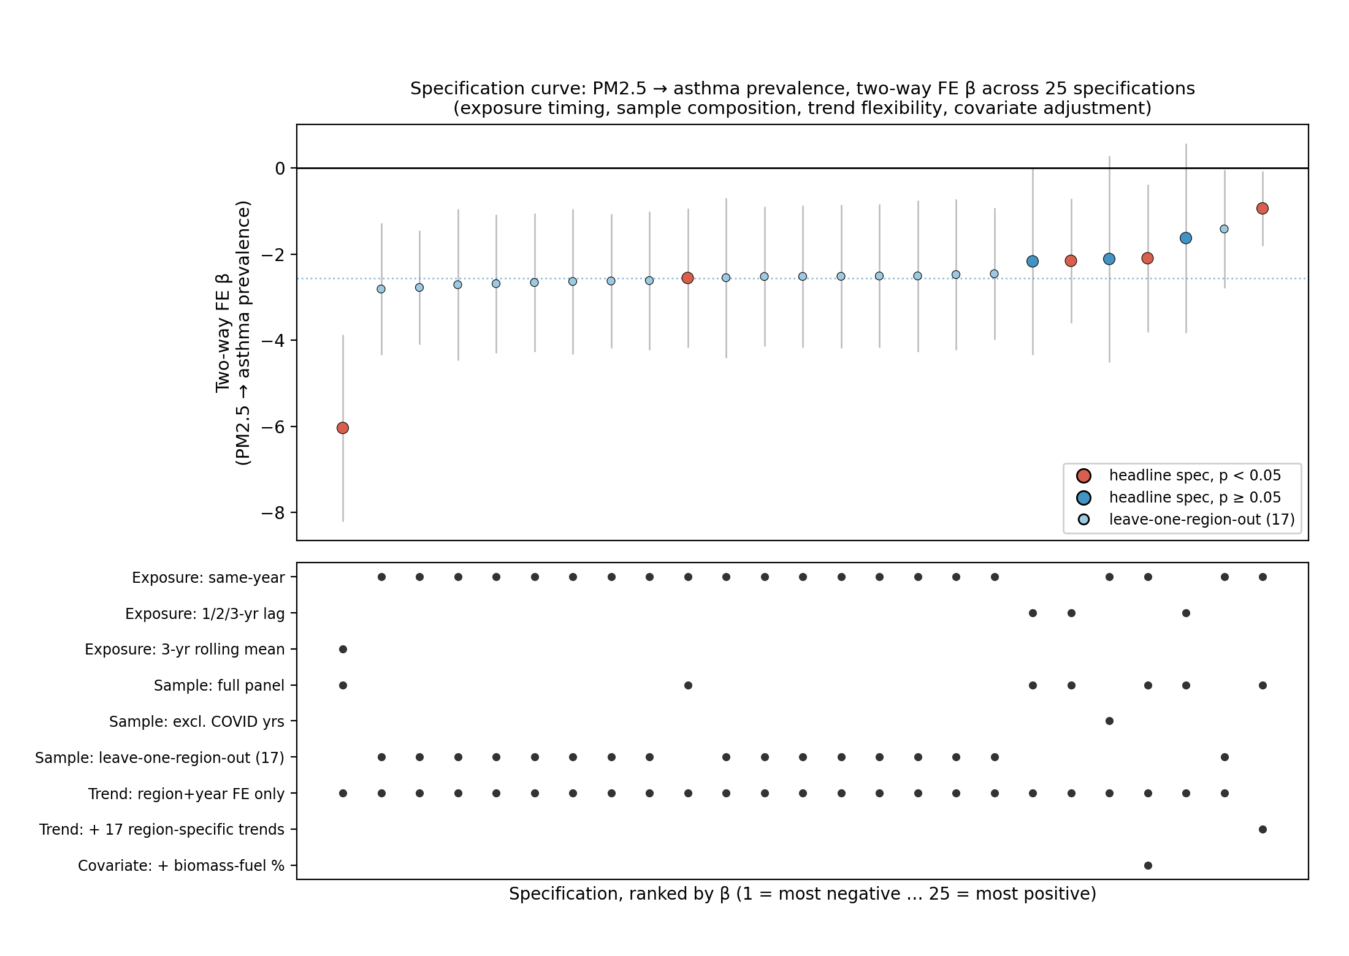
Figure 7. Specification curve for the two-way fixed-effects β across 25 specifications, covering exposure timing, sample composition (incl. leave-one-region-out), trend flexibility and covariate adjustment.³³ Points colored by significance (p < 0.05); bars are 95% CIs (clustered SE). Lower panel indicates which analytic choice each point reflects. All points are drawn from this manuscript's own already-reported robustness-check results (Tables III, IV, VI); no new regressions were estimated for this figure.
Implications for Philippine Environmental Health Policy
Despite the null finding on the primary analytical question, the descriptive results carry direct public health relevance on their own. Every one of the 170 region-years in this panel exceeded WHO's 2021 annual PM2.5 guideline, 34.1% exceeded the stricter Interim Target-3, and NCR exceeded Interim Target-3 in every study year at nearly twice its level (Table I). Philippine regions that consistently exceed Interim Target-3 are exposing millions of children to pollution levels that global evidence identifies as harmful, independent of whether this study's panel design can detect a same-year statistical association.
The more specific and more actionable implication follows from the diagnostic-capacity mechanism above. If regional differences in asthma prevalence partly reflect who gets diagnosed and not simply who gets sick, then improving diagnostic capacity in under-resourced regions is itself a health intervention, and one more tractable in the near term than reducing ambient PM2.5. A concrete next step is a facility-level linkage pilot between the Department of Health (DOH) and PhilHealth, which already operates a National Health Data Repository suited to this kind of research. Such a pilot would match anonymized outpatient and emergency-department respiratory diagnoses to PhilHealth claims in a small number of matched region pairs: one historically high-diagnostic-capacity region (e.g., NCR) and one low-capacity region with comparable estimated PM2.5 (e.g., a mid-exposure region in the Visayas or Mindanao). Comparing diagnosed rates in claims data against symptom-based screening (the ISAAC questionnaire, already validated internationally) in the same regions would directly test whether the gap this study attributes to diagnostic capacity is real, and it would generate the facility-level, higher-frequency data this study's Limitations argue is needed to move past an ecological null result.
A second, complementary step addresses the exposure side instead of the outcome side. The Environmental Management Bureau (EMB) currently concentrates ground-level PM2.5 monitoring in a small number of urban centers. This study's own Davao City validation relied on only two of six regional stations measuring PM2.5, and most Philippine regions have no PM2.5 ground monitoring at all, which is why this study relied on satellite estimates. Expanding EMB's PM2.5-capable network to at least one station per region, prioritizing regions with the highest estimated exposure but no current ground validation, would serve two purposes: generating the ground-truth data future studies need to run a satellite product-version check like the one performed in Davao City, and building infrastructure for the facility-level exposure-outcome linkage proposed above. The existing six-station EMB Region XI network is a concrete template for what comparable coverage in the remaining 16 regions would require. Actual placement should follow documented exposure gaps and existing monitoring deserts instead of population share alone. Sizing and funding that expansion remains a scope question for EMB and local government units (LGUs); this study's data cannot resolve it.
The confounding story above assumes the exposure measure itself is a stable, trustworthy stick to measure against. This manuscript has not yet tested that assumption. Part II tests that assumption directly, using Davao City's ground-monitoring network as an independent check on the satellite PM2.5 estimates the panel above relies on throughout. It examines the satellite exposure measure's own validity in detail, including a ground-station comparison and the product-version-drift finding introduced above.
Part II: Satellite Measurement Validation
Davao City Case Study: Ground-Station Validation of Satellite PM2.5
The main analysis relies on satellite-derived PM2.5 estimates (ACAG V6.GL.02.04) instead of ground-based monitoring, because ground monitoring in the Philippines is too sparse and inconsistent to support a 17-region, 10-year panel. Davao City is one of the few Philippine cities with a multi-year network of government air quality monitors, and it offers a chance to check that choice directly. It also separately surfaces a satellite product-version caution relevant beyond this study. Neither result feeds into or changes the main regional panel results.
Data
Annual PM2.5 for six EMB Region XI monitoring stations in Davao City were drawn from three official government reports (the 2022 and 2025 RSOBERs and the 2023 Annual Airshed Status Report). Only Stations 15 and 16 measure PM2.5 directly, and one reported station, located in Tagum City instead of Davao, was excluded. Two data-quality caveats are carried forward instead of smoothed over. Station 07/17 may have relocated mid-series (it was not used in the PM2.5 comparison below, which relies only on Stations 15 and 16), and Stations 15/16 fell below the required data-capture rate in 2020, so that year's values are less reliable. Separately, 2024 values are rounded to whole numbers in the source report, unlike the decimal precision reported for 2020–2023. Satellite PM2.5 for 2020–2024 was extracted from ACAG's V6GL03 product (0.1° resolution) across the 19 grid cells within the Davao City boundary.
Results
Table VII. Ground-station vs. satellite (V6GL03) annual PM2.5, Davao City, 2020–2024. Ground values are the mean of Stations 15 and 16 only.
Year | Ground PM2.5 (µg/m³)¹ | Satellite PM2.5, V6GL03 (µg/m³) | Difference
2020 | 11.08 | 16.19 | +5.11
2021 | 10.85 | 15.53 | +4.68
2022 | 14.52 | 15.69 | +1.17
2023 | 15.45 | 14.16 | −1.29
2024 | 14.00 | 15.61 | +1.61
¹ Simple mean of Stations 15 and 16 only (the two Davao stations that measure PM2.5). This is not a full-city average; the other four stations measure PM10 only.
Across these five years, satellite and ground station values move in opposite directions from year to year (Pearson r = −0.665, n = 5). With only five years of data, this is descriptive; it is not a reliable estimate of the true relationship between the two data sources.
Satellite Product-Version Drift: A Caution Beyond This Study
Because the main regional panel uses an earlier ACAG release (V6.GL.02.04) while the Davao comparison above used the current release (V6GL03), the same Davao City clip was re-run on the three overlapping years (2020–2022) using the older V6.GL.02.04 files, to test whether the satellite-ground gap reflected atmospheric reality or a product-version artifact (Table VIII).
Table VIII. Version sensitivity check: ground-station PM2.5 vs. two ACAG product releases, Davao City, 2020–2022.
Year | Ground PM2.5 | V6GL02.04 (older) | V6GL03 (current) | Old − Ground | New − Ground | New − Old
2020 | 11.08 | 11.70 | 16.19 | +0.62 | +5.11 | +4.50
2021 | 10.85 | 13.64 | 15.53 | +2.79 | +4.68 | +1.89
2022 | 14.52 | 13.48 | 15.69 | −1.04 | +1.17 | +2.21
The older ACAG release tracked the ground stations substantially more closely (mean absolute error 1.48 µg/m³) than the current release (mean absolute error 3.65 µg/m³) over the same three years, same city boundary and same grid cells. We define a version-drift term, Δversion = PM2.5,V6GL03 − PM2.5,V6.GL.02.04, computed at identical grid cells and years; averaged across the three overlapping years, Δversion = +2.87 µg/m³ (Table VIII): the current release was, on average, 2.87 µg/m³ higher than the older release for identical location-years. This indicates that most, though not necessarily all, of the apparent satellite-ground gap reflects a systematic shift introduced by the ACAG algorithm/version update. A true change in atmospheric PM2.5 that ground stations failed to capture is a less likely explanation. With only three overlapping years, this is evidence of a real, non-trivial version effect. It is not a precise estimate of its size.
This version-drift finding is not a narrow caveat about one city or one dataset; it is a general caution for any environmental panel study that treats a satellite-derived exposure product as a stable, internally consistent time series. ACAG, like other modeled global PM2.5 products such as the Copernicus Atmosphere Monitoring Service (CAMS) reanalysis and NASA's MODIS/MAIAC-derived surface estimates, is not a fixed physical measurement instrument; it is the output of a retrieval-and-calibration pipeline that its developers periodically update as new satellite instruments, aerosol-optical-depth algorithms, geophysical priors and machine-learning components become available.¹² Each such update can shift the product's output at a given location and year even when nothing about the atmosphere has changed. That is precisely the mechanism our Davao City comparison isolates: identical grid cells, identical years, two ACAG releases and a mean 2.87 µg/m³ shift attributable to the algorithm alone. For a field that increasingly relies on these global products to build multi-year subnational panels in exactly the settings with the sparsest ground monitoring, where the ability to validate against reference stations is weakest, this is a systematic source of bias that current practice does not routinely test for.
The magnitude here should not be read as a Davao-specific curiosity. A 2.87 µg/m³ shift is roughly 81% of the standard deviation of PM2.5 across our entire ten-year, 17-region panel (3.52 µg/m³; Table I), and the newer release tracked ground stations substantially worse than the older one over the same years (mean absolute error 3.65 µg/m³ versus 1.48 µg/m³). A shift of this size, introduced mid-panel, is large enough to manufacture a spurious upward trend where none exists, or to mask a genuine one, purely as an artifact of when a research group happened to download its data. We therefore propose a concrete methodological standard for any panel study built on ACAG, CAMS, NASA or comparable modeled satellite exposure products. Before treating a multi-year series as internally consistent, researchers should run a within-location, cross-version reconciliation, comparing overlapping years across whichever product releases the panel spans, exactly as we did here, and should report the result alongside their main analysis instead of assuming version continuity. Our own 17-region panel is insulated from this risk because it draws on a single ACAG release throughout. But as satellite PM2.5 products continue to be updated and as panels are extended forward in time, that insulation reflects a design choice. It is not a property of the data source. We offer this check as a low-cost, generalizable safeguard the field should adopt as standard practice.
A residual gap persists even after accounting for the version effect, most visibly in 2020–2021, and we do not attribute this to version drift. It likely reflects some combination of spatial-averaging differences between a 0.1° satellite pixel and point-source ground monitors, the ground stations' documented 2020 data-capture shortfall and genuine limits on satellite retrieval accuracy over a coastal, cloud-prone tropical city. This study cannot distinguish between these three explanations, and each would also apply, to some degree, to the satellite-derived PM2.5 used throughout the main regional panel.
This version-drift check is temporal: it compares the same location across two product releases instead of comparing different locations, and it leaves an important question about this manuscript's main argument unresolved. The confounding argument in the Discussion rests on between-region PM2.5 differences, most visibly NCR's 26.74 µg/m³ against Eastern Visayas's 12.06 µg/m³, and this study has not tested whether ACAG's retrieval accuracy is itself uniform across that contrast. Dense urban terrain, tall buildings and heterogeneous urban aerosol composition are known to challenge satellite aerosol-optical-depth retrievals differently than rural or coastal terrain, so it remains possible that some share of the NCR-versus-rural PM2.5 gap this study relies on reflects differential satellite accuracy instead of differential atmospheric concentration alone. Ground-station validation was available only for Davao City, a single mid-exposure location, so this study cannot test that possibility directly. Validating ACAG against ground stations in both a high-exposure urban region (NCR) and a low-exposure rural region would be the direct test, and we flag it as a priority for future validation work; this design cannot resolve it.
Limitations
Several limitations must be acknowledged.
- Ecological design: regional-level associations cannot be attributed to individuals²⁵, and correlation does not establish causation.
- Aggregation method: province-to-region aggregation used simple means instead of population-weighted estimates, which may introduce aggregation bias. A population-weighted approach was considered but not implemented^{34,35}, since the only available census-based population dataset covers just 12 of ~81 provinces, and only through 2020.
- Satellite exposure uncertainty: ACAG satellite estimates carry inherent uncertainty in tropical coastal settings, and this study has not tested whether that uncertainty is uniform across regions (see Satellite Product-Version Drift, above). The Davao validation layer adds its own limits: only two of six ground stations measure PM2.5, its window overlaps the main panel in just three years, and with so few satellite-ground pairs its correlations and mean differences are descriptive; they are not statistically robust.
- Residual confounding: with no confounders beyond region and year effects, residual confounding from healthcare access, smoking and socioeconomic factors may remain. Indoor biomass-fuel use, a proxy for regional urbanization, was tested directly (see Discussion) and showed a modest association not robust to a single region (NCR).
- COVID-19 disruption: the 2020–2021 period likely affected diagnosis rates, and this design cannot fully separate that disruption from a genuine loss of statistical power (see Robustness Check: Excluding the COVID-19 Pandemic Years, above).
- Outcome smoothing: GBD subnational estimates are partly modeled and smoothed toward national trends, likely understating real year-to-year fluctuations.
- Statistical power: a minimum-detectable-effect calculation (see Results)²³ indicates this design could reliably detect true effects only down to roughly 90% of the observed magnitude at conventional 80% power, a concrete bound on the study's statistical power.
Conclusion
This subnational ecological panel analysis of 17 Philippine regions over 2013–2022 found that the strong pooled cross-sectional correlation between satellite-derived PM2.5 and GBD-modeled pediatric asthma prevalence (r = +0.887) is driven primarily by between-region structural differences (urbanization, healthcare infrastructure and diagnostic capacity co-occurring with pollution) and not by within-region temporal variation. After adjusting for region and year fixed effects, no robust association was identified, consistent with asthma prevalence being a near-static outcome with only 1.5% within-region variance. This null/negative finding proved directionally stable but only narrowly robust: letting each region follow its own secular trend shrank the coefficient by 63% and left it only narrowly significant, indicating a meaningful share of the primary result may reflect differential regional trajectories instead of a shared within-region mechanism. The diagnostic-capacity mechanism proposed above remains an unconfirmed, hypothesis-level explanation. It is not a demonstrated one: the covariate-adjustment test that most directly supports it loses significance once a single region (NCR) is excluded, and this manuscript treats it as the most parsimonious available explanation; it does not treat it as a proven mechanism.
These findings do not suggest that PM2.5 is harmless to children in the Philippines. They demonstrate that detecting its impact requires finer temporal resolution, outcome variables more responsive to environmental changes and ideally individual-level or facility-level health data. Future research should integrate city-level air quality monitoring with facility-based morbidity data, as available through the Davao City Health Office and EMB-XI monitoring network, to move Philippine pediatric environmental epidemiology forward.
As a check on the satellite-derived exposure measure itself, the Davao City Case Study above compares it against real ground-station monitoring from the Environmental Management Bureau Region XI and finds a version-dependent gap between two ACAG satellite product releases. This standalone result does not change the panel findings above. It should, however, inform how future work interprets or extends this satellite-based approach.
References
1. Yang X, Zhang Y, Zhan X, Xu X, Li S, Xu X, Ying S, Chen Z. Particulate matter exposure is highly correlated to pediatric asthma exacerbation. Aging. 2021. doi:10.18632/aging.203281. PMC8312457.
2. Zhou X, Guo M, Li Z, Yu X, Huang G, Li Z, Zhang X, Liu L. Associations between air pollutant and pneumonia and asthma requiring hospitalization among children aged under 5 years in Ningbo, 2015-2017. Frontiers in Public Health. 2022. PMC9908005.
3. Xu XC, Zhang JN, Yang X, Zhang YY, Chen ZM. The role and potential pathogenic mechanism of particulate matter in childhood asthma: a review and perspective. Journal of Immunology Research. 2020;2020:8254909. doi:10.1155/2020/8254909
4. Legaspi KEY, Dychiao RGK, Dee EC, Kho-Dychiao RM, Ho FDV. Pediatric asthma in the Philippines: risk factors, barriers, and steps forward across the child's life stages. The Lancet Regional Health – Western Pacific. 2023. doi:10.1016/j.lanwpc.2023.100806
5. Ceballos RF, Gallano RC, Visaya LD. Assessing the relationship and effect of air pollution [PM2.5] on child respiratory illness and child mortality in the Philippines. Applied Environmental Research. 2024. Available at: https://ph01.tci-thaijo.org/index.php/aer/article/view/255626
6. Yang CH, Li XY, Lv JJ, Hou MJ, Zhang RH, Guo H, Feng C. Temporal trends of asthma among children in the Western Pacific Region from 1990 to 2045: longitudinal observational study. JMIR Public Health and Surveillance. 2024;10:e55327. doi:10.2196/55327
7. Baharane V, Shatalov AB. Impacts of ambient air pollution exposure on child growth in East African countries. Air Quality, Atmosphere & Health. 2024;17(9):1969-1981. doi:10.1007/s11869-024-01561-y
8. Hein L, Spadaro JV, Ostro B, Hammer M, Sumarga E, Salmayenti R, Boer R, Tata H, Atmoko D, Castañeda JP. The health impacts of Indonesian peatland fires. Environmental Health. 2022;21(1):62. doi:10.1186/s12940-022-00872-w
9. Ma Y, Kaplan J, Rehkopf DH, Huynh BQ, Kiang MV, Benmarhnia T. Two-way fixed effects models in air pollution epidemiology: a proposed framework for model specifications and recommendations for future studies. American Journal of Epidemiology. 2026;kwag069. doi:10.1093/aje/kwag069
10. Global Burden of Disease Collaborative Network. Global Burden of Disease Study 2023 (GBD 2023) Results. Seattle, United States: Institute for Health Metrics and Evaluation (IHME), 2024. Available from https://vizhub.healthdata.org/gbd-results/.
11. von Elm E, Altman DG, Egger M, Pocock SJ, Gøtzsche PC, Vandenbroucke JP; STROBE Initiative. The Strengthening the Reporting of Observational Studies in Epidemiology (STROBE) statement: guidelines for reporting observational studies. Lancet. 2007;370(9596):1453-1457. doi:10.1016/S0140-6736(07)61602-X
12. Shen S, Li C, van Donkelaar A, Jacobs N, Wang C, Martin RV. Enhancing global estimation of fine particulate matter concentrations by including geophysical a priori information in deep learning. ACS ES&T Air. 2024. doi:10.1021/acsestair.3c00054
13. Wooldridge JM. Econometric Analysis of Cross Section and Panel Data. 2nd ed. Cambridge, MA: MIT Press; 2010.
14. Hausman JA. Specification tests in econometrics. Econometrica. 1978;46(6):1251-1271. doi:10.2307/1913827
15. Moran PAP. Notes on continuous stochastic phenomena. Biometrika. 1950;37(1-2):17-23. doi:10.1093/biomet/37.1-2.17
16. Anselin L. Local indicators of spatial association—LISA. Geographical Analysis. 1995;27(2):93-115. doi:10.1111/j.1538-4632.1995.tb00338.x
17. Holm S. A simple sequentially rejective multiple test procedure. Scandinavian Journal of Statistics. 1979;6(2):65-70. doi:10.2307/4615733
18. Wolfers J. Did unilateral divorce laws raise divorce rates? A reconciliation and new results. American Economic Review. 2006;96(5):1802-1820. doi:10.1257/aer.96.5.1802
19. Cameron AC, Miller DL. A practitioner's guide to cluster-robust inference. Journal of Human Resources. 2015;50(2):317-372. doi:10.3368/jhr.50.2.317
20. Cameron AC, Gelbach JB, Miller DL. Bootstrap-based improvements for inference with clustered errors. The Review of Economics and Statistics. 2008;90(3):414-427. doi:10.1162/rest.90.3.414
21. MacKinnon JG, Nielsen MØ, Webb MD. Cluster-robust inference: a guide to empirical practice. Journal of Econometrics. 2023;232(2):272-299.
22. Swamy PAVB, Arora SS. The exact finite sample properties of the estimators of coefficients in the error components regression models. Econometrica. 1972;40(2):261-275.
23. Bloom HS. Minimum detectable effects: a simple way to report the statistical power of experimental designs. Evaluation Review. 1995;19(5):547-556. doi:10.1177/0193841X9501900504
24. Lipsitch M, Tchetgen Tchetgen E, Cohen T. Negative controls: a tool for detecting confounding and bias in observational studies. Epidemiology. 2010;21(3):383-388. doi:10.1097/EDE.0b013e3181d61eeb
25. Robinson WS. Ecological correlations and the behavior of individuals. American Sociological Review. 1950;15(3):351-357. doi:10.2307/2087176
26. VanderWeele TJ, Ding P. Sensitivity analysis in observational research: introducing the E-value. Annals of Internal Medicine. 2017;167(4):268-274. doi:10.7326/M16-2607
27. Haneuse S, VanderWeele TJ, Arterburn D. Using the E-value to assess the potential effect of unmeasured confounding in observational studies. JAMA. 2019;321(6):602-603. doi:10.1001/jama.2018.21554
28. Philippine Statistics Authority (PSA) and ICF. Philippines National Demographic and Health Survey 2013. Manila, Philippines, and Rockville, Maryland, USA: PSA and ICF; 2014.
29. Philippine Statistics Authority (PSA) and ICF. 2022 Philippines National Demographic and Health Survey (NDHS) Final Report. Quezon City, Philippines, and Rockville, Maryland, USA: PSA and ICF; 2023.
30. Wang W, Assaf S, Mayala B, Moonzwe Davis L. Household Air Pollution: National and Subnational Estimates in Bangladesh, India, Indonesia, Nepal, and the Philippines. DHS Working Paper No. 164. Rockville, Maryland, USA: ICF; 2020.
31. Andersen RM. Revisiting the behavioral model and access to medical care: does it matter? Journal of Health and Social Behavior. 1995;36(1):1-10. doi:10.2307/2137284
32. Brulle RJ, Pellow DN. Environmental justice: human health and environmental inequalities. Annual Review of Public Health. 2006;27:103-124. doi:10.1146/annurev.publhealth.27.021405.102124
33. Simonsohn U, Simmons JP, Nelson LD. Specification curve analysis. Nature Human Behaviour. 2020;4:1208-1214. doi:10.1038/s41562-020-0912-z
34. Ivy D, Mulholland JA, Russell AG. Development of ambient air quality population-weighted metrics for use in time-series health studies. Journal of the Air & Waste Management Association. 2008;58(5):711-720. doi:10.3155/1047-3289.58.5.711
35. Philippine Statistics Authority (PSA). 2020 Census of Population and Housing (2020 CPH): Population Counts Declared Official by the President. Quezon City, Philippines: PSA; 2021. Available from: https://psa.gov.ph/content/2020-census-population-and-housing-2020-cph-population-counts-declared-official-president
Artificial Intelligence Disclosure
This research was conducted by Hertzan D. Alquizola II as an independent student researcher. The study design, research question, interpretation of results and scientific conclusions are the author's own. Claude (Anthropic) assisted with Python scripting, data processing, figure generation and document assembly during research sessions documented in the project repository. All analytical decisions, including the choice of statistical methods, the reframing around the variance decomposition finding and the identification of asthma prevalence as an ill-suited outcome variable, were made by the author in dialogue with the tool. The author takes full responsibility for the scientific content of this manuscript.

This is a rough population-based anchor. It is not a siting plan. Region XI's 2020 census population (5,243,536) is roughly one-twentieth of the Philippines' national total (109,035,343) (32), so scaling six stations by population alone implies on the order of 115–120 additional PM2.5-capable stations to reach comparable nominal coverage nationally. This estimate is a back-of-envelope heuristic. Actual placement should follow documented exposure gaps and monitoring deserts. Population share alone is not an adequate basis for siting decisions.

