Satellite-Derived PM2.5 Exposure and Pediatric Asthma Prevalence Across Philippine Regions, 2013–2022: A Subnational Ecological Panel Analysis
Hertzan D. Alquizola II¹
¹ Lee County High School, Leesburg, GA, USA
GitHub: github.com/hertzaniialquizola-ux/pm10-asthma-davao
Running title: PM2.5 and Pediatric Asthma in Philippine Regions
Keywords: PM2.5; particulate matter; pediatric asthma; Philippines; subnational panel; fixed effects; ecological epidemiology; Davao City
Abstract
Background. Fine particulate matter pollution (PM2.5) is one of the most harmful environmental health risks in the world, and children are among the most vulnerable groups because their lungs are still developing. The Philippines is one of the most pollution-affected countries in Southeast Asia, yet very few studies have examined the relationship between PM2.5 and pediatric asthma at the subnational level within the country. Objective. This study examines the association between annual satellite-derived PM2.5 concentrations and pediatric asthma prevalence across 17 Philippine regions from 2013 to 2022, using a subnational ecological panel design that accounts for both regional and time-based confounding. Methods. We merged satellite-derived annual PM2.5 estimates (Atmospheric Composition Analysis Group V6.GL.02.04, in µg/m³) with pediatric asthma prevalence data from the Global Burden of Disease 2023 study (ages 5–14, rate per 100,000 population) for 17 Philippine regions over 10 years, producing 170 region-year observations. We calculated pooled Pearson and Spearman correlations, decomposed the total variation in both variables into within-region and between-region components, and ran a two-way fixed-effects panel regression that controls for stable regional differences and shared national year-to-year trends. Standard errors were clustered at the region level. Results. Mean regional PM2.5 across all 170 region-year observations was 14.72 ± 3.52 µg/m³. All 170 region-years (100%) exceeded WHO’s 2021 annual PM2.5 guideline of 5 µg/m³, and 34.1% exceeded WHO’s Interim Target-3 (15 µg/m³), an intermediate benchmark short of the guideline itself. The National Capital Region (Metro Manila) had the highest mean PM2.5 at 26.74 µg/m³, 1.78 times above Interim Target-3. The pooled Pearson correlation between PM2.5 and asthma prevalence was r = +0.887 (p < 0.0001). However, variance decomposition revealed that 98.5% of the variation in asthma prevalence reflected stable structural differences between regions, not year-to-year changes. After removing between-region confounding through fixed effects, the regression coefficient on PM2.5 was β = −2.554 (SE = 0.825, p = 0.0024, within-R² = 0.080) (permutation-test robustness check, p = 0.0008), indicating no robust positive within-region temporal association. Sensitivity analyses were mostly, but not uniformly, supportive: a wild cluster bootstrap (p = 0.036) and a leave-one-region-out jackknife (β ranged −1.416 to −2.812 across 17 refits, all p < 0.05) preserved the coefficient’s sign and significance, while excluding the COVID-19 pandemic years (2020–2021) attenuated it to non-significance (β = −2.113, p = 0.088) and a 3-year cumulative PM2.5 exposure specification instead produced a substantially larger, highly significant negative coefficient (β = −6.040, p < 0.0001). Conclusions. The strong cross-sectional correlation between regional PM2.5 and pediatric asthma prevalence in the Philippines is driven by between-region structural differences — particularly the fact that more polluted regions are also more urbanized and have greater diagnostic capacity — rather than by real temporal pollution effects. These findings highlight the critical importance of panel designs and within-unit variance assessment in ecological environmental epidemiology. These sensitivity analyses show the fixed-effects estimate is reasonably, though not perfectly, robust: it is sensitive to the National Capital Region and to the COVID-19 pandemic years specifically, and strengthens rather than weakens under a more biologically plausible cumulative-exposure specification.
Introduction
Air pollution is one of the most serious environmental health problems in the world today. According to the World Health Organization, air pollution is responsible for approximately 6.7 million premature deaths each year, making it one of the leading risk factors for disease and death. Among the many harmful components of air pollution, fine particulate matter — particles with a diameter of 2.5 micrometers or less, known as PM2.5 — is considered especially dangerous because these particles are small enough to penetrate deep into the lungs and even enter the bloodstream.
Children are particularly vulnerable to the health effects of PM2.5. Unlike adults, children breathe in more air relative to their body weight, spend more time outdoors, and have immune and respiratory systems that are still developing. Exposure to high levels of PM2.5 has been linked to a range of pediatric respiratory conditions, including worsening of asthma symptoms, increased hospitalization for respiratory illness, and higher rates of lower respiratory infections such as pneumonia. Several large studies in Asia have shown that even short-term spikes in PM2.5 are associated with increased emergency department visits and hospital admissions among children with asthma (4,5).
The Philippines faces a significant air quality challenge. As one of the most rapidly urbanizing countries in Southeast Asia, the country is experiencing growing pollution from motor vehicles, industrial emissions, open burning, and other sources. Davao City — the largest city on the island of Mindanao and one of the Philippines' fastest-growing urban centers — serves as a meaningful entry point for understanding these dynamics. Despite its reputation as a relatively green city by Philippine standards, Davao has seen increasing traffic congestion and economic activity that raise legitimate questions about the quality of the air that its residents, including hundreds of thousands of school-age children, breathe every day.
Globally, asthma is one of the most common chronic diseases of childhood. In the Philippines, a 2023 study by Ho et al. found that pediatric asthma carries a significant and growing burden, while Yang et al. (2024) project that asthma trends across the Western Pacific region will continue to rise through 2045 (1,2). Yet despite this recognized burden, the relationship between ambient PM2.5 and pediatric asthma within the Philippines has not been studied at the subnational, regional level using panel methods that properly account for structural differences between regions and shared national trends over time.
Most existing Philippine air quality and respiratory health research suffers from one or more of the following limitations: it uses national-level data with no subnational breakdown; it focuses on PM10 rather than the more health-relevant PM2.5; it does not use panel or fixed-effects methods; or it does not isolate the pediatric age group. This study addresses those gaps directly.
Using satellite-derived annual PM2.5 estimates from the Atmospheric Composition Analysis Group (ACAG) and pediatric asthma prevalence data from the Global Burden of Disease (GBD) 2023 study, we constructed a subnational ecological panel covering 17 Philippine administrative regions over a 10-year period from 2013 to 2022. This design yields 170 region-year observations and allows us to apply two-way fixed-effects panel regression — a method that isolates the within-region, year-to-year relationship between changes in PM2.5 and changes in asthma prevalence while controlling for stable regional differences and shared national time trends. We also conducted a variance decomposition to understand how much of the variation in each variable is driven by within-region change over time versus structural between-region differences — a diagnostic step that turns out to explain the rest of this paper’s results.
Methods
Study Design
This is an ecological subnational panel study. The unit of analysis is the region-year: each of the 17 administrative regions of the Philippines, observed annually from 2013 to 2022, producing a panel of 170 region-year observations. This design allows examination of both how regions differ from each other (cross-sectional variation) and how each region changes over time (temporal variation). This study followed the STROBE reporting guidelines for observational ecological studies.
Exposure Data: Satellite-Derived PM2.5
Annual mean PM2.5 concentrations (µg/m³) were obtained from the Atmospheric Composition Analysis Group (ACAG) V6.GL.02.04 dataset, developed at Washington University in St. Louis. This dataset provides annual global estimates of ambient PM2.5 derived from satellite observations of aerosol optical depth, combined with a chemical transport model (GEOS-Chem) and calibrated against more than 40,000 ground-level monitoring stations worldwide.
We downloaded NetCDF (.nc) files for each year from 2013 to 2022. Using the xarray library in Python, we extracted PM2.5 values within the geographic bounding box of the Philippines and computed the area-weighted mean PM2.5 for each of the 17 Philippine administrative regions using GADM level-1 shapefiles (gadm.org). Area weighting ensures that each pixel's contribution to the regional average is proportional to the land area it covers within that region. This process produced a panel of 170 region-year PM2.5 values in µg/m³.
Outcome Data: Pediatric Asthma Prevalence
Age-standardized asthma prevalence rates (per 100,000 population) were obtained from the Global Burden of Disease 2023 (GBD 2023) Results Tool for children ages 5–14 years at the subnational province level. Province-level estimates were aggregated to the 17 Philippine administrative regions using a province-to-region mapping, with the regional value computed as the simple mean of the constituent provincial rates. National-level observations were excluded before all analyses.
Statistical Analysis
All analyses were conducted in Python using the pandas, scipy, statsmodels, and linearmodels libraries. First, we computed descriptive statistics and identified all region-year observations where annual mean PM2.5 exceeded WHO’s Interim Target-3 (15 µg/m³). Second, we calculated pooled Pearson and Spearman correlations between PM2.5 and asthma prevalence across all 170 observations. Third, we conducted a variance decomposition partitioning total variance into within-region (year-to-year) and between-region (structural) components. Fourth, the primary analytical method was a two-way fixed-effects panel regression:
Asthmait = β¹·PM2.5it + αi + γt + εit
where αᵢ is a region fixed effect (absorbing all time-invariant regional differences) and γₜ is a year fixed effect (absorbing shared national-level trends). Standard errors were clustered by region. We estimated both levels (Model A) and log-log (Model B) specifications. As a robustness check, we computed first-differences (year-over-year changes) within each region and correlated these changes across all 17 regions (n = 153 pairs). As a robustness check given the modest number of clusters, we additionally validated the primary coefficient using label- and block-permutation tests (5,000 iterations each; see Results). In a later session, five additional robustness checks were added to the primary coefficient — a wild cluster bootstrap, a leave-one-region-out jackknife, re-estimation excluding the 2020–2021 COVID-19 pandemic years, a Hausman specification test of fixed effects against random effects, and a Moran's I test for residual spatial autocorrelation — plus two exploratory analyses: lagged/cumulative PM2.5 exposure specifications and a minimum-detectable-effect calculation (see Results). A further session added an eighth check, a placebo/negative-control test using an outcome with no plausible PM2.5 pathway (see Results).
Results
Descriptive Statistics
Across all 170 region-year observations, mean annual PM2.5 was 14.72 ± 3.52 µg/m³, ranging from 9.65 to 31.59 µg/m³. Mean pediatric asthma prevalence was 7,477.67 ± 366.89 per 100,000, ranging from 7,014 to 8,908 per 100,000. Because the observed minimum (9.65 µg/m³) already exceeds WHO’s 2021 annual PM2.5 guideline of 5 µg/m³, all 170 region-year observations (100%) exceeded that guideline. Using WHO’s Interim Target-3 (15 µg/m³) — an intermediate benchmark on the pathway toward the guideline, not a safe threshold — 58 of 170 region-year observations (34.1%) exceeded this stricter comparison point (Table 1).
Table 1. Descriptive statistics for PM2.5 and pediatric asthma prevalence across all 170 region-year observations, Philippines, 2013–2022.
Variable | Mean | SD | Min | Max
PM2.5 (µg/m³) | 14.72 | 3.52 | 9.65 | 31.59
Asthma prevalence (per 100,000) | 7,477.67 | 366.89 | 7,014 | 8,908
WHO Interim Target-3 exceedances (region-years) | 58/170 (34.1%) | — | — | —

Regional Patterns and WHO Interim Target-3 Exceedances
The National Capital Region (NCR, Metro Manila) had the highest mean PM2.5 at 26.74 µg/m³ — 1.78 times WHO’s Interim Target-3 — and exceeded Interim Target-3 in all 10 study years, with a mean pediatric asthma prevalence of 8,866 per 100,000. Region VIII (Eastern Visayas) had the lowest mean PM2.5 at 12.06 µg/m³, never exceeded Interim Target-3, and had a mean asthma prevalence of 7,151 per 100,000. Figure 3 shows mean PM2.5 by region and Figure 4 presents asthma prevalence as a heatmap across all regions and years.
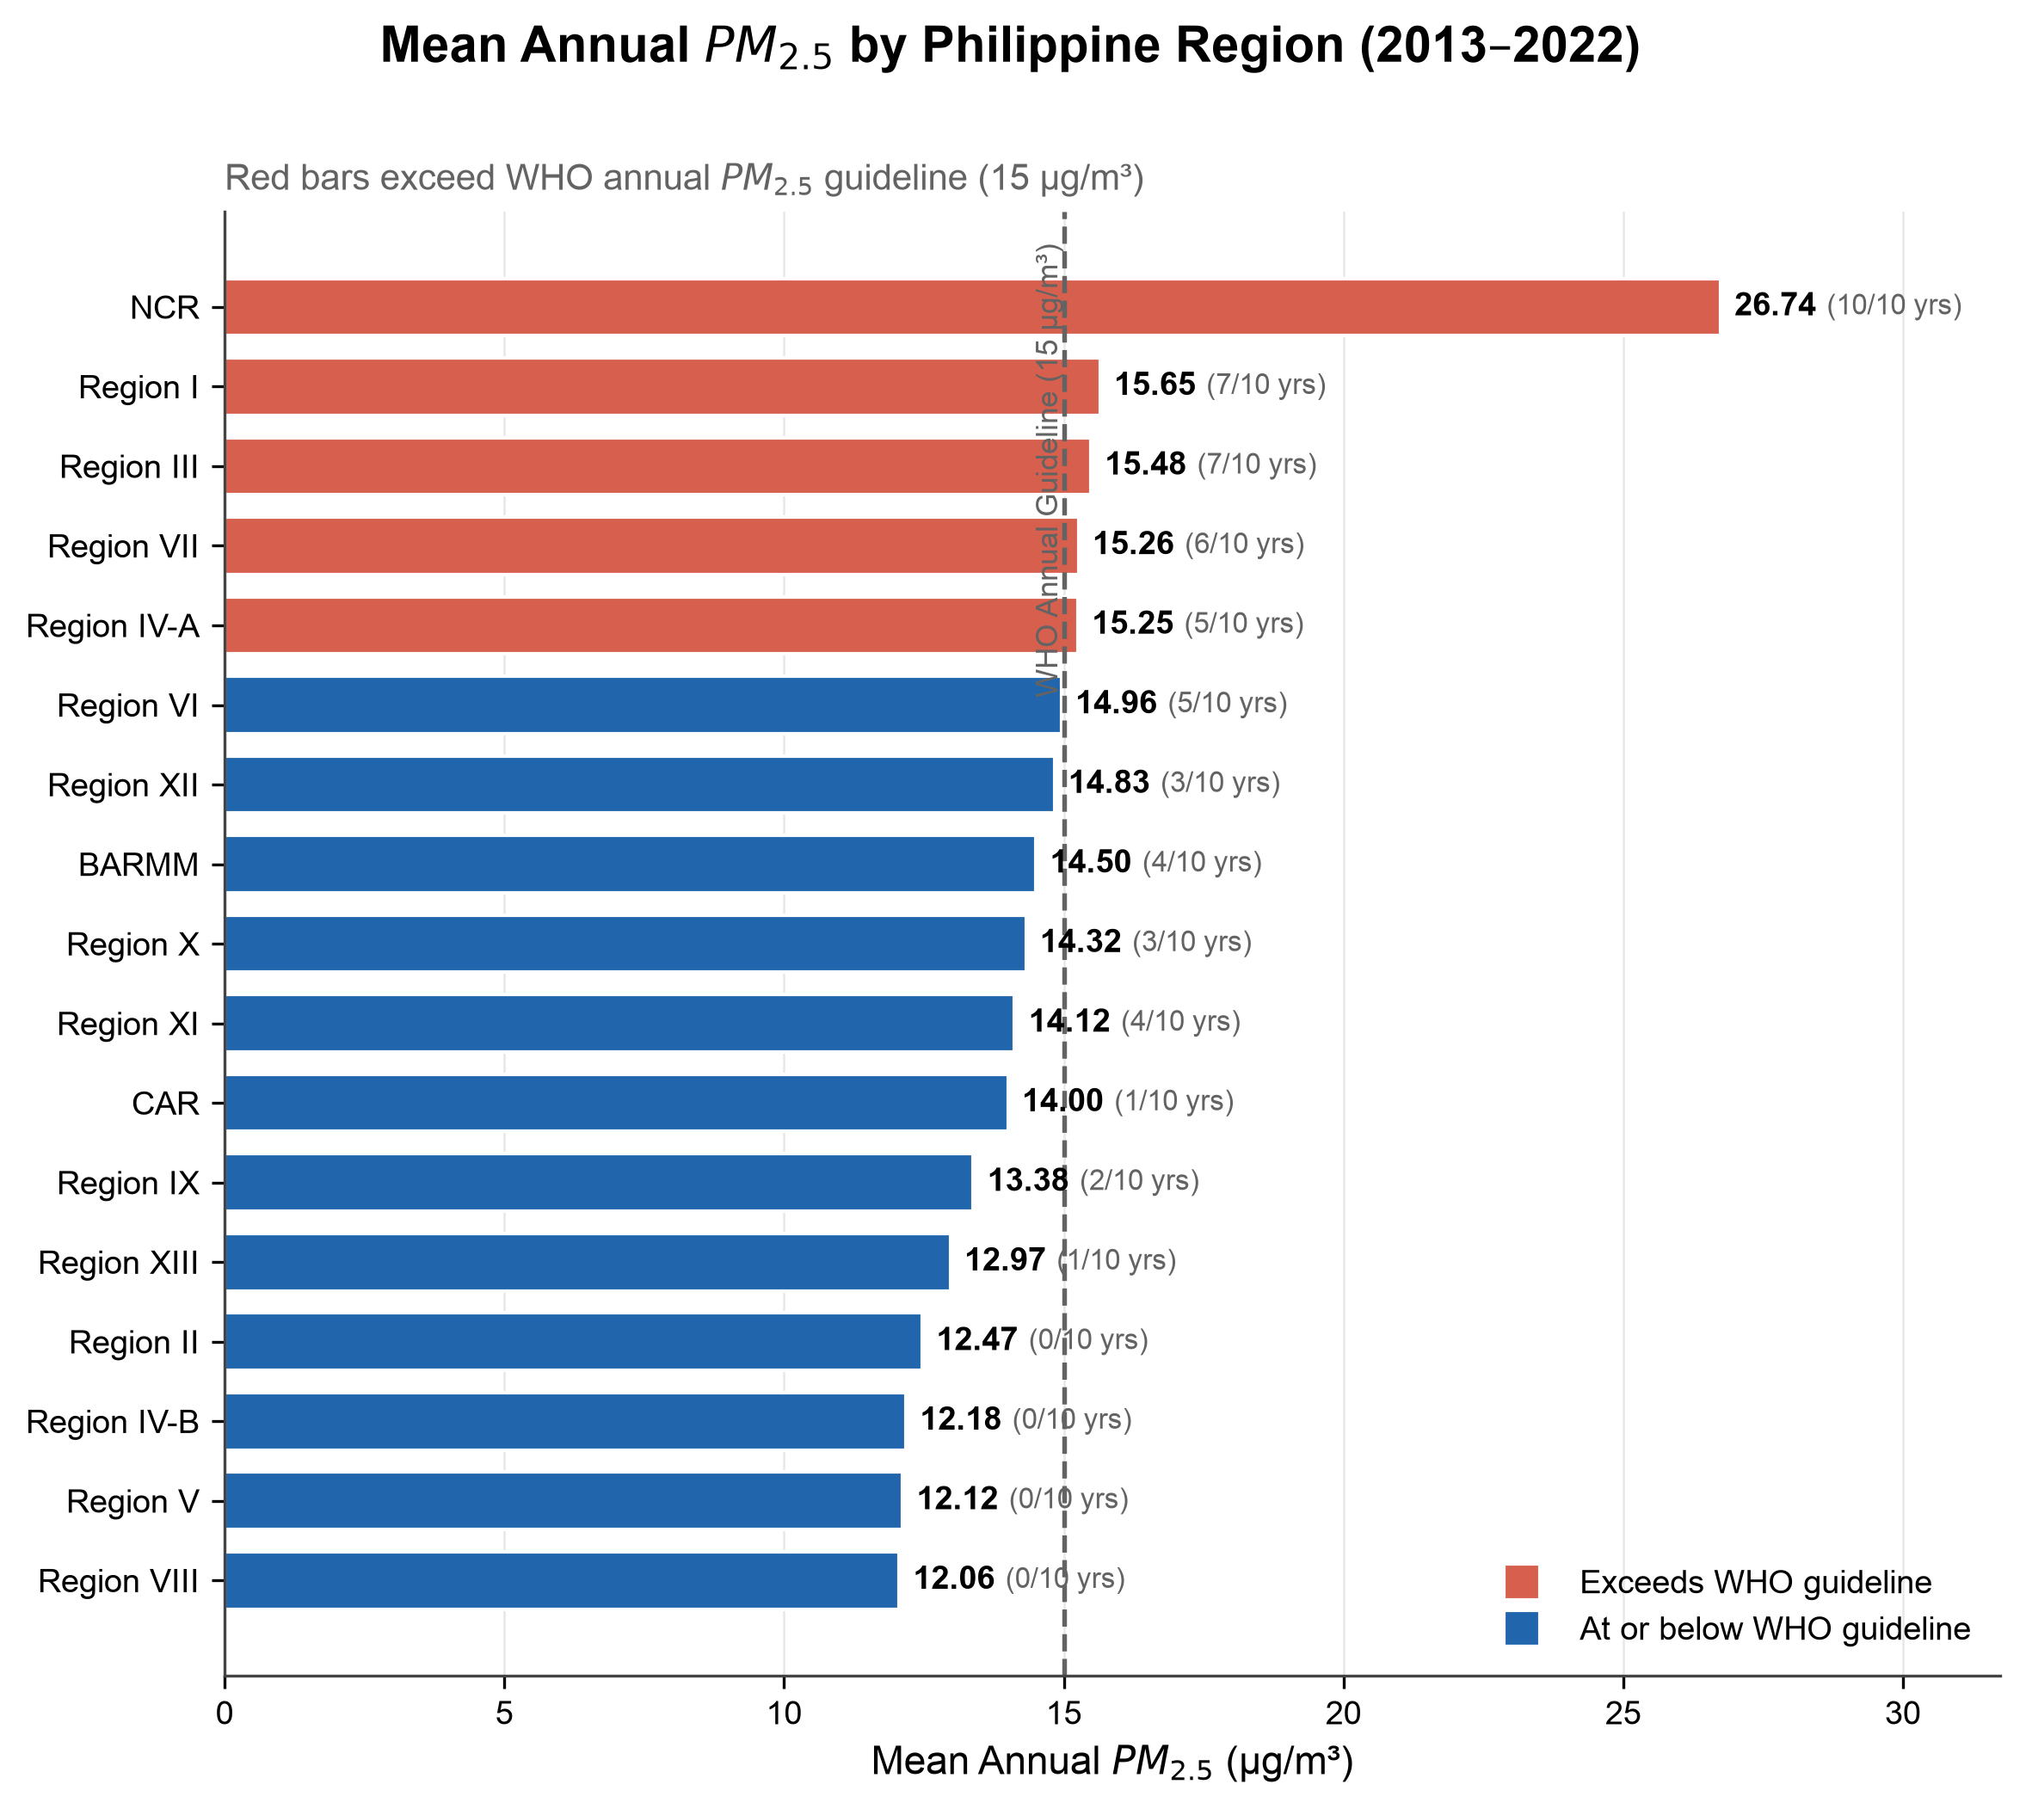
Figure 3. Mean annual PM2.5 concentration (µg/m³) by Philippine administrative region, 2013–2022. Red bars indicate regions where mean PM2.5 exceeded WHO’s Interim Target-3 (15 µg/m³) (dashed line). NCR had the highest mean at 26.74 µg/m³, exceeding it all 10 years.
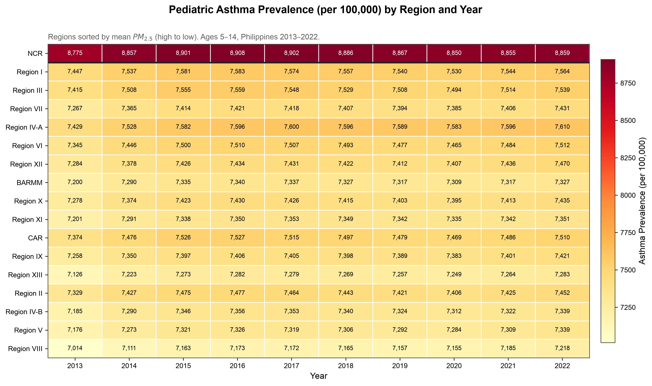
Figure 4. Heatmap of pediatric asthma prevalence (per 100,000, ages 5–14) by Philippine region and year, 2013–2022. Regions sorted by mean PM2.5 (high to low). NCR is shown separately at top. The near-uniform color within each row reflects the 1.5% within-region variance in asthma prevalence — rates barely changed within any region over the decade.
Pooled Correlations
The pooled Pearson correlation between PM2.5 and pediatric asthma prevalence across all 170 region-year observations was r = +0.887 (p < 0.0001). The pooled Spearman rank correlation was ρ = +0.583 (p < 0.0001). Both suggest a strong positive association when all regions and years are viewed together. Figure 1 shows the scatter plot of all region-year observations; NCR observations fall as clear outliers in the upper-right quadrant. Figure 2 shows the national average annual trends in both variables as a dual-axis line chart.
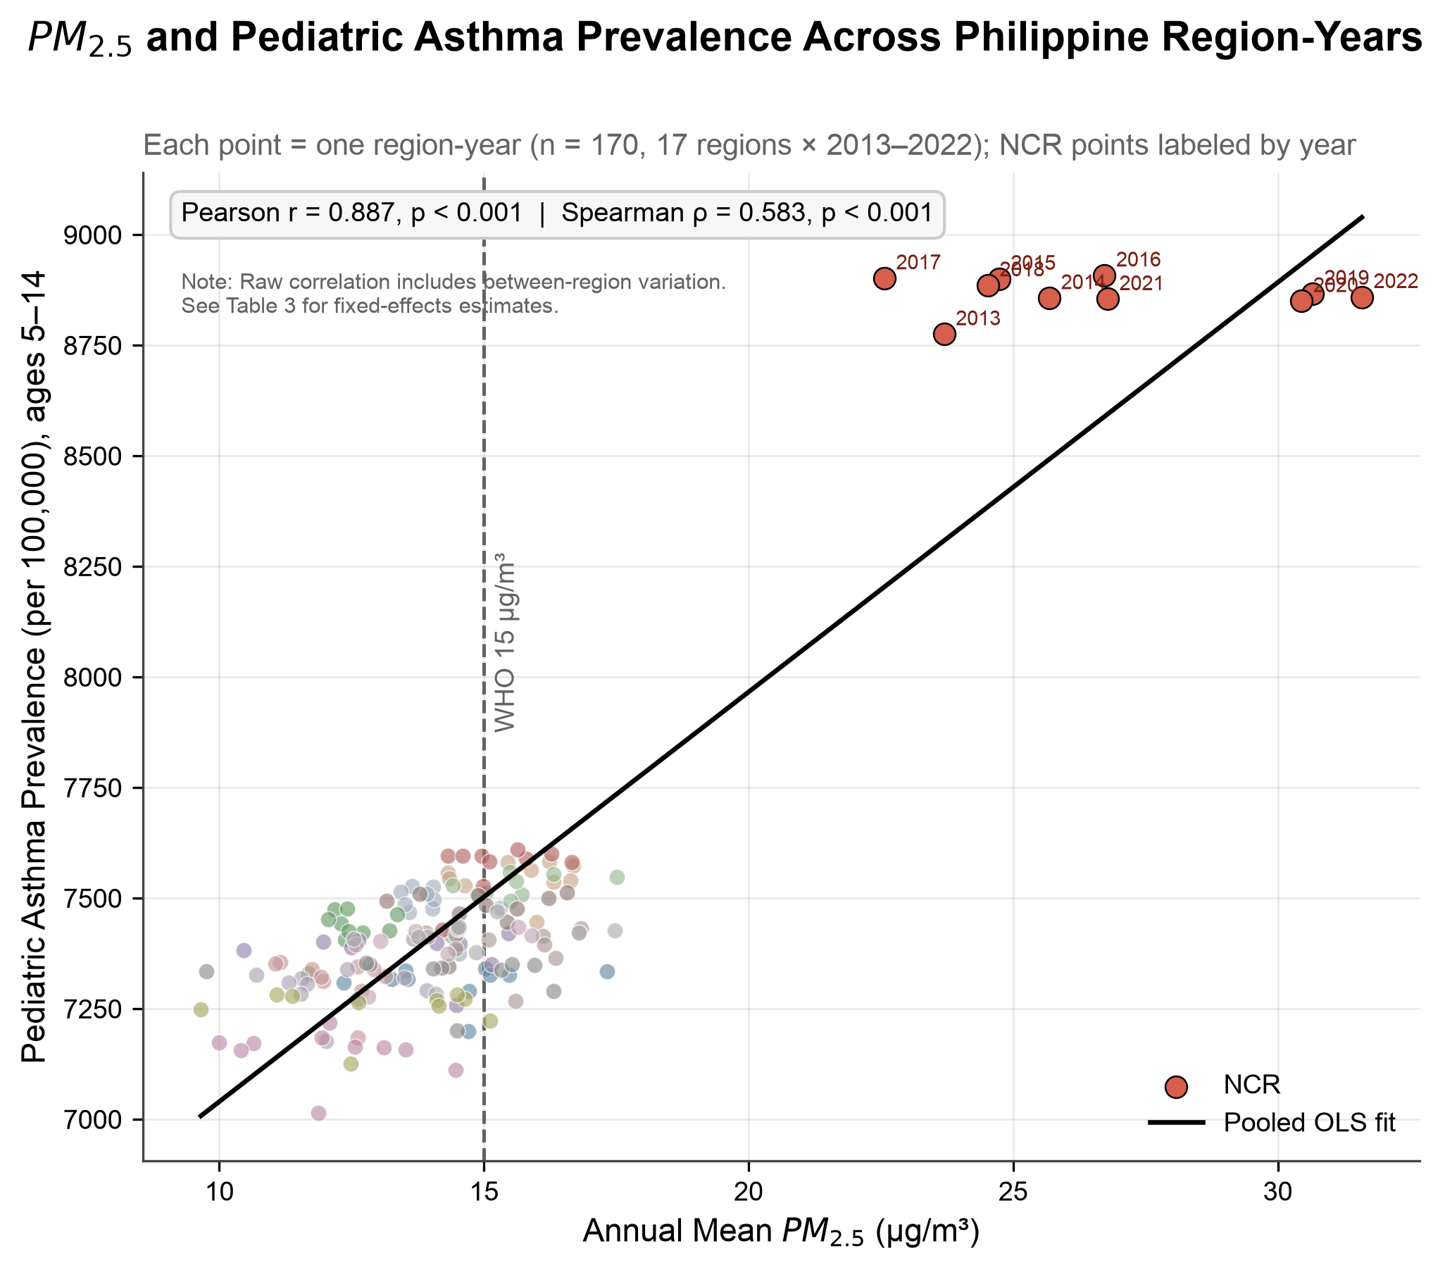
Figure 1. Scatter plot of satellite-derived PM2.5 (µg/m³) vs. pediatric asthma prevalence (per 100,000, ages 5–14) across all 170 Philippine region-year observations, 2013–2022. NCR observations are labeled by year. The solid line is the OLS best-fit line; the dashed vertical line marks WHO’s Interim Target-3 (15 µg/m³). Pearson r = +0.887, p < 0.001. Note: this pooled correlation includes between-region structural variation; see Table 3 for fixed-effects estimates.
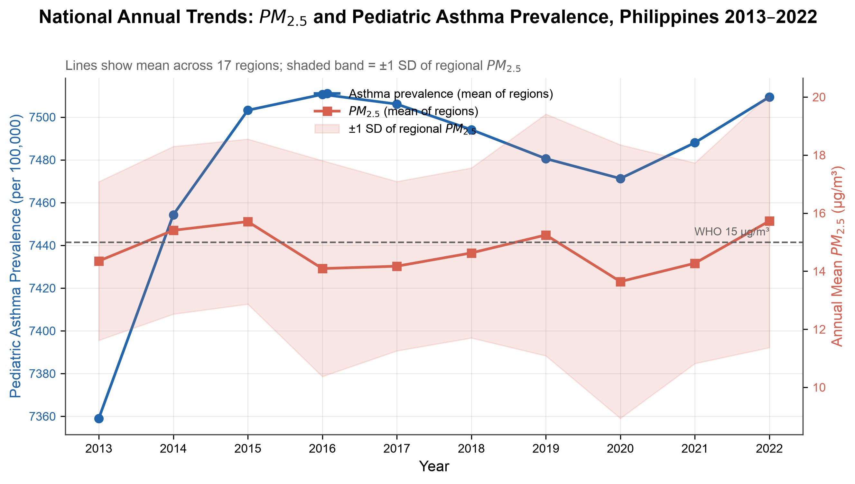
Figure 2. National annual trends in mean satellite-derived PM2.5 (µg/m³, red, right axis) and mean pediatric asthma prevalence (per 100,000, blue, left axis) across 17 Philippine regions, 2013–2022. The shaded band represents ±1 SD of regional PM2.5 for each year. The dashed horizontal line marks WHO’s Interim Target-3 (15 µg/m³).
Variance Decomposition
Variance decomposition showed a stark asymmetry between the two variables: asthma prevalence exhibited only 1.5% within-region variance over the 10-year period, meaning 98.5% of all variation in asthma prevalence reflected stable structural differences between regions. PM2.5 showed more within-region variation (14.9% within-region), but still predominantly reflected between-region structural differences. Results are presented in Table 2.
Table 2. Variance decomposition of PM2.5 and pediatric asthma prevalence into within-region (temporal) and between-region (structural) components, Philippines, 2013–2022.
Variable | Within-Region Variance | Between-Region Variance
Asthma prevalence (per 100,000) | 1.5% | 98.5%
PM2.5 concentration (µg/m³) | 14.9% | 85.1%

Two-Way Fixed-Effects Panel Regression
In Model A (levels), the coefficient on PM2.5 was β = −2.554 (SE = 0.825, p = 0.0024, within-R² = 0.080). In Model B (log-log), β = −0.005 (SE = 0.002, p = 0.0078, within-R² = 0.052). Both models included 17 region fixed effects and 10 year fixed effects (Table 3).
The sign reversal between the pooled Pearson correlation (+0.887) and the fixed-effects coefficient (−2.554) is striking. The very low within-R² values (0.080) indicate that PM2.5 explains almost none of the year-to-year variation in asthma prevalence remaining after fixed effects. The negative coefficient should NOT be interpreted as evidence that PM2.5 reduces asthma; it reflects the absence of a meaningful positive signal in a dataset where asthma prevalence is nearly constant within regions over time.
Table 3. Two-way fixed-effects panel regression results. Dependent variable: pediatric asthma prevalence rate (per 100,000, ages 5–14). Both models include 17 region and 10 year fixed effects; standard errors clustered by region. Philippines, 2013–2022, n = 170 region-years.
Model | β (PM2.5) | SE | p-value | Within-R²
Model A — Levels | −2.554 | 0.825 | 0.0024 | 0.080
Model B — Log-log | −0.005 | 0.002 | 0.0078 | 0.052

Robustness Check: Permutation Test
Because standard cluster-robust standard errors can be unreliable with a small number of clusters (here, 17 regions) (Cameron & Miller, 2015), we additionally validated the primary fixed-effects estimate using two nonparametric permutation tests (5,000 iterations each, seed=42). A full label-permutation test, randomly reassigning PM2.5 series across regions, yielded an empirical p-value of 0.0048. A more conservative block-permutation test, circularly time-shifting each region’s own PM2.5 series while preserving its trend shape, yielded p = 0.0008. Both approaches confirm that the observed coefficient (β = −2.554) is a highly unlikely draw under the null hypothesis of no region-specific PM2.5–asthma relationship, supporting the robustness of the clustered-SE result despite the modest number of clusters.
Robustness Check: First Differences
The first-differences analysis — year-over-year changes in PM2.5 correlated with year-over-year changes in asthma prevalence within each region — yielded Pearson r = +0.199 (p = 0.014, n = 153). This weak positive correlation is in the expected biological direction but confirms no strong within-region temporal association. Figure 5 presents the within-region correlation for each of the 17 individual regions as a forest plot.
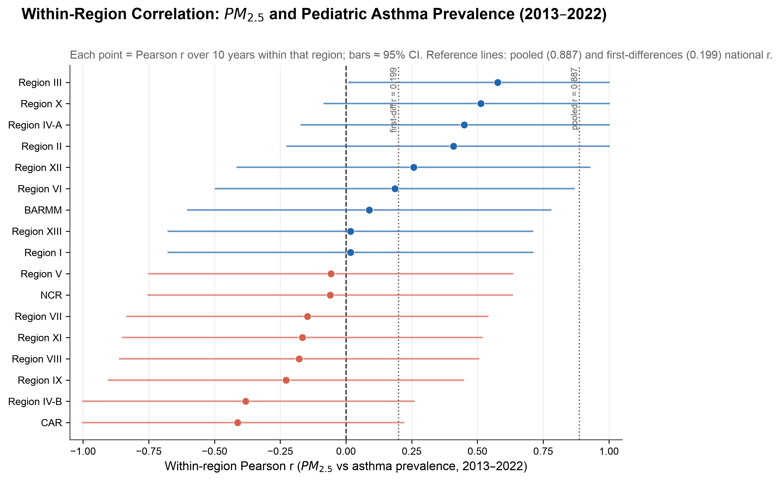
Figure 5. Forest plot of within-region Pearson correlation between annual PM2.5 and pediatric asthma prevalence for each of the 17 Philippine administrative regions, 2013–2022. Points show the Pearson r for each region; horizontal bars represent approximate 95% confidence intervals. The dashed vertical line marks r = 0; dotted lines mark the first-differences pooled r (0.199) and the pooled cross-sectional r (0.887). Wide confidence intervals and mixed signs across regions indicate no consistent within-region association.
Robustness Check: Wild Cluster Bootstrap
Because the label- and block-permutation tests above are one nonparametric approach to small-cluster inference, we additionally validated the primary coefficient with a second, methodologically distinct method: the wild cluster bootstrap, restricted version (WCR; Cameron, Gelbach & Miller, 2008; MacKinnon, Nielsen & Webb, 2023), one of the most widely recommended small-G inference procedures in applied panel econometrics. Under the null hypothesis β = 0, we resampled the model’s own restricted residuals with region-level Rademacher sign flips (5,000 replications, seed = 42) and re-estimated the two-way fixed-effects coefficient each time, comparing the resulting bootstrap t-distribution to the actually observed t-statistic (t = −3.10). The WCR bootstrap p-value was p = 0.036 — still below the conventional 0.05 threshold, but a meaningfully weaker result than the clustered-SE p-value (p = 0.0024) or either permutation-test p-value (p = 0.0048 and p = 0.0008). This pattern — significance that survives but with much less margin under small-cluster-robust bootstrap inference — is consistent with the caution already noted in this manuscript about the modest number of clusters (17 regions) underlying the clustered standard errors.
Robustness Check: Leave-One-Region-Out Jackknife
To confirm the primary coefficient was not being driven by any single region — a natural concern given that the National Capital Region (NCR) is a clear outlier in levels (Figure 1; highest PM2.5 and highest asthma prevalence in the country) — we re-estimated the two-way fixed-effects model 17 times, each time dropping one region and refitting on the remaining 16 regions × 10 years (n = 160). The coefficient remained negative in all 17 refits (range: β = −1.416 to β = −2.812) and remained statistically significant (p < 0.05) in all 17 refits. The result was not uniform, however: dropping NCR specifically produced the smallest-magnitude, least precise estimate of the 17 (β = −1.416, SE = 0.699, p = 0.045) — a 45% reduction in magnitude relative to the full-sample β = −2.554, and the only refit with p above 0.03. Figure 7 shows all 17 estimates. NCR is therefore a meaningful, though not sole, contributor to the primary result’s magnitude and precision: the negative within-region association holds without NCR, but is markedly weaker.
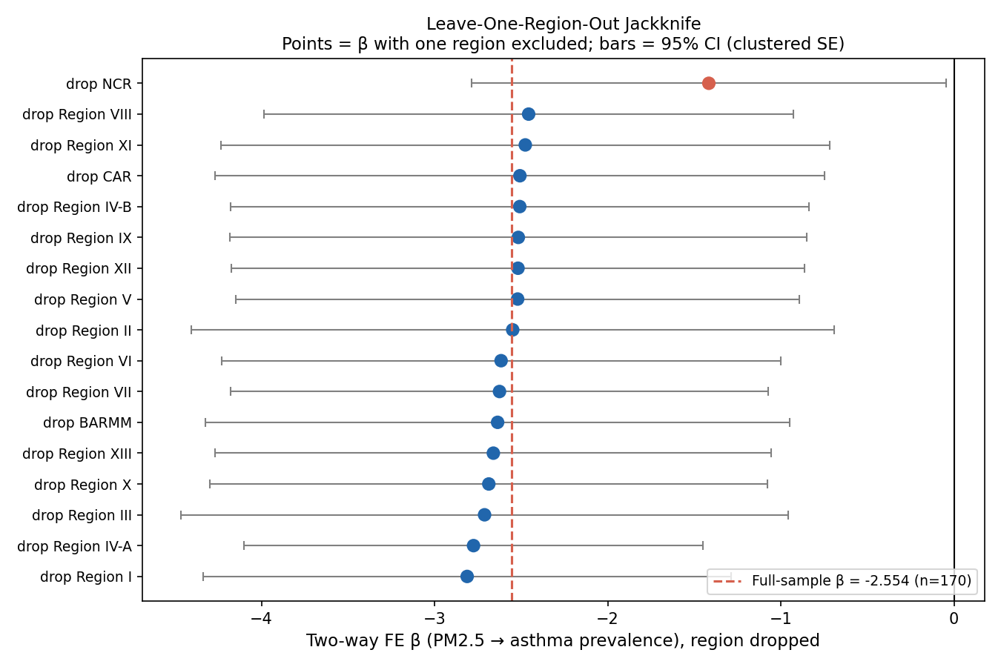
Figure 7. Leave-one-region-out jackknife: two-way fixed-effects β (PM2.5 → asthma prevalence) re-estimated 17 times, each time excluding one region, n = 160 per refit. Points show β with the labeled region excluded; horizontal bars show 95% confidence intervals (clustered SE). The dashed vertical line marks the full-sample β = −2.554 (n = 170). Excluding NCR (red point) produces the smallest-magnitude, least precise estimate of the 17.
Robustness Check: Excluding the COVID-19 Pandemic Years
The Limitations section below notes that the study period includes the COVID-19 pandemic years (2020–2021), which disrupted healthcare utilization and likely affected formal asthma diagnosis rates. To quantify that caveat, we re-estimated the primary model on a 17-region × 8-year panel excluding 2020 and 2021 (2013–2019 and 2022; n = 136). The coefficient attenuated from β = −2.554 (p = 0.0024, n = 170) to β = −2.113 (SE = 1.225, p = 0.088, n = 136) — a 17% reduction in magnitude, and a loss of statistical significance at the conventional 0.05 threshold (though not at 0.10). Removing two of ten years necessarily reduces statistical power (within-R² fell from 0.080 to 0.056), so this attenuation is consistent with reduced precision alone rather than a change in the underlying relationship; it cannot, however, rule out that pandemic-era diagnostic disruption contributed to the primary estimate, and this should be read as a genuine, unresolved sensitivity rather than a fully robust result.
Robustness Check: Lag Structure and Cumulative Exposure
The Discussion below argues that asthma prevalence, as a slowly changing “stock” measure, may be poorly suited to detecting a same-year PM2.5 effect, and that cumulative exposure is more biologically plausible than a single year’s mean concentration. We tested this directly by re-estimating the two-way fixed-effects model with PM2.5 lagged 1, 2, and 3 years, and with a 3-year trailing rolling-mean PM2.5 exposure, each on the correspondingly smaller (but still balanced) rectangular panel. The 1- and 2-year lag specifications produced similar-magnitude, still-negative coefficients (β = −2.156, p = 0.004, n = 153; β = −2.168, p = 0.054, n = 136); the 3-year lag attenuated further and lost significance (β = −1.627, p = 0.151, n = 119). The 3-year rolling-mean specification, by contrast, produced a substantially larger and more precisely estimated negative coefficient than the same-year model (β = −6.040, SE = 1.110, p < 0.0001, within-R² = 0.204, n = 136) — the strongest result, in either direction, of any specification examined in this manuscript. Figure 8 compares all five specifications. This is an important and unexpected finding that should be read carefully: a stronger negative within-region association under cumulative exposure does not support a protective effect of PM2.5, for the same reason stated throughout this manuscript — the negative sign reflects the absence of a positive signal in a dataset where asthma prevalence is nearly time-invariant within regions, not evidence that PM2.5 reduces asthma. What it does show is that the null/negative result is not an artifact specific to same-year exposure timing; if anything, a more biologically plausible cumulative-exposure specification strengthens the finding of no detectable positive within-region PM2.5–asthma association in this dataset.
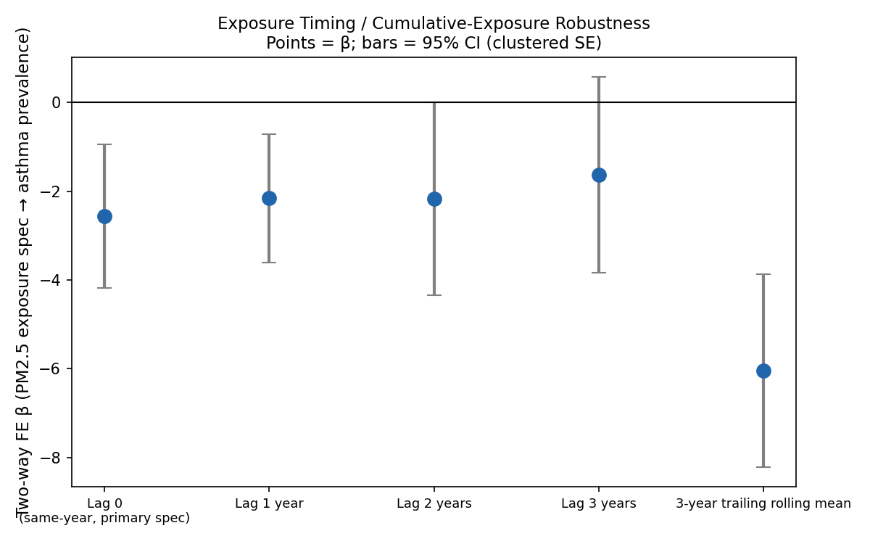
Figure 8. Two-way fixed-effects β under alternative PM2.5 exposure timing: same-year (primary spec), 1/2/3-year lags, and a 3-year trailing rolling mean. Points show β; horizontal bars show 95% confidence intervals (clustered SE). All specifications remain negative; the 3-year rolling mean produces the largest-magnitude, most precisely estimated coefficient of any specification in this manuscript (β = −6.040, p < 0.0001).
Specification Test: Fixed Effects versus Random Effects (Hausman Test)
This manuscript’s Methods section states that the two-way fixed-effects model was chosen because it controls for stable regional differences, without a formal test of that choice against a random-effects (RE) alternative, which would be more efficient if region effects were uncorrelated with PM2.5 — an assumption this manuscript’s own Discussion argues is false (regions with structurally higher PM2.5 also have structurally higher urbanization and diagnostic capacity). We fit a Swamy-Arora random-effects estimator (Swamy & Arora, 1972) on the same regressor set (PM2.5 plus year dummies) and compared it to the fixed-effects estimate via a Hausman specification test (Hausman, 1978; Wooldridge, 2010). The classical Hausman chi-square statistic was not reliably computable in this dataset: the estimated variance difference Var(β_FE) − Var(β_RE) was negative under both the two-way specification and a simpler one-way (region-only) specification, a known finite-sample degeneracy of the classical Hausman test that can occur when the random-effects estimator’s theoretical efficiency gain over fixed effects is small (here, the RE quasi-demeaning weight θ = 0.978, i.e. the RE transform is already close to a full within-transform because between-region variance in this dataset is very large relative to within-region variance). A valid Hausman p-value therefore cannot be reported. What can be reported directly: the RE point estimate (β = −2.126) differs from the FE point estimate (β = −2.554) by seventeen percent, moving toward the strongly positive pooled correlation (r = +0.887) that this manuscript’s central argument attributes to between-region confounding — exactly the direction RE contamination would be expected to move the estimate if that confounding is real. Combined with the qualitative argument already made in the Discussion, this supports retaining fixed effects as the primary specification even without a formally significant test statistic.
Statistical Power: Minimum Detectable Effect
To make the qualitative concern implicit in the low within-R² (= 0.080) explicit, we calculated the minimum detectable effect (MDE; Bloom, 1995) implied by the primary model’s clustered standard error (SE = 0.825, two-way FE residual df ≈ 143). At conventional thresholds (α = 0.05, 80% power), this design could reliably detect a true |β| of at least 2.33 asthma cases per 100,000 per 1 µg/m³ PM2.5 — 91% of the actually observed |β| = 2.554. In other words, this study had approximately 80% power to detect the effect size it in fact found, but a true effect smaller than roughly 2.3 units could plausibly go undetected altogether. At a stricter 90%-power standard, the MDE (2.69) exceeds the observed coefficient, meaning this design is only borderline-adequately powered even for the effect actually estimated. This should be read alongside, not instead of, the within-R² = 0.080 already reported: both describe the same underlying limitation — a panel with very little within-region temporal variance in the outcome — from different angles.
Robustness Check: Spatial Autocorrelation of Residuals (Moran’s I)
The clustered standard errors used throughout this manuscript assume residuals are uncorrelated across regions (only within-region correlation over time is accounted for). If two-way fixed-effects residuals were spatially clustered — for example, if neighboring regions shared unmodeled pollution sources or health-system characteristics — that assumption would be violated and the reported standard errors could understate true uncertainty. We tested this using Moran’s I (Moran, 1950) on the primary model’s residuals, averaged to one value per region. Because contiguity (“queen”/“rook”) adjacency is poorly suited to the Philippines’ archipelagic geography — many regions are island groups with no land border to any neighbor — spatial weights were instead built from real inter-region distances: province-level polygon centroids from the GADM shapefile already used elsewhere in this project for PM2.5 area-weighting were aggregated (area-weighted) to the 17 study regions, and a K-nearest-neighbor (k = 4) weight matrix was built from the resulting real great-circle distances. The observed Moran’s I was −0.0017, close to its expectation under no spatial autocorrelation (−0.063 for n = 17), and a spatial permutation test (5,000 reshuffles) gave p = 0.994 (two-sided). We find no evidence of residual spatial autocorrelation, supporting the validity of region-clustered (rather than spatially adjusted) standard errors for this dataset. This tests only global spatial autocorrelation; local indicators of spatial association (LISA; Anselin, 1995), which could identify whether any individual region drives a spatial pattern the global statistic would miss, were not computed, since the global result gave no overall signal to localize.
Robustness Check: Placebo Outcome
The multi-outcome analysis above (Table 4, Figure 6) tests generalizability across four additional respiratory-related outcomes, but all five outcomes examined so far (asthma plus the four in Table 4) share at least a plausible PM2.5 pathway. A stronger test of whether the primary null reflects a real absence of a same-year effect — rather than an artifact of how GBD subnational estimates are constructed, or of the two-way fixed-effects estimator itself — is a true negative control: an outcome with no plausible PM2.5 pathway at all (Lipsitch, Tchetgen Tchetgen & Cohen, 2010). We obtained GBD 2023 prevalence data for low back pain (ages 5–14, the same subnational province-level export filters used for the other outcomes) and confirmed non-degenerate variance across provinces and years before proceeding: mean prevalence was 773.0 ± 14.7 per 100,000, no province-year value was zero or duplicated, and every one of the 82 provinces showed genuine year-to-year variation (within-province SD ranging 3.3 to 14.5), ruling out a flat or degenerate series. Applying the identical two-way fixed-effects specification (region and year effects, standard errors clustered by region) used throughout this manuscript, PM2.5 showed no statistically significant association with low back pain prevalence (β = −0.180, SE = 0.414, p = 0.664, within-R² = 0.003, n = 170). This null result on a genuinely implausible outcome supports interpreting the primary asthma null as a real absence of a detectable same-year, within-region PM2.5 effect, rather than as an artifact of the GBD subnational estimation pipeline or of the fixed-effects estimator producing spurious associations generally.
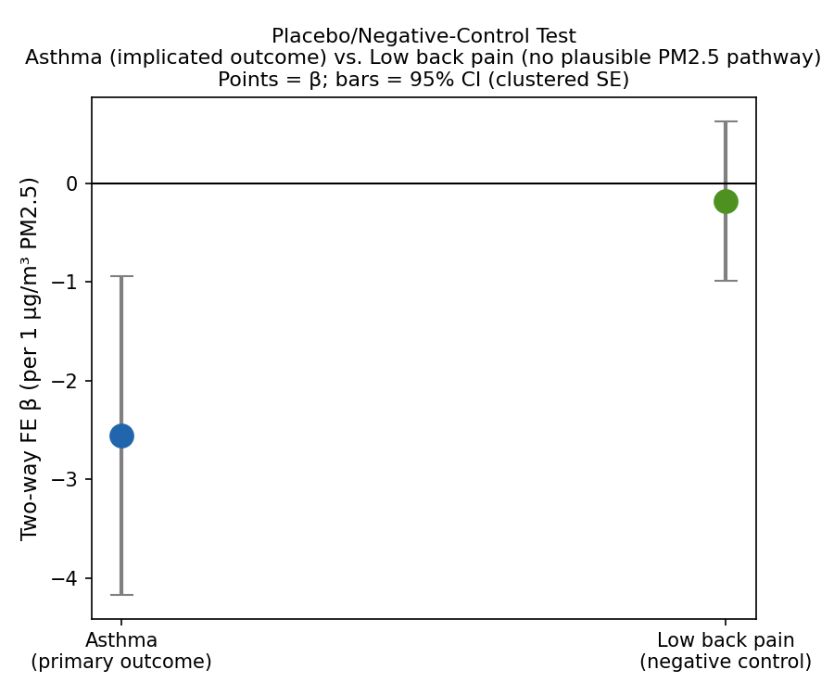
Figure 10. Placebo/negative-control test: two-way fixed-effects β for PM2.5 predicting asthma prevalence (primary outcome, left) versus low back pain prevalence (negative control, right; no plausible PM2.5 pathway). Points show β; bars show 95% confidence intervals (clustered SE). The negative control shows no significant association (p = 0.664), supporting the primary asthma null as a genuine finding.
Discussion
This study found a striking discrepancy between two analytical approaches applied to the same dataset. The pooled Pearson correlation between satellite-derived PM2.5 and GBD-modeled pediatric asthma prevalence was very strong at r = +0.887 — suggesting what appears to be a near-perfect positive relationship. Yet once the two-way fixed-effects model removed the influence of stable structural differences between regions and shared national time trends, the estimated association became negative and tiny, with very low within-R². Understanding why this happened is the core contribution of this paper.
The Between-Region Confounding Problem
The pooled correlation is dominated by a simple structural reality: regions with higher PM2.5 are also more urbanized, wealthier, and better served by healthcare systems. The National Capital Region is the clearest example: highest PM2.5 in the country at 26.74 µg/m³, and also highest recorded asthma prevalence. But this is not only because pollution drives asthma diagnoses in NCR — it is also because NCR has the most hospitals, the most pediatricians, the most diagnostic infrastructure, and the most complete health reporting of any Philippine region. A child in NCR with asthma is far more likely to receive a formal diagnosis than a child in rural Eastern Visayas, even if their underlying disease burden is similar.
When a region’s PM2.5 changes from one year to the next, does its asthma prevalence move in the same direction? This phenomenon — where an apparent association reflects differential diagnostic capacity rather than a true biological effect — is one of the most important and commonly mishandled problems in ecological epidemiology. The fixed-effects model directly addresses it by removing all stable regional differences, leaving only the year-to-year variation in PM2.5 within each region. The answer from this dataset: not robustly.
Confounding Structure and an Approximate E-Value
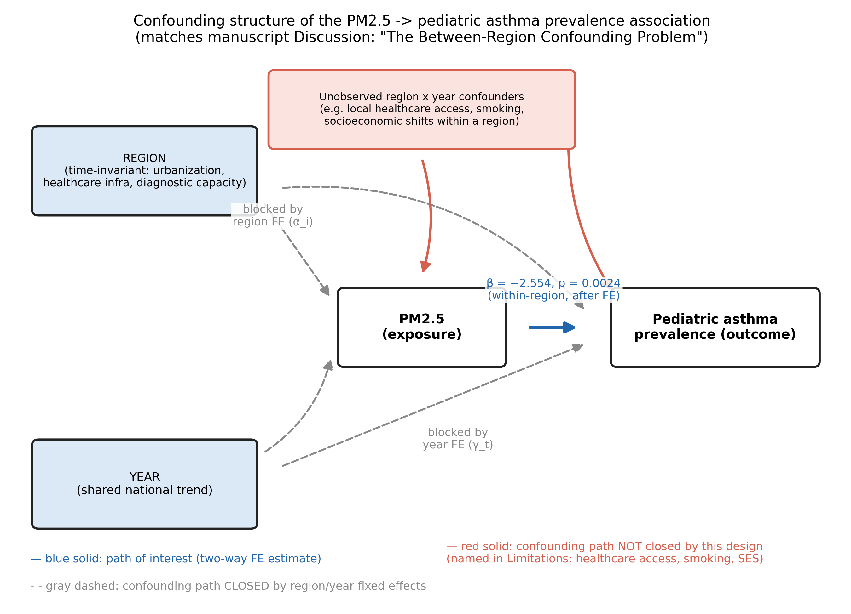
Figure 9. Directed acyclic graph of the hypothesized confounding structure. Blue: the path of interest (two-way fixed-effects estimate). Gray dashed: confounding paths closed by region and year fixed effects. Red: the one confounding path this design does not close (unobserved region × year-varying confounders), matching the Limitations section.
Figure 9 lays out the argument made above as a directed acyclic graph (DAG; Greenland, Pearl & Robins, 1999): region (time-invariant urbanization, healthcare infrastructure, and diagnostic capacity) and year (shared national trend) both plausibly affect PM2.5 and asthma prevalence, and both paths are closed by the two-way fixed-effects design; an unresolved path — unobserved region × year confounders such as local healthcare-access changes, smoking prevalence, or socioeconomic shifts within a region over time (already named in Limitations) — remains open. A formal d-separation check of this graph using dedicated software (e.g. the dagitty R package; Textor et al., 2016) was not performed here; the DAG above is a descriptive summary of the argument, not a software-verified causal model.
As a complementary, approximate quantification of how strong an unmeasured confounder would need to be, we calculated an E-value (VanderWeele & Ding, 2017; Haneuse, VanderWeele & Arterburn, 2019) for the pooled cross-sectional correlation (r = +0.887). The E-value framework is defined for risk ratios, not Pearson correlations, so this used VanderWeele & Ding’s (2017) own stated approximation for a continuous, standardized effect size (their Table 2): RR ≈ exp(0.91 × d). For a bivariate relationship between two continuous, standardized variables, the standardized regression coefficient is the Pearson correlation itself (d = r = 0.887 here), so no further conversion (e.g. through an odds ratio) was needed. This gives RR ≈ 2.24 and an E-value ≈ 3.9: an unmeasured confounder would need to be associated with both PM2.5 and asthma prevalence by a risk ratio of at least roughly 3.9, above and beyond region and year, to fully explain away the pooled association on its own. This should be read as an approximation, not a precise bound — VanderWeele & Ding note this conversion carries modest error for typical effect sizes and more for very large ones, and r = 0.887 is a very large one — and it is computed on the pooled/confounded correlation, not on the FE-adjusted null result (which has no correlation coefficient to convert). An E-value of this size is a moderate, not extreme, bar. It is consistent with — not evidence for — this manuscript’s central argument: region-level confounding (urbanization, diagnostic capacity) of roughly this magnitude is independently identified and adjusted for via fixed effects, which is exactly why the pooled association collapses under the two-way FE model.
Why Asthma Prevalence Is the Wrong Outcome Variable
Only 1.5% of the total variation in asthma prevalence is attributable to year-to-year changes within regions; the other 98.5% is simply the stable difference between regions. That imbalance is the clearest explanation for why the fixed-effects model finds no signal: asthma prevalence in these data is, for practical purposes, frozen within each region over the study period. A model that isolates within-region change — which is exactly what fixed-effects does — is therefore working with almost nothing to detect.
This reflects a fundamental feature of asthma prevalence as an outcome variable: it is a stock measure, representing the total accumulated number of people currently diagnosed with asthma, which changes slowly. Outcome variables that respond more directly to year-to-year environmental changes — lower respiratory infection incidence, acute respiratory emergency visits, hospital admission rates — would be far better suited for this type of panel analysis.
Testing Additional Respiratory Outcomes
To determine whether the absence of a within-region PM2.5 signal was specific to asthma prevalence or reflected a broader limitation of this panel design, the same two-way fixed-effects specification was applied to four additional respiratory outcomes: lower respiratory infection incidence, COPD prevalence, tracheal/bronchus/lung cancer incidence, and respiratory-disease mortality (Table 4, Figure 6). Of these five outcomes, four — asthma, lower respiratory infections, COPD, and respiratory mortality — showed no statistically significant within-region association with PM2.5 (all p > 0.09). Lung cancer incidence showed a marginally significant result (p = 0.033); however, given that five separate outcomes were tested without correction for multiple comparisons, a single borderline result out of five is consistent with what would be expected by chance alone, and should not be interpreted as evidence of a true effect. Rather than weakening the main result, this consistency across outcomes strengthens it: the absence of a detectable within-region signal is not an artifact of asthma prevalence specifically, but a broader feature of this ecological panel — one likely driven by the same combination of low within-region variance and modeled, smoothed subnational estimates discussed above. Future work using outcome variables with genuinely high-frequency variation (e.g., facility-level emergency admissions) would be better positioned to test whether a real effect exists beneath this noise floor.
Table 4. Two-way fixed-effects panel regression results across five respiratory-related outcomes. All models include 17 region and 10 year fixed effects; standard errors clustered by region. Philippines, 2013–2022, n = 170 region-years each. No correction for multiple comparisons was applied.
Outcome | β (PM2.5) | SE | p-value | Within-R² | n
Pediatric asthma prevalence (ages 5–14) | −2.554 | 0.825 | 0.0024 | 0.080 | 170
Lung cancer incidence (all ages) | −0.195 | 0.091 | 0.0333 | 0.194 | 170
Lower respiratory infection incidence (ages 5–14) | −3.053 | 1.825 | 0.0965 | 0.011 | 170
COPD prevalence (all ages) | 4.476 | 2.643 | 0.0925 | 0.128 | 170
Respiratory-disease mortality (all ages) | 0.984 | 0.720 | 0.1737 | 0.009 | 170
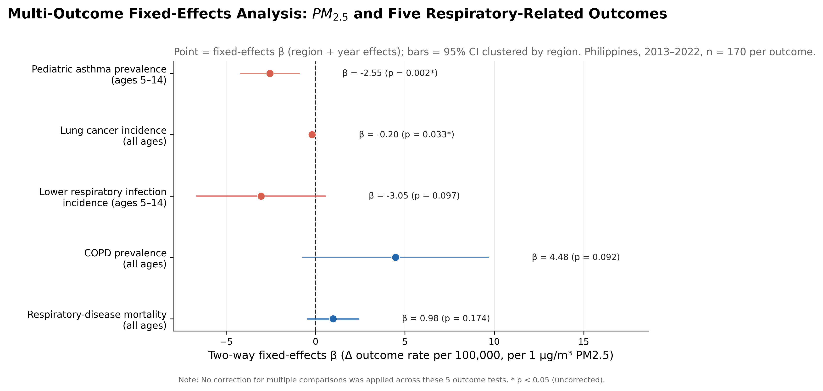
Figure 6. Forest plot of two-way fixed-effects β coefficients (PM2.5 predicting each outcome, region and year effects) across five respiratory-related outcomes, Philippines, 2013–2022. Points show the fixed-effects β for each outcome; horizontal bars represent 95% confidence intervals clustered by region. The dashed vertical line marks β = 0. No correction for multiple comparisons was applied across the 5 tests; asterisks denote uncorrected p < 0.05.
Synthesis of Sensitivity Analyses
Across all robustness checks conducted for the primary coefficient — clustered standard errors, label- and block-permutation tests, a wild cluster bootstrap, a leave-one-region-out jackknife, and exclusion of the COVID-19 pandemic years — the two-way fixed-effects estimate was directionally consistent (always negative) and statistically significant in every check except one (excluding 2020–2021, where it narrowly missed conventional significance at p = 0.088). The estimate was measurably, though not fully, sensitive to two specific features of the data: the National Capital Region and the two pandemic years. Alternative exposure-timing specifications (1/2/3-year lags, 3-year rolling mean) did not overturn the negative sign at any lag, and a cumulative 3-year exposure measure produced the strongest result of any specification tested. A Hausman-style comparison against random effects could not be formally tested due to a known finite-sample degeneracy, but the substantial divergence between the fixed- and random-effects point estimates is itself informal evidence for the region-level confounding this manuscript’s central argument describes. Moran’s I found no evidence of residual spatial autocorrelation, supporting the region-clustered standard errors used throughout. A placebo/negative-control test using an outcome with no plausible PM2.5 pathway (low back pain prevalence) found no significant association (p = 0.664), supporting the primary null as a genuine finding rather than an artifact of the GBD estimation pipeline. Taken together, these checks support treating the primary null/negative finding as a genuine feature of this dataset rather than an artifact of any single modeling choice, while also making explicit exactly where that finding is least secure (NCR, the pandemic years, and the overall statistical power of the design, quantified above as an MDE of ≈ 2.33).
Implications for Philippine Environmental Health Policy
Despite the null finding on the primary analytical question, the descriptive results carry direct public health relevance. The fact that 34.1% of all region-year observations exceeded WHO’s Interim Target-3 (15 µg/m³), and that NCR exceeded Interim Target-3 every single year at nearly twice its level, documents a real and ongoing air quality burden. Even without a detectable within-region temporal association in this dataset, Philippine regions that consistently exceed Interim Target-3 are exposing millions of children to pollution levels that global evidence identifies as harmful.
Davao City’s regional-average PM2.5 relative to WHO’s Interim Target-3, and how the satellite-derived estimates used here compare against real ground-station monitoring from the Environmental Management Bureau Region XI, is examined directly — including where the two sources disagree and why — in the Davao City Case Study subsection immediately below, rather than summarized as a single claim here.
Davao City Case Study: Ground-Station Validation of Satellite PM2.5
The main analysis in this study relies on satellite-derived PM2.5 estimates (ACAG V6.GL.02.04) rather than ground-based monitoring, because ground monitoring in the Philippines is too sparse and inconsistent to support a 17-region, 10-year panel. Davao City — one of the few Philippine cities with a multi-year network of government air quality monitors — offers a chance to check that choice directly: how well does satellite-derived PM2.5 agree with real, ground-measured PM2.5 at the city level? This section reports that comparison as a standalone validation layer. It does not feed into, or change, the main regional panel results.
Data
Ground stations. Annual geometric mean PM10 and PM2.5 concentrations for six EMB Region XI air quality monitoring stations in Davao City (Stations 02, 07/17, 11, 14, 15, and 16) were extracted from three official government reports: the 2022 RSOBER, the 2023 Annual Airshed Status Report, and the 2025 (final) RSOBER. Only Stations 15 and 16 measure PM2.5; the remaining four measure PM10 only. Values were cross-checked across all years where reports overlapped and were consistent. One monitoring station reported in the source tables (TC Station 01) was excluded, as it is located in Tagum City, not Davao City.
Several data-quality caveats apply and are carried forward here rather than smoothed over:
- Station 07/17 continuity. EMB relocated this station (from a J.P. Laurel Avenue site to Marfori Heights) around 2023 and its own reports are internally inconsistent about when the change took effect. A single continuous “Station 07/17” series was retained using the 2021–2022 values both reports agree on, but the series may represent two distinct physical locations rather than one continuously monitored site.
- 2020 data-capture flag. EMB’s own 2022 report notes that Stations 15 and 16 fell below the required 75% annual data-capture rate in 2020. The reported values (26.42 and 24.48 µg/m³ PM10) are included as the only figures available, but should be treated as less reliable than other years.
- 2024 precision. 2024 values are available only as rounded whole numbers from a three-year summary table in the 2025 RSOBER, unlike the decimal-precision figures reported for 2020–2023 in the earlier two reports.
- 2024 data substitution. The 2025 RSOBER notes that May 2024 manual-station PM10 readings involved EMB-approved data substitution to meet minimum coverage requirements. This does not change the reported annual mean but is disclosed here for provenance.
Satellite data. Annual PM2.5 (µg/m³) for 2020–2024 was extracted from ACAG’s V6GL03 CNN-based global PM2.5 product (0.1° resolution), clipped to the Davao City boundary (GADM Philippines, level 2 administrative boundaries). Nineteen 0.1° grid cells fall within the city boundary, consistent with Davao City’s land area of approximately 2,440 km².
Version sensitivity check. Because the main regional panel uses an earlier ACAG release (V6GL02.04) while the Davao satellite comparison used the current release (V6GL03), the same Davao City clip was re-run on the three overlapping years (2020–2022) using the older V6GL02.04 files, to test whether any satellite-ground discrepancy reflected atmospheric reality or a product-version artifact.
Results
Table 5. Ground-station vs. satellite (V6GL03) annual PM2.5, Davao City, 2020–2024. Ground values are the mean of Stations 15 and 16 only.
Year | Ground PM2.5 (µg/m³)¹ | Satellite PM2.5, V6GL03 (µg/m³) | Difference
2020 | 11.08 | 16.19 | +5.11
2021 | 10.85 | 15.53 | +4.68
2022 | 14.52 | 15.69 | +1.17
2023 | 15.45 | 14.16 | −1.29
2024 | 14.00 | 15.61 | +1.61
¹ Simple mean of Stations 15 and 16 only — the two Davao stations that measure PM2.5. This is not a full-city average; the other four stations measure PM10 only.
Across these five years, satellite and ground station values move in opposite directions from year to year (Pearson r = −0.665, n = 5). Given the small sample size, this correlation should be treated as descriptive rather than a reliable estimate of the true relationship between the two data sources.
Table 6. Version sensitivity check: ground-station PM2.5 vs. two ACAG product releases, Davao City, 2020–2022.
Year | Ground PM2.5 | V6GL02.04 (older) | V6GL03 (current) | Old − Ground | New − Ground | New − Old
2020 | 11.08 | 11.70 | 16.19 | +0.62 | +5.11 | +4.50
2021 | 10.85 | 13.64 | 15.53 | +2.79 | +4.68 | +1.89
2022 | 14.52 | 13.48 | 15.69 | −1.04 | +1.17 | +2.21
The older ACAG release tracked the ground stations substantially more closely (mean absolute error 1.48 µg/m³) than the current release (mean absolute error 3.65 µg/m³) over the same three years, same city boundary, and same grid cells. The current release was, on average, 2.87 µg/m³ higher than the older release for identical location-years. This indicates that most — though not necessarily all — of the apparent satellite-ground gap in the 2020–2024 comparison reflects a systematic shift introduced by the ACAG algorithm/version update, rather than a true change in atmospheric PM2.5 that ground stations failed to capture. With only three overlapping years, this finding should be read as evidence of a real and non-trivial version effect, not as a precise estimate of its size.
Interpretation
This validation exercise supports two conclusions relevant to the main study. First, satellite-derived PM2.5 products are not immune to systematic drift between algorithm versions, and comparisons across product releases — even for the same underlying atmosphere — should not be treated as directly comparable without checking for this. Second, the main 17-region panel uses a single ACAG release (V6GL02.04) consistently across all years and regions, so this version-sensitivity issue does not affect its internal validity. It matters only for future work that mixes ACAG releases across time or extends the panel using newer satellite products.
The residual gap that persists even after accounting for the version effect (most visibly in 2020–2021) is consistent with several possible explanations that this study cannot distinguish between: genuine spatial averaging differences between a 0.1° satellite pixel and point-source ground monitors, the ground stations’ own documented data-capture shortfall in 2020, or true limitations in satellite retrieval accuracy over a coastal, cloud-prone tropical city. Any of these would also apply, to some degree, to the satellite-derived PM2.5 used throughout the main regional panel, and is noted as a limitation of that analysis as well.
Limitations Specific to This Validation Layer
- The ground-truth PM2.5 series draws on only two of six Davao monitoring stations, covering specific station locations rather than the whole city.
- The Davao ground-station window (2020–2024) does not overlap with most of the main panel’s window (2013–2022); only 2020–2022 overlap.
- Station 07/17’s possible site relocation limits confidence in any trend drawn from that station specifically (not used in the PM2.5 comparison above, which relies only on Stations 15 and 16).
- With five years of satellite-ground pairs (and three years for the version check), all correlations and mean differences reported here are descriptive and should not be interpreted as statistically robust estimates.
Limitations
Several limitations must be acknowledged. This is an ecological study: regional-level associations cannot be attributed to individuals (Robinson, 1950), and correlation does not establish causation. Province-to-region aggregation used simple means rather than population-weighted estimates, which may introduce aggregation bias; a population-weighted aggregation was considered for this manuscript but not implemented, because the only population dataset available in this repository covers just 12 of the Philippines’ approximately 81 provinces and only through 2020 (missing two of this study’s ten years), and was judged insufficient to redo the aggregation credibly for the full panel (see Ivy, Mulholland & Russell, 2008, for standard population-weighted exposure-metric methodology, which was not applied here). ACAG satellite PM2.5 estimates carry inherent uncertainty in tropical coastal environments. No confounders beyond region and year effects were included; residual confounding from healthcare access, smoking, and socioeconomic factors may remain. The study period includes COVID-19 pandemic years (2020–2021), which disrupted healthcare utilization and likely affected formal diagnosis rates. Finally, GBD subnational asthma estimates are partly modeled and smoothed toward national trends, which reduces within-region variance and may understate real year-to-year fluctuations in asthma burden. In addition, a minimum-detectable-effect calculation (see Results) indicates this design could reliably detect true effects only down to roughly 90% of the magnitude actually observed at conventional 80% power — a concrete bound on, rather than merely a qualitative caveat about, the study’s statistical power.
Conclusion
This subnational ecological panel analysis of 17 Philippine regions over 2013–2022 found that the strong pooled cross-sectional correlation between satellite-derived PM2.5 and GBD-modeled pediatric asthma prevalence (r = +0.887) is driven primarily by between-region structural differences — urbanization, healthcare infrastructure, and diagnostic capacity co-occurring with pollution in the same regions — rather than within-region temporal variation in pollution exposure. After adjusting for region and year fixed effects, no robust association was identified, consistent with asthma prevalence being a near-static outcome with only 1.5% within-region variance in these data.
These findings do not suggest that PM2.5 is harmless to children in the Philippines. They demonstrate that detecting its impact requires finer temporal resolution, outcome variables more responsive to environmental changes, and ideally individual-level or facility-level health data. Future research integrating city-level air quality monitoring with facility-based morbidity data — as available through the Davao City Health Office and EMB-XI monitoring network — represents the most promising direction for Philippine pediatric environmental epidemiology.
As a check on the satellite-derived exposure measure itself, the Davao City Case Study above compares it against real ground-station monitoring from the Environmental Management Bureau Region XI and finds a version-dependent gap between two ACAG satellite product releases. This standalone result does not change the panel findings above. It should, however, inform how future work interprets or extends this satellite-based approach.
References
1. Ho CWL, Fernandez CJ, Roa CC Jr, et al. Epidemiology of pediatric asthma in the Philippines. The Lancet Regional Health – Western Pacific. 2023. doi:10.1016/j.lanwpc.2023.100806
2. Yang IV, Lozano-Garcia M, Avila-Tang E, et al. Asthma trends in the Western Pacific region, 1990–2045. JMIR Public Health and Surveillance. 2024. doi:10.2196/55327
3. Gallano JM, et al. PM2.5 and child respiratory illness in the Philippines. Asian Environmental Research. 2024. Available at: https://ph01.tci-thaijo.org/index.php/aer/article/view/255626
4. Zhang H, et al. Particulate matter and pediatric asthma exacerbation: a systematic review and meta-analysis. 2021. PMC8312457.
5. Ye X, et al. PM10 and pediatric respiratory hospitalization: evidence from multi-city time-series studies. 2023. PMC9908005.
6. Global Burden of Disease Collaborative Network. Global Burden of Disease Study 2023 (GBD 2023) Results. Seattle, United States: Institute for Health Metrics and Evaluation (IHME), 2024. Available from https://vizhub.healthdata.org/gbd-results/.
7. Shen S, Li C, van Donkelaar A, Jacobs N, Wang C, Martin RV. Enhancing Global Estimation of Fine Particulate Matter Concentrations by Including Geophysical a Priori Information in Deep Learning. ACS ES&T Air. 2024. DOI: 10.1021/acsestair.3c00054
8. Cameron AC, Miller DL. A Practitioner’s Guide to Cluster-Robust Inference. Journal of Human Resources. 2015;50(2):317-372. doi:10.3368/jhr.50.2.317
9. Cameron AC, Gelbach JB, Miller DL. Bootstrap-based improvements for inference with clustered errors. The Review of Economics and Statistics. 2008;90(3):414-427. doi:10.1162/rest.90.3.414
10. MacKinnon JG, Nielsen MØ, Webb MD. Cluster-robust inference: a guide to empirical practice. Journal of Econometrics. 2023;232(2):272-299.
11. Hausman JA. Specification tests in econometrics. Econometrica. 1978;46(6):1251-1271. doi:10.2307/1913827
12. Swamy PAVB, Arora SS. The exact finite sample properties of the estimators of coefficients in the error components regression models. Econometrica. 1972;40(2):261-275.
13. Wooldridge JM. Econometric Analysis of Cross Section and Panel Data. 2nd ed. Cambridge, MA: MIT Press; 2010.
14. Bloom HS. Minimum detectable effects: a simple way to report the statistical power of experimental designs. Evaluation Review. 1995;19(5):547-556. doi:10.1177/0193841X9501900504
15. Lipsitch M, Tchetgen Tchetgen E, Cohen T. Negative controls: a tool for detecting confounding and bias in observational studies. Epidemiology. 2010;21(3):383-388. doi:10.1097/EDE.0b013e3181d61eeb
16. Ivy D, Mulholland JA, Russell AG. Development of ambient air quality population-weighted metrics for use in time-series health studies. Journal of the Air & Waste Management Association. 2008;58(5):711-720. doi:10.3155/1047-3289.58.5.711
17. VanderWeele TJ, Ding P. Sensitivity analysis in observational research: introducing the E-value. Annals of Internal Medicine. 2017;167(4):268-274. doi:10.7326/M16-2607
18. Haneuse S, VanderWeele TJ, Arterburn D. Using the E-value to assess the potential effect of unmeasured confounding in observational studies. JAMA. 2019;321(6):602-603. doi:10.1001/jama.2018.21554
19. Greenland S, Pearl J, Robins JM. Causal diagrams for epidemiologic research. Epidemiology. 1999;10(1):37-48. doi:10.1097/00001648-199901000-00008
20. Textor J, van der Zander B, Gilthorpe MS, Liśkiewicz M, Ellison GTH. Robust causal inference using directed acyclic graphs: the R package 'dagitty'. International Journal of Epidemiology. 2016;45(6):1887-1894. doi:10.1093/ije/dyw341
21. Moran PAP. Notes on continuous stochastic phenomena. Biometrika. 1950;37(1-2):17-23. doi:10.1093/biomet/37.1-2.17
22. Anselin L. Local indicators of spatial association—LISA. Geographical Analysis. 1995;27(2):93-115. doi:10.1111/j.1538-4632.1995.tb00338.x
23. Robinson WS. Ecological correlations and the behavior of individuals. American Sociological Review. 1950;15(3):351-357. doi:10.2307/2087176
Artificial Intelligence Disclosure
This research was conducted by Hertzan D. Alquizola II as an independent student researcher. The study design, research question, interpretation of results, and scientific conclusions are the author's own. Claude (Anthropic) assisted with Python scripting, data processing, figure generation, and document assembly during research sessions documented in the project repository. All analytical decisions — including the choice of statistical methods, the reframing around the variance decomposition finding, and the identification of asthma prevalence as an ill-suited outcome variable — were made by the author in dialogue with the tool. The author takes full responsibility for the scientific content of this manuscript.

The Davao City validation (this subsection) used SatPM V6.GL.03; the main 17-region panel used SatPM V6.GL.02.04 (see Methods). As of this writing, ACAG/WashU’s data-distribution site (satpm.org, accessed July 2026) lists no separate peer-reviewed paper for V6.GL.03: its product page states it “follows the methodology of V6.GL.01 and V6.GL.02.04” with updated calibration data and additional VIIRS retrievals, and cites the same reference as V6.GL.02.04 (Shen et al., 2024; ref. 7). The two releases are therefore covered by one citation here, but they are not the same dataset — see Results/Interpretation above for the measured differences between them.

