Name: Hernan Louie Son-oc Course/year: BSIT 3

Instructor: Enrique Torres Date: May 12, 2022

Database (it106 DB name, students Table)

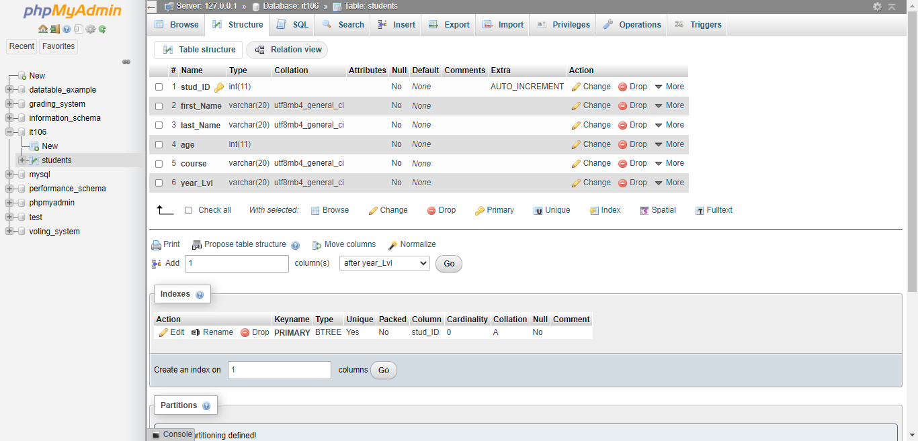

HTML file to insert data

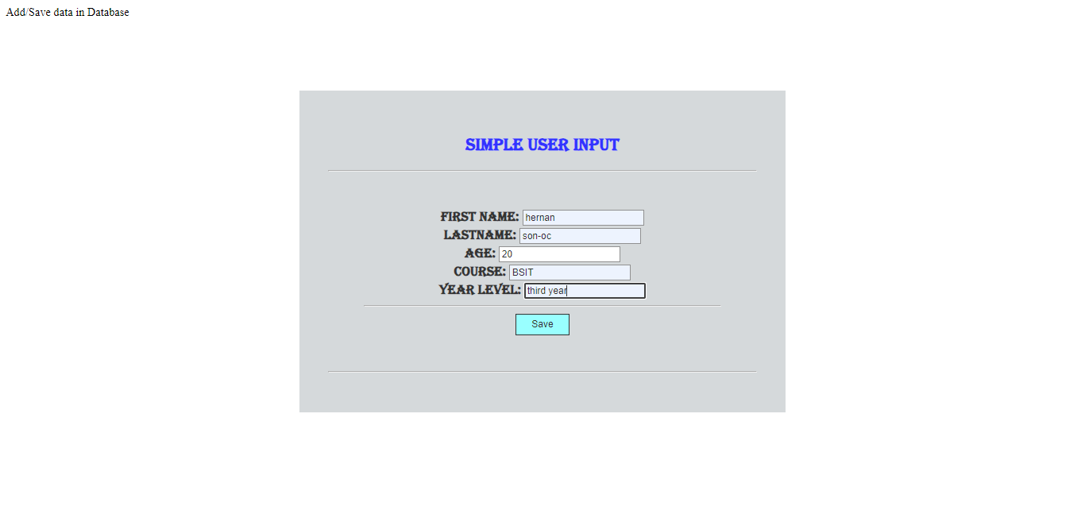

Data has been save to database



Result in database

