
RESOURCE REVENUE GOVERNANCE SERIES · INTEGRATED PAPER
Stabilise, Save, Invest and Grow: Indonesia's Natural-Resource Wealth, Danantara's Pipeline and the Road to 8% Growth
What we have, how we deal with current conditions, how we prepare the future, how we make it sustainable, and how we reach high growth through careful design, execution, monitoring and risk mitigation
Document type: Integrated policy paper, October 2026 data update (supersedes the 8 October integrated paper)
Date: 16 October 2026
Status: Draft for internal discussion
Classification: Restricted. Draws on the DDMF RKAP 2026, marked Private & Confidential
DDMF figures are taken from the RKAP 2026 (presentation version) and are indicative; the RKAP states that the project list is non-exhaustive and subject to change. Figures for six programmes (Giant Sea Wall, defence modernisation, National Data Centre, quantum technology, semiconductors, AI and IT) were updated in October 2026 and replace the RKAP values; their timelines are assumptions. Economic-effect estimates (Chapter 8), the fund simulation and funding stack (Chapter 10) and the growth bridge and scenarios (Chapters 11–12) are illustrative: their parameters are documented assumptions, not forecasts. Revenue, budget and market figures come from official releases and press reports as cited. This paper does not constitute legal or investment advice.

Executive Summary
This paper follows one line of argument in five steps: what Indonesia has, how to deal with current conditions, how to prepare the future, how to make it sustainable, and how to reach high growth through careful design, execution, monitoring and risk mitigation. This edition incorporates figures updated in October 2026 for six programmes and re-clusters the whole pipeline into Industry, Technology and Finance.
What we have (Part I). Natural-resource exports reached US$122 billion in 2025, 8.4% of GDP, after eight boom-and-bust phases since 2000. Danantara's development arm, DDMF, plans a pipeline that, with the October 2026 figures, totals Rp 5,396 trillion for 2027–2040: Industry Rp 4,914 trillion (91%), including defence modernisation Rp 2,125 trillion and the Giant Sea Wall Rp 1,200 trillion; Technology Rp 480 trillion (9%), including the AI and IT programme Rp 200 trillion, the National Data Centre Rp 50 trillion, quantum technology Rp 20 trillion and semiconductors Rp 15 trillion; and Finance, small in capital spending but holding the fund and its funding instruments.
Dealing with current conditions (Part II). Following Chile, a reserve window saves resource revenue above an independent reference price and releases it when prices fall, so that commodity swings stop passing straight into the budget. The 2026 windfall is the moment to start.
Preparing the future (Part III). Following Norway, a future window saves a fixed share of resource revenue every year and spends only its real return, converting a depleting asset into permanent wealth. Timor-Leste shows what happens when the withdrawal rule is not respected.
Making it sustainable (Part IV). A time-limited development window invests part of the savings at home through DDMF under strict rules. Using IMF multipliers for Indonesia, the updated pipeline would raise GDP by about 2.2% at its 2031 peak and 0.9% permanently, adding about 0.6 points to growth a year in 2027–2030, and need about US$124 billion of imports, 58% of it for defence. Counted project by project, it supports about 25.5 million job-years (4.0 million jobs at the 2029 peak) and 1.4 million lasting jobs, lowering open unemployment from 4.7% to about 3.7% in 2028–2030. Natural resources can fund about 54% of the Rp 4,881 trillion needed in 2027–2034 and anchor 74%, if the fund saves 40% of resource revenue and directs 80% of it to development for 2027–2034, earmarks windfall, coal-duty and royalty receipts, and uses loans funded by retained export proceeds; the budget gives up about Rp 111 trillion a year.
Reaching high growth (Part V). Growth is roughly the investment ratio divided by the ICOR. Natural-resource levers and the updated pipeline lift growth from 5.1% to about 6.4% in 2029, and to about 6.9% with better investment efficiency. The pipeline brings investment to about 32.5% of GDP, close to what 8% needs, so the remaining gap of about 1.1 points is mainly efficiency: 8% requires the ICOR to fall to about 4.3. Three scenarios reach 8%; the recommended path combines an industrial and export leap with efficiency reforms: investment of about 33.5% of GDP and an ICOR of about 4.2, monitored through a public dashboard with pre-agreed triggers.
Key messages
- Stabilise with a reserve window, save with a future window, and invest a time-limited, rule-bound share of the savings through a development window, all under one Law owned by the Ministry of Finance.
- Three clusters: Industry (Rp 4,914 T) builds physical capacity, Technology (Rp 480 T) buys productivity at a high import cost, Finance holds the fund that pays for both. Defence (39%) and the sea wall (22%) now dominate the pipeline.
- Natural resources first in funding: about 54% of the 2027–2034 need from resource cash and resource-backed debt, 74% resource-anchored.
- Jobs and consumption: about 4.0 million jobs at the peak and 1.4 million lasting jobs; the sea wall and housing are the most labour-intensive. Hire locally so that wages become Indonesian consumption.
- Growth reaches about 6.9%, not 8%, with the pipeline. Investment is no longer the constraint; efficiency is. 8% needs an ICOR of about 4.3.
- Watch defence imports, the 2032 drop and the current account. Raise defence domestic content to 60%, prepare a successor pipeline from 2030, and keep the current-account deficit below 2.5% of GDP.

Contents
Part I What We Have
Chapter 1 Indonesia's Natural-Resource Exports, 2000–2025
Size, industry, maturity, trends and correlation with GDP
Chapter 2 Danantara's Development Pipeline in Three Clusters
The RKAP 2026, the October 2026 update, and the Industry, Technology and Finance clusters
Part II Dealing with Current Conditions: Stabilise
Chapter 3 How Other Countries Stabilise Resource Revenue
Chile, Mexico and Brazil; the reference-price rule
Chapter 4 Stabilising Indonesia's Resource Revenue
Starting position, one fund, the reference-price rule, import substitution and timing
Part III Preparing the Future: Save
Chapter 5 How Other Countries Plan, Execute and Save Resource Wealth
Norway, Alaska, Kuwait, and Timor-Leste as the contrasting case
Chapter 6 Saving for Future Generations in Indonesia
The future window, saving at home, and safeguards
Part IV Making It Sustainable: Invest
Chapter 7 From Saving to Investing: the Development Window
Design, rules and the sovereignty tier
Chapter 8 Economic Effects: Growth, Jobs and Consumption
GDP, growth, imports, defence, jobs project by project, unemployment and consumption
Chapter 9 Due Diligence on Four High-Risk Projects
Textile, biosimilar & pharma, semiconductors, e-commerce
Chapter 10 Sizing, Funding and Screening
Sources and uses, saving-only versus aggressive, natural-resources-first funding, project screen
Part V Reaching High Growth: Design, Execute, Monitor, Mitigate
Chapter 11 The Arithmetic of 8% and What Natural Resources Can Contribute
Growth bridge and the limits of resource-led growth
Chapter 12 Three Scenarios for 8% Growth
Efficiency first, big push, industrial and export leap; the recommended path
Chapter 13 Designing and Executing the Programme
Design principles, institutions, working plan, timeline, success factors
Chapter 14 Monitoring and Risk Mitigation
Dashboard, triggers, review cycle and risk registers
Chapter 15 Conclusion and Recommendations
Appendices A. Projects by cluster · B. Cluster model · C. Points requiring clarification · D. Evidence by cluster · E. Growth model · F. Employment model · References
PART I
What We Have
What does Indonesia own, and what does it plan to build with it?
Chapter 1 measures Indonesia's natural-resource exports over 25 years: their size, composition, maturity and volatility, and their link with GDP. Chapter 2 sets out what Danantara's development arm, DDMF, plans to build, as updated in October 2026: Rp 5,396 trillion in three clusters, Industry, Technology and Finance.
CHAPTER 1

Indonesia's Natural-Resource Exports, 2000–2025

1.1 Scope and data
This chapter examines Indonesia's exports of sixteen natural-resource commodity groups, built from twenty four-digit headings of the Harmonized System (HS). They cover energy (coal, crude oil, refined products and natural gas), plantation products (palm and palm-kernel oil, oleochemicals and biodiesel, natural rubber), forestry (plywood) and metals and minerals (nickel ore, ferronickel and nickel matte, stainless steel, copper ore and refined copper, bauxite, tin and gold). Fish, coffee, cocoa, pulp and paper and aluminium are excluded, so the totals are narrower than broad definitions of the resource sector.
Export values are taken from UN Comtrade as reported by Indonesia, which is consistent with Statistics Indonesia (BPS). For eleven years (2001–2003, 2005–2009 and 2011–2013) the UN database could not be queried; values for those years are estimates from the CEPII BACI database, scaled to Comtrade levels, and are marked with an asterisk. GDP, real growth and total merchandise exports are from the World Bank. All values are in current US dollars.

1.2 Growth and changing composition
Resource exports rose more than five-fold, from US$23 billion in 2000 to US$122 billion in 2025 (Figure 1.1). Growth was not steady: exports peaked at US$111 billion in 2011, fell to US$59 billion in 2016, and reached a record US$150 billion in 2022. Their weight in the economy peaked in 2008, when they equalled 15.6% of GDP and 57% of merchandise exports.
Figure 1.1. Natural-resource exports by industry, 2000–2025 (US$ billion)
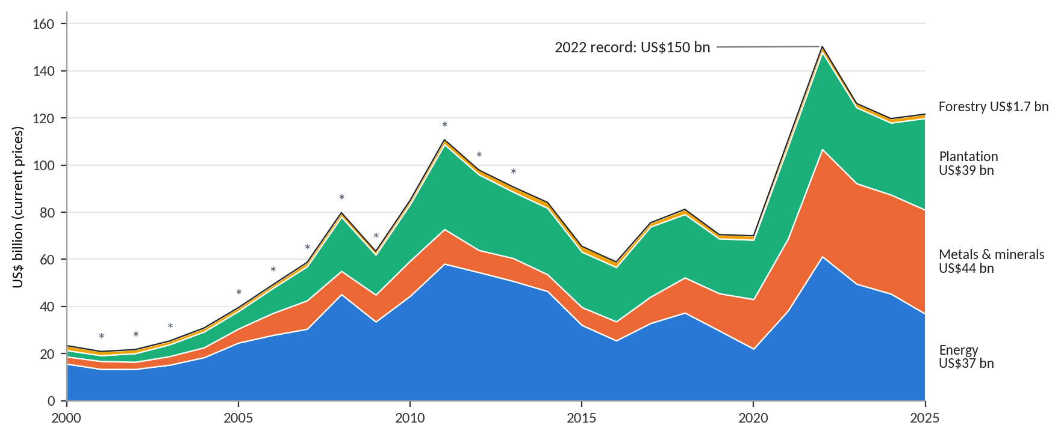
Source: author's calculation from UN Comtrade (reported by Indonesia) and CEPII BACI. * Estimated years (see Section 1.1).
The composition changed as much as the level. Energy's share fell from 67% to 30%, because crude oil and gas declined while coal rose and then fell back. Metals and minerals rose from 13% to 36%, driven almost entirely by the nickel processing chain created after the raw-ore export bans of 2014 and 2020. Plantation products rose from 12% to 32%, led by palm oil and its derivatives. Forestry, which accounted for 9% in 2000, has become marginal at 1%.

1.3 Classification by size, industry and maturity
Each commodity group is classified along three dimensions (Figure 1.2 and Table 1.1). Size uses average annual exports in 2021–2025: large above US$10 billion, medium between US$3 and 10 billion, small below US$3 billion. Processing stage follows the HS heading: raw (ores, crude, coal, rubber), semi-processed (palm oil, LNG, ferronickel, matte, tin, refined copper, gold), processed (refined fuels, plywood) and downstream (oleochemicals, biodiesel, stainless steel). Industry stage is an assessment of each sector's life cycle, from emerging to declining.
Figure 1.2. Commodity groups ranked by size (average annual exports 2021–2025)
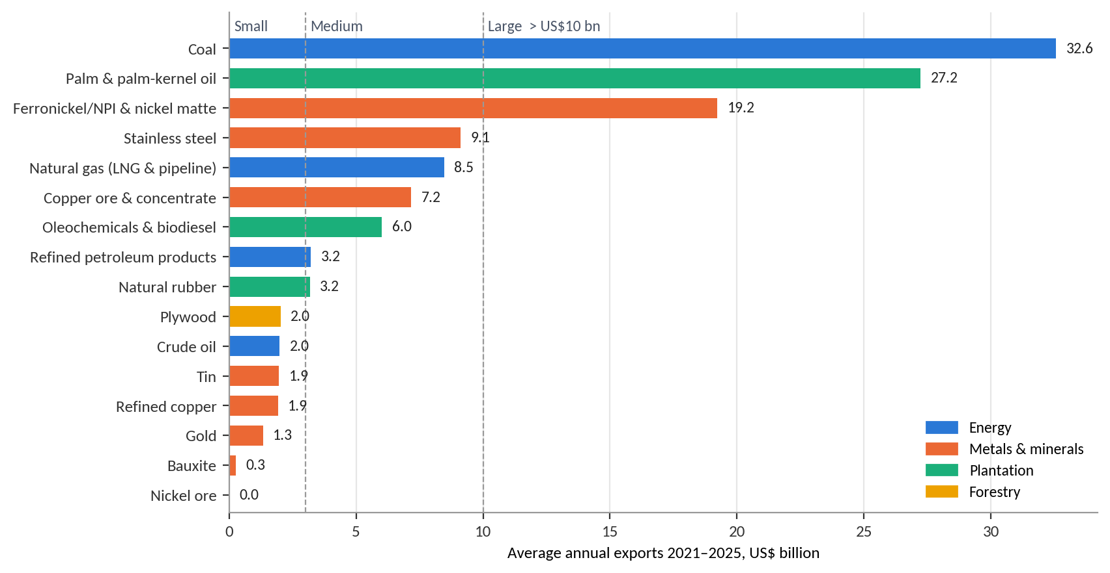
Source: author's calculation. Dashed lines mark the US$3 billion and US$10 billion size thresholds.
Table 1.1. Classification of Indonesia's natural-resource exports (US$ billion)
Commodity group | Industry | Size (avg 2021–25) | Processing stage | Industry stage | 2000 | Peak (year) | 2025
Coal | Energy | Large · 32.6 | Raw | Mature, peaking | 1.3 | 46.8 (2022) | 24.5
Palm & palm-kernel oil | Plantation | Large · 27.2 | Semi-processed | Mature | 1.6 | 30.9 (2022) | 28.4
Ferronickel/NPI & nickel matte | Metals & minerals | Large · 19.2 | Semi-processed | Emerging, fast growth | 0.4 | 24.9 (2025) | 24.9
Stainless steel | Metals & minerals | Medium · 9.1 | Downstream | Emerging, fast growth | 0.0 | 10.9 (2022) | 7.8
Natural gas (LNG & pipeline) | Energy | Medium · 8.5 | Semi-processed | Declining | 6.6 | 19.4 (2011*) | 7.4
Copper ore & concentrate | Metals & minerals | Medium · 7.2 | Raw | Mature, shifting to smelting | 1.6 | 9.2 (2022) | 4.9
Oleochemicals & biodiesel | Plantation | Medium · 6.0 | Downstream | Growing | 0.2 | 7.6 (2025) | 7.6
Refined petroleum products | Energy | Medium · 3.2 | Processed | Mature | 1.6 | 4.4 (2023) | 3.4
Natural rubber | Plantation | Medium · 3.2 | Raw | Declining | 0.9 | 11.8 (2011*) | 3.0
Plywood | Forestry | Small · 2.0 | Processed | Declining | 2.0 | 2.5 (2021) | 1.7
Crude oil | Energy | Small · 2.0 | Raw | Declining | 6.1 | 12.0 (2008*) | 1.6
Tin | Metals & minerals | Small · 1.9 | Semi-processed | Mature, declining reserves | 0.3 | 2.4 (2021) | 1.8
Refined copper | Metals & minerals | Small · 1.9 | Semi-processed | Growing | 0.3 | 2.9 (2011*) | 2.6
Gold | Metals & minerals | Small · 1.3 | Semi-processed | Mature, volatile | 0.4 | 5.5 (2020) | 2.2
Bauxite | Metals & minerals | Small · 0.3 | Raw | Banned (2014, 2023) | 0.0 | 1.2 (2013*) | 0.0
Nickel ore | Metals & minerals | Small · 0.0 | Raw | Banned (2014, 2020) | 0.0 | 1.1 (2019) | 0.0
Source: author's calculation from UN Comtrade and CEPII BACI. * Peak falls in an estimated year.
Three pillars stand out. Coal is the largest (US$32.6 billion a year) but a raw, mature export exposed to long-term demand risk from the energy transition. Palm oil (US$27.2 billion, plus US$6.0 billion of oleochemicals and biodiesel) is renewable and still growing downstream. The nickel chain (US$28.3 billion of ferronickel, matte and stainless steel) did not exist at scale before 2017. By contrast, crude oil, gas, rubber and plywood are in decline, and the export of nickel ore and bauxite has been banned.
Downstreaming is visible in the processing mix (Figure 1.3). Raw products fell from 43% of resource exports in 2000 to 28% in 2025, while downstream products rose from 1% to 13%. The 2022 coal windfall briefly pushed the raw share back up to 41%, a reminder that price swings can mask structural change.
Figure 1.3. Resource exports by processing stage, selected years (% of total)
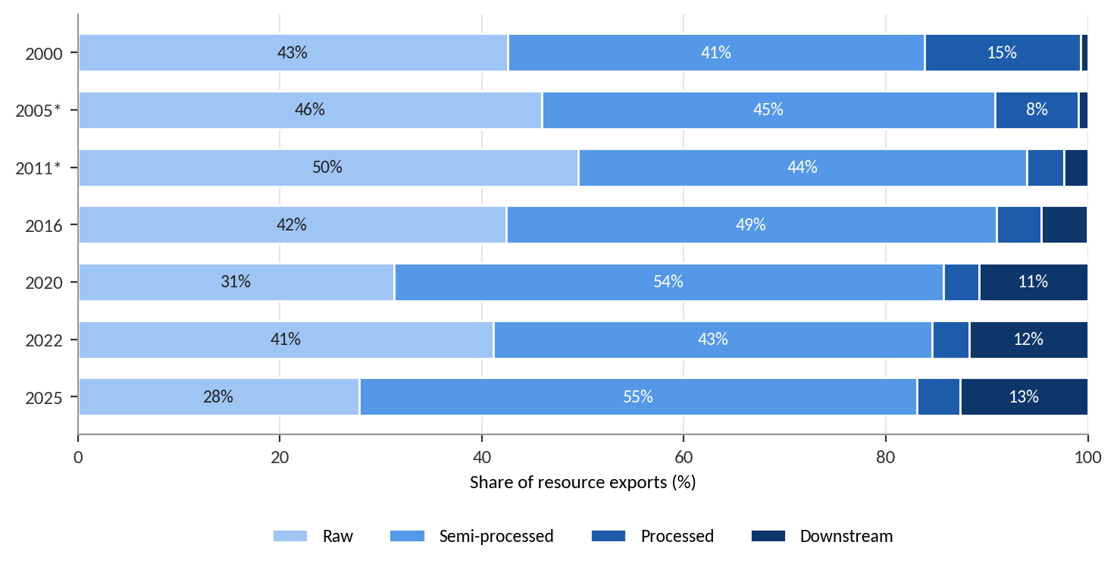
Source: author's calculation. * Estimated year.

1.4 The ups and downs: eight phases
Resource exports moved through eight distinct phases between 2000 and 2025 (Table 1.2). The phases were set mainly by world commodity prices, and secondarily by Indonesia's own policy decisions, in particular the export bans on raw ores.
Table 1.2. Phases of Indonesia's resource exports, 2000–2025 (US$ billion)
Period | Phase | Exports | Change | Main drivers
2000–2002 | Low base | 23 → 22 | −7% | Weak prices after the Asian crisis; oil and gas about 60% of resource exports
2003–2008 | Commodity supercycle | 22 → 80 | +268% | Chinese demand lifts all commodities; coal 1.6 → 14.2, palm oil 2.4 → 14.7
2009 | Global financial crisis | 80 → 63 | −21% | Oil, gas and rubber fall hardest; coal holds up
2010–2011 | Rebound to a peak | 63 → 111 | +75% | Gas (19.4) and rubber (11.8) reach all-time highs
2012–2016 | Five-year bust | 111 → 59 | −47% | Prices fall five years in a row; the 2014 raw-ore ban halts most nickel ore and bauxite exports
2017–2020 | Recovery and nickel pivot | 59 → 70 | +19% | Partial recovery, then weak coal, the 2020 nickel ore ban and the pandemic; nickel products 1.3 → 10.1
2021–2022 | Windfall | 70 → 150 | +115% | Energy shock after the invasion of Ukraine; coal reaches 46.8
2023–2025 | Normalisation and downstreaming | 150 → 122 | −19% | Coal falls back to 24.5 while nickel products grow to 32.7
Source: author's calculation. Estimated years are included in the 2003–2013 phases.
Volatility differs sharply by commodity. The standard deviation of annual changes is about 26% for palm oil and gas, 32–33% for crude oil and coal, and 44% for the nickel intermediates. These are the magnitudes that a stabilisation mechanism must absorb.

1.5 Correlation with GDP
Figure 1.4 relates annual changes in resource exports to annual changes in GDP between 2001 and 2025. The correlation with GDP measured in US dollars is strong (r = 0.63): a 10% rise in resource exports is associated with about 3.1 percentage points of additional dollar GDP growth. The correlation with real GDP growth is weak (r = 0.17, or 0.20 excluding 2020): real growth stayed close to 5% through most booms and busts. The correlation of levels (r = 0.89) mainly reflects the shared upward trend and should not be read as causal.
Figure 1.4. Annual change in resource exports against GDP in US dollars (left) and real GDP growth (right), 2001–2025
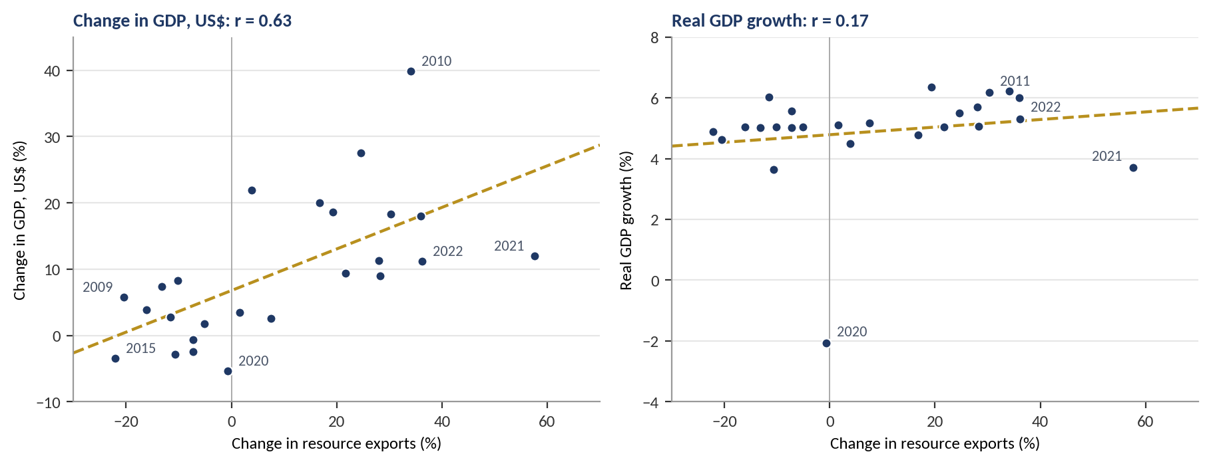
Source: author's calculation from World Bank WDI and the export series. Each dot is one year; dashed lines are least-squares fits.
The interpretation matters for policy. The commodity cycle moves the exchange rate, the value of output in dollars and, through royalties, taxes and dividends, the state's revenue. It does not, on the evidence, drive the underlying pace of real growth, which rests on domestic demand and a diversified economy. The main economic cost of the cycle is therefore fiscal and monetary instability, which is precisely what a stabilisation mechanism addresses.
Figure 1.5. Natural-resource exports as a share of GDP, 2000–2025 (%)
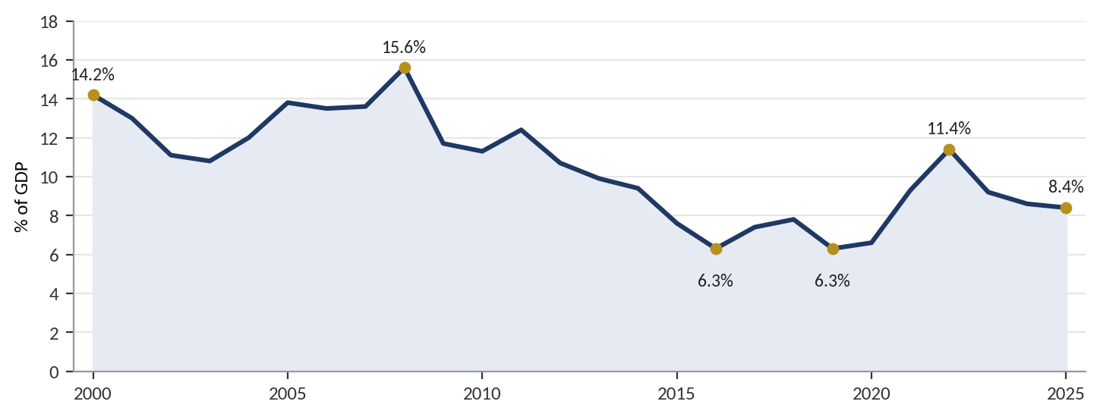
Source: author's calculation from World Bank WDI and the export series.
Dependence has fallen but remains large and unstable (Figure 1.5). Resource exports fell from 15.6% of GDP in 2008 to 6.3% in 2016, rose to 11.4% in 2022 and settled at 8.4% in 2025. A swing of five percentage points of GDP in two years is large enough to destabilise the budget if revenue is spent as it arrives.

1.6 Two problems and three layers
The evidence points to two separate policy problems. Volatility calls for a stabilisation mechanism: a rule that separates spending from current prices and a liquid buffer that absorbs the difference. Depletion calls for a savings mechanism: a permanent fund that converts finite resources into financial wealth and spends only the return (Hartwick, 1977; van der Ploeg & Venables, 2011). Large inflows also carry the risks of Dutch disease (Corden & Neary, 1982) and pro-cyclical fiscal policy, and the resource-curse literature links abundance to weaker growth where institutions are weak (Sachs & Warner, 2001).
Figure 1.6 organises the policy response into three layers. Layer 1 acts on private export receivables and addresses liquidity and the exchange rate. Layer 2, a reserve window, acts on the state's resource revenue and addresses volatility. Layer 3, a future window, holds permanent wealth and addresses depletion. Chapters 3 and 5 examine how other countries have built Layers 2 and 3; Chapters 4 and 6 apply the lessons to Indonesia, which today operates only Layer 1.
Figure 1.6. Three layers between export receivables and intergenerational wealth
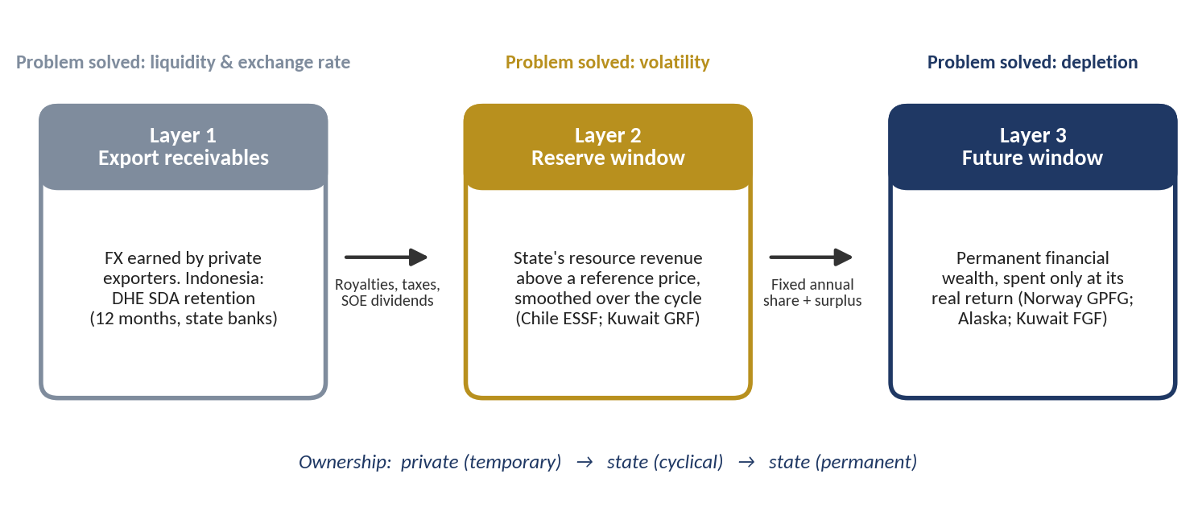
Source: author's framework.
CHAPTER 2

Danantara's Development Pipeline in Three Clusters
Part I takes stock of what Indonesia has: resource wealth that is large but volatile and depleting (Chapter 1), and a development pipeline that could convert part of that wealth into lasting capacity. This chapter describes the pipeline as set out in DDMF's RKAP 2026, how it maps to the export pillars, the figures updated in October 2026, and how all projects fall into three clusters: Industry, Technology and Finance.

2.1 What DDMF plans
Danantara Development Mandate Fund (DDMF) is the development-investment holding of BPI Danantara, established under Law No. 16/2025, PP 19/2026 and Perpres 28/2026. Unlike Danantara's commercial arm, it may accept returns below commercial levels when a project has a clear development mandate. Its own benchmarking places it between Khazanah Dana Impak, which targets only a sovereign-yield floor of about 3–4%, and development-finance hybrids such as Bpifrance and SDIC, whose returns run at roughly 3–7%.
Table 2.1. DDMF plan at a glance (RKAP 2026)
Item | Value
Strategic pipeline, 2027–2032 | 40 projects in 5 clusters; investment Rp 2,091 T; financing gap Rp 1,672 T
DDMF equity required, all 40 projects | Rp 419 T (about Rp 70 T a year)
Priority projects prepared in 2026 | 15 projects (the RKAP's 13 plus shipyards & ship components and alutsista, added for sovereignty); investment Rp 799.0 T; equity Rp 147.7 T over five years
Standard financing structure | Debt 70 : equity 30; DDMF holds 70% of the equity, so it funds 21% of capex. Athens: 90 : 10, with DDMF holding 90% of the equity
Leverage implied | Rp 1 of DDMF equity accompanies about Rp 4.8 of total investment
Capital and 2026 budget | Initial capital Rp 0.1 T plus Rp 10 T additional paid-in capital; 2026 operating budget Rp 0.79 T (Rp 0.52 T project preparation)
Development-impact KPIs | Jobs, domestic value added, TKDN, import substitution and emissions are defined, but every 2026 target is set at zero
Source: DDMF RKAP 2026 (presentation version). Exchange rate used in the RKAP: US$1 = Rp 17,800.
Table 2.2. The 15 priority projects (revised 2 October 2026)
Cluster | Project | Investment (Rp T) | Equity (Rp T) | Status and remarks
Energy | CDME (coal to DME) | 46.3 | 9.7 | Joint FS PTM–MIND ID; CAPEX data gaps
Energy | PLTS 100 GW | 231.4 | 48.6 | Hybrid-tariff regulation pending
Energy | Decentralised waste | 4.6 | 1.0 | Funding channel unresolved (no grants)
Energy | Landfill mining | 6.0 | 1.3 | Private-led; land and study pending
Energy | Legacy waste – RDF | 6.0 | 1.3 | Proposals received; offtake needed
Industry | EV Power Pack (maritime) | 3.0 | 0.6 | Moving to pre-FS
Industry | Biosimilar & pharma | 8.9 | 1.9 | On hold (overlap with SOEs)
Industry | Textile ecosystem | 89.0 | 18.7 | Early talks; DEN roadmap review
Industry | Tarsius Ph.1 (rare earths) | 2.3 | 0.5 | Pilot built; pre-FS under way
Industry | MOBNAS & MOLINAS | 25.0 | 5.3 | About one month behind plan
Industry | Athens (naval PPP) † | 167.2 | 15.1 | Remark: unknown / black programme (classified; scope and details not disclosed). NDA discussion with Naval Group ongoing (per RKAP p. 129); defence-PPP Perpres pending
Infra | Tech Corridor | 186.9 | 39.2 | Scope still to be determined
Infra | E-commerce | 1.0 | 0.2 | RFI final; investment PoV under way
Sovereignty | Shipyard & ship components | 5.2 | 1.1 | Added for sovereignty (RKAP p. 111)
Sovereignty | Alutsista production | 16.1 | 3.4 | Added for sovereignty (RKAP p. 111)
Total |  | 799.0 | 147.7 | Equity realised over five years
Source: DDMF RKAP 2026, p. 11 (priority list), p. 111 (added projects) and p. 119–131 (project overviews). † Athens is an unknown / black programme: classified, with scope and details not disclosed; figures shown are the RKAP's indicative values.
Figure 2.1 groups the 40 projects by how they relate to Indonesia's natural-resource wealth. The largest group is public goods and social infrastructure: affordable housing, 500 schools, smart cities, the Giant Sea Wall and water supply. This group accounts for Rp 997 trillion, or almost half of the pipeline. Projects that convert resources into higher-value products (coal to DME, refinery, biodiesel, rare earths, metals, copper and silica) and energy-transition projects (the 100 GW solar programme, RDF and the maritime EV Power Pack) together come to Rp 561 trillion.
Figure 2.1. DDMF's 40 projects grouped by their link to natural-resource wealth
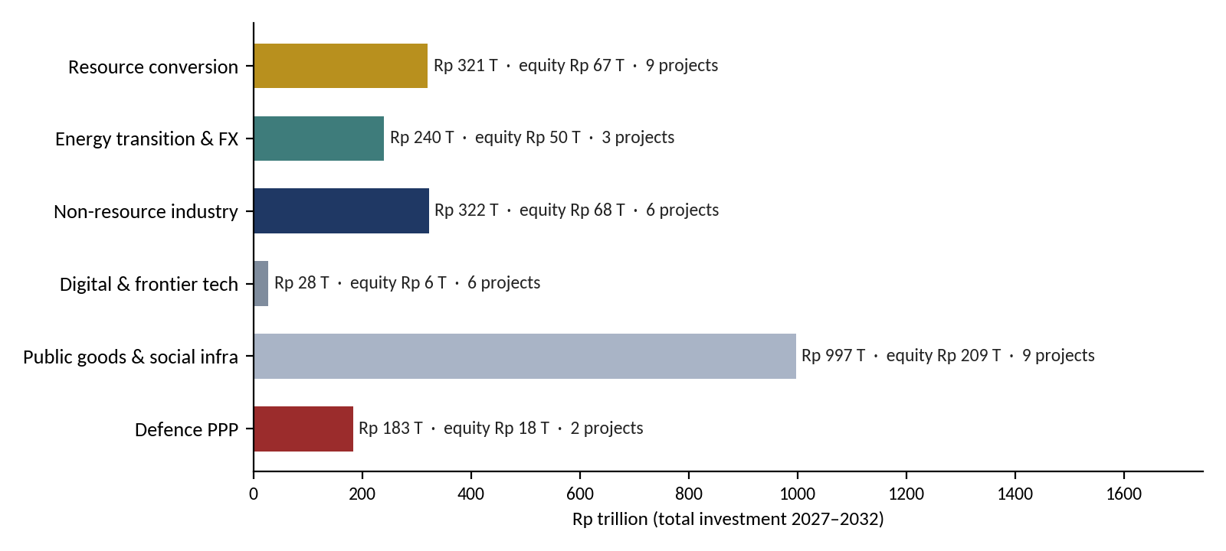
Source: author's classification of the RKAP 2026 project list. The CPE project is not described in the RKAP; it is classified as resource conversion on the assumption that it is a petrochemical project. Five projects without cost estimates (IMX, ERP Merah Putih, electric stoves, high-speed rail and the Trans-Sumatra toll road) are excluded.

2.2 Mapping the pipeline to the export pillars
Table 2.3. Indonesia's resource-export pillars and the DDMF projects that build on them
Export pillar | Exports, US$ bn (avg 2021–25) | DDMF projects linked | Stabilise-and-save reading
Coal | 32.6 | CDME (coal to DME); PLTS 100 GW as the replacement asset; RDF (a coal substitute in cement) | The largest and most mature pillar, exposed to transition risk. Converting coal rent into solar capacity is Hartwick in practice; CDME keeps value tied to coal
Oil and gas | 13.7 | Refinery; CPE | Depleting output. Refining cuts the fuel import bill and so reduces foreign-exchange pressure
Palm oil | 33.2 | Biodiesel | Renewable. Biodiesel is already subsidised through the BPDP levy, so fund money must not become a second subsidy
Nickel chain | 28.3 | Al, Fe, Ni, Mn metals for auto, aerospace and defence; EV Power Pack; MOBNAS (indirectly) | The fastest-growing pillar. Deeper processing captures more value but concentrates price risk
Copper | 9.1 | Copper project | Shift from concentrate to smelting is under way
Tin and minerals | 1.9 | Tarsius and Anoa (rare earths from tin tailings); Silica | Small tickets (Rp 0.4–8.9 T) with high strategic value; a pilot plant is already built
Source: export values from the author's 2000–2025 export analysis (UN Comtrade and CEPII BACI); project list from DDMF RKAP 2026.

2.3 The October 2026 update
In October 2026 new figures became available for six programmes. They are larger than the RKAP values, in two cases by more than ten times, and this paper uses them in place of the RKAP values (Table 2.4). The two defence lines of the RKAP, the Athens naval PPP and alutsista production, are replaced by a single defence modernisation programme of Rp 2,125 trillion; the sovereign AI line is replaced by a broader AI and IT programme.
Table 2.4. Programmes updated in October 2026 (Rp trillion)
Programme | RKAP 2026 | Updated | Multiple | Timeline assumed
Giant Sea Wall | 97.0 | 1,200 | 12.4× | 2027–2040
Defence modernisation ‡ (replaces Athens and alutsista) | 183.4 | 2,125 | 11.6× | 2027–2034
National Data Centre | 4.1 | 50 | 12.2× | 2027–2031
Quantum technology | 0.5 | 20 | 38.7× | 2027–2031
Semiconductors | 7.1 | 15 | 2.1× | 2027–2030
AI and IT programme (replaces sovereign AI) | 13.8 | 200 | 14.5× | 2027–2032
Total of the six | 305.9 | 3,610 | 11.8×
Source: RKAP DDMF 2026 (p. 110–112) and figures provided in October 2026. ‡ New submarines, unmanned surface vessels (USV), fast attack craft, refurbishment of the carrier Sriwijaya, fighter squadrons and maintenance, repair and overhaul (MRO). Timelines and the DDMF equity share for new figures (21%, the RKAP average) are the author's assumptions; see Appendix C.
With these figures the pipeline grows from Rp 2,092 trillion to Rp 5,396 trillion, 2.6 times larger, and DDMF-type equity from Rp 419 trillion to about Rp 1,133 trillion. The composition changes even more than the size. Defence modernisation is now 39% of the pipeline and the Giant Sea Wall 22%: together, almost two-thirds. Neither earns a commercial return, so the share of the pipeline that a recyclable fund can finance falls, and the question of who pays becomes central (Section 10.3).

2.4 Three clusters: Industry, Technology, Finance
Earlier drafts grouped the projects into natural resources, infrastructure and defence, with an Others group. With the updated figures that grouping no longer fits: defence alone would be bigger than the rest of the pipeline, and the new technology programmes do not belong with physical infrastructure. All projects are therefore re-clustered into three groups by what they build and how they create value: Industry (physical capacity: resource processing, energy, infrastructure, the sea wall, defence and manufacturing), Technology (digital infrastructure, deep technology and the Tech Corridor) and Finance (the fund itself and financial and commercial platforms). Inside each cluster, segments keep the economic differences that matter for the model of Chapter 8.
Table 2.5. Classification rules
Cluster | Segments | Boundary choices made
Industry | Resource processing & energy; Infrastructure & social; Giant Sea Wall; Defence platforms & MRO; Defence & maritime industry; Manufacturing | Solar, RDF, landfill mining and fishing villages are resource processing & energy; water and decentralised waste are infrastructure; the sea wall is its own segment because of its size; defence is split into platforms (imported-heavy, little productive capacity) and the domestic industrial base (shipyards, components, maritime EV power packs); MOBNAS/MOLINAS, textile and pharma are manufacturing
Technology | Digital infrastructure; Deep tech; Technology park | National Data Centre and AI and IT programme are digital infrastructure; quantum, semiconductors, the space programme and drones are deep tech; the Tech Corridor is the technology park; IMX is placed here, purpose to be confirmed
Finance | Financial & commercial platforms | The B2G/B2B e-commerce platform for MSMEs and ERP Merah Putih (uncosted). The resource fund and its funding instruments (Section 10.3) belong to this cluster but are sources of money, not capital spending
Source: author's classification of the RKAP DDMF 2026 project list and the October 2026 update. Boundary choices can be changed; see Appendix C.
Figure 2.2. Investment by segment and cluster (Rp trillion)
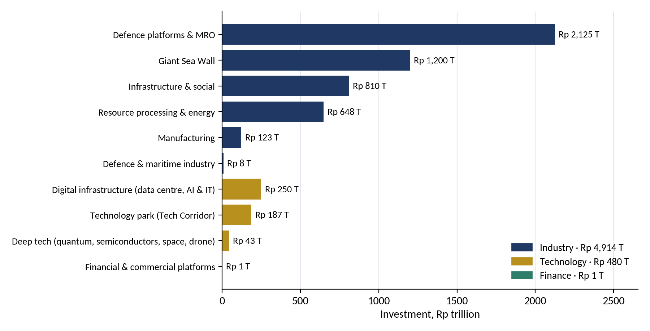
Source: RKAP DDMF 2026 (p. 110–112), October 2026 update; author's classification. Excludes five programmes without cost estimates.
Table 2.6. Clusters and segments at a glance
Cluster / segment | Projects | Investment (Rp T) | Equity (Rp T) | Share | Domestic content of capex
Industry | 26 | 4,914.3 | 1,032.0 | 91%
Resource processing & energy | 13 | 647.8 | 136.0 | 12% | 55%
Infrastructure & social | 6 | 810.3 | 170.2 | 15% | 80%
Giant Sea Wall | 1 | 1,200.0 | 252.0 | 22% | 85%
Defence platforms & MRO | 1 | 2,125.0 | 446.3 | 39% | 40%
Defence & maritime industry | 2 | 8.2 | 1.7 | 0% | 60%
Manufacturing | 3 | 122.9 | 25.8 | 2% | 50%
Technology | 7 | 480.3 | 100.9 | 9%
Digital infrastructure (data centre, AI & IT) | 2 | 250.0 | 52.5 | 5% | 35%
Deep tech (quantum, semiconductors, space, drone) | 4 | 43.4 | 9.1 | 1% | 40%
Technology park (Tech Corridor) | 1 | 186.9 | 39.2 | 3% | 75%
Finance | 1 | 1.0 | 0.2 | 0%
Financial & commercial platforms | 1 | 1.0 | 0.2 | 0% | 60%
Total (34 costed + 5 to be confirmed) | 34 | 5,395.5 | 1,133.1 | 100%
Source: as Figure 2.2. Equity: RKAP values for RKAP projects, 21% of investment for updated programmes. Domestic content is the share of capital spending that stays in Indonesia, an assumption used in Chapter 8 (Appendix B).
Figure 2.3. Investment by cluster and year, 2027–2040 (Rp trillion; label = % of GDP)
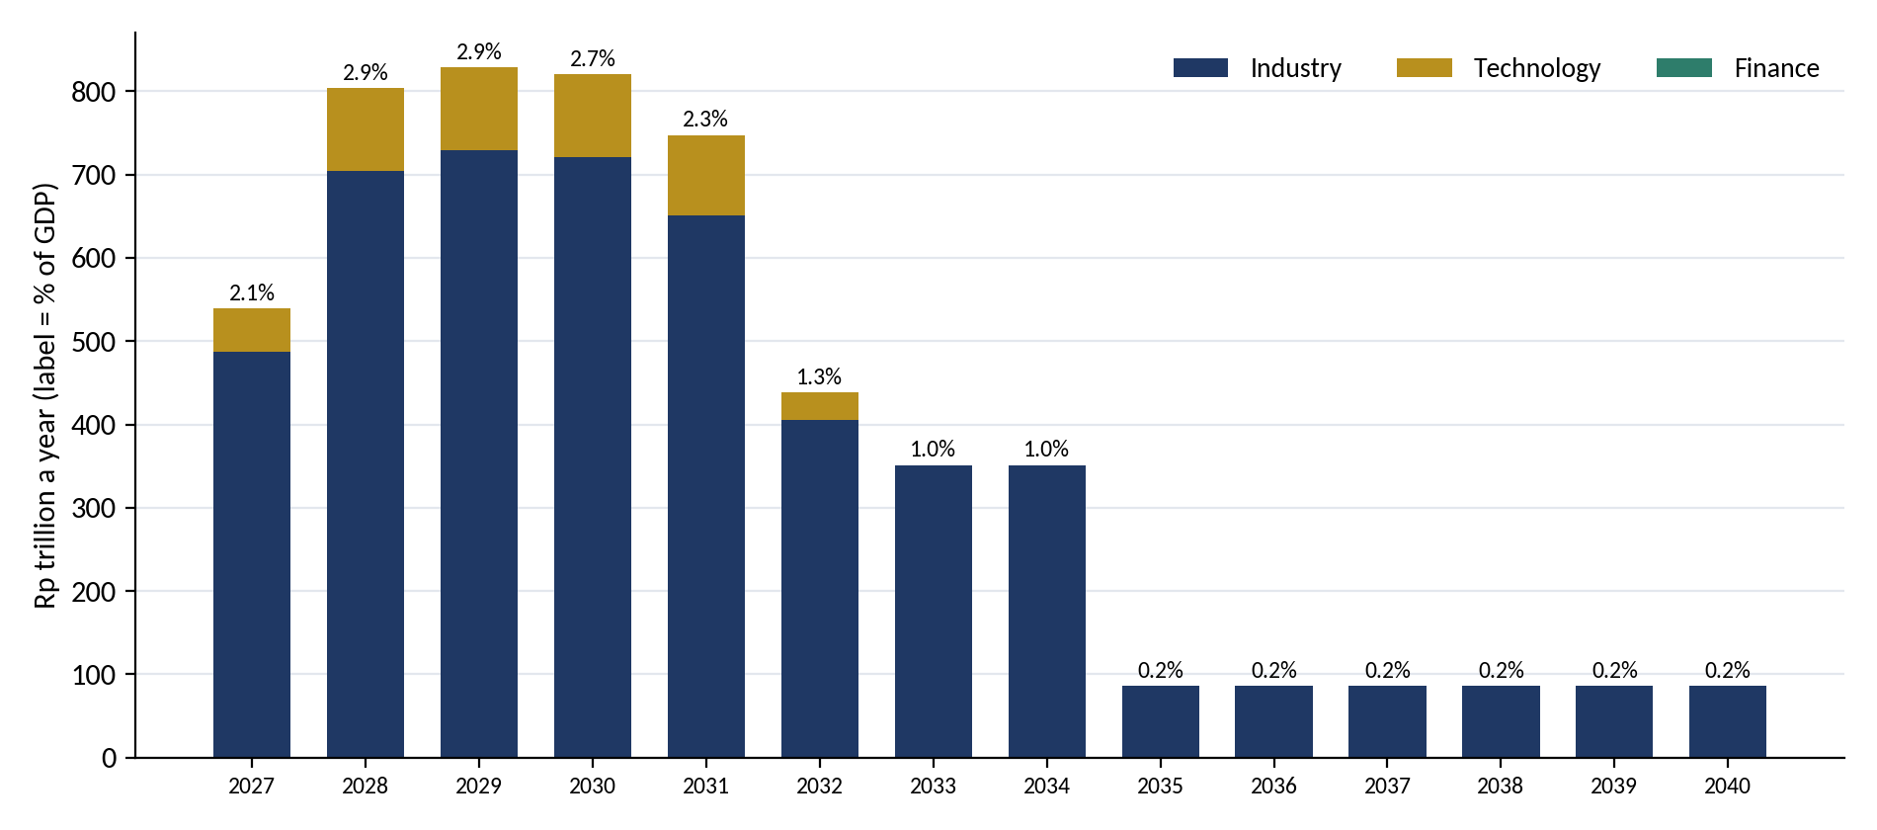
Source: author's calculation, spreading each project's investment evenly over its timeline. GDP projected from Rp 23,821 trillion in 2025 (BPS) at 5% a year in constant 2025 prices.
Investment rises from Rp 539 trillion in 2027 to about Rp 829 trillion a year in 2028–2030, about 2.9% of GDP at its highest, almost twice the RKAP peak of 1.7%. It falls in three steps: in 2032, when the RKAP projects end (to Rp 438 trillion); in 2035, when the defence programme ends (to Rp 86 trillion, the sea wall alone); and in 2041, when the sea wall is finished. Each step is a drag on growth (Section 8.3).

2.5 The Industry cluster
Industry is 91% of the pipeline: 26 projects worth Rp 4,914 trillion in six segments. Two of them are the October additions, defence modernisation (Rp 2,125 trillion) and the Giant Sea Wall (Rp 1,200 trillion). The other four are the RKAP's physical projects: resource processing and energy (Rp 648 trillion), infrastructure and social projects (Rp 810 trillion), manufacturing (Rp 123 trillion) and the defence and maritime industrial base (Rp 8.2 trillion).
Table 2.7. Industry projects (Rp trillion)
Segment | Project | Investment | Equity | Timeline
Resource processing & energy | PLTS 100 GW (solar) | 231.4 | 48.6 | 2027–2030
Resource processing & energy | Fishing-village food security | 83.8 | 17.6 | 2028–2031
Resource processing & energy | Biodiesel | 75.4 | 15.8 | 2028–2031
Resource processing & energy | Al, Fe, Ni, Mn metals | 73.3 | 15.4 | 2029–2031
Resource processing & energy | CPE (assumed petrochemical) | 71.2 | 15.0 | 2028–2031
Resource processing & energy | CDME (coal to DME) | 46.3 | 9.7 | 2027–2030
Resource processing & energy | Refinery | 40.9 | 8.6 | 2027–2032
Resource processing & energy | Silica | 8.9 | 1.9 | 2028–2031
Resource processing & energy | Legacy waste – landfill mining | 6.0 | 1.3 | 2028–2031
Resource processing & energy | Legacy waste – RDF | 6.0 | 1.3 | 2028–2031
Resource processing & energy | Project Tarsius Ph.1 (rare earths) | 2.3 | 0.5 | 2029–2032
Resource processing & energy | Copper | 2.0 | 0.4 | 2028–2031
Resource processing & energy | Project Anoa (rare earths) | 0.4 | 0.1 | 2027–2031
Infrastructure & social | 10 smart cities | 225.0 | 47.3 | 2028–2032
Infrastructure & social | Affordable housing | 219.4 | 46.1 | 2028–2031
Infrastructure & social | 500 schools | 178.0 | 37.4 | 2027–2031
Infrastructure & social | Centralised water | 112.2 | 23.6 | 2028–2031
Infrastructure & social | STEM university | 71.0 | 14.9 | 2027–2031
Infrastructure & social | Decentralised waste | 4.6 | 1.0 | 2027–2031
Giant Sea Wall | Giant Sea Wall * | 1,200.0 | 252.0 | 2027–2040
Defence platforms & MRO | Defence modernisation ‡ * | 2,125.0 | 446.3 | 2027–2034
Defence & maritime industry | Shipyard & ship components | 5.2 | 1.1 | 2028–2032
Defence & maritime industry | EV Power Pack (maritime) | 3.0 | 0.6 | 2028–2031
Manufacturing | Textile ecosystem | 89.0 | 18.7 | 2028–2031
Manufacturing | MOBNAS & MOLINAS | 25.0 | 5.3 | 2027–2029
Manufacturing | Biosimilar & pharma | 8.9 | 1.9 | 2028–2031
Source: RKAP DDMF 2026, p. 11 and 110–112; * October 2026 update. ‡ Submarines, USV, fast attack craft, carrier Sriwijaya refurbishment, fighter squadrons and MRO. Uncosted: electric stoves, high-speed rail and the Trans-Sumatra toll road (Appendix A).
Resource processing: what the evidence says. Indonesia's nickel downstreaming is the template and the warning. Nickel exports rose from US$3.3 billion in 2017–2018 to US$33.5 billion in 2023, and exported products are worth many times the ore (Antara, 2024). Indonesia produced 58% of world nickel in 2024, but Chinese firms control about 75% of refining capacity and China took 82% of the exports (CSIS, 2025). A World Bank study finds that the ore export ban raised domestic value added in iron- and steel-using industries by 5.6%, but by only 1.1% across all exports, with lower productivity (Kee and Xie, 2025). The IMF (2023 Article IV) recommended phasing out export restrictions. CREA and CELIOS (2024) estimate health costs of US$2.6 billion a year from captive coal power at smelters. The lesson for the fund is that conversion pays only with domestic ownership, technology and clean energy.
Coal to DME carries a direct precedent: the PTBA–Air Products–Pertamina project (US$2.1 billion, 1.4 Mtpa, about 6 Mt of coal a year) broke ground in January 2022, and Air Products withdrew in March 2023 (Petromindo, 2023). Press reports in November 2025 put Danantara's revived DME programme at Rp 164 trillion, far above the RKAP's Rp 46.3 trillion; the scope needs to be reconciled (Appendix C). Solar: the RKAP's PLTS 100 GW compares with 17.1 GW of new solar in PLN's RUPTL 2025–2034 and only about 700 MW installed by 2024 (IESR, 2024); the JETP plan needs US$97.3 billion for 44% renewable power by 2030 (JETP, 2023). Offtake, not finance, is the binding constraint, as the RKAP itself notes. Copper: Freeport's US$3.7 billion Gresik smelter (1.7 Mt of concentrate) and Amman's Sumbawa smelter (900 kt) are already built, so DDMF's Rp 2 trillion copper project must find a niche downstream. Rare earths: PT Timah estimates 25,700 t of monazite in Bangka Belitung but has struggled for a decade with processing technology, which is exactly what Tarsius and Anoa aim to solve.
Infrastructure: what the evidence says. The IMF (2026) estimates Indonesia's public-investment multiplier at about 0.5 in the first year, 1.2 after five years and 2.0 in the long run, rising to 0.7 and 2.6 if investment efficiency reached advanced-economy levels; public capital per person is about a quarter of advanced-economy levels, and reaching high income by 2045 needs 5.3–6.3% growth a year. The record is mixed. 190 national strategic projects worth Rp 1,515 trillion were completed in 2016–2023 (Kemenko Perekonomian, 2024), but the Jakarta–Bandung high-speed rail cost US$7.27 billion including a US$1.2 billion overrun, with the Indonesian consortium losing Rp 4.2 trillion in 2024 (Annisa and Kingsley, 2025), and the Ministry of Finance is taking it over from Danantara (Jakarta Post, 2026). Hutama Karya received Rp 131.1 trillion of state capital for the Trans-Sumatra toll road in 2015–2024 (Kompas, 2024).
Needs are real. The housing ownership backlog fell from 12.75 million units in 2020 to 9.9 million in 2023 (PKP, Susenas). Data-centre capacity is 637 MW and projected to reach about 1.6 GW by 2027 (Bisnis, 2026).
Giant Sea Wall. The updated figure of Rp 1,200 trillion is close to the government's estimate of about US$80 billion (Indonesia Business Post, 2025) and replaces the RKAP's Rp 97 trillion first phase. Spread over 2027–2040, it is about Rp 86 trillion a year. It is the most domestic project in the pipeline (85% of capex assumed to stay at home) and the largest employer (Section 8.7), but it protects existing assets rather than creating new output, so only 60% of its capital is counted as productive.
Defence modernisation. At Rp 2,125 trillion over 2027–2034, the programme averages about Rp 266 trillion a year, about 1% of GDP and well above the whole 2026 Ministry of Defence budget of Rp 187.1 trillion, of which alutsista modernisation is Rp 84.5 trillion. Whether the programme is additional to that budget or partly replaces it is the most important open point of this update (Appendix C). The economic return depends almost entirely on how much is built at home. This paper assumes 40% domestic content, slightly below the 43% that DEFEND ID reports (Triantama, 2026); at that level about US$72 billion of the cost is imported. Submarines built at PT PAL, fast attack craft from domestic yards, and MRO carried out in Indonesia raise that share; fighter aircraft bought abroad lower it.
Defence: what the evidence says. The 2026 Kemhan budget is Rp 187.1 trillion, about 0.8% of GDP and the lowest share in Southeast Asia; at least half goes to routine costs and about 30% to procurement (ASPI, 2026). Of Rp 84.5 trillion for alutsista modernisation, Rp 46.5 trillion comes from foreign loans (CNBC Indonesia, 2026). Minimum Essential Force achievement was 63.2% in 2019 against a 68.9% target and 62.3% in 2020 against 72% (Databoks, citing the 2024 budget note). Law 16/2012 requires local content and/or offset of at least 35%, rising 10% every five years (Kemhan). DEFEND ID, the defence SOE holding, earned US$1.1 billion of arms revenue in 2024 (+39%) and entered the SIPRI Top 100 at 96th; its local content is 43%, targeting 50% by 2029, but only 9% of transactions take place between domestic supply-chain tiers (Triantama, 2026). Indonesia has 342 shipyards with 1 million DWT of annual new-build capacity and more than 46,000 workers (Antara, 2025), and two Scorpène Evolved submarines contracted in March 2024 are being built at PT PAL Surabaya with technology transfer (Naval News, 2024).
On growth, the international evidence is unfavourable: the survey by Dunne and Tian (2013) of about 170 studies finds more recent evidence of a negative effect of military spending on growth. The positive cases come where spending builds domestic industrial capability and supplier depth. That is why the sovereignty tier finances the industrial base and not platform purchases, and why supplier development for SMEs (for example through a Develop–Off-taker–Certification–Upgrading programme) is the main economic lever in this cluster.
Industry: implications
- Resource processing converts depleting rent into lasting capacity and stays the core of what the resource fund itself should own.
- Infrastructure and the sea wall give the largest short-run boost and the most jobs per rupiah; they are public goods for the budget, KPBU and resource-backed bonds, not for recyclable fund equity.
- Defence modernisation is justified by sovereignty first. Per rupiah it adds the least to GDP; raising its domestic content from 40% to 60% is worth about 0.3 points of GDP at the peak and saves about US$24 billion of imports (Section 8.5).

2.6 The Technology cluster
Technology has 7 projects worth Rp 480 trillion, 9% of the pipeline, in three segments: digital infrastructure (the National Data Centre, Rp 50 trillion, and the AI and IT programme, Rp 200 trillion), deep tech (quantum technology Rp 20 trillion, semiconductors Rp 15 trillion, the national space programme and drones) and the Tech Corridor (Rp 186.9 trillion). IMX is placed in this cluster with its purpose still to be confirmed.
Table 2.8. Technology projects (Rp trillion)
Segment | Project | Investment | Equity | Timeline
Digital infrastructure | AI and IT programme * | 200.0 | 42.0 | 2027–2032
Digital infrastructure | National Data Centre * | 50.0 | 10.5 | 2027–2031
Deep tech | Quantum technology development * | 20.0 | 4.2 | 2027–2031
Deep tech | Semiconductors * | 15.0 | 3.2 | 2027–2030
Deep tech | National space programme | 5.4 | 1.1 | 2027–2031
Deep tech | Drone | 3.0 | 0.6 | 2028–2031
Technology park | Tech Corridor | 186.9 | 39.2 | 2028–2031
Digital infrastructure | IMX (purpose to be confirmed) | n.a. | n.a. | n.a.
Source: RKAP DDMF 2026, p. 110–112; * October 2026 update. The RKAP sovereign AI line (Rp 13.8 T) is replaced by the AI and IT programme.
What the evidence says. Indonesia's data-centre capacity is about 637 MW and projected to reach about 1.6 GW by 2027 (Bisnis, 2026), much of it built by private and foreign operators. Servers, accelerators and cooling equipment are imported, so this paper assumes that only 35% of digital-infrastructure capex stays in Indonesia. The return lies in productivity and adoption, not in construction. In semiconductors, the realistic segments are back-end assembly and test, power devices and chip design (Section 9.3); Danantara and Arm agreed in February 2026 to train up to 15,000 chip designers. Quantum technology is at the research stage everywhere; Rp 20 trillion is a long-term capability bet.
Technology: implications
- The highest import content of any cluster: about US$13 billion of equipment over 2027–2032. Tie data centres to domestic renewable power and to sovereign-data rules that secure demand.
- Define the Rp 200 trillion AI and IT programme in tranches: shared compute, public-sector systems, skills and applications, each with an owner, a user and a measurable output.
- Keep deep tech small and staged: back-end semiconductors and design talent first, quantum as research partnerships, no front-end fab.

2.7 The Finance cluster
Finance is small in capital spending, Rp 1 trillion for a B2G/B2B e-commerce platform for MSMEs plus ERP Merah Putih, which has no cost estimate yet. Its role is larger than its size. The Finance cluster also holds the resource fund of Parts II and III and the instruments that pay for the other two clusters: the development window, earmarked resource receipts, resource-SOE dividends, loans funded by retained export proceeds (DHE SDA) and resource-revenue bonds. Section 10.3 sets out how far natural resources can fund the pipeline.
- Platforms. State platforms survive where the state is the buyer (Section 9.4). The e-commerce line should consolidate PaDi UMKM and e-Katalog into a B2G/B2B platform with supply-chain finance; ERP Merah Putih needs a scope and cost before it is assessed.
- The fund as a source of money. Under the maximised resource-first rule, natural resources provide about 54% of the money needed for 2027–2034 and anchor about 74% (Section 10.3).
PART II
Dealing with Current Conditions: Stabilise
How do we protect the budget and the economy from today's price swings?
Chapter 3 reviews how Chile, Mexico and Brazil manage commodity-revenue volatility. Chapter 4 applies the lessons to Indonesia: the starting position, the export-proceeds regime, which commodities to cover, the architecture of one fund, the reference-price rule, the palm oil levy, and the case for acting during the 2026 windfall.
CHAPTER 3

How Other Countries Stabilise Resource Revenue
This chapter reviews three Latin American commodity exporters that illustrate different approaches to price volatility. Chile provides the leading model, Mexico an instructive variant based on financial insurance, and Brazil a cautionary case of relying on general spending rules alone.

3.1 Chile: a reference-price rule with independent experts
Since 2001 Chile's structural balance rule has set public spending according to revenue at a long-run copper price and trend GDP, not at current values. Both parameters are estimated each year by independent expert committees whose methods are published. When copper trades above the reference price the surplus is saved; when it trades below, the government may draw on savings.
The Fiscal Responsibility Law of 2006 created the Economic and Social Stabilization Fund (ESSF) from the older Copper Stabilization Fund (established in 1985), together with a separate Pension Reserve Fund. Chile drew heavily on the ESSF during the 2009 global financial crisis, financing a counter-cyclical stimulus without new borrowing, and again during the pandemic. An Autonomous Fiscal Council was established by law in 2019. Academic reviews note one weakness: frequent changes to the rule's methodology have weakened its anchoring of expectations. The central lesson is that credibility depends on who sets the reference price. Chile's advantage is also structural: the state-owned Codelco gives the government direct revenue from copper, supplemented by the 2023 royalty reform.

3.2 Mexico: insurance and a stabilisation fund
Mexico's annual budget assumes a reference oil price, and since the early 2000s the Ministry of Finance has bought put options to lock in a floor for oil revenue. The programme paid out large sums when prices collapsed, notably in 2009 and 2015, with payouts in the order of US$5–6 billion. It is complemented by a budget revenue stabilisation fund (FEIP) and, since the 2013–2014 energy reform, by the Mexican Petroleum Fund (FMP), managed by the central bank.
Mexico shows that market insurance can protect a single budget year cheaply and transparently. It also shows the limits of a buffer without a strong deposit rule: the FEIP was drawn down to a small fraction of its earlier size between 2019 and 2021, leaving little protection for the next shock.

3.3 Brazil: general spending rules without a commodity rule
Brazil has no commodity-price rule comparable to Chile's. Fiscal policy has been anchored by a constitutional spending cap in 2016, replaced in 2023 by a framework linking expenditure growth to revenue growth. Commodity revenue still flows through oil royalties, the CFEM mining royalty (restructured in 2017) and dividends and taxes from Petrobras and Vale. The Sovereign Fund of Brazil, created in 2008, remained small, was used for other purposes and was wound down in 2018; a Pre-salt Social Fund created in 2010 directs part of offshore oil income to education and health. During the 2000s supercycle, windfall revenue supported expanding spending and credit; when prices fell after 2014, the adjustment was abrupt and coincided with a deep recession.
Table 3.1. Stabilisation approaches in Chile, Mexico and Brazil
Dimension | Chile | Mexico | Brazil
Main commodity | Copper (state-owned Codelco plus private mines) | Oil (Pemex) | Oil, iron ore (private and mixed firms)
Budget price | Long-run reference price set by independent committee | Reference oil price in annual budget | Implicit in revenue forecasts
Shock absorber | ESSF: saves surplus, drawn in downturns | Put-option hedge; FEIP; FMP | None dedicated; FSB wound down in 2018
Fiscal anchor | Structural balance rule (2001); Fiscal Responsibility Law (2006) | Budget balance law and reference price | Spending cap (2016); fiscal framework (2023)
Independent oversight | Expert committees; Autonomous Fiscal Council (2019) | Limited | Limited
Main lesson | Independent price-setting gives the rule credibility | Insurance protects one year; buffers need deposit rules | Spending caps alone do not save windfalls
Sources: Hacienda Chile; UNU-WIDER; Mexican Ministry of Finance; Brazilian National Treasury.

3.4 How a reference-price rule works
Figure 3.1 illustrates the mechanism with hypothetical numbers for coal revenue. The budget assumes a reference price of US$100 per tonne. In the simulation, 80% of revenue above the reference is saved in the reserve window; when prices fall below the reference, the window tops up the budget, with withdrawals capped at 25% of the balance in any year. Over twelve years the market price swings between US$70 and US$165, but budget spending moves only between 100 and 113 on the index, and the reserve window never runs dry. The actual coal export series in Chapter 1, which rose from US$15 billion in 2020 to US$47 billion in 2022 and fell back to US$24 billion in 2025, has exactly this profile.
Figure 3.1. Illustrative reference-price rule for coal revenue (hypothetical data)
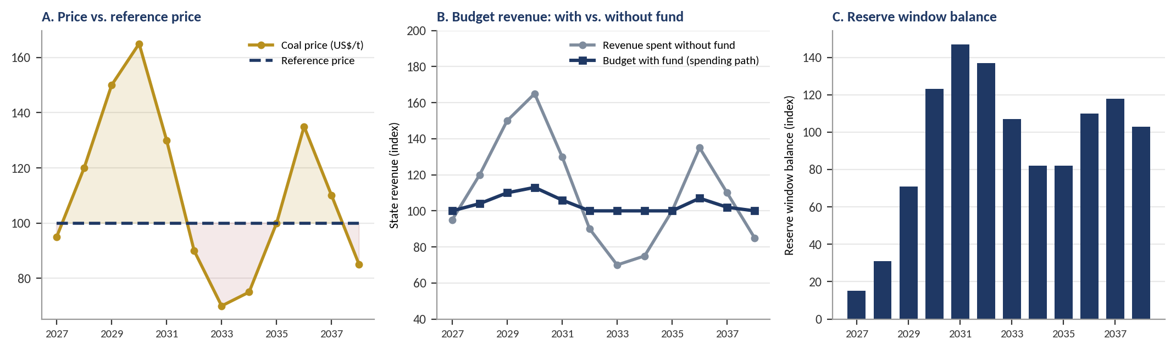
Source: author's simulation. Revenue indexed to 100 at the reference price with constant volume. Rules: 80% of windfall saved; withdrawals capped at 25% of balance a year; opening balance 20. The numbers illustrate the mechanism and are not forecasts.

3.5 Why future receivables cannot be spent in advance
A recurring question is whether future export receivables can be brought into the present, either as collateral for borrowing or as backing for money creation, as gold once backed currencies. The evidence suggests they can be brought forward, but not for free (Table 3.2). Countries that have managed resource revenue well have done the opposite: they have moved windfalls forward in time through stabilisation and savings rules.
Table 3.2. Ways of using future export receivables, and their limits
Mechanism | Examples | Assessment
Future-flow securitisation | Pemex oil receivables; Brazilian and Mexican banks' diversified payment rights | Lowers borrowing costs for specific firms by routing cash flows offshore. A financing efficiency, not a growth engine
Resource-backed loans | Angola and Ecuador oil-for-loan deals | Cash arrives now but future revenue is pre-committed; both countries lost fiscal flexibility when prices fell
Money creation against receivables | Zimbabwe bond notes (2016); Venezuela Petro (2018); French assignats | Receivables are uncertain and not owned by the central bank; printing against them has ended in inflation
Stabilisation rule | Chile structural balance rule; Mexico oil hedge | Prevents temporary windfalls from being spent and smooths spending across the cycle
Savings rule | Norway GPFG; Alaska Permanent Fund; Kuwait FGF | Converts depleting resources into permanent financial assets and spends only the return
Sources: Ketkar & Ratha (2009); World Bank and IMF case material.
CHAPTER 4

Stabilising Indonesia's Resource Revenue
Part II deals with the present: how to stop commodity price swings from passing straight into the budget and the economy. This chapter applies the lessons of Chapter 3 to Indonesia.

4.1 Starting position
Indonesia's State Finance Law caps the budget deficit at 3% of GDP and public debt at 60% of GDP. These limits constrain borrowing but do not smooth commodity windfalls: in a boom, higher resource revenue can finance higher spending without breaching either limit. The budget assumes an oil price (the Indonesian Crude Price), lifting volumes and an exchange rate, but coal, palm oil and nickel are not treated through a reference-price rule, and mineral royalties and non-tax revenue (PNBP) are spent within the year.
Two sovereign investment vehicles exist. The Indonesia Investment Authority (INA), established in 2021, co-invests with foreign partners. Danantara, established under Law No. 1 of 2025, consolidates state-enterprise holdings and invests largely at home, including US$7 billion of downstream processing projects launched in February 2026. It is financed mainly by SOE dividends rather than resource rent (IEEFA, 2026), and East Asia Forum (2026) notes tension between its commercial and development mandates. Neither vehicle saves in booms and releases funds in busts.

4.2 The DHE SDA regime
Table 4.1. Evolution of the DHE SDA regime
Instrument | Effective | Main provisions
PP 36/2023 | 2023 | Resource exporters retain at least 30% of export proceeds in the domestic financial system for at least three months
PP 8/2025 | 1 March 2025 | Non-oil-and-gas sectors: 100% retention for 12 months in special FX accounts. Oil and gas unchanged at 30% for three months
PP 21/2026 | 1 June 2026 | Special accounts only at state-owned banks (Himbara); conversion to rupiah capped at 50%; income tax on placement instruments as low as 0%
Sources: BPK regulation database; Coordinating Ministry for Economic Affairs (2025); Ministry of Finance press release SP-39/KLI/2026.
Bank Indonesia reported reserves of US$146.5 billion at the end of August 2026, equal to 5.4 months of imports. Measured against Figure 1.6, DHE SDA is a Layer 1 instrument: the money remains the exporters' and returns to them after 12 months. It does not transfer resource rent to the state, and it can be pro-cyclical: retained balances rise when prices are high and fall when they are low.

4.3 Which commodities should the fund cover?
Combining the export evidence of Chapter 1 with the state's revenue channels gives a clear sequence (Table 4.2). Coal and oil and gas combine large, volatile revenue with clear state revenue lines and should come first. Palm oil is large and volatile but its levy is earmarked, so it should follow a levy reform. The nickel chain is large and growing, but the state's share is limited while smelter tax holidays run, so it should be added later.
Table 4.2. Suitability of Indonesian commodities for the fund
Commodity | Exports, avg 2021–25 | State revenue channel | Main constraint | Fit
Coal | US$32.6 bn | Royalties, PNBP, CIT, export-related revenue | Domestic market obligation and capped domestic prices; long-term demand risk | High: start here
Oil and gas | US$13.7 bn | Production-sharing income, taxes; ICP already in budget | Declining output; domestic gas price cap | High: start here
Palm oil and derivatives | US$33.2 bn | Export duty and levy (BPDP); CIT | Levy earmarked for biodiesel and replanting; ~40% smallholder area | Medium: after levy reform
Nickel chain | US$28.3 bn | Royalties; smelter CIT | Tax holidays; foreign-owned smelters; Indonesia's supply moves the world price | Medium: add later
Copper | US$9.1 bn | Royalties, dividends (MIND ID stake), CIT | Shift from concentrate to domestic smelting | Medium: add later
Tin, gold, rubber, plywood | US$8.5 bn | Royalties, forest charges, CIT | Small or declining revenue | Low
Source: author's calculation from the export series; revenue channels from earlier reports in this series.

4.4 The proposed architecture: one fund, two windows
The paper proposes a single Natural Resource Stabilisation and Wealth Fund, established by Law and funded from the state's own resource revenue rather than private export proceeds. One Law, one governance structure and one reporting line reduce administrative cost and make the trade-offs between the two windows explicit, as Kuwait's experience recommends (Figure 4.1 and Table 4.3).
Figure 4.1. Proposed architecture of the Natural Resource Stabilisation and Wealth Fund
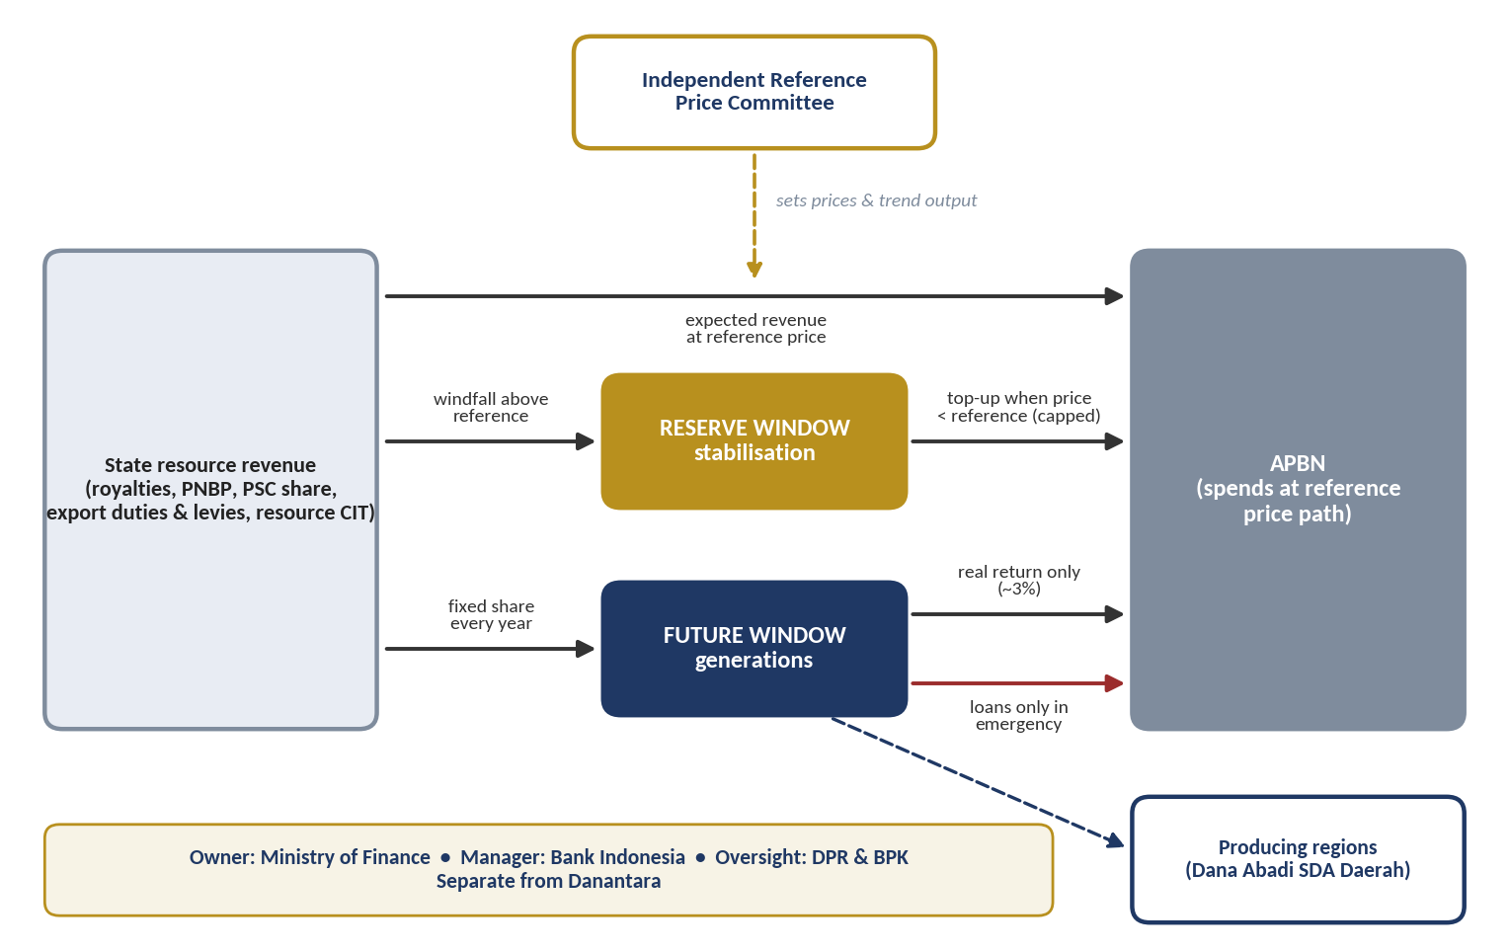
Source: author's proposal. Dashed arrows show price-setting and an optional regional share; the red arrow shows emergency borrowing only.
Table 4.3. Proposed rules for the two windows
Element | Reserve window (stabilisation) | Future window (generations)
Purpose | Smooth resource revenue across the price cycle | Convert depleting resources into permanent financial wealth
Inflow | Revenue above the reference price for coal, oil and gas (later palm oil and nickel); most of the windfall saved automatically | A fixed share of resource revenue every year, regardless of price (reference points: Kuwait 10%, Alaska 25%)
Outflow | Automatic top-up when revenue falls below the reference path, capped at a share of the balance per year; a floor below which draws stop | Only the expected real return (reference: Norway 3%); principal locked
Emergency access | Not applicable | Borrowing only, capped (reference: Kuwait 10% of net assets), repayment first, no write-off without a Law
Investment | Liquid foreign-currency assets | Diversified global portfolio, largely abroad
Precedent | Chile ESSF; Mexico FEIP and hedge; Kuwait GRF | Norway GPFG; Alaska principal; Kuwait FGF
Percentages are reference points from the cases reviewed, not calibrated recommendations.

4.5 Stabilising: the reference-price rule
Each covered commodity receives a medium-term reference price, for example a ten-year smoothed estimate, published before the budget is drafted by an Independent Reference Price Committee of experts outside the Ministry of Finance, with published methods. Expected revenue at the reference price and trend output sets the spending ceiling for resource revenue. Because Indonesia's own supply moves the world price of nickel and palm oil, their reference prices should carry a conservative discount and be checked against external forecasts. The 3% deficit limit remains; the fund reduces the need to approach it. A modest annual put-option programme, on the Mexican model, can protect a single budget year while the reserve window is still small.

4.6 Reforming the palm oil levy
The palm oil levy administered by BPDP is already a quasi-stabilisation instrument, but most of its proceeds finance the biodiesel subsidy. Three changes would bring palm oil into the fund: a rising share of levy revenue saved when prices are above the reference; smallholder replanting support ring-fenced; and an explicit annual budget ceiling for the biodiesel programme.

4.7 Import substitution as structural stabilisation
Several projects stabilise the economy by a route that Parts II and III did not consider: they cut imports. CDME alone would save about US$0.9 billion a year in LPG imports at 20% substitution, rising to US$4.5 billion at full substitution, against a capex of US$2.88 billion for 1.4 MTPA. The refinery, biodiesel and ship-component projects work the same way. Each dollar of imports replaced makes the current account, and therefore the rupiah, less dependent on commodity export prices. This complements the reserve window, which absorbs price swings on the fiscal side.
There is a catch. Resource-conversion projects earn revenue that moves with the same commodity prices as the state's own resource revenue. When coal or nickel prices fall, the budget, the reserve window and the projects' dividends all weaken at the same moment. A development window that holds only resource-conversion assets would concentrate risk rather than spread it. The portfolio therefore needs caps by commodity and a share of assets whose returns do not move with commodity prices, such as solar power under long-term contracts and labour-intensive manufacturing.

4.8 The timing argument: a boom is under way
In January–August 2026 total PNBP reached Rp 435.1 trillion, 41.7% higher than a year earlier and already 94.8% of the full-year target. Natural-resource PNBP contributed Rp 194.6 trillion (oil and gas Rp 80.1 trillion, non-oil-and-gas Rp 114.4 trillion). For comparison, natural-resource PNBP for the whole of 2024 was Rp 229.2 trillion. This is exactly the kind of windfall that the reserve window is designed to capture. Without a fund, it will be spent as it arrives. With a development window, part of it could seed the equity DDMF needs from 2027 without adding to the deficit.
PART III
Preparing the Future: Save
How do we turn a depleting asset into permanent wealth?
Chapter 5 reviews how Norway, Alaska and Kuwait save resource wealth, and what went wrong in Timor-Leste. Chapter 6 designs Indonesia's future window: how much to save, where, and how to protect it, and why saving can also mean converting rent into lasting assets at home.
CHAPTER 5

How Other Countries Plan, Execute and Save Resource Wealth
This chapter examines three jurisdictions that turn resource revenue into lasting wealth, each with a distinct design: a single consolidated fund (Norway), a fund with a constitutional principal and a citizen dividend (Alaska), and a dual reserve and future structure (Kuwait). Timor-Leste is treated as a contrasting case. For each, the analysis covers how money enters, how it leaves, the macroeconomic effects and the safeguards against overspending.

5.1 Norway: everything in, only the return out
Planning. Norway settled the rules before revenue arrived in volume. The Petroleum Fund was established in 1990, the first transfer made in 1996, and the fund renamed the Government Pension Fund Global (GPFG) in 2006. Execution. The state's entire net cash flow from petroleum, from a special petroleum tax, direct ownership of licences and Equinor dividends, goes into the fund, and money can leave only by decision of Parliament. The fund invests only abroad, which keeps petroleum income from flowing directly into the domestic economy and limits Dutch disease. Saving. Since 2001 a fiscal rule has guided withdrawals toward the fund's expected real return, set at 4% and lowered to 3% in 2017. For 2026 the government proposed spending NOK 579.4 billion, 2.8% of the fund's value, financing 26.8% of central government expenditure.
At the end of 2025 the fund was worth about NOK 21,300 billion. Cumulative returns (NOK 13,457 billion) are about 2.5 times the net petroleum inflows (NOK 5,420 billion). Monetary policy is separate, under an inflation-targeting central bank. The rule rests on cross-party consensus rather than the constitution; the OECD (2026) notes the fund now covers a growing share of deficits and recommends a medium-term expenditure plan.

5.2 Alaska: a constitutional principal and a citizen dividend
Planning. Alaskan voters created the Permanent Fund by constitutional amendment in 1976, shortly before Prudhoe Bay revenue arrived. Execution. At least 25% of mineral royalties and related receipts must be deposited, and the principal cannot be spent. Since 2018 a draw of 5% of average market value finances government services and the Permanent Fund Dividend. Effects. The dividend had no effect on overall employment while raising part-time work (Jones & Marinescu, 2022) and substantially reduced poverty among Alaska Natives (Berman, 2024). Weaknesses. The constitutional lock on the principal has held for five decades, but the dividend has not: in 2016 the governor vetoed about half of it, and the courts ruled it must be appropriated annually. The 2026 dividend was US$1,000 plus a one-time US$200 energy payment. A dividend builds public support for the fund, but only if its formula is protected.

5.3 Kuwait: separate reserve and future funds
Planning. Kuwait set up the world's first sovereign fund in 1953. Execution. The General Reserve Fund (GRF) receives oil revenue and pays for the budget; the Future Generations Fund (FGF), governed by a 1976 law, is a long-term savings fund. For decades 10% of state revenue was transferred automatically to the FGF; in 2020 the transfer was made conditional on a budget surplus. Emergency access. In 2026, with exports disrupted and a deficit projected near 20% of GDP, Decree-Law No. 81 of 2026 allowed the GRF to borrow from the FGF under strict conditions: outstanding loans capped at 10% of FGF net assets, annual borrowing capped at the fund's five-year average return, repayment first when surpluses return, and no write-off without a new law. Lesson. Kuwait protected its future fund but did not constrain the wage and subsidy bill its reserve fund had to finance, so the reserve layer drained first.
Table 5.1. Savings approaches in Norway, Alaska and Kuwait
Dimension | Norway (GPFG) | Alaska (Permanent Fund) | Kuwait (GRF and FGF)
Inflow rule | 100% of state net petroleum cash flow | At least 25% of royalties (constitution) | All oil revenue to GRF; 10% to FGF until 2020, now surplus years only
Outflow rule | Expected real return, 3% since 2017 | 5% of average market value (since 2018) | FGF closed to withdrawals; capped borrowing since Sept 2026
Legal strength | Parliamentary guideline with broad consensus | Principal: constitution. Draw and dividend: statute and annual budget | FGF: statute; 2026 decree-law sets borrowing limits
Citizen link | Indirect: funds public services | Direct cash dividend | Indirect: wages and subsidies
Main weakness | Growing reliance to cover deficits | Earnings spendable by simple majority | Unconstrained budget drained the reserve fund
Sources: Norwegian Ministry of Finance (2025); APFC (2025); Moody's and Fitch via Times Kuwait (2026); AGBI (2026).

5.4 The contrasting case: Timor-Leste
Timor-Leste's Petroleum Fund Law of 2005 was modelled on Norway. All petroleum income enters the fund, which invests only abroad. Its distinctive feature is the Estimated Sustainable Income (ESI): 3% of total petroleum wealth, defined as the fund balance plus a prudent present value of future revenue from approved projects. In other words, it counts future export receivables as wealth, but only those that are reasonably certain. In practice, withdrawals have exceeded the ESI almost every year since 2009, averaging about 5% (Figure 5.1). The fund pays for more than 80% of the budget, held US$18.74 billion in June 2025, and is projected to be depleted within about a decade now that the Bayu-Undan field has ceased production.
Figure 5.1. Withdrawal ceiling set by rule vs. recent practice (% of fund value per year)
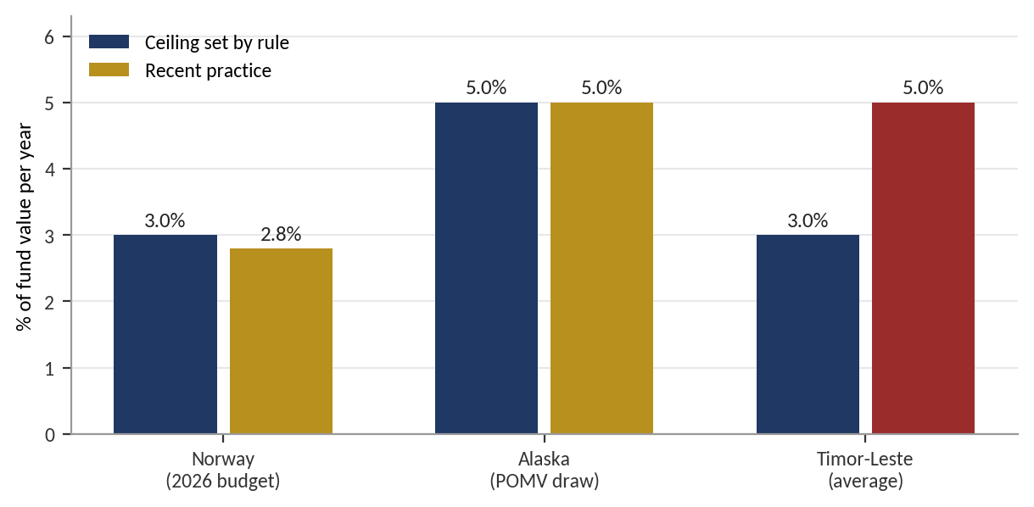
Sources: Norwegian Ministry of Finance (2025); Alaska Statutes; EITI (2023). Red marks practice above the rule.
Why Timor-Leste matters for Indonesia
- Counting future receivables is prudent only if spending respects the result: the ESI limited the wealth base correctly, but discipline failed at the withdrawal stage.
- Soft ceilings erode: a limit that Parliament can exceed each year with a justification becomes a target, not a cap.
- A fund cannot replace a domestic tax base: drawing on the fund proved easier than building revenue capacity.
- Regional relevance: Timor-Leste joined ASEAN in 2025, and its fiscal stability is of direct interest to Indonesia.

5.5 Lessons across all cases
Figure 5.2 places the key institutional events of all jurisdictions on one timeline. Two patterns stand out. First, the durable funds were legislated before or at the start of the revenue boom, when there was little yet to spend. Second, the most damaging changes came under fiscal stress: Kuwait's 2020 amendment, Alaska's 2016 dividend veto, Mexico's 2019–2021 drawdowns and Brazil's 2018 wind-down all weakened buffers when they were most needed.
Figure 5.2. Timeline of stabilisation and savings institutions, 1953–2026
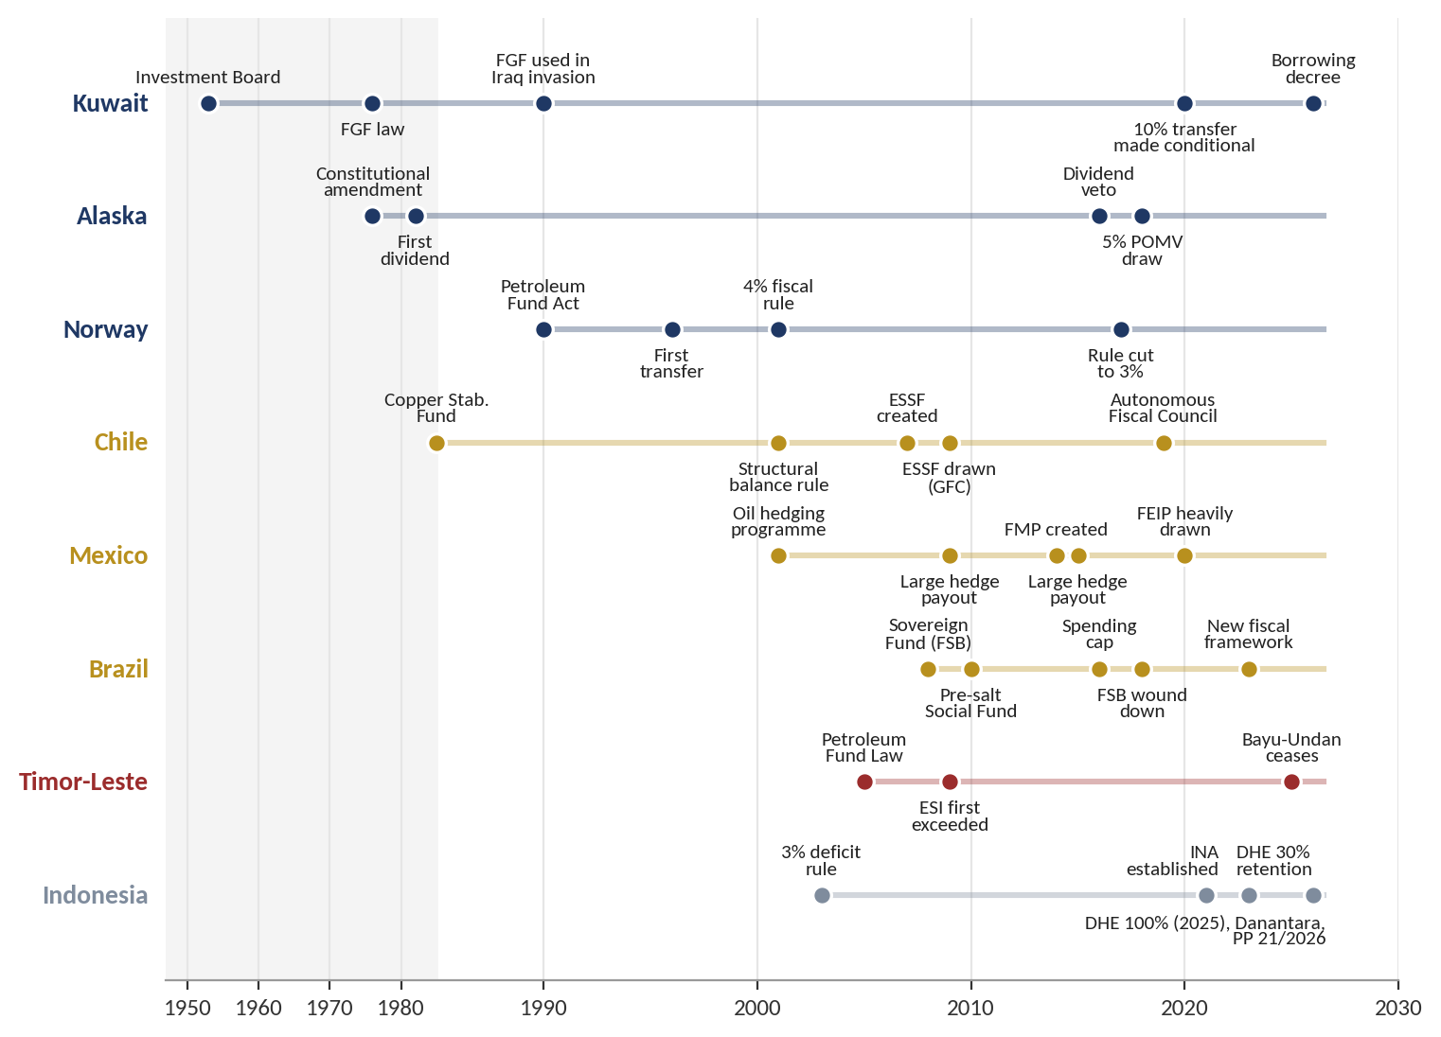
Stabilisation cases in gold, savings cases in navy, the contrasting case in red and Indonesia in grey. The shaded period 1950–1985 is shown at one-third scale.
Table 5.2. What Indonesia should adopt, and what it should avoid
Case | Adopt | Avoid
Chile | Reference price and trend output set by independent experts; automatic saving of surplus; fiscal council | Frequent changes to methodology that weaken expectations
Mexico | Market hedging of a budget-year price floor; central-bank management of the fund | A buffer without a binding deposit rule, drained in one downturn
Brazil | An expenditure-growth rule alongside commodity rules | Relying on general spending caps alone; small, multi-purpose funds
Norway | All relevant revenue through the fund; spend only the expected real return; invest abroad | Treating the fund as a permanent source of deficit finance
Alaska | Constitutional-level lock on the principal; visible citizen benefit | A benefit formula renegotiated in every annual budget
Kuwait | Separate reserve and future windows; borrowing-only emergency access with repayment first | Conditional deposits; an unconstrained wage and subsidy bill
Timor-Leste | Counting only approved future receivables as wealth | Soft ceilings exceeded every year; no domestic revenue base
Source: author's synthesis.
CHAPTER 6

Saving for Future Generations in Indonesia
Part III turns from the present to the future. Stabilisation smooths the cycle; saving deals with depletion. This chapter applies the lessons of Chapter 5 to Indonesia's future window.

6.1 Saving: the future window and development
The future window receives a fixed share of resource revenue every year, whatever the price, so that saving does not depend on a surplus that may never come. Only the expected real return is released to the budget, where it can finance long-term development priorities such as education, research and infrastructure maintenance, in the spirit of Botswana's rule that mineral revenue should fund investment rather than consumption. A share can flow to producing regions through Dana Abadi SDA Daerah, giving citizens a visible stake in the fund without Alaska's annual contest over a cash dividend. Saving and development are therefore complementary: the future window converts depleting assets into a permanent income stream for development.

6.2 Saving does not have to mean saving abroad
The saving principle in Parts II and III rests on the Hartwick rule: a country that uses up a non-renewable resource stays as wealthy as before only if it reinvests the rent in other assets. Norway chose foreign financial assets because its domestic economy was already capital-rich, and investing at home would have fuelled inflation and Dutch disease. The literature on capital-scarce economies reaches a different conclusion. Collier, van der Ploeg, Spence and Venables (2010) and van der Ploeg and Venables (2011) show that where domestic capital is scarce and its return is high, a larger share of resource revenue should be invested at home. Foreign assets then serve as a temporary 'parking' place while the capacity to invest well is built.
Indonesia sits between the two cases. Its infrastructure and industrial gaps are large, which argues for investing at home. Its record of public-investment efficiency is uneven, and the IMF (2015) estimates that on average about 30% of the potential gains from public investment are lost to inefficiency. The aggressive option therefore spends from savings, but only through rules that protect the quality of each investment.

6.3 Safeguards and fit with existing institutions
- Legal level: establish the fund by Law, not by Government or Presidential Regulation; the DHE regime itself has been amended three times in three years.
- Automatic deposits: contributions to the future window are unconditional; Kuwait shows that conditional deposits weaken the fund when it is most needed.
- Hard withdrawal limits: caps are written into the Law, with no routine exceptions; Timor-Leste shows that justified exceptions become the norm.
- Spending-growth limit: pair the fund with a limit on growth in resource-financed spending, since the main threat in Kuwait and Timor-Leste came from the budget.
- Separation and transparency: keep the fund separate from Danantara; Ministry of Finance as owner, Bank Indonesia as operational manager; reporting to the DPR, BPK audit and adherence to the Santiago Principles (IFSWF, 2008).
The fund complements existing instruments. DHE SDA remains the Layer 1 tool for liquidity and the exchange rate under Bank Indonesia. In boom years, when retention increases domestic foreign-exchange supply, a reserve window investing abroad acts as a counterweight to rupiah appreciation, following Norway's logic. Danantara remains the owner and developer of state enterprises: the fund saves, Danantara invests. Indonesia's floating rupiah and inflation-targeting central bank place it structurally closer to Norway and Chile than to Kuwait or Timor-Leste.
PART IV
Making It Sustainable: Invest
How do we invest part of the savings at home without spending the future?
Chapter 7 designs a time-limited development window that invests part of the savings through DDMF, including a sovereignty tier for maritime and defence. Chapter 8 computes the economic effects of each cluster and segment, including jobs project by project, unemployment and consumption. Chapter 9 examines four high-risk projects. Chapter 10 sizes the fund flows, simulates saving-only against the aggressive option, sets out how natural resources can fund the pipeline, and screens the projects.
CHAPTER 7

From Saving to Investing: the Development Window
Part IV asks whether part of the savings can be invested at home, for larger multiplier effects, without spending the future. This chapter designs the development window and its sovereignty tier; Chapters 8 to 10 test it against DDMF's pipeline.

7.1 Design
The fund proposed in Parts II and III gains a third window between the reserve window and the future window (Figure 7.1). The reserve window is unchanged and still stabilises the budget. The future window still saves a fixed share every year and still pays only its real return to the budget. The development window takes part of the long-term savings flow in the early years, and may borrow a capped amount from the future window. It invests this money as catalytic equity or subordinated debt in resource-conversion and energy-transition projects, with DDMF acting as the implementing partner. Dividends and exit proceeds flow back to the future window, so the savings are recycled rather than consumed.
Figure 7.1. Three-window architecture with a development window
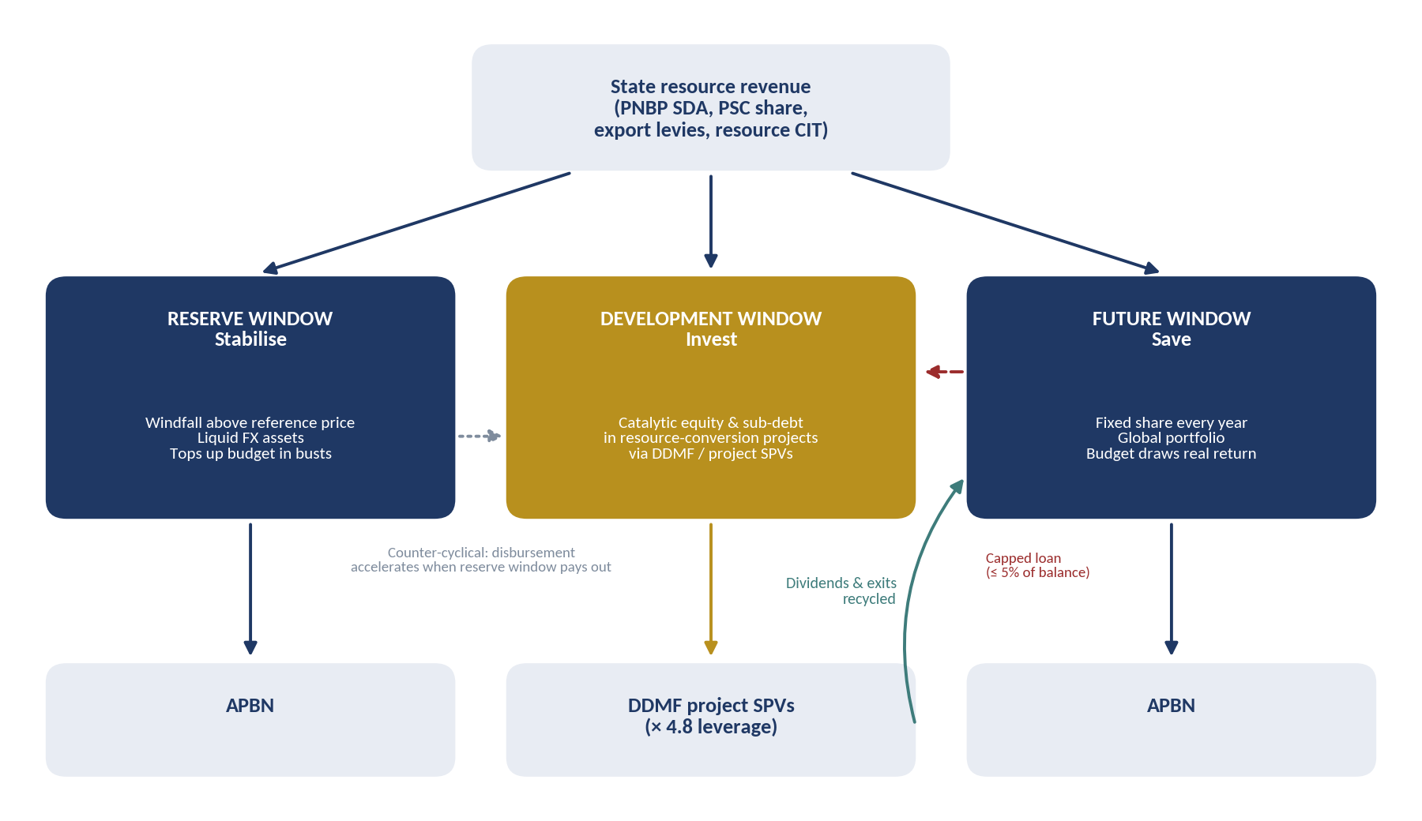
Source: author's proposal, extending Figure 4.1. The dashed red arrow is a capped loan from the future window, the teal arrow recycles proceeds, and the dotted grey arrow is the counter-cyclical link.
The design has precedents. Nigeria's Sovereign Investment Authority (2011) splits its capital into a stabilisation fund, a future generations fund and an infrastructure fund that invests at home. Ireland's Strategic Investment Fund (2014) was created by redirecting the National Pensions Reserve Fund, a savings fund, to domestic investment with a 'double bottom line' of commercial return plus economic impact. Malaysia's Khazanah Dana Impak, cited in the RKAP, ring-fences impact capital with a sovereign-yield floor. The cautionary cases are equally clear. Timor-Leste financed a US$650 million purchase of Greater Sunrise stakes through its Petroleum Fund in 2019, a large and concentrated domestic bet taken outside the ESI discipline. Malaysia's 1MDB showed what happens when a state investment vehicle escapes oversight.

7.2 Rules
Table 7.1. Proposed rules for the development window
Element | Rule | Why
Inflow | Long-term savings raised from 25% to 30% of natural-resource PNBP. The development window receives 60% of this flow in 2027–2032 and 30% in 2033–2038, and nothing after 2038 unless renewed by Law | Front-loads investment while domestic returns are highest; the sunset keeps the future window as the long-run destination
Spending from savings | May borrow up to 5% of the future window's balance a year until 2034, with total borrowing capped; repaid first from exits; no write-off without a Law | This is the 'spend from savings' element, bounded on Kuwait's 2026 model
Eligible projects | At least 70% in resource-conversion and energy-transition projects; at most 30% in other projects, of which the sovereignty tier (Table 7.2) at most 20%. Public goods and social infrastructure are excluded | A resource fund should convert resource wealth; social assets have no cash flow to recycle
Return floor | Expected portfolio financial return at least the 10-year government bond yield in real terms (DDMF's own 'sovereign floor', score 1) | Keeps the principal recyclable; below the floor, the subsidy belongs in the APBN
Multiplier hurdle | Economic IRR of at least 10% real, counting foreign-exchange savings, taxes, jobs and TKDN, verified by an independent reviewer | Captures the benefits a financial return misses
Crowding in | At least Rp 3.5 of other capital for every Rp 1 of fund money (the RKAP's structure implies 3.8) | Makes the multiplier explicit and measurable
Concentration | At most 15% of the window in any one project and 35% in any one commodity chain | Limits the correlation risk described in Section 4.7
Instruments | Equity, subordinated debt and capped first-loss tranches only; no guarantees or comfort letters | The RKAP identifies contingent liabilities as a key risk
Disbursement | Stage-gated tranches at feasibility study, financial close and construction milestones | Money follows readiness, not announcements
Counter-cyclical timing | When the reserve window is paying out, approved projects may draw up to 1.5 times the annual allocation | Fiscal multipliers are larger in downturns (Auerbach and Gorodnichenko, 2012)
Governance | MoF owns the money; a Development Window Investment Committee with independent members decides; DDMF executes under a mandate agreement; BPK audit; project-level public reporting | Keeps the separation principle of Parts II and III and adds a contractual channel
Percentages are reference points for discussion, not calibrated recommendations.

7.3 The sovereignty tier: maritime and defence
Indonesia's resource wealth sits largely at sea and in its outer islands: offshore oil and gas, nickel in Sulawesi and Maluku, fisheries in the exclusive economic zone. Saving that wealth means little if the state cannot protect it. Maritime and defence capability is therefore treated as a priority: the deterrent must be kept at the required level and sovereignty safeguarded. This revision adds shipyards and ship components and alutsista production to the priority list, which now has 15 projects, and creates a sovereignty tier inside the development window.
The way defence is financed today also bears on stabilisation. In the 2026 Ministry of Defence budget of Rp 187.1 trillion, alutsista modernisation takes Rp 84.5 trillion, and Rp 46.5 trillion of that (55%) is financed by foreign loans (Figure 7.2). Imported platforms paid with foreign loans add to dollar outflows today and to dollar debt service later, the same pressure on the rupiah that the fund is meant to reduce. Building platforms and components at home turns part of that spending into domestic output, jobs and technology, in the same way that CDME replaces LPG imports.
Figure 7.2. Funding sources of alutsista modernisation in the 2026 Ministry of Defence budget (Rp trillion)
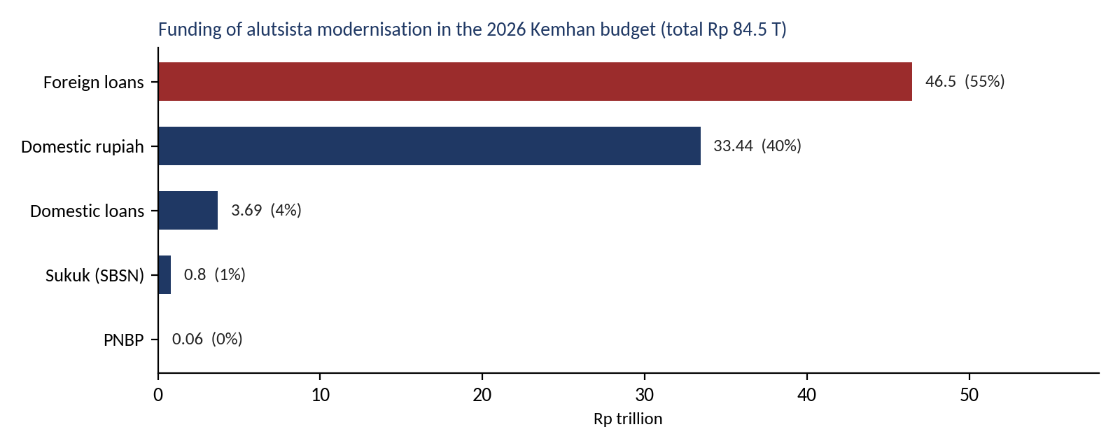
Source: CNBC Indonesia (2026), based on the 2026 Kemhan budget.
The evidence on defence spending and growth is mixed: surveys find more studies with negative or insignificant effects than positive ones (Dunne and Tian, 2013), and the positive cases tend to be those where spending builds a domestic industrial base. The case for the sovereignty tier therefore rests on sovereignty and deterrence first, and on the localisation multiplier second. It follows that the fund should finance the defence-industrial base (yards, components, local production and maintenance) and not the purchase or operation of platforms, which remain budget spending.
Table 7.2. Rules for the sovereignty tier
Element | Rule | Why
Scope | Defence-industrial capacity: shipyards, ship components, domestic alutsista production and maintenance. Not platform purchases or operations | Builds lasting domestic capital, in line with the Hartwick logic of the fund
Size | At most 20% of the development window; at most 15% in any one project | Keeps the resource-conversion core at 70% or more
Offtake | Multi-year contract from Kemhan or the TNI, or availability payments within a Ministry of Finance ceiling | Defence has a single buyer; revenue must be contracted before money moves
Localisation | Local content and offsets under Law 16/2012 on the Defence Industry; KKIP endorsement; work channelled to domestic yards and SME suppliers (for example through a Develop–Off-taker–Certification–Upgrading programme) | The multiplier comes from domestic content, not from the platform itself
Athens † | Remark: unknown / black programme (classified; scope and details not disclosed). The fund may hold DDMF's SPV equity (Rp 15.1 T). The 20-year availability payments stay on the APBN; vessels built at domestic yards; debt consolidation onto Danantara resolved first | Separates the investable industrial stake from the budget obligation
Instruments | Equity only; no guarantees or comfort letters | Avoids hidden contingent liabilities
Disclosure | Financial aggregates public; classified details reported in closed session to DPR Commission I and BPK | Balances secrecy with accountability
Percentages are reference points for discussion, not calibrated recommendations.
In numbers, maritime and defence projects need Rp 20.2 trillion of DDMF equity for Rp 191.6 trillion of investment, about 9.5 times leverage because Athens is financed 90% by debt. The sovereignty tier's Rp 19.5 trillion (shipyards, alutsista and Athens; the EV Power Pack is already in the energy-transition group) is about 7% of the development window's Rp 270 trillion for 2027–2032. Athens's availability payments would be roughly Rp 15.8 trillion a year (an illustrative annuity on Rp 167 trillion at 7% over 20 years), about 8% of the 2026 Kemhan budget; in later years the future window's annual return can help fund them. Availability-payment income is contracted and does not move with coal or nickel prices, so it lowers the correlation risk of Section 4.7, although in the end it is the budget paying the fund.
October 2026 update. The defence modernisation programme of Rp 2,125 trillion replaces Athens and alutsista production in the RKAP and is about eleven times larger. It cannot fit in the sovereignty tier, which is capped at 20% of the development window. The rules above therefore matter more, not less: the fund holds only the domestic defence-industrial share (yards, components, MRO) within the cap; platforms stay on the budget; and the imported share is financed with loans funded by retained natural-resource export proceeds instead of foreign loans (Section 10.3).
CHAPTER 8

Economic Effects: Growth, Jobs and Consumption

8.1 Method in brief
The calculation uses two lenses, explained fully in Appendix B. During construction, it applies the IMF's Indonesia-specific public-investment multipliers (IMF, 2026): about 0.5 in the first year, rising to about 1.2 after five years. Because imported equipment does not add to Indonesian GDP, each segment's multiplier is scaled by its domestic content of capex relative to a reference of 70%. After construction, the lasting effect comes from the productive capital the projects leave behind: productive capital divided by an incremental capital-output ratio (ICOR) of 6.5. In each year the larger of the two effects is used. Parameters are set by segment, so that a sea wall, a submarine and a data centre are not treated alike (Table 8.1).
Table 8.1. Segment parameters
Segment | Cluster | Domestic content | Productive capital | Labour productivity | Basis
Resource processing & energy | Industry | 55% | 100% | 2.5× | Imported smelter, refinery and solar equipment; capital-intensive
Infrastructure & social | Industry | 80% | 80% | 1.0× | Construction mostly domestic; social assets partly non-productive
Giant Sea Wall | Industry | 85% | 60% | 1.0× | Civil works and materials largely domestic; protects existing assets
Defence platforms & MRO | Industry | 40% | 20% | 1.5× | Platforms and aircraft largely imported; DEFEND ID local content 43%
Defence & maritime industry | Industry | 60% | 100% | 1.5× | Domestic yards and components
Manufacturing | Industry | 50% | 100% | 0.8× | Imported machinery; textile labour-intensive
Digital infrastructure (data centre, AI & IT) | Technology | 35% | 100% | 2.0× | Servers, accelerators and cooling imported
Deep tech (quantum, semiconductors, space, drone) | Technology | 40% | 100% | 2.0× | Imported tools; research-heavy
Technology park (Tech Corridor) | Technology | 75% | 80% | 1.5× | Mostly construction
Financial & commercial platforms | Finance | 60% | 100% | 1.0× | Software and services
Sources: DEFEND ID local content from Triantama (2026); I-O output multipliers (BPS) as reported by Pitaloka et al. (2020). Domestic-content, productive-share and productivity parameters are the author's assumptions, to be calibrated with the import matrix of the BPS Input-Output Table 2020.

8.2 GDP and growth
Figure 8.1. GDP level effect by cluster, 2027–2045 (% of GDP)
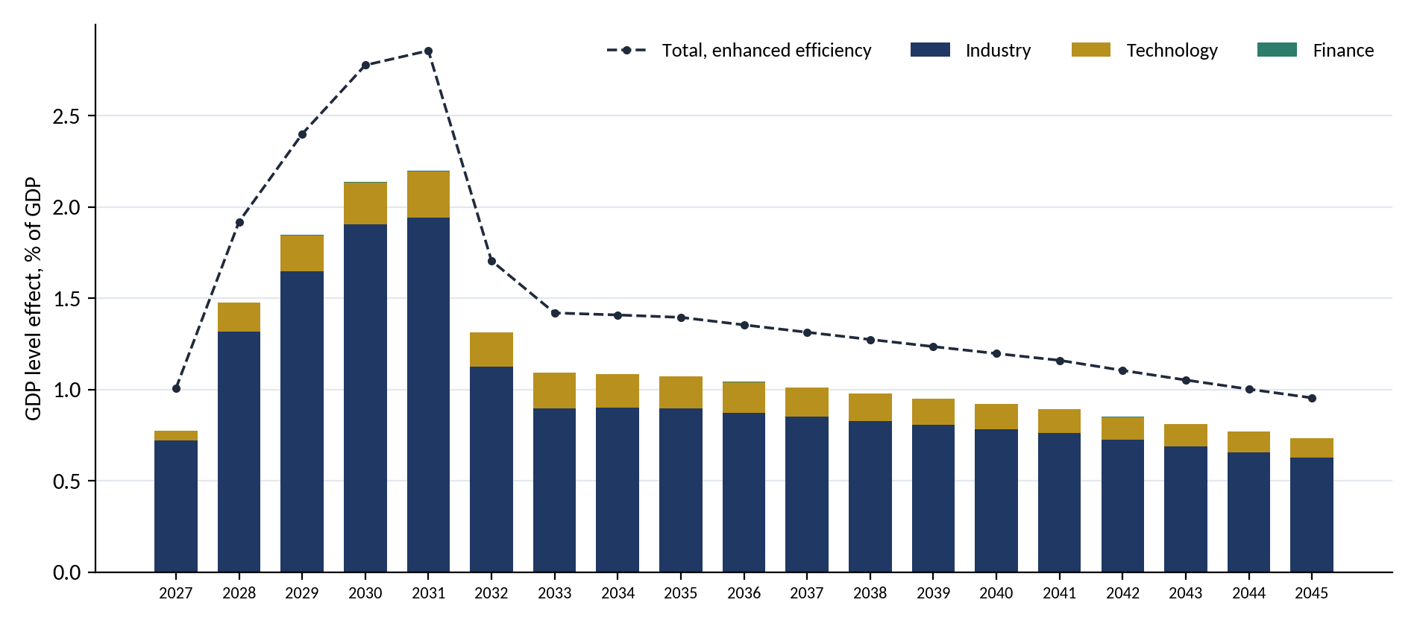
Source: author's calculation. Bars: base case; dashed line: total with enhanced investment efficiency (IMF multipliers 30% higher, ICOR 5.0).
Table 8.2. Economic effects by cluster (base case)
Indicator | Industry | Technology | Finance | Total | Unit
Investment | 4,914 | 480 | 1 | 5,396 | Rp T
Peak GDP level effect | 1.94 | 0.25 | 0.00 | 2.20 | % of GDP (2031)
Cumulative GDP during build | 3,221 | 285 | 1 | 3,507 | Rp T
Permanent GDP gain | 396 | 68 | 0 | 464 | Rp T a year
Job-years during build (GDP-based) | 16.0 | 1.0 | 0.0 | 17.1 | million
Extra tax during build | 300 | 27 | 0 | 327 | Rp T
Imports embodied in capex | 110.9 | 13.2 | 0.0 | 124.1 | US$ bn
DDMF-type equity | 1,032 | 101 | 0 | 1,133 | Rp T
Source: author's calculation (Appendix B). Job-years count one job for one year; Section 8.7 gives the project-by-project count. Values are illustrative and depend on the parameters in Table 8.1.
The updated pipeline raises the level of GDP by about 2.20% at its peak in 2031, or about 2.86% if investment efficiency improves as the IMF describes, compared with about 1.5% for the RKAP pipeline. Growth is about 0.81 points higher in 2027 and 0.78 in 2028, when investment jumps, 0.46 in 2029 and 0.61 on average in 2027–2030. The permanent gain is about Rp 464 trillion a year, 0.89% of GDP in 2041. Industry provides 88% of the peak effect. The pipeline is 2.6 times larger than the RKAP's, but its peak effect is only about 1.5 times larger, because the two largest additions, defence and the sea wall, have high import content or low productive capacity.
Table 8.3. Year-by-year path of the whole pipeline (base case)
Year | Investment (Rp T) | Investment (% of GDP) | GDP level effect (% of GDP) | Added growth (pp) | Enhanced efficiency (% of GDP)
2027 | 539 | 2.05 | 0.77 | 0.81 | 1.01
2028 | 804 | 2.92 | 1.48 | 0.78 | 1.92
2029 | 829 | 2.86 | 1.85 | 0.46 | 2.40
2030 | 821 | 2.70 | 2.14 | 0.40 | 2.78
2031 | 748 | 2.34 | 2.20 | 0.17 | 2.86
2032 | 438 | 1.31 | 1.31 | -0.82 | 1.71
2033 | 351 | 1.00 | 1.09 | -0.17 | 1.42
2034 | 351 | 0.95 | 1.08 | 0.05 | 1.41
2035 | 86 | 0.22 | 1.07 | 0.04 | 1.40
2040 | 86 | 0.17 | 0.92 | 0.02 | 1.20
Source: author's calculation (Appendix B). Added growth is the change in the GDP level effect as a share of the previous year's GDP; negative values show the drag when investment falls.

8.3 The 2032 drop
The RKAP projects still end in 2031 or 2032. Investment therefore falls from about Rp 748 trillion in 2031 to Rp 438 trillion in 2032, and growth would be about 0.82 points lower in 2032 and a further 0.17 points lower in 2033. The longer timelines of the October update soften but do not remove the drop: defence spending continues to 2034 and the sea wall to 2040. Because both of those have a low capacity effect, the step down in 2035 is small in growth terms, but about 0.6 million jobs end with the defence programme (Section 8.7). The responses are unchanged: stretch large infrastructure timelines so that investment declines gradually, and prepare a successor pipeline from 2030.

8.4 Per rupiah: what each segment buys
Table 8.4. Effects per Rp 1 trillion of investment, by segment
Segment | GDP in the first year (Rp T) | GDP after five years (Rp T) | Permanent GDP a year (Rp T) | Imports embodied (US$ m) | Job-years (bottom-up)
Resource processing & energy | 0.39 | 0.94 | 0.15 | 25 | 4,649
Infrastructure & social | 0.57 | 1.37 | 0.12 | 11 | 6,439
Giant Sea Wall | 0.61 | 1.46 | 0.09 | 8 | 5,925
Defence platforms & MRO | 0.29 | 0.69 | 0.03 | 34 | 3,291
Defence & maritime industry | 0.43 | 1.03 | 0.15 | 22 | 5,236
Manufacturing | 0.36 | 0.86 | 0.15 | 28 | 5,759
Digital infrastructure (data centre, AI & IT) | 0.25 | 0.60 | 0.15 | 37 | 4,470
Deep tech (quantum, semiconductors, space, drone) | 0.29 | 0.69 | 0.15 | 34 | 4,559
Technology park (Tech Corridor) | 0.54 | 1.29 | 0.12 | 14 | 5,925
Source: author's calculation (Appendix B; job-years from Appendix F, including indirect and induced jobs).
The comparison shows the trade-off at the heart of the update. The sea wall and infrastructure buy the largest short-run boost and the most jobs. Resource processing and the technology segments buy the most permanent capacity. Defence platforms buy sovereignty, with the lowest economic return per rupiah: about Rp 0.03 trillion of permanent GDP a year and US$34 million of imports for every Rp 1 trillion. Because they are 39% of the pipeline, their parameters matter more than any others.

8.5 Sensitivity
Table 8.5. Pipeline effects under alternative assumptions
Variant | Added growth 2029 (pp) | Average 2027–30 (pp) | Peak level effect (% of GDP) | 2032 (pp) | Imports (US$ bn)
Base case | 0.46 | 0.61 | 2.20 | −0.82 | 124
Defence domestic content 60% (instead of 40%) | 0.51 | 0.69 | 2.48 | −0.82 | 100
Sea wall built in 2027–2034 (instead of 2027–2040) | 0.51 | 0.69 | 2.49 | −0.82 | 124
Both | 0.56 | 0.76 | 2.78 | −0.82 | 100
Enhanced efficiency (IMF) | 0.60 | 0.80 | 2.86 | -1.07 | 124
Source: author's calculation. Enhanced efficiency raises the multipliers by 30% and lowers the ICOR to 5.0.
Three conclusions are robust. Domestic content in defence is the largest single lever: moving from 40% to 60% adds about 0.3 points to the peak GDP effect and saves about US$24 billion of imports, without spending another rupiah. Timing matters: building the sea wall faster adds about 0.05 points of growth a year in 2027–2030 but brings forward its funding need. Efficiency matters as much as size: the IMF's enhanced efficiency raises the peak effect by about 30%. None of the variants changes the 2032 drop.

8.6 Imports, defence and other parameters
- Balance of payments. About US$124 billion of capex leaks abroad over 2027–2040, of which defence platforms US$72 billion (58%). Imports peak at about US$19 billion in 2029, about 1.2% of GDP; with the extra downstream plants of Chapter 11 they reach about 1.6% of GDP. Import-substituting projects work the other way: CDME alone saves about US$0.9 billion a year at 20% LPG substitution (RKAP p. 119).
- Financing the import bill. Imported defence equipment financed by foreign loans adds to dollar debt service later (Section 7.3). The resource-first funding stack of Section 10.3 finances it instead with foreign-currency loans funded by retained natural-resource export proceeds (DHE SDA), which keeps the dollars inside the Indonesian banking system.
- Fiscal position. Extra tax revenue of about Rp 327 trillion during the build. This is small against the cost of the programmes that the budget will carry, above all defence and the sea wall.
- Inflation and the rupiah. Domestic investment of almost 3% of GDP a year in 2028–2030 is a large demand impulse. The counter-cyclical timing rule of the development window, phasing of defence deliveries and Bank Indonesia's monitoring (Chapter 14) limit pressure on prices and the exchange rate.
- ICOR and efficiency. With an ICOR of about 6.5, Rp 1 of productive capital adds about Rp 0.15 a year to GDP; reaching the IMF's enhanced efficiency would add about Rp 0.20.

8.7 Jobs, project by project
The estimates above derive jobs from GDP. This section checks them from the bottom up, project by project, because the pipeline mixes very labour-intensive work (the sea wall, housing, schools) with capital-intensive plants and imported equipment (smelters, data centres, defence platforms).
Method. Each of the 34 costed projects is assigned to one of seven types of work. Construction-phase jobs use job-years per rupiah from the input-output analysis of Indonesia's national strategic projects (ERIA, 2023): about 5.7 job-years per Rp 1 billion for roads and bridges, 5.5 for industrial zones and electricity, 4.3 for technology and 3.7 for smelters, in 2016–2022 prices. These are rebased to 2025 prices by the rise in output per worker (×1.30) and include both on-site and supplier jobs. Induced jobs from household spending add 35%. Defence modernisation is scaled by its 40% domestic content. Permanent operating jobs are set per project, anchored on IMIP Morowali (about 129 workers per Rp 1 trillion) and Danantara's 26 downstream projects (about 168). Appendix F lists every assumption.
Table 8.6. Employment by cluster
Cluster | Invest. Rp T | Direct m job-yrs | Indirect m | Induced m | Total m job-yrs | Job-yrs per Rp 1 T | Permanent direct (k) | Permanent total (k)
Industry | 4,914 | 8.68 | 8.42 | 5.98 | 23.08 | 4,697 | 490 | 1,190
Technology | 480 | 0.84 | 0.95 | 0.63 | 2.42 | 5,044 | 87 | 212
Finance | 1 | 0.00 | 0.00 | 0.00 | 0.00 | 4,470 | 0 | 0
Total | 5,396 | 9.52 | 9.37 | 6.61 | 25.51 | 4,728 | 577 | 1,403
Source: author's calculation (Appendix F). Job-years count one job for one year during construction. Permanent jobs are jobs sustained after completion.
In total the pipeline supports about 25.5 million job-years during construction: 9.5 million on site, 9.4 million at suppliers and 6.6 million from household spending. At the peak in 2029 that is about 4.0 million jobs at the same time. After completion, about 1.4 million jobs remain, 0.58 million of them direct operating jobs. The bottom-up count is higher than the GDP-based estimate of Table 8.2 (17.1 million) mainly because the ERIA coefficients count the domestic work on defence equipment at full value, while the GDP lens discounts the imported share more heavily; the truth is likely to lie between the two.
Table 8.7. The 15 projects with the most construction jobs
Project | Cluster | Invest. Rp T | Job-years (thousand) | Job-years per Rp 1 T | Permanent jobs (k)
Giant Sea Wall | Industry | 1,200.0 | 7,110 | 5,925 | 58.3
Defence modernisation | Industry | 2,125.0 | 6,993 | 3,291 | 309.8
Affordable housing | Industry | 219.4 | 1,495 | 6,814 | 16.0
10 smart cities | Industry | 225.0 | 1,333 | 5,925 | 54.7
500 schools | Industry | 178.0 | 1,213 | 6,814 | 64.9
Tech Corridor | Technology | 186.9 | 1,107 | 5,925 | 113.5
PLTS 100 GW (solar) | Industry | 231.4 | 1,066 | 4,607 | 56.2
AI and IT programme | Technology | 200.0 | 894 | 4,470 | 72.9
Centralised water | Industry | 112.2 | 665 | 5,925 | 21.8
Textile ecosystem | Industry | 89.0 | 513 | 5,759 | 259.5
Fishing-village food security | Industry | 83.8 | 496 | 5,925 | 203.5
STEM university | Industry | 71.0 | 484 | 6,814 | 12.1
Biodiesel | Industry | 75.4 | 434 | 5,759 | 22.0
Al, Fe, Ni, Mn metals | Industry | 73.3 | 283 | 3,856 | 26.7
CPE (assumed petrochemical) | Industry | 71.2 | 275 | 3,856 | 8.7
Source: author's calculation (Appendix F). Job-years include direct, indirect and induced jobs. Textile permanent jobs are largely jobs preserved if existing mills are restructured (Chapter 9).
Figure 8.2. Construction job-years and labour intensity by project
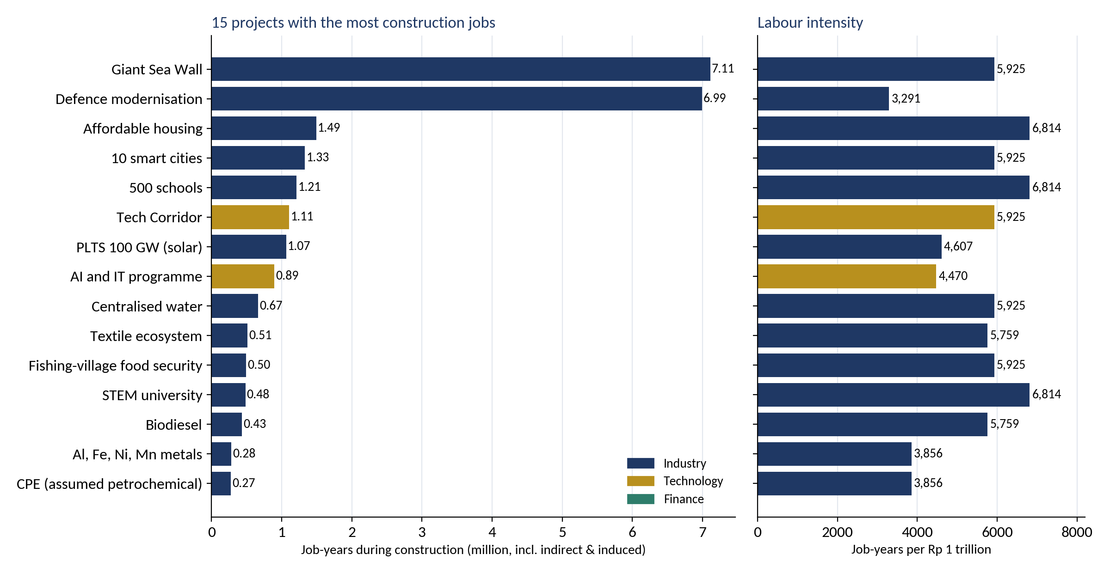
Source: author's calculation. Bar colours show the cluster.
The two largest employers. At Rp 1,200 trillion the Giant Sea Wall supports about 7.1 million job-years, about 508 thousand jobs a year for 14 years, with 5,925 job-years per Rp 1 trillion. Defence modernisation supports about 7.0 million job-years over 2027–2034, but only 3,291 per Rp 1 trillion, because most of the money buys imported equipment. Each extra 10 points of domestic content in defence adds roughly 1.7 million job-years.
Effect on unemployment. Jobs supported are not all new jobs. Indonesia has 10.7 million underemployed workers, a large informal sector and about 1.9 million labour-force entrants a year, so many jobs will go to people who already work or who are just entering the labour force. Assuming that 40% of the extra jobs reduce open unemployment (range 25–55%), the open unemployment rate falls from 4.7% in February 2026 to about 3.7% in 2028–2030 (range 3.3–4.1%). It rises to about 4.0% in 2032 when the RKAP projects end and to about 4.2% in 2035 when the defence programme ends; the sea wall and permanent jobs hold it about 0.4 points below the 2026 level to 2040 (Table 8.8 and Figure 8.3).
Table 8.8. Jobs supported and open unemployment by year
Year | Direct (m) | Indirect (m) | Induced (m) | Permanent (m) | Total (m) | Unemployment rate
2027 | 0.84 | 0.90 | 0.61 | 0.00 | 2.35 | 4.08%
2028 | 1.46 | 1.44 | 1.01 | 0.00 | 3.91 | 3.69%
2029 | 1.49 | 1.48 | 1.04 | 0.00 | 4.01 | 3.68%
2030 | 1.47 | 1.46 | 1.03 | 0.02 | 3.99 | 3.69%
2031 | 1.36 | 1.33 | 0.94 | 0.10 | 3.73 | 3.77%
2032 | 0.66 | 0.70 | 0.47 | 0.89 | 2.72 | 4.02%
2033 | 0.50 | 0.53 | 0.36 | 1.03 | 2.42 | 4.10%
2034 | 0.50 | 0.53 | 0.36 | 1.03 | 2.42 | 4.11%
2035 | 0.21 | 0.17 | 0.13 | 1.34 | 1.85 | 4.24%
2040 | 0.21 | 0.17 | 0.13 | 1.34 | 1.85 | 4.27%
Source: author's calculation; BPS Sakernas February 2026 (labour force 154.9 million, unemployment 4.68%). Central case: 40% of extra jobs reduce open unemployment; the baseline holds the rate at its February 2026 level.
Figure 8.3. Jobs supported by the pipeline and the open unemployment rate, 2027–2037
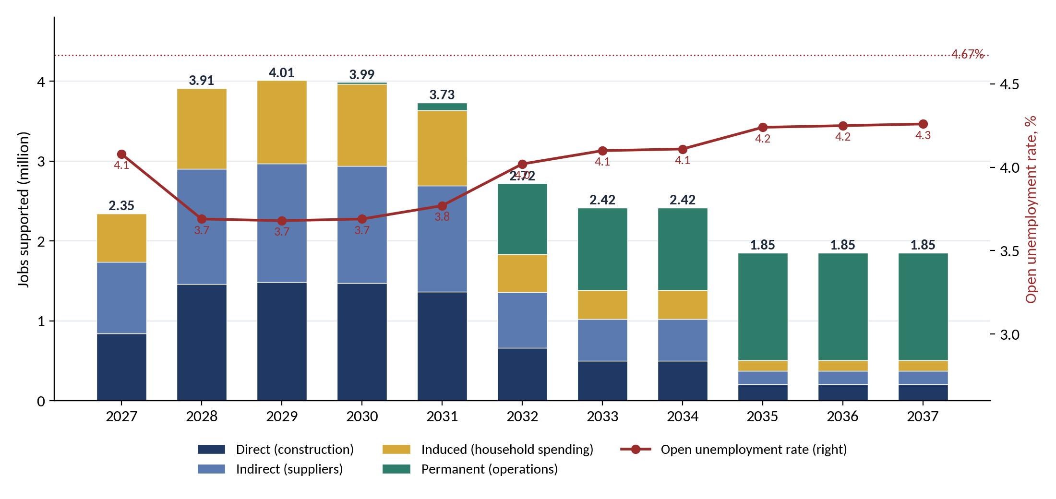
Source: author's calculation. Gross jobs supported, not net of displacement.
Who gets the jobs. Smelter projects have relied heavily on foreign workers in the past, and defence programmes can place much of the skilled work abroad. Domestic-content and local-hiring conditions, vocational training tied to each project, and supplier development for small firms (DOCK-UP) decide how much of this employment goes to Indonesians and to the regions where projects are built.

8.8 From jobs to consumption and growth
Jobs matter for growth because wages are spent. Household consumption is 53.9% of GDP and contributed 2.62 of the 5.11 points of growth in 2025, so every rupiah of new wage income that is spent at home becomes demand for other firms, which hire in turn.
Table 8.9. The consumption loop at the 2029 peak
Step | Value | Basis
On-site and supplier jobs | about 3.0 million | Table 8.8
Wage income a year | about Rp 119 T | BPS average wage Rp 3.33 million a month (Aug 2025)
Genuinely new household income | Rp 59–95 T | 50–80% of wages; the rest replaces other, lower-paid work
Extra consumption | Rp 45–81 T (0.15–0.28% of GDP) | Spending 75–85% of extra income
Total lift to GDP after further rounds | about 0.3–0.6% of GDP | After imports and taxes
Source: author's calculation. This loop is already part of the IMF multipliers in Section 8.1 and of the induced jobs in Table 8.6; it explains their size and is not added again to the growth bridge of Chapter 11.
- The loop is already in the numbers. The IMF multipliers rise from 0.5 to 1.2 partly because they include this consumption round, and the 6.6 million induced job-years are the same loop measured in jobs. Adding it again to the growth bridge would count it twice.
- It works in both directions. When the RKAP projects end in 2032, about one million jobs and their wages disappear, and another 0.6 million when the defence programme ends in 2035. A successor pipeline protects household incomes as well as investment.
- Lasting, formal jobs matter most. A permanent job with a steady wage supports spending every year and allows households to borrow, for example for mortgages under the housing programme. The roughly 1.4 million permanent jobs (defence maintenance, textile, fisheries, the Tech Corridor, AI and IT, processing) keep consumption higher after construction.
- The 8% path depends on it. The plan for 8% in 2029 reportedly assumes household consumption growth of about 7.3%, against 4.98% in 2025. That is only possible if jobs and wages grow fast enough, which makes labour-intensive projects and local content part of the growth strategy, not only social goals.
With the growth scenarios. Using the observed link between growth and employment (each point of GDP growth raised employment by about 0.26% over the past year), the resource-led path of Chapter 11 lowers open unemployment to about 4.2% in 2029 and 4.1% in 2030, and the recommended 8% path of Chapter 12 to about 3.85% by 2030. These economy-wide estimates are net of displacement and therefore more cautious than the gross project-level jobs above.
CHAPTER 9

Due Diligence on Four High-Risk Projects
This chapter tests four projects with specific commercial risks against the questions raised for each: raw materials and market for textile and for biosimilars and pharma (Industry cluster, manufacturing); the projected market for semiconductors (Technology cluster, now Rp 15 trillion); and the current industry configuration for e-commerce (Finance cluster), to avoid a programme that dies on arrival.
Table 9.1. Due-diligence summary
Project | Rp T (equity) | Key finding | Verdict | Recommended redesign
Textile ecosystem | 89.0 (18.7) | Binding constraint is demand and import competition, not capacity; mills at 30–50% utilisation; cotton almost fully imported | Restructure, don't build | Acquire and modernise distressed assets; viscose-based fabric; tranches tied to utilisation and trade enforcement
Biosimilar & pharma | 8.9 (1.9) | 70–90% of APIs imported; three domestic EPO producers already; few trials; local manufacturing rule favours JVs | Conditional | Monoclonal antibodies and insulin with a technology partner; priority APIs; clinical-trial capacity via INA-CRC
Semiconductors | 15.0 (3.1) | Domestic demand about US$5bn and fragmented; Rp 15 T (about US$0.8bn) cannot build a fab; OSAT model proven in Batam | Redesign | OSAT and power devices with an anchor offtaker; silica materials; chip-design talent; no front-end fab
E-commerce | 1.0 (0.2) | Two platforms hold about 92% of GMV; Bukalapak and Blanja exited; state platforms survive only where the state is the buyer | High death-on-arrival risk | B2G/B2B platform for MSMEs: consolidate PaDi UMKM and e-Katalog; supply-chain finance; export aggregation
Source: see Sections 9.1–9.4.

9.1 Textile ecosystem: raw materials and market
Raw materials. Cotton is almost entirely imported: 1.85 million bales in 2024/25, making Indonesia the world's seventh-largest importer (USDA via Databoks), with domestic cotton covering about 4% of need (API). Viscose is the one strong domestic feedstock: Asia Pacific Rayon has 300,000 t a year of capacity integrated with pulp from the same group, and Indo-Bharat Rayon added 65,000 t; viscose staple fibre is already exported. The polyester chain has a feedstock gap: paraxylene and PTA capacity have historically run below installed levels, with imports making up the difference.
Market and industry condition. Sritex, once the largest integrated textile firm, was declared bankrupt in December 2024 with US$1.6 billion of obligations and stopped operating in March 2025, laying off more than 10,600 workers; at least 60 textile firms closed or cut jobs in two years, and polyester mills such as Asia Pacific Fibers ran at 30–35% utilisation (BenarNews; Bisnis; APSyFI). The causes are cheap, often illegal imports and changing import rules. The sector still employs 3.96 million people, and Kemenperin reports 2025 exports of US$12.1 billion, although other data show export value falling in 2022–2024. Assessment: adding new fabric capacity would meet the same import pressure. DDMF's Rp 89 trillion should instead buy and modernise distressed assets, focus on viscose-based fabric where Indonesia has its own feedstock, and be released in tranches tied to utilisation and to effective enforcement against illegal imports.

9.2 Biosimilar & pharma: raw materials, research and clinical trials
Raw materials. More than 90% of chemical active pharmaceutical ingredients (APIs) are imported, according to the industry association GPFI (2025); the Minister of Health said in June 2026 that dependence has fallen to 70–80%, with 35 APIs now made locally, but even local paracetamol relies on imported phenol. Existing capacity. Kalbio (Kalbe, Rp 500 billion plant since 2018), Daewoong Infion (EPO with more than 40% market share) and Etana (mRNA and EPO since 2022) already produce biologics; three domestic producers compete for EPO, so a new entrant needs a different pipeline.
Research and clinical trials. R&D spending is 0.28% of GDP. The BGSi genome initiative had sequenced about 6,000 genomes by 2024, targeting 100,000 in five years. WHO counts 66 clinical trials in Indonesia in 2024, mostly small and academic; trial start-up has fallen from about two years to 6–9 months, and INA-CRC was created in 2023. BPOM Regulation 8/2024 governs trial approval. Local trials are not required to register a biosimilar, but holders of import registrations must manufacture locally within five years, a built-in incentive for joint ventures. The pharma market is about Rp 100–140 trillion. Assessment: conditional. Focus on monoclonal antibodies and insulin with a technology partner, the highest-volume APIs, and clinical-trial capacity, rather than another EPO plant; the project is on hold in the RKAP because of overlap with SOEs, which should be resolved first.

9.3 Semiconductors: is there a market?
Projected market. Indonesia imported about US$4.9 billion of semiconductors in January–November 2025, up from US$2.3 billion in 2020, mainly from Taiwan and China (Kemenperin). A forecast cited by DHL puts the domestic market at US$5.1 billion in 2025 and US$7.1 billion by 2030. Globally, WSTS forecasts the market rising from US$796 billion in 2025 to US$1.51 trillion in 2026, but the jump is driven by AI memory; discretes and analog, the segments a new entrant could serve, grow only about 8–10%. Domestic demand is small, spread across many chip types and largely embedded in imported modules: there is no captive market for a domestic fab.
Cost and realistic segments. An advanced logic fab costs US$35–43 billion over ten years (BCG); the updated Rp 15 trillion is about US$0.8 billion. The proven model in Indonesia is back-end assembly and test (OSAT): Infineon's Batam site does automotive assembly and test with more than 2,000 staff. The national roadmap puts design and talent first, and Danantara and Arm agreed in February 2026 to train up to 15,000 chip designers; a US$26.7 billion Batam consortium has named no offtakers. Assessment: redesign. Invest in OSAT and power devices for electric vehicles, solar and the grid, linked to the PLTS and EV projects, and in silica materials, only with an anchor customer's offtake signed before capital is committed.

9.4 E-commerce: avoiding death on arrival
Industry configuration. Indonesia's e-commerce market was US$58–71 billion in 2025 (Momentum Works; e-Conomy SEA 2025). Shopee holds 54% and TikTok Shop with Tokopedia 38%: two players, about 92%. TikTok bought 75% of Tokopedia in 2024; Bukalapak stopped selling physical goods in February 2025 after heavy losses; Telkom's Blanja.com closed in 2020. Permendag 31/2023 shapes the market by banning payments on social media and setting a US$100 floor for direct cross-border sales.
Where the state can win. State platforms survive where the state is the buyer. Telkom's PaDi UMKM, a B2B platform for SOE procurement, grew from Rp 172 billion of transactions in 2020 to Rp 7.5 trillion by mid-2023, and LKPP's e-Katalog handled Rp 83 trillion in 2023, 44% of it from MSMEs. Assessment: a consumer marketplace has a high risk of dying on arrival. The Rp 1 trillion should build a B2G and B2B platform for MSMEs on demand the state already controls (consolidating PaDi and e-Katalog), with supply-chain finance and export aggregation.
CHAPTER 10

Sizing, Funding and Screening

10.1 Sources and uses
The simulation assumes natural-resource PNBP of Rp 250 trillion a year in constant 2026 prices, roughly the midpoint of 2024 (Rp 229 trillion) and the 2026 pace. Figure 10.1 compares the fund's annual flows with DDMF's equity needs. A 25% saving rule produces Rp 62.5 trillion a year, more than twice the Rp 29.5 trillion a year the priority list needs. In the aggressive design the development window receives Rp 45 trillion a year in 2027–2032. That covers the eligible equity of resource-linked and sovereignty-tier projects (about Rp 22.9 trillion a year) with room for capped non-resource industry, but not the whole 40-project list (Rp 69.9 trillion a year).
Figure 10.1. Annual fund flows compared with DDMF equity needs (Rp trillion a year)
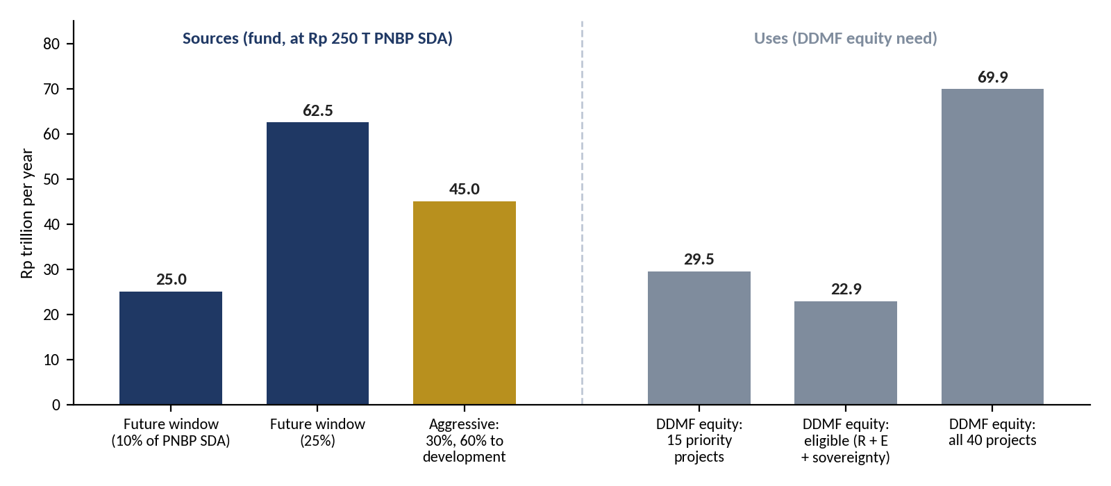
Source: author's calculation. Priority equity (15 projects) is spread over five years; eligible equity (resource-linked plus sovereignty tier) and the 40-project total over six (2027–2032).

10.2 Saving-only versus aggressive
Figure 10.2 and Table 10.1 compare the two paths from 2027 to 2050. The assumptions are:
- Resource PNBP falls 2% a year after 2030 as coal and oil and gas deplete.
- The future window earns 4% real and releases 3% of its balance to the budget each year.
- Development equity yields 4.5% real in cash from its fifth year and is exited evenly over years 10–15.
Figure 10.2. Illustrative simulation, 2027–2050 (Rp trillion, constant 2026 prices)
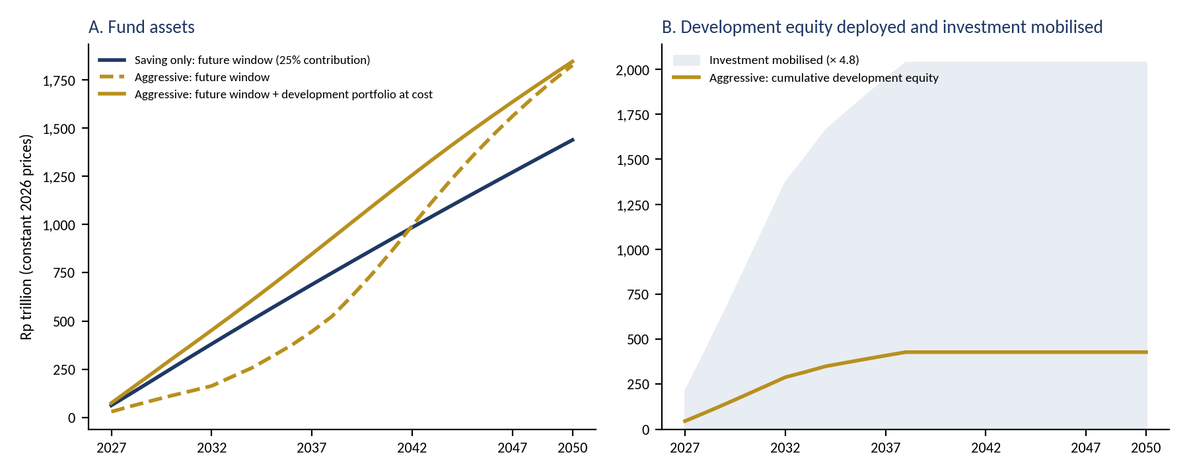
Source: author's illustrative model. Panel B shows DDMF-type leverage: Rp 1 of fund equity for Rp 4.8 of investment. The model covers the fund's own balance sheet only; taxes and GDP effects of the projects are excluded.
Table 10.1. Scenario results (Rp trillion, constant 2026 prices)
Scenario | Fund assets 2035 | Fund assets 2050 | Development equity deployed | Investment mobilised | Budget draws 2027–35
Saving only (25% to future window) | 567 | 1,438 | 0 | 0 | 68
Aggressive (30%; 60/30/0 split; 5% loan) | 685 | 1,845 | 428 | 2,039 | 32
Aggressive at 25% contribution | 570 | 1,537 | 357 | 1,698 | 26
Stress: aggressive, half of development equity lost, 1.5% yield | 670 | 1,507 | 428 | 2,037 | 31
Source: author's illustrative model. Fund assets include the development portfolio at cost. In the aggressive scenarios the budget receives less because the development portfolio does not pay the 3% budget draw.
Three results stand out:
- The cost is budget income now, not wealth later. The aggressive path releases about Rp 36 trillion less to the budget in 2027–2035, but its total assets are no lower, because development equity is recycled rather than spent.
- The payoff is large. About Rp 428 trillion of equity mobilises roughly Rp 2,039 trillion of investment, around 0.9% of 2025 GDP a year in 2027–2032. On IMF (2014) estimates, public investment of 1% of GDP raises output by about 1.5% after four years where investment is efficient. The effect is smaller where it is not.
- The downside is bounded. Even if half the development equity is lost, fund assets in 2050 stay close to the saving-only path, because the higher contribution rate and the sunset clause protect the future window. Without those two rules, this result would not hold.

10.3 Funding the updated pipeline: natural resources first
Sections 10.1 and 10.2 size the development window on the RKAP's equity needs. The October update changes the question. The pipeline now needs about Rp 4,881 trillion in 2027–2034, the years in which almost all of it is spent: Rp 1,260 trillion for commercial projects that can recycle capital, Rp 1,496 trillion for public goods (infrastructure and the sea wall) and Rp 2,125 trillion for defence, of which about Rp 1,275 trillion is imported. This section asks how much of that natural resources can pay for, using every resource-linked source available.
Figure 10.3. Resource-first funding stack, 2027–2034 (Rp trillion, cumulative)
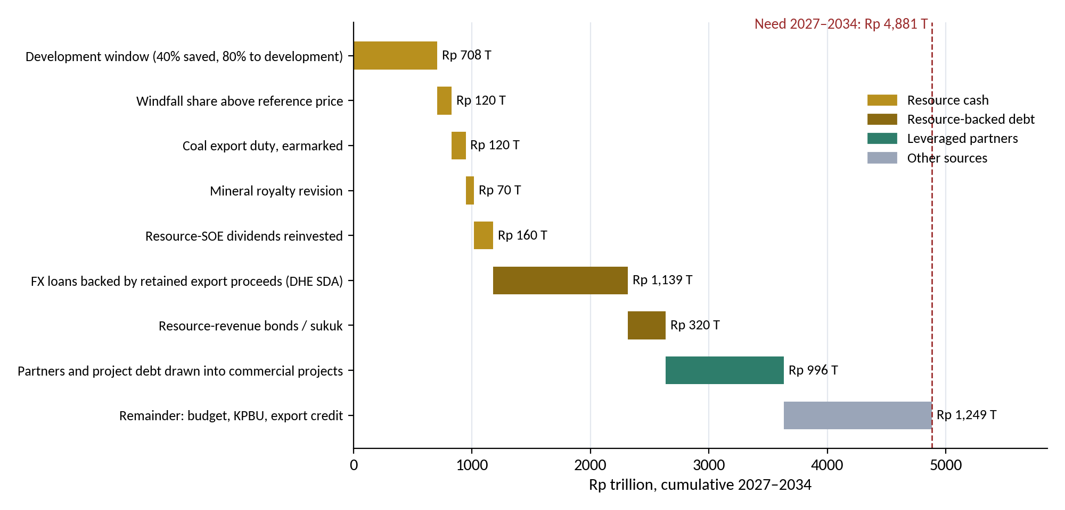
Source: author's calculation. Resource PNBP from the RAPBN 2027 (Rp 283.4 trillion), flat to 2030 and falling 2% a year after. US$ at Rp 17,800.
Table 10.2. Sources of money for the pipeline, 2027–2034 (Rp trillion)
Source | Current rule (save 30%, 60% to development) | Maximised (save 40%, 80% to development) | Basis
Development window (share of resource PNBP) | 398 | 708 | Resource PNBP Rp 283.4 T in the RAPBN 2027
Windfall above the reference price (50%) | 120 | 120 | Rp 15 T a year; the 2026 windfall shows the scale
Coal export duty, earmarked | 120 | 120 | Moderate 2.5% duty; simulations give Rp 11.7–19 T a year
Mineral royalty revision | 70 | 70 | From 2028; the increase was postponed in May 2026
Resource-SOE dividends reinvested by Danantara | 160 | 160 | Rp 20 T a year of SOE dividends (Rp 142.3 T in 2025)
Resource cash | 868 | 1,178
FX loans funded by retained export proceeds (DHE SDA) | 1,139 | 1,139 | US$8 bn a year; DHE retained US$22.9 bn in March–April 2025
Resource-revenue bonds or sukuk | 320 | 320 | Rp 40 T a year, serviced from future PNBP
Resource money (cash + resource-backed debt) | 2,327 (48%) | 2,637 (54%)
Partners and project debt drawn into commercial projects | 996 | 996 | 79% of commercial investment, crowded in by 21% equity
Resource-anchored total | 3,323 (68%) | 3,633 (74%)
Remainder: budget, KPBU, export credit | 1,558 | 1,249
Resource PNBP saved, a year (budget gives up) | 83 | 111
Source: author's calculation; RAPBN 2027; Bank Indonesia and press reports on DHE SDA; Kontan and Bisnis on coal export duty, royalties and SOE dividends. All flows are illustrative and in constant prices.
Under the maximised rule, natural resources provide about 54% of the money needed: Rp 1,178 trillion of resource cash and Rp 1,459 trillion of resource-backed debt. Counting the partners whom resource-funded equity draws into commercial projects, about 74% of the pipeline is anchored on natural resources. The remaining Rp 1,249 trillion, about a quarter, must come from the budget, KPBU and export credit.
How the money is used. The order of priority follows the fund's rules:
- Commercial equity first (Rp 265 trillion): the 21% equity in resource processing, manufacturing, the defence-industrial base and technology, which is recycled when projects are sold down.
- Public goods next (Rp 449 trillion, 30% of their cost): equity or availability payments for infrastructure and the sea wall, with resource-revenue bonds and KPBU for the rest.
- Defence domestic share last (Rp 464 trillion): domestic shipbuilding, components and MRO. At most about Rp 142 trillion can come from the development window under the 20% sovereignty-tier cap; the rest should come from the earmarked windfall, coal duty and royalty receipts through the defence budget. The imported share (Rp 1,275 trillion) is matched by the DHE SDA loans, replacing foreign loans.
The trade-offs. Maximising the resource share has three costs. The budget gives up about Rp 111 trillion a year of resource PNBP instead of Rp 83 trillion. The future window receives 8% of resource PNBP instead of 12%, so wealth for future generations grows more slowly until 2034. And resource-backed debt, about Rp 1,459 trillion, must be serviced from future resource revenue or from the projects. The maximised rule should therefore be time-limited to 2027–2034, return to the 30% and 60/30 rule afterwards, and be written into the fund Law with the same caps and sunset as the development window.

10.4 Screening the projects
Table 10.3 applies the rules in Tables 7.1 and 7.2 to the 15 priority projects and to the resource-linked projects further down DDMF's list. It is a first screen based on the RKAP's own information, not an investment appraisal.
Table 10.3. First screen of DDMF projects for the development window
Project | Equity (Rp T) | Verdict | Conditions or reason
PLTS 100 GW | 48.6 | Anchor | The main coal-transition asset. Commit in 10 GW tranches after the hybrid-tariff regulation is issued; link to domestic PV and silica manufacturing; demand risk shown by Trina's unused 3 GW
CDME (coal to DME) | 9.7 | Conditional | US$0.9 bn a year of FX savings at 20% substitution. Requires a take-or-pay offtake, a DME price rule versus subsidised LPG, a carbon-cost test and a time-limited mandate
Tarsius Ph.1 and Anoa (rare earths) | 0.6 | Eligible, pull forward | Small tickets, pilot plant built, MIND ID, PT Timah and Perminas already cooperating; the start of a mine-to-magnet chain
Al, Fe, Ni, Mn metals; Copper; Silica | 17.7 | Eligible | Deepens the nickel and copper chains; subject to the 35% commodity cap and a feasibility study
Refinery; CPE; Biodiesel | 39.4 | Conditional | Import substitution. Biodiesel only alongside BPDP levy reform, to avoid a second subsidy
EV Power Pack (maritime) | 0.6 | Eligible, priority | Nickel link and ship-import substitution; preferred site near PT PAL's shipyard; requires captive demand from SOEs and ministries
Shipyard & ship components | 1.1 | Eligible, priority (sovereignty tier) | Localises yard capacity and components; tranches tied to the national vessel backlog, TKDN milestones and SME supplier development
Defence modernisation (Rp 2,125 T) * | 446.2 | Split: industry share eligible (sovereignty tier); platforms on the budget | Only the domestic industrial share (yards, components, MRO) within the 20% tier cap; platforms and crews on the APBN; imported share financed by DHE SDA loans, not foreign loans; 60% domestic-content target
Textile ecosystem | 18.7 | Conditional (≤30% tier) | No resource link but a high employment multiplier; finance machine modernisation through co-financing
MOBNAS & MOLINAS | 5.3 | High risk, capped | Behind schedule, land not secured and no partner yet; stage-gate strictly
Tech Corridor | 39.2 | Not yet | Scope, milestones and support are all still to be determined
National Data Centre; AI and IT programme * | 52.5 | Conditional | Commercial tranches only (shared compute, sovereign cloud) with anchor public demand; public systems and skills on the budget; renewable power required
Quantum technology; semiconductors * | 7.3 | Conditional / redesign | Quantum as staged research partnerships; semiconductors in back-end and power devices with an anchor offtaker (Section 9.3)
Biosimilar & pharma; E-commerce | 2.1 | Outside the fund | On hold or commercial; DDMF's own capital or private investors
Waste, landfill mining, RDF | 3.5 | Outside the fund | Regional public services; the regional endowment or budget. RDF could qualify later as a coal substitute
Housing, schools, STEM university, smart cities, water, fishing villages | 207.2 | Budget route | No cash flow to recycle. Finance through the APBN, SBSN or KPBU, which can be supported by the future window's annual return draw
Giant Sea Wall (Rp 1,200 T) * | 252.0 | Budget route, resource-backed | No cash flow to recycle; APBN, KPBU availability payments and resource-revenue bonds; up to 30% from resource cash (Section 10.3); stage by segment
Source: author's assessment based on the project overviews in DDMF RKAP 2026. Equity figures are the RKAP's DDMF equity estimates. * Updated in October 2026.
PART V
Reaching High Growth: Design, Execute, Monitor, Mitigate
How can careful design, execution, monitoring and risk management lift growth towards 8%?
Chapter 11 sets out the arithmetic of 8% growth and how far natural-resource levers can take Indonesia. Chapter 12 builds three scenarios that reach 8% by 2029 and recommends a path. Chapter 13 covers design and execution, Chapter 14 monitoring and risk mitigation, and Chapter 15 concludes with recommendations.
CHAPTER 11

The Arithmetic of 8% and What Natural Resources Can Contribute
The government's development plan (RPJMN 2025–2029) targets real GDP growth of 8% by 2029, up from about 5%. This chapter asks how much of that gap natural resources can close, using the fund design of Parts II to IV and the updated pipeline of Part I (Rp 5,396 trillion). It uses a simple, transparent growth arithmetic and documented assumptions, so that every number can be checked and changed.

11.1 Where growth stands
The economy grew 5.11% in 2025 and 5.29% year on year in the second quarter of 2026; the IMF projects 5.0% for 2026. Household consumption, 53.9% of GDP, contributed 2.62 percentage points of 2025 growth. Gross fixed capital formation (PMTB) was 28.8% of GDP, grew 5.09% and contributed 1.58 points. Manufacturing, 19.1% of GDP, grew 5.30%. Mining and quarrying, 8.75% of GDP, contracted by 0.66% in 2025 and by 1.64% in the second quarter of 2026, when metal-ore output fell 9.24% because of lower bauxite, tin and nickel-ore production and the incomplete recovery of the Grasberg mine.
The plan's ambitions are equally clear. The RPJMN sets 8% growth for 2029, an industry share of 21.9% of GDP and manufacturing growth of 8.14% by 2029, and estimates investment needs of Rp 47.6 quadrillion over 2025–2029, rising from Rp 7.6 quadrillion in 2025 to Rp 11.8 quadrillion in 2029. The government's ICOR path falls from 6.2 in 2025 to 3.9 in 2029. Realised investment reached Rp 1,931.2 trillion in 2025, of which downstreaming accounted for Rp 584.1 trillion (30.2%).

11.2 The arithmetic of 8%
Over a few years, growth is roughly the investment ratio divided by the incremental capital-output ratio (ICOR): the number of rupiah of investment needed to add one rupiah of annual output. In 2025, 28.8% ÷ 5.6 ≈ 5.1%. The implied ICOR of 5.6 is close to the government's estimate of about 6; the cluster model of Chapter 8 uses a more conservative 6.5 for the permanent capacity effect of specific projects. To reach 8%, Indonesia must invest more, invest better, or both (Table 11.1).
Table 11.1. Investment needed for 8% growth at different levels of efficiency
ICOR | Investment needed for 8% (% of GDP) | Comment
3.9 | 31.2 | Government target for 2029; Singapore level
4.2 | 33.6 | Recommended path (Chapter 12)
4.3 | 34.4 | Needed with all resource levers and the updated pipeline (Section 11.4)
4.5 | 36.0 | Malaysia level
5.0 | 40.0 | Moderate improvement
5.6 | 44.8 | Today's implied efficiency
6.0 | 48.0 | Official estimate of today's ICOR
Source: author's calculation; investment needed = 8 × ICOR. ICOR values for Malaysia and Singapore as cited by the Coordinating Minister for Infrastructure (Bisnis, 2025).
The table makes the central point of this Part. At today's efficiency, 8% would need investment of about 45% of GDP, far above anything Indonesia has financed. Efficiency is therefore not an add-on to the growth strategy; it is the larger half of it.

11.3 The natural-resource levers
Five levers link natural resources directly to growth, and a sixth, investment efficiency, is enabled in part by the fund's rules. Table 11.2 and Figure 11.1 show their contributions in 2029; Figure 11.2 shows the path to 2032.
- Upstream recovery. Mining returns from contraction to 3% growth a year by 2029 (Grasberg back to full output, realistic production quotas). Because mining is 8.75% of GDP, moving from −0.66% to +3% adds about 0.32 points.
- The updated pipeline (Industry, Technology, Finance). The base-case growth contribution from Chapter 8: +0.61 points a year on average in 2027–2030, +0.46 in 2029. It is larger than the RKAP pipeline's +0.34 but less than proportionally, because defence and the sea wall have high import content or low productive capacity.
- Downstream acceleration beyond DDMF. Private and foreign downstream investment rises by 1.1% of GDP by 2030 (about Rp 336 trillion), on top of the Rp 584 trillion of 2025, with domestic content of 50% and an ICOR of 5. This adds about 0.28 points in 2029.
- Plantation and marine productivity. Replanting, biodiesel blending and fisheries raise agricultural growth by 0.75 points from 2028; agriculture is 13.1% of GDP, so the effect is about 0.10 points.
- Stabilisation dividend. The reserve window stops resource-revenue swings from passing into spending; the literature links lower volatility with higher growth (Ramey and Ramey, 1995; van der Ploeg and Poelhekke, 2009). We assume a modest 0.10 points from 2028.
- Investment efficiency (enabler). The ICOR on existing investment falls from 5.6 to 5.1 by 2029, supported by the six-test project gate, lower logistics costs and better project preparation. This adds about 0.53 points.
Table 11.2. Growth bridge: from 5.1% towards 8% (percentage points)
Lever | 2029 | Average 2027–30 | Key assumption
Baseline | 5.10 | 5.10 | 2025 actual 5.11%; IMF 2026 5.0%
Upstream recovery | +0.32 | +0.27 | Mining from −0.66% to +3% a year
Updated pipeline | +0.46 | +0.61 | Cluster model, base case (Chapter 8)
Downstream acceleration | +0.28 | +0.22 | +1.1% of GDP investment by 2030
Plantation & marine | +0.10 | +0.07 | Agriculture +0.75 pp from 2028
Stabilisation dividend | +0.10 | +0.08 | From 2028
Natural resources alone | 6.37 | 6.35
Investment efficiency | +0.53 | +0.40 | ICOR 5.6 → 5.1 (2029) → 5.0
Achievable | 6.90 | 6.75
Gap to 8% | 1.10 | 1.25 | Non-resource reforms
Source: author's calculation (Appendix E). Figures may not add exactly because of rounding.
Figure 11.1. Growth bridge for 2029 (real GDP growth, %)
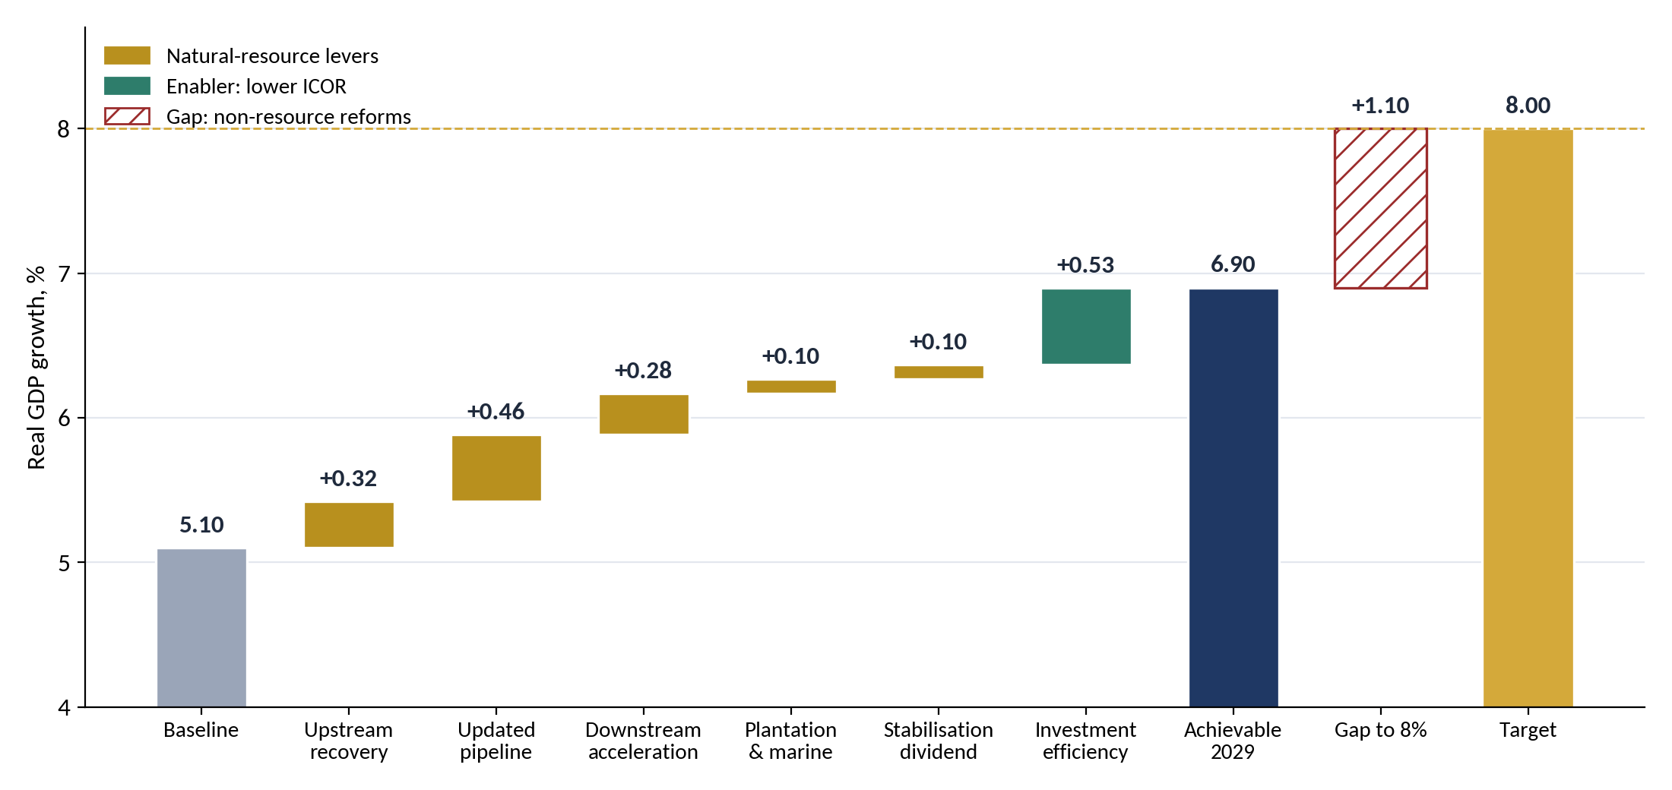
Source: author's calculation (Appendix E). Gold: natural-resource levers; green: investment efficiency; hatched: gap to be closed by non-resource reforms.
Figure 11.2. Growth path with natural-resource levers, 2026–2032 (%)
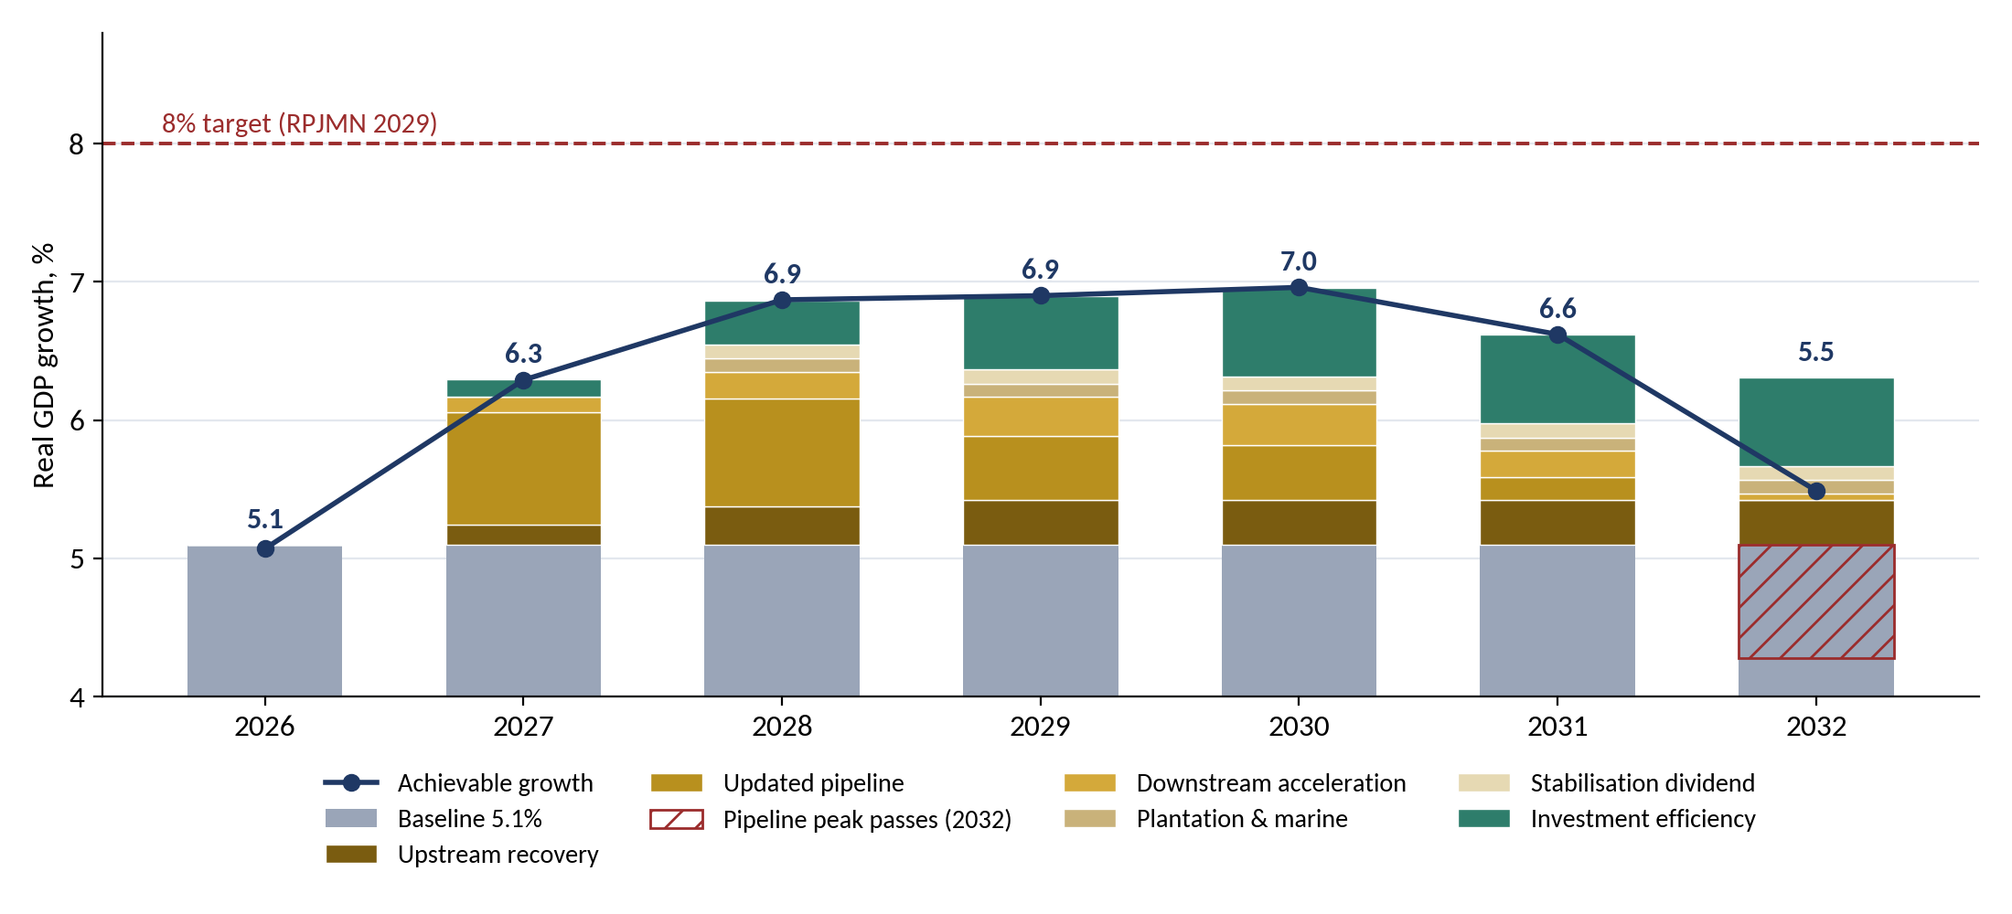
Source: author's calculation. The hatched bar in 2032 shows the end of the RKAP projects (Section 8.3); without a successor pipeline growth falls back towards 5.5%.

11.4 What natural resources can and cannot do
With every lever working, natural resources and the updated pipeline lift growth to about 6.4% on their own and to about 6.9% with better investment efficiency: roughly 1.3 to 1.8 of the 2.9 points needed. Seven findings follow.
- The downstreaming claim is too high. The Energy Minister has argued that executing the 28-commodity downstreaming roadmap (US$618 billion to 2040) would add at least 2 points of growth. Our estimate for all resource-processing levers together is about 0.6 to 0.9 points, because much of the equipment is imported, the plants are capital-intensive, and mining itself is currently contracting.
- Investment is no longer the binding constraint; efficiency is. With the updated pipeline, the investment ratio reaches about 32.5% of GDP in 2029, one point below the 33.5% of the recommended path (Chapter 12). Growth reaches about 6.9% in 2028 and stays near 7% to 2030, but stays below 8% because each rupiah still buys too little output.
- The 2032 drop pulls growth back to about 5.5%. A successor pipeline must be prepared from 2030.
- Upstream recovery is the quickest win. It needs no new money: restoring Grasberg and setting realistic production quotas add about 0.3 points.
- Jobs and consumption follow. At its peak the pipeline supports about 4.0 million jobs and lowers open unemployment from 4.7% to about 3.7%; the wages spent are part of the multiplier (Sections 8.7–8.8).
- Imports rise first. In 2029, the pipeline and the extra downstream plants need about US$27 billion of imports, about 1.6% of GDP, mostly for defence equipment; processed exports repay the industrial part only after the plants are built.
Two numbers summarise the chapter. With all resource levers and the updated pipeline in place, 8% in 2029 requires the ICOR to fall to about 4.3, close to Malaysia's 4.5. Without them, it would have to fall to about 3.6, below Singapore's. Natural resources do not deliver 8% on their own, but they make it reachable.
CHAPTER 12

Three Scenarios for 8% Growth
Chapter 11 showed that natural resources close about half of the gap. This chapter asks what it would take to close the rest, through three scenarios that each reach 8% by 2029 by a different route. Each rests on at least one very hard assumption; the point is to make those assumptions visible, so that the choice between routes is deliberate.

12.1 How the scenarios are built
- Growth rule. Growth = investment ratio ÷ ICOR, calibrated to 2025 (28.8% ÷ 5.6 = 5.1%). Each scenario moves both variables from their 2025 values to a 2029 target and holds them in 2030. The shape of the path differs: reforms are back-loaded (S1), spending is front-loaded (S2), and new factories come on stream gradually (S3).
- Sector check. Using 2025 sector shares (manufacturing 19.1%, agriculture 13.1%, mining 8.75%, construction about 10%, services and other about 49%), each scenario's sector growth rates must add up to 8%.
- Financing check. The current account equals national saving minus investment. Starting from a deficit of 0.1% of GDP in 2025, extra investment not matched by extra saving widens the deficit.

12.2 Scenario 1: Efficiency first
Storyline. Indonesia gets far more growth from each rupiah it already invests. Investment rises only modestly, to 31.5% of GDP, while the ICOR falls to 3.95, the government's own target. Growth is back-loaded: 5.3% in 2026, 5.8% in 2027, 6.6% in 2028 and 8.0% in 2029.
Hardest assumption. An ICOR of 3.95 within four years, a level comparable to Singapore. What it takes: logistics costs cut from 14.3% to 8–9% of GDP by 2030, as the Coordinating Minister for Economic Affairs has asked; licences granted in days rather than months; state enterprises consolidated under Danantara and run for returns rather than volume; and every public project screened through the six-test gate of Chapter 7.
Role of natural resources. The resource levers of Chapter 11 (about +1.3 points), with the fund's project gate setting the standard for public investment. Numbers. Extra investment of Rp 834 trillion a year by 2029 (US$47 billion); investment growth of 8.9% a year; a current-account deficit of about 1.3% of GDP if saving rises 1.5 points. Main risk: the politics and pace of reform; if reforms stall, growth stays near 6%.

12.3 Scenario 2: Big push
Storyline. Indonesia invests on a Chinese scale. Investment rises to 38.5% of GDP, with an ICOR of 4.8. Growth comes early: 6.3% in 2026, 6.9% in 2027, 7.5% in 2028 and 8.0% in 2029.
Hardest assumption. About Rp 3,000 trillion a year of extra investment by 2029, with investment growing 15% a year. What it takes: the updated pipeline kept near its 2028–2030 level until 2035, with a successor pipeline so that the 2032 drop never happens; downstreaming at about twice the roadmap pace; a fully aggressive fund (an 80/20 development split instead of 60/30, and loans of up to 10% of the future window, as Kuwait now allows); national saving up 6 points of GDP through fiscal consolidation, pension reform and the fund itself; and foreign direct investment up about 2 points of GDP.
Role of natural resources. The largest of the three, about +2 points: mining grows 6% a year and the fund becomes a main source of capital. Numbers. Extra investment of Rp 3,058 trillion a year by 2029 (US$172 billion); construction growth of 13%. Main risk: a current-account deficit of about 3.8% of GDP, above the roughly 3% at which the rupiah came under heavy pressure in 2013, together with inflation, excessive credit growth and wasted projects.

12.4 Scenario 3: Industrial and export leap
Storyline. Indonesia follows the export-manufacturing route, using its own resources as feedstock. Investment rises to 34.5% of GDP with an ICOR of 4.3. Growth reaches 5.5% in 2026, 6.1% in 2027, 6.9% in 2028 and 8.0% in 2029.
Hardest assumption. Manufacturing growth of 11.5% a year, against 5.3% in 2025 and the RPJMN target of 8.14% for 2029, raising its share towards 22% of GDP. What it takes: nickel processed into battery materials, cells and electric vehicles; bauxite into aluminium; copper into cable; palm oil into oleochemicals; shipbuilding and defence as export industries; factories relocating out of China and the Indonesia–EU agreement in force from 2027; and small domestic suppliers brought into the supply chain through programmes such as DOCK-UP (develop, off-taker, certification, upgrading).
Role of natural resources. Feedstock rather than raw exports, about +1.5 points, much of it appearing in manufacturing. Numbers. Extra investment of Rp 1,765 trillion a year by 2029 (US$99 billion); a current-account deficit of about 1.8% of GDP if saving rises 4 points, cushioned by rising exports. Main risk: global demand, trade frictions and nickel prices, and whether skills and productivity can rise fast enough.

12.5 Comparison
Table 12.1. Three scenarios for 8% growth by 2029
 | S1 Efficiency first | S2 Big push | S3 Industrial & export leap
Investment, % of GDP (2029) | 31.5 | 38.5 | 34.5
ICOR (2029) | 3.95 | 4.8 | 4.3
Growth 2026 / 27 / 28 / 29 | 5.3 / 5.8 / 6.6 / 8.0 | 6.3 / 6.9 / 7.5 / 8.0 | 5.5 / 6.1 / 6.9 / 8.0
Extra investment a year by 2029 | Rp 834 T (US$47 bn) | Rp 3,058 T (US$172 bn) | Rp 1,765 T (US$99 bn)
Investment growth needed a year | 8.9% | 15.3% | 11.6%
Sector growth 2029: manufacturing / mining / construction / services | 8.5 / 3.0 / 7.5 / 9.8 | 9.0 / 6.0 / 13.0 / 8.1 | 11.5 / 5.0 / 8.0 / 8.2
Extra national saving assumed | +1.5 pp of GDP | +6.0 pp of GDP | +4.0 pp of GDP
Current account 2029 | −1.3% of GDP | −3.8% of GDP | −1.8% of GDP
Extra GDP in 2029 vs 5.1% baseline | Rp 1,474 T | Rp 2,352 T | Rp 1,726 T
Contribution of natural resources | ≈ +1.3 pp | ≈ +2.0 pp | ≈ +1.5 pp
Hardest assumption | ICOR 3.95 in four years | Investment +15% a year | Manufacturing +11.5% a year
Main risk | Reform politics | Balance of payments | Global markets
Source: author's calculation (Appendix E). Illustrative scenarios built on documented assumptions, not forecasts.
Figure 12.1. Three routes to 8%: investment ratio against ICOR
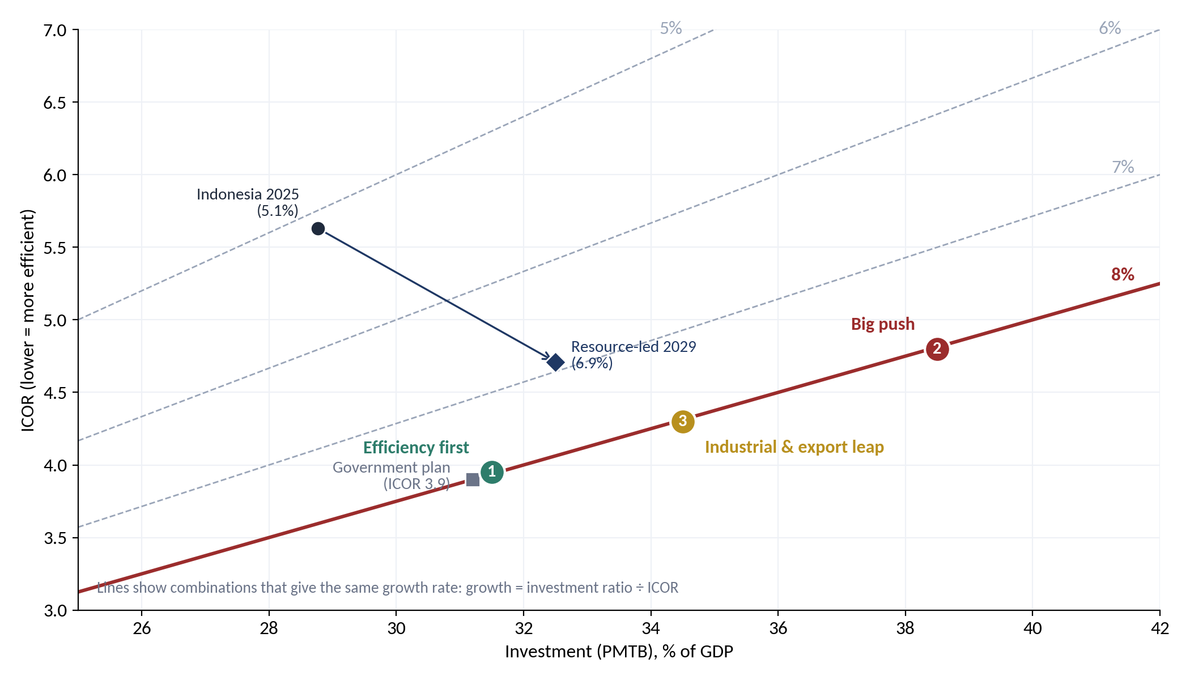
Source: author's calculation. Each line joins combinations that give the same growth rate. The resource-led point (6.9%) includes the updated pipeline of Chapter 8.
Figure 12.2. Growth paths of the three scenarios, 2025–2030 (%)
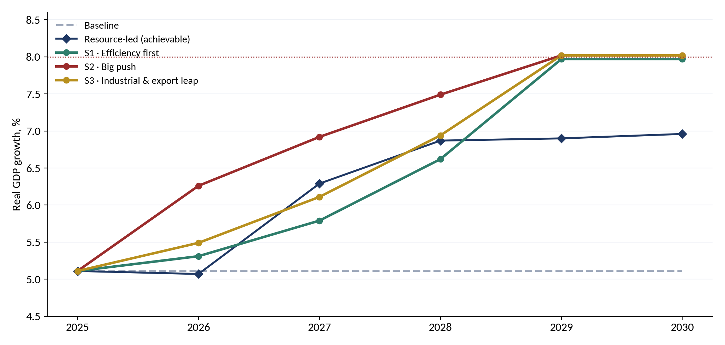
Source: author's calculation. The resource-led path is the achievable growth of Chapter 11.
No scenario reaches 8% on natural resources alone: in each, resources supply roughly 1.3 to 2 of the 2.9 points needed, and the rest comes from efficiency (S1), money (S2) or manufacturing (S3). Each carries a different risk: S1 the politics of reform, S2 the balance of payments, S3 the global market.

12.6 The recommended path: an industrial leap with efficiency discipline
The most credible route combines S3 with the reforms of S1. Efficiency reforms make the industrial investment more productive, so that investment of about 33.5% of GDP with an ICOR of about 4.2 is enough for 8% (33.5 ÷ 4.2 ≈ 8.0), instead of the 38.5% that S2 needs. Indonesia has done something similar before: in the mid-1990s it grew about 7–8% a year with investment of roughly 30% of GDP. With the updated pipeline, the resource-led path already lifts investment to about 32.5% of GDP in 2029, so most of the remaining distance is efficiency: an ICOR of about 4.2–4.3 instead of 5.1.
- 2026–2027: fix and prepare. Restore mining output; pass the fund Law; start logistics, licensing and SOE reforms; prepare bankable industrial projects in battery materials, aluminium, copper, oleochemicals and shipbuilding.
- 2027–2029: build. Run the pipeline through the six-test gate, with the resource-first funding stack of Section 10.3; accelerate downstream investment towards Rp 1,000 trillion a year; bring small suppliers into national projects; keep the current-account deficit below 2.5% of GDP.
- 2029–2032: sustain. Launch the successor pipeline before the 2032 drop; shift from building capacity to exporting from it; review the development window and prepare its tapering from 2033.
Holding 8% beyond 2029 depends on that successor pipeline and on keeping the ICOR low. Without them, growth would fall back to the mid-5s once construction ends.
CHAPTER 13

Designing and Executing the Programme
High growth depends less on the size of the plan than on how carefully it is designed and executed. This chapter sets out the design principles, the institutions and their roles, the working plan, the timeline and the factors that will decide success.

13.1 Design principles
- One Law, three windows. Stabilise, save and invest under a single Law owned by the Ministry of Finance, so that the rules cannot be changed by a budget circular.
- Rules before money. Contribution, withdrawal and investment rules are fixed before the first rupiah moves; changes require Parliament.
- Every project through the gate. No project receives fund money without passing the six tests of Chapter 7; the same discipline should apply to large public projects outside the fund.
- Efficiency as a target. The ICOR, cost per unit of capacity and domestic content become published targets, not by-products.
- Build at home. Domestic content and supplier development (DOCK-UP) are part of project design, especially in defence and maritime.
- Recycle, don't spend. Development equity returns to the fund; the window narrows on schedule and closes in 2038 unless renewed by Law.
- Publish everything. Fund accounts, project screens, the dashboard of Chapter 14 and independent reviews are public, except classified defence details.

13.2 Institutions and roles
Table 13.1. Who does what
Institution | Role
Ministry of Finance | Owns the fund; sets contribution and withdrawal rules; reports to Parliament
Independent reference-price committee | Sets commodity reference prices each year (Chile model)
Danantara / DDMF | Executes the development window under a mandate; screens and manages projects
Bappenas | Links the fund to the RPJMN; tracks the ICOR and the growth dashboard
Ministry of Investment and Downstreaming (BKPM) | Downstream investment pipeline, licensing, investor facilitation
Coordinating Ministry for Economic Affairs | Logistics-cost reform and cross-ministry coordination
Ministry of Defence and KKIP | Sovereignty tier, domestic-content and offset policy
Bank Indonesia | Macro-financial monitoring: current account, rupiah, inflation
BPK and an independent investment committee | Audit, project review and annual public report
Parliament (DPR) | Approves the Law and any rule change; receives annual reports
Source: author's proposal.

13.3 Working plan
Table 13.2. Working plan by workstream
Workstream | Lead and partners | Key outputs | Timing
1. Fiscal modelling and calibration | MoF (BKF) with BI, ESDM | Reference-price method; contribution shares; withdrawal caps; revenue scenarios | Q4 2026 – Q2 2027
2. Legal drafting | MoF with Ministry of Law, BI; DPR Commission XI | Academic paper (naskah akademik); draft Law; Prolegnas entry; enactment | 2027 – 2028
3. Reference Price Committee | MoF; independent experts; universities | Committee charter, membership, first published reference prices | 2028 – 2029
4. Revenue base review | MoF (DJP, DJA), ESDM, Ministry of Investment | Review of smelter tax holidays and royalty design; nickel and copper inclusion plan | 2027 – 2030
5. Palm oil levy reform | Coordinating Ministry for Economic Affairs, BPDP, MoF | Levy saving rule; ring-fenced replanting; biodiesel budget ceiling | 2028 – 2030
6. Fund operations | BI (operational manager), MoF (owner) | Investment mandate; custody; risk framework; first deposits | 2028 – 2029
7. Transparency and regions | BPK, DPR, Ministry of Home Affairs, regions | Annual and quarterly reports; audit; Dana Abadi SDA Daerah rules | 2029 onwards
8. Data and monitoring | BPS, BI, MoF | Resource revenue dashboard; export and revenue series; first full-cycle review | 2027 onwards; review 2032
Source: author's proposal. Lead institutions are indicative.

13.4 Timeline
The plan proceeds in four phases (Figure 13.1): preparation from late 2026, legislation in 2027–2029, operation from 2029 starting with oil, gas and coal, and expansion with a first full-cycle review in 2031–2032. The key milestones are the draft Law submitted to the DPR (2027), the Law enacted (2028), the first published reference prices (2029), the first deposits in both windows (2029), palm oil inclusion (2030–2031) and nickel inclusion with a full review (2032).
Figure 13.1. Indicative implementation timeline, 2026–2032
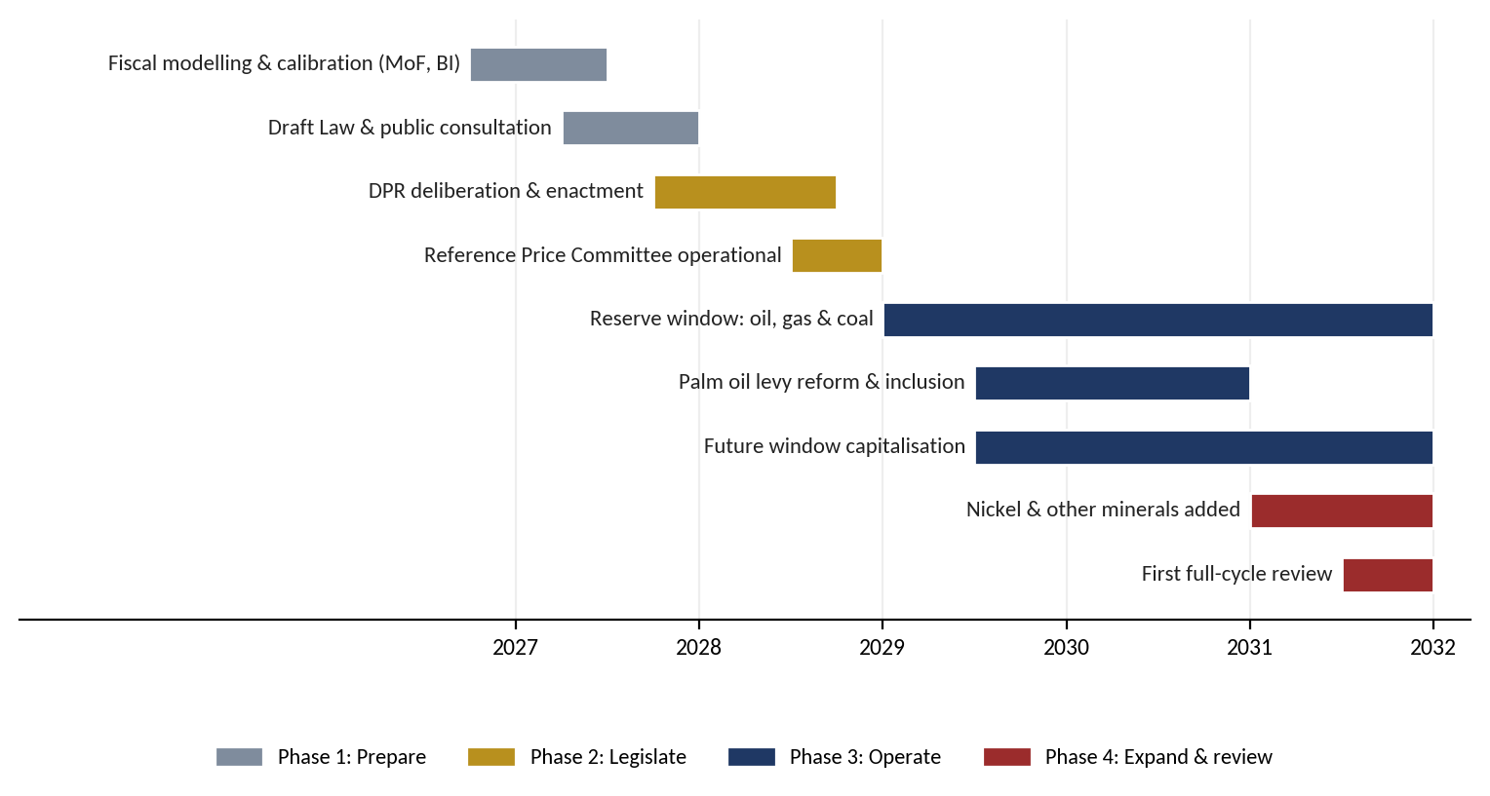
Source: author's proposal. Dates are indicative and depend on the legislative calendar.

13.5 Key success factors
Table 13.3. Key success factors and indicators
Success factor | Why it matters | Indicator of success
Legal durability | Rules protected by Law survive changes of government | Fund established by Law; no weakening amendment in the first cycle
Independent price-setting | Removes the incentive to declare a boom permanent | Committee outside MoF; methods and prices published before each budget
Automatic rules | Saving does not depend on annual political decisions | Deposits made in every year as the Law requires; withdrawals within caps
Transparency | Public scrutiny deters misuse and builds trust | Quarterly reports; BPK audit opinion; Santiago Principles self-assessment
Broad political ownership | Consensus sustains the rules through cycles, as in Norway | Cross-party support in the DPR; regional participation
Visible benefits | Citizens defend a fund they can see working for them | Regional endowment allocations; development spending financed by returns
Gradual phasing | Early success builds credibility | Oil, gas and coal first; palm oil and nickel added on schedule
Source: author's synthesis from the cases reviewed.
CHAPTER 14

Monitoring and Risk Mitigation
A programme of this size will go off course somewhere. What matters is to see it early and to have agreed in advance what happens next. This chapter sets out a monitoring dashboard with targets and triggers, a review cycle, and the risks with their mitigations.

14.1 The monitoring dashboard
Table 14.1. Growth and fund dashboard: targets and triggers
Indicator | 2025 | 2029 target | Red flag (trigger) | Owner
Real GDP growth (%) | 5.1 | 8.0 | Below 6.0% for four quarters after 2027 | Bappenas, BPS
Investment, PMTB (% of GDP) | 28.8 | 33–34 | Below 30% in 2027 | Bappenas, BKPM
Open unemployment rate (%) | 4.7 | 3.7–4.0 | Above 4.5% in 2028 | Ministry of Manpower, BPS
ICOR | 5.6 | ≤ 4.3 | Above 5.0 in 2028 | Bappenas
Manufacturing growth (%) | 5.3 | ≥ 10 | Below 7% in 2028 | Ministry of Industry
Downstream investment (Rp T a year) | 584 | ≥ 1,000 | Below 700 in 2027 | BKPM
Mining growth (%) | −0.7 | ≥ 3 | Negative in 2027 | Ministry of Energy
Logistics cost (% of GDP) | 14.3 | ≤ 9 | Above 12% in 2028 | Coordinating Ministry
Current account (% of GDP) | −0.1 | ≥ −2.5 | Below −2.5% | Bank Indonesia
Inflation (%) | Target 2.5 ± 1 | Within target | Above 3.5% for two quarters | Bank Indonesia
Share of resource PNBP saved | — | 40% (2027–34) | Any shortfall | Ministry of Finance
Pipeline funded by natural resources | — | ≥ 50% | Below 40% | Ministry of Finance, Danantara
DDMF projects passing the gate; cost overrun | — | 100%; < 15% | Overrun above 15% | DDMF, investment committee
Defence domestic content (%) | 43 | ≥ 60 | Below 45% in 2028 | Ministry of Defence, KKIP
Defence imports (US$ bn a year) | — | ≤ 7 | Above 9 | Ministry of Defence, Bank Indonesia
Source: author's proposal. 2025 values from BPS, BKPM, Bank Indonesia, the Coordinating Ministry and Chapter 2; targets follow the recommended path of Chapter 12.

14.2 Review cycle and pre-agreed responses
- Quarterly: the dashboard goes to the fund's steering committee and is published.
- Annually: an independent review of the fund and of every DDMF project above Rp 5 trillion, reported to Parliament.
- 2028 mid-term review: confirm or change the growth path and the development-window share.
- Pre-agreed responses: if the current-account deficit passes 2.5% of GDP, slow development-window drawdowns and re-phase import-heavy projects; if the ICOR is above 5.0 in 2028, freeze new projects that have not passed the gate; if inflation stays above 3.5%, re-phase construction; if growth stays below 6% after 2027, reassess the scenario rather than add spending.
- 2038 sunset review: the development window closes unless renewed by Law.

14.3 Risk identification
Table 14.2. Risk register
Risk | Likelihood | Impact | Mitigation
Political pressure to spend windfalls | High | High | Automatic deposits and hard caps in the Law; fiscal council oversight; public reporting
Reference price set too high | Medium | High | Independent committee; published methods; conservative discount for nickel and palm oil
Small state revenue share | High | Medium | Review smelter incentives and royalty design as tax holidays expire
Domestic price controls (DMO, caps, export bans) | Medium | Medium | Show the fiscal cost of such measures explicitly in the budget
Launch during a price downturn | Medium | Medium | Legislate now; capitalise in the first high-price year; temporary hedging
Institutional overlap (Danantara, INA, DHE) | Medium | Medium | Clear legal mandates: the fund saves, Danantara invests, DHE manages liquidity
Investment losses in the future window | Low | Medium | Diversified global mandate; risk limits; BI management; independent audit
Governance capture or misuse | Low | High | Santiago Principles; BPK audit; DPR reporting; no domestic project lending
Source: author's assessment. Likelihood and impact are qualitative.

14.4 Risks of the aggressive option
Table 14.3. Main risks of the aggressive option
Risk | Evidence | Safeguard
Correlated commodity exposure | Project revenue and state revenue both fall when coal or nickel prices fall | 35% commodity cap; share of assets with stable contracted returns
Stranded coal assets | DME may be uncompetitive against LPG; long-term decline in coal demand | Time-limited CDME mandate; carbon-cost test; solar as the anchor
Contingent liabilities | The RKAP lists guarantees, comfort letters and bailout pressure; Athens's availability payments | No guarantees from the fund; defence through equity only, availability payments on the APBN
Defence-specific risks | Single buyer; export controls and limits on technology transfer; budget-dependent revenue; classified information | Multi-year contracts; offset agreements; 20% tier cap; closed-session reporting to DPR Commission I and BPK
Exceptions become the rule | Timor-Leste: withdrawals above the ESI almost every year since 2009 | Caps written into the Law; sunset in 2038; any extension requires a Law
Capture and misuse | 1MDB; subsidised lending with large fiscal costs elsewhere | Independent committee; BPK audit; project-level disclosure; Santiago Principles
Absorptive capacity and Dutch disease | Investment inefficiency (IMF, 2015); rupiah pressure from domestic spending | Stage-gating; disbursement tied to readiness; counter-cyclical timing
Unmeasured impact | The RKAP's impact KPIs all have zero targets for 2026 | No disbursement without a quantified baseline for jobs, TKDN, FX effect and emissions
Source: author's assessment.

14.5 Risks of the growth push
Table 14.4 lists the risks specific to the push for 8% growth, the scenario most exposed to each, the early-warning indicators and the mitigations.
Table 14.4. Risks of the growth push and their mitigation
Risk | Most exposed | Early warning | Mitigation
Overheating and inflation | S2 | Core inflation, credit growth above 15% | Re-phase construction; macroprudential limits; Bank Indonesia independence
Current account and rupiah | S2, S3 | Deficit above 2.5% of GDP; reserves | Slow drawdowns; favour domestic-content projects; FDI over portfolio flows
Debt and contingent liabilities | S2 | SOE debt; guarantees issued | Equity rather than guarantees; cap on DDMF leverage; publish contingent liabilities
ICOR does not fall (white elephants) | All | Cost overruns; utilisation of new capacity | Six-test gate; independent appraisal; stop-loss rules
Weak global demand and trade frictions | S3 | Export orders; trade measures against Indonesia | Diversify markets; EU agreement; domestic offtake for part of output
Commodity prices (nickel, coal) | All | Reference-price gap | Reserve window; conservative project price decks
Reform fatigue | S1 | Delays in logistics and licensing reforms | Presidential delivery unit; publish milestones
Governance and corruption | All | Audit findings; single-bidder contracts | BPK audit; open contracting; independent investment committee
Environmental and social licence | S2, S3 | Local conflicts; emissions | Environmental and social standards; benefit sharing with regions
Skills shortage | S3 | Vacancies in technical jobs | Vocational programmes tied to projects; STEM university
Defence import bill | All | Defence imports above US$9 bn a year | Domestic-content targets; DHE SDA loans instead of foreign loans; phase deliveries
Resource revenue shortfall | All | Resource PNBP below Rp 250 T | Reserve window; stage-gated tranches; budget fallback for public goods
Source: author's assessment.

14.6 Possible drawbacks and obstacles
- Opportunity cost: money saved abroad is not spent on domestic infrastructure or social programmes today. The design limits this by saving only windfalls and a modest fixed share, and by releasing the real return for development.
- Political economy: election cycles and budget pressure favour spending over saving; Alaska and Kuwait show that rules erode under stress unless protected at a high legal level.
- Coordination with monetary policy: foreign-currency deposits interact with Bank Indonesia's reserve and liquidity management and with the DHE regime, and require close coordination.
- Central–regional revenue sharing: resource revenue is shared with producing regions (DBH SDA); the fund must be designed so that it does not reduce regions' legal entitlements.
- Business reaction: exporters already bear DHE retention; the fund must be clearly financed from state revenue, not from private proceeds.
- Energy transition: coal revenue may decline structurally, which argues for saving now but also limits how large the fund can become.
- Capacity: reference-price estimation, investment management and reporting require skills that must be built or procured.
CHAPTER 15

Conclusion and Recommendations

15.1 Conclusion
Indonesia's natural-resource wealth is large, volatile and depleting. Twenty-five years of export data show eight boom-and-bust phases, and international experience shows how to respond: stabilise like Chile, save like Norway, and protect both by Law. For a capital-scarce economy, this paper adds a third element: invest a time-limited, rule-bound share of the savings at home through a development window that recycles every rupiah that comes back.
With the October 2026 figures, the pipeline is Rp 5,396 trillion in three clusters. Industry (91%) builds physical capacity: resource processing converts depleting rent into lasting assets and is the fund's core; infrastructure and the Giant Sea Wall give the largest short-run boost and the most jobs, mostly as public goods; defence modernisation, now 39% of the pipeline, protects the wealth being saved, but its economic return depends on how much is built at home. Technology (9%) buys productivity at a high import cost. Finance is small in capital spending but holds the fund and the instruments that pay for the rest. Together the pipeline could lift GDP by about 2.2% at its peak and about 0.9% permanently, support about 4.0 million jobs at the peak and 1.4 million lasting jobs, and lower open unemployment to about 3.7% while construction lasts.
Natural resources can pay for about half of it. Under a time-limited, maximised rule, resource cash and resource-backed debt provide about 54% of the Rp 4,881 trillion needed in 2027–2034, and anchor about 74% once partners are counted, at a cost to the budget of about Rp 111 trillion a year of resource revenue.
On growth, natural resources and the updated pipeline lift Indonesia from about 5.1% to about 6.4%, and to about 6.9% with better investment efficiency. With the pipeline, investment reaches about 32.5% of GDP, close to what 8% needs; what is missing is efficiency. The recommended path is an industrial leap with efficiency discipline: investment of about 33.5% of GDP and an ICOR of about 4.2–4.3, using Indonesia's resources as feedstock for manufacturing rather than as raw exports. It is ambitious but has a precedent in Indonesia's own history, and it depends on careful design, disciplined execution, transparent monitoring and pre-agreed responses to risk.

15.2 Recommendations
- Adopt the three-window fund in one Law. The reserve window stabilises, the development window invests and the future window saves. The development window is sunset in 2038 unless renewed by Law.
- Capture the 2026 windfall now. Natural-resource PNBP is running far above 2024. Place the excess over the budget assumption in a transitional account that becomes the fund's opening capital, part of which can seed the development window in 2027.
- Give DDMF a mandate, not the money. Sign a mandate agreement under which DDMF originates and executes projects and the fund's committee approves each disbursement. This keeps the separation from Danantara recommended in Parts II and III.
- Start with the resource-conversion core. PLTS 100 GW in tranches, rare earths, metals, copper and silica first; CDME, refinery, CPE and biodiesel once their conditions are met.
- Route public goods through the budget. Housing, schools, sea walls and water should be financed by the APBN, SBSN or KPBU, supported by the future window's annual return. Platform purchases and availability payments stay on the budget.
- Create a sovereignty tier. Add shipyards and ship components and alutsista production to the priority list (now 15 projects), finance the maritime and defence-industrial base within a 20% cap, and channel the work to domestic yards and SME suppliers.
- Require measurable impact. Before the first disbursement, DDMF should set quantified baselines and targets for jobs, value added, TKDN, import substitution and emissions, and report on them publicly each year.
- Recalibrate in 2027. Fiscal modelling (Workstream 1 of the earlier working plan) should test the 30% rate, the 60/30/0 split, the loan cap and the return floor against revenue scenarios, including a coal price collapse.
Eight further decisions for high growth, jobs and funding:
- Choose the path. Adopt the industrial leap with efficiency discipline as the reference scenario, with the targets of Table 14.1.
- Make the ICOR a national target. Publish it each year, and use cost per unit of capacity in every project decision. With the updated pipeline, efficiency is the binding constraint.
- Fund natural resources first. Adopt the maximised rule (save 40%, 80% to development) for 2027–2034 only, earmark the windfall, coal export duty and royalty revision, reinvest resource-SOE dividends, and use DHE SDA loans instead of foreign loans for imported equipment (Section 10.3).
- Maximise defence domestic content. Set a 60% target for the Rp 2,125 trillion programme, build submarines and fast attack craft at domestic yards, and keep MRO at home; confirm whether the programme is additional to the existing alutsista budget.
- Restore upstream output first. Mining recovery is the cheapest growth available in 2026–2027.
- Prepare the successor pipeline from 2030. Avoid the 2032 drop and keep investment near 33–34% of GDP.
- Hire locally and train for it. Make local hiring, vocational training and SME supplier development (DOCK-UP) conditions of every project, so that jobs and wages stay in Indonesia and in the project regions.
- Monitor and act on triggers. Run the quarterly dashboard and the pre-agreed responses of Section 14.2, including the 2.5%-of-GDP current-account limit and the defence import ceiling.
The recommendation in one paragraph
- Establish by Law, before the next commodity boom, a Natural Resource Stabilisation and Wealth Fund with three windows: a reserve window that saves revenue above an independent reference price, a future window that saves a fixed share every year and spends only its real return, and a time-limited development window that invests part of the savings through DDMF under a mandate. Organise the Rp 5,396 trillion pipeline in three clusters, Industry, Technology and Finance; make resource processing the fund's core, finance infrastructure and the sea wall as public goods, build defence at home within a sovereignty tier, and stage the technology programmes. Fund the pipeline natural-resources first, for about half of its cost, and use it as one engine of an industrial leap with efficiency discipline aiming at 8% growth, through investment of about a third of GDP and an ICOR near 4.2–4.3, run on a public dashboard with pre-agreed responses to risk.
APPENDIX A

The Projects by Cluster and Segment
Table A.1. All projects by cluster and segment (Rp trillion)
Project | Segment | Investment | Equity | Timeline
Industry |  | 4,914.3 | 1,032.0
PLTS 100 GW (solar) | Resource processing & energy | 231.4 | 48.6 | 2027–2030
Fishing-village food security | Resource processing & energy | 83.8 | 17.6 | 2028–2031
Biodiesel | Resource processing & energy | 75.4 | 15.8 | 2028–2031
Al, Fe, Ni, Mn metals | Resource processing & energy | 73.3 | 15.4 | 2029–2031
CPE (assumed petrochemical) | Resource processing & energy | 71.2 | 15.0 | 2028–2031
CDME (coal to DME) | Resource processing & energy | 46.3 | 9.7 | 2027–2030
Refinery | Resource processing & energy | 40.9 | 8.6 | 2027–2032
Silica | Resource processing & energy | 8.9 | 1.9 | 2028–2031
Legacy waste – landfill mining | Resource processing & energy | 6.0 | 1.3 | 2028–2031
Legacy waste – RDF | Resource processing & energy | 6.0 | 1.3 | 2028–2031
Project Tarsius Ph.1 (rare earths) | Resource processing & energy | 2.3 | 0.5 | 2029–2032
Copper | Resource processing & energy | 2.0 | 0.4 | 2028–2031
Project Anoa (rare earths) | Resource processing & energy | 0.4 | 0.1 | 2027–2031
10 smart cities | Infrastructure & social | 225.0 | 47.3 | 2028–2032
Affordable housing | Infrastructure & social | 219.4 | 46.1 | 2028–2031
500 schools | Infrastructure & social | 178.0 | 37.4 | 2027–2031
Centralised water | Infrastructure & social | 112.2 | 23.6 | 2028–2031
STEM university | Infrastructure & social | 71.0 | 14.9 | 2027–2031
Decentralised waste | Infrastructure & social | 4.6 | 1.0 | 2027–2031
Giant Sea Wall * | Giant Sea Wall | 1,200.0 | 252.0 | 2027–2040
Defence modernisation ‡ * | Defence platforms & MRO | 2,125.0 | 446.3 | 2027–2034
Shipyard & ship components | Defence & maritime industry | 5.2 | 1.1 | 2028–2032
EV Power Pack (maritime) | Defence & maritime industry | 3.0 | 0.6 | 2028–2031
Textile ecosystem | Manufacturing | 89.0 | 18.7 | 2028–2031
MOBNAS & MOLINAS | Manufacturing | 25.0 | 5.3 | 2027–2029
Biosimilar & pharma | Manufacturing | 8.9 | 1.9 | 2028–2031
Electric stoves (kompor listrik) (TBC) | Infrastructure & social | n.a. | n.a. | n.a.
High-speed rail (kereta cepat) (TBC) | Infrastructure & social | n.a. | n.a. | n.a.
Trans-Sumatra toll road (TBC) | Infrastructure & social | n.a. | n.a. | n.a.
Technology |  | 480.3 | 100.9
AI and IT programme * | Digital infrastructure | 200.0 | 42.0 | 2027–2032
National Data Centre * | Digital infrastructure | 50.0 | 10.5 | 2027–2031
Quantum technology development * | Deep tech | 20.0 | 4.2 | 2027–2031
Semiconductors * | Deep tech | 15.0 | 3.2 | 2027–2030
National space programme | Deep tech | 5.4 | 1.1 | 2027–2031
Drone | Deep tech | 3.0 | 0.6 | 2028–2031
Tech Corridor | Technology park | 186.9 | 39.2 | 2028–2031
IMX (purpose to be confirmed) (TBC) | Digital infrastructure | n.a. | n.a. | n.a.
Finance |  | 1.0 | 0.2
E-commerce (B2G/B2B MSME platform) | Financial & commercial platforms | 1.0 | 0.2 | 2028–2031
ERP Merah Putih (TBC) | Financial & commercial platforms | n.a. | n.a. | n.a.
Total (34 costed + 5 TBC) |  | 5,395.5 | 1,133.1 | 2027–2040
Source: RKAP DDMF 2026, p. 11 and 110–112; * October 2026 update; classification by the author. ‡ Submarines, USV, fast attack craft, carrier Sriwijaya refurbishment, fighter squadrons and MRO; replaces Athens and alutsista. TBC = to be confirmed; no cost estimate.
APPENDIX B

Cluster Model: Method and Parameters
- Investment profile. Each project's investment is spread evenly over its timeline: RKAP timelines for RKAP projects (p. 110–112); for the October 2026 figures, defence 2027–2034, the sea wall 2027–2040, the data centre and quantum 2027–2031, semiconductors 2027–2030 and AI and IT 2027–2032 (author's assumptions). Values are treated as constant 2025 prices.
- GDP baseline. Nominal GDP of Rp 23,821.1 trillion in 2025 (BPS), projected at 5% a year in constant prices; employment 146.54 million (BPS, August 2025), giving output per worker of about Rp 163 million.
- Build-phase effect (Lens A). GDP level effect in year t = m(h) × (domestic content ÷ 0.70) × investment in year t, where m(h) rises linearly from 0.5 in the first year to 1.2 in the fifth (IMF, 2026, baseline efficiency). The 0.70 reference is the assumed domestic content of typical public investment embedded in the IMF estimate.
- Permanent effect (Lens B). GDP gain = productive capital share × cumulative investment ÷ ICOR, with ICOR = 6.5; capital becomes productive with a one-year lag. In each year and segment the larger of the two lenses is used.
- Segment parameters. Domestic content, productive capital share and labour productivity as in Table 8.1. Equity for the October 2026 figures is 21% of investment, the RKAP average.
- Enhanced efficiency. Multipliers 30% higher and ICOR 5.0, matching the IMF's long-run multiplier of 2.6 instead of 2.0 when the efficiency gap closes.
- Jobs, tax and imports. Jobs = GDP effect ÷ (output per worker × productivity factor). Tax = 9.31% of the GDP effect (2025 broad tax ratio). Imports = (1 − domestic content) × investment, at Rp 17,800 per US$.
- Limitations. No depreciation of the capital stock, no crowding-out of private investment and no second-round tax or debt effects. The defence and sea-wall parameters carry the most weight because of their size. The results show orders of magnitude and the ranking of segments, not forecasts.
APPENDIX C

Points Requiring Clarification
The following points should be clarified before the analysis is used for decisions. Points on the Giant Sea Wall scope and the Athens value, raised in earlier drafts, are superseded by the October 2026 figures.
Table C.1. Open points
# | Point | Why it matters
1 | Is the Rp 2,125 T defence programme additional? | About Rp 266 T a year against a 2026 Kemhan budget of Rp 187.1 T (alutsista Rp 84.5 T). If part replaces existing alutsista spending, the macroeconomic effect and the funding need are smaller
2 | Defence financing and domestic content | How much is built at PT PAL and other domestic yards; which items are imported; whether foreign loans are used. Domestic content is the largest lever in the model (Section 8.5)
3 | Timelines of the October figures | Defence 2027–2034 and the sea wall 2027–2040 are assumptions; a shorter sea-wall schedule raises growth but brings the funding need forward
4 | IMX | Purpose, cost and owner; placed in Technology provisionally
5 | AI and IT programme (Rp 200 T) | Composition by hardware, software, skills and public systems; who operates and who uses it
6 | Funding assumptions | Windfall share, coal export duty, royalty revision (postponed in May 2026), resource-SOE dividends and DHE SDA loans of US$8 bn a year are illustrative and need MoF, Bank Indonesia and Danantara confirmation
7 | RKAP total and equity | The RKAP text gives Rp 1,994.5 T and Rp 398.8 T of equity, while the tables sum to Rp 2,091.5 T and Rp 419.1 T; the difference is the earlier sea-wall figure
8 | Coal-to-DME scope | RKAP Rp 46.3 T versus press reports of Rp 164 T for Danantara's revived DME programme
9 | PLTS 100 GW | Far above the RUPTL 2025–2034 (17.1 GW of new solar); which offtake and grid plan applies?
10 | CPE (Rp 71.2 T) | Not described in the RKAP; assumed petrochemical
11 | Other uncosted projects | ERP Merah Putih, electric stoves, high-speed rail and the Trans-Sumatra toll road: costs and timelines
12 | Domestic-content parameters | Assumptions pending the import matrix of the BPS Input-Output Table 2020
Source: author's review of the RKAP DDMF 2026, the October 2026 update and the sources cited.
APPENDIX D

Evidence by Cluster: Key Publications
Table D.1. Key publications and findings by cluster
Cluster | Source | Key finding used in this paper
Industry: resources | Antara (2024) | Nickel exports rose from US$3.3 bn (2017–18) to US$33.5 bn (2023); mineral downstream investment Rp 181.4 T in H1 2024
Industry: resources | CSIS (2025) | Indonesia 58% of world nickel (2024); Chinese firms about 75% of refining capacity; 82% of exports to China
Industry: resources | Kee & Xie, World Bank (2025) | Ore export ban raised domestic value added by 5.6% in iron/steel-using industries, 1.1% overall; productivity fell
Industry: resources | IMF (2023) | Article IV: consider phasing out export restrictions; do not extend them to other commodities
Industry: resources | CREA & CELIOS (2024) | Health costs of nickel processing US$2.6 bn a year; 6.1 GW of captive coal power for smelters
Industry: resources | Petromindo (2023); Indonesia Business Post (2025) | Air Products quit the US$2.1 bn DME project; revived DME programme reported at Rp 164 T
Industry: resources | JETP (2023); RUPTL 2025–2034; IESR (2024) | US$97.3 bn plan for 44% renewables by 2030; 17.1 GW new solar planned; about 700 MW installed
Industry: infrastructure | IMF (2026) | Public-investment multiplier about 0.5 (year 1), 1.2 (5 years), 2.0 (long run); 0.7/2.6 with better efficiency
Industry: infrastructure | Kemenko Perekonomian (2024) | 190 national strategic projects worth Rp 1,515 T completed in 2016–2023
Industry: infrastructure | Annisa & Kingsley (2025); Jakarta Post (2026) | Whoosh cost US$7.27 bn incl. US$1.2 bn overrun; Indonesian consortium lost Rp 4.2 T in 2024; MoF takes over from Danantara
Industry: infrastructure | Kompas (2024) | Rp 131.1 T of state capital to Hutama Karya for the Trans-Sumatra toll road, 2015–2024
Industry: infrastructure | PKP / Susenas; Bisnis (2026) | Housing backlog 9.9 million units (2023); data-centre capacity 637 MW, about 1.6 GW by 2027
Industry: defence | CNBC Indonesia (2026); ASPI (2026) | Kemhan 2026 Rp 187.1 T (about 0.8% of GDP); alutsista modernisation Rp 84.5 T, of which Rp 46.5 T foreign loans
Industry: defence | Kemhan; Law 16/2012 | Local content and/or offset at least 35%, rising 10% every five years
Industry: defence | Triantama (2026) | DEFEND ID arms revenue US$1.1 bn (2024), SIPRI Top 100 #96; local content 43%; 9% domestic inter-tier transactions
Industry: defence | Dunne & Tian (2013) | Survey of about 170 studies: more recent evidence of a negative effect of military spending on growth
Industry: defence | Naval News (2024); Antara (2025) | Two Scorpène Evolved submarines to be built at PT PAL with technology transfer; 342 shipyards, 1 m DWT new-build capacity
Industry: manufacturing | USDA/Databoks; APSyFI; BenarNews | Cotton almost fully imported; mills at 30–50% utilisation; Sritex bankruptcy and 60 firms closed
Industry: manufacturing | GPFI (2025); WHO (2026); BPOM Reg. 8/2024 | 70–90% of APIs imported; 66 trials in 2024; local manufacturing required within 5 years for imported drugs
Technology | Kemenperin (2026); WSTS (2026); BCG | Semiconductor imports US$4.9 bn (Jan–Nov 2025); advanced fab US$35–43 bn; growth in discretes/analog 8–10%
Finance | Momentum Works; e-Conomy SEA 2025; Telkom; LKPP | Shopee 54%, TikTok-Tokopedia 38%; PaDi UMKM Rp 7.5 T (2023); e-Katalog Rp 83 T, 44% MSMEs
Full citations are in the References. Several sources are secondary (press or think-tank summaries); figures should be traced to primary documents before formal publication.
APPENDIX E

Growth Model: Method and Parameters
- Growth rule. Real growth g = investment ratio (PMTB, % of GDP) ÷ ICOR. Calibrated to 2025: 28.77% ÷ 5.63 = 5.11% (BPS). The baseline holds growth at 5.1%.
- Upstream recovery. Contribution = mining share (8.75%) × (mining growth − (−0.66%)). Mining growth: −1.0% (2026), 1.0% (2027), 2.5% (2028), 3.0% thereafter.
- Updated pipeline. Year-on-year change in the GDP level effect of the cluster model (Chapter 8, Appendix B), base case.
- Downstream acceleration. Extra investment of 0.3, 0.6, 0.9 and 1.1% of GDP in 2027–2030, constant thereafter; domestic content 0.5; build-phase multiplier rising from 0.5 to 1.2 over five years; capacity effect = cumulative investment ÷ 5.0; the larger effect applies each year.
- Plantation and marine. Agriculture share (13.1%) × 0.75 points from 2028. Stabilisation dividend: +0.10 points from 2028.
- Investment efficiency. Contribution = 28.77 ÷ ICOR(t) − 5.11, with ICOR 5.5 (2027), 5.3 (2028), 5.1 (2029) and 5.0 (2030 onwards).
- Scenarios. Investment ratio and ICOR move from 2025 values to 2029 targets along a path (y − 2025)/4 raised to the power k (k = 1.7 for S1, 0.6 for S2, 1.3 for S3), then stay constant. Targets: S1 31.5% and 3.95; S2 38.5% and 4.8; S3 34.5% and 4.3.
- Financing. Current account = −0.1% of GDP + extra national saving − (investment ratio − 28.77%). Extra saving assumed: 1.5, 6.0 and 4.0 points of GDP. US dollar values at Rp 17,800.
- Caveats. The ICOR rule is a medium-term accounting relation, not a structural model; it ignores demand-side constraints, price effects and lags in factory start-up. All results are illustrative.
APPENDIX F

Employment Model: Method and Parameters
- Construction-phase coefficients. ERIA (2023) input-output results for completed national strategic projects, job-years per Rp 1 billion (2016–2022 prices): roads and bridges 5.70; industrial zones 5.54; electricity 5.54; technology 4.30; smelters 3.71. Rebased to 2025 prices by output per worker (Rp 162.6 million in 2025 ÷ Rp 125.2 million in 2019 = 1.30).
- Project types. Civil works 4,389 job-years per Rp 1 trillion (including the Giant Sea Wall); buildings (housing, schools, campus) +15% = 5,047; industry 4,266; power and waste 4,266; solar PV −20% for imported modules = 3,413; smelters, refining and petrochemicals 2,857; technology 3,311 (data centre, AI and IT, quantum, semiconductors). Defence projects are scaled by domestic content relative to 70% (defence modernisation 40%, shipyard 60%).
- Direct share. On-site share of direct-plus-supplier jobs: 55% for civil works, 58% for buildings, 45% for industry and power, 40% for smelters and technology.
- Induced jobs. 35% of direct-plus-supplier jobs (household spending of wages).
- Permanent jobs. Direct operating jobs per Rp 1 trillion of capex set per project, anchored on IMIP Morowali (89,849 workers on Rp 697 trillion ≈ 129) and Danantara's 26 downstream projects (37,833 jobs on Rp 225 trillion ≈ 168); defence modernisation counts crews and MRO staff; indirect operating jobs 0.8 per direct job; induced 35%.
- Labour market. BPS Sakernas February 2026: labour force 154.9 million, unemployed 7.24 million (4.68%); labour force growing 1.22% a year. Share of extra jobs that reduce open unemployment: 40% (range 25–55%). Employment elasticity to growth 0.26 (employment growth Feb 2025–Feb 2026 ÷ GDP growth 2025).
- Caveats. Jobs are gross jobs supported, not net of displacement; coefficients from completed PSN projects may differ for new project types such as defence platforms and AI; all results are illustrative.

References
AGBI (2026). Kuwait allows borrowing from Future Generations Fund. Arabian Gulf Business Insight, September 2026.
Alaska Permanent Fund Corporation (2025). 2025 Annual Report. Juneau: APFC.
Annisa, M. & Kingsley, J. J. (2025). The Whoosh debt debacle: what the need for speed will cost Indonesia. Indonesia at Melbourne, 28 November.
Antara (2024). Downstreaming propels nickel export value tenfold: minister. 30 July.
Antara (2025). Indonesia eyes global ship production hub status.
ASPI (2026). More money, same problems: how Indonesia can make the most of its defence budget. The Strategist.
Auerbach, A. J. & Gorodnichenko, Y. (2012). Measuring the output responses to fiscal policy. American Economic Journal: Economic Policy, 4(2), 1–27.
Bank Indonesia (2025). Retention of natural-resource export proceeds (DHE SDA) under PP 8/2025: US$22.9 billion retained in March–April 2025, as reported by Bisnis.com and CNBC Indonesia.
BCG (2023). Navigating the costly economics of chip making. Boston Consulting Group.
BenarNews (2025). Bankruptcy of Sritex and layoffs. 7 March.
Berg, A., Portillo, R., Yang, S.-C. S. & Zanna, L.-F. (2013). Public investment in resource-abundant developing countries. IMF Economic Review, 61(1), 92–129.
Berman, M. (2024). Long-term effects of the Alaska Permanent Fund Dividend on poverty. Poverty & Public Policy.
Bisnis.com (2025). AHY: Perbaikan konektivitas dan digitalisasi bantu tekan ICOR ke level 4. 23 September.
Bisnis.com (2026). Hilirisasi sumbang 30,2% total investasi, realisasi Rp584,1 triliun. 15 January.
BPS (2025). Input-Output Tables Indonesia 2020; Pertumbuhan Ekonomi Indonesia 2024; Keadaan Ketenagakerjaan Agustus 2025. Jakarta: Badan Pusat Statistik.
BPS (2025). Rata-rata upah buruh Rp3,33 juta per Agustus 2025 (as reported by Bisnis.com, 5 November).
BPS (2026). Ekonomi Indonesia 2025 tumbuh 5,11 persen; Ekonomi Indonesia triwulan II-2026 (as reported by Jawapos, KabarBursa and IDN Financials).
BPS (2026). Keadaan Ketenagakerjaan Indonesia Februari 2026 (open unemployment 4.68%, 7.24 million unemployed, 147.67 million employed), as reported by Bisnis.com and CNN Indonesia, 5–6 May.
CEPII (2026). BACI: International trade database at the product level, HS92 version, accessed via the Observatory of Economic Complexity.
CNBC Indonesia (2026). Kementerian Pertahanan dapat Rp187 triliun, berapa buat alutsista? 30 January 2026.
Collier, P., van der Ploeg, F., Spence, M. & Venables, A. J. (2010). Managing resource revenues in developing economies. IMF Staff Papers, 57(1), 84–118.
Coordinating Ministry for Economic Affairs (2025). Socialisation of Government Regulation No. 8 of 2025 on DHE SDA. Jakarta.
Corden, W. M. & Neary, J. P. (1982). Booming sector and de-industrialisation in a small open economy. The Economic Journal, 92(368), 825–848.
CREA & CELIOS (2024). Debunking the value-added myth in the nickel downstream industry. February.
CSIS (2025). Gray, R. & Nguyen, D. M. N. Indonesian industrialization: downstreaming up the value chain. 30 September.
Databoks (2024). The Indonesian armed forces' core strength remains below the minimum target (citing the 2024 State Budget Financial Note).
DDMF (2026). Rencana Kerja dan Anggaran Perusahaan (RKAP) 2026, presentation version. Private & Confidential.
DDTC News (2025). Masuk RPJMN 2025–2029, pertumbuhan ekonomi 2029 ditarget tembus 8%.
DDTC News (2026). Setoran PNBP tembus Rp435,1 triliun, sudah 94,8% dari target APBN 2026. September 2026.
Dunne, J. P. & Tian, N. (2013). Military expenditure and economic growth: A survey. The Economics of Peace and Security Journal, 8(1), 5–11.
East Asia Forum (2026). Indonesia's sovereign wealth fund faces an impossible trinity. 27 August 2026.
EITI (2023). Timor-Leste country profile. Oslo: Extractive Industries Transparency Initiative.
ERIA (2023). Impact analysis of Indonesia's national strategic projects (PSN), Volume 1, Chapter 5: economic and employment effects using input-output analysis. Economic Research Institute for ASEAN and East Asia.
Fortune Indonesia (2024). Bahlil uraikan peta jalan hilirisasi buat capai pertumbuhan ekonomi 8%; Bappenas targetkan investasi RI 2025–2029 capai Rp47,59 kuadriliun.
Gelb, A., Tordo, S. & Halland, H. (2014). Sovereign wealth funds and long-term development finance: risks and opportunities. World Bank Policy Research Working Paper 6776.
GPFI / CNBC Indonesia (2025). Tanaman obat berserakan di RI, tapi impor 90% bahan baku obat. 18 July; Bisnis.com (2026), Menkes klaim impor bahan baku obat berhasil diturunkan 20%. 24 June.
Hacienda Chile (n.d.). Economic and Social Stabilization Fund. Ministry of Finance of Chile.
Hartwick, J. M. (1977). Intergenerational equity and the investing of rents from exhaustible resources. American Economic Review, 67(5), 972–974.
IEEFA (2026). Sovereign wealth fund Danantara holds the key to Indonesia's profitable and green future. May 2026.
IESR (2024). Indonesia Energy Transition Outlook 2025. Institute for Essential Services Reform.
IFSWF (2008). Generally Accepted Principles and Practices for Sovereign Wealth Funds (Santiago Principles).
IMF (2014). Is it time for an infrastructure push? The macroeconomic effects of public investment. World Economic Outlook, October, Chapter 3.
IMF (2015). Making Public Investment More Efficient. IMF Staff Report.
IMF (2023). Indonesia: 2023 Article IV Consultation. Washington, DC.
IMF (2025). Timor-Leste: 2025 Article IV Consultation. IMF (2026). Kuwait: 2025 Article IV Consultation, Country Report 26/052.
IMF (2026). Batsuuri, T., Huidrom, R. & Wingender, P. Golden Vision 2045: Making the Most out of Public Investment – Indonesia. Selected Issues Paper SIP/2026/006.
IMF (2026). World Economic Outlook Update, January 2026 (Indonesia growth projection 5.0% for 2026, as reported by IDN Financials).
IMIP (2026). Investasi IMIP capai Rp696,9 triliun, serap 89.849 tenaga kerja. PT Indonesia Morowali Industrial Park.
Indonesia Business Post (2025). Danantara considers direct investment in coal gasification to DME (7 November); Indonesia seeks global investors for US$80 billion Giant Sea Wall (9 September).
Infineon / eeNews (2024). Infineon doubles packaging capacity in Indonesia.
JETP Secretariat (2023). Comprehensive Investment and Policy Plan. 21 November.
Jones, D. & Marinescu, I. (2022). The labor market impacts of universal and permanent cash transfers. American Economic Journal: Economic Policy, 14(2), 315–340.
Katadata (2025). Menko Airlangga minta biaya logistik turun jadi 8% pada 2030.
Kee, H. L. & Xie, E. (2025). Nickel, steel and cars: export ban and domestic value-added in Indonesia. World Bank Policy Research Working Paper.
Kemenperin / Investortrust (2026). Semiconductor imports hit Rp81.64 trillion; roadmap for semiconductors. January.
Kementerian BUMN / Danantara (2026). Setoran dividen BUMN 2025 Rp 142.3 triliun, as reported by Bisnis.com.
Kementerian Keuangan (2025). PNBP 2024 terealisasi 117% dari target APBN. Media Keuangan.
Kementerian Keuangan (2026). Nota Keuangan dan RAPBN 2027 (PNBP sumber daya alam Rp 283.4 trillion: oil and gas Rp 129.9 trillion, non-oil-and-gas Rp 153.5 trillion).
Kemhan (n.d.). Law No. 16 of 2012 on the Defence Industry: local content and offset. Ministry of Defence.
Ketkar, S. & Ratha, D. (eds.) (2009). Innovative Financing for Development. Washington, DC: World Bank.
Kompas (2024). Hutama Karya receives Rp18.6 trillion of state capital to complete the Trans-Sumatra toll road. 24 April.
Kontan (2025). Prabowo bidik ekonomi tumbuh 8% di 2029, konsumsi rumah tangga naik 7,27%.
Kontan (2026). Danantara garap 26 proyek hilirisasi senilai Rp 225 triliun, serap 37.833 pekerja; Bisnis.com (2026), Daftar lengkap 6 proyek hilirisasi Danantara (6 February).
Kontan (2026). Simulasi bea keluar batu bara: potensi penerimaan Rp 11.7–19 triliun; kenaikan royalti mineral ditunda (May 2026).
Ministry of Finance of Indonesia (2026). Press release SP-39/KLI/2026 on PP 21/2026.
Momentum Works (2026). Indonesia e-commerce market share 2025 (via Bisnis.com, May 2026). Google, Temasek & Bain (2025). e-Conomy SEA 2025.
Naval News (2024). Naval Group and PT PAL have signed a contract with Indonesia for 2 Scorpène Evolved submarines. April.
New Straits Times (2026). Indonesia Q4 current account deficit at 0.7pct of GDP (full-year 2025 deficit US$1.5 billion, about 0.1% of GDP). February.
Norwegian Ministry of Finance (2025). Meld. St. 1 (2025–2026), National Budget 2026; Norwegianpetroleum.no (2026), Management of revenues.
Nugroho et al. (n.d.). Input-output multipliers of Indonesia, 17 sectors. ICDSOS proceedings, Politeknik Statistika STIS.
OECD (2026). OECD Economic Surveys: Norway 2026. Paris: OECD Publishing.
Petromindo (2023). Air Products also quits coal-to-methanol project with KPC. March.
Pitaloka, Jumiati & Wibisono (2020). Analisis sektor unggulan berdasarkan Tabel Input-Output Indonesia 2016. Jurnal Ekonomi Ekuilibrium, 4(2).
Ramey, G. & Ramey, V. A. (1995). Cross-country evidence on the link between volatility and growth. American Economic Review, 85(5), 1138–1151.
Republic of Indonesia (2012). Law No. 16 of 2012 on the Defence Industry.
Resource Revenue Governance Series (2026). Stabilise and Save: Managing Indonesia's Natural-Resource Wealth for Today and for Future Generations. Policy paper.
Sachs, J. D. & Warner, A. M. (2001). The curse of natural resources. European Economic Review, 45(4–6), 827–838.
Telkom (2023). PaDi UMKM consistently expands MSMEs' market network; LKPP / Kontan, e-Katalog MSME products.
Times Kuwait (2026). Moody's and Fitch assessments of Decree-Law No. 81 of 2026. September 2026.
Triantama, F. (2026). A milestone, not a finish line: Indonesia's defence industry in SIPRI's Top 100. Australian Outlook, AIIA, 22 January.
UN Comtrade (2026). UN Comtrade Database, Indonesia exports by HS heading, 2000–2025. United Nations Statistics Division.
UNU-WIDER (n.d.). Copper, the fiscal rule and stabilisation funds in Chile. Working paper.
USDA via Databoks (2025). Indonesia enters the list of top global cotton importers 2024/2025; API / Kontan (2017), cotton supply almost 100% imported.
van der Ploeg, F. & Poelhekke, S. (2009). Volatility and the natural resource curse. Oxford Economic Papers, 61(4), 727–760.
van der Ploeg, F. & Venables, A. J. (2011). Harnessing windfall revenues: optimal policies for resource-rich developing economies. The Economic Journal, 121(551), 1–30.
van der Ploeg, F. & Venables, A. J. (2011). Harnessing windfall revenues. The Economic Journal, 121(551), 1–30.
WHO (2026). Driving clinical trials in Indonesia through collaborative action. 7 January.
World Bank (2026). World Development Indicators: Indonesia. Washington, DC.
WSTS (2026). Semiconductor market forecast, spring 2026. World Semiconductor Trade Statistics.

