To use this application you need to connect to an Enzo instance using an authentication token. There are two Enzo products available: Enzo Online and Enzo Unified. There are key differences between the two products, however the Enzo Device Emulator application will work with both.

In order to use this emulator, you will need to create an Azure IoT Hub service separately using the Microsoft Azure portal. The documentation on how to create an IoT Hub can be found here: https://docs.microsoft.com/en-us/azure/iot-hub/iot-hub-create-through-portal.

Connecting to Enzo requires three parameters: the Enzo HTTPS endpoint, an Authentication Token, and a Configuration Setting. You can find additional help below on how to obtain this information depending on the edition of Enzo you use.

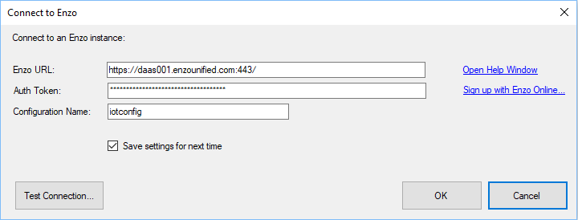

Enzo Online
This version of Enzo is provided as a service hosted in the cloud. To obtain the necessary credentials, you first need to signup; there is a freemium tier available for non-production environments. The Enzo Online portal is found here: https://portal.enzounified.com

Once logged in, you can obtain the Enzo URL and AuthToken under the Enzo Accounts tab.

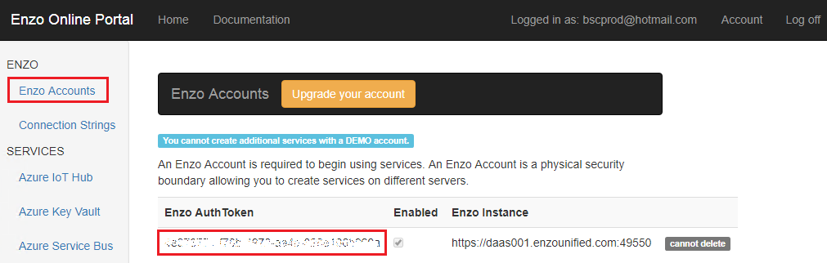

You will also need to create an Azure IoT Hub setting under the Azure Iot Hub tab so that Enzo can connect to Azure on your behalf.

The following parameters are needed to create an Azure IoT Hub configuration setting in Enzo:

Name (*) | This is a friendly configuration name for this configuration
Enzo Instance | This is the server on which this configuration will be saved
IoT Hub Name | The name of the IoT Hub to use in Azure (must be created separately)
IoT Hub Connection String | The connection string to the Azure IoT Hub service

(*) Use the Name for the Configuration Name.

Enzo Unified
Enzo Unified is a server product that you install in your infrastructure on real or virtualized hardware. You can download and install Enzo Unified here: http://www.enzounified.com/download/. You should use the latest version available.

Once you have installed and configured Enzo Unified, the Enzo URL is the path to the HTTPS endpoint of Enzo Unified.

Use Enzo Manager to find your AuthToken, and to create the Azure IoT Hub configuration setting. The configuration setting values are the same as for Enzo Online.

The AuthToken is found under Manager Logins; each login has its own token. You can use the ‘sa’ default login, or create a new login.

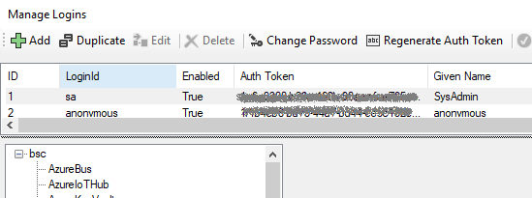

You then need to create a configuration setting for the Azure IoT Hub you would like Enzo to use.

