Github and Python

Notes from GitHub Guides

A **repository** is usually used to organize a single project. Repositories can contain folders and files, images, videos, spreadsheets, and data sets – anything your project needs.

**1/ Create a repository**

One can **import** an existing project repository or **create** a new one:

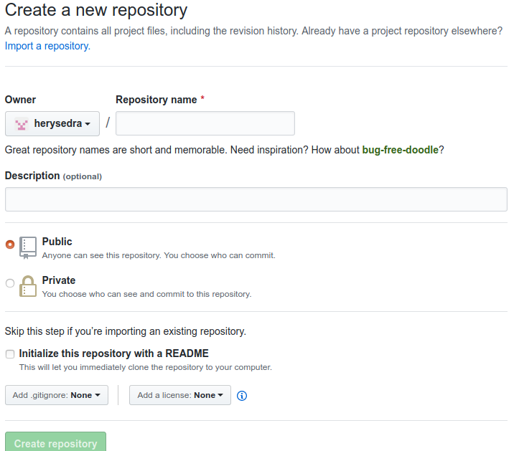

In case, one import an existing repository, it would look like:

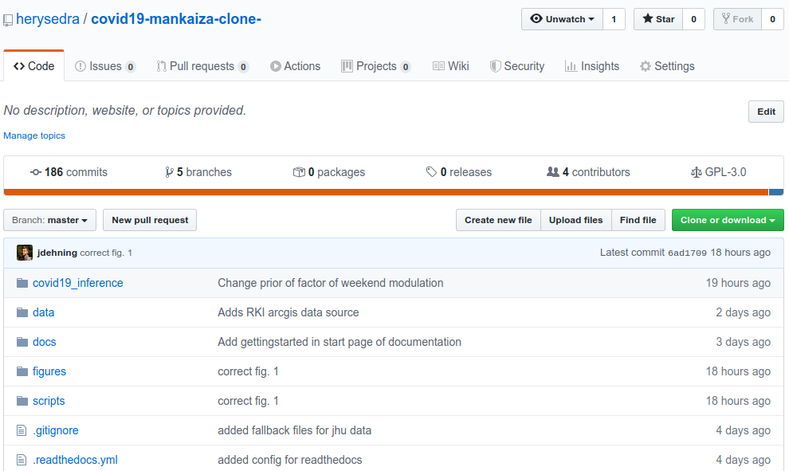

**2/ Create a branch**

By default, the main work is in one branch named **master**; but different versions of the same project can be hosted on different branches (usually called **topic** or **feature** branches).

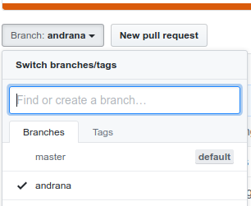

Exemple: if one want to modify the file README.md in the feature branch, then:

a/ Click the file to open it

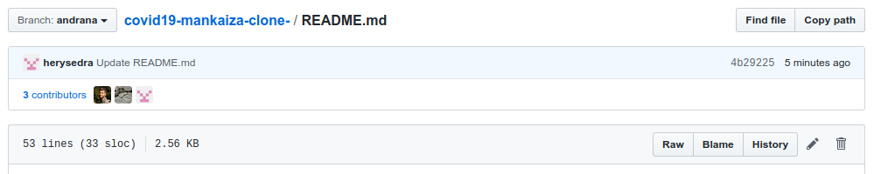

b/ Click the pencil icon in the upper right corner of the file view to edit/modify.

c/ Write your modifications.

d/ Write a commit message that describes your changes.

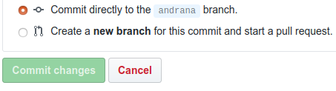

e/ Click the button 

**4/ Add changes from one branch to another one**

Changes from the **feature** branches can be added/merged to the **master** or any other branch by using the Pull request.

a/ Click the onglet **Pull Requests**, then :

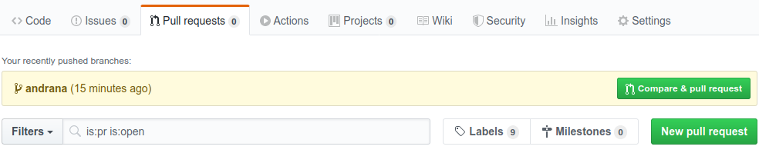

If the repository is shared by different persons, the one who work on a particular branch can inform other contributors by means the Pull request method.