Linux Firewall Exploration Lab
!!!until task 3 we consider swap between names home and work we just didn’t remarque it!!!

Lab Tasks

Task 1: Using Firewall
Machines used for the task 1:
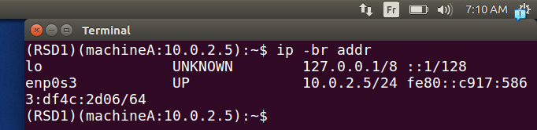
.machine A
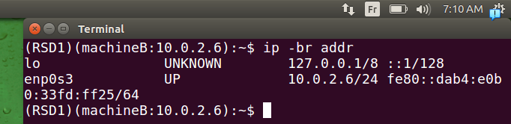
.machine B
Prevent A from doing telnet to Machine B:
.

.
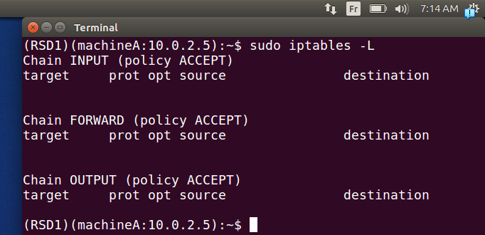
.there was no policies or rule at first
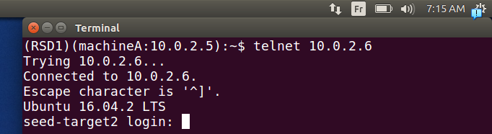
.if we telnet machine A=>machine B it works fine

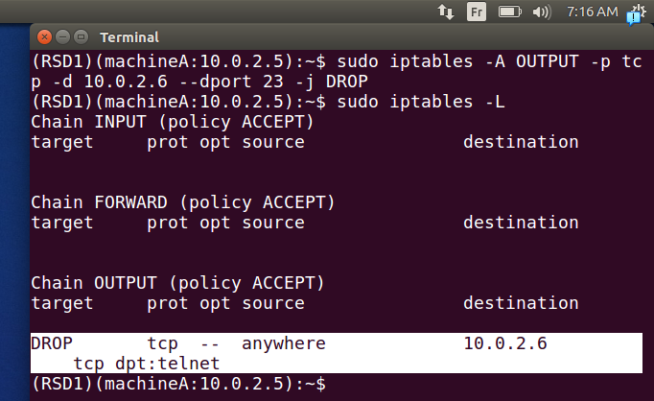
.we add a rule output packet to dst of tenet should be droped
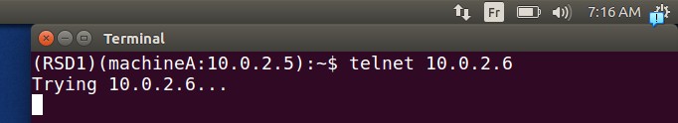
.if we try now it will not work
Prevent B from doing telnet to Machine A.
.
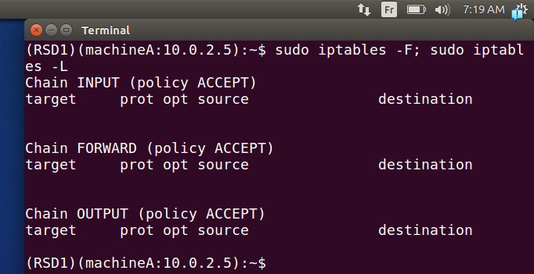
.we flush first the rules so it’s empty again
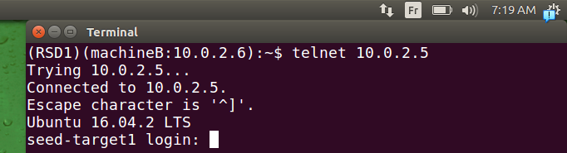
.we can connect B=>A
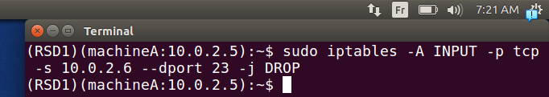
.we add a role for packet coming (ingress) to filre if they came from B and to dst of telnet port 23 they should be dropped
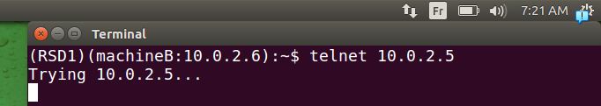
.as we can see now we can’t connect
Prevent A from visiting an external web site. You can choose any web site that you like to block, but keep in mind, some web servers have multiple IP addresses.
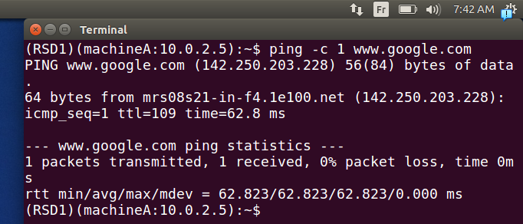
.if we ping google we can see reply coming from an address we should stop it as an example
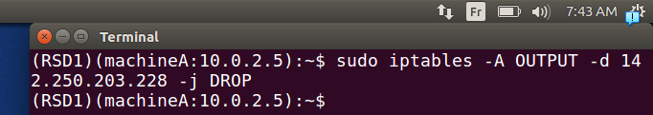
.so for erach packet going outside it should be filtered if it’s dst is that address (we drop packets)
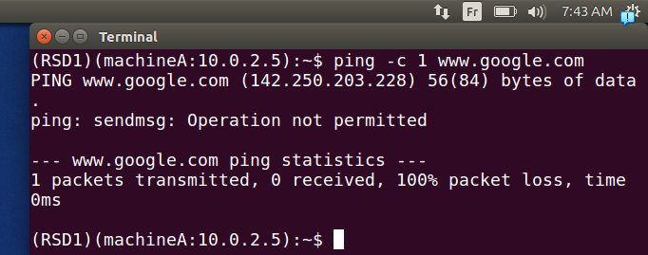
.now it’s not working .

Task 2: Implementing a Simple Firewall
.tihis task is based on LKM and netfilter:
.
Prevent A from doing telnet to Machine B:
.
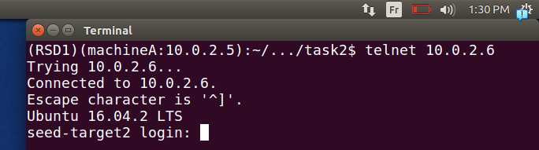
.we can connect at first
.
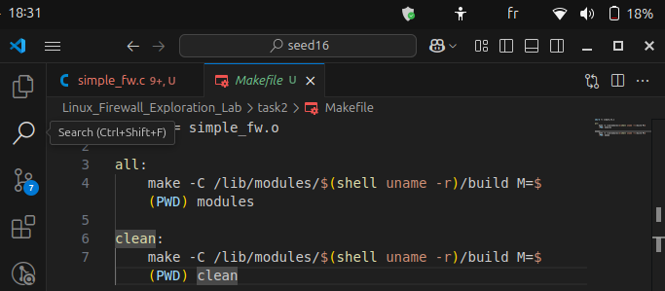
.we made a make file to build the files needed (ko: kernal object ) to be loaded later on
.
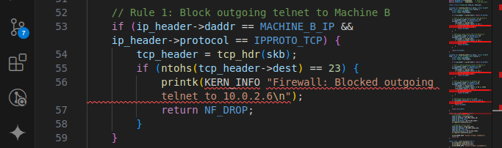
.we define our rule with a simple text will be shown later on(printk: is for kernal affichage), NF_DROP is a hock for droping packets
.
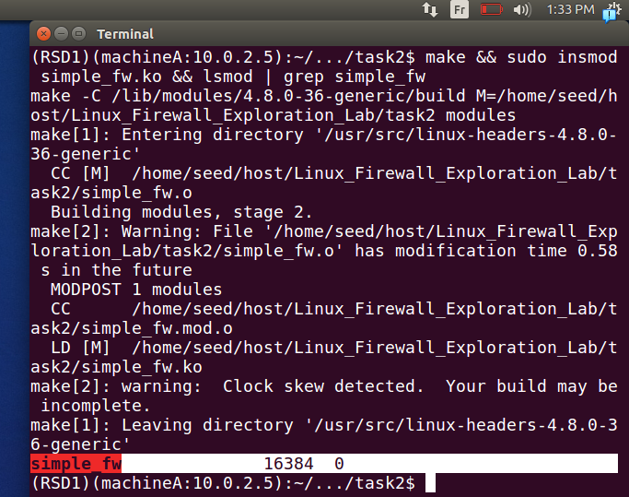
.now we make our ko file to be loaded using LKM as mentionned using hocks(make, then inserting then showing module if inserted)
.
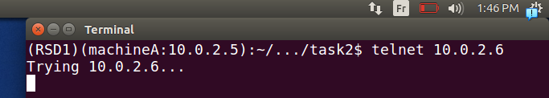
.now we can see that we couldn’t connect
.
Prevent B from doing telnet to Machine A:
.
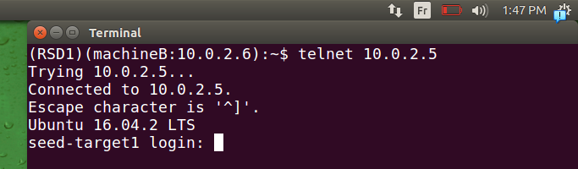
.we can connect B=>A
.
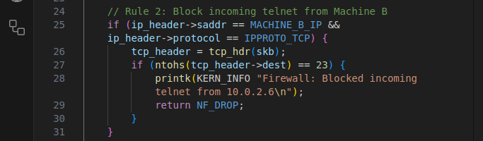
.we add the condition with the hock
.
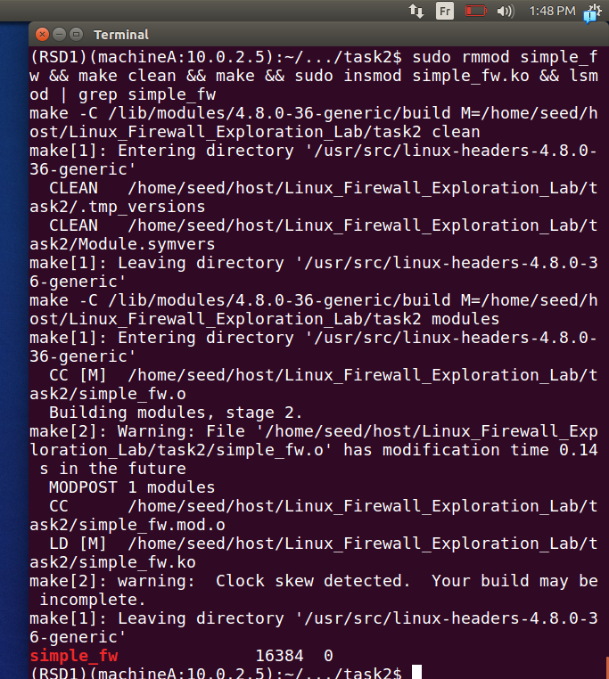
.we remove the module first to remkae it because code is changed then redo the same
.
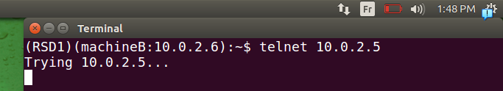
.
it works fine we can’t connect
.
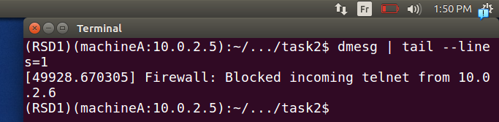
.note that we can see the kernal message like this
.
Prevent A from visiting an external web site. You can choose any web site that you like to block, but keep in mind, some web servers have multiple IP addresses.
.
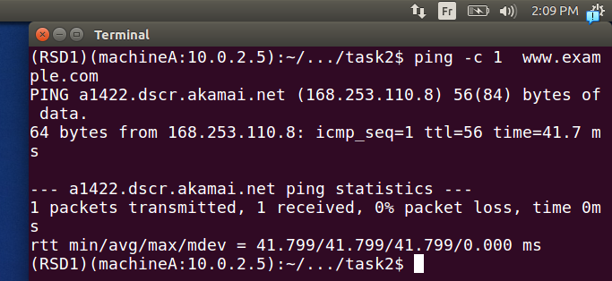
.we can ping at first
.
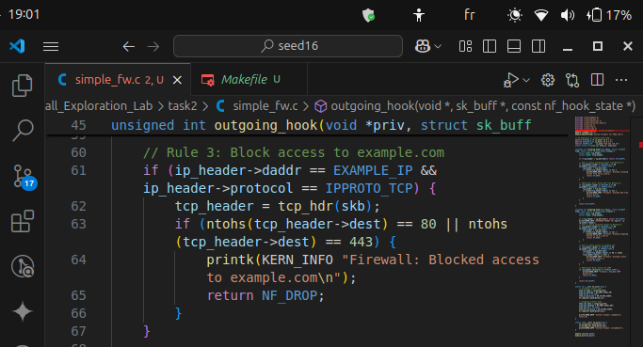
.
.now we made the rule 3 and redo the remove, make and insertion procedure
.
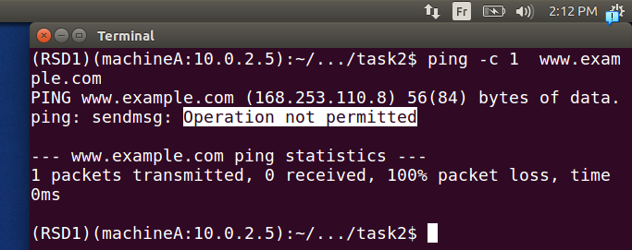
.we can see now clearly operation not permitted our rule worked correctly.
.Prevent ssh connection:
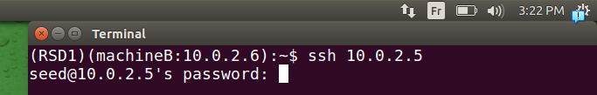
.here we can connect at first normally
.
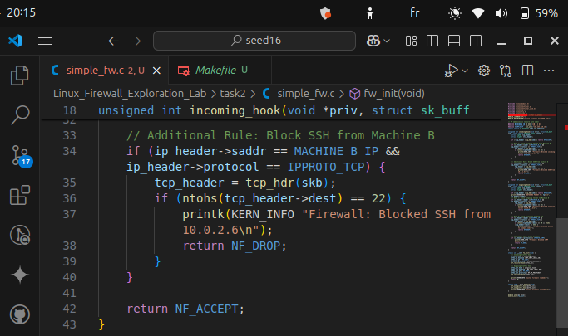
.we add our rule
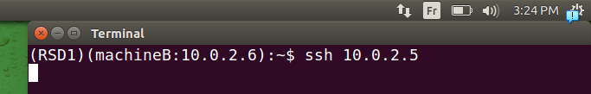
.as seen it’s not working(it got stuck)
Prevent ICMP packets:
.
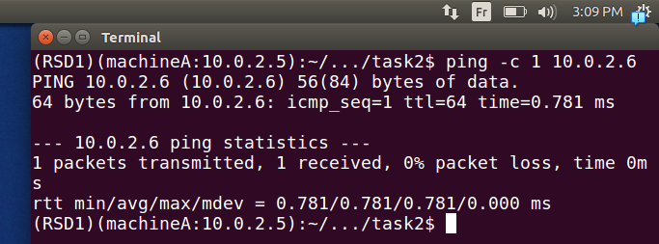
.we could ping at first correctly (icmp packets are sent)
.
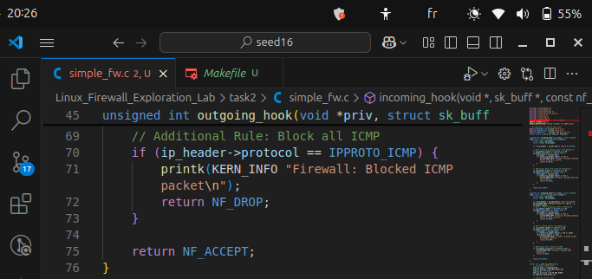
.we add code to prevent icmp packets(we do the same procedure again)
.
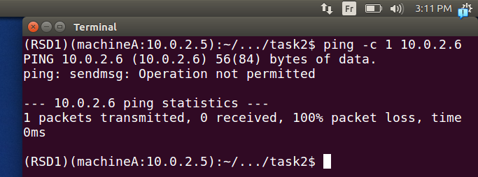
.here if we ping again no response is gotten.

Task 3: Evading Egress Filtering
.Block all the outgoing traffic to external telnet servers.
.
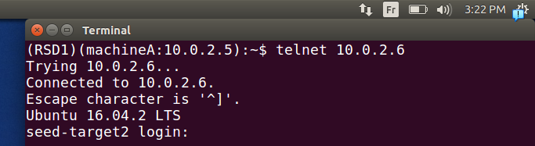
.first we could connect
.
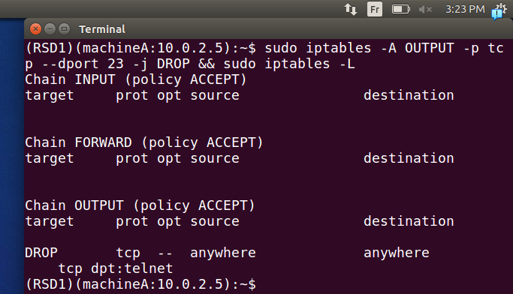
.we add our rule
.
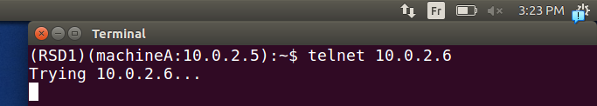
.then it works fine we can’t connect now using telnet
Block all the outgoing traffic to www.syr.edu
.
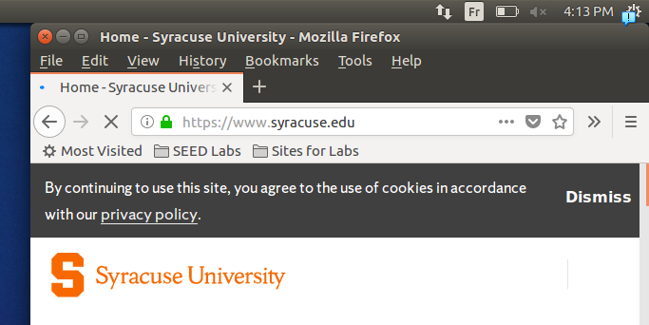
.first we could connect normally
.
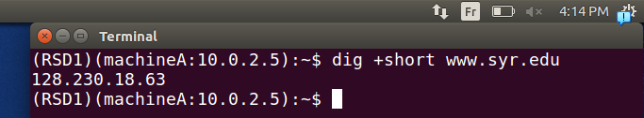
we get ip address to be blocked(as mentioned 1 ip)
.
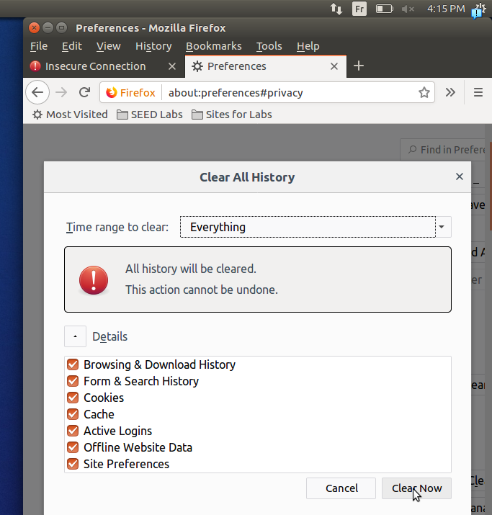
.here we clear the history of browser
.
.
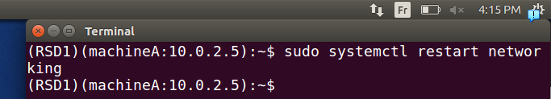
.then we force to clear the cache
.

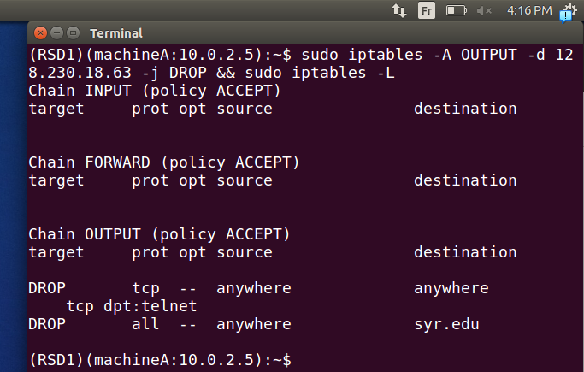
.we add our rule
.
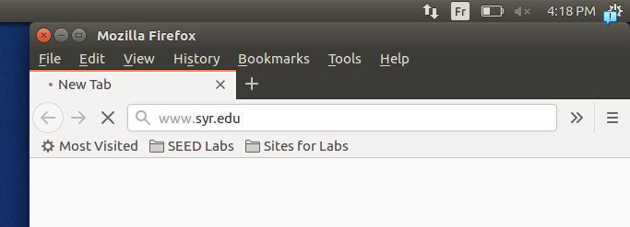
.we try the browser and no chance
.
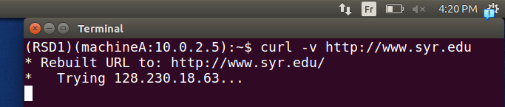
.we try it also with terminal but no chance also it works correctly.

Task 3.a: Telnet to Machine B through the firewall
As mentioned in the diagram(3 machines home, work, apollo)
.first we difine our mchines
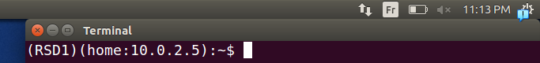
.
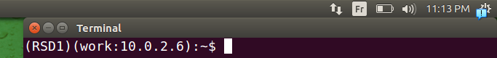
.
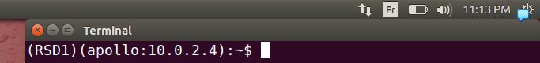
.
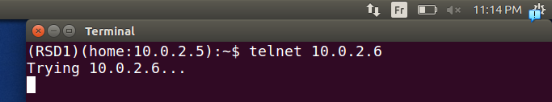
.here we can’t at first
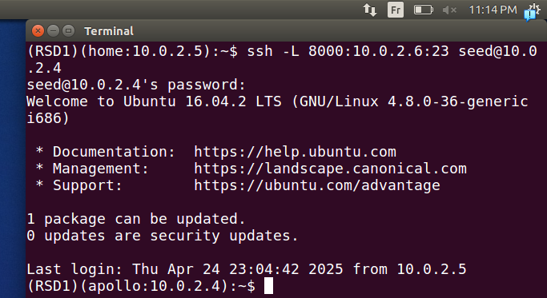
.if we set it to be forwarded through a turnel through another machine appolo as mentionned
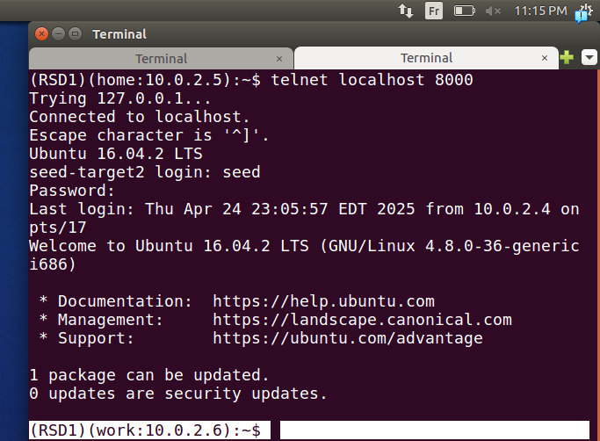
.now we can connect correctly

.
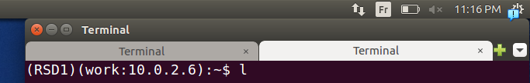
.if we wirte a carracterre “l”
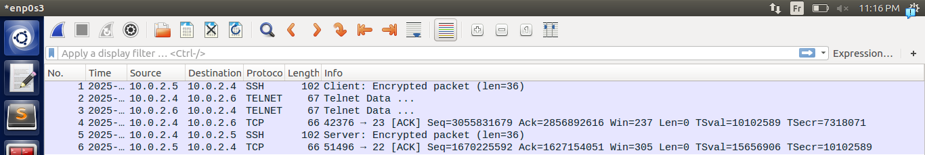
.we can see clearly because we’re in LAN and can sniff
machine home wants telnet work ???? so:
the carracterre is sent:
home ==> apollo ==> work
response of the carracterre because it’s telnet:
work ==>apollo ==> home.
We could’ve used also 2 machines, also but 3 make more comprehensive.

Task 3.b: Connect to syr.edu using SSH Tunnel.
.here it’s not facebook but we’ve chosen before is syr.edu
.
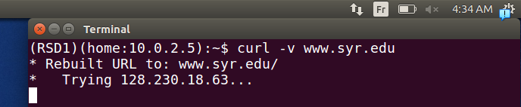
.we couldn’t at first connect
.
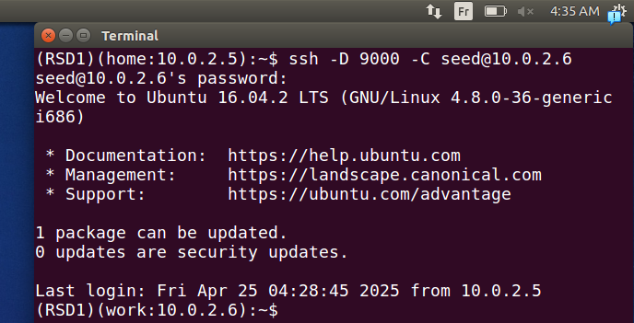
.we establish that an ssh tunnel(we call this a dynamic port forwarding)
.
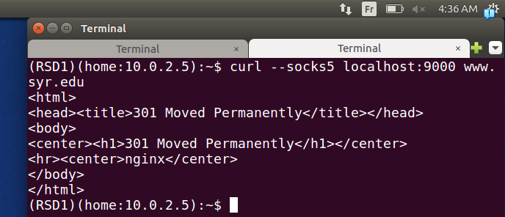
.then if we specify (and the sock is routing the traffic of an application
.
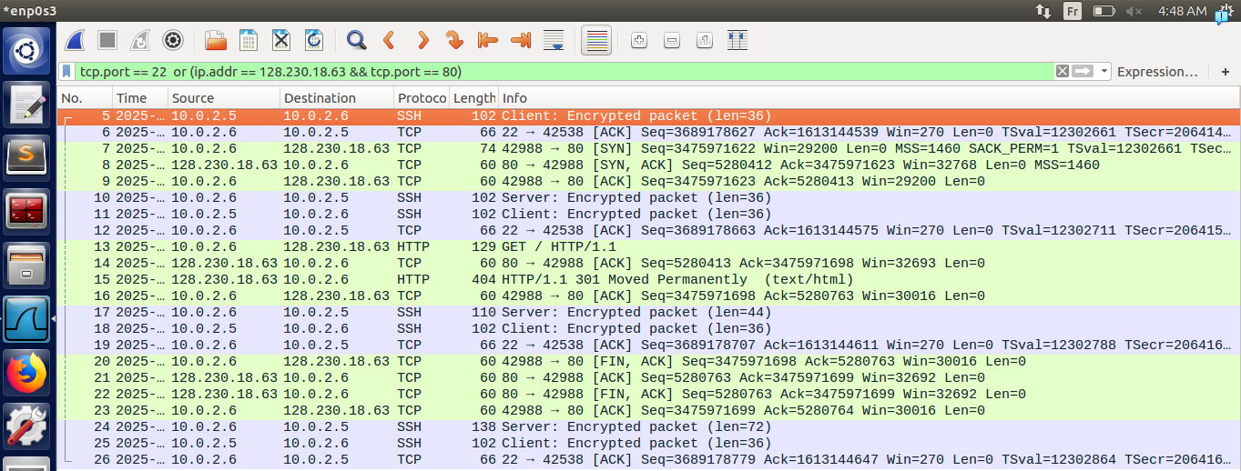
.we can see the connection clearly
encrypted connection: home and work machines(request through)
non encypted connection: work and syr.edu server(request/response forwarded)
encrypted: home and work machines again(response through)

Task 4: Evading Ingress Filtering
At first:
.

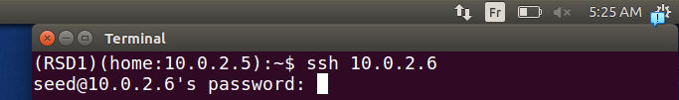
.we could connect with ssh
.
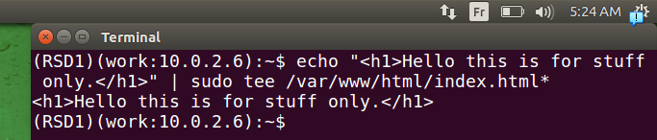
.we make a simple webpage
.
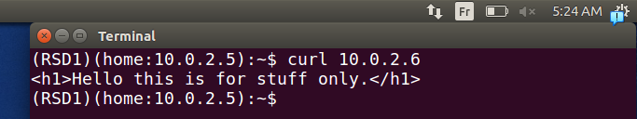
.we try to connect to it
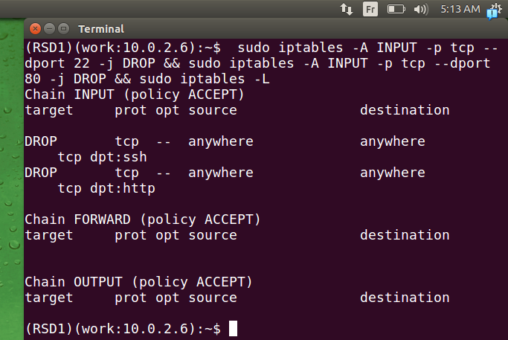
.we set our firewall correctly this time before we confused home with work machines.
.
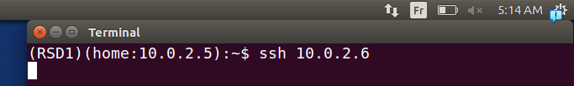
.we can’t ssh work machine
.
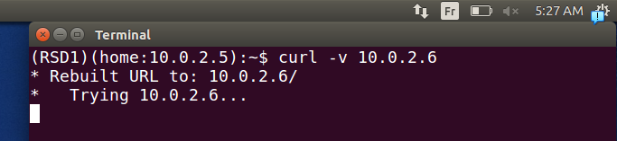
.and we can’t access webpage hosted
.we’re all set up now
.
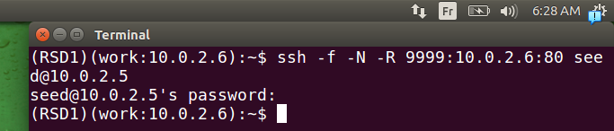
.establish a reverse ssh tunel with home machine that’s on it’s port 9999 listenning on it, and forwarding traffic into machine work on port 80
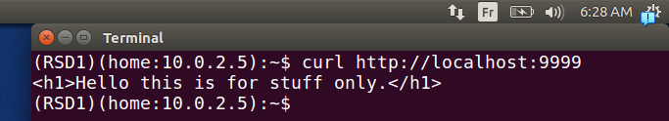
.now if we go to specific port 9999 we could succeffuly browse.
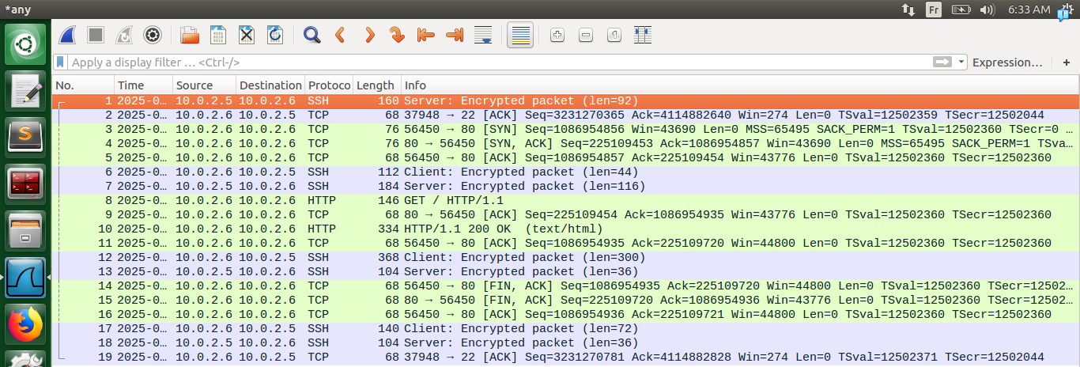
We can see it clearly on wireshark.
First two paquets is for keep alive or we can say an ssh handshake.(request and response)
afer loopback for local host (means the site server is interogated http)
then an encrypted response and keeps going with exchage of encrypted between home, work and plain work and localhost(loopback)

