Q1.
ls
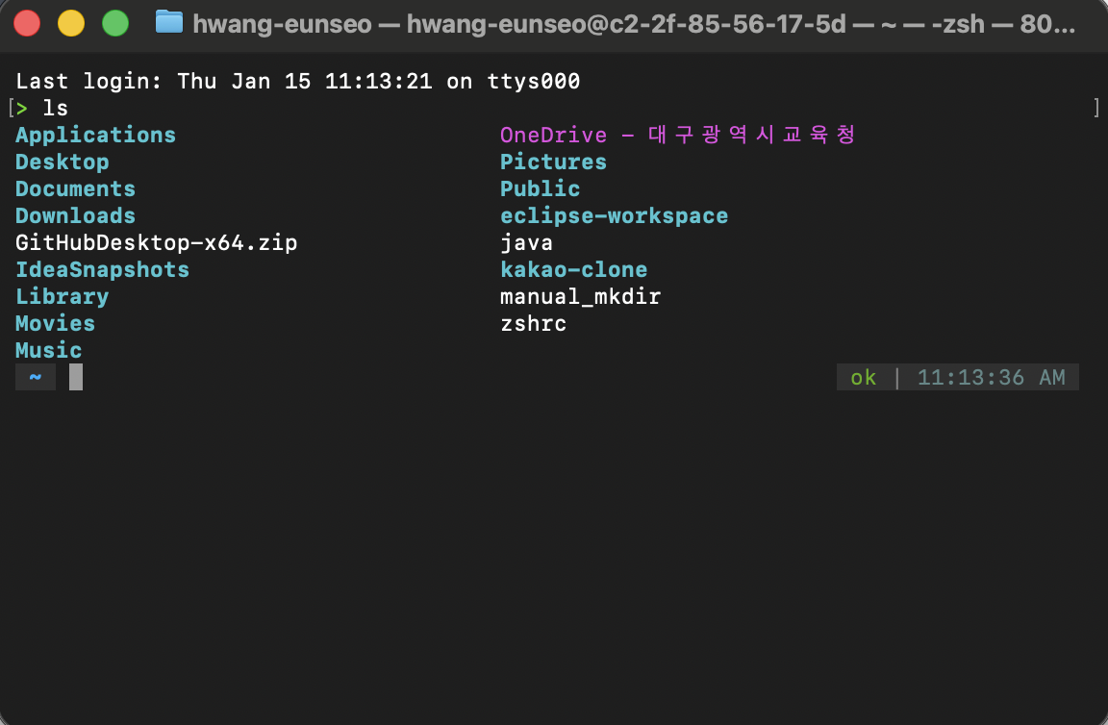
pwd
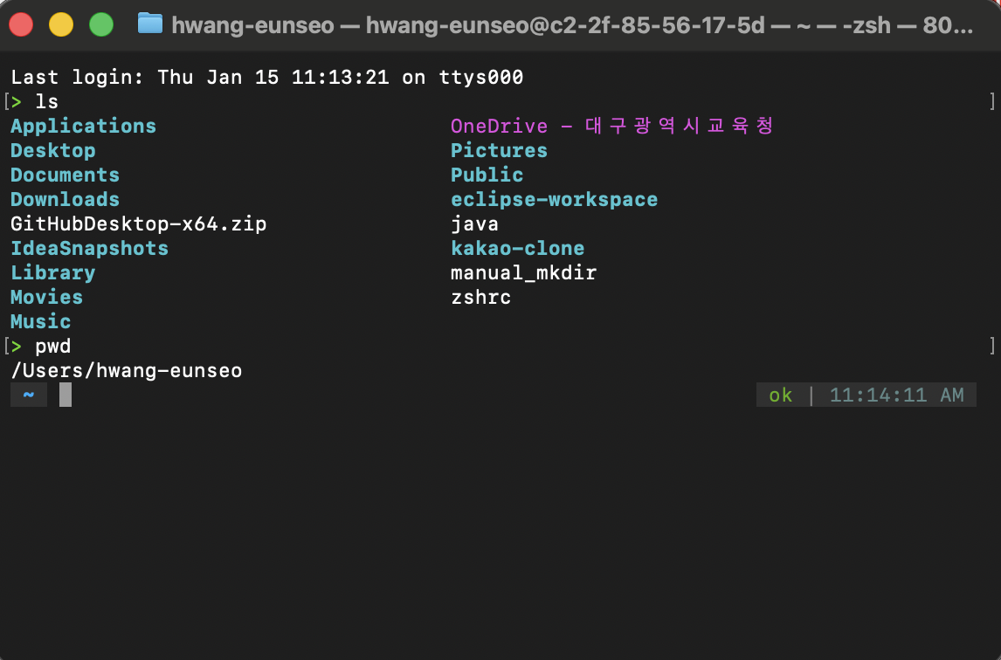
xy
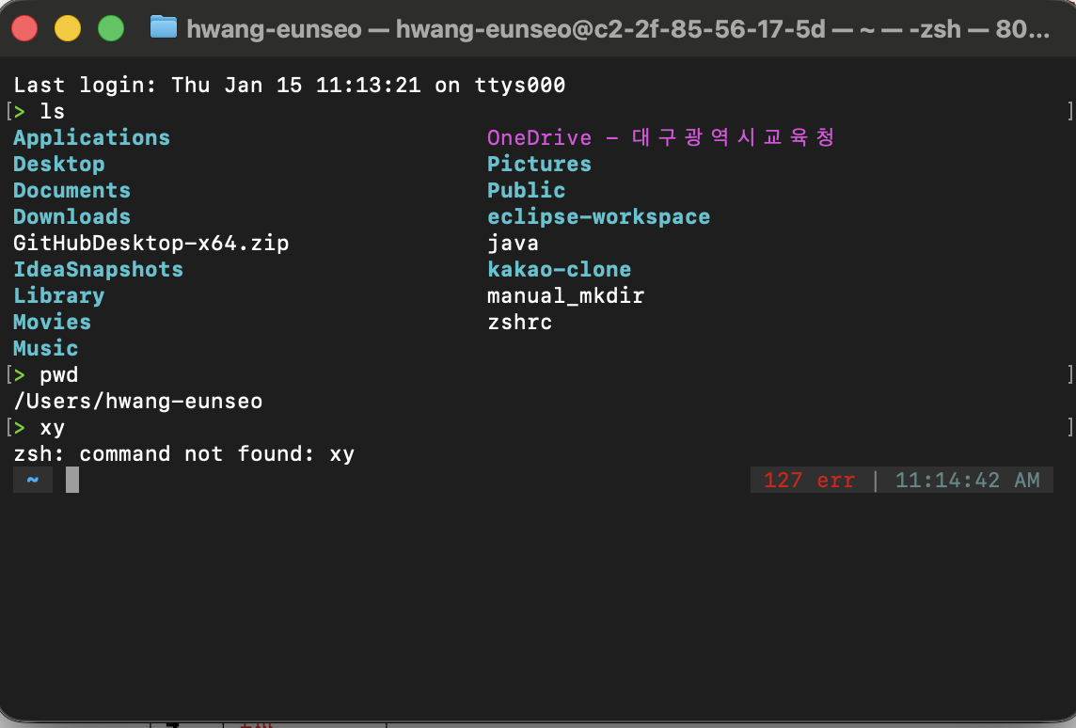

cd ..
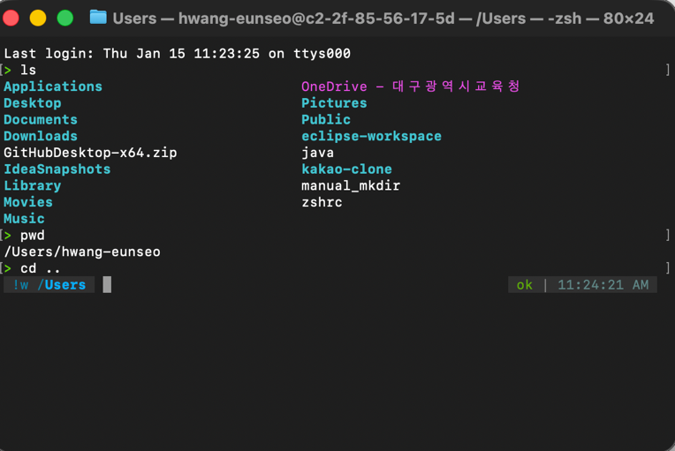
pwd
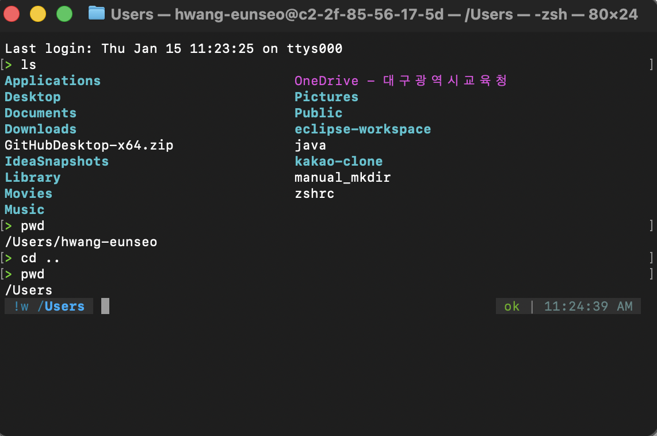

cd /usr/local
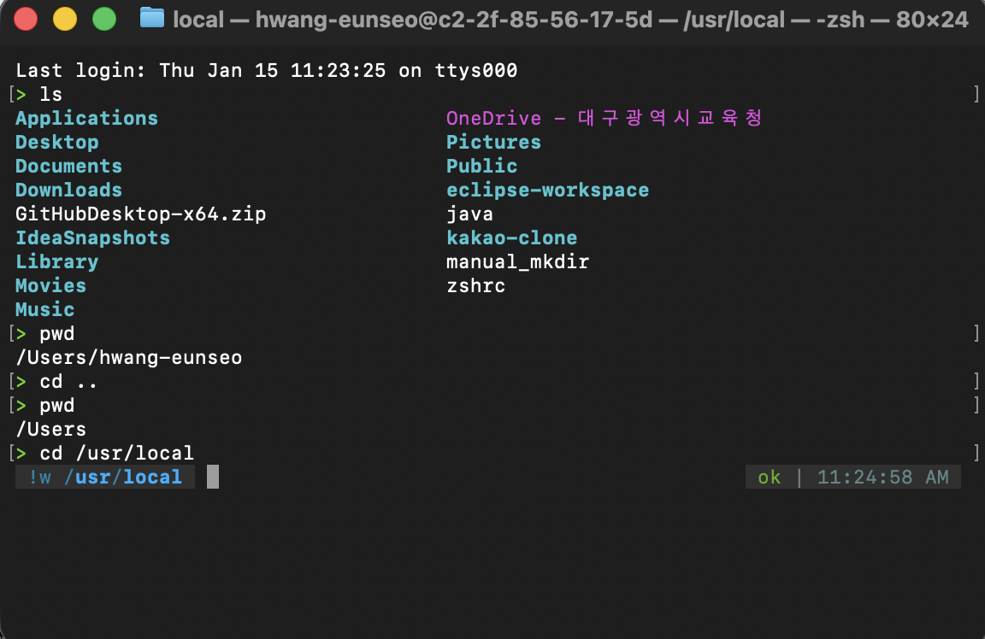

ls
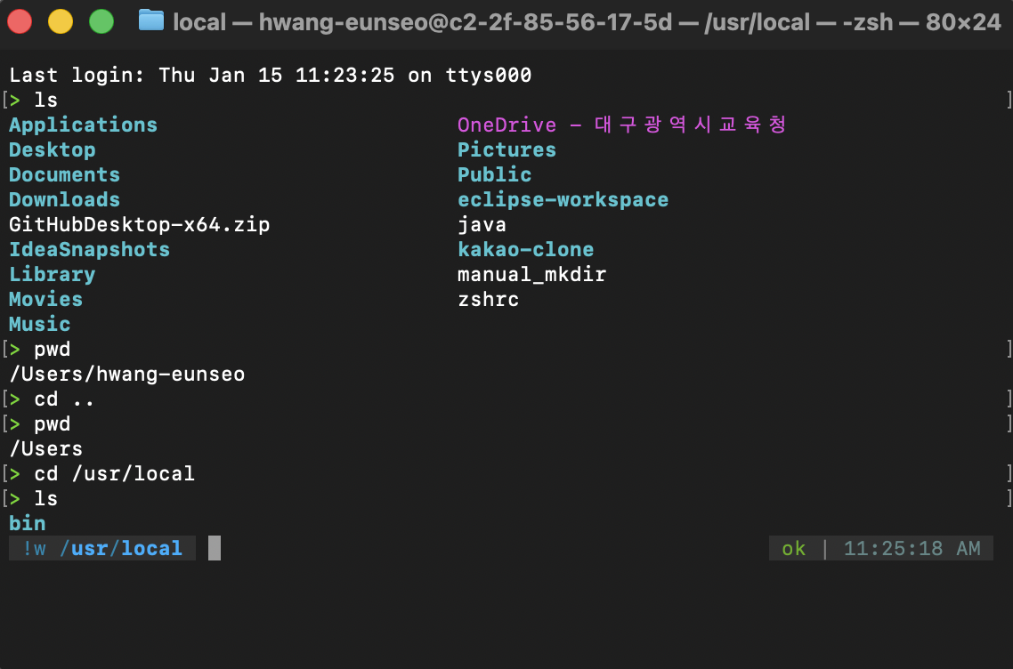

cd
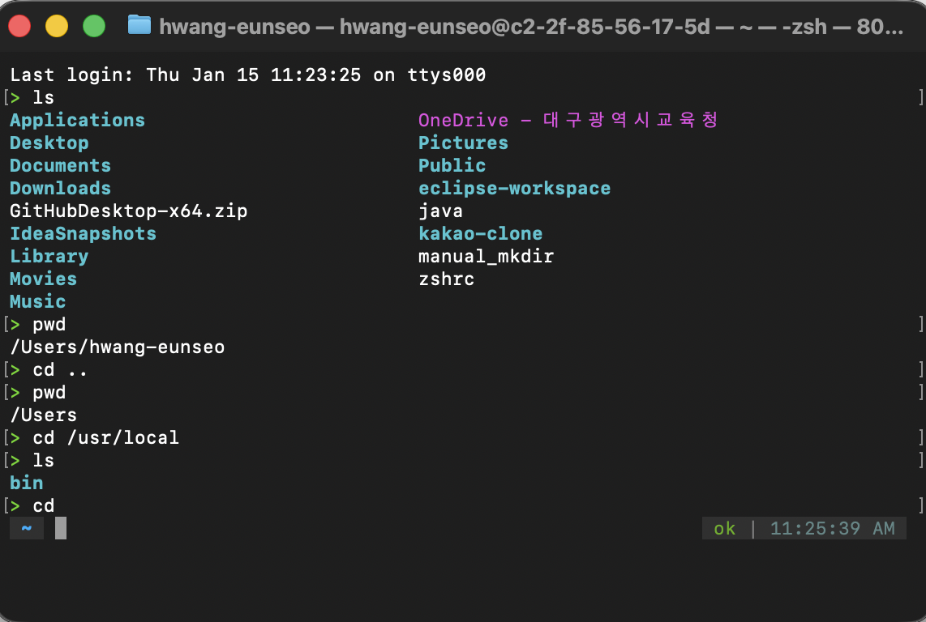

Q2.
# cat – The cat command reads files orderly and prints their contents to the screen.
1 more – The more command displays the content of a file one screen at a time.
2 cp – The cp command copies the content of the source file to the target file.
3 mv – The mv command moves or renames a file or directory.
4 rm – The rm command removes the non-directory type files specified on the command line.
5 ls – The ls command displays files and directories in the current directory.
6 mkdir – The mkdir command creates new directories.
7 cd – The cd command changes the current working directory.
8 pwd – The pwd command writes the absolute pathname of the current directory to the standard output.
9 rmdir – The rmdir removes an empty directory.
10 whoami – The command whoami displays the username of the current user.

Q3.
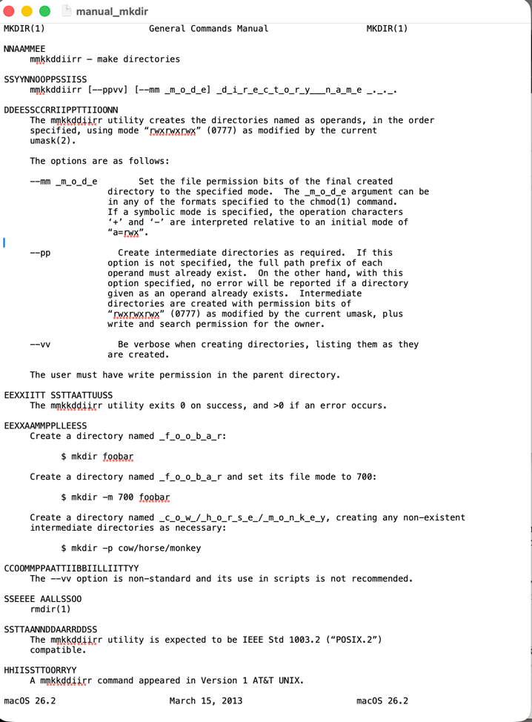
Q4.
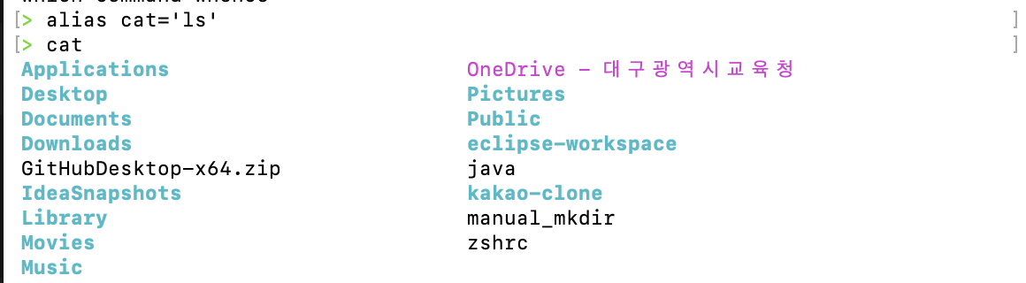
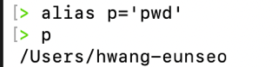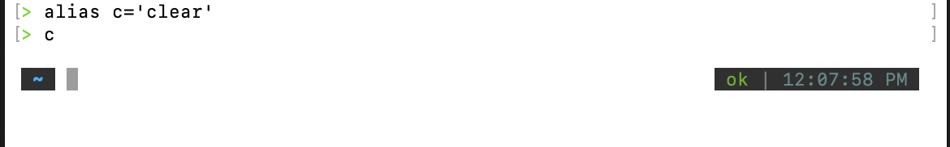
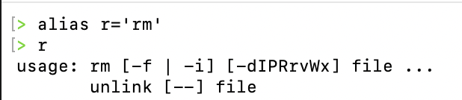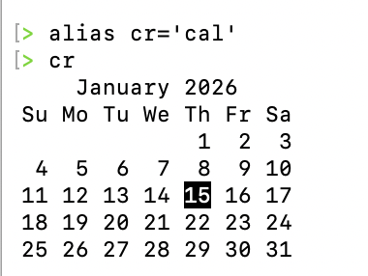
Q5.
a. cal 4, cal 53, cal 1752, cal 1952, cal 2004, cal 2005
b. Yes. 4, 52, 1752, 1952, and 2004 are leap years and 2005 is non-leap year. I can see the 29th of February in those what are leap years.
c. Only 355 days existed in 1752 because 11 days were skipped in September 1752.
Google show about 18,300,300 results searching Gregorian calendar.
https://en.wikipedia.org/wiki/Gregorian_calendar
Pope Gregory XIII issued Gregorian calendar in October 1852. So we call Gregorian calendar.

Q6.
a. Darwin
b. c2-2f-85-56-17-5d.wireless.temple.edu
c. arm

Q7.
- How many users are currently using your UNIX system? = 2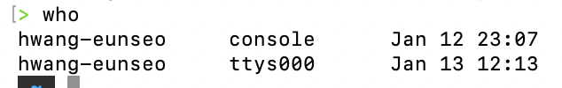

Q8.
When I typed bash, the shell starts successfully on my system. When I typed tcsh, it displayed [Eunseos-MacBook-Air:~] hwang-eunseo%, which means that shell is installed and available on my UNIX system.

