به نام خدا

گزارش تمرین شماره 2 شبیه‌سازی **JMT**

حسام تاج‌بخش

93725102

استاد: دکتر آنالویی

زمستان 93

Part A:

Service demand of transaction at each resource:

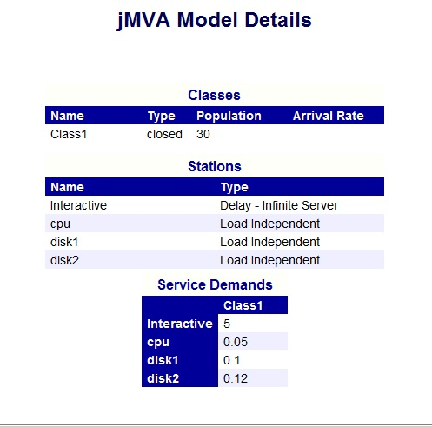

System throughput and throughput of each resource:

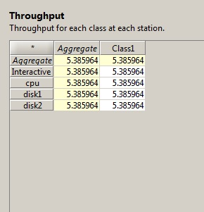

Utilization of each resource:

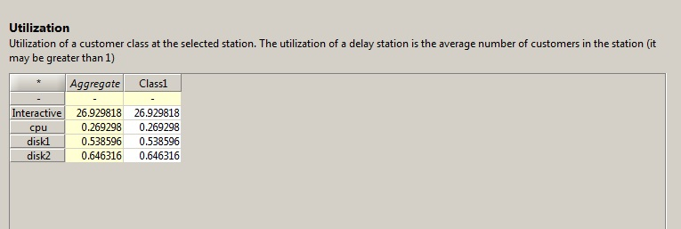

Residence time of transaction at each resource and system response time (aggregate response time) :

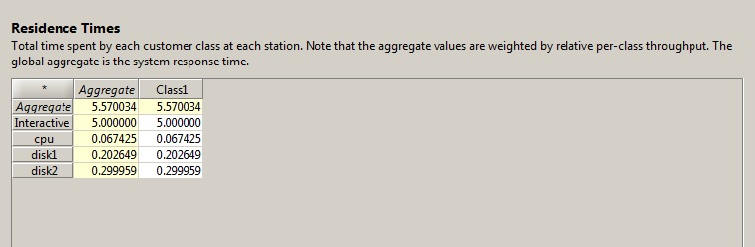

Number of transaction at system and each resource:

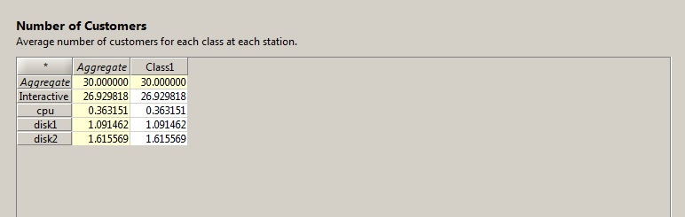

Part B:

1.453

0.179s

Part C:

Scenario 1: Doubling the number of terminals:

Service demand:

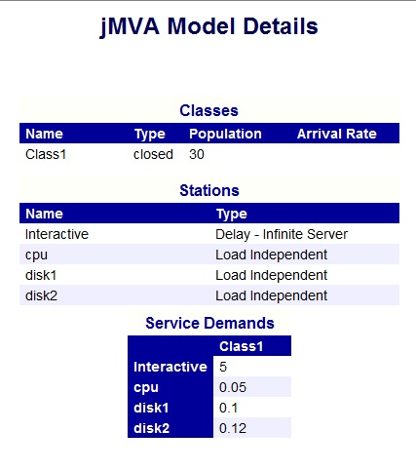

Throughput of each resource:

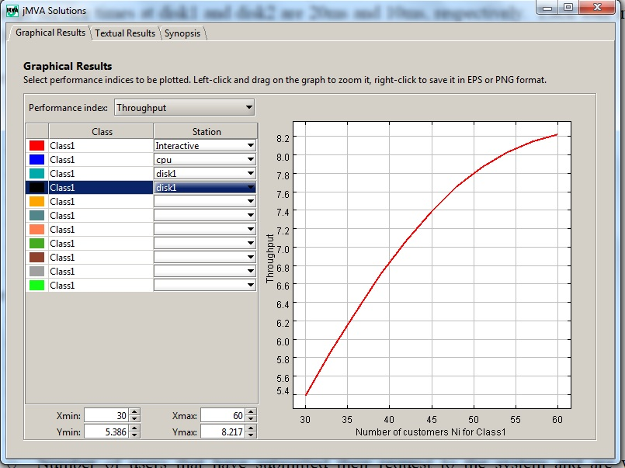

Throughput of system :

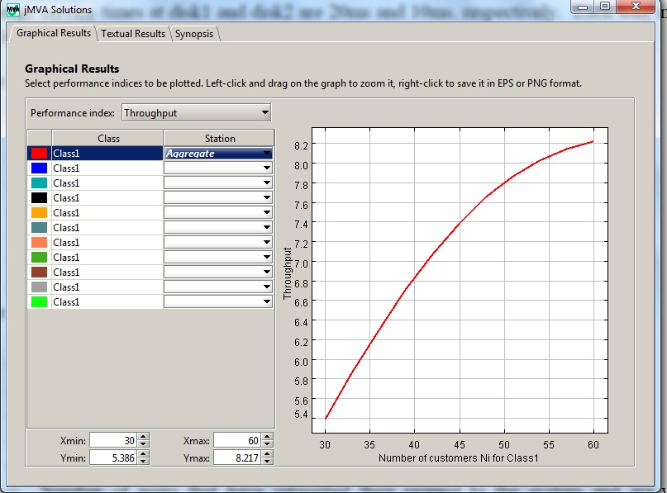

Utilization of each resource:

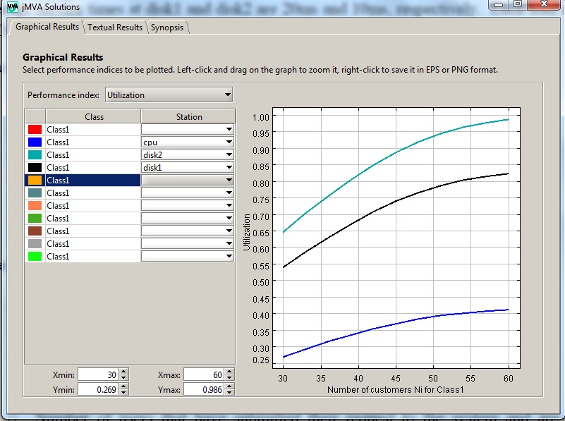

Residence time of transaction at each resource:

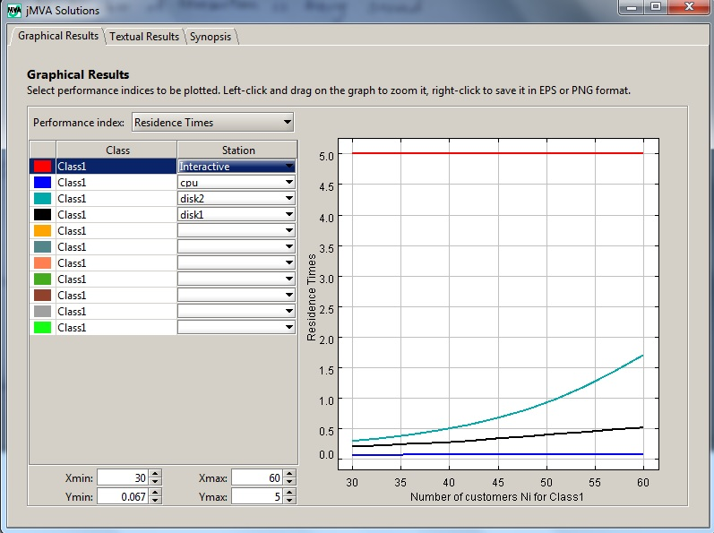

System response time:

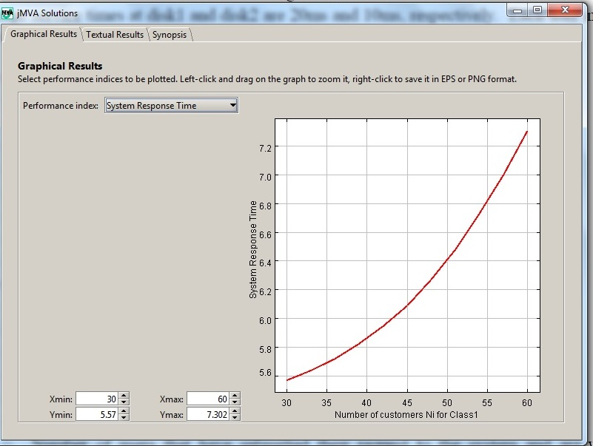

Number of user’s transaction in the system:

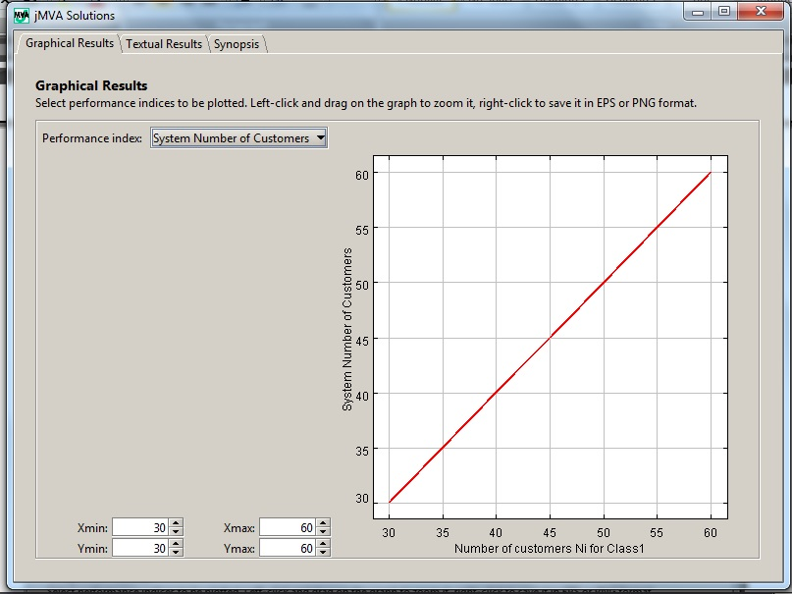

Number of user’s transaction in each resource:

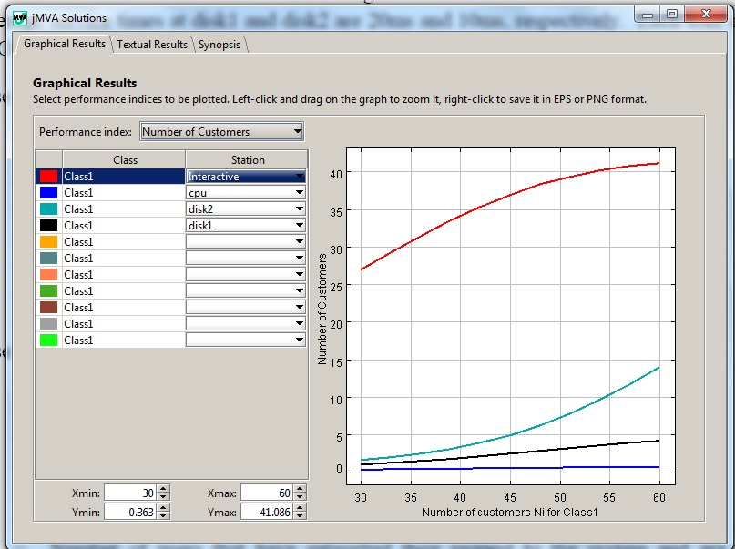

Scenario 2:

Scenario 1: Decreasing of think time by 50%

Service demand:

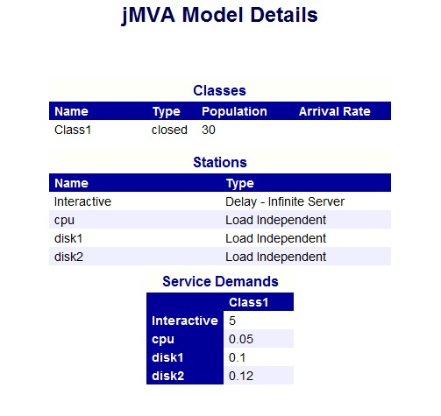

Throughput of each resource:

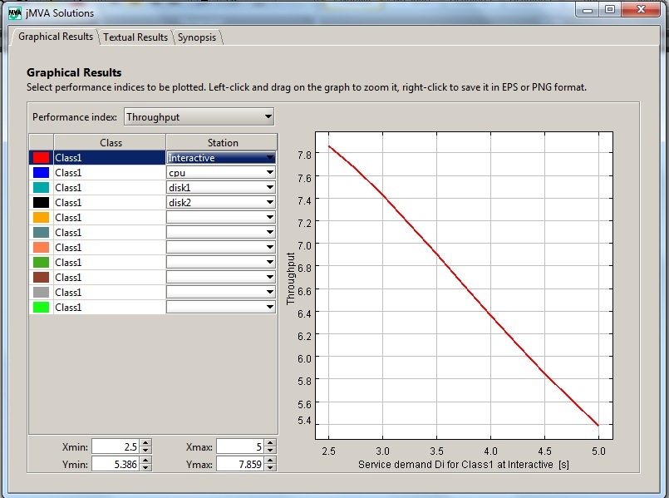

Throughput of system :

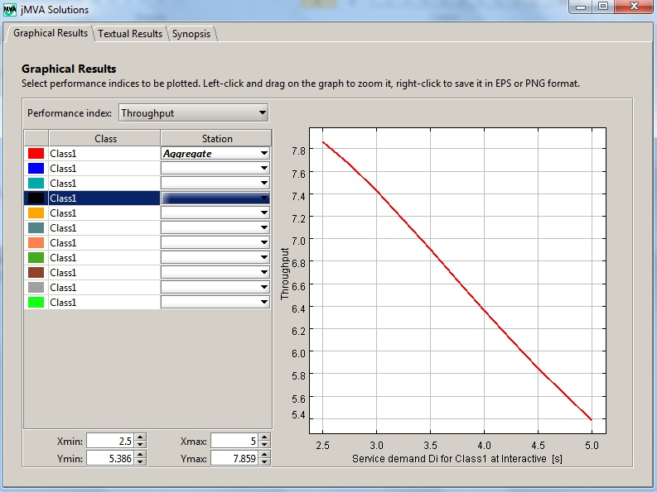

Utilization of each resource:

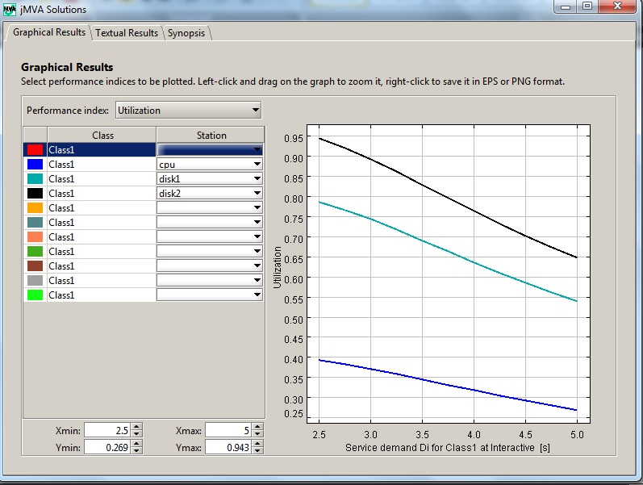

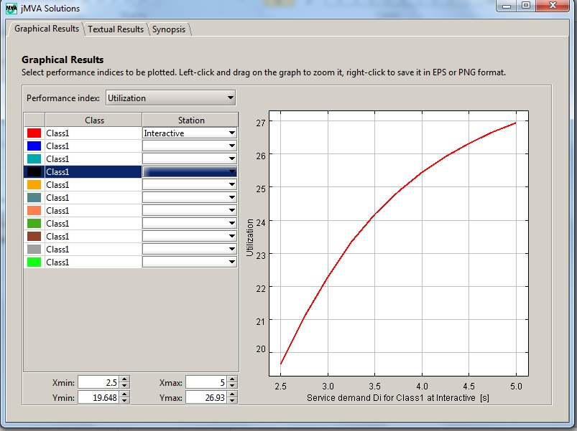

Residence time of transaction at each resource:

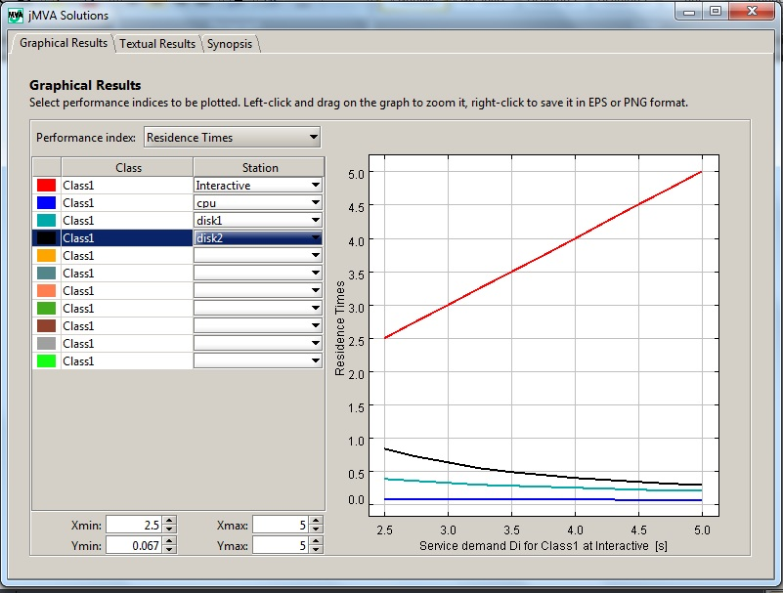

System response time:

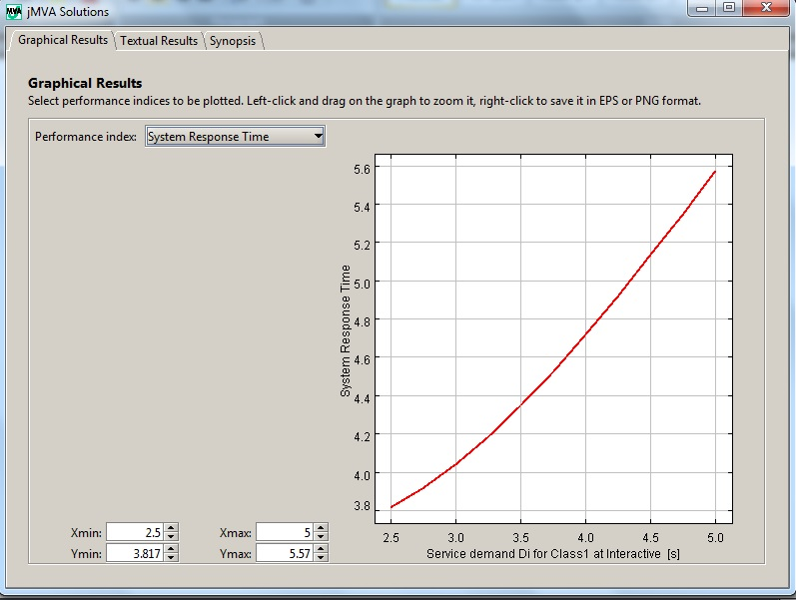

Number of user’s transaction in the system:

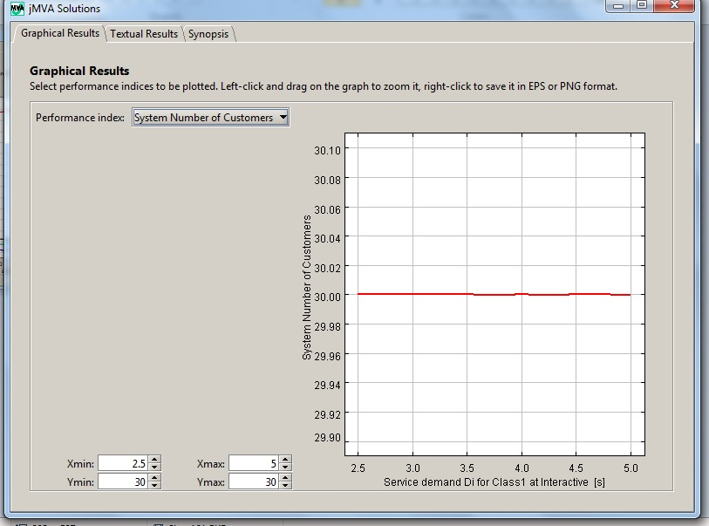

Number of user’s transaction in each resource:

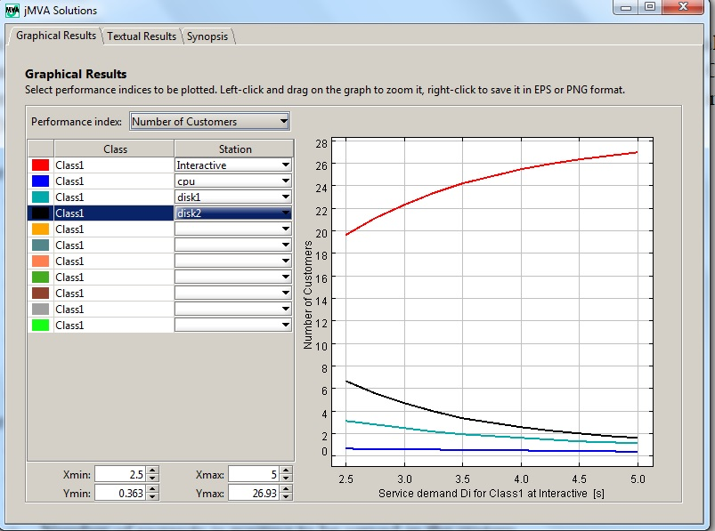

Scenario 3: using faster resource:

Service demand:

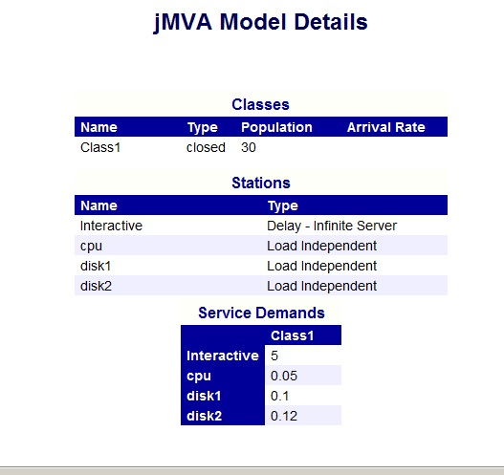

Throughput of each resource and system:

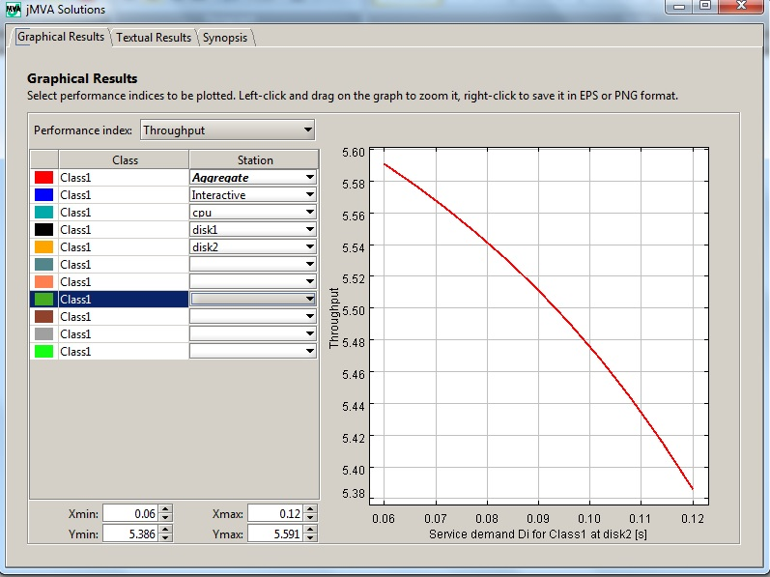

Utilization of each resource:

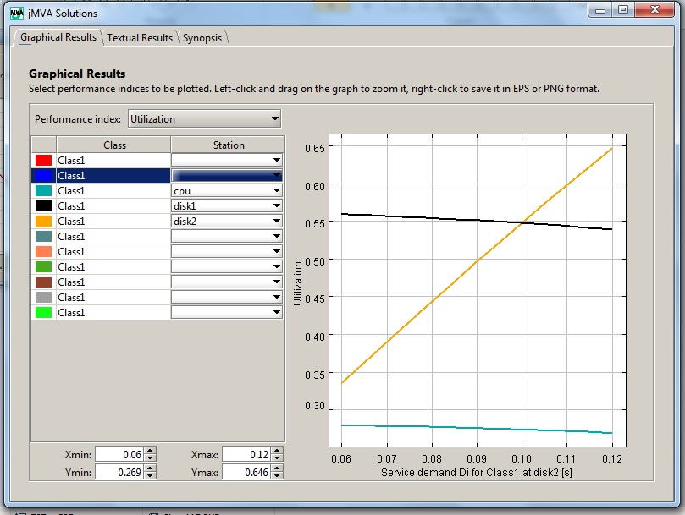

Residence time of transaction at each resource:

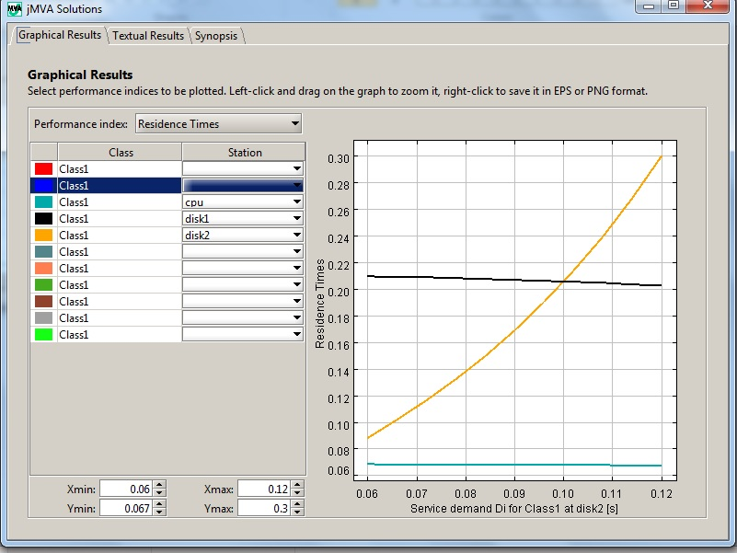

System response time:

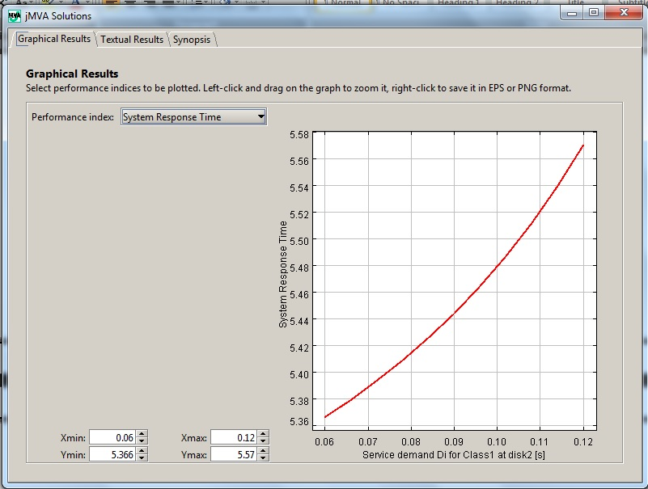

Number of user’s transaction in the system:

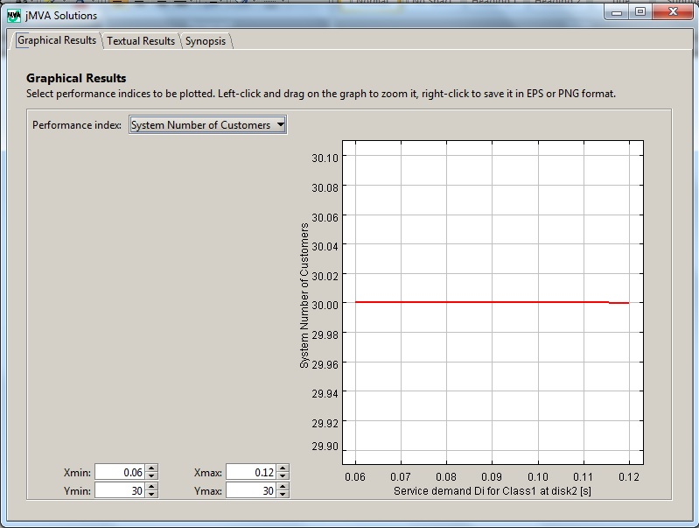

Number of user’s transaction in each resource:

