Informatics Institute of Technology



Foundation Certificate in Higher Education

**Implementation and Final Document**

Module: DOC330 Designing Innovative Solutions

Module Leader: Ms. Aniqah Zeezan

Assessment Type: Group Coursework

Group Name: JA-4

|  |  |
| --- | --- |
| Student ID: | Name: |
| 20200467 | Heshan Nipuna |
| 20200490 | Maneesha Shehara |
| 20200150 | Shanjay Sharma |
| 20200593 | Abbas Sirajul |
| 20200519 | Jinithi Yasami |
| 20200547 | Romel Perera |

# Abstract

In the year 2017 on May 27th at least 126 people have been killed and over 500,000 displaced due to floods and landslides. In the month of May 2021, not even 2 months ago over 20 people were reported dead and the number of affected people as of June rose to 176,49 and almost 8000 individuals have been displaced. Our app is designed for people in areas most prone to floods. It alerts the user when there might be floods and tells them what to do and where to go. Our app also has the hotlines for every medical need. It also provides donation opportunities for all the people affected and are in dire need of help. The team was recognized the problem of how most people in rural areas might not be able to get this app but if a few people get this app, they can help others with the knowledge they have acquired.

# Acknowledgement

In performing our assignment, we had to take the help and guideline of some respected persons, who deserve our greatest gratitude.

The completion of this assignment gives us much Pleasure. We would like to show our gratitude to our module leader Mrs. Aniqah Zeezan and tutor Ms. Tharushi Sandamali) for giving us a good guideline for assignment throughout numerous consultations. We would also like to expand our deepest gratitude to all those who have directly and indirectly guided us in writing this assignment.

Many people, especially our classmates and team members itself, have made valuable comment suggestions on this proposal which gave us an inspiration to improve our assignment. We thank all the people for their help directly and indirectly to complete our assignment.

Thank You!

**Table of Contents**

Abstract 2

Acknowledgement 3

CHAPTER 1: Introduction and Description of the Project 6

1.1 GAP analysis 8

CHAPTER 2: Methodology 9

2.1 SLDC model used for this application 9

2.2 Steps used to build this application with this model 9

CHAPTER 3: Solution Outline 10

3.1 Techniques used to validate the solution idea. 11

3.2 Key benefits. 11

CHAPTER 4: Innovative features incorporated in the project 13

4.1 Features 13

CHAPTER 5: Requirements and Analysis 15

5.1 Requirement elicitation process 15

5.2 Requirements of the Project 16

5.3 Context Diagram 17

Screenshots of the Prototype 18

CHAPTER 6: Evaluation 34

6.1 Test case 34

6.2 Techniques Used to Analyze Data 35

6.3 Lessons learned 35

6.4 Suggestions 35

Conclusion 36

References 37

Appendices 38

Requirements Elicitation. 39

Idea Validation. 40

Test Case. 41

**List of Figures**

Figure 1- Clinical Care 13

Figure 2 - Splash Screen 18

Figure 3 - Login Screen 19

Figure 4 - Birth Date 20

Figure 5 - Sign Up Screen 21

Figure 6 - Registration Passed 22

Figure 7 - Home Screen 23

Figure 8 - Menu Bar 24

Figure 9 - Disaster Map 25

Figure 10 - Finding Path 26

Figure 11 - Satellite map 27

Figure 12 - weather forecast 28

Figure 13 - Donation Screen 29

Figure 14 - Emergency numbers 30

Figure 15 - Medicare tab 31

Figure 16 - News tab 32

Figure 17 - User profile 33

**List of Tables**

Table 1 - GAP analysis 8

Table 2 - Test case 34

Table 3 - Workload Matrix 38

Table 4 - Meeting Agenda & Meeting Minutes 38

Table 5 - GAP analysis 42

# CHAPTER 1: Introduction and Description of the Project

Floods have a massive impact on both individuals and communities, the affect it has on a social, economic, and environmental perspectives are massive. The consequences of floods vary greatly depending on the location and extent of flooding, and the value and vulnerability of that location. The immediate effects of floods include loss of human life, destruction of crops, property damage, and deterioration of health conditions owing to water-borne diseases and vector-borne. These water-borne diseases include typhoid fever, cholera, leptospirosis and hepatitis A and E. The vector-borne diseases include malaria, dengue and dengue hemorrhagic fever, and west Nile fever. Due to the immense property damage, the economy can come to a standstill if communication links and infrastructure such as power plants, roads and bridges are damaged and disrupted.

Similarly, if infrastructure of an industry is compromised it can lead to loss of jobs and livelihood. Damage to infrastructure can result in long term effects such as disruption to the supplies of clean water, wastewater treatment, electricity, transport, education, and health care. Flooding in agricultural production areas can lead to widespread damage to crops and fencing and loss of livestock. The effects of this can be increases prices of food due to shortage in supply. Due to the damage to roads and railways daily transportation for personal needs and business activities become difficult. Tourists are less likely to visit a country after it has been victim to a flood. This leaves the economy of the communities extremely vulnerable. Floods can also result in losing loved ones, being forced out of one’s home, immense damage to property and can cause extreme psychological trauma to its victim.

Flooding affects people in a multitude of ways. People suffer stress on multiple fronts, not just as flooding occurs, but also in the anticipatory period preceding a flood and during the cleanup and recovery phase. Flooding can damage properties, destroy homes, create financial burden, and cause emotional hardship. Coping with floods also can bring together communities, fostering camaraderie and goodwill. (F. Smith,2019).

The most expensive type of natural disaster in Australia is floods with average costs of $337 million per year between 1967-2005. The costliest year for floods in Australia was in the year 1974, which resulted in a total cost of $2.9 billion with New South Wales, Victoria and Queensland being affected. The government of Queensland exceeded $2.9 billion for the damages caused solely to Queensland in the year 2011 with the total damage done to public infrastructure across the state between $5 and $6 billion.

Due to heavy rains and strong winds the western and south-western region of Sri Lanka tend to experience flooding. The Central province of Sri Lanka gets affected the most due to its terrain. The monsoon rains caused floods and landslides in Sri Lanka and have killed at least 17 people and have displaced over tens of thousands of people from their homes just this last month. The flooding occurred when the rivers overflowed due to just two days of heavy rain. More than 270,000 people have been affected by flooding and over 100,000 buildings have suffered power cuts and over 1100 buildings have been damaged. Floods should not be taken lightly because with excessive floods come landslides and mudslides. Sri Lanka experiences floods every year and there are so many deaths because of it. There is so facilities provided for people who are already affected by floods, but prevention is better than cure.

Our app has daily weather forecasting and will predict and alert the user when there might be floods so the user will be prepared. With permission of the government our team has found safe places for people to go in case of floods. Developers had named these places as safe houses, and they are mostly schools and government buildings that can accommodate a lot of people. Some people know what to do when floods occur but do not know when floods can occur and on the other hand some people know when floods occur but do not know what to do. There are so many hotlines available for every medical need that most people do not know. Most people do not have a place to go to when floods occur, the safe houses will have medical facilities and food and water for all the people affected. People affected by floods require immediate medical attention since there are so many lethal germs that could make u ill. Over the years irrigation technology has improved profoundly but still cannot stop floods from occurring. Floods have been so common in third world countries that it is not even taken serious anymore.

Our app gives advice to the user as to what the user must do. It gives the user every single hotline for every single medical need weather or not they are in an emergency or not. It shows the safest and closest path to the nearest hospital and to the nearest safe house. The medical authorities have been notified and will make their way to the safe houses as soon as they are alerted. Our app has a monitoring radius and alerting radius which predicts floods by the data gathered by weather forecasting and monitoring rainfall. Our app provides long ranged detailed weather forecasting which track each flood stage level. Our app also gives the user donation opportunities for the people who have been victim to floods and have no home to go back to. This is a free app which anyone can download and get daily weather forecasting and it gives effective warnings and advisory messages. It has all hotlines for every medical emergency and gives medical advice to the user. It shows the safest path to the closest hospitals and safe houses where there is help waiting for them. 4U solutions urge the people in the alerting radius to get this app because the chances of the people within this radius becoming victim to floods is very high. The reason so many people are getting affected by floods is because they are either not being informed of when a flood might occur or are being misinformed. The deaths of the people being affected by floods due to lack of information is something team cannot overlook. Developers found it as a necessity to give the necessary information to the people who need it the most at their most crucial hour. The crew hope that through the knowledge and information provided through our app the annual death toll due to floods decreases massively.

## 1.1 GAP analysis

|  |  |  |  |  |  |  |
| --- | --- | --- | --- | --- | --- | --- |
| **Application** | Advisory messages | Interactive Quizzes | Detailed Weather Forecast | Flood stage level Tracking | Extensive weather Alert | Free for IOS and Android |
| American Red Cross | ü | ü | û | û | û | ü |
| NOAA Weather Radar Live | û | û | ü | û | ü | û |
| Flood Watch | û | û | û | ü | û | û |
| NOAA Weather Center | ü | û | ü | û | ü | û |
| Weather channel forecast  And radar maps | û | û | ü | û | ü | ü |
| Disaster Survivor | ü | ü | ü | ü | ü | ü |

Table 1 - GAP analysis

# CHAPTER 2: Methodology

## 2.1 SLDC model used for this application

The solution for this kind of problem required a model which already knows the problem upfront and a feature to add updates in the future based on user’s feedback. When this kind of a requirement was placed, The Incremental SLDC model was chosen for this problem. Like the “STRUCTURED EVOLUTIONARY PROTOTYPING MODEL”, the app was not created during the requirement phase because, the requirements are very well clarified which is, providing an application for the users, which will notify them on floods, landslides majorly and on other disasters secondarily. Since this country is more prone to floods and landslides the people affected by this needed a solution like this app which solves almost half of the problem and yet can evolve over time with user feedbacks. So, this application was created using this model because the problem is more clarified, the initial release of the product is very fast, and customers can respond to each build which will help the developers in updating the application.

## 2.2 Steps used to build this application with this model

**Requirement Analysis**: Major researched were not needed for the development of the initial product because, the requirement was already well known by everyone which was creating an application to solve the slow notifications and alerts on floods, landslides, and other disasters.

**Developing and designing**: A simple design and layout with new innovative features were created by the developers. Simple design was created since this was an initial release also, an option for feedback was designed so users can give their feedback on the application to improve the application to a more user-friendly app which, is an important step in the Incremental SLDCmodel.

**Testing the application**: The initial development of the application was released to a handful of users to test whether the application is working fine without any errors. The test release was also to ensure that the users were satisfied with the idea of the app or wanted more from the app.

**Implementation**: With the given feedback and comments on the test release, the developers and coders updated and added more features to the application for the second release. This updating and adding more features keeps continuing to ensure that the users get satisfied with the app and the application has all the features which were required by the users. After adding new features and correcting the mistakes from the first release, the final product was released to the users.

# CHAPTER 3: Solution Outline

According to the project IT solution needed for this problem. Because of that an application named, “Disaster Survivor” is identified as the solution for this problem. Government weather department has official rights to publish weather information and emergency disaster alerts to the public. So, the selected information source connected with this app is government weather department of Sri Lanka. With the permission of the department by asking or accessing the servers required information will be collected. Using these information by tracking real-time hazards and with the use of satellite images can be identified the most dangerous areas. Satellites can detect the early stages of the disasters. Besides of these technologies artificial intelligence also will be used to predict natural disasters. GPS (Global Positioning System) is another main technology used to develop this application. GPS will be used to track the real-time information of location of the users. With the use of these main technologies this app will developed to identify the users who are near those hazards. In the registration process user needs to give the address, location and other required information needed for the app. To use this app and to get the advantages provide this application user needs to update the location if he travels to another place or the user can turn on the location. When user install this app user will receive safety messages and alerts about emergency disaster situations like earthquakes, floods. Not only user’s location-based disasters but also user will receive news about the nearest natural disasters according to user’s location. Daily weather forecasting also available in this app according to the user’s location. And this app provides news to the public mainly connected to weather and other news also will be available in this app. If the user has to face emergency disaster situation like flood the app provides evacuation advice/instructions according to that situation. In these kind of emergency situations this app will help the user in many ways. If we think about flood situation people do not know what the areas, roads that have the most impacts are with that situation. Sometimes they were unable to find a way to reach their homes. For this problem, this app gives a solution to the user under the finding path feature. This feature will help the user to find the safest path to arrive his location. With the use of GPS and AI technology this app can find the location of the users. So, if any of the users need help their location and the situation will share with the rescue operation team of the government to help these people. Besides of that the application shares information about nearest hospitals and emergency contacts that people need in these kinds of situations and the app provides all users to donate their money using an online payment method to the official collection of donations of this app or the centers that collect donations to help the people.

## 3.1 Techniques used to validate the solution idea.

After creating a solution, the solution idea needs to be validated. So, in this project also idea validation techniques use to validate the solution idea. At first, brainstorming technique is used to validate this idea. After creating this solution, with a group of team consists of different people in various sides get together and discuss about this idea and share their opinions and they agree with this solution idea. And idea validation survey also conducted to validate this idea. Mostly the survey was conducted targeting the people who lived in the areas which have the most impacts from those natural disasters (flood). Apart from them the survey was conducted to different people using social networks. According to that survey details 96.6% people were agreed with our solution idea. (Refer the appendix for Idea validation survey)

## 3.2 Key benefits.

1. **Real – time Updates**

Most important or actually the main reason caused to build this app is because it is important to take those alerts to the public as soon as it released. Television and radio channels cast these news when they get it. But each and every one is not at home in every time and also, they do not switch on radio or TV whenever they are in home. But now most of the people in the society use smartphones, tablets, and laptops. Not only the young people but also elder generation also use these smartphones and whenever they go out, they take their phones. Because of that sending those emergency alerts to their mobile phones is very much effective. With the use of the mobile phones the news can be spread among many people within few minutes. If we think about emergency disasters this is the most important thing that we can do to save their lives.

1. **Versatility**

This application is mainly designed to provide emergency alerts. But except that this app has many features to help the user in a disaster situation. As an example, if the user has to face a disaster, first this app notify it to the user. After that this app will help to the user in many ways. In that situation with the use of evacuation advice and finding path feature user can get the help from the app. what the user need to do? Where should he need to go to protect his life? if the user gets injured what to do in that time? If he need any help from the rescue teams in that time also this app will help the user. Not only that if the people need any help with donations, to that thing also this app gives solutions. Actually, this app will help the user most of every time you need some help in a disaster situation.

1. **Accuracy**

Publishing Emergency alerts about natural disasters is a very responsible thing. As it relates to human lives. Because of that the information publish through this app need to be trustworthy. That is why this application is directly connected with the government weather department of the country. So, people can trust these information and take actions to protect their lives.

1. **Strict Security**

This app need user’s location details and some other necessary information. In this process there will not any harm to their privacy. Developers take great responsibility for security. User can take more actions to protect their details. In security settings they can use two-factor verification also.

1. **User friendly**

Although this application is connected with disasters the app is designed as very much user-friendly. In another way to each and everyone, from a child to an adult, this app can easily use without any big knowledge. When the user become a member of this app, it will provide many services without disturbing the user. Each and every interface of this app will be effective and user friendly. During an emergency situation, the interfaces of the app helps end users to quickly find the most relevant features, without being distracted by icons.

1. **Target the audience**

Each and every disaster alert will not receive to everyone who use this app. As explained in the solution GPS and AI technology is use in this app. With the use of that the emergency alert will receive only to the selected users. Other users also receive these natural disaster information through the local news feature in the app.

1. **Formal communication**

From this app except weather news other special notices (ex: putting curfew to the country) also will be delivered to the public. As additional features selected local and global news.

# CHAPTER 4: Innovative features incorporated in the project

## 4.1 Features

**Alerts on natural hazards**

Can you detect natural disasters in advance? One can not predict the upcoming hazards. But our application is the perfect yet reliable solution to this common issue. This app sends off emergency alerts which can possibly save many lives! It simply informs everyone to move to the safest area according to the situation. Once the emergency message is received, the people will begin to prepare for the possible natural disaster such as floods or landslides. When we think of floods and landslides, we think of the possible outcomes and whether or not we will be prepared in time for it. Which is why you will thank our app, “DISASTER SURVIVOR”, for the warning in advance. This feature will surely save you time to gather the stuff you need in order for a safe survival. Without our app, preparation is difficult due to the sudden presence of such disasters. But our app can definitely change this outcome. The change in technology supports our system and helps detect the danger beforehand.

**Sending the safety message and notifications**

This part of our app is super handy when it comes to the safety of our loved ones. Our family members may live in nearby towns so when you hear about a danger that’s coming, you’ll start to worry about their safety. But thankfully for our app, “DISASTER SURVIVOR”, our team were made a way for you to talk to your loved ones to make sure they are safe. This is a great way to communicate and relieve your stress.

**Clinical Care**

Figure 1- Clinical Care

Our application has an exceptional highlight which is, if flood or landslide occurs to a user, this application will consequently interface with rescue vehicle service (including doctors, nurses, blood bank thus many), fire detachment and security the executive’s group and go as soon as could really be expected.

**Correspondence**

The modern world is highly connected these days. Using mobile technology for emergency response makes perfect sense. Most people carry their smartphones, laptops, and tablets with them almost everywhere they go. These devices are the first place they will look for new information during an emergency, making them an ideal fit for crisis planning.

**Convenience**

These days, mobile apps/software are complex and high-tech, with the first priority being ease-of-use. There is no difference in today's society when it comes to emergency planning apps, but they are simple, fast, and easy to use when consumers are in the midst of a disaster's fast-paced and panicked moments.

**Speed of Delivery**

Time is of the essence when it comes to keeping people safe during emergency situations such as natural disasters. The emergency notification system will be configured to send the appropriate alert messages to users. Within 5 seconds, the messages were delivered. Developers make certain that.

**Severe Security**

Security is a major concern for developers. Because our team is obligated to keep all our users' personal information private. For things like this, they have an address and a location.

Because of the data-saving server, the application has a high level of security. Users can increase the security of their accounts even further by using two-factor authentication.

**Formal Interaction**

This app's interface is simple to use. It is also methodical. The crew has made it so that it can be worn by anyone. In the event of an accident, our app will also send out regular notifications and push alerts. Also, through the news edition here, anyone can learn about major events that occurred in the country as well as major disasters that are occurring around the world. Our team systematize by assigning different people to each of our missions. Build them up and train them to do a good job.

# CHAPTER 5: Requirements and Analysis

## 5.1 Requirement elicitation process

This is an app which people who need help during natural disasters. The 4u solutions make happens this app. When developers are making this project, they firstly gone through an requirement elicitation process. They used Interviews, Brainstorming and Observation techniques for this project.

**Brainstorming** - It is very important to make a good team with specialist who are working in these fields. Also, our team need to select some people who live in these areas to work with this team. As developers must pay our attention to many areas team needs to work together and discuss our idea. Then only developers can give more effective output to the society.

**Interviewing** - Our project is to help people who faced natural disasters. So, our solution needs to be practical. Because of that interviewing team of people who live these areas which have most effects from these disasters is very important. Because in an interview team can talk with them directly. So, their experiences are very useful for us. If the crew develop our app with their ideas, developers can easily give them to use it.

**Observation** - The impact of a disaster is not felt evenly across communities. The human pain of natural disasters is profound, but already vulnerable or marginalized individuals often suffer the most. People affected by natural disasters often lose family members, homes, land, and property.

Why have team chosen these techniques? Because by interviewing and brainstorming our team can get a clear image of what they are doing and what features to be add or what move they don’t do for this app. There are several types of interviews like, through phone, face to face, online survey. On this pandemic situation team was decided to do these interviews by online sessions. They created a zoom session and distributed to our target audience and stakeholders.

In Brainstorming, it allows people to think more freely, without fear of judgment. It also allows teams to swiftly develop a huge number of ideas that can then be improved and combined to achieve the ultimate answer. It would be helping to get different perspectives and allows to out-of-the-box innovations.

## 5.2 Requirements of the Project

In interviewing the company are planning to get as much as responses. To do that firstly team has to identify the stakeholders for interview. Here’s whom they interviewed.

* Officers from the government weather department.
* Team of doctors.
* Representatives from volunteer committees.
* Selected journalists
* Selected team of people live in each district which have most impacts from the disasters.

List of functional requirements

A Functional Requirement is a description of the service that they are giving through the app. It refers to a software system or a component of one. A function is nothing more than the inputs, behavior, and outputs of a software system. A calculation, data manipulation, business procedure, user interaction, or any other unique functionality that defines what function a system is likely to execute can all be considered.

In this app has,

* Weather forecasting
* Alert of hazards
* News of weather changes or natural disasters
* Emergency numbers
* Medicare information
* User can create a profile or customize details
* Users can donate who are helpless people
* Get a clear satellite and disaster area map
* Finding a path when people are trapped by a disaster

Stakeholders and users who consent are,

* Officers from the government weather department.
* Representatives from volunteer committees.
* Target audience of prone to have natural disaster.

## 5.3 Context Diagram

Request for their information to call them.

Weather Information

Company Server

Rescue Operation Team

User’s location

Donations

Recently happened disasters and news about people affected.

Weather forecasting,

Disaster alerts,

Evacuation advice

Registration

Location of disaster >

Type of disaster >

No. of people affected.

Navigations

Weather forecasting,

Disaster alerts

Weather Information

Volunteer Communities

Google Map

Request for weather information

Admin

User

# Screenshots of the Prototype

Figure 2 - Splash Screen

Figure 3 - Login Screen

Figure 4 - Birth Date

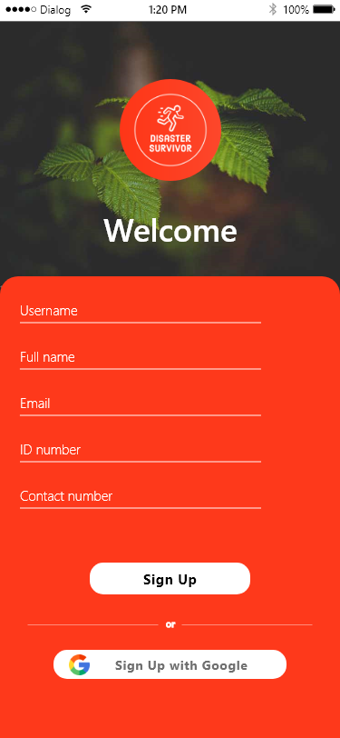

Figure 5 - Sign Up Screen

Figure 6 - Registration Passed

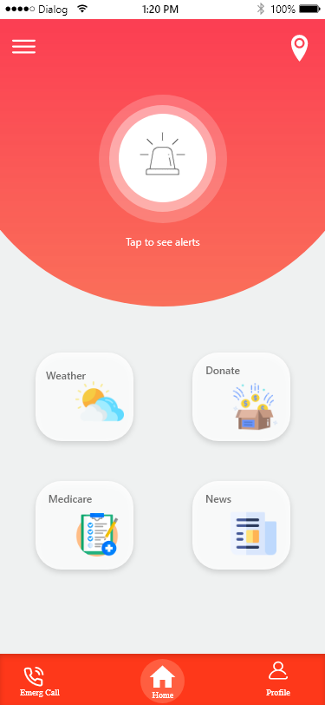

Figure 7 - Home Screen

Figure 8 - Menu Bar

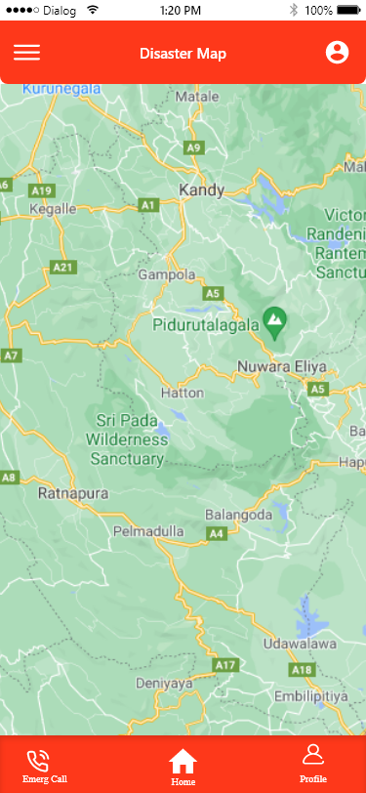

Figure 9 - Disaster Map

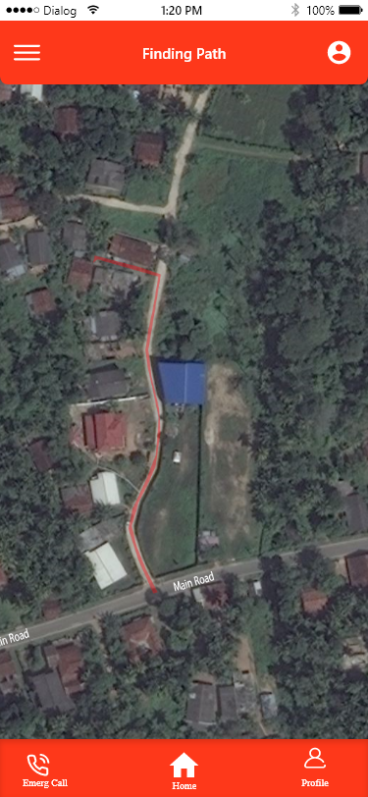

Figure 10 - Finding Path

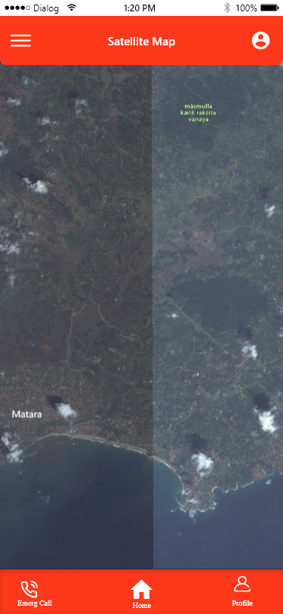

Figure 11 - Satellite map

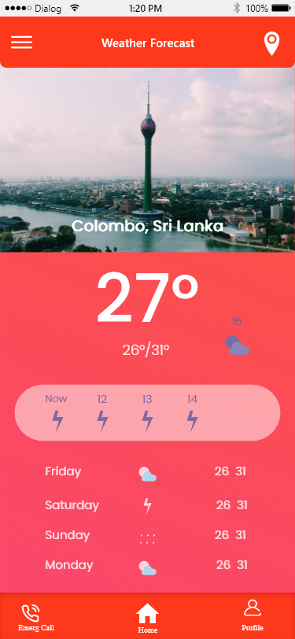

Figure 12 - weather forecast

Figure 13 - Donation Screen

Figure 14 - Emergency numbers

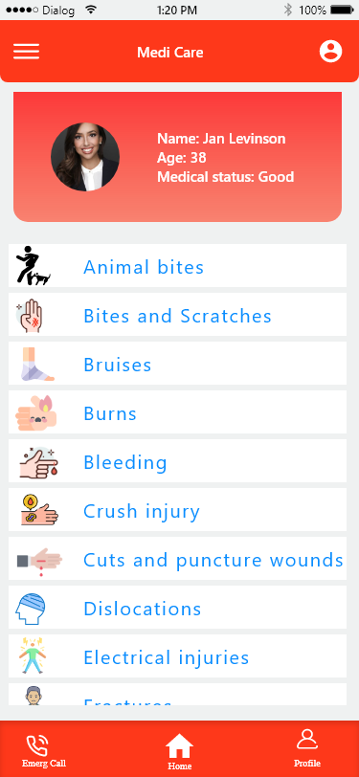

Figure 15 - Medicare tab

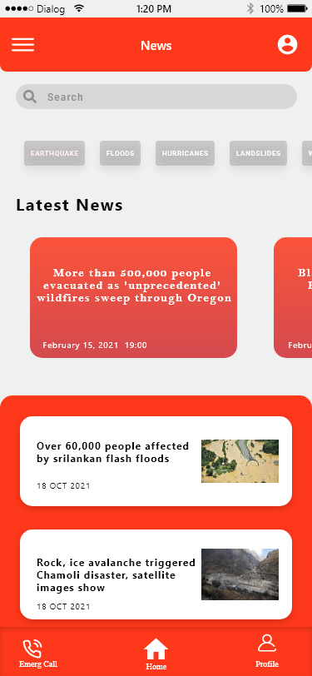

Figure 16 - News tab

Figure 17 - User profile

# CHAPTER 6: Evaluation

## 6.1 Test case

|  |  |  |  |  |  |  |
| --- | --- | --- | --- | --- | --- | --- |
| Test Case ID | Test Scenario | Test Steps | Test Data | Expected Results | Actual Results | Pass / Fail |
| 1 | Registering into Disaster Survivor | 1. Open the app  2. Enter Registration Details  3. Tap Register | Full name, Username, Email, ID number, Birth date, Contact number, Address | Successfully Registered. | As expected, | Pass |
| 2 | Sign-in into Disaster Survivor | 1. Open the app  2. Enter sign in details  3. Tap sign in | Email/Username, Password | Welcome back | As expected, | Pass |
| 3 | Weather Forecasting | 1. Open the app  2. Choose the location 3. Get weather information | Location | Weather information of current location | As expected, | Pass |
| 4 | Emergency Medi Care information | 1. Open the app  2. Choose an injury  3. Get the information | Injury type | Medicare information of the injury type | As expected, | Pass |
| 5 | Alert | 1. An alert notification coming  2. Click the notification  3. Get information | Flood Warning | Information of current natural disaster | As expected, | Pass |

Table 2 - Test case

## 6.2 Techniques Used to Analyze Data

* Using google forms

The techniques what used are, the team create a google form for the questioner. It is a survey questions for regarding our project. Then analyze all data and information by what users reply for those questions.

## 6.3 Lessons learned

Instead of rushing things and starting off, team first created a time – based plan by going step to achieve our goal without fail.

Developers were enjoyed how this project made such a big difference how everyone came together to help put something so small together and how it became something big. Our team got to meet wonderful people and they feel great because they have made a great impact in life. And because everyone shared their knowledge and contribute well as a group, they ended up with a great product.

**Communication skills**

* Developers were learnt new user validation models and techniques.
* Can sense how others feel based on their nonverbal communication.
* They learnt to gather information more accurately and efficiently.

## 6.4 Suggestions

The application should be user friendly. And it must simply using application because mostly it used to update alerts.

It has mobile app service in initial state and after can update the application in website versions. Then the website version is more helpful for the donations with online donating facilities.

Include a list of items needed to gather in case of emergency it can be useful as many people tend to forget at such situations.

**Refer the rest of the test case in appendix.**

# Conclusion

One of the most important problems that people face in Sri Lanka is, floods and landslides. The Central Province is more prone to floods and landslides. Over the last months many houses have been damaged by floods, 17 people have been killed and many lives have been put in danger. The news in television tries their best to put out the news and the alert as early as possible but, by the time the news reveals it, it is too late. Many houses and lives will already have been gone by then.

To solve this problem, an application was created which is free for all the members. The main purpose of this application is to provide early alert and notification on floods, landslides, and other disasters in the country. This application cooperates with the government and the weather department in order to provide the accurate results. This is app ensures to be very user friendly. The app uses GPS and AI technology to provide real time feedback about the disasters. By using this application, many lives are believed to be saved.

To come up with this kind of an app a strong SLDC model needs to be chosen, therefore the Incremental SLDC model was chosen. The main reason why this model was chosen is because, the requirement and the solution has been known upfront before creating this application. The product was designed where it could be updated based on user feedbacks. The steps of analyzing, designing, and testing was done perfectly to ensure that this application is well fit to be used by the people. After these the application was created.

This application needed to be innovative and required to be unique compared to other weather/natural disaster apps. In order to make this innovative, many steps were taken. First thing was to make this application user friendly so, a feedback option and interactive quizzes were made available to the users. The real time tracking feature was implemented so people in a disaster can use this app to find a safe place to evacuate immediately. Emergency services such as Fire Brigade, Police Station, Hospital Hotline and Ambulance Services were made available so people can use the help of this to call them. An option was created where outsiders can donate to the people who were affected by a disaster so, it will be helpful to the people in need.

With all of this techniques “Disaster Survivor” app was created and it is believed that it will save many people from disasters.

# References

Anon., (2018). *Queensland Government.* [Online]   
Available at: https://www.chiefscientist.qld.gov.au/publications/understanding-floods/flood-consequences  
[Accessed 18 July 2021].

Anon., (n.d.). *Depertment of Meteorology.* [Online]   
Available at: www.meteo.gov.lk  
[Accessed 18 July 2021].

Anon., (n.d.). *Guru99.* [Online]   
Available at: https://www.guru99.com/functional-requirement-specification-example.html  
[Accessed 18 july 2021].

Anon., (n.d.). *Incremental Model-converted.* [Online]   
Available at: https://magadhuniversity.ac.in/download/econtent/pdf/Incremental%20%20Model-converted.pdf  
[Accessed 17 July 2021].

Anon., (n.d.). *Virginia Tech.* [Online]   
Available at: https://guides.lib.vt.edu/researchmethods/interviews  
[Accessed 17 July 2021].

Mcconnel, B., (2019). *Mind manager Blog.* [Online]   
Available at: https://blog.mindmanager.com/blog/2019/11/what-is-brainstorming-and-why-is-it-important/  
[Accessed 17 July 2021].

Smith, F., (2019). *Sciencing.* [Online]   
Available at: https://sciencing.com/how-are-people-affected-by-floods-12510012.html  
[Accessed 17 July 2021].

Strachen, R., (n.d.). *3 Sided Cube.* [Online]   
Available at: https://3sidedcube.com/disaster-management-apps-features-save-lives/  
[Accessed 17 July 2021].

# Appendices

|  |  |
| --- | --- |
| **Workload Matrix** | |
| **Student ID/Name** | **Task** |
| 20200467 Heshan Nipuna (Group Leader) | Requirements and Analysis, Report editing, Prototype making. |
| 20200490 Maneesha Shehara | Evaluation |
| 20200150 Shanjay Sharma | Innovative features incorporated in the project, Acknowledgements |
| 20200593 Abbas Sirajul | Methodology, Conclusion |
| 20200519 Jinithi Yasami | Solution outline |
| 20200547 Romel Perera | Introduction and Description of the Project, Abstract |

Table 3 - Workload Matrix

|  |  |  |  |
| --- | --- | --- | --- |
| **Meeting Minutes & Meeting Agenda** | | | |
| **Date** | **Time** | **Duration** | **Meeting Minutes** |
| 2021.06.29 | 19:00pm | 1 hour | Report specification understanding |
| 2021.07.04 | 19:00pm | 2 ½ hours | Report dividing and gather information |
| 2021.07.11 | 19:30pm | 2 hours | Making the report |
| 2021.07.17 | 19:00pm | 1 ½ hours | Making prototype |
| 2021.07.18 | 19:00pm | 2 hours | Making prototype |
| 2021.07.24 | 20:00pm | 3 hours | Finalize the prototype |
| 2021.07.25 | 21:00pm | - | Finalize and Submitting the Report |

Table 4 - Meeting Agenda & Meeting Minutes

## Requirements Elicitation.

**Survey questionnaire / Interview questions**

I) Have you been exposed to a natural disaster?

II) If it is yes, what did you learn from that experience?

III) What do you do on that natural disaster?

IV) Are you using any app connected with disasters?

V) Do you like to share your location with the app?

VI) Do evacuation advice/instructions receive from the app are useful for you in an emergency disaster situation?

VII) In emergency disaster situation do you like if the app shows you the directions to arrive into a safety place?

## Idea Validation.

**Survey questionnaire / Interview questions**

1. How often do u watch the news?

Daily Once or Twice a week Very rarely

1. How you have been notified about previous natural disasters?

Television Radio Social Media

1. What are the most common natural disasters in your area?
2. Would you like if an application develop to provide early warnings for you before a disaster?

Yes No

1. How long does it take for the emergency services to come for help during disasters?

In an hour Immediately.

1. How prone is your area to natural disaster?
2. Do you know what to do when a natural disaster occurs?
3. Do you know the hotlines to call in emergencies?

Yes No

1. What is the safest place for you to evacuate to in a natural disaster?
2. How long did it take for u to recover from the last disaster?
3. What do you think you should have done during the last natural disaster?
4. Please share any additional comments or suggestions that you would expect natural disaster application?

## Test Case.

|  |  |  |  |  |  |  |
| --- | --- | --- | --- | --- | --- | --- |
| 6 | Donating Option | 1. Open the app.  2. Sign in.  3. Select bank.  4. Donate | Bank card details,  Account details,  Amount of money,  Location of disaster | You have donated, thank you! | As expected, | Pass |
| 7 | News | 1. Open the app.  2. Go News feature  3. Select the category  4. Receive news updates | Local news,  Recent news about natural disaster | News | As expected, | Pass |
| 8 | Disaster Map, Satellite Map,  Finding Path | 1. Open the app.  2. Click the Menu icon  3. Select the feature | Satellite Map,  Google Map | Map | As expected, | Pass |
| 9 | Emergency numbers | 1. Open the app.  2. Click the Menu icon  3. Select emergency numbers | Hospital numbers,  Police station numbers,  Ambulance numbers,  Covid-19 Emergency numbers | Display numbers | As expected, | Pass |

Table 5 - GAP analysis