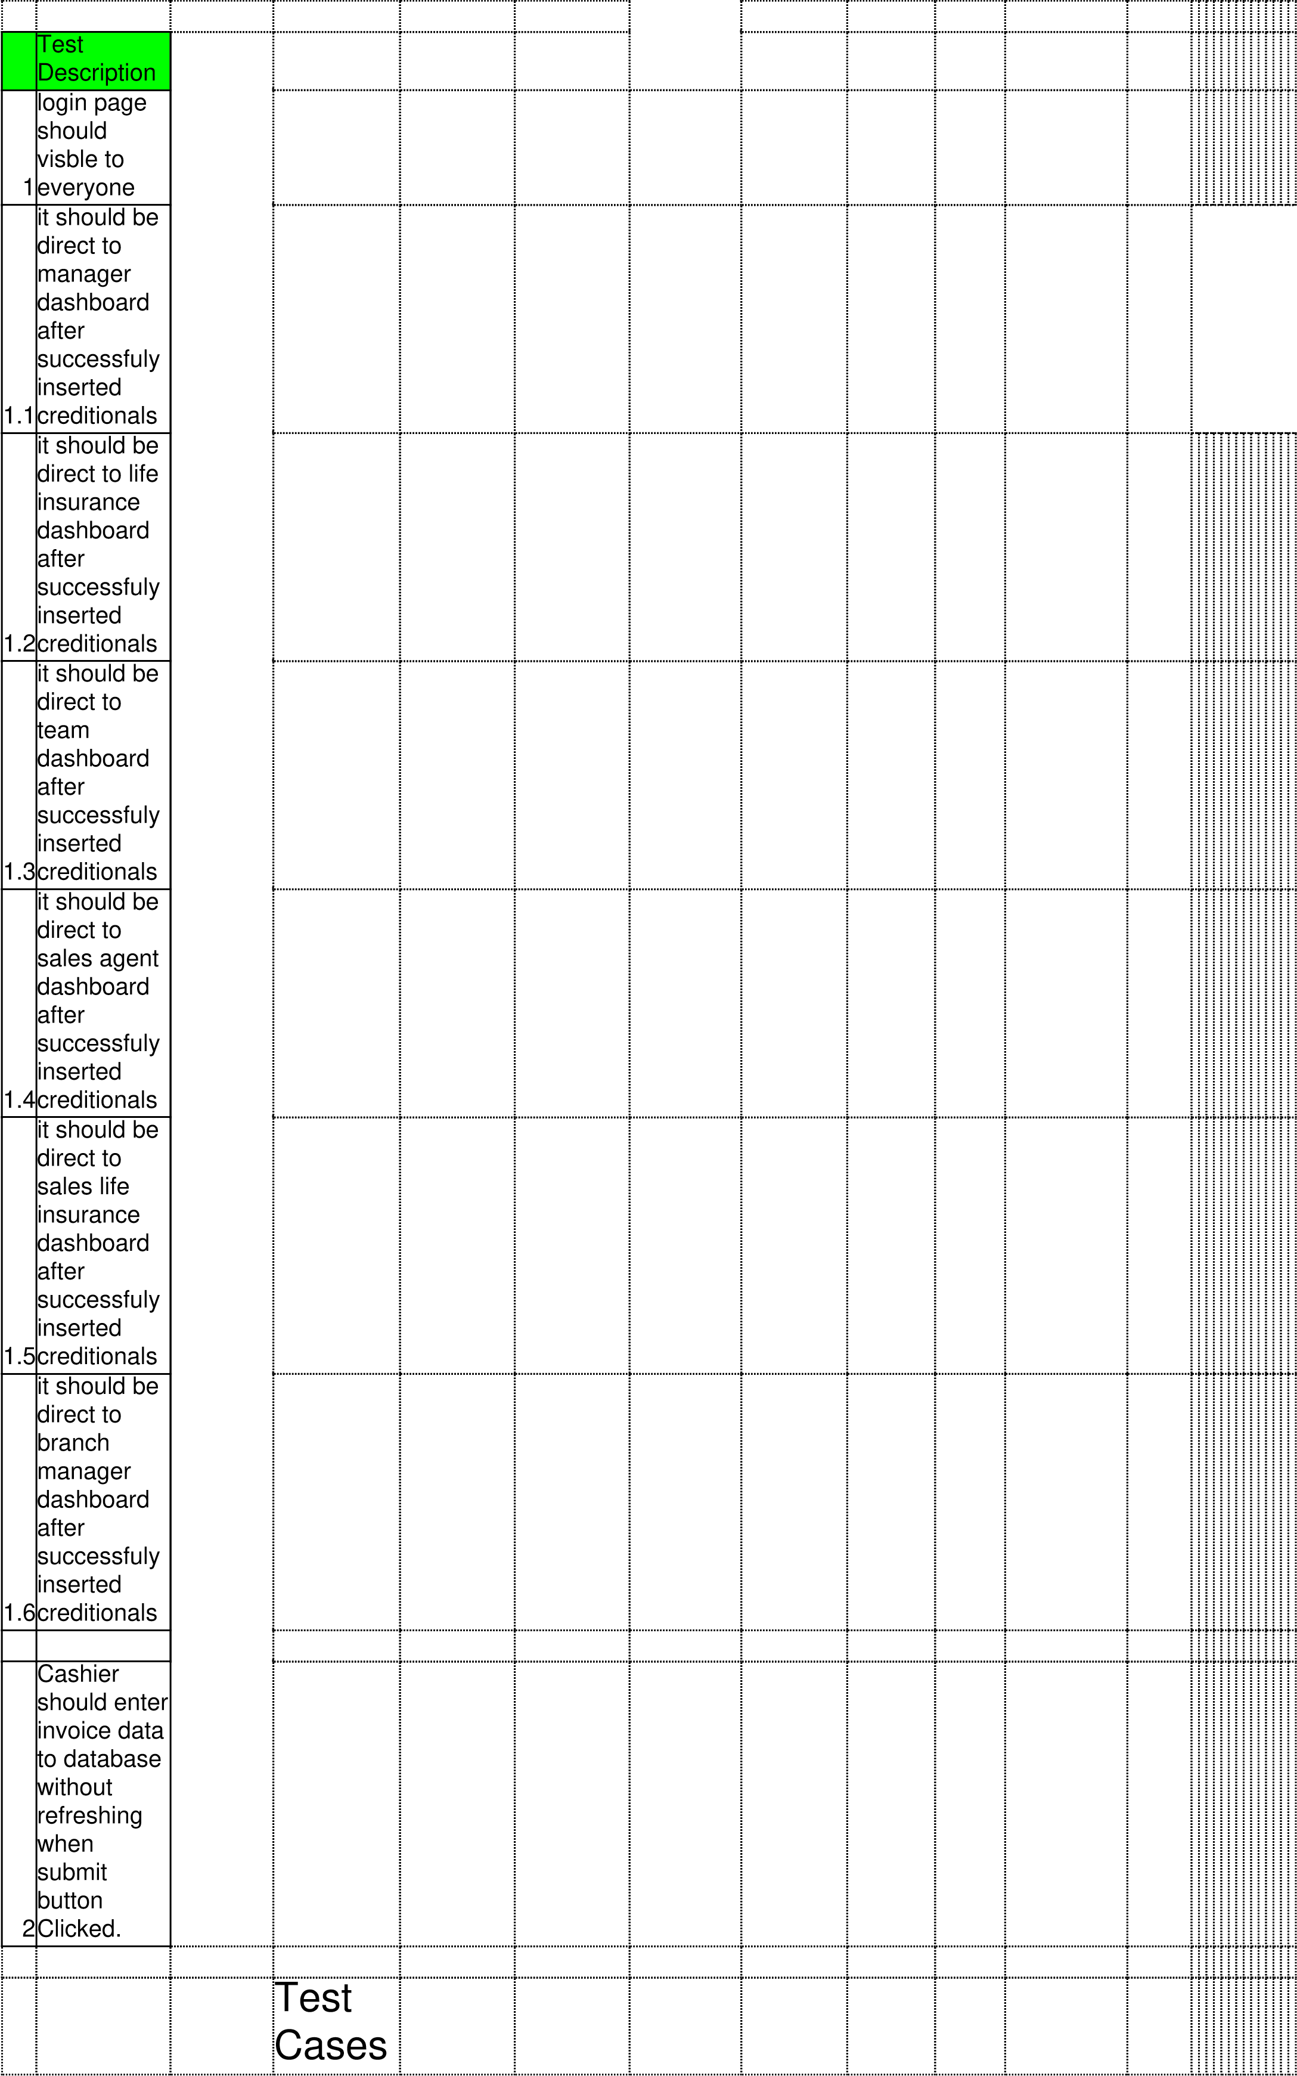

 | Precondition | Test  Steps | Input Data | Expected  Result | Actual  Result | Test Env | Execution  Status | bug  Severity | Bug  Priorty | Attachment | Notes
1 | click application endpoint and press enter | Go to browser and type end point |  |  | login page appeared |  | Success | Critica | High
1.1 | login page must appear  with login form | Go to login page and enter agent code and password | agentCode-  6 passwordmanager | Direct to  manager dashboard without refreshing the page | direct to  manager dashboard without refreshing | ubuntu  20.0 LTS  Chromium  Web  Browser | Success | Major | medium
1.2 | login page must appear  with login form | Go to login page and enter agent code and password | agentCode-  9 passwordinse | Direct to insurance dashboard without refreshing the page | direct to insurance dashboard without refreshing | ubuntu  20.0 LTS  Chromium  Web  Browser | Success | MAjor | medium
1.3 | login page must appear  with login form | Go to team page and enter agent code and password | agentCode-  8 passwordteam | Direct to  Team  dashboard without refreshing the page | Direct to  Team  dashboard without refreshing the page | ubuntu  20.0 LTS  Chromium  Web  Browser | Success | MAjor | medium
1.4 | login page must appear  with login form | Go to sales agent page and enter agent code and password | agentCode-  7 passwordsales | Direct to sales dashboard without refreshing the page | Direct to sales dashboard without refreshing the page | ubuntu  20.0 LTS  Chromium  Web  Browser | Success | MAjor | medium
1.5 | login page must appear  with login form | Go to branch manager page and enter agent code and password | agentCode-  7 passwordsales | Direct to sales dashboard without refreshing the page | Direct to sales dashboard without refreshing the page | ubuntu  20.0 LTS  Chromium  Web  Browser | Success | MAjor | medium
1.6 | login page must appear  with login form
2 | login page must appear  with login form | Cashier can enter invoice details and click submit button |  |  |  | ubuntu  20.0 LTS  Chromium  Web  Browser | Success | MAjor | medium

