Sri Lanka Institute of Information Technology



Enterprise Standards and Best Practices for IT Infrastructure

4th Year 2nd Semester

2016

Group Details:

* IT 13067366-C.K.B.Wickramasinghe
* IT 13119386-U.R.R.I.S. Bandara
* IT 13131784-R.W.H.V. Samarasinghe

Practical Session: WD

Practical: Vmotion

Date of Submission: 11.09.2016

**VMotion**

**Introduction**

Virtual machine migration among different virtual machines is known as Vmotion. Vmotion provides a zero downtime and achieve integrity while proceeding in migration. Therefor by migration using vmotion methods high availability is been achieved. In order to commence/achieving migration in between virtual machines the virtual machines must not have any hardware dependency. Only a shared storage must be available to achieve migration among the machines. The virtual machines must be connected through the same network.

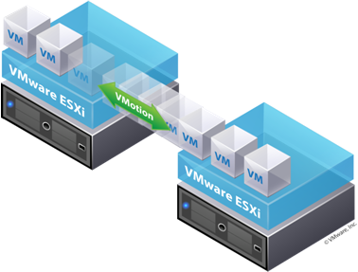

The underlying network infrastructure will be determining the success of the success of the migration. In this way it is critical that IP system be flexible, strong, and very accessible. And also it lets the client to;

• Automatically streamline and apportion whole pools of assets for most extreme equipment use and accessibility.

• Perform equipment support with no booked downtime.

• Proactively relocate virtual machines far from coming up short or failing to meet expectations servers.

**VMotion Requirements**

VMware VMotion application mobility is based on certain infrastructure requirements:

* An IP network with a minimum bandwidth of 622 Mbps is required.
* The maximum latency between the two VMware vSphere servers cannot exceed 5 milliseconds (ms).
* The source and destination VMware ESX servers must have a private VMware VMotion network on the same IP subnet and broadcast domain.
* The IP subnet on which the virtual machine resides must be accessible from both the source and destination VMware ESX servers. This requirement is very important because a virtual machine retains its IP address when it moves to the destination VMware ESX server to help ensure that its communication with the outside world (for example, with TCP clients) continues smoothly after the move.
* The data storage location including the boot device used by the virtual machine must be active and accessible by both the source and destination VMware ESX servers at all times.
* Access from VMware vCenter, the VMware Virtual Infrastructure (VI) management GUI, to both the VMware ESX servers must be available to accomplish the migration.

Benefits of vMotion

1. Automatic resources are been allocated in an optimized method.
2. High availability is achieved.
3. VMware Storage VMotion allows you relocate virtual machine disk files between and across shared storage locations, which improves VM storage performance without creating downtime.
4. No down time is been occurred while migrating the servers. Therefor no service delay or not available is occurred.
5. Storage vMotion

While technically its own separate feature, it works similar to vMotion, except it deals completely with data.

1. Minimizes scheduled Downtime

Most of the downtimes are scheduled, before vMotion administrators had to do server maintenance late at night in order to avoid disrupting users.

1. Enhanced Application Performance and Availability

**Actions to be taken through vSphere Client connected to VirtualCenter.**

We connect to Virtual Center and gain access to one of the servers 2. We select the tab Configuration-> Network Adapters and we see that we have visibility of the new connections.

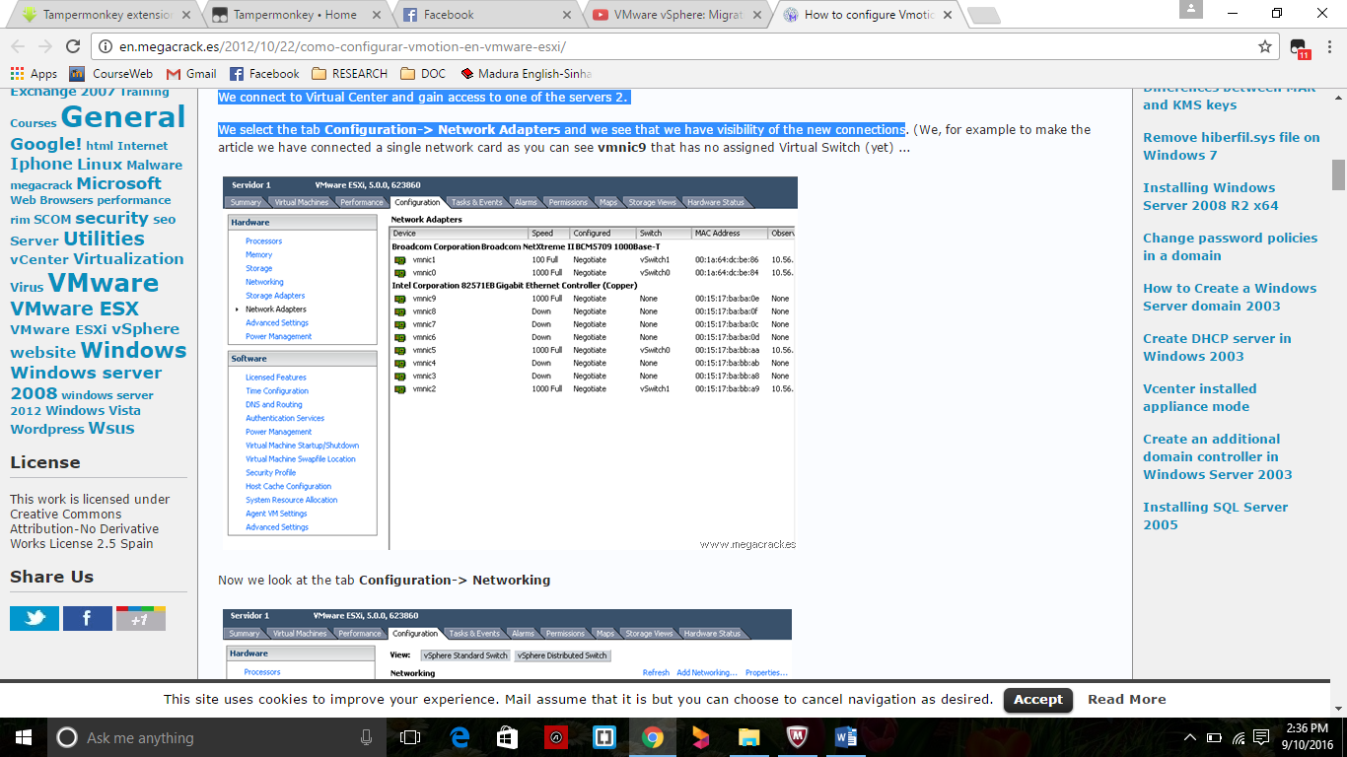

Navigate to Configuration-> Networking

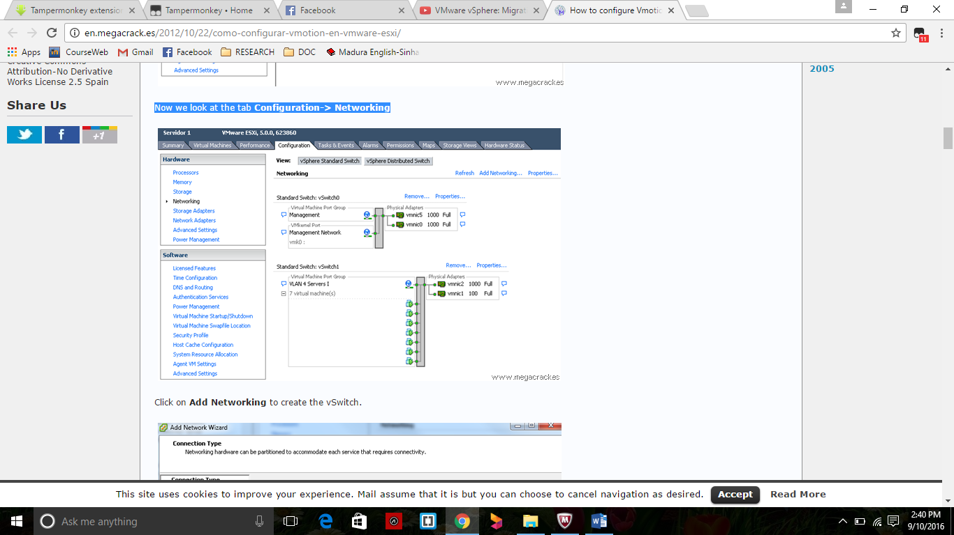

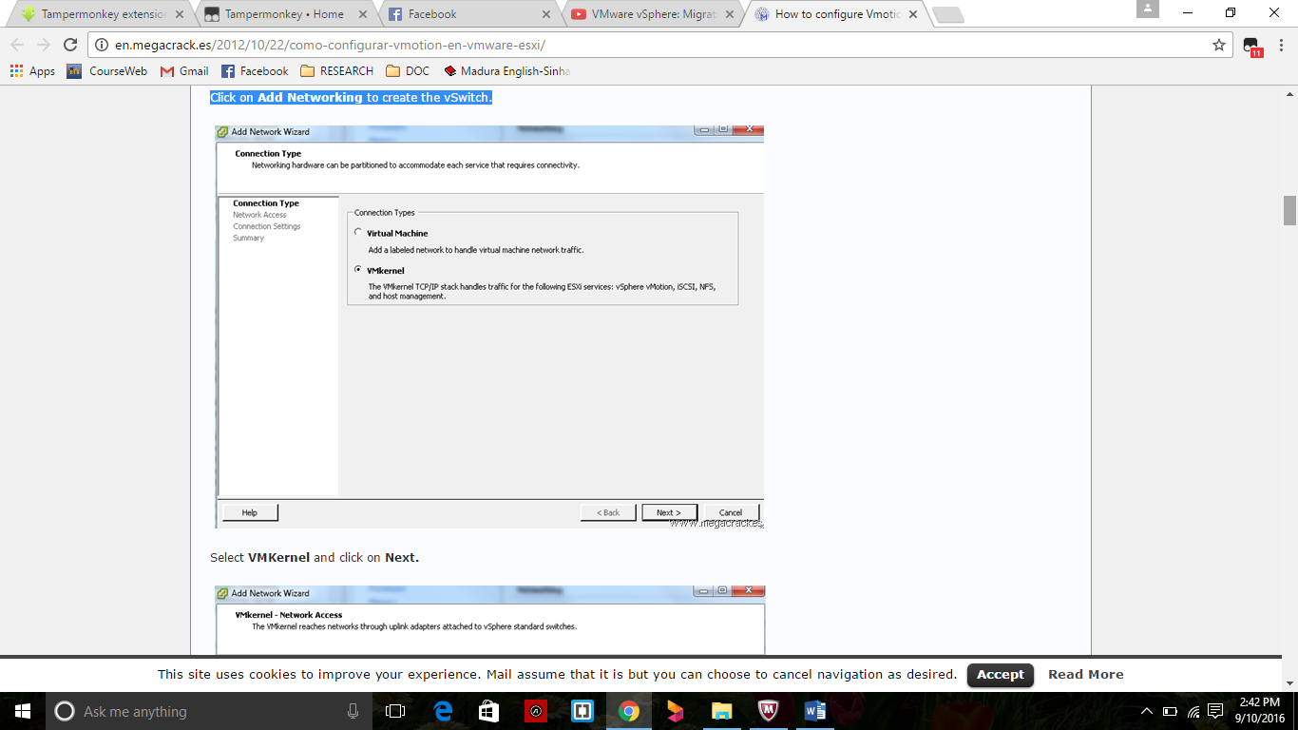Create a new network VSwitch

Choose required VMKernel.

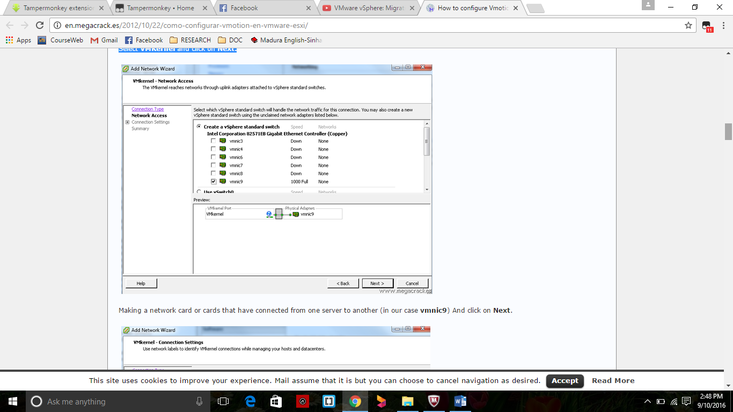

.

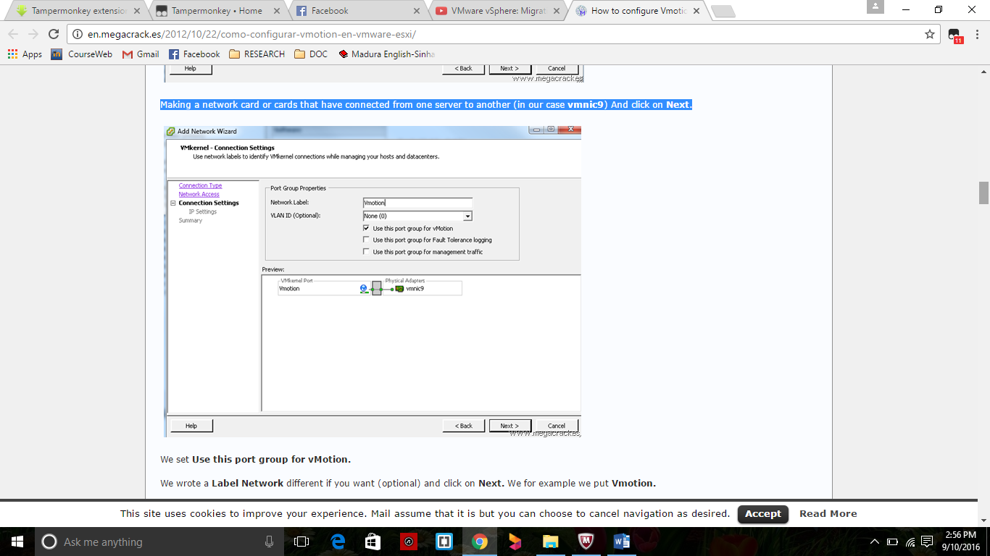

New port group for vMotion is been labeled for the different network if you want (optional) and click on Next. We for example we put Vmotion.

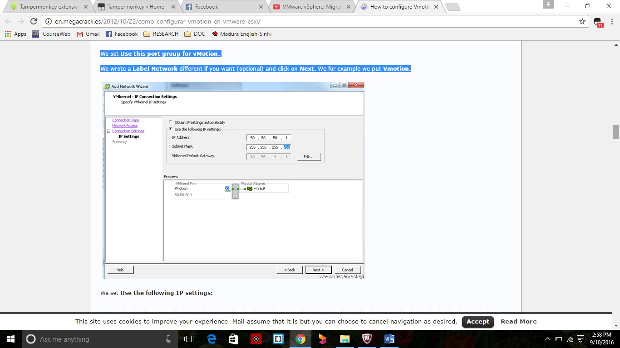

We set Use the following IP settings. IP Address as 50.50.50.1 and Subnet Mask as 255.255.255.252 (Since we will use only 2 ip's).

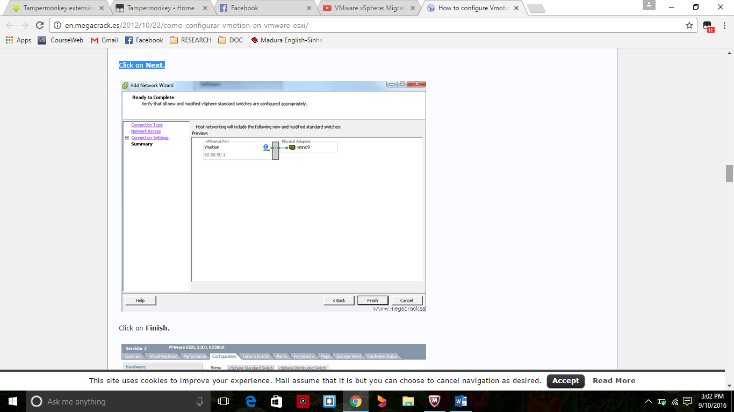

The entire system is been tested to check working properly to migrate a VM from one ESXi to the using Vmotion functionality you just configured.

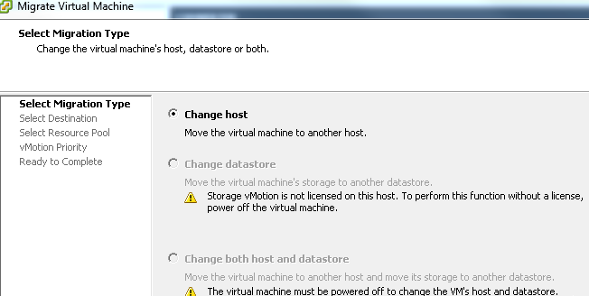

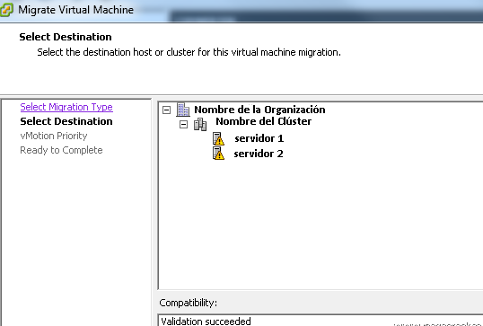

Select the target server where we will move the virtual machine.

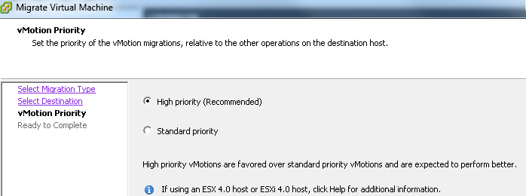

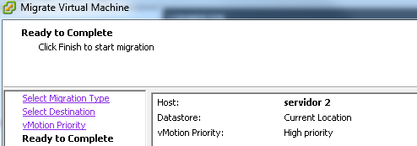

Completion of VM Migration

