

Research on secondary modeling and related issues of air quality forecasting
Abstract：
Today, when atmospheric environmental pollution has an important impact on the human body and the ecological environment, it is very necessary to take corresponding pollution prevention and control measures. By establishing an air quality forecast model, knowing the possible air pollution processes in advance and taking corresponding control measures is one of the effective methods to reduce the harm caused by air pollution to human health and improve ambient air quality. Currently, the WRF-CMAQ simulation system is commonly used in my country to forecast air quality, but it is limited by the uncertainty of the simulated meteorological fields and emission inventories, as well as the incomplete understanding of the generation mechanism of pollutants including ozone, and the atmospheric physics and chemistry. There are also flaws in the mechanism analysis, which results in a low hit rate for primary pollutants and air quality levels, and the results of the WRF-CMAQ forecast model are not ideal. Therefore, based on the simulation results of primary forecast models such as WRF-CMAQ, more data sources are combined for remodeling to improve the accuracy of forecasts.
For question 1, there is no abnormal data in the daily measured data of monitoring point A from August 25 to August 28, 2020. You can directly calculate the monitoring point A from August 25 to August 2020 according to the method in the appendix. The measured AQI and primary pollutants were measured every day on the 28th. The results are shown in Tables 3-4 and 3-6.
For question 2, collect and record the data in Appendix 1 and perform data preprocessing on the records. Mainly to deal with data anomalies, the following processing methods are adopted: When part or all of the measured data is missing: the missing value of the variable value is taken as the time before and after Average value; affected by some accidental factors, the value of the measured data at a certain hour (a certain day) deviates from the normal distribution of the data: if it exceeds the normal variable distribution range, it is taken as the corresponding minimum or maximum value; the 3σ criterion is used to remove the abnormality Data culling. Based on the variable values ​​of data preprocessing, the corresponding AQI value for each day is calculated according to the formula. According to its attributes, the clustering method k-means based on division is used to cluster the meteorological conditions according to the degree of influence on the pollutant concentration. Visualize the category results; reasonably classify meteorological conditions based on the ranking of AQI results, and describe the characteristics of various meteorological conditions; cluster the overall data multiple times, and finally choose to divide it into three categories based on the clustering results. The cluster center points are as shown in the table As shown in 4-1, the characteristics of various meteorological conditions are explained.
For question 3, a prediction framework based on BP neural network was established based on the representative and independent meteorological conditions selected based on the impact of previous meteorological conditions on pollutant concentrations. This model builds a neural network framework to input primary forecast data and real-time monitoring data to complete the prediction of air quality forecast, and continuously adjusts it during the process of adding updated weather quality data. This model is suitable for predictive modeling of data updates. After a series of tests, the secondary forecast mathematical model is applicable to the three monitoring points A, B, and C at the same time, and the AQI forecast value in the forecast result of the established BP neural network secondary forecast model has a smaller error than the forecast value of the primary modeling. , the prediction accuracy of primary pollutants is higher. In addition, the results of the secondary modeling model for air quality prediction were compared with the real values ​​and compared with other models to verify the effectiveness of the model. And use this model to predict the single-day concentration values ​​of 6 conventional pollutants at monitoring points A, B, and C from July 13 to July 15, 2021, and provide the corresponding AQI and primary pollutant results, as shown in Table 5 -3 is shown.
For question 4, based on the BP neural network prediction framework established in question 3, the wind direction and the positions between monitoring points A, A1, A2, and A3 were added to improve the model to construct a collaborative forecast model. Genetic algorithms were used to use real number coding and simulated binary Crossover and polynomial mutation were used to improve the BP neural network prediction model, and the use of the test set was also changed. The pollutant concentration and meteorological information tested at four different monitoring points in the same time period were taken as the training set. Train the neural network and the results are shown in Table 6-1.
Keywords: air quality forecast, primary pollutants, AQI, k-means clustering, quadratic modeling, BP neural network, genetic algorithm.

Context
1. Problem Restatement 4
2. Model Assumptions and Key Symbols Explanation 6
3.Analysis and Solution of Problem 7
3.1 Analysis of Problem 7
3.2 Solution of Problem 7
4.Analysis and Solution of Problem 2 9
4.1 Analysis of Problem 2 9
4.2 Solution of Problem 2 10
4.2.1 Data Preprocessing 10
4.2.2 Model Principle and Framework 12
4.2.3 Clustering Results 13
5. Analysis and Solution of Problem 3 15
5.1Analysis of Problem 3 15
5.2 Solution of Problem 3 16
5.2.1Model Principle and Framework 16
5.2.2 Model Results 18
6. Analysis and Solution of Problem 4 21
6.1Analysis of Problem 4 21
6.2Solution of Problem 4 21
6.2.1Model Principle and Framework 21
6.2.2 Model Results 23
7.Conclusions and Model Evaluation 24
7.1 Conclusions 24
7.2 Model Evaluation 25
7.2.1 Model Advantages 25
7.2.2 Model Disadvantages 25
References 27

1. Problem Restatement
The spatiotemporal variation of air pollutant emissions and the corresponding changes in meteorological conditions can have both short-term and long-term impacts on human health. Exceeding pollutant concentration limits poses significant harm to public health and has a profound effect on ecosystems, the environment, transportation, and other human societal activities. An effective air quality forecasting system helps humans monitor future pollutant concentration levels, formulate appropriate prevention and control strategies, and provide accurate predictions of pollutant concentration levels in advance. This enables the spatiotemporal variation of pollutant emissions and the corresponding meteorological changes to be anticipated, mitigating their short-term and long-term impacts on human health, and reducing the harmful effects of pollutant concentration excesses on public health, ecosystems, the environment, transportation, and other human activities【2】.
The commonly used WRF-CMAQ modeling system (hereinafter referred to as the WRF-CMAQ model) is employed for air quality forecasting.
The WRF-CMAQ model mainly consists of two components: WRF and CMAQ. WRF is a mesoscale numerical weather prediction system used to provide the necessary meteorological data for CMAQ. CMAQ is a three-dimensional Eulerian atmospheric chemistry and transport modeling system that simulates the changes in pollutants based on meteorological information from WRF and the emission inventory within the domain. It uses the principles of physical and chemical reactions to model the variation processes of pollutants, providing forecast results for specific time points or periods. The structures of WRF and CMAQ are shown in Figures 1-1 and 1-2, 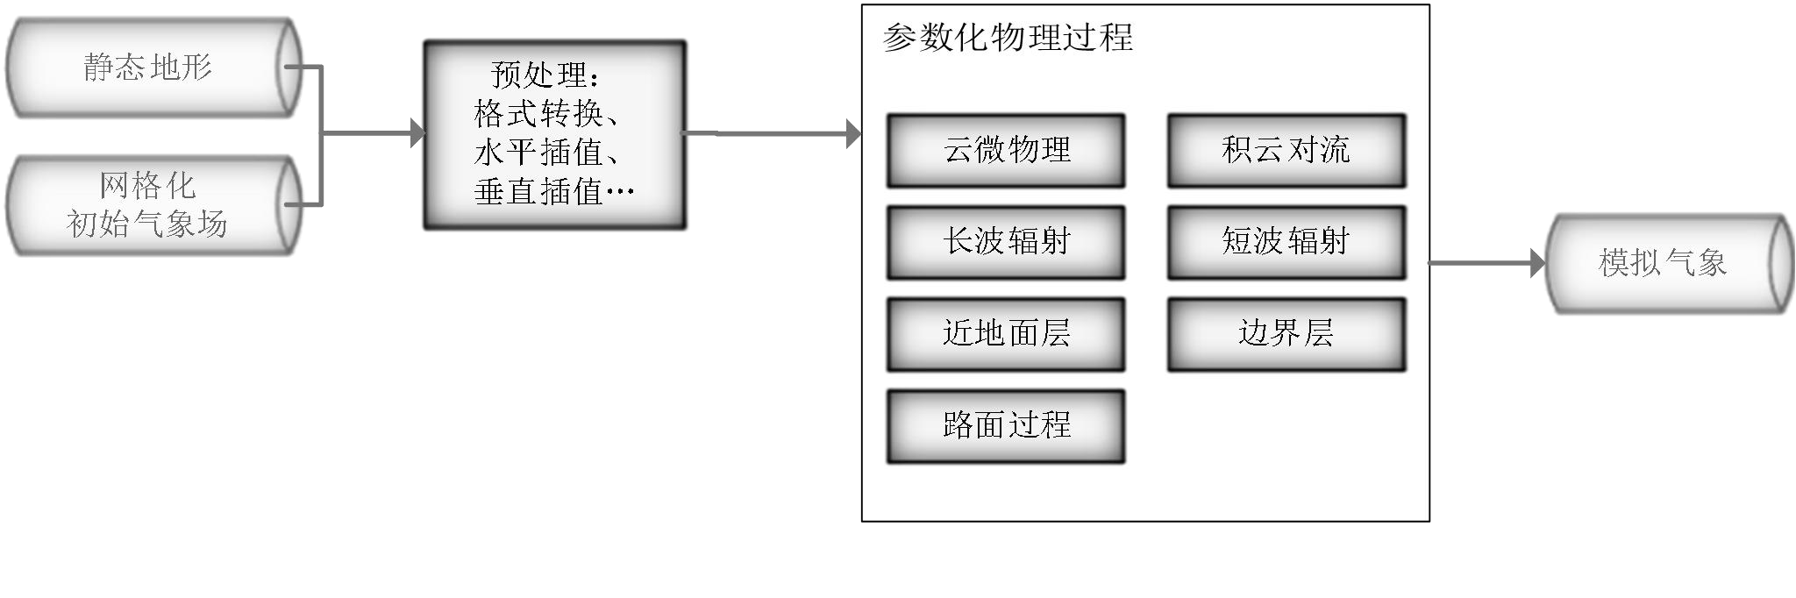
Figure 1-1 Structure of the mesoscale numerical weather prediction system WRF[1]
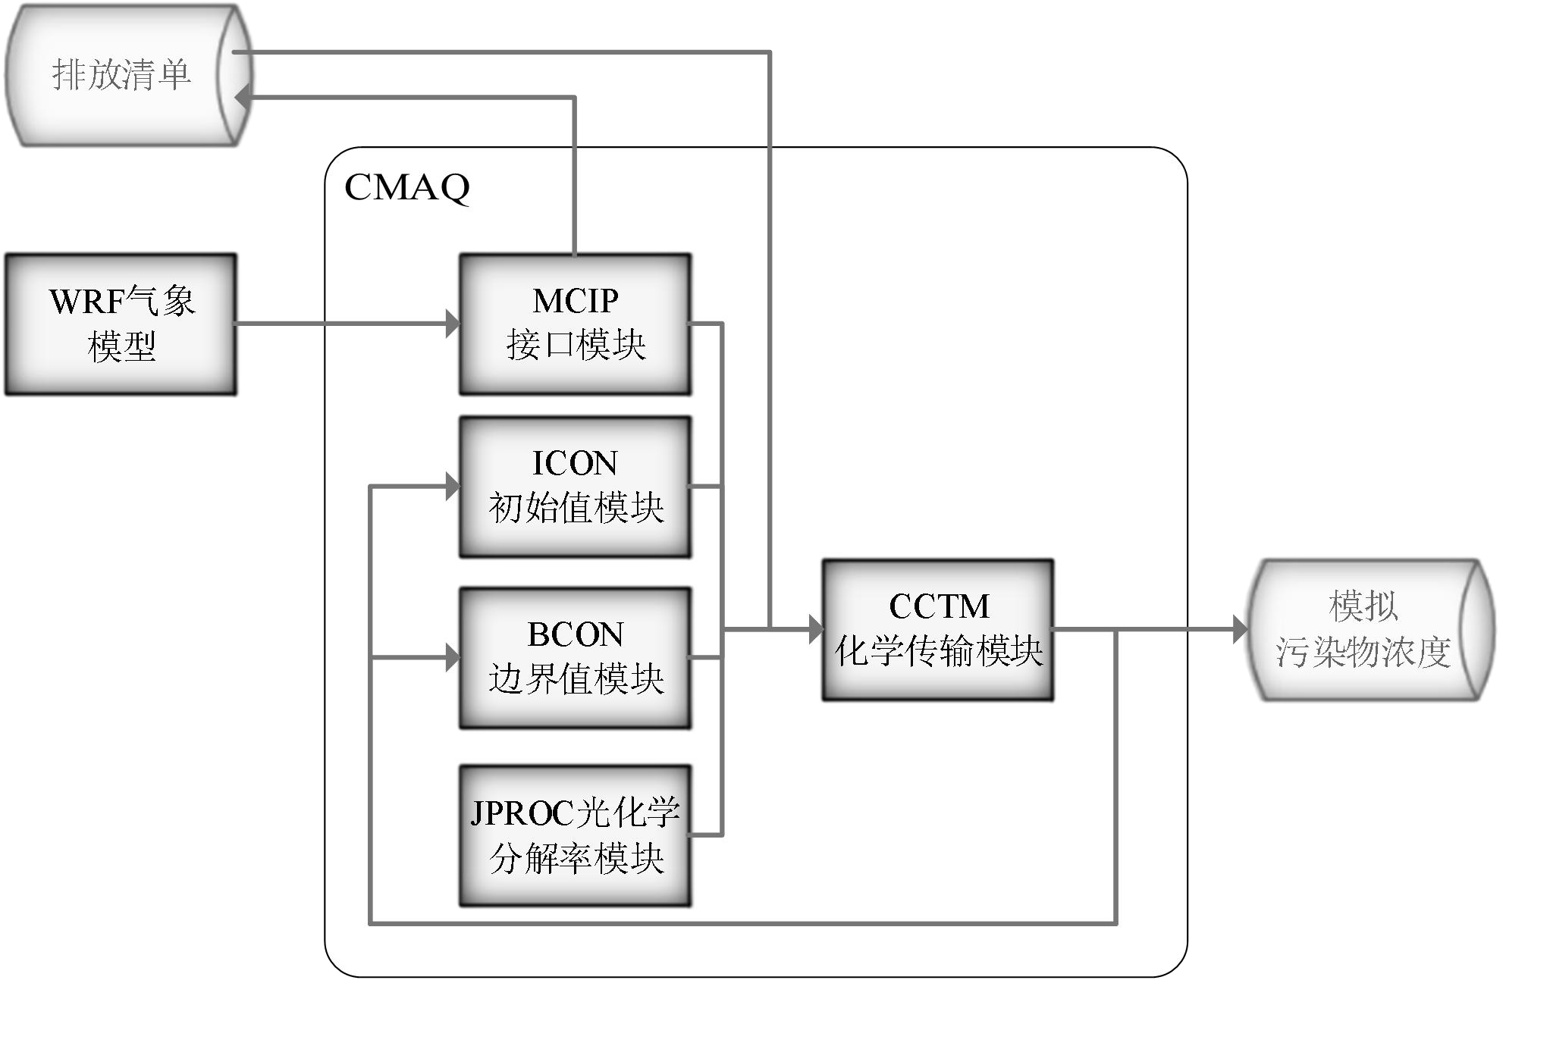
Figure 1-2 Structure of the Air Quality Prediction and Assessment System CMAQ
However, due to the uncertainties in the simulated meteorological fields and emission inventories, as well as the incomplete understanding of the generation mechanisms of pollutants, including ozone, the results of the WRF-CMAQ forecast model are not ideal. Therefore, the concept of secondary modeling is proposed: this refers to re-modeling based on the results of first-stage forecast models such as WRF-CMAQ, incorporating additional data sources to improve forecast accuracy. Since actual meteorological conditions have a significant impact on air quality (e.g., reduced humidity is conducive to ozone formation), and the variation of observed pollutant concentration data provides valuable reference for air quality forecasting, secondary modeling typically refers to integrating meteorological and pollutant data obtained from air quality monitoring stations to optimize the forecast model.
The relationship between the secondary model and the WRF-CMAQ model is shown in Figure 1-3. The data generated by running the WRF-CMAQ model is referred to as "first-stage forecast data," while the data obtained from air quality monitoring stations is referred to as "observed data." Generally speaking, the correlation between the first-stage forecast data and the observed data is not high, but during the forecasting process, observed data is often used to adjust the first-stage forecast data for better results.
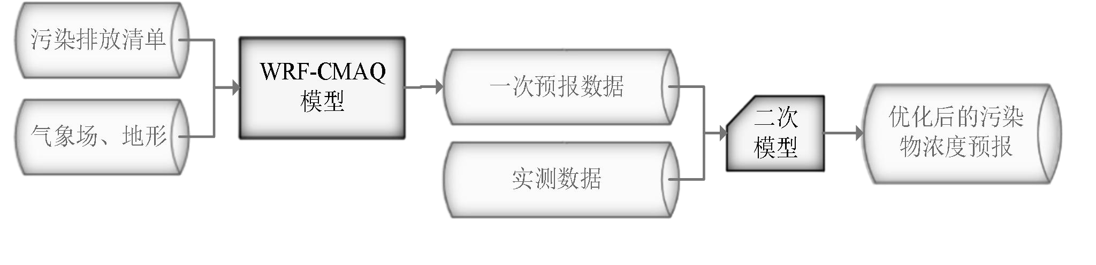
Figure 1-3 WRF-CMAQ Air Quality Forecasting Process Optimized by Secondary Modeling

To perform secondary modeling for predicting the air quality at a given monitoring station for the next three days, the study provides the foundational data for long-term air quality forecasting at the monitoring station, including first-stage forecast data for pollutant concentrations, first-stage forecast data for meteorological conditions, observed meteorological data, and observed pollutant concentration data. The time span for all first-stage forecast data is from July 23, 2020, to July 13, 2021, while the time span for all observed data is from April 16, 2019, to July 13, 2021. The total data volume is in the order of hundreds of thousands (for detailed information, see Appendices 1-3).
It should be noted that:
(1) The daily forecast time is fixed at 7:00 AM, at which point observed data up to and including 7:00 AM of the current day can be obtained, along with first-stage forecast data for the current and prior dates (with the forecast period extending until 11:00 PM on the third day). Observed hourly data after 7:00 AM on the current day, as well as first-stage forecast data for the next day and beyond, are unavailable. For example, in the air quality forecast for July 13 to July 15, 2021, conducted on the morning of July 13, 2021, the available reference observed data range is from 00:00 on April 16, 2019, to 7:00 AM on July 13, 2021, while the model’s operational date range is from July 23, 2020, to July 13, 2021.
(2) Due to restrictions on monitoring data access and the functionality of relevant monitoring equipment, some meteorological variables observed data are unavailable.
(3) Since the first-stage forecast tends to be more accurate for dates closer to the forecast date, the secondary forecast is theoretically also more accurate for dates close to the forecast date.

According to the "Ambient Air Quality Standards" (GB3095-2012), there are six common air pollutants used to assess air quality: sulfur dioxide (SO2), nitrogen dioxide (NO2), particulate matter with a diameter less than 10 μm (PM10), particulate matter with a diameter less than 2.5 μm (PM2.5), ozone (O3), and carbon monoxide (CO). Among them, ozone pollution occurs frequently in many regions across the country, and early warning and prevention of ozone pollution are key tasks for environmental protection agencies. Ozone concentration forecasting is also one of the more difficult tasks among the six pollutants, because: as the only secondary pollutant among the six, ozone is not directly emitted from pollution sources but is generated through a series of chemical and photochemical reactions in the atmosphere (refer to the section on the mechanism of near-surface ozone pollution formation in the appendix). This makes it very challenging to accurately predict ozone concentration changes using the WRF-CMAQ model. Furthermore, existing research both domestically and internationally has not yet reached a general conclusion on the mechanism of ozone formation .
综上所述，根据问题要求，基于一次预报数据及实测数据(见附件)进行空气质量预报二次数学建模，建立一个具有一定的鲁棒性的模型，完成以下四个问题。请注意，实际工作中会遇到数据为空值或异常值的情况(见附录)，故要求建立的模型具有一定的鲁棒性。
问题 1. 使用附件 1 中的数据，按照附录中的方法计算监测点 A 从 2020 年 8 月 25 日到
8 月 28 日每天实测的 AQI 和首要污染物，按照附录“AQI 计算结果表”的格式给出结果。
问题 2. 在污染物排放情况不变的条件下，某一地区的气象条件有利于污染物扩散或沉降时，该地区的 AQI 会下降，反之会上升。使用附件 1 中的数据，根据对污染物浓度的影响程度，对气象条件进行合理分类，并阐述各类气象条件的特征。
问题 3. 使用附件 1、2 中的数据，建立一个同时适用于 A、B、C 三个监测点(监测点两两间直线距离>100km，忽略相互影响）的二次预报数学模型，用来预测未来三天 6 种常规污染物单日浓度值，要求二次预报模型预测结果中 AQI 预报值的最大相对误差应尽量小，且首要污染物预测准确度尽量高。并使用该模型预测监测点 A、B、C 在 2021 年 7 月 13 日至 7 月 15 日 6 种常规污染物的单日浓度值，计算相应的 AQI 和首要污染物，依照附录
“污染物浓度及 AQI 预测结果表”的格式给出结果。
问题 4. 相邻区域的污染物浓度往往具有一定的相关性，区域协同预报可能会提升空气质量预报的准确度。如图 4，监测点 A 的临近区域内存在监测点 A1、A2、A3，使用附件 1、3 中的数据，建立包含 A、A1、A2、A3 四个监测点的协同预报模型，要求二次模型预测结果中 AQI 预报值的最大相对误差应尽量小，且首要污染物预测准确度尽量高。使用该模型预测监测点 A、A1、A2、A3 在 2021 年 7 月 13 日至 7 月 15 日 6 种常规污染物的单日浓度值，计算相应的 AQI 和首要污染物，依照附录“污染物浓度及 AQI 预测结果表”的格式在文中给出结果。并讨论：与问题 3 的模型相比，协同预报模型能否提升针对监测点
A 的污染物浓度预报准确度？并说明原因。

2.模型假设及关键性符号说明
(1)假设空气质量检测站点实时监测所采集数据可以良好反映此时刻的空气质量情况；
(2)假设设备检测过程中所采集的正常数据都是准确的；
(3)假设通过数据找出的首要污染物浓度可以反映出空气质量等级；
(4)假设每改变一次首要污染物的值，空气质量情况和情况都会相应及时的发生变化。
符号说明：
符号 | 意义
AQI | 空气质量指数；
CO₃ | 臭氧（O₃）最大8小时滑动平均；
IAQI_{P} | 污染物 P 的空气质量分指数，结果进位取整数；
C_{P} | 污染物 P 的质量浓度值；
BP_{Hi} | 与C_{P}相近的污染物浓度限值的高位值；
BP_{Lo} | 与C_{P}相近的污染物浓度限值的低位值；
IAQI_{Hi} | 与BP_{Hi}对应的空气质量分指数；
IAQI_{Lo} | 与BP_{Lo}对应的空气质量分指数。

3.问题一分析与求解

3.1问题一分析
题目提供了监测点长期空气质量预报基础数据，包括污染物浓度一次预报数据、气象一次预报数据、气象实测数据和污染物浓度实测数据，其中，所有一次预报数据的时间跨度为 2020 年 7 月 23 日到 2021 年 7 月 13 日，所有实测数据的时间跨度为 2019 年 4 月 16 日到 2021 年 7 月 13 日，一次预报数据包括了近地 2 米温度(℃)、地表温度(K)、湿度(%)、近地 10 米风速(m/s)、大气压(Kpa)的相应气象参数共 15 个，及用于衡量空气质量的六种常规大气污染物的小时平均浓度，常规大气污染物分别为一氧化碳(CO)、二氧化硫(SO₂)、氮氧化物(NOx)、臭氧(O₃)等气体污染物和可吸入颗粒物(PM₁₀)、细颗粒物(PM_{2.5}) 等颗粒态污染物，这些大气污染物对公众生活具有潜在的负面影响，甚至会引发一系列健康问题
[1]。
其中，臭氧污染在全国多地区频发，对臭氧污染的预警与防治是环保部门的工作重点。臭氧浓度预报也是六项污染物预报中较难的一项，其原因在于：作为六项污染物中唯一的二次污染物，臭氧并非来自污染源的直接排放，而是在大气中经过一系列化学及光化学反应生成的^{[3]}。问题要求使用附件 1 中的数据，按照附录中的方法计算监测点 A 从 2020 年 8 月 25 日到 8 月 28 日每天实测的 AQI 和首要污染物，并将结果按照附录“AQI 计算结果表” 的格式放在正文中。根据观察发现，需要用到的参数在 2020 年 8 月 25 日到 8 月 28 日中不存在空值缺失等问题，因此问题 1 可以直接通过公式求出相应的结果。

3.2问题一求解
首先要计算臭氧(O₃)最大 8 小时滑动平均，因为当臭氧(O₃)最大 8 小时滑动平均浓度值高于 800 μg ∕ m³ 时，或其余污染物浓度高于 IAQI=500 对应限值时，不再进行其空气质量分指数计算。
臭氧(O₃)最大 8 小时滑动平均是指一个自然日内 8 时至 24 时的所有 8 小时滑动平均浓度中的最大值，其中 8 小时滑动平均值指连续 8 小时平均浓度的算术平均值。其计算公式如下：
1  CO3 = t=8,9,max…,24 { 8 ti=t−7 ci }  其中c_{i}为臭氧在某日 t − 1 时至 t 时的平均污染物浓度。  各项污染物的空气质量分指数(IAQI)，其计算公式如下： | (3-1)
IAQIP = IAQIHi−IAQILo ⋅ CP − BPLo + IAQILo | (3-2)
BPHi−BPLo
各项污染物项目浓度限值及对应的空气质量分指数级别见表 3-1。表 3-1 空气质量分指数(IAQI)及对应的污染物项目浓度限值
序号 | 指数或污染物项目 |  | 空气质量分指数及对应污染物浓度限值 |  |  |  |  |  |  | 单位
0 | 空气质量分指数(IAQI) | 0 | 50 | 100 | 150 | 200 | 300 | 400 | 500 | -
1 | 一氧化碳(CO)24 小时平均 | 0 | 2 | 4 | 14 | 24 | 36 | 48 | 60 | mg ∕ m³
2 | 二氧化硫(SO₂)24 小时平均 | 0 | 50 | 150 | 475 | 800 | 1600 | 2100 | 2620 | μg ∕ m³
3 | 二氧化氮(NO₂)24 小时平均 | 0 | 40 | 80 | 180 | 280 | 565 | 750 | 940 | μg ∕ m³
4 | 臭氧(O₃)最大 8 小时滑动平均 | 0 | 100 | 160 | 215 | 265 | 800 | - | - | μg ∕ m³
5 | 粒径小于等于 10μm 颗粒物(PM₁₀)24 小时平均 | 0 | 50 | 150 | 250 | 350 | 420 | 500 | 600 | μg ∕ m³
6 | 粒径小于等于 2.5μm 颗粒物(PM_{2.5})24 小时平均 | 0 | 35 | 75 | 115 | 150 | 250 | 350 | 500 | μg ∕ m³
空气质量指数(AQI)取各分指数中的最大值，即
AQI = max IAQI₁, IAQI₂, IAQI₃, …, IAQI_{n} (3-3)
式中，IAQI₁, IAQI₂, IAQI₃, …, IAQI_{n}为各污染物项目的分指数。在问题中，对于 AQI 的计算仅涉及表 1 提供的六种污染物，因此计算公式如下：
AQI = max IAQISO2, IAQINO2, IAQIPM10, IAQIPM2.5, IAQIO3, IAQICO (3-4) 空气质量等级范围根据 AQI 数值划分，等级对应的 AQI 范围见表 3-2。
表 3-2 空气质量等级及对应空气质量指数(AQI)范围
空气质量等级 | 优 | 良 | 轻度污染 | 中度污染 | 重度污染 | 严重污染
空气质量指数（AQI）范围 | [0,50] | [51,100] | [101,150] | [151,200] | [201,300] | [301,+∞)
当 AQI 小于或等于 50（即空气质量评价为“优”)时，称当天无首要污染物；当 AQI 大于 50 时，IAQI 最大的污染物为首要污染物，若 IAQI 最大的污染物为两项或两项以上时，并列为首要污染物；IAQI 大于 100 的污染物为超标污染物。
通过 Matlab 编程，监测点 A 从 2020 年 8 月 25 日到 8 月 28 日根据逐日实测数据计算
出的各项污染物的 IAQI 如表 3-3 所示，
表 3-3 监测点 A 从 2020 年 8 月 25 日到 8 月 28 日每天实测的 IAQI 和空气质量等级(逐日实测数据计算)
监测日期 | 地点 | IAQI 计算 |  |  |  |  |  | 空气质量等级
监测日期 | 地点 | IAQI_{CO} | IAQISO2 | IAQINO2 | IAQI_{O3} | IAQIPM10 | IAQIPM2.5 | 空气质量等级
2020/8/25 | 监测点 A | 13 | 8 | 15 | 60 | 27 | 16 | 良
2020/8/26 | 监测点 A | 13 | 7 | 20 | 46 | 24 | 15 | 优
2020/8/27 | 监测点 A | 15 | 7 | 39 | 109 | 37 | 33 | 轻度污染
2020/8/28 | 监测点 A | 18 | 8 | 38 | 138 | 47 | 48 | 轻度污染
则监测点 A 从 2020 年 8 月 25 日到 8 月 28 日根据逐日实测数据计算出的 AQI 和首要污染物，结果如表 3-4 所示。
表 3-4 监测点 A 从 2020 年 8 月 25 日到 8 月 28 日每天实测的 AQI 和首要污染物(逐日实测数据计算)
监测日期 | 地点 |  | AQI 计算
监测日期 | 地点 | AQI |  | 首要污染物
2020/8/25 | 监测点 A | 60 |  | O₃
2020/8/26 | 监测点 A | 46 |  | O₃
2020/8/27 | 监测点 A | 109 |  | O₃
2020/8/28 | 监测点 A | 138 |  | O₃
监测点 A 从 2020 年 8 月 25 日到 8 月 28 日每日根据逐小时实测数据的平均值计算出的各项污染物的 IAQI 如表 3-5 所示，
表 3-5 监测点 A 从 2020 年 8 月 25 日到 8 月 28 日每天实测的 IAQI 和空气质量等级(逐小时实测数据计算)
监测日期 | 地点 | IAQI 计算 |  |  |  |  |  | 空气质量等级
监测日期 | 地点 | IAQI_{CO} | IAQISO2 | IAQINO2 | IAQI_{O3} | IAQIPM10 | IAQIPM2.5 | 空气质量等级
2020/8/25 | 监测点 A | 13 | 8 | 15 | 61 | 27 | 16 | 良
2020/8/26 | 监测点 A | 13 | 8 | 21 | 47 | 25 | 15 | 优
2020/8/27 | 监测点 A | 17 | 7 | 39 | 109 | 38 | 33 | 轻度污染
2020/8/28 | 监测点 A | 19 | 9 | 38 | 138 | 48 | 47 | 轻度污染
则监测点 A 从 2020 年 8 月 25 日到 8 月 28 日根据逐小时实测数据的平均值根据逐小时实测数据的平均值的 AQI 和首要污染物，结果如表 3-6 所示。
表 3-6 监测点 A 从 2020 年 8 月 25 日到 8 月 28 日每天实测的 AQI 和首要污染物(逐小时实测数据计算)
监测日期 | 地点 |  | AQI 计算
监测日期 | 地点 | AQI |  | 首要污染物
2020/8/25 | 监测点 A | 61 |  | O₃
2020/8/26 | 监测点 A | 47 |  | O₃
2020/8/27 | 监测点 A | 109 |  | O₃
2020/8/28 | 监测点 A | 138 |  | O₃
根据结果可以看出：根据逐日实测数据计算出的 AQI 和根据逐小时实测数据的平均值根据根据逐日实测数据计算出的 AQI 值十分接近，且首要污染物相同。

4.问题二分析与求解

4.1问题二分析
空气质量预报模型的构建需要符合实际情况且误差控制在一定范围内的、相对准确的相关变量测量数据作为支撑。但是在实际的监测站点设备在进行数据测量、数据记录、数据导出等过程中难免会存在一定问题，使得最终得到的数据（原始数据）与希望得到的良好数据存在一定差距。例如，监测站点设备在进行数据测量过程中会遇到各种不同条件的较为复杂的实际工况，最终会导致采集的原始数据中存在着或多或少的不良数据，包括连续或间断性的数值缺失、数值漂移（偏大或偏小）等情况。因此，对不良数据进行科学有效地预处理，对于空气质量预报模型的构建有着决定性意义。
For data collected in real time from different sites in the database, some monitoring station devices have issues with data from certain sites. Specifically, some sites only have data for certain time periods, some sites have entirely empty data or partially missing values, and some sites have data exceeding set limits. Thus, it is necessary to process the raw data before using it.
Regarding meteorological data collected by actual monitoring station devices—such as near-surface temperature at 2 meters (°C), surface temperature (K), humidity (%), near-surface wind speed at 10 meters (m/s), and atmospheric pressure (KPa)—these meteorological parameters typically fluctuate. However, within short time frames, they can be considered relatively stable.

4.2问题二求解

4.2.1数据预处理
The raw concentration data of carbon monoxide (CO), sulfur dioxide (SO₂), nitrogen dioxide (NO₂), ozone (O₃), particulate matter with a diameter of less than 10 μm (PM₁₀), and particulate matter with a diameter of less than 2.5 μm (PM₂.₅) is visualized, as shown in Figure 4-1.
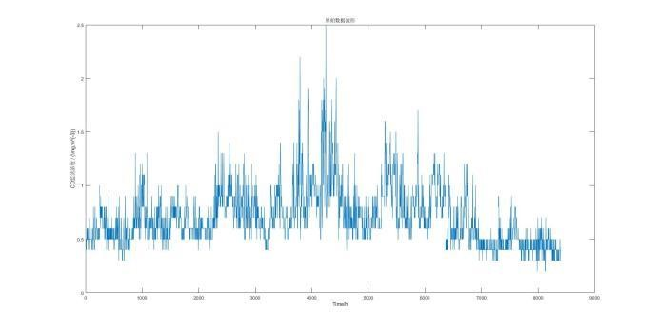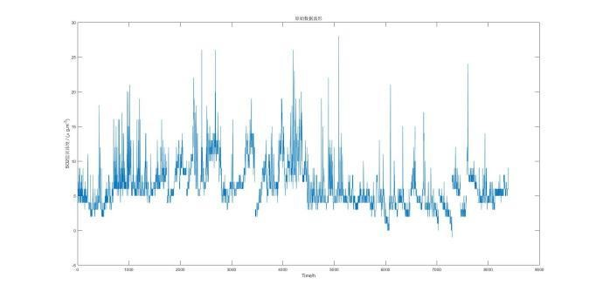
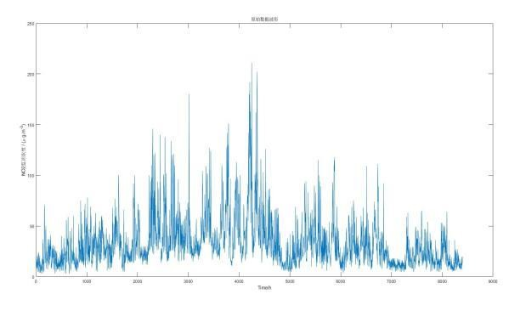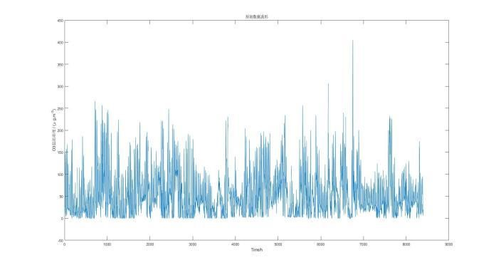
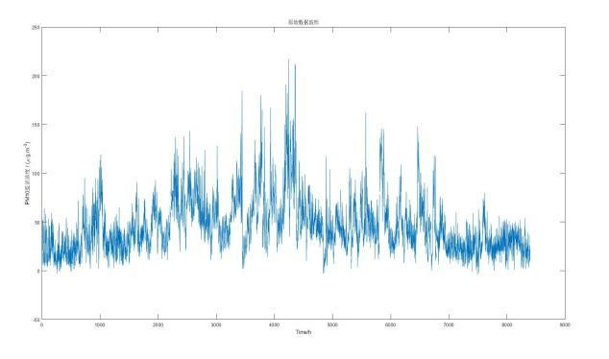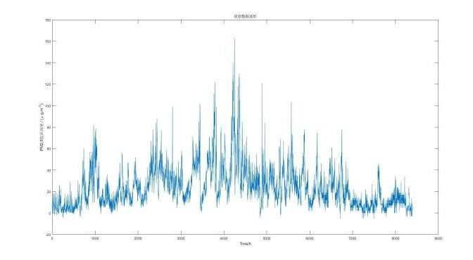
图 4-1 污染物浓度原始数据可视图
Due to factors such as monitoring station equipment adjustments and maintenance, the observed data may have partial or complete gaps over continuous time periods. Additionally, influenced by certain occasional factors around the monitoring site, the observed data may deviate from normal distribution values for a particular hour (or day). The meteorological indicators provided in the project include a total of five items (temperature, humidity, pressure, wind direction, and wind speed), but due to differences in equipment used across different monitoring stations, some indicators may be unavailable at certain sites.
Based on the above analysis, a corresponding analysis and processing will be conducted for each type of problematic data in the raw data from Appendix 1. For the raw data in Appendix 1, outliers should be removed, with the removal criteria set according to the Riad Criterion (3σ rule). In summary, the following preprocessing steps are proposed for potential anomalies in the raw data:
- Missing Values:
During data collection by monitoring station equipment, certain points may experience continuous or intermittent missing values. For such cases, the average of the values within one hour before and after the missing point will be used to fill in the gaps.
- Values Outside the Range Limits (Exceeding Minimum or Maximum):
In practical operations, there may be instances where the actual control of variables exceeds the minimum or maximum range specified in the appendix. In these cases, values outside the range will be removed. When calculating the final averaged values across different sites, any data exceeding the limits will be replaced by the minimum or maximum allowable values.
- Values Outside the 3σ Range:
It is reasonable to assume that the variables from monitoring station equipment are continuous and should not exhibit abrupt jumps. However, due to potential issues during the data collection process, certain “jumps” may be observed in the raw data. To address this, these jump values will be excluded when averaging variable data from each station, meaning data points outside the 3σ range will not be considered in the final averaged value.
- Inconsistent Units:
The units of certain variables in the appendix are inconsistent. For example, in one forecast dataset, the unit for pressure is given in KPa, while in the actual data, it is in MBar. The conversion between these units is 1 KPa = 10 MBar.
The processed data and daily AQI values are provided in Appendices 1 and 2, along with the visualized data results, as shown in Figure 4-2.

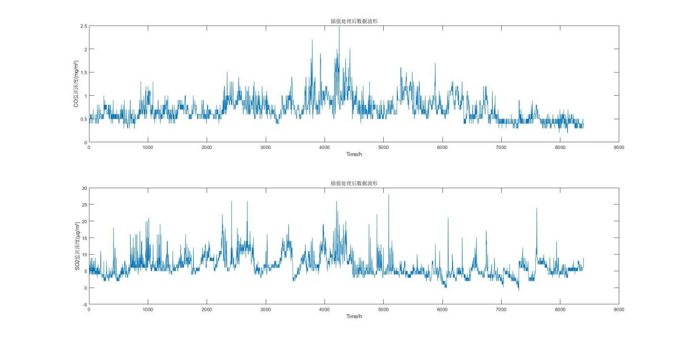
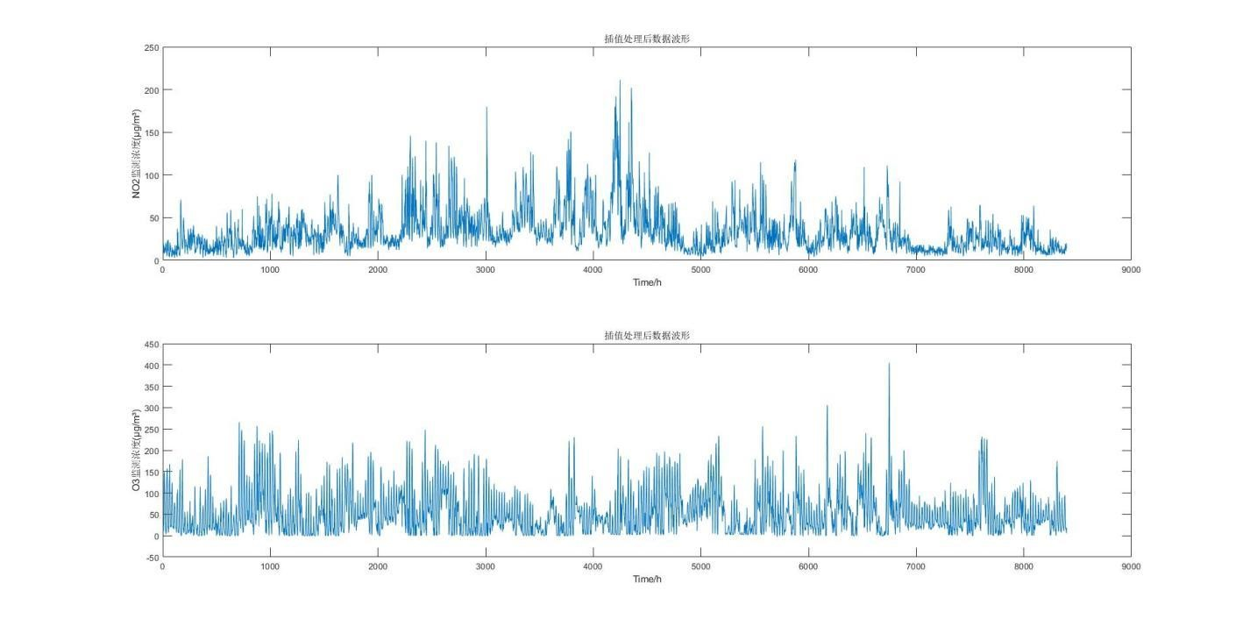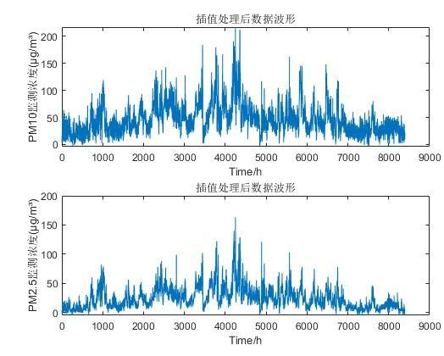
Figure 4-2 Visualization of Pollutant Concentration Data After Processing
4.2.2 Model Principles and Framework
k-means Clustering Algorithm
For a given dataset containing n data points X={X1​,X2​,…,Xn​}, where each Xi​∈Rd, and the number of subsets to be generated, the K-Means clustering algorithm organizes the data objects into K partitions C={c1​,c2​,…,cK​}. Each partition represents a cluster with each cluster having a centroid.
The Euclidean distance is used as the similarity and distance criterion. The algorithm calculates the sum of squared distances between the points within each cluster and its centroid.

显然根据最小二乘法和拉格朗日原理，聚类中心μ_{k}应该取为类别c_{k}类各数据点的平均值。
K-Means 聚类算法从一个初始的 K 类别划分开始，然后将各数据点指派到各个类别中，以减少总的距离平方和。因为 K-Means 聚类算法中总的距离平方和随着类别个数 K 的
增加而趋向于减少。因此，总的距离平方和只能在某个确定的类别个数 K 下，取得最小值。
定义：
- 两个数据对象间的距离：
我们采用欧式距离（Euclidean Distance）进行计算，计算公式为
p
d(xi , xj)  (| xik - xjk |2 )1/2
k1 (4-3)
- 准则函数 E
对于 K-means 算法，通常使用准则函数 E，也就是误差平方和（Sum of Squared Error，
SSE）作为度量聚类质量的目标函数。
k
E d ² (C_{i} , x)
i1 xCi (4-4) 其中，d( )表示两个对象之间的距离。
对于相同的 k 值，更小的 SSE 说明簇中对象越集中。对于不同的 k 值，越大的 k 值应该越小的 SSE。
The k-means clustering algorithm involves the following steps:
First, randomly select k objects as the initial cluster centers. Then, for each remaining object, assign it to the cluster whose center is closest (or most similar). Afterward, update the cluster centers by calculating the mean of all objects in each cluster. Repeat the process of assigning objects to the nearest cluster and updating cluster centers until the clusters no longer change. The goal is to minimize the squared error criterion, which ensures that the clusters are as compact and independent as possible.
Input: The number of clusters k and a database X with n data objects.
Output: k clusters that minimize variance.

4.2.3 Clustering Results
The results obtained from clustering using the k-means algorithm in Matlab are as follows:
First, under the condition of constant pollutant emissions, when meteorological conditions in a certain area favor pollutant dispersion or settlement, the AQI in that area decreases, and vice versa, it increases. Among meteorological factors, high temperature, low pressure, low humidity, and high wind speed all promote the removal and dispersion of pollutant concentrations. Any change in these factors can cause fluctuations in ambient air quality, and different pollutants are affected by meteorological conditions to varying degrees. Therefore, based on the impact of each meteorological condition on pollutant concentrations, clustering analysis was performed on meteorological conditions and the calculated corresponding AQI values, with cluster centers rounded to three decimal places
- Temperature was divided into two categories:
  - High temperature (cluster center: 27.691)
  - Low temperature (cluster center: 17.921)
- Humidity was divided into two categories:
  - High humidity (cluster center: 72.988)
  - Low humidity (cluster center: 45.970)
- Pressure was divided into two categories:
  - High pressure (cluster center: 1016.784)
  - Low pressure (cluster center: 1006.346)
- Wind speed was divided into three categories:
  - Gentle breeze (cluster center: 2.226)
  - Light breeze (cluster center: 1.530)
  - Calm wind (cluster center: 0.994)
Based on an analysis of the clustering results, meteorological conditions can be classified as follows:
1.Temperature Classification:
Category 1: High temperature, with an average temperature of 1.27.691°C, which is conducive to pollutant dispersion. The higher temperature at the lower layer intensifies air movement, increasing turbulence, which aids in the upward transfer of pollutants, thereby reducing pollutant concentration near the surface and improving air quality. The AQI range for this category is (0, 60).
Category 2: Low temperature, with an average temperature of 17.921°C, which is unfavorable for pollutant dispersion. Pollutant concentrations increase as ambient temperature decreases, with an AQI range of (60, 150).
2.Humidity Classification:
Category 1: High humidity, with an average humidity of 72.988%. High humidity helps in pollutant adsorption, especially during precipitation when high water vapor content can increase the mass of PM10 and PM2.5, causing particulate matter to settle. This lowers the concentration of PM10 and PM2.5, aiding pollutant dispersion and reducing concentrations. The AQI range for this category is (0, 65).
Category 2: Low humidity, with an average humidity of 45.970%, which is less conducive to pollutant dispersion, leading to higher pollutant concentrations and an AQI range of (65, 150).
3.Pressure Classification:
Category 1: High pressure, with an average pressure of 1016.784 MBar. Atmospheric pressure is positively correlated with pollutant concentration; under high pressure, the atmospheric layer is stable, airflow is downward, which hinders vertical dispersion of pollutants, leading to an accumulation of pollutant concentration. The AQI range for this category is (55, 150).
Category 2: Low pressure, with an average pressure of 1006.346 MBar, where upward airflow promotes pollutant dispersion, resulting in an AQI range of (0, 55).
4.Wind Speed Classification:
Category 1: Gentle breeze, with an average wind speed of 2.226 m/s. Wind aids in the horizontal dispersion of pollutants; the stronger the wind, the better the horizontal dispersion capability, which lowers pollutant concentration. The AQI range for this category is (0, 50).
Category 2: Light breeze, with an average wind speed of 1.530 m/s, where pollutant concentration is relatively high, with an AQI range of (50, 100).
Category 3: Calm wind, with an average wind speed of 0.994 m/s. Low wind speed enhances mixing rather than dispersion, which is unfavorable for pollutant dispersion, resulting in high pollutant concentrations and correspondingly high AQI values, ranging from (100, 150).
The clustering result graphs for temperature, humidity, pressure, and wind speed are shown in Figure 4-3 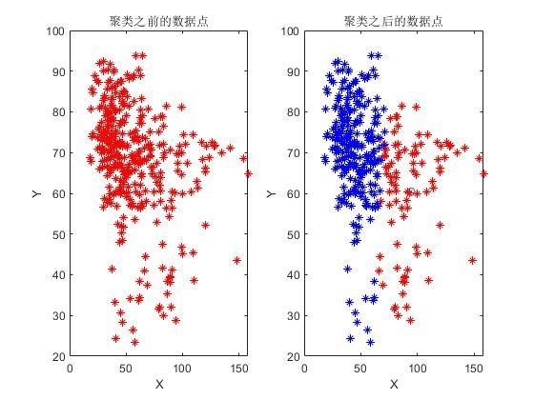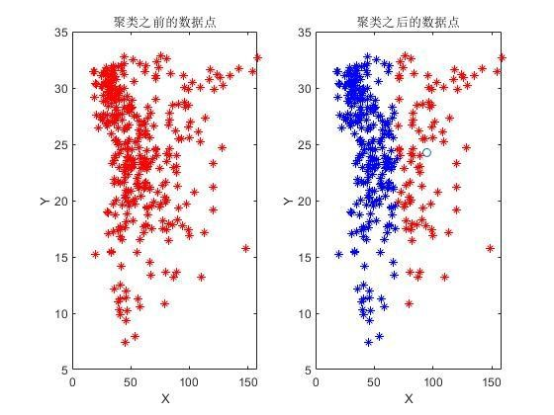
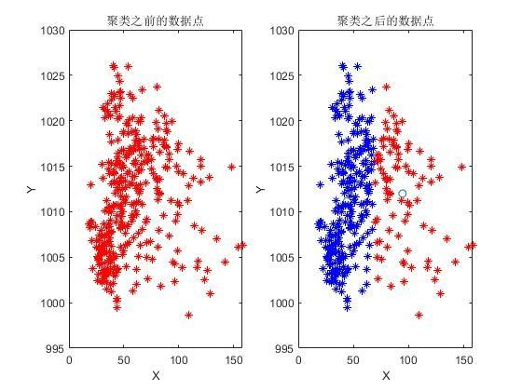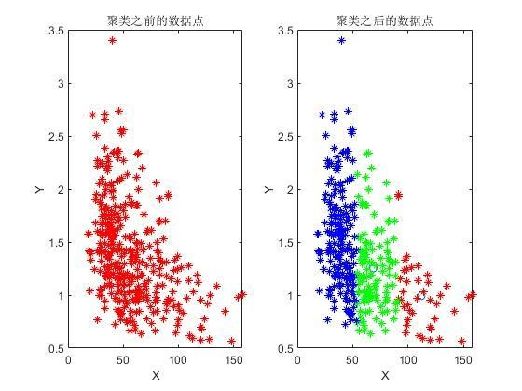
Figure 4-3 Clustering Results of Temperature, Humidity, Pressure, and Wind Speed
After performing clustering based on AQI values for different meteorological conditions, clustering was also conducted for the entire dataset. Since k-means clustering requires prior specification of the number of clusters, but we cannot predict the optimal number of clusters, a maximum of 13 clusters was set for multiple clustering attempts. The clustering results were evaluated using the clustering validity indicators DB (Davies-Bouldin index) and SSE (sum of squared errors). Ultimately, the optimal number of clusters was determined to be 3, dividing the entire dataset into three categories. The cluster centers are shown in Table 4-1 (rounded to three decimal places)：
Table 4-1 cluster centers
聚类中心 | SO₂  (μg/m  3) | NO₂( μg/m  ³) | PM₁₀( μg/m³) | PM_{2.5}(μ g/m³) | O₃(μg/ m³) | CO(m  g/m³) | 温 度  (℃) | 湿 度  (%) | 气 压  (MBar) | 风速  (m/s) | 风 向  (°)
第一类 | 0.644 | 7.240 | 24.545 | 122.812 | 54.732 | 27.778 | 26.660 | 56.879 | 1011.303 | 1.575 | 79.178
第二类 | 0.707 | 6.283 | 31.822 | 48.908 | 45.798 | 24.578 | 25.100 | 67.665 | 1010.3 | 1.343 | 288.373
第三类 | 0.712 | 6.257 | 37.400 | 30.752 | 41.785 | 21.729 | 23.081 | 72.649 | 1012.385 | 1.360 | 50.188

Based on the clustering results, the meteorological conditions can be divided into three categories:

Category 1 has an average temperature of 26.60°C, average humidity of 56.876%, average pressure of 1011.303 MBar, average wind speed of 1.575 m/s, and an average wind direction of 79.178°. Under these conditions, the average pollution concentrations of SO2, NO2, and PM10 are low, but the pollution concentrations of PM2.5, O3, and CO are the highest among the three categories.

Category 2 has an average temperature of 25.100°C, average humidity of 67.665%, average pressure of 1010.3 MBar, average wind speed of 1.343 m/s, and an average wind direction of 288.373°. Under these conditions, the average concentration of PM2.5 is the highest among the three categories, while the concentrations of other pollutants are moderate.

Category 3 has an average temperature of 23.081°C, average humidity of 72.649%, average pressure of 1012.385 MBar, average wind speed of 1.360 m/s, and an average wind direction of 50.188°. Under these conditions, except for PM10, which has the highest concentration among the three categories, the concentrations of other pollutants are at their lowest levels.

5.问题三分析与求解

5.1问题三分析
一个有效的空气质量预报系统有助于人类掌握污染物未来浓度信息，制定相应的防治策略，对空气中污染物的浓度水平提前给出精确的预报，使因污染物浓度超标所造成的非线性智能统计模型，目前常用 WRF-CMAQ 模拟体系对空气质量进行预报。WRF-CMAQ 模型主要包括 WRF 和 CMAQ 两部分：WRF 是一种中尺度数值天气预报系统，用于为 CMAQ 提供所需的气象场数据；CMAQ 是一种三维欧拉大气化学与传输模拟系统，其根据来自 WRF 的气象信息及场域内的污染排放清单，基于物理和化学反应原理模拟污染物等的变化过程，继而得到具体时间点或时间段的预报结果^{[6]}。
但受制于模拟的气象场以及排放清单的不确定性，以及对包括臭氧在内的污染物生成机理的不完全明晰，WRF-CMAQ 预报模型的结果并不理想^{[7]}。故提出二次建模概念：即指在 WRF-CMAQ 等一次预报模型模拟结果的基础上，结合更多的数据源进行再建模，以提高预报的准确性。其中，由于实际气象条件对空气质量影响很大（例如湿度降低有利于臭氧的生成），且污染物浓度实测数据的变化情况对空气质量预报具有一定参考价值，故目前会参考空气质量监测点获得的气象与污染物数据进行二次建模，以优化预报模型。
如何预测空气中污染物浓度是一个复杂的问题。目前我国的城市环境空气质量预报的主要模型包括多元线性回归、人工神经网络、NAQPMS、CAMx、WRF-Chem 及多模式集合预报体系等^{[8]}，国内外的研究表明神经网络能够比回归模型更好地预报空气污染物的浓度随时间的变化趋势，得出更加理想的预报效果。神经网络空气质量预报模型适用于当前难以开展空气质量数值预报，并且回归统计模型的预报精度无法满足要求的城市开展空气质量预报工作及相关研究。因此本文在 WRF-CMAQ 的一次预报模型模拟结果的基础上二次建模建立 BP 神经网络空气质量预测模型。

5.2问题三求解

5.2.1模型原理及框架
BP 神经网络
BP 算法由数据流的前向计算（正向传播）和误差信号的反向传播两个过程构成。正向传播时，传播方向为输入层→隐层→输出层，每层神经元的状态只影响下一层神经元。若在输出层得不到期望的输出，则转向误差信号的反向传播流程。通过这两个过程的交替进行，在权向量空间执行误差函数梯度下降策略，动态迭代搜索一组权向量，使网络误差函数达到最小值，从而完成信息提取和记忆过程。
神经网络模型原理描述：
（1）正向传播
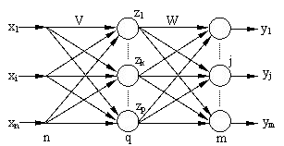
图 5-1 三层神经网络的拓扑结构
设 BP 网络的输入层有 n 个节点，隐层有 q 个节点，输出层有 m 个节点，输入层与隐层之间的权值为v_{ki}，隐层与输出层之间的权值为w_{jk}，如图 5-1 所示。隐层的传递函数为 f1(·)，输出层的传递函数为 f2(·)，则隐层节点的输出为（将阈值写入求和项中）：
z_{k} = f₁（ ^{n}_{i=0} v_{ki} x_{i}） k=1,2,...,q (5-1)
输出层节点的输出为：
y_{j} = f₂（ ^{q}_{k=0} w_{jk} z_{k}） j=1,2,...,m (5-2)
至此 BP 网络就完成了 n 维空间向量对 m 维空间的近似映射^{[10]}。
反向传播
(1) 定义误差函数输入 P 个学习样本，用x¹, x², . . . , x^{p}, . . . , x^{P}来表示。第 p 个样本输入到网络后得到输出y^{p}_{j}
（j=1,2,…m）。采用平方型误差函数，于是得到第 p 个样本的误差E_{p}：
Ep = 12 mj=1 (tpj − ypj )2  式中：t^{p}_{j} 为期望输出。  对于 P 个样本，全局误差为： | (5-3)
E=1 pp=1 mj=1 (tpj − ypj ) = Pp=1 Ep  2  采用累计误差 BP 算法调整w_{jk}，使全局误差 E 变小，即 | (5-4)
△ wjk=−η∂ wEjk =− η∂∂wjk( Pp=1 Ep)= Pp=1 −η∂∂wEpjk ∂  式中：η—学习率  (2)定义误差信号为： | (5-5)
∂  δyj=− ∂ ESpj =− ∂∂ Eypj ·∂∂ ySjj  其中第一项： | (5-6)
∂∂ Eyp ∂∂y 12 m p p 2=− mj=1 (tjp − yjp ) (5-7) = j=1 (tj − yj )
j j
第二项：
∂ yj=f'2(Sj)  ∂ S_{j} 是输出层传递函数的偏微分。于是： | (5-8)
δyj= mj=1 (tpj − ypj ) f'2(Sj) | (5-9)
由链定理得：
∂ ∂ ∂
= · =− δ  Ep Ep Sj m (tp pj ) f'2(Sj)·zk  ∂ wjk ∂ Sj ∂ wjk yjzk=− j=1 j − y  输出层各神经元的权值调整公式为： | (5-10)
Δwjk = Pp=1 mj=1 η(tpj − ypj )f'2(Sj)Zk  (3)隐层权值的变化 | (5-11)
∆vki =− ∂ vEki =− η∂∂vki ( Pp=1 Ep) = p=1P ( − η∂∂ vEkip ) ∂  定义误差信号为： | (5-12)
∂  δzk = ∂ ESkp =− ∂∂ Ezkp ∙ ∂∂ Szkk  其中第一项： | (5-13)
= [ (t − y )  ∂ Ekp ∂ k 1 m p p 2] =− mj=1 (tjp − ypj ) ∂∂ zykj  ∂ z ∂ z 2 j=1 j j  依链定理有： | (5-14)
∂
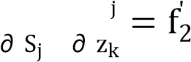
y_{j} = ∂ y_{j} ∙ ∂ S (Sj)wjk (5-15)
∂ _{zk}
第二项是隐层传递函数的偏微分：
∂ zk = f'1(Sk)  ∂ S_{k}  于是： | (5-16)
δzk = mj=1 tpj − ypj )f2'(Sj)wjkf'1(Sk)  由链定理得： | (5-17)

∂∂ vEF = ∂∂ ESF ∙ ∂∂ vSk =− δzkxi =− mj=1 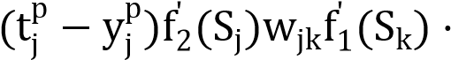 x₁ (5-18)
ki k ki 从而得到隐层各神经元的权值调整公式为：
∆vki = Pp=1 mi=1 η(tpj − ypj )f2'(Sj)wjkf'1(Sk)xi | (5-19)

5.2.2 模型结果
BP 神经网络预测模型是基于统计预报方法的空气质量预测模型，是以分析历史空气质量数据和气象条件为基础，找出内在的发展规律从而完成预测^{[9]}。相比于数值预测模型方法，该方法主要基于历史气象数据以及污染物监测浓度的规律性分析，利用气象条件预报产品开展污染物浓度预测，分析方法较为灵活多样，具有较好的适用性。 BP 神经网络预测模型结构如图 5-2 所示。
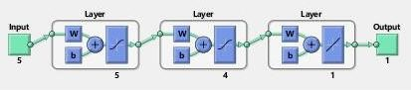
图 5-2 BP 神经网络预测模型结构
根据问题 3 的要求，需要建立一个满足两个目标的预测模型，极小化 AQI 预报值的相对误差，极大化首要污染物精确度，运用 BP 神经网络进行空气中 6 种污染物浓度进行预测,通过输入 6 种污染物浓度及温度、湿度、气压、风速、风向等实测数据，他们对应的评价量化值为 AQI，设置隐层元为 4，输出层为 1.在训练过程中不断修正神经网络，把步数设置为 10000 进行训练。BP 神经网络的学习训练算法流程图如图 5-3 所示。基于问题三的 BP 神经网络模型如图 5-4 所示。
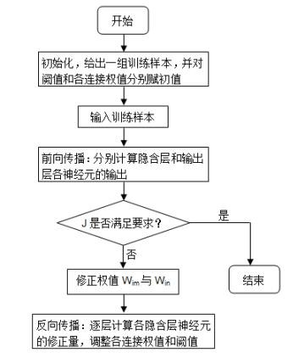
图 5-3 BP 神经网络学习训练算法流程图
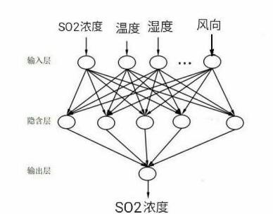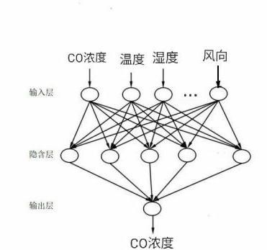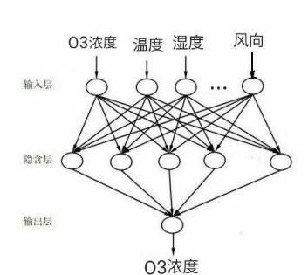
图 5-4 基于问题三的 BP 神经网络模型
借助于 Matlab 编程来实现训练神经网络，对所建立的模型进行多次测试，下面给出了选取七个月的数据对 2021 年 1 月 1 日到 2021 年月 3 日的空气中六种污染物的浓度进行预测的结果，并计算了相应的 AQI 值，与一次预报数据和实测数据进行对比分析，发现建立的二次模型的预测 AQI 值的相对误差小于且优于一次预测结果，首要污染物预测结果与实测数据吻合。训练结果如表 5-1 所示。详细数据见附件 3~5。
表 5-1 污染物的浓度预测测试结果
数据类型 | 监测时间 | 地点 | CO(mg/ m³) | SO2(μ g/m³) | NO2(μ g/m³) | O3 最大八小时滑动平均  (μg/m³) | PM10(μ g/m³) | PM2.5(μ g/m³) | AQ  I | 首要污染物
实测数据 | 2021/1/1 | 监测点 A | 0.75833  3333 | 5.9583  33333 | 33.4583  3333 | 63.5 | 41.472222  22 | 19.41666667 | 42 | NO₂
实测数据 | 2021/1/2 | 监测点 A | 0.9 | 8.8333  33333 | 56.5416  6667 | 63.0313 | 54.25 | 27.33333333 | 71 | NO₂
实测数据 | 2021/1/3 | 监测点 A | 1.27083  3333 | 11.25 | 80.9166  6667 | 59.75 | 99.791666  67 | 53.625 | 101 | NO₂
一次预测数据 | 2021/1/1 | 监测点 A | 0.25005  3083 | 11.400  92708 | 89.6932  875 | 44.9809 | 57.902516  67 | 48.6755375 | 105 | NO₂
一次预测数据 | 2021/1/2 | 监测点 A | 0.46449  2833 | 16.505  80083 | 112.752  0708 | 29.0943 | 61.907141  67 | 48.0132375 | 117 | NO₂
一次预测数据 | 2021/1/3 | 监测点 A | 0.37904  6917 | 13.844  09125 | 107.232 | 40.2365 | 71.170229  17 | 57.745025 | 114 | NO₂
二次预测数据 | 2021/1/1 | 监测点 A | 0.98594  7658 | 7.0326  58524 | 56.2410  7064 | 53.3643 | 60.746656  83 | 28.344585 | 71 | NO₂
二次预测数据 | 2021/1/2 | 监测点 A | 0.77367  7718 | 7.4838  70105 | 48.5104  9485 | 52.1166 | 53.957651  04 | 28.59299089 | 61 | NO₂
二次预测数据 | 2021/1/3 | 监测点 A | 0.82150  6546 | 10.865  27288 | 60.3280  1011 | 54.4457 | 69.719329  26 | 44.67635322 | 96 | NO₂
采用相对误差来分析模型的预测效果，相对误差的计算公式为：
相对误差=监测 AQI−预测 AQI (5-18) 监测 AQI 表 5-2 AQI 相对误差
AQI 相对误差 | 一次预测 | 二次预测
2021/1/1 | 1.5 | 0.69047619
2021/1/2 | 0.647887324 | 0.14084507
2021/1/3 | 0.128712871 | 0.04950495
从表中可以看出通过二次建模预测的空气质量指数(AQI)比一次预测所得到的数据更加接近实测的数据，因此相对误差更小，说明建立的二次模型—BP 神经网络的预测模型能够较好地实现污染物浓度的预测，BP 神经网络预测模型比 WRF-CMAQ 预测模型在污染物的预测精度上都有了明显的提高，证明 BP 神经网络预测模型比一般的 WRF-CMAQ 预测模型具有更好的性能。
输入 5 种类型影响污染物浓度的气象指标，通过训练好的神经网络进行预测监测点 A、
B、C 在 2021 年 7 月 13 日至 7 月 15 日 6 种常规污染物的单日浓度值，计算相应的 AQI 和首要污染物，结果“污染物浓度及 AQI 预测结果表”如表 5-3 所示。
表 5-3 污染物浓度及 AQI 预测结果表
预报日期 | 地点 | 二次模型日值预测
预报日期 | 地点 | SO2 (μg/m³) | NO2  (μg/m³) | PM10 (μg/m³) | PM2.5 (μg/m³) | O3 最大八小时滑动平均  (μg/m³) | CO  (mg/m³) | AQI | 首要污染物
2021/7/13 | 监测点 A | 5.1526922 | 23.122807 | 27.121428 | 10.885860 | 49.14677 | 0.4228630 | 71 | NO₂
2021/7/14 | 监测点 A | 5.0530244 | 22.85133 | 27.502836 | 10.873185 | 50.910004 | 0.4358628 | 61 | NO₂
2021/7/15 | 监测点 A | 5.1166190 | 21.855769 | 26.21298 | 10.820821 | 45.12730 | 0.4198489 | 76 | NO₂
2021/7/13 | 监测点 B | 5.8729689 | 11.324613 | 23.587731 | 7.8127631 | 51.147857 | 0.4836970 | 26 | O₃
2021/7/14 | 监测点 B | 5.8453821 | 11.556665 | 23.588575 | 7.429732 | 51.332743 | 0.4158622 | 26 | O₃
2021/7/15 | 监测点 B | 5.8383749 | 11.508974 | 23.404963 | 7.8730105 | 51.033290 | 0.4177488 | 26 | O₃
2021/7/13 | 监测点 C | 6.4421460 | 18.96087 | 27.282557 | 17.81683 | 56.397678 | 0.5776881 | 29 | O₃
2021/7/14 | 监测点 C | 6.4111316 | 18.25703 | 27.15913 | 17.081047 | 55.955754 | 0.5745183 | 28 | O₃
2021/7/15 | 监测点 C | 6.5140483 | 17.940326 | 26.907403 | 17.039779 | 58.792392 | 0.5793493 | 30 | O₃

6.问题四分析与求解

6.1问题四分析
相邻区域的污染物浓度往往具有一定的相关性，区域协同预报可能会提升空气质量预报的准确度。需要进一步考虑方位和距离对空气质量的影响。需建立监测点 A 及其临近区域内存在监测点 A1、A2、A3，四个监测点的协同预报模型，要求二次模型预测结果中 AQI 预报值的最大相对误差应尽量小，且首要污染物预测准确度尽量高，模型评价指标和问题 3 相同，故可以在问题 3 的基础上进行考虑。需要对建立的 BP 神经网络二次预测模型进行改进，用遗传算法改进 BP 神经网络，并根据点 A 和 A1、A2、A3 的方位和坐标信息，在进行训练集的选取进行改进，选取同一时间段，4 个不同监测点监测的污染物浓度和气象数据，作为训练集^{[10]}。在进行测试前需按照前面对数据的处理方式对表格数据进行预处理，将缺失值、负值和异常值进行处理，并对气压数据进行单位换算。

6.2问题四求解

6.2.1模型原理及框架
遗传算法原理遗传算法（GA）是进化计算的一部分，是模拟达尔文的遗传选择和自然淘汰的生物进化过程的计算模型，是一种通过模拟自然进化过程搜索最优解的方法。算法简单、通用、鲁棒性强，适于并行处理。遗传算法包括选择、交叉和变异三个算子。
(1)选择算子
通过选择算子模拟“优胜劣汰”，适应度高的个体被遗传到下一代的概率大，适应度低的个体，被遗传到下一代的概率低。常用的选择算子：轮盘赌选择法，假设f_{i}表示种群中第 i 个个体的适应度函数，n 是种群中个体数量， f_{i};就是群里适应度的和，产生后代的能力如式(3)所示，其中 k=1,2..。
Pi= nfki fki (6-1) i=1
(2)交叉算子
交叉算子是指对两个相互配对的染色体按某种方式相互交换其部分基因，从而形成新的个体，是遗传算法区别于其它算法的重要特征，是产生新个体的主要方法。常用的交叉方式有单点交叉、双点交叉、多点交叉、均匀交叉、算术交叉等。
(3)变异算子
遗传算法中的变异运算是指将个体染色体编码串中的某些基因座上的基因值用该基因座的其他等位基因来替换，从而形成一个新的个体。遗传算法中的变异操作是为了保持种群的多样性，防止基因丢失。
遗传算法基本步骤
(1)染色体编码。
(2)初始化种群。
(3)设计适应度函数，确定个体的环境适应能力，适应度值越高，适应能力越强，存活的几率就越大。
(4)基于适应度函数，从父代种群中选择优胜个体。
(5)根据交叉率执行交叉操作。
(6)根据变异率执行变异操作。
(7)判断是否达到终止条件，是，转向(8),否，转向(3)。
(8)结束迭代，选出适应度函数值最大的个体作为问题的最优解^{[8]}。
遗传算法的基本步骤如图 6-1 所示。
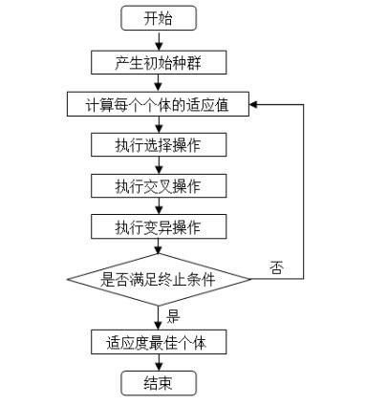
图 6-1 遗传算法基本步骤
改进遗传BP神经网络空气质量预报模型
(1)确定 BP 神经网络的结构以 A、A1、A2、A3 四监测点检测的污染物浓度和气象数据为基础，构建 BP 神经网络的结构，设计输人层、输出层变量，确定隐含层的节点数和层数。
(2)优化 BP 神经网络设计适应度函数，计算每个个体的适应度值，通过遗传算法中的选择(二进制锦标赛选择)、交叉(模拟二进制交叉)、变异(多项式变异)等相关操作，确定优胜个体，优化 BP 神经网络中每一层的权重和阙值。
基于遗传算法的 BP 神经空气质量预测模型流程图见图 6-2.
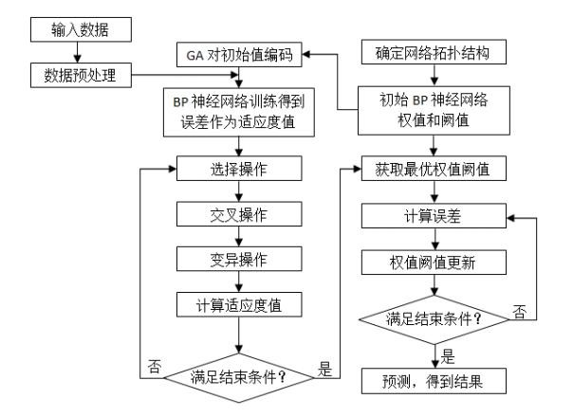
图 6-2 基于遗传算法的 BP 神经空气质量预测模型流程图

6.2.2 模型结果
使用该模型预测监测点 A、A1、A2、A3 在 2021 年 7 月 13 日到 7 月 15 日 6 种常规污染物的单日浓度值，计算相应的 AQI 和首要污染物预测结果(保留六位小数)如表 6-1 所示。
处理后的数据及预测结果详细内容见附件 6~9。
表 6-1 二次模型 AQI 和首要污染物预测结果
预报日期 | 地点 |  |  | 二次模型日值预测
预报日期 | 地点 | SO2  (μg/m  ³) | NO2  (μg/m³) | PM10 (μg/m³) | PM2.5 (μg/m³) | O3 最大八小时滑动平均  (μg/m  ³) | CO  (mg/m³) | AQI | 首要污染物
2021/7/13 | 监测点 A | 6.026498 | 12.754470 | 23.135363 | 6.526287 | 43.911091 | 0.396785 | 24 | PM10
2021/7/14 | 监测点 A | 5.981969 | 12.971135 | 21.672379 | 6.321114 | 44.094971 | 0.395751 | 23 | O3
2021/7/15 | 监测点 A | 5.880314 | 12.881624 | 21.495475 | 6.382446 | 25.802753 | 0.396683 | 22 | PM10
2021/7/13 | 监测点 A1 | 7.027309 | 15.332967 | 29.684920 | 9.177502 | 46.661877 | 0.451259 | 30 | PM10
2021/7/14 | 监测点 A1 | 7.281718 | 14.683218 | 29.130652 | 9.039957 | 46.462130 | 0.639348 | 30 | PM10
2021/7/15 | 监测点 A1 | 7.181598 | 14.934196 | 30.305947 | 9.019191 | 25.802753 | 0.961902 | 31 | PM10
2021/7/13 | 监测点 A2 | 4.850706 | 16.518653 | 27.087839 | 8.169413 | 58.828821 | 0.443849 | 71 | NO2
2021/7/14 | 监测点 A2 | 4.894688 | 16.241063 | 26.025836 | 8.814907 | 58.144192 | 0.445929 | 61 | NO2
2021/7/15 | 监测点 A2 | 4.913525 | 16.284831 | 26.080662 | 8.513877 | 25.802753 | 0.466164 | 76 | NO2
2021/7/13 | 监测点 A3 | 3.849022 | 10.188080 | 17.846609 | 6.898581 | 58.828821 | 0.307802 | 30 | O3
2021/7/14 | 监测点 A3 | 3.852278 | 10.017528 | 17.209906 | 25.802753 | 58.144192 | 0.307467 | 37 | PM2.5
2021/7/15 | 监测点 A3 | 7.344998 | 9.8094291 | 16.454645 | 11.317941 | 25.802753 | 0.308424 | 17 | NO2
与问题 3 的模型相比，新建立的 GA-BP 神经网络区域协同预报模型提升了监测点 A 的污染物浓度预报准确度，降低了空气质量指标 AQI 预测值的相对误差，预测首要污染物的精准性提高。经过测试发现优化的 GA-BP 神经网络区域协同预报模型对污染物浓度的的预测误差明显小于 BP 网络预测模型，AQI 预测值的相对误差更小，预测的首要污染物更加准确说明 GA-BP 预测模型预测精度更高。通过对两种模型的输出结果与期望输出进行分析，发现 GA-BP 模型的相关系数更高，说明优化的预测模型有更强的泛化能力。

7.结论与模型评价

7.1 结论
(1)对于问题 1，问题要求使用附件 1 中的数据，按照附录中的方法计算监测点 A 从
2020 年 8 月 25 日到 8 月 28 日每天实测的 AQI 和首要污染物，并将结果按照附录“AQI 计算结果表”的格式放在正文中。根据观察发现，需要用到的参数在 2020 年 8 月 25 日到 8 月 28 日中不存在空值缺失等问题，因此问题 1 可以直接通过附录中提供的公式求出空气质量指数(AQI)的值。
(2)利用多种数学原理和计算软件，完成了数据处理
预处理提供了所有时间跨度为 2020 年 7 月 23 日到 2021 年 7 月 13 日的一次预报数据，时间跨度为从 2019 年 4 月 16 日到 2021 年 7 月 13 日的实测数据的采集记录，同时还提供了所有气象条件的相关信息。对于提供的采集数据中存在的各种不良数据或错误数据，先后采用了相应的处理手段：对于由于设备、外界条件导致的变量值缺失为空值的异常数据作了取前后一段时间内平均的补全处理；对于变量值超出可调控最小或最大范围的数据，根据该变量的可调控范围，直接将其取为相应的最小值和最大值；对于变量值超出 3σ区间范围的数据，考虑利用 3σ准则将每个站点采集到的跳跃值数据剔除出去。
利用 k-means 聚类，根据每个气象条件对污染物浓度的影响程度，对气象条件和计算所得对应 AQI 值分别进行聚类分析，对气象条件进行划分，1.温度分成两类：高温、低温；
2.湿度分成两类：高湿、低湿；3.气压分成两类：高压、低压；4.风速分成三类：微风、轻风、软风。并讨论了每种气象条件的特征，相对应的污染物浓度的变化，空气质量指标 AQI 值的变化范围。并利用 k-means 聚类算法对处理后的数据整体进行聚类，通过选取不同的簇数进行多次聚类，采用聚类有效性指标 DB、SSE，进行聚类结果评价，选取最佳的聚类方案，最终将其分为 3 类，并对聚类结果进行可视化；另外，根据对聚类结果进行分析，阐述相应的气象特征和污染物浓度变化。
(3)建立了基于 BP 神经网络的空气质量二次预测模型。该模型，首先对 5 个主要的气象特征进行了分析筛选出 4 维特征温度、湿度、气压、风速，其次搭建 BP 神经网络模型，并搭建即时学习框架，根据时间序列，和空气质量监测的时序性，选取 7 个月的数据对未来 3 天的污染物浓度进行预测。此外，BP 神经网络预测模型结果与真实值和一次预测结果进行对比。 为保证预测模型满足两个目标，通过随机选取时间(3 天)对模型进行测试，并与一次预测结果进行比较，结果表明建立的二次预测模型优于一次预测结果。
(4)通过数据处理和对 A、A1、A2、A3 的坐标、方位、距离进行分析，为建立一个协同预测模型，在特征中加入气象特征风向，改进预测模型。

7.2 模型评价

7.2.1 模型优点
(1)设计了较为合理的方法对原始数据进行预处理，同时还考虑到监测站点设备在进行数据测量过程中会遇到各种不同条件的较为复杂的实际工况，使用 3σ准则对数据进行了处理，使原始数据更为精确。
(2)在对数据进行分析时，采用 k-means 聚类方法，对不同的气象特征进行聚类分析，并进行可视化处理，能直观的看到分类的气象特征及对应污染物浓度、空气质量指标 AQI 值的变化。在不确定聚类簇数时采用多组聚类对数据进行聚类，通过指标评价聚类效果，选取最优聚类方案。
(3)现有的空气质量预报模式受到气象(气温、湿度、气压、风速、风向等)和污染源排放的影响，对数据的分析不够深入，无法获取到数据更深层次的联系，而所采用的 BP 神经网络的方法，能通过大量的数据集进行训练，挖掘、捕捉数据直接的深层联系，提高预测结果的精准性，随着训练样本的增长，由于模型具有动态偏差修正功能，能对结果进行实时修正，模型的性能也优于一般方法。BP 神经网络，简单有效，容易实现、训练学习时间快、对基础数据时间长度要求不高。
(4)改进的 GA-BP 神经网络协同预报模型，能更精确的预测污染物浓度、首要污染物、
AQI 预测值的相对误差也更小。改进后的 GA-BP 神经网络区域协同预报模型，使得网络收敛速度、预测精度、拟合度以及泛化能力都有所加强。

7.2.2 模型缺点
(1)本文中空气质量预报模型及优化方案是基于 BP 神经网络的空气质量预测模型预测性能有待提高，为之后利用机器学习和深度学习模型进行预测提供了一定的理论基础。同时 BP 神经网络中参数的初始化也是一个问题，网络层数和每层的神经节点个数都需要不断的尝试来确定最优值，网络隐含层神经元数据选择和连接权重初值选取没有理论依据，凭借经验，全局最优收敛没法保证，复杂函数容易落入局部最优解，此外模型的性能对与训练集的要求较高，在进行空气质量预测时，要选取合适的空气质量数据，从而能使得 AQI 预测值的相对误差小，首要污染物的预测精准度高。
(2)建立多种模型相互结合的预测模型。加入影响因子(权重)，包括风速、湿度和降水等因素，挖掘空气质量特征、天气特征、天气预报特征、历史突变相关特征以及外部数据
(空间点、污染源清单、文本图像数据)特征，从时间和空间维度提高模型的预测精度。
(3)因遗传算法在初始化种群时采用的是随机初始化种群，有可能陷入局部最优，可以改进初始种群方案；可以改进遗传算子，交叉、变异，在循环过程中可以通过改进遗传算子保留父代种群中的优良解。能加快算法收敛速度。
(4)继续优化空气质量预测模型。针对短时与长时的空气质量预测，训练与测试相对应的预测模型，达到不仅能准确预测未来一天内的短时间空气质量，更能预测未来长达七天甚至更长时间的空气质量的目的，同时能保证预测精度维持在较高的水平。此外，还可以针对重大的节日活动训练出特定的预测模型，达到特定时间段预测精度提升的效果。对于模型参数的初始化问题，可以针对这些参数再建立一个初始值模型，发掘不同预测场景下初始值之间的内在关联，从而达到预测效果最优化的目的。
(5)建立空气质量与污染源排放之间的深层次关联。针对污染源排放污染物对空气质量具有负面影响这一问题，可以利用深度学习模型，对输入的气象数据、空气质量指数以及污染源排放量、排放地点等参数进行深层次分析，在保证空气质量的前提下，得出可以接受的污染物排放数量，从而将排放量控制在合理范围内，为政府部门进行科学决策提供参考。

参考文献
[1]伯鑫等，空气质量模型(SMOKE、WRF、CMAQ 等)操作指南及案例研究[M].北京:中国环境出版集团,2019.
[2]赵秋月,李荔,李慧鹏.国内外近地面臭氧污染研究进展[J].环境科技,31(05):72-76,2018.
[3]陈敏东.大气臭氧污染形成机制及研究进展[J/0L].https://max.book118.com/html/2018/0201
/151478594.shtm.2018.
[4] 陶莹 , 杨锋 , 刘洋 , 戴兵 .K 均值聚类算法的研究与优化 [J]. 计算机技术与发展,28(06):90-92,2018.
[5]王晓彦,刘冰,李健军,丁俊男,汪巍,赵熠琳,鲁宁,许荣,朱媛媛,高愈霄,李国刚.区域环境空气质量预报的一般方法和基本原则[J].中国环境监测,31(01):134-138,2015.
[6]郝吉明,马广大,王书肖.大气污染控制工程[M].北京:高等教育出版社,2010.
[7]戴树桂.环境化学[M].北京:高等教育出版社,1997.
[8]宋鹏程,张馨文,黄强,龙平,杜云松.我国城市环境空气质量预报主要模型及应用[J].四川环境,38(03):70-76,2019.
[9]宋宇辰,甄莎.BP 神经网络和时间序列模型在包头市空气质量预测中的应用[J].干旱区资源与环境,27(07):65-70,2013.
[10]牛玉霞.基于遗传算法和BP神经网络的空气质量预测模型研究[J].软件,38(12):49-53,201
7.

