|  |  |
| --- | --- |
| For office use only | |
| T1 |  |
| T2 |  |
| T3 |  |
| T4 |  |

|  |
| --- |
| Team Control Number  **1916375** |
| Problem Chosen  **F** |

|  |  |
| --- | --- |
| For office use only | |
| F1 |  |
| F2 |  |
| F3 |  |
| F4 |  |

### 2019 ICM Summary Sheet

**未来已来：货币革命**

随着信息时代的到来，数字技术应用，如数字货币，已经变得普遍并广泛应用于全球。我们的研究构建了一个模型来代表全球去中心化的数字金融系统，主要使用数学分析和经济模型的工具。在我们的模型基础上，我们分析了不同国家的货币选择及其长期效应。此外，我们还提出了对这种全球数字货币的监管机制，并测试了我们模型的鲁棒性。

首先，我们选择了可能限制或促进数字金融系统的关键因素，并将这些因素整合到收益和成本中。然后，我们建立了成本-收益分析模型，以识别全球去中心化数字金融市场的可行性，这些模型在我们的假设下被简化和合理化。我们通过将层次分析法（AHP）与模糊综合评价法（FCE）相结合，量化了收益和成本。根据这些因素的重要性，我们赋予不同的权重来量化总净收入（NI）。同时，我们还根据这些因素对个人、国家和全球的影响，赋予不同的权重，以量化不同层次的净收入。

其次，我们根据不同国家的意愿和需求分析了不同国家的选择。我们将不同国家简化为小型国家和大型国家，然后参考蒙代尔-弗莱明开放经济理论进行分析并得出结论。此外，我们还考虑了一个国家是否会放弃其本国货币。在这一部分，我们将“不可能三角”引入模型，从而得出结论：如果国家放弃本国货币，那么固定汇率制度可能是最有效的。

第三，我们结合模型分析与现实情况，提出了全球数字货币系统的监管机制。

第四，我们将模型扩展到长期。我们使用逻辑斯蒂模型来模拟银行业前景的变化。从长期来看，银行业几乎会失去所有的表内业务，这意味着它可能转变为一个投资中介。我们将成本-收益模型转化，用以分析该系统在地方、区域和全球三个层面的影响。此外，我们还从国际关系的角度，审视了长期内国家之间的互动。

最后，我们测试了模型的稳定性和敏感性，接下来是什么？我们总结了模型的优点和缺点。此外，我们根据我们的研究成果，为国家领导人撰写了政策建议。

**关注数学模型**

**2**

**MATHmodels**

政策建议

**尊敬的总统/总理：**

**感谢您对我们的信任。我们的团队在国际货币委员会（ICM）的支持下设计了一个全球数字货币系统。我们猜测您对我们构建的系统可能有不同的看法。因此，我们有责任向您推荐最佳策略，以确保数字货币系统在贵国的成功运作。**

**根据我们对成本-收益模型的分析，就自由资本流动和全球金融市场的自由接入而言，新货币系统对于国家和人民而言，具有最大的权重。然而，它也带来了更大的风险成本，因为货币政策的独立性受到影响。存在大量成本，且净收入函数受到国民生产总值和货币流通速度的影响，随着数字货币接受度的提高，这些成本会增加。我们发现了一些有趣的现象，即在该系统中，国家随着接受度的提高，在长期内获得最大边际收益，而个人的边际收益可能会下降，这提醒我们需要更加关注安全的维护。以下是我们的建议：**

**拥有固定汇率**

**在长期内，接受新的数字货币系统对大经济体和小经济体都是可取的。在我们的设计中，放弃或维持主权货币在数字货币系统中都是可行的。如果贵国放弃主权货币，这意味着放弃主权货币政策。根据不可能三角理论，这意味着贵国的汇率将固定；如果贵国维持主权货币，则浮动利率将带来不可持续的高通胀风险。因此，我们建议贵国实施固定汇率，以确保通胀风险可控。**

**建立监管节点并完善法律**

**数字货币金融系统将全球的个人和机构连接成一个网络，具有不可篡改和去中心化的优势，因此我们建议贵国可以与其他国家合作，建立全球监管节点，以便发现犯罪行为并促进税收。此外，法律支持与技术支持同样重要。**

**保持良好的国际关系**

**在我们的系统中，各国之间的交流与融合将以前所未有的规模发展。过去被许多人视为零和博弈的情况将不再合理，只有贵国保持与其他国家的良好国际关系，才能最大化数字货币全球化带来的利益。**

**我们的模型的稳健性**

**我们的模型基于一些假设，这些假设可能与贵国的实际情况有所不同。贵国及其团队可以根据现实情况制定更具体的操作策略。**

**我们希望我们的建议对贵国有所帮助，且数字货币系统将成为未来全球发展的理想蓝图。**

**此致敬礼**

Team # 1916375

# Content

1. INTRODUCTION *3*
   1. Background 3
   2. Restatement of the Problem 3
2. Assumptions and Variable Descriptions *4*
   1. Assumptions 4
   2. Terms, Definitions and Symbols 5
3. BASIC MODEL ANALYSIS *6*
   1. Measure of the Return about Currency Stability𝑅1 6
      1. Model of Currency Value *6*
      2. Measure of the Return about the Currency StabilityR1 *6*
   2. Measure of the Return about the Output Growth𝑅2 7
   3. Measure of the Return of Capital Availability𝑅3 8
      1. Short-term Model *8*
      2. Long-term Model *8*
   4. Total Model of Return 9
   5. Total Model of Cost 10
   6. Total Evaluation Model 11
4. Choices of Different Countries *12*
   1. Different Choices because of size 12
      1. Large Countries *12*
      2. Small Countries *13*
   2. Give Up National Currency or Not 14
      1. Give Up National Currency *14*
      2. Not Give Up National Currency *14*
5. Imagination of the Regulatory Mechanism *16*
   1. the Global Level 16
   2. the National Level 16
   3. the Individual Level 17
   4. Conclusion 17
6. Dynamic Analysis *17*
   1. Long-term Impact on the Banking Industry 18
   2. Long-term Impact on Different Regions 19
   3. Long-term Impact on International Relationship… 20
7. Model Testing *21*
8. Strengths and Weaknesses *21*
9. Reference *22*

# 引入

## 背景

*“所需的是一个基于密码学证明的电子支付系统，而不是依赖信任，使任何两个愿意的方可以直接进行交易，而无需可信的第三方。”*

*—— 中本聪，比特币的创造者和开发者，摘自他的论文*

正如中本聪所说，随着经济全球化的发展，现有的支付系统和货币体系越来越难以满足人们对生产和贸易的需求。人们对由政府控制的货币感到厌烦，不再愿意承受通货膨胀和汇率波动的成本。基于区块链等技术的数字货币是解决这一问题的良好途径。

加密货币是数字货币的一个子集，具有隐私性、去中心化、安全性和加密性等独特特征。以比特币为代表的加密货币越来越受到经济学家和银行家的青睐。加密货币的发展和应用已成为金融研究的前沿课题。

在南美的委内瑞拉，政府错误的货币政策给公众带来了极其严重的恶性通货膨胀，人民开始持有比特币以避免通货膨胀的影响，保护自己的财产免受侵蚀。随着时间的推移，人们对数字货币的热情逐渐从私人领域转向官方领域，最近备受关注的央行数字货币就是一个极好的证明。

## 问题陈述

为了帮助识别全球去中心化数字金融市场的可行性和影响，我们需要构建一个能够充分代表这种金融系统的模型。接着，我们旨在解决以下问题：

任务 1：识别可能限制或促进全球去中心化数字金融市场在个人、国家和全球层面上的增长、准入、安全性和稳定性的关键因素。

任务 2：考虑各国的不同需求以及它们在多大程度上愿意与这个新的金融市场进行合作。

任务 3：修改现有的银行和货币模型，并考虑它们是否应当放弃本国货币。

任务 4：建立对全球数字货币的监管机制。

任务 5：扩展我们的分析，考虑这种系统对当前银行业、地方、区域和全球经济以及国际关系的长期影响。

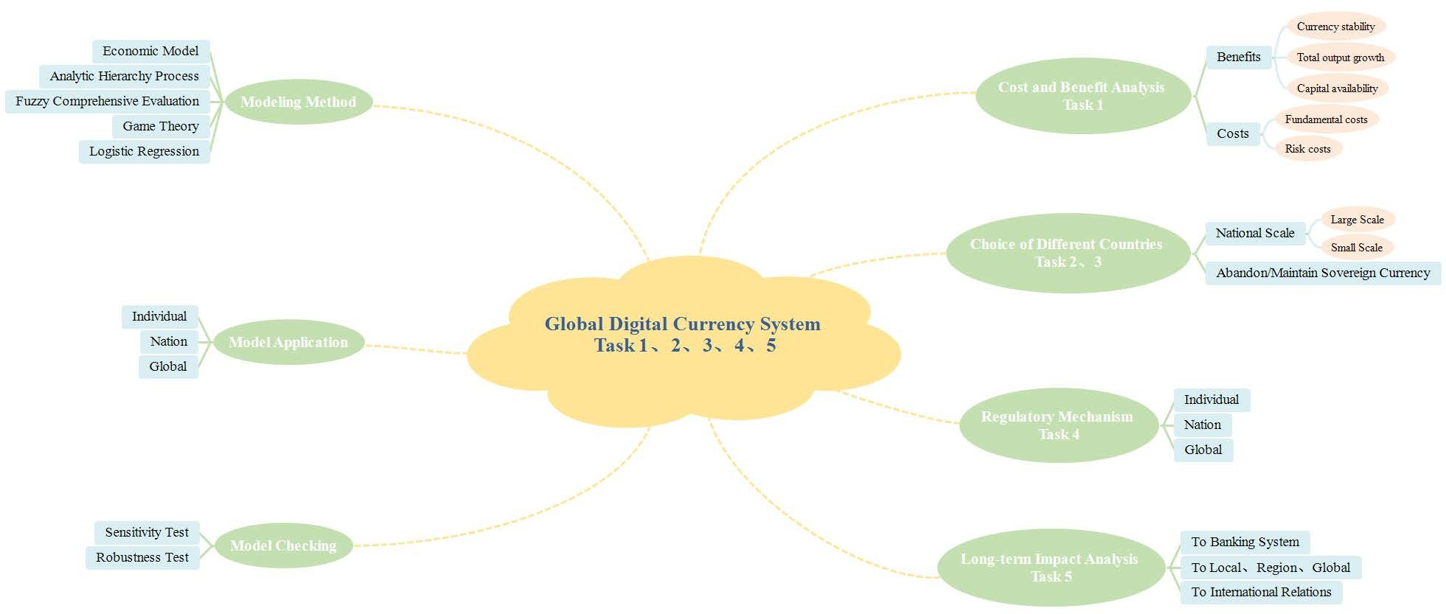

图一：我们的工作总览

**2 假设与变量描述**

**2.1 假设**

### 为了简化问题，我们做出以下基本假设。我们的每个假设都有其合理性，并且与基本事实一致。

### 数字货币的总数是固定的

### 由于编程节点是确定的，因此数字货币的总数也是固定的，也就是说，数字货币的数量是有限的。

### 大多数国家将数字货币作为法定货币

### 存在像全球中央银行这样的国际组织来管理全球数字金融系统

### 一个公共组织是必要的，以建立公众信任。货币系统首先是一个社会约定，它的产生是为了在经济交易中建立陌生人之间的信任。我们使用博弈论来分析这个过程，如图2所示。只有当交易者确信现在使用的符号性物品将在未来被其他交易者接受时，这种信任机制才能得以维持。

### 一个公共组织是必要的，以监督全球数字金融系统

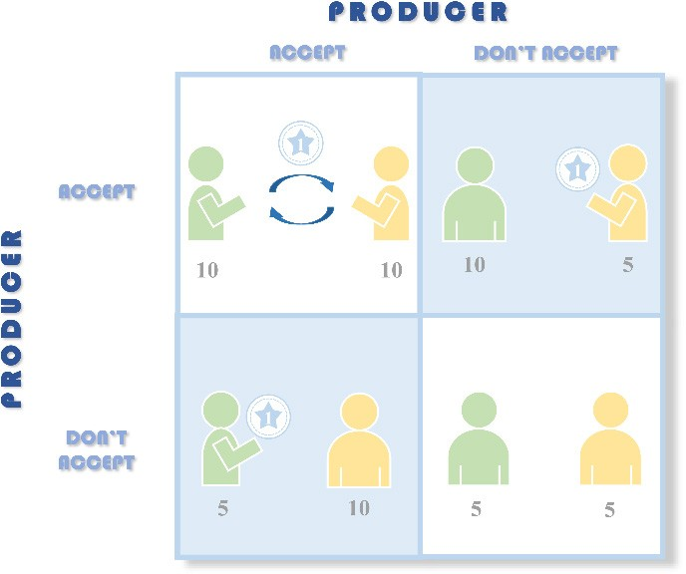



只有当现有货币系统得到人们的信任时，才能达到纳什均衡，而中央银行作为引导公众信任的存在是必要的。

图2：关于中央银行必要性的博弈论分析

* **市场环境完全开放，元素可以自由流动。**

**2.1 术语、定义和符号**

|  |  |  |  |  |
| --- | --- | --- | --- | --- |
| ***Variable*** | ***Meaning*** | | |  |
| *V* | 货币交易速度 | | | |
| ** 0 | 基本商品篮子的价值 | | |  |
| ** | 货币的购买力，指的是单位货币中所包含的商品篮子内容 | | | |
| *S* (*w*,** ) | 货币稳定性的回报 | | |  |
| *w* | 数字货币的接受程度 | | | |
| ** | 数字货币体系下资本使用效率 | | |  |
| *K* * | 全球数字货币使用后资本使用效率的提高 | | | |
| *😐* | 全球数字货币使用前的资本使用效率 | | |  |
| *L* | 劳动投入 | | | |
| *RT* | 我们的数字货币系统的总回报 | | |  |
| *R*i | 货币稳定性、产出增长和资本可得性的回报 | | | |
| *C*f | 数字货币系统的隐性成本 | | |  |
| *Cr* | 系统风险导致的成本 | | | |
| *NI* | 数字货币系统的净收入 | | |  |
| *P* r0 | 银行业在初始时刻的利润 | **2** | **关注数学模型获取更多资讯** | |
|  | |  |

# 基本模型分析

## 货币稳定性的回报度量 *R*1

我们的假设假定数字货币的总数量是固定的，但货币需求不断增加。最终，系统中必然会出现通货紧缩。我们尝试根据生产力水平来设定货币的价值，以确定通货紧缩的程度。最后，我们希望利用货币稳定性来衡量数字货币系统的回报。

### 货币价值模型

首先，我们尝试使用货币经济学中的交换方程来定义每个数字货币的价值。

*MV*  *PT*

因此, *PT表示名义支出的水平，M被视为固定参数。价格指数与货币价值是互为倒数的，我们定义了一个新的参数 * 0

** 0  *P* **

(1)

(2)

* ** 0 -基本商品篮子的价值
* ** -货币（货币的购买力，即单位货币中包含的一篮子商品的内容）

通过简单计算，将方程（1）和方程（2）结合，我们可以得到方程（3）。

**  ** 0  *T*

(3)

*M V*

国家生产总值（GDP）由三个部分组成：一年内生产的商品和服务。如果Y代表国民收入（GDP），那么这三部分的用途：消费、投资和政府采购可以表示为：

*Y*  *C*(*Y*  *T* )  *I* (*r*)  *G*

(4)

* *Y* -国民总收入或产出 *C*(*Y* -*T* ) -可

支配收入 *T* - 固定的税, *I* (*r*) -投资， *G* -政府固定购买金

  ** 0 / *M* *Y*

**



 *V* (*t*)

*dI*  0

*dr*

(5)

*Y*  *C*(*Y*  *T* )  *I* (*V* )  *G*

**关注数学模型**

**2**

**MATHmodels**



可以看出，一种货币的价值 ** 仅与 *r* , *Y* 和*V* (*t*) 有关. 它随着货币的增长而增加，随着货币加速贬值而减少，这与实际的金融操作环境是一致的。因此，维持货币价值的稳定有助于保持全球货币体系的稳定

### 货币稳定性的回报度量 *R*1

我们定义一个新的函数（6）来衡量货币稳定性的回报*R*1 如下图所示

*S* (*w*,** )  (1

* t*  * t* 1

* t* 1

) • *w*

(6)

* *S* (*w*,** ) -货币稳定性的回报
* *w* - 数字货币的接受度程度

## 产出增长的回报度量 *R*2

我们认为，随着数字货币的使用，国际结算的便利性将促进国际资本流动的加速。我们引入一个新函数

*Y* (*Vt* , *w*) 来衡量输出的增长 *R*2

现在我们定义一个函数，用于描述新系统下资本的自由流通率

**  *f* (*Vt* )

*d dVt*

 0,**  1

(7)

* ** -数字货币体系下的资本使用效率

显然的，我们用 *😐* 来表示真实的使用效率 *K* *

*K* *  *😐*

(8)

* *K* * - 全球数字货币使用之前的资本使用效率
* *😐* -全球数字货币使用后，资本使用效率提高

我们试图引入**科布-道格拉斯**生产函数来描述资本流动效率对产出的影响。

*Y*  *F* (*K* , *L*)  *AK  L*

(**  **  1 , **  0,1  **  0 )

(9)

* *Y* -**总生产**（指一年或365.25天内生产的所有商品的实际价值）
* *K* -资本投入
* *L* -劳动力投入
* *A* -**全要素生产力**

通过将公式（8）和公式（9）结合起来，可以很容易地得到如下的公式（10）。

*Y* *  *F* (* K* , *L*)  *A*(* K* )* L*

(10)

*Y*\*  * Y*

**  1,**  0

(11)

**关注数学模型**

**2**

**MATHmodels**

*Y* *  *Y 规模报酬递增*

0

* ** -资本在产出价值中的份额

**关注数学模型**

**2**

**MATHmodels**

* ** -劳动在产值中的份额

公式 (11) 表明，资本在全球范围内的自由流动导致了总产出的增加

## 资本可得性回报的度量 *R*3

在全球数字货币体系下，支付方式必须发生重大变化。我们将其有利影响视为资本的可得性。在全球数字货币体系中，资本成本将波动在一个合理的范围内，我们将讨论长期和短期的情况。我们希望使用经济供需模型来展示我们的分析。

### Short-term Model

在任何区域市场中，如果利率 *r* 比均衡利率*r*\* 大，该地区将吸引来自其他地区的资本流入，导致该地区的资本供应超过资本需求，从而导致当地的利率下降。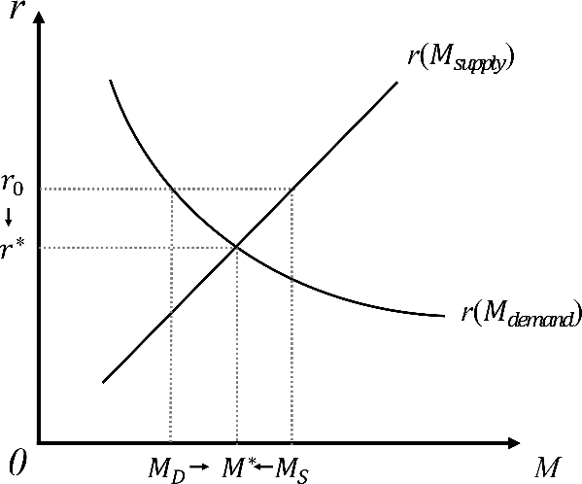

0

图 3:短期利率分析

### 长期模型

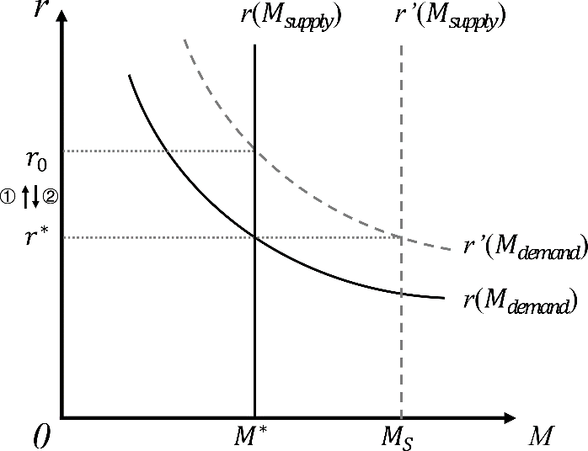由于数字货币的总量是固定的，随着资本需求的持续上升，利率可能会上升。在此情况下，中央银行可以通过政策调控来改变货币流通速度。

图 4:长期利率分析

现在我们将公式（5）的一部分更新为公式（12）。

**  ** 0 / *M* *Y*

(12)

When

*V* (*t* )

减,

* i* 增*i V* (*t*)

公式（5）如下所示:

*P*  ** 0 * i*

(13)

*M*  *L*(*r*,*Y* ) *P*

(14)

*M* 与 *r成反比* ,和 *Y成正比*

*P*

中央银行可以通过货币政策调整将货币供应量从 $M$ 调整为 $M^{*}$，使得 $r_{0}$  下降到均衡水平 $r$ 。

总之，在全球数字货币系统下，资本价格受一个相对稳定的 $r^{*}$ 影响 , 而 $r^{*}$ 在基准利率附近波动

## Total Model of Return

基于第 4.1 节到第 4.3 节的分析，我们的数字货币系统的总回报可以表示为公式（15）。

*RT*  *R*1  *R*2  *R*3

(15)

* *RT* -我们数字货币系统的总回报
* *R*1 - 货币稳定回报
* *R*2 - 产出增长回报
* *R*3 – 资本可得性回报

然后，我们认为数字货币系统的总回报也可以分为三个部分，包括个人回报、国家回报和全球回报。它们可以表示为公式（16）

*RT*  **1*Rindividual*  **2 *Rnation*  **3 *Rglobal*

(16)

el**关**s:**注**th**数**e **学模型**

e  ~~di~~ffere**2**nt lev

**MATHmodels**

* *Rindividual* – 个人回报
* *Rnation* – 国家回报
* *Rglobal* – 全球回报

我们引入模糊评价法（FEC）来评估来自个人、国家和全球的风险因素。接下来是单因素系数矩阵。

Table 1: the membership of factors *Rindividual* , *Rnation* ,

*Rglobal*

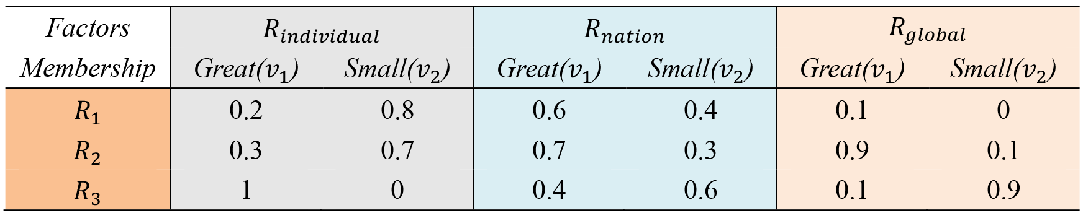

 0.2 0.8 

 0.6 0.4 

 1 0 

*R*   0.3 0.7  ， *R*   0.7 0.3 ， *R*

  0.9 0.1

(17)

*individual*   *nation*  

*global*  

 1 0 

 0.4 0.6 

 0.1 0.9 

     

*A*  (*R*1, *R*2 , *R*3 )  0.45 0.32 0.2

*A* • *Rindividual*  (0.395 0.605)

*A* • *Rnation*

|  |  |  |
| --- | --- | --- |
|  (0.595 | 0.405) | (20) |
|  (0.785 | 0.215) | (21) |

*A* • *Rglobal*

According to the principle of maximum membership degree, we can get the following results.

*RT*  0.395*Rindividual*  0.595*Rnation*  0.785*Rglobal*

(18)

(19)

(22)

## Total Model of Cost

Considering the possible cost of the global digital currency system, we break down the whole cost into two

parts: fundamental cost *C*f

and risk cost

*Cr* .In this model, we also try to use the ***Fuzzy Evaluation***

***Method(FCE)*** for quantitative analysis like the total model of return.

* *C*f - The hidden costs of the digital currency system, including digital currency acquisition (mining) cost, the invisible external cost of maintaining the operation of the system, etc.
* *Cr* -Including uncontrollable nature due to Internet technology, impaired independence and malicious manipulation
  + *a*1 -the Uncontrollable Internet, like personal accounts may be offended by theft, data leakage and system failure caused by technical failure of government or international organization systems
  + *a*2 -Impaired independence. The state has lost the independence of monetary policy to some extent.

In the face of asymmetric shocks, individual countries cannot impel independent and effective monetary policies for macroeconomic regulation and controlling like before. Digital currency

integration will also accelerate the transmission of global financial risks

**2 关注数学模型**

* + *a*3 - Malicious manipulation.

Based on the above considerations, we consider the risks at the individual, the national and the global level

respectively, they are

*Cr* , *Cr* and *Cr* .Through easy analysis, we could empower these indicators as follows:

1 2 3

Table 2: the member ship of factors

*C* , *C* , *C*

1 2 3

*r*

*r*

*r*

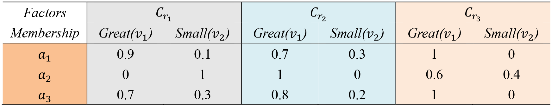

 0.9 0.1

 0.7 0.3

 1 0 

*C* = 0 1

 , *C* =1 0

 , *C* =  0.6 0.4  , *A*=*a a a* 

*r*1  

 0.7 0.3

 

*r*2  

 0.8 0.2 

 

*r*3  

 

1 0

 

1 2 3

*Si*  *Cr* • *A*

*j*

(23)

*S*1  *A* • *Cr S*2  *A* • *Cr S*3  *A* • *Cr*

1

2

3

 0.59 0.41

 0.81 0.19

 0.88 0.12

According to the principle of maximum membership degree, we can get the following results.

*C*  *Cf*  0.59*Cr*  0.81*Cr*  0.88*Cr*

(24)

1 2 3

## Total Evaluation Model

Based on the total model of return and the total model of cost we did above, in order to identify the viability of the global decentralized digital financial market, we can define some new weights according to the importance for different levels: the individuals, the nations and the global. To evaluate the net income and determine the feasibility of our digital currency system.

*n n n*

*NI*   *Rk*  (*Cf*  *iCrj* )

(25)

*k* 1

*i*1

*j* 1

We use the AHP method, then get the weight of *R*1 , *R*2 , *R*3 , *a*1 , *a*2 , *a*3

**关注数学模型**

**2**

to NI as follow:

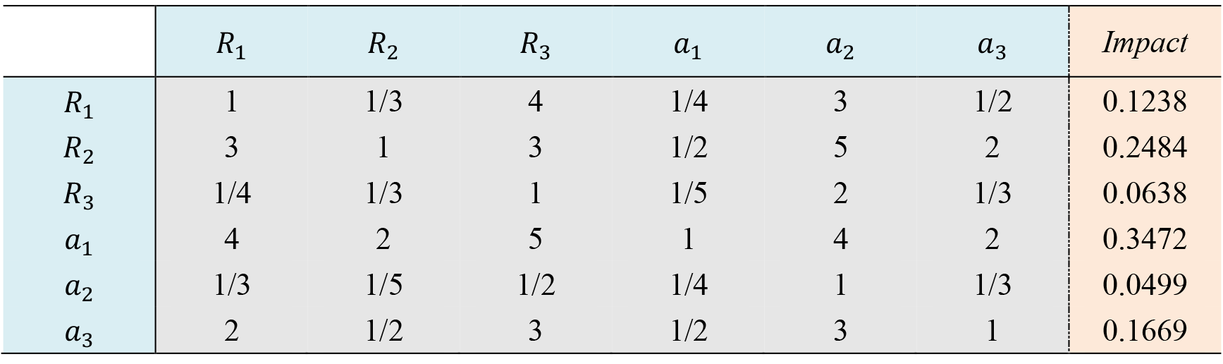Table 3: AHP Weight and Impact

*NIindividual*  0.395[0.1238*S* (*Y* , *w*)  0.2484*Y* (*Vt* , *w*)  0.0638*M* (*r*, *w*)]  *Cf*  0.59  0.3472*Cr* (*w*) *NInation*  0.595[(0.1238*S* (*Y* , *w*)  0.2484*Y* (*Vt* , *w*)  0.0638*M* (*r*, *w*)]  *Cf*  0.81 0.0499*Cr* (*w*) *NIglobal*  0.785[0.1238*S* (*Y* , *w*)  0.2484*Y* (*Vt* , *w*)  0.0638*M* (*r*, *w*)]  *Cf*  0.88 0.1699*Cr* (*w*)

1

2

3

*NI* -net income of the digital currency system

# Choices of Different Countries

## Different Choices because of size

### Assumptions:

* **We divide the country into large countries and small countries according to the size of the economy**.
  + **large countries:** the volume of an economy that accounts for a considerable proportion of the world economy and can influence the world market, leading the formation of world market interest

rates *r*\*

* + **small countries:** a small part of the open world market, so its impact on world interest rates is

negligible. Small countries can only become the recipients of world interest rates *r*\*

Different countries have different monetary transmission mechanisms, but they all have same demand for new digital monetary financial systems, such as stability and economic growth. Recalling that:

*Y*  *C*(*Y*  *T* )  *I* (*r*)  *G*  *NX*

(26)

*NX*  *Y*  *C*(*Y*  *T* )  *G*  *I* (*r*) (27)

*Y*  *C*(*Y*  *T* )  *G*  *S* (28)

### Large Countries

*NX*  *S*  *I* (*r*)

(29)

(30)

**关注数学模型**

(31)

**2**

**MATHmodels**

*NX*  *CF* (*r*)

*S*  *I* (*r*)  *CF* (*r*)

In large countries, the interest rates are determined internally, the loanable capital is determined by the function of domestic and foreign investment on interest rates. They can be displayed as follow:

* *S* - Loanable funds

*T* )  *I* (*r*)  *G*+*CF*（*r*)

(32)

* *CF* (*r*) - Net capital outflow

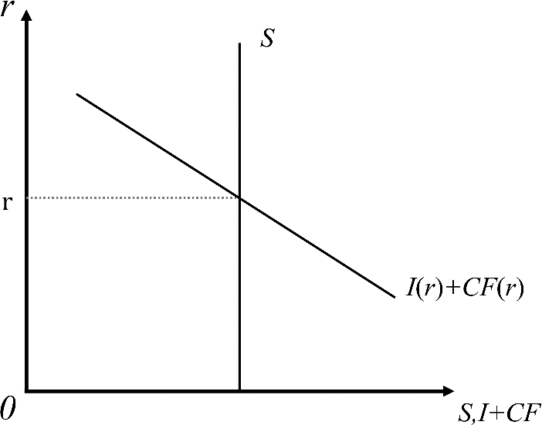

Figure 6: the analysis for large countries about their choices

Both *I* and *CF* are negatively affected by *r* When *r* rises, *Y* will fall faster, and the increase in elasticity will cause *r* not to rise excessively, then *Y* will not fall too much, eventually *r* will reach a desirable balanced level.

For large countries, under the digital monetary financial system, interest rate stability and economic growth will be guaranteed, also their demand of capital will be met.

### Small Countries

*NX=S - I*(*r*) (33)

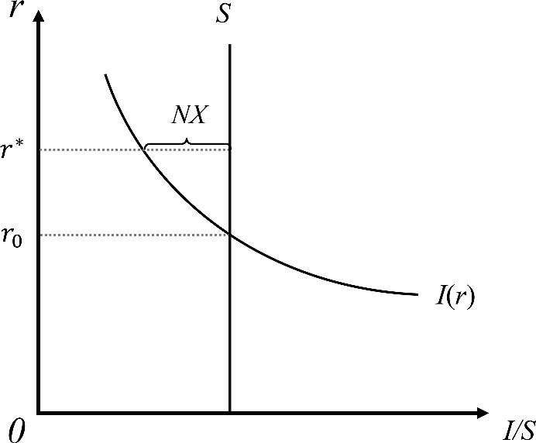

Figure 7: the analysis for small countries about their choices

When

*S*  *I* (*r*) ,then

*S*  *I* (*r*)  *NX*  0 , excess loanable capitals will flow abroad,

outcome for the people of the country, This is a desirable outcome for the people of t



which is**2**  ~~a de~~

**MATHmodels**

~~he cou~~ntry.

si**关**ra**注**bl**数**e **学模型获取更多资讯**

When *S*  *I* (*r*) , the country’s loanable funds will all be internally consumed, which is also desirable for the public.

In general, in small countries, the digital currency financial system makes interest rates relatively stable, the economy grows, and demand will be met.

## Give Up National Currency or Not

### Assumptions:

* **There is only a small number of countries do not give up their original national currency , the country A is one of them, we assume that the exchange rate between the country’s currency and**

### the global currency is *i*

* **In the long term, employment is sufficient and the amount of capital is fixed**

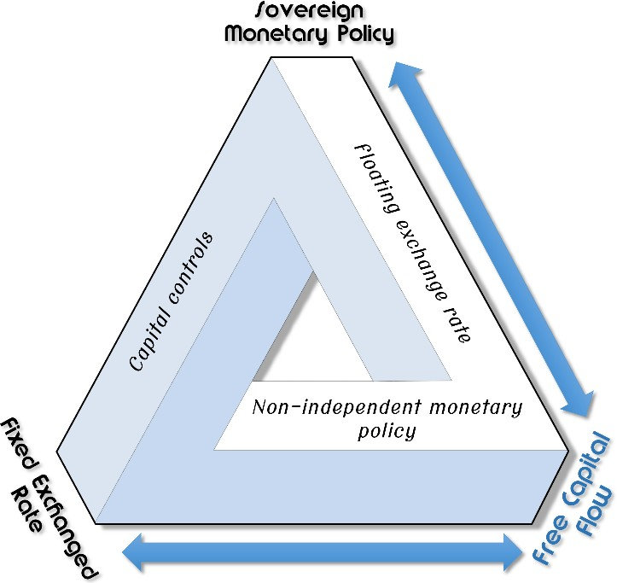We are trying to introduce the ***Impossible Trinity Theory*** to analyze the choices of different countries under the digital currency system. As we all know, it is impossible for a country to complete the following three aims at the same time: *Capital Mobility*, *Fixed Exchange Rate* and *Independent Monetary Policy*. It is clear that the flow of the capital is free and the monetary policy is not independent in our digital currency system.

Figure 5: ***Impossible Trinity Theory***

### Give Up National Currency

For countries who choose to abandon their national currency to become one part of the global digital currency system, their monetary policy is not independent, they keep a fixed exchange rate with digital currency .When trading with countries who use national currency, they use a basket of commodity values as exchange rate

### Not Give Up National Currency Floating Exchange Rate



**关注数学模型获取更多资讯**

ll decr**M**e**ATHm**a**ode**s**ls** ~~e.~~

**2**

When *r* decreases, following is the increase of *CF* ,and *NX* equals to *CF* ,so ** wi

**关注数学模型**

**2**

**MATHmodels**

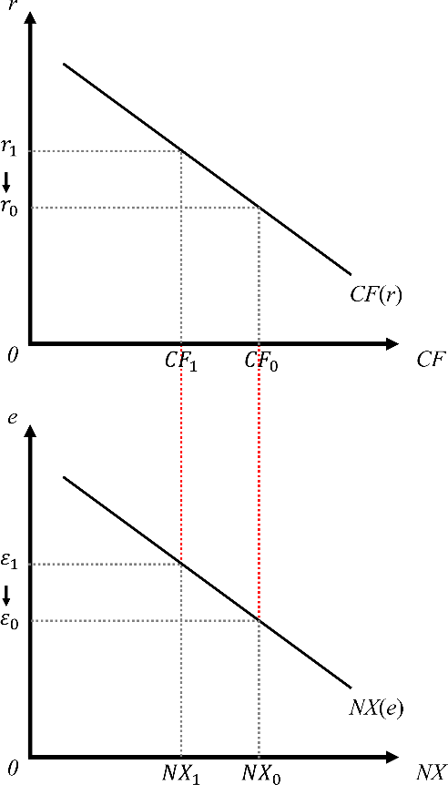

Figure 8: model of floating exchange rate

* *NX* -Net exports
* *CF* -Net capital outflow
* ** -Exchange rate

In the short term, *NX* will increase, and *Y* also increase, then ** keep falling, finally the price of goods will rise

### Fixed Exchange Rate

In this situation, monetary policy, trade, and global central bank regulation just have limited impact and its impact is close to invalid.

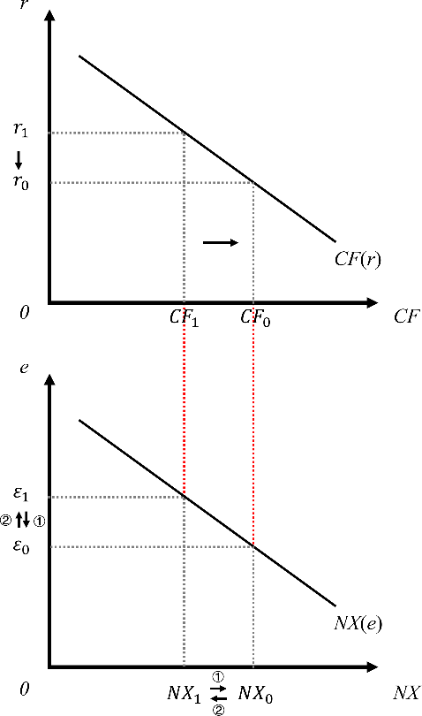

dering

es**关**s**注**til**数**l **学模型**

ancial

~~ng mo~~ne~~y, laun~~

privileged nod

**2**

onetar**MA**y**THmode**a**ls** nd fin

Since the central bank of country *A* use the regulation to achieve the fixed exchange rate, it will cover the impact from imports and exports, the *Y* level will not change. However, there are only two general ways for the central bank to regulate the exchange rate, namely ***foreign exchange reserves*** and ***pegged exchange rates***. Due to the limitation of foreign exchange savings under the digital currency system, the influence of the regulation by foreign exchange savings will be close to valid. Therefore, the nation like *A* country only can choose to peg the exchange rate as the only method to fix the exchange rate, so that it can stabilize the price level at a lower cost and avoid the problem caused by currency instability.

# Imagination of the Regulatory Mechanism

In the global digital and monetary financial system we design, generalized, decentralized, and electronic are its biggest features, which is the biggest difference from the current legal currency system. This fundamental difference has also triggered our thinking about regulation.

The current sovereign state monetary system is endorsed by national credit, and the currency is issued and regulated by central banks. All the Countries belong to the system naturally have a variety of regulatory measures to detect and observe the circulation and increase of money. In the global digital financial system, central banks are no longer the main body of electronic money issuance. The basic technical characteristics of electronic money bring people the natural trust, and the country's credit endorsement is no longer useful.

At this point, the current regulatory system will no longer apply in the future. We have design a digital currency regulatory framework to ensure that this technological innovation will not become a cradle of crime. Our digital currency regulatory framework will be developed at the global, national and individual levels.

## the Global Level

The first is the global level. In the future global digital and monetary financial system, the account system under the global central bank management makes everyone a node in the digital currency financial system, and its principle is similar to the node concept in Blockchain Technology. Unlike existing blockchain technology applications (such as Bitcoin), our system will have a God node that is a global central bank. The God node will have much higher authority than other individuals or institutional nodes. This node does not belong to any country, and it is shared by global sovereign states but operated and managed by an international organization similar to the United Nations. Its function is mainly to coordinate regulatory investigations and data analysis of transnational crimes. In order to ensure the super node is not abused, there must be a public international law to comprehensively manage its authority and management.

## the National Level

The second is the national level. In the global digital and monetary financial system we design, the national regulatory authorities will also have their own secondary super nodes, whose rights and functions are similar to those of global super nodes, but the scope of authority is limited to the domestic market economy participants and their citizens. From this perspective, in order to ensure the effectiveness of national governance and the timeliness of crime prevention, the sub-super nodes of the national regulatory authorities will have the authority to penetrate the entire node in the national digital currency network, which can effectively track and interfere with illegal trading behaviors such as tracki

activities and freezing illegal digital currency assets. At this level, the removal of requires legal protection as an aid to maintain the rational operation of the digital m

## the Individual Level

Finally, it is the personal level. In the system we designed, taxes and other things that are usually related with the efficiencies of the system will become more affordable and effective. This is because global and institutional accounts are connected in a network, and tax evasion will be easier to be detected by regulatory authorities. In addition, the bookkeeping characteristics of the digital currency will enable individuals to read historical transaction records within the scope of authority, then track better , to protect personal property, and supervise the capital flow procedures of relevant government departments.

## Conclusion

In general, in our global digital financial system, as long as the relevant digital currency regulatory framework is implemented, it can ensure that there is no shortage of supervision at the individual, national and global levels. The technical framework and related laws we design will shape a transparent and efficient world. The flow of assets and data will all be difficult to escape from our supervision. And the efficiencies of the financial system is even better

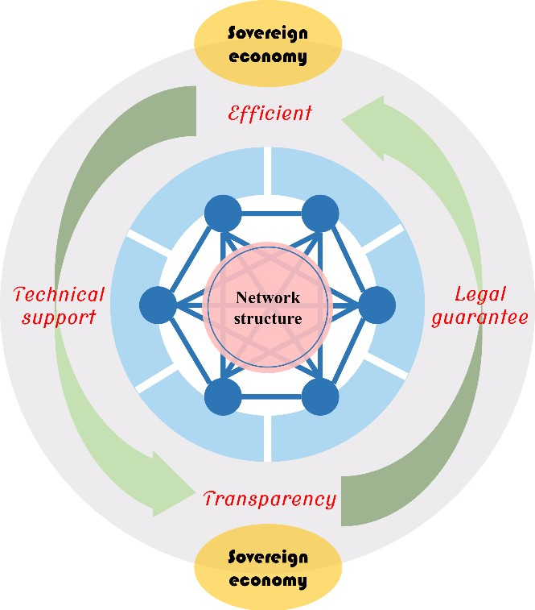

Figure 10: imagination of regulatory system

# Dynamic Analysis

## Long-term Impact on the Banking Industry

In this section, we want to consider the long-term impact of such systems on the current banking industry; local, regional and world economies; and international relations with the international community

### Assumptions：

* **before the promotion of the digital currency market ,the profit of the In-table business of**

### banking industry grows at a fixed rate

*g*0 **of growth**

*P* r  *P* r0 (1 *g*0

) , *dPt*  *g*

*dt* 0

, Pr(0)  Pr0

(34)

* *P* r0 - the rate of return to the banking industry at the initial moment, assuming it grows at a

fixed rate *g* of growth

### after the promotion of the digital currency market, the profit of the In-table business of

**banking industry grows at a changing rate**

*g*(*w*)

### of growth

with the promotion of the digital currency market ，the importance of the bank's on premise business will become smaller and smaller until the bank is transformed into an investment

intermediary, and

*g*(*w*)

decreased as *w* increases

*d* Pr  *g*(*w*) • Pr , Pr(0)  Pr

(35)

*dt* 0

### in the long term, when

*w*  *wm* **, the bank in-table business income will no longer expand**

### Analysis

Based on the above assumptions, we can define that

*g*(*w*)  *g*-*mw* ( *g*  0, *m*  *wm* ), *m* is a fixed number,

2

and then we define

*m*  *g wm*

*g*(*w*)  *g*  *g* • *w*

*wm*

(36)

*d* Pr  Pr• *g*  *g* Pr• *w*

(37)

*dt wm*

*d* Pr  Pr• *g*(1 *w* )

(38)

*dt wm*

Then, we try to use programming to simulate this formulation.

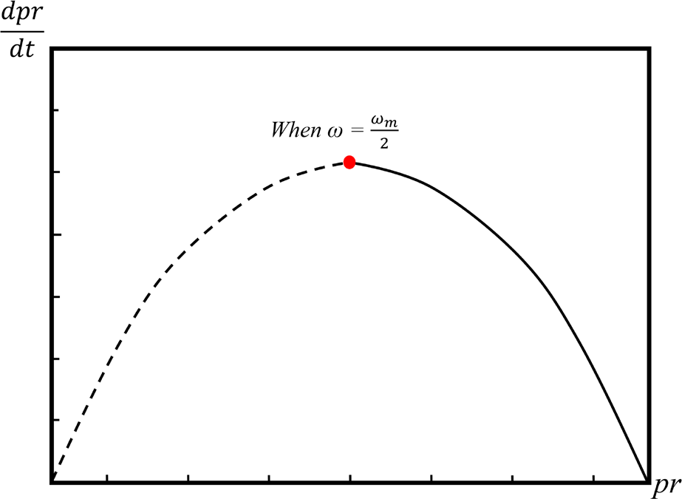 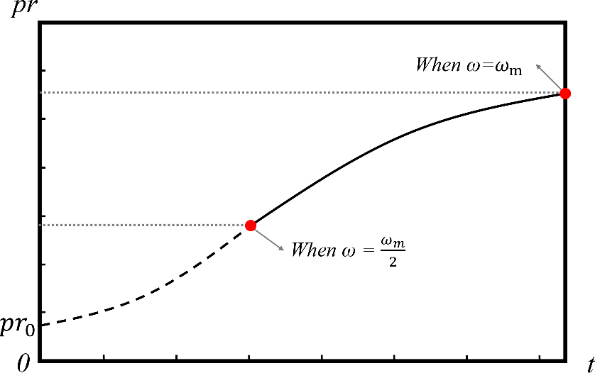

Figure 11: long-term impact on banking system

From the figure and the formulation, In the long run, the growth rate of the bank's business will drop to zero, and the bank will transform itself as an investment intermediary

## Long-term Impact on Different Regions

To simplify the analysis, we consider the long-term impact of the local *Elocal* as the average of the sum of the effects of all individuals in the local. By the same token, we consider the long-term impact of the region *Ereligion* as the average of the sum of the effects of all countries within the hierarchy

*n*

 *NIindividual*

*E*  *i*1 , *E*

*n*

 *NInation*

 *i*1

(39)

*local n religion n*

In the digital currency system, we can draw from the previous analysis that

*r*  *r*\* ,and they are close to

benchmark interest rate level *r*0 , According to the production function:

*Y*  *F* (*L*, *K* )

In the long term, we can conclude that

*L*  *L* , *K*  *K* , *Y*  *Y*

It is easy to know that *vt*

and *w* are positively correlated。So when we consider the extent of *w* , we can

assume lim *w*  *w*

*m*

*t* 

in the long run

Through partial derivative of *w* in

matrix

*NIindividual* , *NInation* and

*NIglobal*

,we get the following coefficient

*NIindividual*

 0.048901 *S*  0.073661 *Y*  0.97183 *M*  0.20484 *C*r

(40)

*w* *w* *w* *w* *w*



**关**(4**注**1**数**) **学模型获取更多资讯**

1

*NInation*

 0.073661 *S*  0.147798 *Y*  0.037961 *M*  0.040419 *C*r **2**

*w* *w* *w* *w*

2

*w* **MATHmodels**

*NIglobal*

 0.097183 *S*  0.194994 *Y*  0.050083 *M*  0.149512 *C*r

(42)

*w* *w* *w* *w* *w*

3

The coefficient matrix is as follows:

|  |  |  |  |
| --- | --- | --- | --- |
| 0.03263 0.048901  0.219001  0.073661 | 0.098118  0.147798 | 0.25201  0.037961 | 0.204848  0.040419   |
| ⬇0.192748✗ ⬇0.097183 | 0.194994 | 0.050083 | 0.149512✗ |

⬇  ⬇

(43)

Our explanations are as follow：

* In the long run, with the increase of *w* , the marginal benefit obtained by the national level in the global digital monetary system is the largest, and from the perspective of the global and nation, the profitability brought by the international monetary system accounts for the largest share of marginal revenue. Our model is in line with the actual situation
* From the perspective of risk cost, the national level has less risk than the global and individual levels, because the country's main risk cost is the potential risk of impaired monetary policy independence. In the long run, countries can reduce this effect through regional cooperation.
* It is worth noting that the personal level of income has the smallest marginal benefit in the whole system and shows a small diminishing effect. Combined with the analysis of the reality, it is not difficult to find that the main utility of digital money to individuals, such as the availability of funds and the convenience of more flexible payment methods, tend to be short-term effects, while the risk that the digital currency system brings to individuals is a Long-term existence.

Under our hypothesis, contacting with the impact on local, we can think that the marginal benefits brought by digital currency to the local in the long run are negligible, and we should consider more from the perspective of improving security to reduce the risk

## Long-term Impact on International Relationship

With the continuous development of the global digital currency system, political relations will also change. Especially the international relations between countries. Based on the existing geopolitics, there are roughly three parties of study on the relationship between countries, ***realism***, ***liberalism*** and ***constructivism***. The realism views the problem from the perspective of Hobbesian zero-sum and it is valued by many countries. Its basic view is that the world is always in conflicts of states. What is beneficial to one entity is inevitably harmful to another entity, and there is no intermediate zone. There may be some opportunities for cooperation (for example, alliances such as NATO), but such cooperation is often short-lived and has a strong focus. John Mearsheimer, a professor at the University of Chicago, believes that in an anarchic world of countries without hierarchy between people, they are constantly looking for opportunities to gain power over competitors because they must rely solely on themselves for security. This is undoubtedly a pessimistic view, but it is of great inspiration to us.

In the digital currency system we design, countries around the world will be better connected together through super-sovereign digital currencies, and all economic individuals in the world will become nodes exist in the global digital money network. Economic networking will not only promote economic exchanges, but also make political, cultural, diplomatic, military, and educational exchanges more frequently. As mentioned above, many countries still retain a rooted and zero-sum game in the future, and this kind of thinking will be strongly impacted in the digital currency world.



**关注数学模型**

ked in

ty**获**a**取**nd**更多资讯**

tage th**MATH**a**mode**t**ls** is ~~la~~c

~~kind o~~f identi

**2**

The digital currency system based on the encryption system has a significant advan the geopolitical theory, which is the common sense of identity and purpose. This

common goal is based on the technical framework and legal guarantee, it beyond the trust of sovereignty. Because of this influence, international relations will continue to develop towards integration and cooperation. The confrontation between countries will be reduced. This is also in line with the tend of the current world economy. In the mainstream trend of politics, conflicts between countries will be reduced. At the same time, digital currency’s advantages on anti-terrorist economic activities, anti-money laundering, anti-corruption are also expected to solve global sensitive issues, such as terrorist activities and ethnic separatist movements, which will also reduce regional friction and promote the international relations between countries.

# Model Testing

We construct a model that represents global decentralized digital currency system. Our model based on a reasonable assumption and characteristics of the digital currency system, also combined with objective facts and economic principles, such as the impossible triangle theory. Since we don't rely on certain data in the process of building models, when the data changes, our results can be transformed into new results corresponding to reality. Regardless of we add some data into the model or remove some data out, the results of the model will not have large fluctuations, indicating that our model has good stability and weak sensitivity.

We quantify the influencing factors of the income and cost in the global digital money system using the comprehensive fuzzy evaluation method (CFE) and the analytic hierarchy process (AHP). In the Consideration of the tools we take have strong subjectivity in the determination of weights, so we analyze the dynamic analysis in the analytic hierarchy. According to the results of computer test, we can find out that the function expression is more accurate when the factor w is increased.

Based on the above stability and sensitivity analysis, our model is robust

# Strengths and Weaknesses

* Strengths
* We apply scientific methods in approximating our model parameters like ***Fuzzy Comprehensive Evaluation Method (FCE)*** and ***Analytic Hierarchy Process (AHP)***.
* Our model of the global digital currency system takes various factors into account.
* We build our model based on reliable economic theory and link with realistic feature of digital currency
* According to the characteristics of variables in economics, we consider different situations in the long and short term.
* We have put forward our own ideas on the regulatory mechanism of this system.
* We extend our model to the long run and analyze the impact from different levels and perspectives.
* Weaknesses
* The value setting in pairwise-comparison criteria matrix of ***AHP*** is a little subjective.
* In the analysis of different countries, we have a rough classification of country types.
* We build up assumptions and simplify the reality while establishing our model, but these simplifications may leave some errors.
* Some models are only theoretical inferences and lack of data to test.

# Reference

1. Paul Krugman. O Canada: A neglected nation gets its Nobel [J]. Slate, Oct 19, 1999.
2. Stephanie Lo and J. Christina Wang, Bitcoin as Money? [J]. Current Policy Perspectives, 2014.
3. Satoshi Nakamoto. Bitcoin: A Peer-to-Peer Electronic Cash System [J/OL]. [www.bitcoin.org,](http://www.bitcoin.org/) 2008.
4. N. Gregory Mankiw. Macroeconomics, Ninth Edition [M]. New York: Worth Publishers, 2016.
5. Michael Bordo and Andrew Levin. Central Bank Digital Currency and the Future of Monetary Policy [J]. Economic Journal, 2017.
6. Paul A. Samuelson. An Exact Consumption-Loan Model of Interest with or without the Social Contrivance of Money [J]. The Journal of Political Economy, Vol. 66, No. 6, 1958.
7. Aleksi Grym. The great illusion of digital currencies [J]. BoF Economics Review, 2019.
8. N. Gregory Mankiw. Principles of Economics, Seventh Edition [M]. Bei Jing: Peking University, 2015.
9. Sun Ni, Wang Wei. Research on the Impact of Central Bank's Issue of Digital Money on Commercial Banks [J]. Times Finance, 2017(06): 100+104.
10. Wen Xinxiang, Zhang Bei. The Impact of Digital Money on Monetary Policy [J]. China Finance, 2016(17): 24-26.
11. Ming Haoyi, Zhu Yingying, Zhang Lei. The Impact of Internet Finance on Traditional Commercial Banks and Its Countermeasures [J]. Southwest Finance, 2014(11): 59-62.
12. Huang Tao. Analysis of International Risk Sharing Mechanism of Monetary Integration in East Asia: Based on the Expansion of the Second Generation Optimal Currency Area Theory [J]. Studies of International Finance, 2009(09): 87-96.
13. Yue Hua, Lou Dang. Game Analysis of Monetary Integration in East Asia [J]. Finance and Economics, 2005(06): 146-151.
14. Xie Ping, Shi Wuguang. Research on Digital Encrypted Money: A Literature Review [J]. Journal of Financial Research, 2015(01): 1-15.