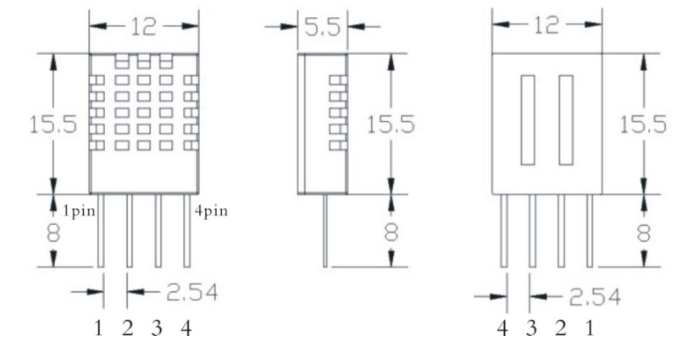

5⃪Product parameters

Relative humidity

Resolution: 16Bit

Repeatability: ±1% RH

Accuracy: At 25․ ±5% RH

Interchangeability: fully interchangeable

Response time: 1 / e (63%) of 25․ 6s

1m / s air 6s

Hysteresis: <± 0.3% RH

Long-term stability: <± 0.5% RH / yr in

Temperature

Resolution: 16Bit

Repeatability: ±0.2․

Range: At 25․ ±2․

Response time: 1 / e (63%) 10S

Electrical Characteristics

Power supply: DC 3.5～5.5V

Supply Current: measurement 0.3mA standby 60μ A

Sampling period: more than 2 seconds

Pin Description

1, the VDD power supply 3.5～5.5V DC

2 DATA serial data, a single bus

3, NC, empty pin

4, GND ground, the negative power