**Planning and Managing Groundwater Source in the Jordan River Basin based on Reliability Analysis**

**Hessam Tavakol-Davani, Seungyub Lee, Yonas Tsegay**

**0. Introduction of Project**

This project is part of class project for Water Resources Engineering, University of Utah. Each group will choose a stakeholder in the Jordan River basin, identify the objective, and propose metrics to quantify achievement towards that objective. Water Evaluation and Planning (WEAP) model is used to evaluate the proposed solution against the metric(s) defined for the stakeholder. All the products will published as GitHub repository.

**1. Stakeholder**

**1.1 Salt Lake City Department of Public Utilities (SLCDPU)**

Salt Lake City Department of Public Utilities is committed to serving our customers and protecting our environment by delivering high-quality drinking water, managing flood control and storm water, collecting and treating wastewater to standards that exceed EPA regulations, and maintaining and enhancing public street lighting. They actively protect their source waters and promote its efficient use. Established in 1876, the Utility is the oldest retail water provider in the West.

**1.2 Missions of Stakeholder**

1. Delivering high quality of drinking water
2. Managing flood control and storm water
3. Collecting and treating wastewater to standards that exceed EPA regulations
4. Maintaining and enhancing public street lighting

**1.3 Service Area**

The Utility provides culinary water to over 345,000 residential customers, and serves nearly 92,000 connections within Salt Lake City, Cottonwood Heights, Holladay, Millcreek Township, and portions of Murray, Midvale, and south Salt Lake, a service area of 195 square miles (Figure 1). Included in our customer base are an international airport, two universities, numerous hospitals, public schools, and over 1400 acres of irrigated public parks and golf courses.

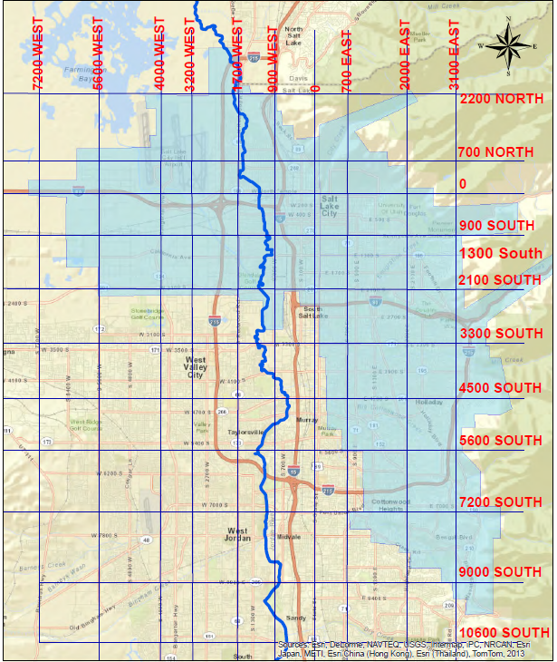

Fig 1. Schematic of Service Area of SLCDPU

**1.4 Water Sources**

55% of water used in SLCDPU service area comes from river system. Table 1 shows the capacity of each existing water source within the service area. Major river sources are little cottonwood, Big Cottonwood, Parlyes Creek, and City creek. Also two big reservoir Little Dell and Mountain Dell are used as water source. Last major water source is groundwater.

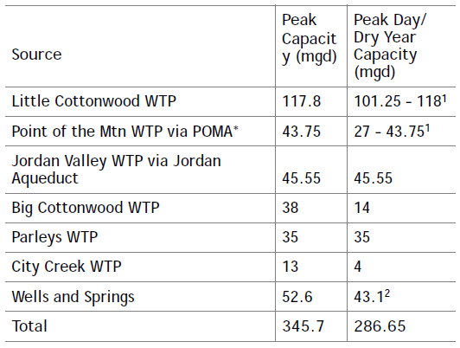Table 1. Existing Source Capacities for Public Utilities Service Area

SLCDPU plans to develop some new source to meet the growing future demands. First, the Utility has planned for the development of additional wells at various locations throughout its system. The City estimates development of current City rights could yield up to 12,000 acre-ft additional ground water; Second, additional surface water development – A potential new surface water supply the Utility is exploring is construction of treatment facilities to treat water from Mill Creek Canyon or from other surface water sources. Estimated production from new surface water sources is 3,300 acre-ft during dry years and 3,967 acre-ft during average water years; Third, wastewater reuse – The Utility is actively pursuing opportunities for wastewater reuse. Probable reuse opportunities currently being studied include irrigation of two large golf courses and a park area near the Utility’s wastewater treatment plant. Initial plans for wastewater reuse would produce approximately 5,000 acre-ft annually and would begin deliveries in 2015; and Finally, Utah Lake System Water – The Utility has petitioned Central Utah Water Conservancy District (CUWCD) through MWDSLS for Central Utah Project (CUP) water in the planned Utah Lake System (ULS). The total volume of water MWDSLS has petitioned for is 8,600 acre-ft, to be divided between Salt Lake City and Sandy. For this analysis, it has been estimated that the Utility’s portion of this water will be 4,750 acre-ft. Table 2 summarizes the plans for each water sources.

Table 2. Projected Dry Year Production for Public Utilities Service Area 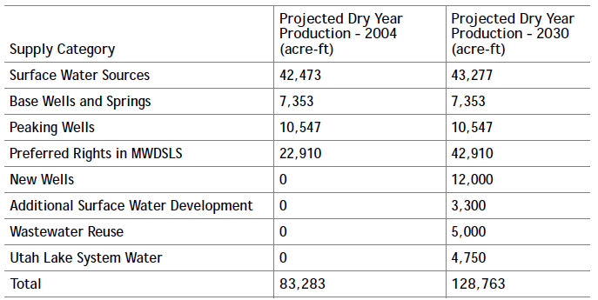Existing and Future Sources

Following six options are recommendations for water resources from SLCDPU.

1. Additional Water Supply –Salt Lake City will need additional dry year water supply to meet projected demands. It is recommended that the Utility continue to pursue opportunities to develop new water. This will likely need to include the development of additional ground water and surface water supplies, ULS water, and wastewater reuse.
2. Source Reliability – The development of additional supply as described above will be adequate to meet long term needs only if all sources are available and operating at capacity. To account for the potential loss of a source, it is recommended that the Utility consider securing additional sources or work to improve the reliability of its existing sources. Related to this, but not addressed in the conclusions of the Major Conveyance Study, is the need to continue source protection, especially in critical watershed areas.
3. System Production Capacity – It is estimated that the ultimate peak day demand in the City will be approximately 40 mgd greater than its current production capacity. If 5 mgd of additional capacity is developed through new surface water sources, it is recommended that an additional 35 mgd be developed through new ground water or other sources.
4. Timing of Supply Development – It is recommended that the Utility continue to monitor annual demands to optimize the timing of new source development. Variations in development patterns in the northwest quadrant of the City or other areas could delay the need for additional supply.
5. Conservation – All of the conclusions contained in this report are based on Salt Lake City successfully reaching its long-term conservation goal of a 25 percent reduction in per capita water use by the year 2050 using the year 2000 as the baseline. It is recommended that Salt Lake City continue to actively promote conservation to achieve this goal.
6. Global Climate Change – The Utility currently uses a number of surface water sources whose yields are highly dependent on snow pack. If changes in global climate result in reduced snow pack, yields from sources could be significantly diminished. The results of this report are based on historic water yields. If global climate change or other factors permanently lower the yield of existing sources, the Utility will need to develop additional storage or other water resources to meet the shortfall.

**1.5 Current Problem**

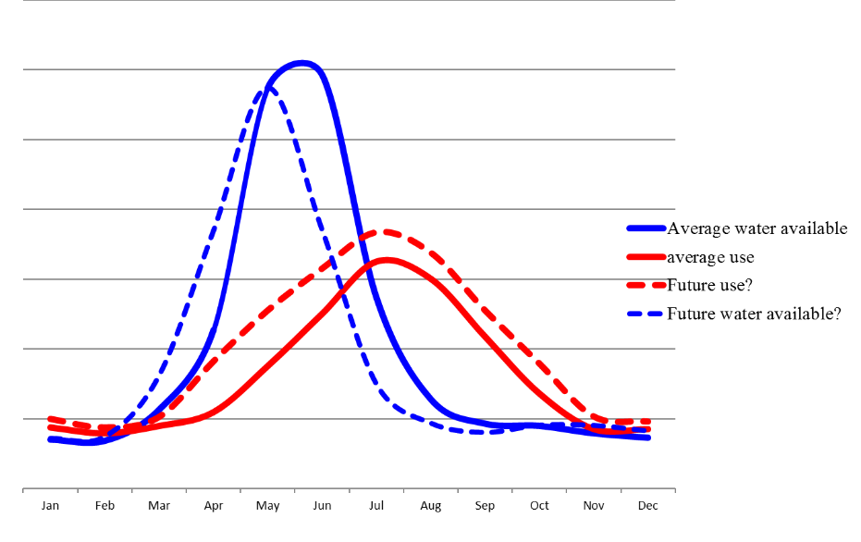Fig. 2 Schematic of future demand and water availability trend.

Climate change and population growth is a huge concern in Utah and SLCDPU as well. X% amount of water is supplied from snow pack. Climate change shift precipitation trend to rain from snow. Also increase the average or minimum temperature which leads rapid and earlier melt of snow pack. While climate change decreases water availability, population growth increases the water demand. So there are needs of the increasing water supply as well as decreasing demand. More water source and the conservancy strategies are considers as the solution.

**1.6 Object of stakeholder**

Look for additional water source to meet demand or reduce demand by water conservation strategies. Water conservation planning and implementation are critical strategies employed by Public Utilities to sustain our water supply in light of an ever increasing population, increasing demand, and changes in short and long-term supply levels due to weather fluctuations and climate change. In many cases, water conservation measures are the least expensive actions to extend a water supply, and they may also be implemented more quickly than changes to the water infrastructure. But unlike traditional supply-side strategies, successful water conservation depends on the participation and dedication of the community that uses the water. It is only with your partnership that we will accomplish what we set out to do: ensure a continued supply of high quality drinking water and a meaningful quality of life now and for the future.

**2. Description of Project**

Currently SLCDPU has the WEAP model which can simulate the future demand based on river and reservoir as source for the service area. Existing WEAP model is shown in figure 3.

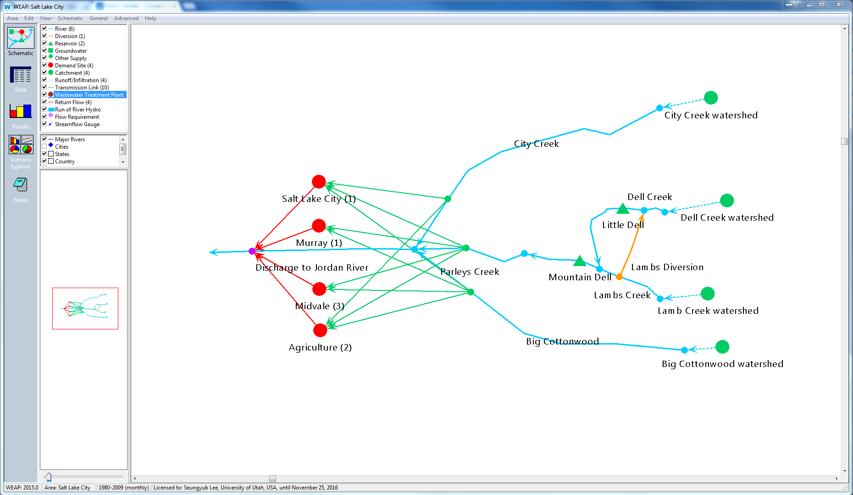

Fig 3. Schematic of existing WEAP model

Although river and reservoir includes most of water source in the service area, groundwater source still takes a considerable portion of the whole water source. So work here will modify existing WEAP model by adding groundwater source and evaluate more realistic results from modified model. In addition, as SLCDPU considers new wells for future water source and also looking for best timing, capacity as well as best timing for each groundwater source will be simulated using developed model. The best timing will be seek by using reliability of the system.

Current model uses rainfall-runoff and precipitation data are achieved based on climate change factor. All the aforementioned issues are related to supply part. For the better estimation on demand part, additional analysis on demand projection will be considered by various data. Following paragraphs are describing in more details about this project.

**2.1 Quantitative Metric(s)**

For the quantitative metric, we are considering to use reliability. This will show how the system works for the decreased or increased water supply and population (or demand).

**2.2 The proposed management alternative**

*2.2.2 Supply side*

1. Increase the capacity of reservoirs (more costly)
2. Investment in natural resources stewardship

*2.2.1 Demand Side*

1. Conservation 25-30 % in outdoor use, which consists 50% water use
2. Better Land use planning
3. Changing the prices (Will have issues because some levels (specific group) will hurt more)

**2.3 WEAP ("Water Evaluation And Planning" system)**

WEAP is a user-friendly software tool that takes an integrated approach to water resources planning. Operating on the basic principle of water balance accounting, WEAP is applicable to municipal and agricultural systems, single subbasins or complex river systems. Moreover, WEAP can address a wide range of issues, e.g., sectoral demand analyses, water conservation, water rights and allocation priorities, groundwater and streamflow simulations, reservoir operations, hydropower generation and energy demands, pollution tracking, ecosystem requirements, and project benefit-cost analyses.

Also WEAP itself can do reliability analysis. Reliability in WEAP is the percent of the timesteps in which a (demand site’s demand/flow requirement’s demand/reservoir’s hydropower energy demand) was fully satisfied. For example, if a demand site has unmet demands in 6 months out of a 10-year scenario, the reliability would be (10*12-6)/(10*12)=95% (WEAP User Guide)

**3. Major findings to date and future steps**

3/10: Additional data collection

3/22: Review on our project and decide best pathway for our project based on peer review

3/29: Work on demand projection

4/5: Finish adding groundwater source into WEAP

4/12: Finalize WEAP model with demand projection and adding groundwater and simulate impacts of new wells; scripting will be included using optimization

4/19: Revise WEAP model, suggest best timing, and work on paperwork

4/26: Prepare final presentation