Group Project: A large part of the course work will involve a semester-long group project. Groups of up to 3 students will choose a stakeholder in the Jordan River basin. Each group will gather background history and information on the stakeholder, identify a current management- or infrastructure-related problem the stakeholder is facing, identify the objective the stakeholder is working to meet, and propose one or more metrics to quantify achievement towards that objective. Along the way, groups will perform an institutional analysis, collect data, propose a structural or non-structural management alternative or solution to the problem the stakeholder is facing, and use (or expand) the existing Water Evaluation and Planning (WEAP) model for the Jordan River system to evaluate the proposed solution against the metric(s) defined for the stakeholder the group is representing. Groups will also identify tradeoffs between the quantitative metric for the stakeholder the group represents and metrics defined by other groups for other basin stakeholders. Group project work will comprise the following components:

1. Topic: a paragraph describing stakeholder, group members, and problem(s) to be explored (not graded).

2. Progress report: Submitted in the form of a Github repository that summarizes:

a. stakeholder’s type(s) of water uses, current problem(s), stakeholder objectives, and results of an institutional analysis,

b. available data on stakeholder water demands in the basin,

c. quantitative metric(s) to be used to evaluate the extent to which a management alternative meets the stakeholder’s objective(s),

d. the proposed management alternative, and

e. major findings to date and future steps (for the remainder of the semester).

Presenting work in this format will help facilitate communication among group members and make group work and results available to the rest of the class, future classes, and others. See the River Basin Planning Class Wiki for Dr. Rosenberg’s class for examples of prior work.

3. Peer review: provide feedback to another group on their progress report. Identify ways they can improve their study and the write-up of their work.

4. Demo of modeling work: A first oral presentation that will overview the stakeholder under study and how objectives and performance metrics for the stakeholder are implemented in the model. A secondary goal is educating audience members on how to use the model to generate results for the stakeholder.

5. Final webpage: Final report that continues and expands upon progress report to describe the proposed management alternative, model results, tradeoffs among quantitative metrics and stakeholder objectives, management recommendations, and major findings. The final webpage must include electronic copies of mode input data, modeling files, and results so that the reader can replicate the work done. The final webpage must synthesize all the work done on the project for the semester.

6. Final oral presentation: Overviews work for the semester and highlights select, key results and findings.

Salt Lake Public Utilities

**Delivering high quality of drinking water**

**Managing flood control and storm water**

Collecting and treating wastewater to standards that exceed EPA regulations

Maintaining and enhancing public street lighting

water supply resources: (55% comes from this)

1. little cottonwood
2. Big Cottonwood
3. Parlyes
4. City creek

Several pressure zones, they use gravitational forces, which are enough.

>90000 connections

Problems/challenges:

Climate change→ Precipitation change/ET increase/ Snow pac decrease/time of runoff changes

population growth, increase in demand

Aged infrastructure

Coordination with other water agencies

That Figure: water shortage in late June, Jul, Aug, Sep, Oct

More intense drought periods

Solutions:

Conservation 25-30 % in outdoor use, which consists 50% water use

Increase the capacity of reservoirs (more costly)

good Land use planning

Investment in natural resources stewardship

Changing the prices (Will have issues because some levels (specific group) will hurt more)

WEAP

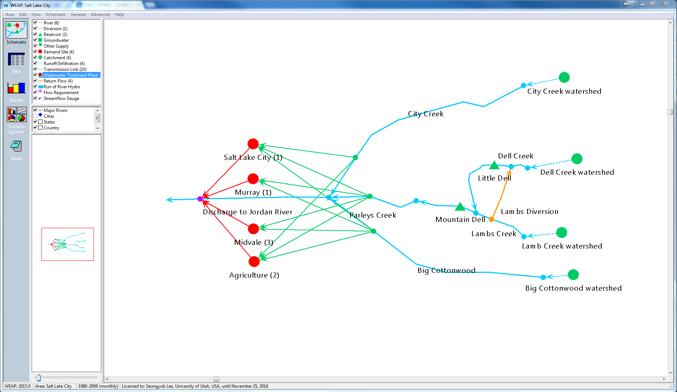

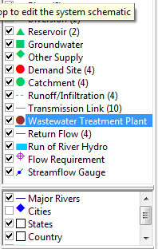

Capabilities

Operating on the basic principle of water balance accounting, WEAP is applicable to municipal and agricultural systems, single subbasins or complex river systems. Moreover, WEAP can address a wide range of issues, e.g., sectoral demand analyses, water conservation, water rights and allocation priorities, groundwater and streamflow simulations, reservoir operations, hydropower generation and energy demands, pollution tracking, ecosystem requirements, and project benefit-cost analyses.

Reliability calculation available

We can set up some scenario through forecasting demand or other options

WEAP has internal scripting option, or we can use other program to utilize the input value

Programs we can use

-WEAP

-MySQL

-Python

-R

-VBA

Water Conservation Measures:

Water conservation planning and implementation are critical strategies employed by Public Utilities to sustain our water supply in light of an ever increasing population, increasing demand, and changes in short and long-term supply levels due to weather fluctuations and climate change. In many cases, water conservation measures are the least expensive actions to extend a water supply, and they may also be implemented more quickly than changes to the water infrastructure. But unlike traditional supply-side strategies, successful water conservation depends on the participation and dedication of the community that uses the water. It is only with your partnership that we will accomplish what we set out to do: ensure a continued supply of high quality drinking water and a meaningful quality of life now and for the future.