Design pattern:

Factory pattern

https://medium.com/@amirm.lavasani/design-patterns-in-python-factory-method-1882d9a06cb4

Abstract factory pattern , when we have more than one products in factory we onl have one products while in abstact we have more than one products

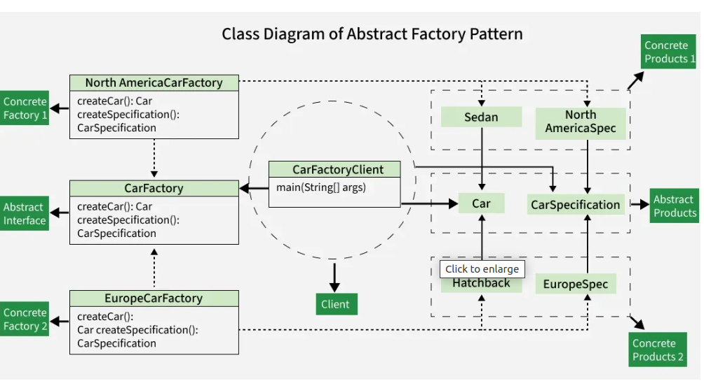
https://www.geeksforgeeks.org/system-design/abstract-factory-pattern/

Builder design pattern

The Builder Design Pattern is a creational pattern that provides a flexible solution to construct complex objects. Instead of requiring all the parameters for object creation in one go (like a large constructor), the Builder Pattern breaks the object construction process into simpler, step-by-step methods.

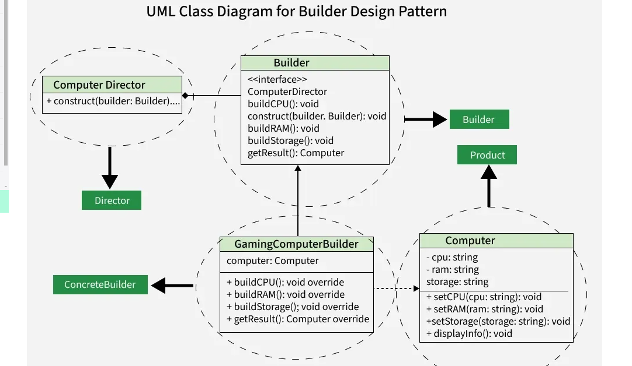
X

https://manishankarjaiswal.medium.com/builder-design-pattern-using-python-a-step-by-step-guide-for-beginners-aeb29a6b747e

Prototype design pattern

The Prototype Pattern is a creational design pattern used when creating objects is time-consuming or resource-intensive. Instead of creating new objects from scratch, it creates copies of existing objects to improve performance and efficiency.
- Objects are created by cloning existing instances rather than instantiating new ones.
- The cloned object can modify only the required properties.
- This approach saves time and system resources when object creation is costly.
- The clone() method is commonly used, though cloning logic depends on the business require

