TITLECLEAR · ARCHITECTURE NOTE
How the system is split up
Eight modules with walls between them, so that a change to a law, a language, a state or a model touches one module and leaves the rest alone.
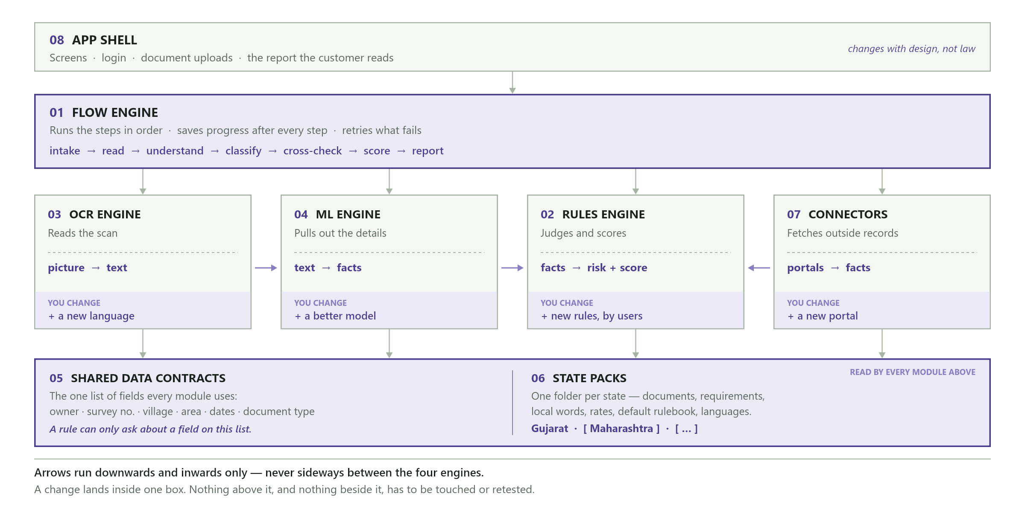
The whole design in one picture: four engines in a line, a manager above them, and two shared layers underneath.
WHY IT IS BUILT THIS WAY
Four things will change under us, repeatedly, for as long as the product exists:
- Laws change — rates, required documents and red flags are revised regularly, and users must be able to change them without a developer.
- States get added — Gujarat today; each new state has different documents, different words and different rules.
- Languages get added — Gujarati and English today; Hindi and Marathi later.
- Models improve — a better AI arrives every few months and must be swappable.
If all of that lives in one place, every change is a risk. So each module does one job and hands on an agreed set of fields — like stations on a factory line. A station can be swapped overnight, as long as it accepts and returns the same tray.
THE EIGHT MODULES
# | MODULE | WHAT IT DOES | WHAT IT MUST NOT DO
1 | Flow Engine | Runs the seven steps in order, saves progress, retries failures. | Must not know any land law.
2 | Rules Engine | Holds the rules users edit; produces flags, review items and the score. | Must not read files or call AI.
3 | OCR Engine | Turns a scan into text, one plug-in per language, with a confidence figure. | Must not interpret the text.
4 | ML Engine | Turns text into organised facts and compares them across documents. | Must not decide what is bad.
5 | Contracts | The one agreed list of fields every module passes around. | Must stay small and stable.
6 | State Packs | One folder per state: documents, requirements, local words, rates, rulebook. | Must hold data, never logic.
7 | Connectors | Fetches records from government portals behind one interface. | Must stop at a captcha, not solve it.
8 | App Shell | Screens, login, file storage, and the report the customer reads. | Must not contain scoring logic.
Modules 1–4 are the engines that do the work. Modules 5–8 exist so the engines never have to know about each other.
WHAT YOU TOUCH WHEN SOMETHING CHANGES
This table is the real test of the design. Everything not named stays untouched.
WHEN THIS CHANGES | YOU EDIT ONLY THIS
A penalty weight or score threshold | Rules Engine — numbers only
A new required document in Gujarat | Gujarat state pack
A new rule, written by a user | Rules Engine, through the editor — no code
A stamp duty or jantri rate revision | Gujarat state pack
Support Marathi documents | OCR Engine — one new language pack
A better handwriting or extraction model | OCR / ML Engine — swap the provider
Add Maharashtra | A new state pack, plus its connectors
A new pipeline step, e.g. a fraud check | Flow Engine, plus the one new step
A government portal opens up | Connectors — one new connector
Redesign the report screen | App Shell
The one guard rail that makes user-written rules safe: a rule can only ask about a field that Module 5 guarantees exists. The editor offers a dropdown, not a free text box — so a user can write a wrong rule, but never a broken one.
WHERE WE ARE TODAY
MODULE | STATUS | DETAIL
Flow Engine | Built | Seven steps, progress saved, restart on stall, tested end to end.
Rules Engine | Half built | Rules run and score; the numbers are already data. Not yet user-editable — no editor, no rulebook versions, no effective dates.
OCR Engine | Built | Two engines behind one interface, two languages, accuracy harness. Handwriting is the weak point.
ML Engine | Scattered | All three parts work and are swappable, but sit in two different folders.
Contracts | Built | Shared shapes, document list and bilingual text in place.
State Packs | Scattered | Gujarat is data, not hardcoded — but spread across five files instead of one pack.
Connectors | One real | GujRERA works behind a flag; the rest are mocks on the same interface.
App Shell | Built | Screens, login, document library, report rendering.
NEXT THREE STEPS, IN ORDER
- Consolidate the Gujarat state pack into one folder — cheap now, expensive once a second state exists.
- Group the ML engine into one module so extraction, classification and matching sit together.
- Make rules user-editable: rulebook storage, versions with effective dates, an editing screen, and test-before-publish. This is what makes the product customisable, and what the rest of the architecture was arranged to support.
The goal in one sentence: a law changes, we edit one file in one state pack, and nothing else has to be retested.

