

Forecasting Inpatient Bed Occupancy
Team 9: Chun Geng, Neha Kolagatla, Jaya Sruthi Raj Perikala, Heta Shah, Leo Yu

Technical Appendix

Predictive Analytics

Mar 20, 2026
1. Introduction 2
2. Data 3
2.1 Data Description and Variable Selection 3
2.2 Cleaning and Preprocessing 5
2.3 Data Challenges 7
3. Exploratory Data Analysis 9
4. Modeling Approach 11
4.1 Modeling for Texas 11
4.2 Modeling for California 16
4.3 Modeling for Florida 20
5. Conclusions 24
6. Lessons Learned 26
7. Data Sources and References 26

1. Introduction
This project analyzes and predicts future hospital inpatient bed occupancy based on historical data from U.S. hospitals. The goal is to develop a time-series model that forecasts future inpatient bed occupancy using historical weekly respiratory illness and capacity data, capturing trends in admissions and informing hospital preparation. Our objective is to investigate three primary questions.
- What historical trends and seasonal patterns exist in inpatient bed occupancy?
- How do respiratory-related hospitalizations and admissions influence inpatient bed utilization over time?
- Can short-term inpatient bed occupancy be accurately forecasted using historical respiratory and capacity data?
The goal is to then support hospitals in anticipating fluctuations of inpatient bed utilization in order to manage staffing, resource allocation and quality of care. The unpredictability of sudden surges in hospital admissions, driven by diseases such as COVID-19, influenza and Respiratory Syncytial Virus (RSV), poses a considerable risk to public health. These unexpected increases exert substantial pressure on healthcare resources and ultimately jeopardize patient well-being. Forecasting models are developed separately for the three states with the highest average inpatient bed occupancy: California (CA), Florida (FL), and Texas (TX). The full structure of this appendix, covering data description, exploratory analysis, modeling, conclusions, and lessons learned, is outlined in the table of contents above.

2. Data

2.1 Data Description and Variable Selection
The data set used in this project is the “Weekly Hospital Respiratory Data and Metrics” dataset from Kaggle, which aggregates hospital reported operational and respiratory illness data collected by the Centers for Disease Control and Prevention (CDC) through the National Healthcare Safety Network (NHSN). The dataset covers hospital-level information across 56 U.S. regions (50 states, the District of Columbia, and five U.S. territories), including measures related to hospital capacity, inpatient and ICU bed availability, bed occupancy, and the burden of respiratory illnesses associated with COVID-19, Influenza and RSV. It provides insight into how trends in respiratory diseases influence hospital utilization over time.
The data is recorded at a weekly time interval, making it well-suited for time-series analysis and short-term forecasting of inpatient bed utilization. The raw dataset spans August 8, 2020 through November 16, 2024, though the analysis window is restricted to August 8, 2020 through May 4, 2024 as described in Section 2.3. The full dataset contains approximately 12,800 rows and 157 columns, however a targeted subset of 13 columns was selected to eliminate redundant and highly correlated features. The dataset, while relatively comprehensive, necessitates some preprocessing. This includes handling missing values, removing aggregated national-level records, and selecting variables that are most relevant to modeling inpatient bed utilization. The selected variables are described in Table 1.
The key target variable is the Number of Inpatient Beds Occupied, which serves as a direct indicator of hospital capacity utilization. COVID-19 and influenza admission variables are retained as exogenous regressors for applicable models given their demonstrated correlation with bed occupancy.
Table 1: Selected Variables and Descriptions
Variable Name | Description | Data Type
Week Ending Date | End date of the weekly reporting period | Date
Geographic aggregation | Geographic region for which the data is aggregated | Categorial
Number of Inpatient Beds | The total number of inpatient beds available in the region | Numeric (Integer)
Number of Inpatient Beds Occupied | Total number of inpatient beds occupied | Numeric (Integer)
Total COVID-19 Admissions | The total number of COVID-19 admissions | Numeric (Integer)
Total Influenza Admissions | Total number of influenza admissions | Numeric (Integer)
Total RSV Admissions | Total number of RSV admissions | Numeric (Integer)
Percent Hospitals Reporting Total Patients Hospitalized with COVID-19 | The percentage of hospitals reporting the total number of patients currently hospitalized due to COVID-19. | Numeric (Float)
Percent Hospitals Reporting Total Patients Hospitalized with Influenza | The percentage of hospitals reporting the total number of patients currently hospitalized due to Influenza. | Numeric (Float)
Percent Hospitals Reporting Total Patients Hospitalized with RSV | The percentage of hospitals reporting the total number of patients currently hospitalized due to RSV. | Numeric (Float)
Percent Hospitals Reporting COVID-19 Admissions | The percentage of hospitals reporting the total number of COVID-19 admissions. | Numeric (Float)
Percent Hospitals Reporting Influenza Admissions | The percentage of hospitals reporting the total number of Influenza admissions | Numeric (Float)
Percent Hospitals Reporting RSV Admissions | The percentage of hospitals reporting the total number of RSV admissions. | Numeric (Float)

2.2 Cleaning and Preprocessing
The following preprocessing steps were applied in sequence to prepare the dataset for time-series analysis:
- Column selection and standardization: Columns not directly relevant to the analysis were removed, retaining only the 13 variables described in Table 1. The remaining "Percent Hospitals Reporting" columns were standardized from a 0-100 scale to a uniform 0-1 decimal scale (e.g., 92 → 0.92) to ensure comparability across reporting metrics.
- RSV exclusion: Reporting completeness for RSV was assessed across all regions. Given an average RSV reporting below 5%, all RSV related columns were dropped to prevent noise from an underreported variable biasing the models. (See Figure 1)
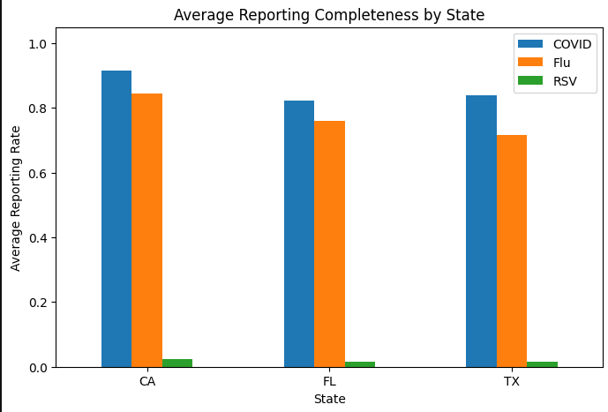
Figure 1: Average reporting completeness across all relevant states for this report
- National-level record removal: Rows aggregated at the national level ("USA") were removed to preserve state-level patterns.
- Date standardization: The “Week Ending Date” column was converted to proper datetime format to enable time-series indexing and model fitting.
- Regions with insufficient history: American Samoa and Northern Mariana Islands were excluded due to insufficient reporting, leaving 54 regions in the final dataset.
- Target column missing values: Rows with missing values in the target variable (Number of Inpatient Beds Occupied) were removed rather than imputed, as interpolated values during the COVID-19 period would distort structurally elevated occupancy trends.
- Remaining missing values: Missing values were filled using linear interpolation per region, with forward and backward filling for edge cases.

2.3 Data Challenges
Several data quality issues were identified and addressed during preprocessing.
Outlier in Georgia (GA)
A severe data anomaly (as seen in Figure 2) was detected in Georgia for the week ending January 23, 2021, where the reported number of inpatient beds occupied was 63,483,001, which far exceeds the total beds available in the state (31,470). This is clearly a data entry error. The anomalous value was replaced using linear interpolation based on the surrounding observations (January 16, 2021: 26,283 beds; January 30, 2021: 25,921 beds).
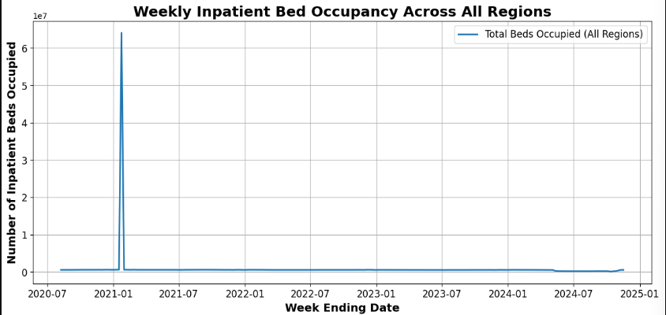
Figure 2:Line Graph of The Number of Inpatient Beds Occupied in GA
Reporting Policy Change (Mid-2024)
A major structural break occurred on May 11, 2024, when hospital reporting transitioned from mandatory to voluntary. This caused reporting coverage to fall below 80%. This produced a sharp and unnatural decline in reported inpatient bed occupancy that does not reflect true patient volumes (as observed in Figure 3). All weeks from May 11, 2024 through November 2, 2024 were removed from the analysis to prevent this decline from biasing model training or forecasts. The final analysis dataset covers August 8, 2020 through May 4, 2024.
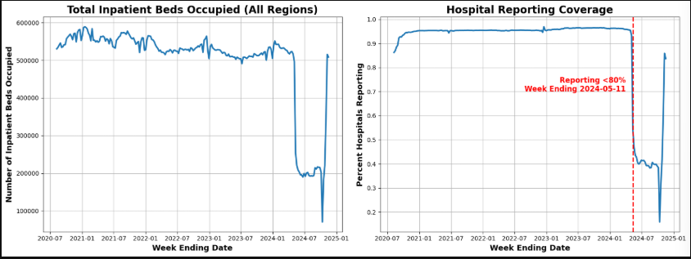
Figure 3: Line graph of total inpatient beds occupied and hospital reporting coverage across regions

3. Exploratory Data Analysis
After data preparation, an exploratory data analysis (EDA) was conducted to identify trends, seasonal patterns and relationships between variables.
National Occupancy Trend (Aug 2020 – May 2024)
Total inpatient beds occupied across all regions shows a clear structural shift from pandemic-driven high utilization to a stable post pandemic-baseline. A clear pattern emerged: the peak of COVID-19 cases coincided with the initial rollout of vaccinations in late 2022, after which case numbers generally decreased. From mid-2022 onward, the series stabilises within a narrower range of approximately 500,000 – 550,000 beds nationwide, with a consistent annual seasonal pattern: winter peaks (December–February) and summer troughs (June–August).

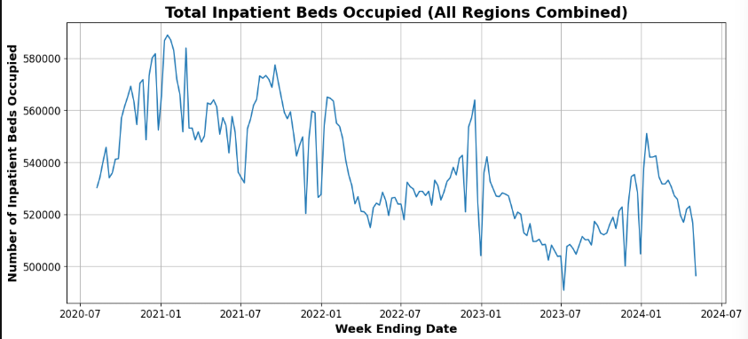
Figure 4: Total Number of Inpatient Beds Occupied reported over Week Ending Date.
Regional Distribution
A bar chart of average inpatient beds occupied by state reveals a heavily right skewed distribution. Texas (TX) and California (CA) exhibit the highest average occupancy by a wide margin, followed by Florida (FL), which is consistent with their large populations. The distribution of weekly bed occupancy across all regions is also right-skewed: most observations fall below 2,000 beds (smaller states), while a small number of large-state observations reach 40,000–60,000 beds. These three states were selected as the focus of individual forecasting.
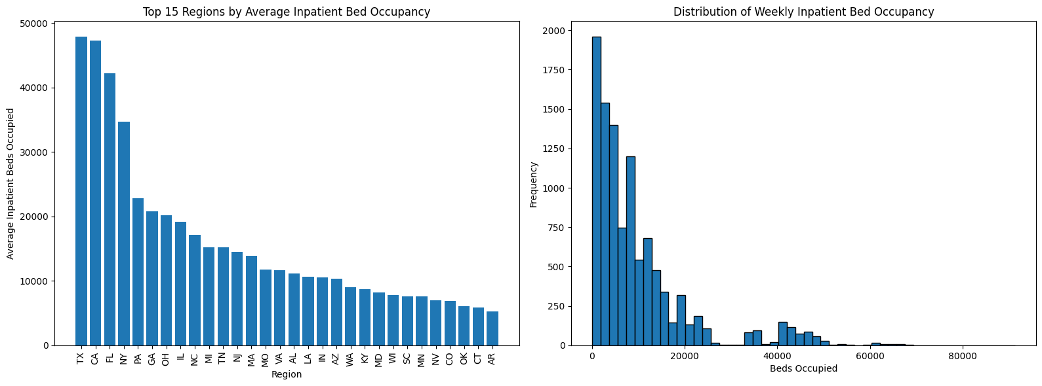
Figure 5: Regional Comparison and Distribution of Inpatient Bed Occupancy

Relationship Between Respiratory Admissions and Bed Occupancy
A correlation analysis revealed a strong positive relationship between COVID-19 admissions and inpatient bed occupancy (r = 0.73), confirming COVID-19 as a significant driver of hospital utilization. Influenza admissions showed a near-zero correlation (r = -0.11), suggesting its impact is more seasonal and localized than a consistent national driver. These findings inform the inclusion of COVID-19 and influenza admissions as exogenous variables in applicable forecasting models.
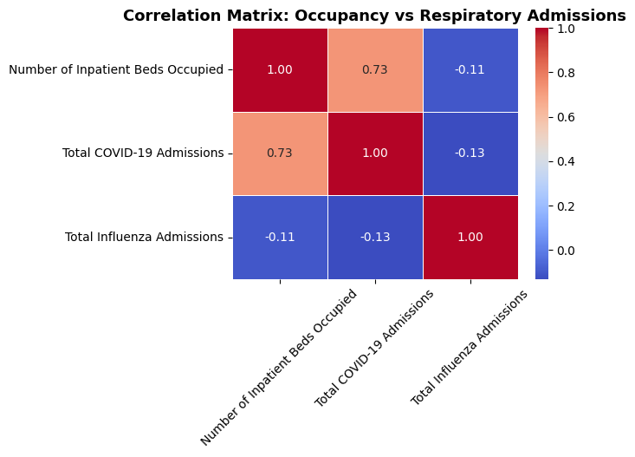

4. Modeling Approach
A uniform methodology was used across all three states, with state-specific adjustments based on the structure of each series. The forecast horizon was set to 13 weeks (May 11 to August 3, 2024). The final 13 weeks of available data were reserved for testing, and all earlier data were used for training.
For each state, the following steps were carried out:
- Baseline: A naïve forecast was established with the assumption that (future value would be the same as the last observed value) as a performance benchmark
- Stationarity testing: The Augmented Dickey–Fuller (ADF) test was applied. ACF and PACF plots were examined to identify autocorrelation structure and guide model order selection.
- ARIMA Model selection: Candidate ARIMA configurations were compared using the Akaike Information Criterion (AIC) and Bayesian Information Criterion (BIC). The configurations with the lowest values were selected.
- Model comparison: ARIMA, ETS, SARIMA, Seasonal ETS, and SARIMAX (with COVID-19 and influenza admissions as exogenous regressors) were evaluated on the test set using Root Mean Squared Error (RMSE) and Mean Absolute Percentage Error (MAPE).
- Residual diagnostics: ACF plots of model residuals were checked to confirm that leftover errors (residuals) behaved as white noise, which confirmed that the selected model had successfully captured the relevant time-based patterns.
- Final forecast: The best performing model was refitted on the full series and used to generate the 13-week out-of-sample forecast.

4.1 Modeling for Texas
The Texas inpatient bed occupancy series shows a clear structural shift in early 2021. Following the winter COVID-19 wave, occupancy spiked to over 90,000 beds for the week ending February 27, 2021, an anomaly associated with the Great Texas Freeze (February 10–20, 2021), which disrupted healthcare facilities and concentrated delayed admissions into the subsequent reporting week. From mid-2021, occupancy declined and stabilized in the 41,000–48,000 bed range, with moderate fluctuations and a mild seasonal pattern through 2022–2024.
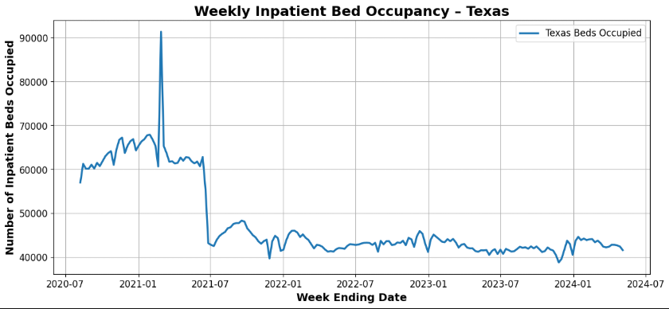
Figure 6: Time Series Plot of Occupancy in Texas
Stationarity, ACF and PACF
The ADF test on the original Texas series returned a p-value of 0.55, indicating that the series was not stationary (failure to reject the null hypothesis at ⍺ = 0.05). After applying first-order differencing (d = 1), the p-value fell to 1.29 × 10⁻¹⁹, confirming stationarity. The original series Autocorrelation Function (ACF) shows a slow decay, consistent with non-stationarity. After differencing, the ACF cuts off sharply after lag 1 and the Partial Autocorrelation Function (PACF) shows a significant spike only at lag 1, suggesting either an ARIMA(0,1,1) or ARIMA(1,1,0) specification.
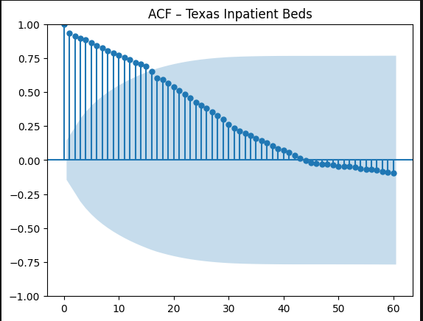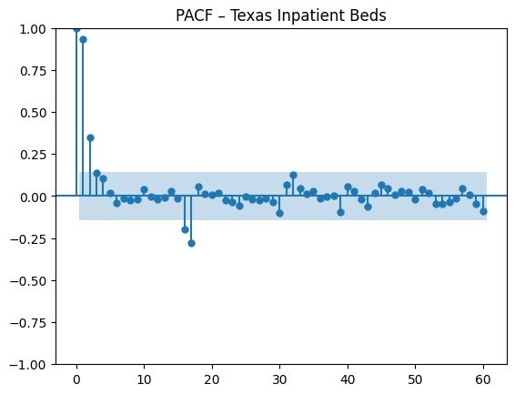
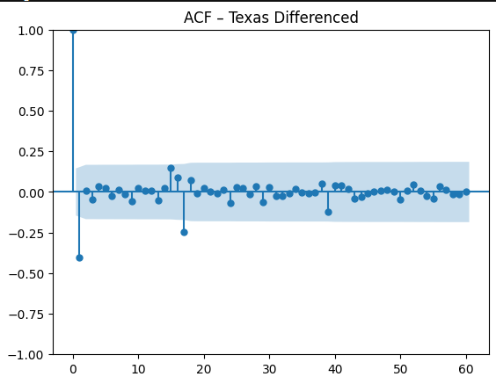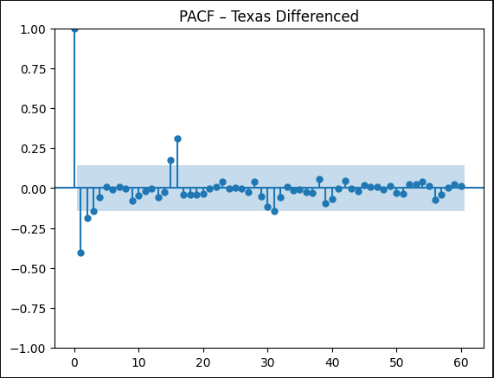
Figure 7: ACF and PCF of Texas Inpatient Bed Series Before and After differencing.
ARIMA Model Comparison (AIC / BIC)
Model | AIC | BIC
ARIMA(0,1,1) | 3475.48 | 3481.88
ARIMA(1,1,0) | 3475.11 | 3481.52
ARIMA(1,1,1) | 3476.91 | 3486.52
ARIMA(2,1,0) | 3477.00 | 3486.61

To identify the best-fitting model for Texas Inpatient Beds, multiple ARIMA configurations were evaluated using AIC and BIC), where lower values indicate a superior balance between accuracy and complexity. The models compared were: ARIMA(0,1,1), ARIMA(1,1,0), ARIMA(1,1,1), and ARIMA(2,1,0). Of these, ARIMA(1,1,0) produced the lowest AIC (3475.11) and BIC (3481.52) scores, suggesting it offers the best fit without unnecessary complexity. As a result, ARIMA(1,1,0) was selected as the preferred ARIMA model for forecasting.

Model Comparison on Test Set
Model | RMSE | MAPE
Baseline | 1214.61 | 2.44
ARIMA (1,1,0) | 1248.90 | 2.51
ETS | 531.08 | 0.99
Seasonal ETS | 2820.14 | 3.26
SARIMA | 1193.69 | 2.40
SARIMAX (2,1,1)(1, 0, 0, 52) | 945.54 | 1.86

The ETS model substantially outperformed all other candidates with an RMSE of 531.08 and a MAPE of 0.99%, which is less than half the error of the next-best model. This is consistent with the data: after the structural break of 2021, Texas occupancy follows a stable level pattern with no strong seasonality, which is precisely the signal simple exponential smoothing captures. While SARIMAX (RMSE: 945.54) improved over the baseline by incorporating exogenous regressors, it still fell short of ETS, suggesting that respiratory admissions provide limited additional explanatory power for Texas once the stable post-pandemic trend is accounted for. The poor performance of Seasonal ETS (RMSE: 2820.14) confirms that imposing seasonal structure on a non-seasonal series is not appropriate.
Error Diagnostics
Figure 7 displays both the ACF and line plots for the residuals. The model's errors appear relatively stable. In the ACF plot, the residuals largely fall within the 95% confidence interval, with only a few early spikes corresponding to the 2021 structural break. The residual time series fluctuates around zero and stabilises after mid-2021. The residual distribution is approximately normal and centred at zero.
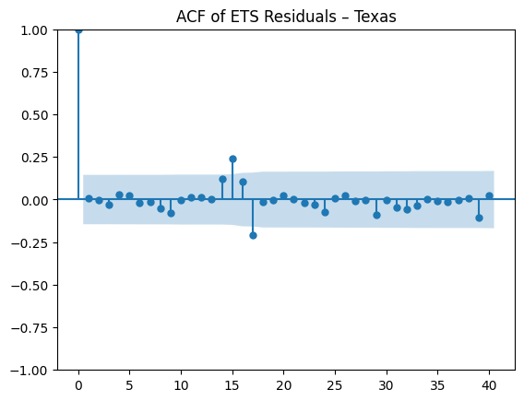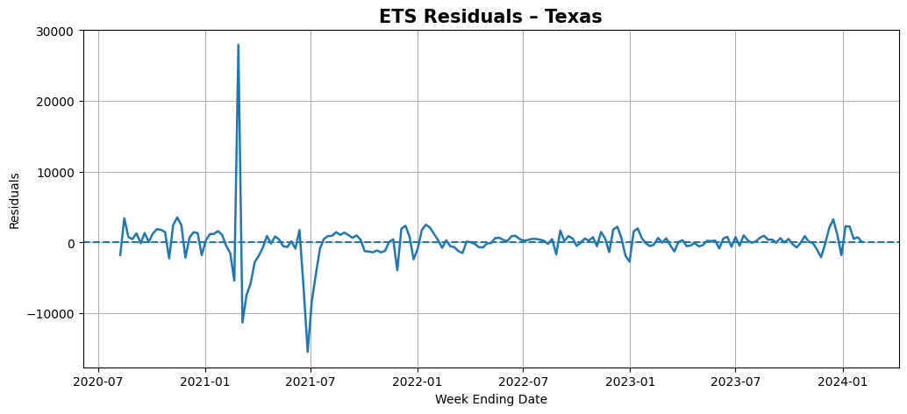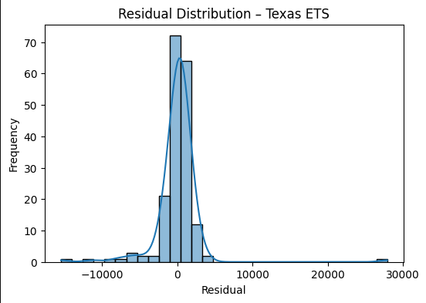
Figure 7 ACF, timeseries, and histogram of the ETS residuals
13 Week Forecast
The ETS model was refitted on the full Texas series and used to generate the 13-week forecast. Projected occupancy remains stable at approximately 41,000 beds through mid-2024, with a slight gradual decline. These results suggest that short-term hospital demand in Texas remains predictable with no major spikes anticipated, supporting the use of ETS as a reliable model for near-term capacity planning.
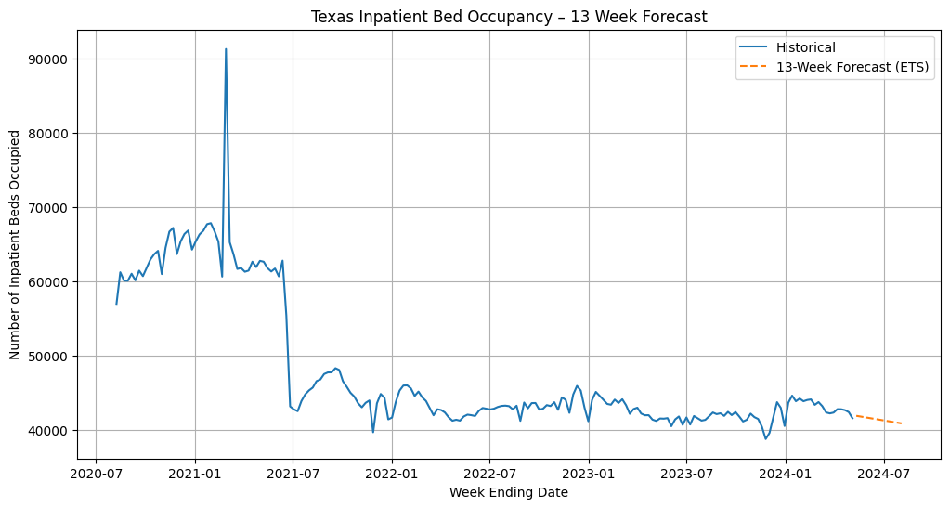
Figure 8: 13-week Forecasts of Texas Inpatient Bed Occupancy with ETS model

4.2 Modeling for California
California’s inpatient bed occupancy series shows a noticeably different structure from Texas (Figure 9). The series exhibits strong, recurring seasonality with consistent winter peaks (December–February) driven by respiratory illness surges, followed by surges by sharp spring declines and lower summer bed occupancy rates. This seasonal cycle repeats clearly across 2021, 2022, 2023, and 2024. Overall occupancy has remained broadly stable in the 44,000–51,000 bed range since mid-2021.
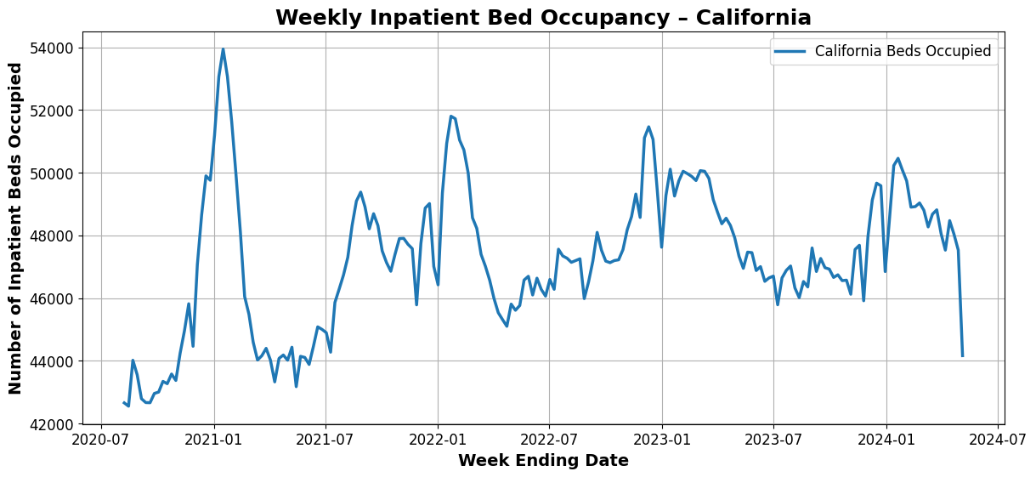

Figure 9: Time Series Plot of Occupancy in California
Stationarity, ACF and PACF
The ADF test on the California series returned a p-value of approximately 0.0002, which allows for the rejection of the unit root null hypothesis at α = 0.05 without differencing (d = 0). The series is therefore stationary in levels. The PACF shows a very strong spike at lag 1 (p = 1) with values inside the confidence interval at subsequent lags, suggesting an AR(1) or AR(2) process is appropriate. A clear decay over time in the ACF plot is seen until at around lag 35, after which an upward trend is exhibited, as can be observed in the ACF and PACF plot in Figure 10. A similar trend to the differenced Texas PACF plot is then exhibited by the PACF plot and, besides the early lags, it is shown that most of the values are within the confidence interval.
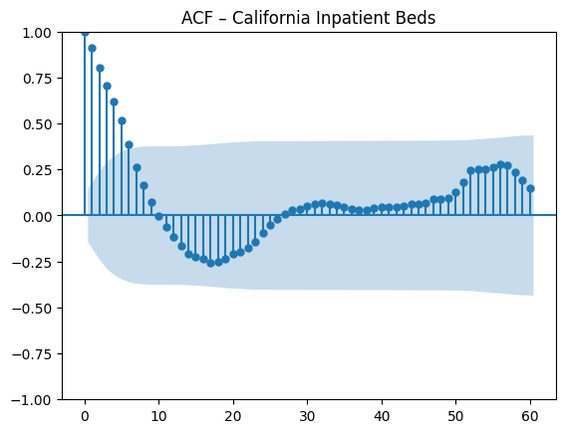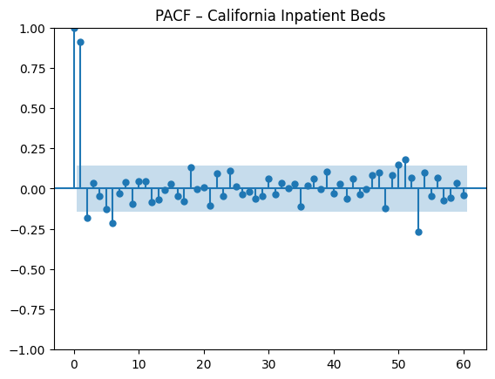
Figure 10: ACF and PCF of CA inpatient beds

ARIMA Model Comparison (AIC / BIC)
Model | AIC | BIC
ARIMA(1,0,0) | 3002.26 | 3011.89
ARIMA(2,0,0) | 2997.65 | 3010.49
ARIMA(1,0,1) | 2997.66 | 3010.45

ARIMA(2,0,0) achieves the lowest AIC (2997.65) and BIC(3010.49) and is selected as the preferred ARIMA configuration for California, consistent with the strong spikes at lags 1 and 2 in the PACF.
Full Model Comparison on Test Set
SARIMAX(2,0,0)(1,0,0,52) was the best performing model with the lowest RMSE (877.99) and MAPE (1.15%). Its advantage over ARIMA(2,0,0) (RMSE: 1,067.03) confirms the importance of the 52-week seasonal component, while its advantage over SARIMA (RMSE: 1,267.88) confirms that COVID-19 and influenza admissions provide meaningful additional predictive power. The poor performance of both ETS variants suggests that California's seasonal dynamics are too strong for models without explicit seasonal structure.
Model | RMSE | MAPE
Baseline | 2054.81 | 3.49
ARIMA (2,0,0) | 1067.03 | 1.2
ETS | 2337.81 | 4.06
Seasonal ETS | 3749.95 | 7.11
SARIMA | 1267.88 | 1.97
SARIMAX(2,0,0)(1,0,0,52) | 877.99 | 1.15
Residual Diagnostics
SARIMAX residuals are plotted over time, in an ACF and as a histogram. Residuals are normally distributed near zero (Figure 11). The ACF shows most autocorrelations within the 95% confidence band, with no significant remaining lag patterns. The residual distribution is approximately normal and symmetric, confirming the model is capturing the behavior of the data and can make effective predictions.
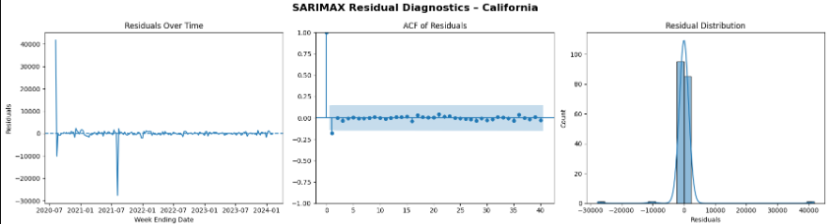
Figure 11: ACF, Lineplot, and histogram of the residuals of the SARIMA model for CA
13 Week Forecast
The SARIMAX model was refitted on the full California series and used to generate the 13-week forecast. Projected occupancy shows a slight decline followed by stabilisation in the 43,000–45,000 bed range through mid-2024, which is consistent with the seasonal troughs that were historically observed during the spring to summer transition. Because it has well-calibrated residuals, they support using this forecast for short-term capacity planning.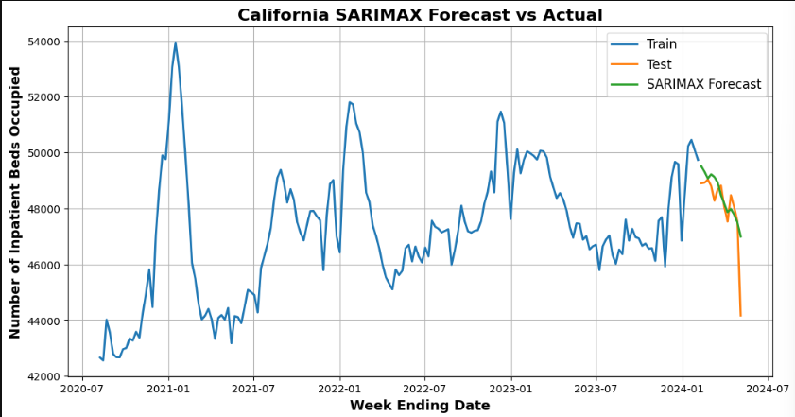
Figure 12: 13-week forecasts of California inpatient bed occupancy with the SARIMAX model

4.3 Modeling for Florida
Florida's inpatient bed occupancy looks quite different from Texas and California. It starts at around 55,000 beds in mid-2020 and drops sharply to between 37,000 and 40,000 beds by early 2021. This drop reflects how hospitals across the country adjusted during the early stages of the pandemic: fewer elective procedures, changed admission patterns and shifting patient behavior. From 2021 onward, occupancy settles into a steadier range of 38,000–45,000 beds, with a consistent seasonal rhythm: beds fill up in winter and free up in summer, and this pattern repeats every year throughout the study period.
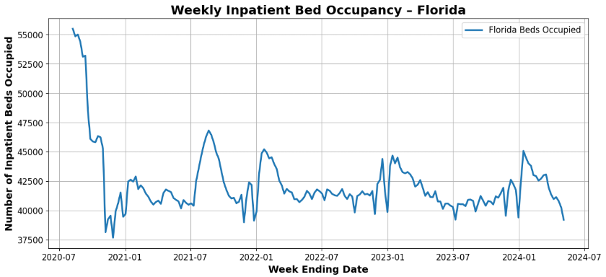
Figure 13: Time Series Plot of Occupancy in Florida
Stationarity, ACF, and PACF
The ADF test returned a p-value below 0.05, rejecting the null hypothesis and confirming stationarity (d = 0). The ACF and PACF plots indicate strong short-term autocorrelation and a seasonal signal at longer lags, suggesting that models incorporating both short-term memory and a seasonal component are appropriate.
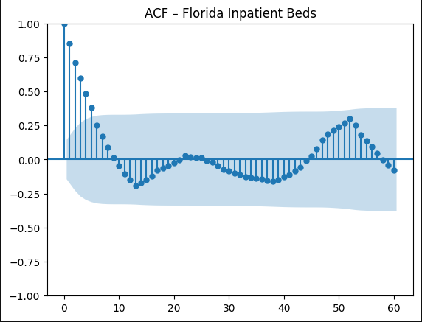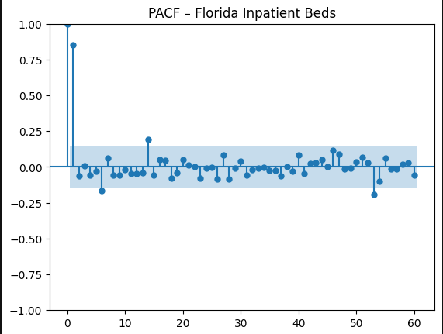
Figure 14: ACF and PCF of FL inpatient beds
ARIMA Model Comparison (AIC / BIC)
Model | AIC | BIC
ARIMA(1,0,0) | 3116.28 | 3125.91
ARIMA(1,0,1) | 3117.83 | 3130.67
ARIMA(2,0,0) | 3117.95 | 3130.79
ARIMA(1,0,0) had the lowest AIC (3116.28) and BIC (3125.91) of the three options we tested, so it was chosen as the best ARIMA model for Florida. Lower AIC and BIC scores indicate a better fit without unnecessary complexity.
Full Model Comparison on Test Set
Model | RMSE | MAPE
Baseline | 2365.75 | 4.97
ARIMA (1,0,0) | 1882.7 | 3.87
ETS | 1820.29 | 3.77
Seasonal ETS | 1004.26 | 1.91
SARIMA | 1665.71 | 3.4
SARIMAX (2,1,1)(1, 0, 0, 52) | 1921.98 | 3.90
Seasonal ETS was the best performing model for Florida with an RMSE of 1,004.26 and MAPE of 1.91%, nearly half the error of the next best model. In contrast to California, which required SARIMAX to incorporate external admission data, Florida's occupancy is sufficiently explained by its seasonal pattern alone. Adding exogenous variables worsened performance (SARIMAX RMSE: 1,921.98), confirming that the time of year provides most of the predictive information needed. The 52-week seasonal cycle with no trend component is appropriate given Florida's relatively flat occupancy since 2021, and the gap between Seasonal ETS (MAPE: 1.91%) and plain ETS (MAPE: 3.77%) underscores the strength of Florida's annual winter-summer rhythm.
Residual Diagnostics
Residual diagnostics confirm the Seasonal ETS model is well-specified. Residuals fluctuate around zero with no discernible trend, the ACF shows no significant autocorrelation, and the error distribution is approximately normal and centered at zero, indicating the model has successfully captured the principal patterns in the data.
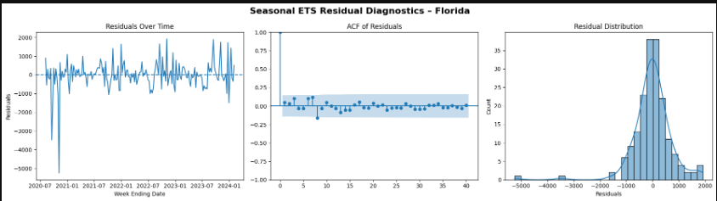
Figure 15: ACF, Lineplot, and histogram of the residuals of the Seasonal ETS model for FL
13-Week Forecast
The Seasonal ETS model was refitted on the full Florida dataset to generate a 13-week forecast. The forecast projects a modest upward drift through summer 2024, consistent with Florida's historical seasonal pattern, with occupancy remaining in the low-to-mid 40,000 range before climbing toward the winter peak. This predictable annual cycle provides a reliable basis for proactive hospital staffing and resource planning.
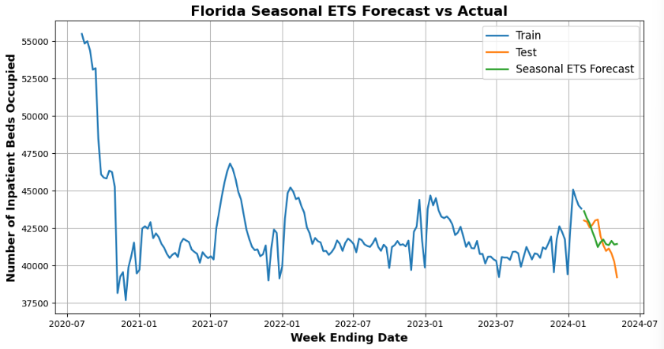
Figure 16: 13-week forecasts of Florida inpatient bed occupancy with the Seasonal ETS model

5. Conclusions
Summary of Results
State | Best Model | RMSE | MAPE (%)
Texas (TX) | ETS | 531.08 | 0.99
California (CA) | SARIMAX (2,0,0)(1,0,0,52) | 877.99 | 1.15
Florida (FL) | Seasonal ETS | 1004.26 | 1.91
Question 1: Historical Trends and Seasonal Patterns
All three states went through the same broad shift: high and unpredictable occupancy during the pandemic years of 2020–2021, followed by a calmer, more predictable pattern from 2022 onward. Once things went back towards normalcy, a seasonal rhythm emerged across all three states: occupancy rises in winter and falls in summer. However, the strength of those spikes varies by state. California has the most consistent seasonal peaks and troughs. Florida has a moderate but reliable cycle. Texas has the weakest seasonal pattern, especially after the disruption caused by the 2021 freeze.
Question 2: Influence of Respiratory Illnesses
COVID-19 admissions were the primary driver of occupancy surges between 2020 and 2022 (r = 0.73 nationally). Since then, COVID-19's influence has diminished and occupancy is now more strongly governed by recurring seasonal patterns. Whether incorporating respiratory admission data improved forecast accuracy varied by state. For California, including both COVID-19 and influenza admissions as exogenous variables meaningfully improved performance. For Florida, adding these variables worsened performance, indicating that Florida's seasonal pattern is sufficiently predictable from historical occupancy alone.
Question 3: Short-Term Forecast Accuracy
All three final models came in below 2% MAPE, meaning the forecasts were off by less than 2% on average during the 13-week test period. That is a strong result. The best model type was different for each state, which is exactly why we tested several approaches rather than picking one upfront.
What This Means in Practice
- Texas: Occupancy is expected to remain stable or drift slightly lower, indicating that hospitals do not face an imminent surge and can focus on maintaining operational efficiency and optimizing resource allocation.
- California: Occupancy is stabilizing following the winter peak. Hospitals should maintain steady staffing levels and monitor COVID-19 and influenza admission trends, which serve as early indicators of future occupancy increases.
- Florida: A modest seasonal uptick is expected through summer 2024, consistent with Florida's reliable annual pattern. Hospitals should proactively plan staffing and resource allocation ahead of the anticipated winter surge.
Limitations
Due to the transition to voluntary reporting in May 2024, forecast accuracy could not be validated against real post-cutoff data. The models rely solely on COVID-19 and influenza admissions as exogenous inputs; additional factors such as local demographics, weather patterns, or emergency department volumes may improve predictive accuracy. As state-level models, they cannot identify capacity strain at the individual hospital level. Future work could extend this framework to all 50 states and explore more advanced multivariate or hierarchical forecasting methods to better capture regional variation.

6. Lessons Learned
- There is no one-size-fits-all model. ETS worked best for Texas, SARIMAX for California, and Seasonal ETS for Florida. The right choice depends on the data, so testing several models and comparing them on real held-out data is essential.
- Simpler models can win. ETS proved to be one of the most straightforward forecasting methods and it outperformed every other model for Texas. Making a model more complex is only worth it if the data actually has the patterns that complexity is meant to capture.
- Extra variables do not always help. Adding COVID-19 and Influenza admissions as inputs improved accuracy for California but made things worse for Florida. Whether to include external data should always be tested, not assumed.
- Data quality requires domain knowledge. Anomalies such as the Georgia outlier and the 2024 reporting policy change appeared as plausible trends without contextual investigation, and the 2020 to 2021 pandemic period introduced unusual spikes and structural shifts requiring careful handling through anomaly correction, training window trimming, and differencing to avoid misleading model training.
- Checking residuals matters. Looking at the errors a model leaves behind is not just a formality. It tells you whether the model has genuinely learned the patterns in the data or whether it has missed something important. Good error metrics on the test set alone are not enough.

7. Data Sources and References
Primary dataset: Noeyislearning (2024). “Weekly Hospital Respiratory Data and Metrics.” Kaggle. Originally sourced from the CDC National Healthcare Safety Network (NHSN). https://www.kaggle.com/datasets/noeyislearning/weekly-hospital-respiratory-data-and-metrics

Centers for Disease Control and Prevention (CDC). National Healthcare Safety Network (NHSN): Hospital Respiratory Data. https://www.cdc.gov/nhsn

Hyndman, R.J., & Athanasopoulos, G. (2021). Forecasting: Principles and Practice (3rd ed.). OTexts. https://otexts.com/fpp3/

