Flowcharts
1. Workflow of Smart Blind Navigation Stick (ESP32-CAM + Ultrasonic + GPS + Audio)
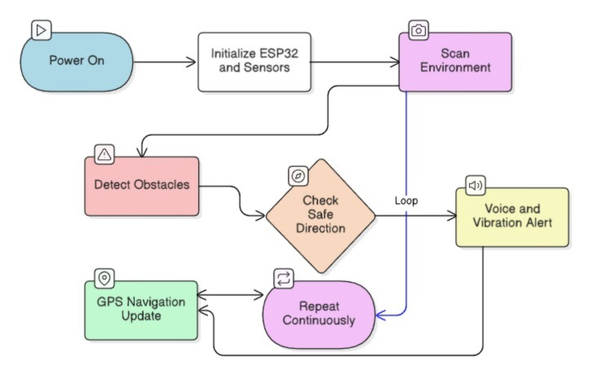
2. Arduino Code Logic Flowchart
