Predicting Restaurant tips using Predictive Analytics on Excel

HETAL SANGANI
Data Analyst
Excel

Here, the screenshot of dataset is given below
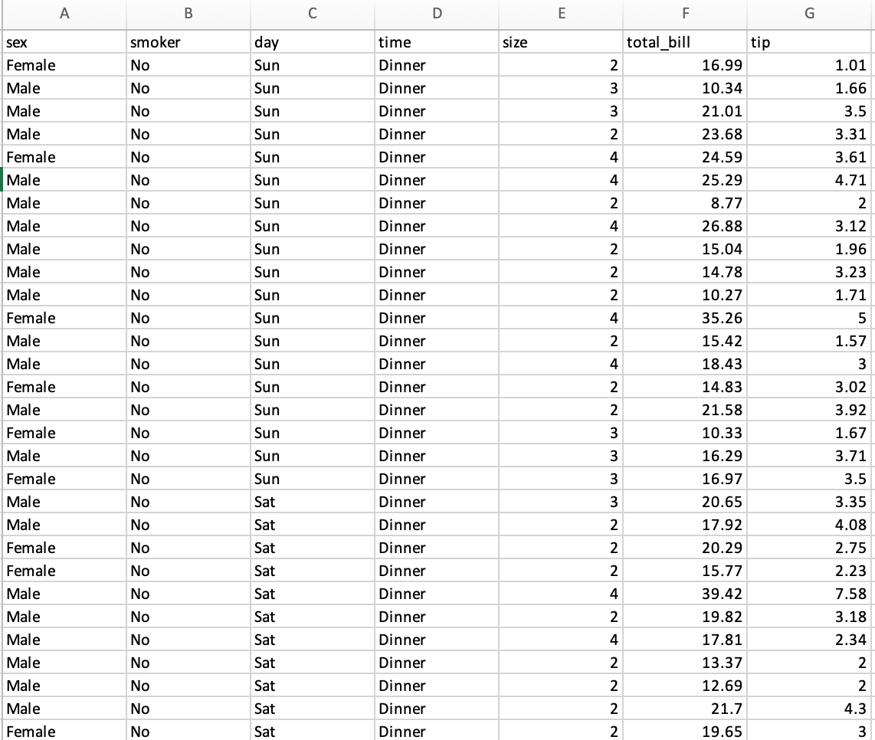

Here, Linear regression is used for only numeric data but in this dataset we have categorical data. So, we have to encode the categorical data using conditional formatting.
So, here we consider male as 1 and female as 0 by using if formula.
Same we have to do encoding for smoker, day and time columns.
After encoding we have to copy the value and paste special as a values and remove the original columns.
After that, we will see the dataset as a below
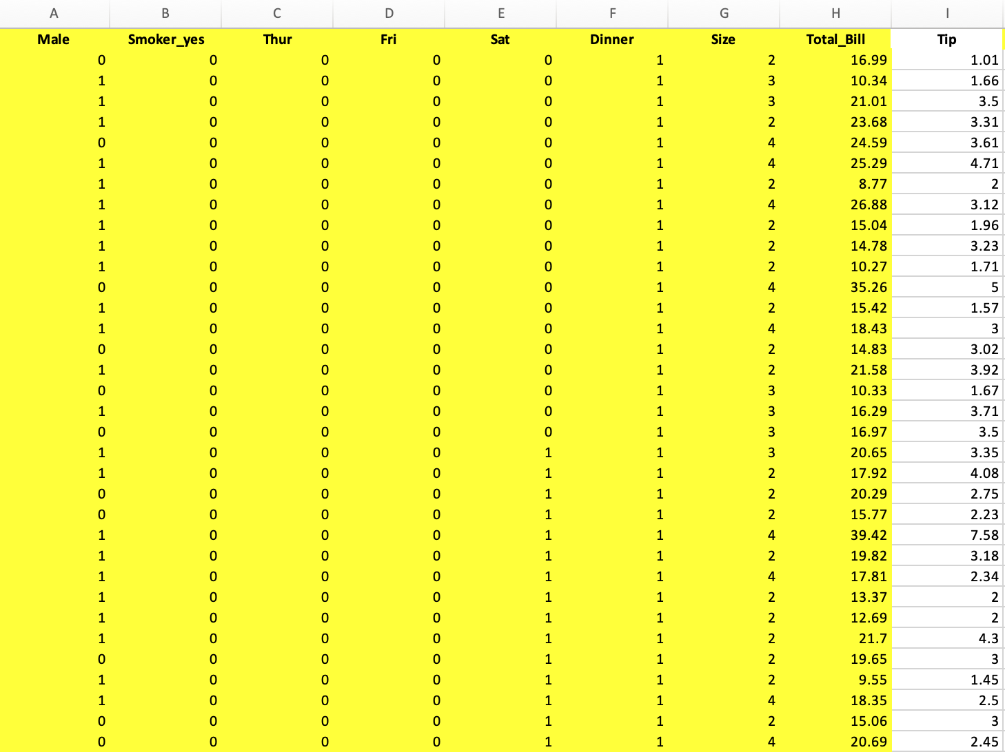

After that, In Data tab-- Data Analysis
Choose the Regression and then
Give the Range of Y (Independent Variable)tip column(I1 to I245)
Range of X (Dependent Variables)Male, Smoker_yes, Thur, Fri, Sat, Dinner, Size, Total_Bill (A1 to H245)
Check mark to the labels in dialogue box
It will create another sheet and In that sheet, you can see all summary of regression.
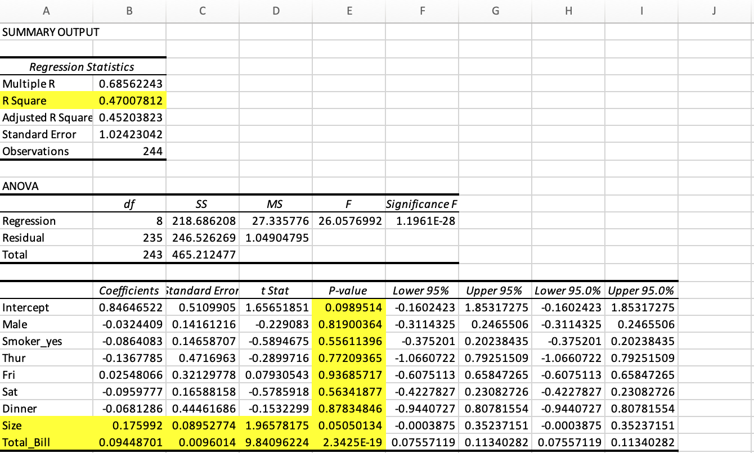
From above image,
If p-value is <= 0.05 then that variable is highly significant to predict variable
So here, size and total_bill is more significant to it.
So we consider coefficients of intercept, size and total_bill.
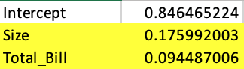
Now, we will add the column which name is “Predicted tip”
Its formula is y = mx+c
Here, y is independent variable
m is coefficients of size and total_bill columns
x is value of size and total_bill columns
c is coefficient of intercept
after applying this formula we get Predicted tip values
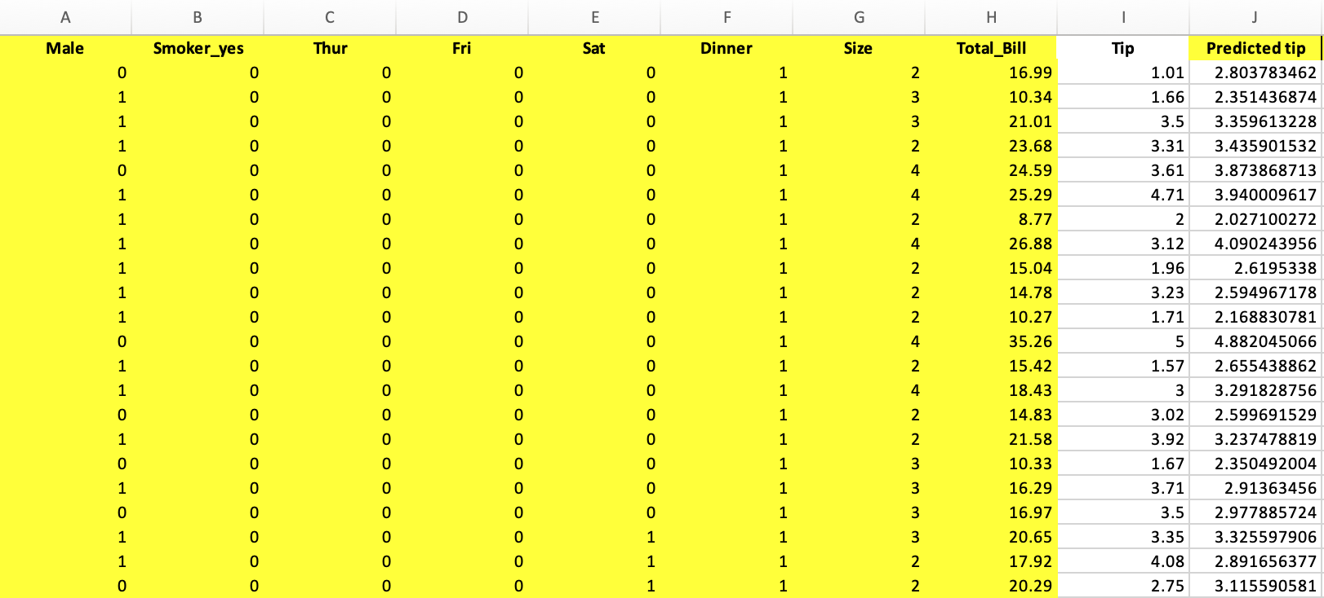
Then, we add the new column which name is “Error”
Error = Original tip – Predicted tip
After applying this formula, we get the result which is showing below
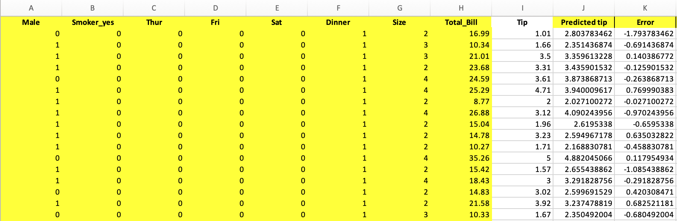
Then, we add the new column which name is “Sq of error”
Sq of error = (Error) * (Error)
After applying this formula, we get the result which is showing below
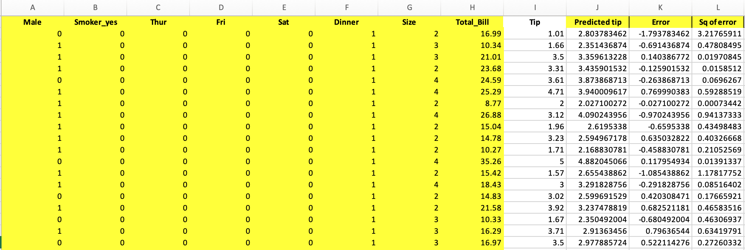
Then, we will calculate the MSE (Mean Square of Error), RMSE (Square root of MSE), Average of tip and Error in percentage
MSE = Average of Sq of error
RMSE = Sqrt (MSE)
Average tip = average of tip
Error (%) = RMSE / Average of tip
Here, we got values of MSE, RMSE, Average tip and Error
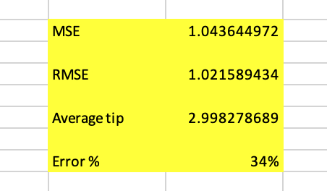
So here we got the 34% of error for predicting the tip.

