Test Plan – Insurance Broker System

High level testing strategy to capture details for an Insurance Broker System focusing on following initiatives,

* Registration functionality.
* Login and Logout functionalities.
* Request and Retrieve Quotation functionalities.
* View and Edit Profile functionalities.

To support ever changing technology landscape and support end user by providing an ability to access profile and request or review quotation organisation has decided to introduced web application – Insurance Broker System. This initiative will help end user to use web application/system to login and review or request quotation for an insurance and new users can register within system using registration functionality. This system will allow end user to view user profile and update if needed.

Testing Scope

* **Personas**
  + End user/Customers
  + Internal Operations team
  + Internal Customer Success/Support Team
  + Internal Engineering Team (Quality Engineers, Backend Engineers, Front hand Engineers, DevOps Engineers)
* **In Scope**
  + Following features/systems are in scope:
    - Web application -> Registration functional verification.
    - Web application -> Login page functional verification.
    - Web application -> Logout page functional verification.
    - Web application -> Request quotation functional verification.
    - Web application -> Retrieve quotation functional verification.
    - Web application -> View profile functional verification.
    - Web application -> Edit profile functional verification.
* **Out of Scope**
  + Following features/systems are out of scope:
    - Database testing.
    - Performance testing (Load, Stress and Scalability).
    - API testing.
    - Security testing (Penetration and Vulnerability).
    - Compatibility testing (Browser and Device).
    - Accessibility testing.
* **High Level Scenarios & Quality Objectives**
  + Verify system behaves as expected based on User requirements.
  + Verify system meets all quality standards defined by quality engineering team such as no open high priority or severity bugs before deploying to Production environment, deployment process is documented before handover to operations/DevOps team).

Testing Dynamics

**Types of Testing**:  
Team will focus on following different types of testing as a part of project,

* Unit testing
* System Integration testing
* Functional testing

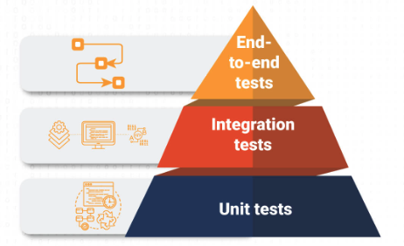

Various testing will take place across different environments and details are highlighted as below:

* **Development**
  + Unit testing - for each component.
  + System Integration testing.
* **QA**
  + Regression testing (for any existing functionalities).
  + Functional testing.
* **UAT**
  + User Acceptance testing
  + Smoke testing
  + **If Smoke testing fails:**
    1. Team needs to identify root cause and address the fix before moving to higher environment.
  + **If UAT testing fails:**
    1. Team needs to identify root cause and address the fix before moving to higher environment.
* **Prod**
  + Production verification testing by running identified scenarios.

**Defect Triage:**

Quality engineering team is responsible to set up Defect triage process in place. Defect triage workflow is defined as below,

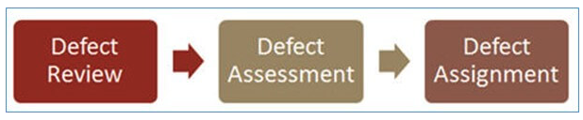

Defect workflow is defined as below,

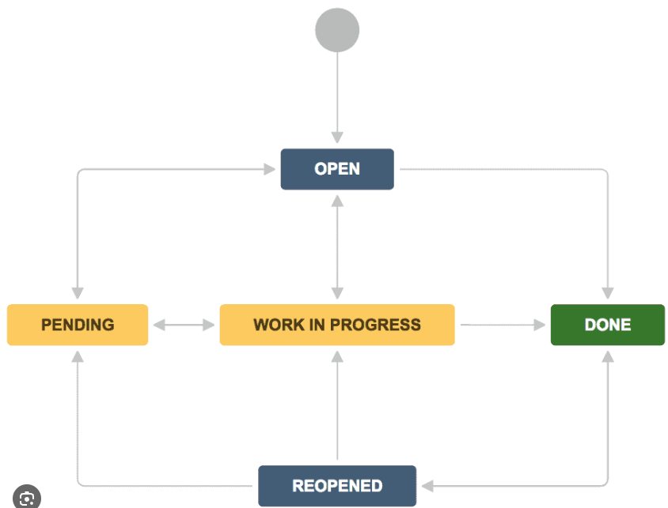

Important factors to consider for Defect triage meetings are as follow,

* Project Schedule.
* Number of defects.
* Team availability.

Defect triage meeting participants,

* Project Manager
* Test/Quality Engineering Lead
* Engineering Lead
* Delivery Lead
* Rest of the team member/s (as required)

Testing Documentation  
As a part of project following Testing Documentation will be delivered during different phases of the testing,

* Test Plan: Before commencing testing activities.
* Test Cases: Before and During Sprint activities.
* Requirements Traceability Matrix: During and End of each Sprint.
* Defect Triage Report: During and End of each Sprint.
* Customer Sign Off: End of UAT testing.

Testing Schedule

Testing on QA: 23 Oct 2023 – 06 Nov 2023

Testing on UAT: 07 Nov 2023 – 10 Nov 2023

Testing on production: 13 Nov 2023 – 16 Nov 2023

Testing Tools

During testing following tools, infrastructure will be required,

* Production like QA environment
* Test Management Tool (Xray or similar)
* Version Control Tool (GitHub or similar)
* Project Management Tool (JIRA or similar)
* Bug Triage Tool (JIRA or similar)
* Test Automation Tool (Cypress, Cucumber or similar)